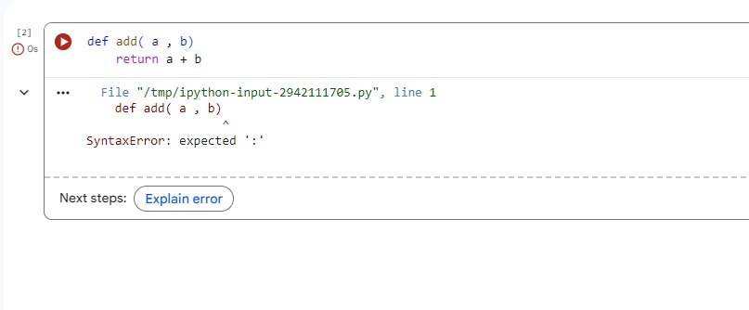

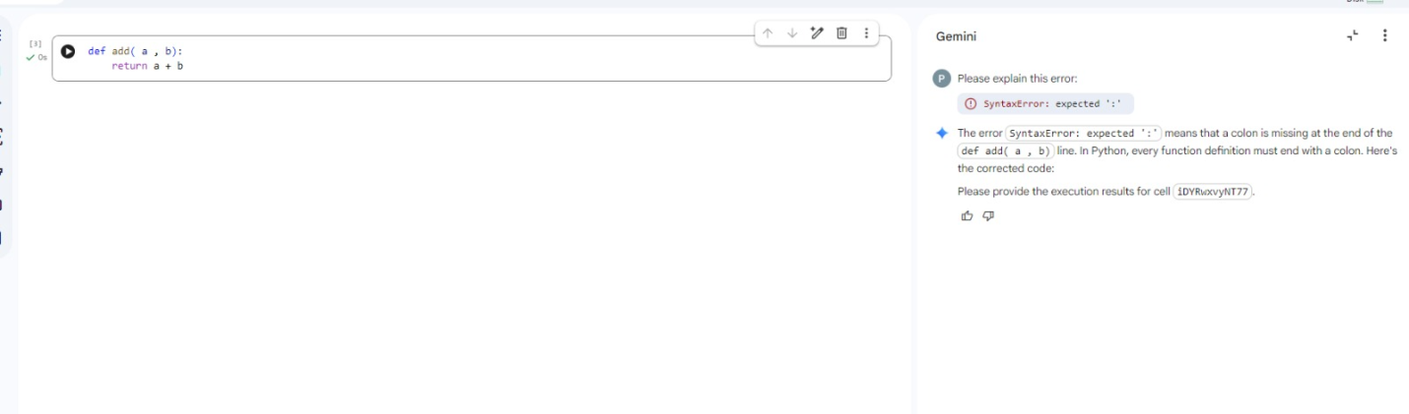

Task 2 :

Introduce Infinite Loop

Subtask:
Identify the count_down function as the example of an infinite loop to be analyzed.

Identify the count_down function as the example of an infinite loop to be analyzed.
The count_down function, defined in the cell with ID jnKJjf7TQjtt, is an example of an infinite loop. The loop condition is while n >= 0, and inside the loop, the value of n is incremented by n += 1. If n starts as a non-negative number, it will always remain non-negative, causing the loop to run indefinitely. This function will be the focus for demonstrating and correcting infinite loops in the subsequent steps.

Identify the count_down function as the example of an infinite loop to be analyzed.
The count_down function, defined in the cell with ID jnKJjf7TQjtt, is an example of an infinite loop. The loop condition is while n >= 0, and inside the loop, the value of n is incremented by n += 1. If n starts as a non-negative number, it will always remain non-negative, causing the loop to run indefinitely. This function will be the focus for demonstrating and correcting infinite loops in the subsequent steps.

keyboard_arrow_down

Identify Cause of Infinite Loop

Subtask:
Analyze the provided count_down function to explain why it results in an infinite loop, specifically pointing out the incorrect increment/decrement logic.

The count_down function, as currently defined:
def count_down(n):
while n >=0:
print(n)
n += 1
contains an infinite loop. The problematic line of code is n += 1.
The while n >= 0: loop condition is intended to continue as long as n is greater than or equal to 0. However, inside the loop, the line n += 1 increments the value of n by 1 in each iteration. If n starts as a non-negative number (e.g., 0, 1, 2, ...), incrementing it will always keep it non-negative. This means the condition n >= 0 will always remain true, and n will never become less than 0, causing the loop to run indefinitely without ever terminating.

keyboard_arrow_down

Fix Loop Logic

Subtask:
Modify the count_down function to correct the increment/decrement logic, ensuring the loop terminates as expected.

Reasoning: The subtask requires modifying the count_down function to correct its logic. I will change the increment operation to a decrement operation to ensure the loop terminates as expected.
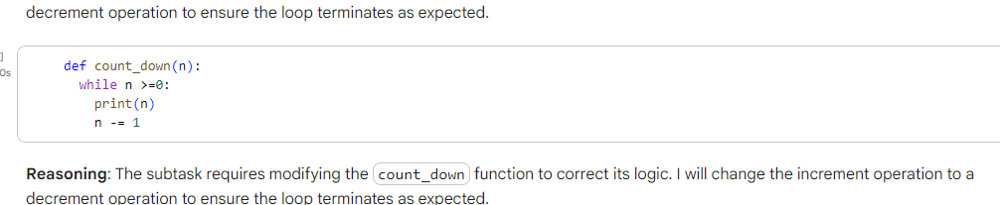
The count_down function has been corrected by changing n += 1 to n -= 1. With this modification, the value of n will now decrease in each iteration. This ensures that eventually n will become less than 0, making the condition n >= 0 false and terminating the while loop. For example, if n starts at 5, it will print 5, 4, 3, 2, 1, 0 and then terminate, successfully counting down as intended.

Analyze Corrected Loop Behavior

Subtask:
Describe the behavior of the corrected count_down function, explaining how it now properly decrements and terminates.

The corrected count_down function now properly decrements and terminates. The change from n += 1 to n -= 1 within the while n >= 0: loop is crucial.

How it Works:
- Initialization: The function starts with an initial value n.
- Loop Condition: The while n >= 0 condition checks if n is greater than or equal to 0.
- Decrement: Inside the loop, n -= 1 decreases the value of n by 1 in each iteration.
- Termination: As n continuously decreases, it will eventually become a negative number (e.g., -1, -2, etc.). Once n becomes less than 0, the condition n >= 0 evaluates to False, and the while loop naturally terminates.
This ensures that the function counts down from the initial value of n to 0, printing each number, and then stops, preventing an infinite loop.

Example Execution:
Let's consider calling the function with count_down(5):
count_down(5)
# Expected output:
# 5
# 4
# 3
# 2
# 1
# 0
In this example, n starts at 5, is printed, and then decremented. This process repeats until n becomes -1, at which point the loop condition n >= 0 is no longer met, and the function finishes execution.
addCode
addText

Task 3 :
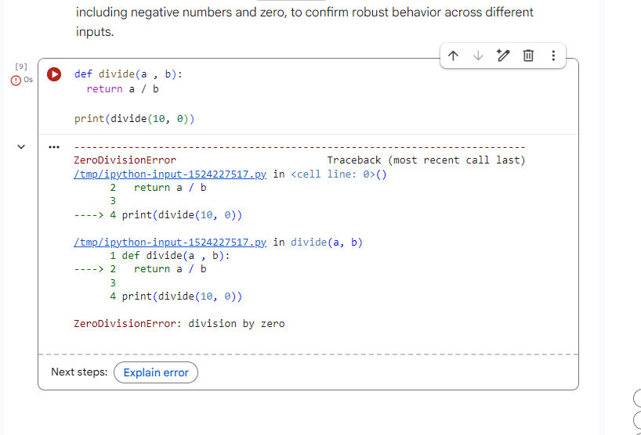

Introduce Division Function

Subtask:
Review the divide function and its execution with a zero divisor, observing the ZeroDivisionError.

The divide function is defined as follows:
def divide(a , b):
return a / b
This function is designed to perform division. However, a critical issue arises when the divisor b is zero, as demonstrated by the execution of print(divide(10, 0)). In mathematics, division by zero is undefined, and in Python, this operation explicitly raises a ZeroDivisionError.
The traceback shows:
ZeroDivisionError Traceback (most recent call last)
... (details of traceback)
ZeroDivisionError: division by zero
This ZeroDivisionError clearly indicates that the program attempted an invalid arithmetic operation, which caused the execution to halt. This scenario highlights the importance of handling potential division by zero errors in robust code.

keyboard_arrow_down

Identify Runtime Error

Subtask:
Analyze the execution of the divide function with a zero divisor to explain the ZeroDivisionError and its cause.

The execution of divide(10, 0) in the previous step resulted in a ZeroDivisionError.

1. Traceback and Error Message
The traceback clearly points to the line return a / b within the divide function as the source of the error. The error message ZeroDivisionError: division by zero explicitly states the problem.

2. Exact Line of Code
The ZeroDivisionError occurred on the line:
return a / b
specifically when b was 0.

3. Explanation of the Error
Mathematically, division by zero is undefined. In computing, attempting to divide any number by zero is an invalid operation. Python, like many programming languages, does not allow this operation and raises a ZeroDivisionError to indicate that an attempt was made to divide by zero.

4. Consequence of the Error
When a ZeroDivisionError occurs and is not handled (e.g., with a try-except block), it causes the program to terminate abruptly, or "crash." The execution stops at the point of the error, and any subsequent code in that execution path is not run, as demonstrated by the traceback that marked the cell as executed with an error.

Implement Error Handling

Subtask:
Modify the divide function to include a try-except block to gracefully handle the ZeroDivisionError. Provide the corrected code.

Reasoning: The subtask requires modifying the divide function to include error handling for ZeroDivisionError. I will define the function with a try-except block and then call it with an input that would trigger the error to demonstrate its graceful handling.
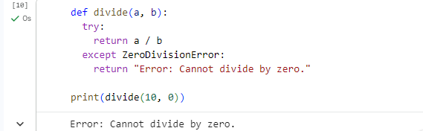

Analyze Error Handling

Subtask:
Describe how the try-except block in the corrected divide function prevents the program from crashing, explaining the role of try, except ZeroDivisionError, and the message returned in case of an error.

The corrected divide function now includes a try-except block to gracefully handle the ZeroDivisionError, preventing the program from crashing.
def divide(a, b):
try:
return a / b
except ZeroDivisionError:
return "Error: Cannot divide by zero."

Explanation of the try-except block:
- The try block: This block encloses the code that is likely to raise an error. In this case, return a / b is placed inside the try block because division by zero (when b is 0) will cause a ZeroDivisionError. If no error occurs within the try block, the code executes normally, and the except block is skipped.
- The except ZeroDivisionError: block: This block is designed to catch and handle a specific type of error – the ZeroDivisionError. If the code within the try block raises a ZeroDivisionError, the program's execution immediately jumps to this except block, and the code inside it is executed. By specifying ZeroDivisionError, we ensure that only this particular error is caught, while other types of errors would still cause the program to crash (unless handled by other except blocks).
- Execution flow when ZeroDivisionError occurs: When divide(10, 0) is called:
  - The try block attempts to execute return a / b.
  - Since b is 0, a ZeroDivisionError is raised.
  - Instead of crashing, the Python interpreter looks for an except block that can handle ZeroDivisionError.
  - It finds except ZeroDivisionError: and executes the code within it.
- Returning "Error: Cannot divide by zero.": Inside the except block, the function return "Error: Cannot divide by zero." is executed. This is crucial because:
  - It provides a user-friendly message explaining what went wrong, rather than displaying a cryptic traceback.
  - It allows the program to continue execution after the function call, rather than terminating abruptly. The calling code can then check the return value and act accordingly, making the application more robust and user-friendly.

The corrected divide function now includes a try-except block to gracefully handle the ZeroDivisionError, preventing the program from crashing.
def divide(a, b):
try:
return a / b
except ZeroDivisionError:
return "Error: Cannot divide by zero."
Task 4 :

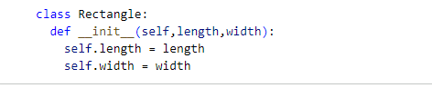

Identify Class Definition Error

Subtask:
Explain the error in the __init__ method of the Rectangle class, specifically addressing the missing self parameter.

The current Rectangle class definition is:
class Rectangle:
def __init__(length,width):
self.length = length
self.width = width
When attempting to create an instance of Rectangle, such as rect = Rectangle(10, 5), Python will raise a TypeError. The error message will typically indicate that __init__ is called with too few arguments, or that length is not an instance of the class.

Cause of the Error:
The primary issue is the omission of the self parameter as the first argument in the __init__ method signature: def __init__(length, width):.
In Python, self is a convention used to refer to the instance of the class that is being created or on which a method is being called. It is implicitly passed as the first argument to all instance methods. Without self, the length parameter is incorrectly interpreted as the instance itself, and width becomes the length argument you intended to pass. Consequently, self.length = length fails because self is not defined in the scope of the method in the way Python expects for instance attributes.

Task 5 :
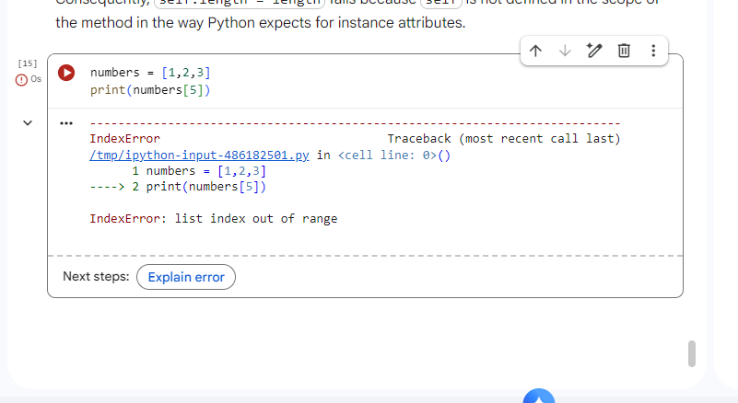

Identify IndexError

Subtask:
Analyze the traceback and error message for the IndexError, explaining why it occurs when an out-of-range index is accessed.

keyboard_arrow_down

Introduce IndexError

Subtask:
Provide a Python code snippet that defines a list and then attempts to access an index that is out of its bounds, triggering an IndexError.

The code in cell Oy_y42WoV5mC:
numbers = [1,2,3]
print(numbers[5])
already defines a list numbers and attempts to access an index (5) that is out of its bounds, as the list only contains elements at indices 0, 1, and 2. Executing this cell clearly triggers an IndexError, which directly addresses the subtask's requirement to demonstrate this type of error.

1. Traceback and Error Message
The traceback clearly indicates the error occurred at print(numbers[5]) and the specific error message is IndexError: list index out of range.

2. Explanation of the Error
- List Definition: The list numbers is defined as [1, 2, 3].
- List Length and Valid Indices: This list has a length of 3. In Python, list indices are zero-based, meaning the valid indices for this list are:
  - 0 (for the element 1)
  - 1 (for the element 2)
  - 2 (for the element 3)
- Out-of-Range Access: The code attempts to access numbers[5]. Since 5 is outside the valid range of indices (0, 1, 2), Python raises an IndexError. This error occurs because there is no element at index 5 in the numbers list, and the program cannot fulfill the request to retrieve an element from a non-existent position.

keyboard_arrow_down

Implement Safe List Access

Subtask:
Modify the code to safely access list elements by either performing bounds checking (e.g., using an if condition) or implementing exception handling (e.g., using a try-except block) to prevent an IndexError.

Reasoning: To safely access list elements, I will define a function that utilizes a try-except block to handle potential IndexError exceptions. This function will attempt to retrieve an element at a given index and, if unsuccessful due to an IndexError, will return an informative message instead of crashing. I will then demonstrate both safe and unsafe access scenarios.
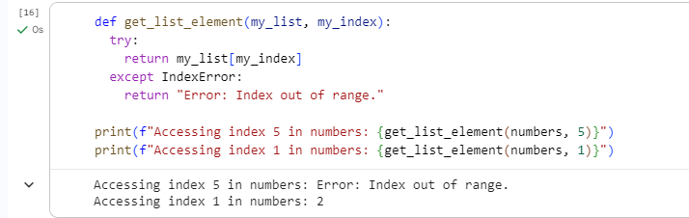

Analyze Corrected Behavior

Subtask:
Explain how the implemented safe access method (bounds checking or exception handling) resolves the IndexError and ensures that list elements are accessed without causing runtime errors.

The get_list_element function, as implemented using a try-except block, effectively resolves the IndexError and ensures safe access to list elements.
def get_list_element(my_list, my_index):
try:
return my_list[my_index]
except IndexError:
return "Error: Index out of range."

How the try-except block works:
- The try block: This block contains the code that might raise an exception. In this case, return my_list[my_index] is placed inside the try block. This is where the attempt to access a list element by its index occurs. If the index is valid, the element is returned, and the except block is skipped. If the index is invalid (out of range), an IndexError will be raised here.
- The except IndexError: block: This block is specifically designed to catch an IndexError. When my_list[my_index] in the try block raises an IndexError (because my_index is out of bounds), Python's execution flow immediately jumps to this except block. The code inside this block is then executed.
- Returned Message: Instead of crashing the program with a traceback, the except block executes return "Error: Index out of range.". This provides a clear, user-friendly message indicating that the requested index was invalid. This makes the program more robust and user-friendly as it continues to run and provides meaningful feedback, rather than terminating unexpectedly.

