**Article information**

Title: **Restraint Stress in Mice Alters Set of 25 miRNAs Which Regulate Stress- and Depression-Related mRNAs**

Author: **Joanna Solich, Maciej Kuśmider, Agata Faron-Górecka, Paulina Pabian and Marta Dziedzicka‑Wasylewska**

Journal: **International Journal of Molecular Sciences**

**DOI: 10.3390/ijms21249469**

Written code allow to create the bar plot from the data, which was used to create the bar plot below.

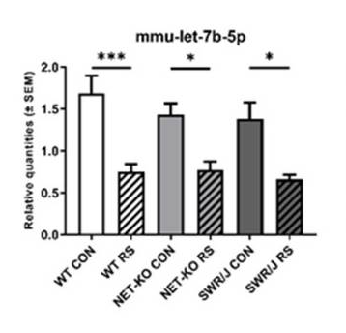

The aim of the experiment was identify the effect of restrain stress (RS) on the expression of miRNAs in mouse serum. For this purpose, the three mice strain was used:

1. Mice C57BL/6J 🡪 named WT on x axis
2. Mice NET-KO 🡪 named NET-KO on x axis
3. Mice SWR/J 🡪 named SWR/J on x axis

To comparison the effect of restrain stress, two group of mice were used:

1. The control group 🡪 named WT CON, NET-KO CON, SWR/J CON on x axis
2. The group submit procedure of restraint stress 🡪 named WT RS, NET-KO RS, SWR/J RS on x axis

On y axis we can see the changing level of expression miRNA (mmu-let-7b-5p) dependent on the mice strain and the submitted procedure.