Agatha Christie

Team work project for Object-Oriented-Programming (OOP) course February 2014

# Team Agatha Christie

## Team members

We are:

|  |  |  |
| --- | --- | --- |
| **Name** | **Username** (from the student system) | **Github user** |
| Ventsislav Kulin | kulin_1987 | Kulin1987 |
| Georgi Georgiev | GeorgievG | SantiagoVedra |
| Martina Petrova | martina.petrova.779 | martinapetrova |
| Diana Dimitrova | didimitrova | didimitrova |
| Dimitar Katarov | chichuMitku | chichuMitku |
| Konstantin Severi | ksevery | ksevery |
| Nikolai Karachorov | specnaz | specnaz222 |

# Project explanation

## Summary

The game is created with Microsoft XNA Game Studio 4.0. It is a classic RPG (role-playing-game). You can play the game with 3 different heroes – Warrior, Mage and Shooter. The hero walks around the map and kill monsters.

## More details

1. The game starts with the **Main menu screen**. The user can **navigate through the menu** with Up and Down arrows and select an item with <Enter>. It has the following options:

* New Game
  + Starts a **new game**.
* Controls
  + Here the user can see the controls which he needs to know to play the game
* High score
  + **Lists the high-scores** in the format <Rang> <User name> <Score> <Date>
* Exit
  + Exits the console.

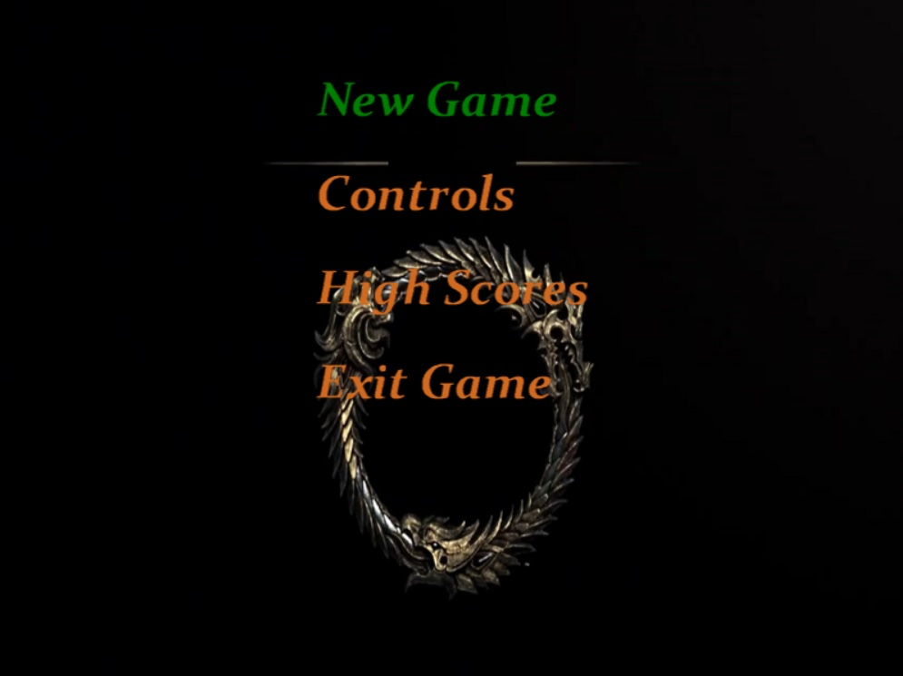

1. The Game

The player can **move Right/Left/Up/Down** with the arrows and **slash (shoot)** with <Space>. When a monster is hit, it brings points to hero experience.

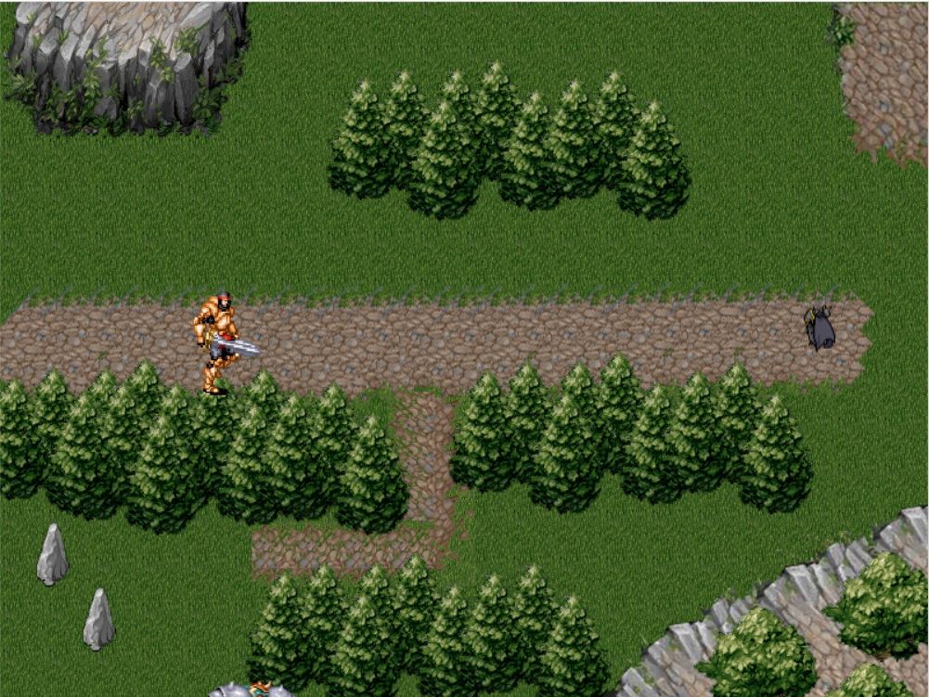

By pressing **Tab** button the user can see the status of a hero:

* Current experience
* Equipped items
* Hero class and level
* Skills



The purpose of the game is to gather more **experience** possible by killing monsters. The game finishes when a monster kills the hero. When the game finishes, the **player’s score is recorded** in the score archive.

# Class diagram

# GitHub Repository

# https://github.com/AgathaCristie/TeamProject.git

# Other information

* N/A