**Test basis**

Test basis is defined as the source of information or the document that is needed to write test cases and also for test analysis.

Test basis should be well defined and adequately structured so that one can easily identify test conditions from which test cases can be derived.

Typical Test Basis:

* Requirement document
* Test Plan
* Codes Repository
* Business Requirement

## What is Test case?

A test case is a document, which has a set of test data, preconditions, expected results and postconditions, developed for a particular test scenario in order to verify compliance against a specific requirement.

Test Case acts as the starting point for the test execution, and after applying a set of input values, the application has a definitive outcome and leaves the system at some end point or also known as execution postcondition.

## Typical Test Case Parameters:

* Test Case ID
* Test Scenario
* Test Case Description
* Test Steps
* Prerequisite
* Test Data
* Expected Result
* Test Parameters
* Actual Result
* Environment Information
* Comments

## What is a Test Suite?

Test suite is a container that has a set of tests which helps testers in executing and reporting the test execution status. It can take any of the three states namely Active, Inprogress and completed.

A Test case can be added to multiple test suites and test plans. After creating a test plan, test suites are created which in turn can have any number of tests.

Test suites are created based on the cycle or based on the scope. It can contain any type of tests, viz - functional or Non-Functional.

## Test Suite - Diagram:

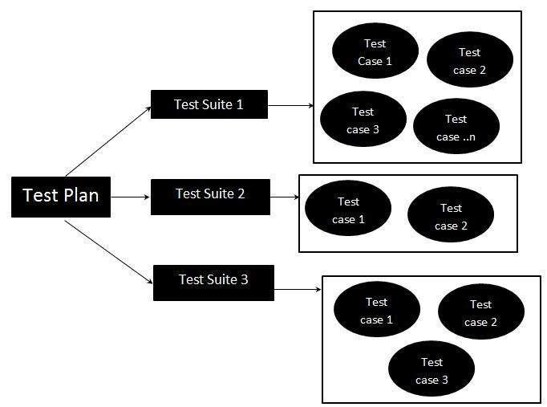

**Test scenario**

* In software development, a scenario is a user journey while using an application or website. A tester job is to find out how people interact with the functionality and what problems they can face.
* A test scenario is a set of manual or automated test cases that helps determine the positive and negative project characteristics. It provides an overview of what needs to be tested by a QA company.
* The main purpose of a test scenario is to check the entire system performance from the end-user point of view. A tester needs to put themselves in a user’s shoes. It gives them a clear idea of actual scenarios the software will have to cope with after release.