**RESUME**

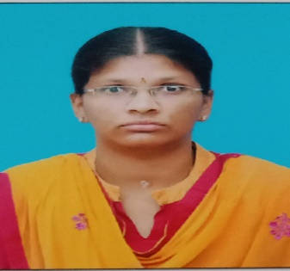

**AGATHIYA.S**

**EmailId**: [agathiya201003@gmail.com](mailto:agathiya201003@gmail.com)

**Mobile:** 9087650862,9442650862.

**Address:** 27, Kasilingampalayam, Mulanoor,

Dharapuram(tk),Tirupur(dt),Tamilnadu.

**Career Objective:**

To work in a innovative and challenging environment extracting the best out me enhancing my professional skills with learning and experience for career growth.

**Academic Profile:**

|  |  |  |  |  |
| --- | --- | --- | --- | --- |
| **Education** | **Institution** | **Board** | **Aggregate** | **Year of passing** |
| BCA. | Navarasam arts and science college for women, Arachalur. | Bharathiar university. | 92.75% | 2024. |
| HSC. | St. Aloysius girls hr sec school,Dharapuram. | State board. | 92% | 2021. |
| SSLC. | St. Aloysius girls hr sec school,Dharapuram. | State board. | 86% | 2019. |

**Skills:**

● Willing to learn and adopt to new opportunities and challenges.

● Highly organized and efficient.

● proven leadership skills and ability to motivate.

**Technical Skills:**

● Certified in Python from ETS Academy in Erode.

● Languages : C, C++, Java, Python.

● Web Technologies : HTML.

● Operating System :windows OS.

**Extra Curricular Activities:**

● Assistant secretary of Navarasam arts and science college for women union council.

**Co Curricular Activities:**

● attended International Webinar on the topic of **BIG DATA** in Navarasam Arts and science college for women,Arachalur.

● presented paper in international conference on the topic of **BIG DATA** in navarasam arts and science college for women,Arachalur.

●attended national seminar in **CAPACITY BUILDING & PERSONALITY** **DEVELOPMENT PROGRAMME** by national commission for women in Navarasam arts and science college for women ,Arachalur.

**Personal Information:**

**DOB :** 20th October 2003.

**Gender :** Female.

**Father’s name :** Senthil Kumar.P

**Mother’s name :** Abirami. S

**Languages known** **:** English(to speak and write),Tamil(to speak and write).

**Hobbies :**Gardening,Cooking.

**Declaration:**

I hereby confirm that all the above information is true to the best of my knowledge and belief. If I have been recruited I will be sincere and dedicated to my job.

Place:Arachalur.

Date:

[Agathiya.S]