CYBERSECURITY LAB ENVIRONMENT SETUP
Building an isolated virtual lab for penetration testing an ethical hacking practice

Project Overview

This project focuses on setting up a virtual cybersecurity and penetration-testing laboratory using VirtualBox and Kali Linux.
The purpose of the lab is to create a controlled environment where cybersecurity tools, network scanning, reconnaissance, vulnerability assessment, and other security-testing activities can be performed safely and repeatedly.
The lab is configured on a private virtual network so that additional machines can be added later and used as targets for authorized security testing.

Project Objectives

The main objectives of this project are to:
- Install and configure VirtualBox.
- Install/import Kali Linux as a virtual machine.
- Create a private NAT Network for the cybersecurity lab.
- Configure network connectivity for Kali Linux.
- Assign a consistent IP address to the Kali VM.
- Verify network connectivity and DNS resolution.
- Take a clean VM snapshot for recovery.
- Document the complete setup process.
- Prepare the environment for future cybersecurity projects.

Purpose of The Lab
The lab provides an isolated and controlled environment for cybersecurity learning and authorized security testing.
It can be used for activities such as:
- Network reconnaissance
- Port scanning
- Vulnerability assessment
- Packet analysis
- Web security testing
- Exploitation practice
- Security-tool experimentation

Lab Structure

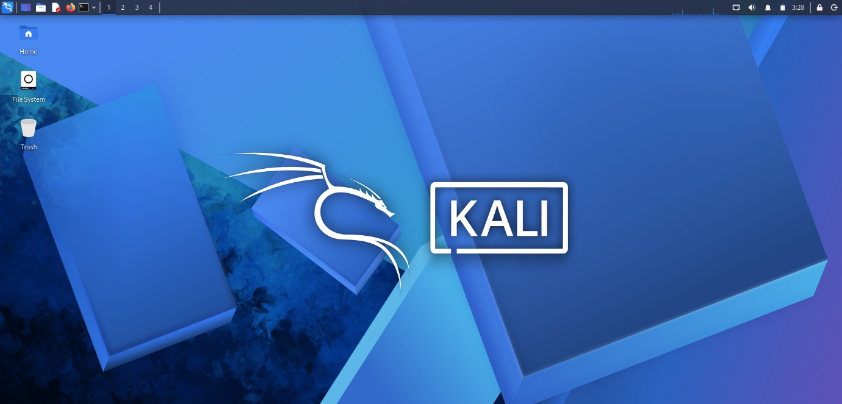

Lab Configuration

Component | Configuration
Host OS | Windows 11
Host RAM | 16 GB
Processor | Intel Core i5
Security OS | Kali Linux 2026.2
Kali RAM | 4048 MB
Virtual Network | NAT Network
Network Address | 10.0.0.0/24
Kali IP Address | 10.0.0.2/24
Default Gateway | 10.0.0.1
DNS Server | 8.8.8.8

Lab Setup Procedure

Step 1. Install 7-Zip
7-Zip was installed to extract the Kali Linux virtual-machine package, which may be distributed as a .7z archive.
Tool: 7-Zip

Step 2. Install VirtualBox
VirtualBox was installed as the hypervisor.

Step 3. Create the NAT Network
A dedicated NAT Network was created in VirtualBox.
Configuration: Network Name: NatNetwork IPv4 Prefix: 10.0.0.0/24 DHCP: Enabled IPv6: Disabled

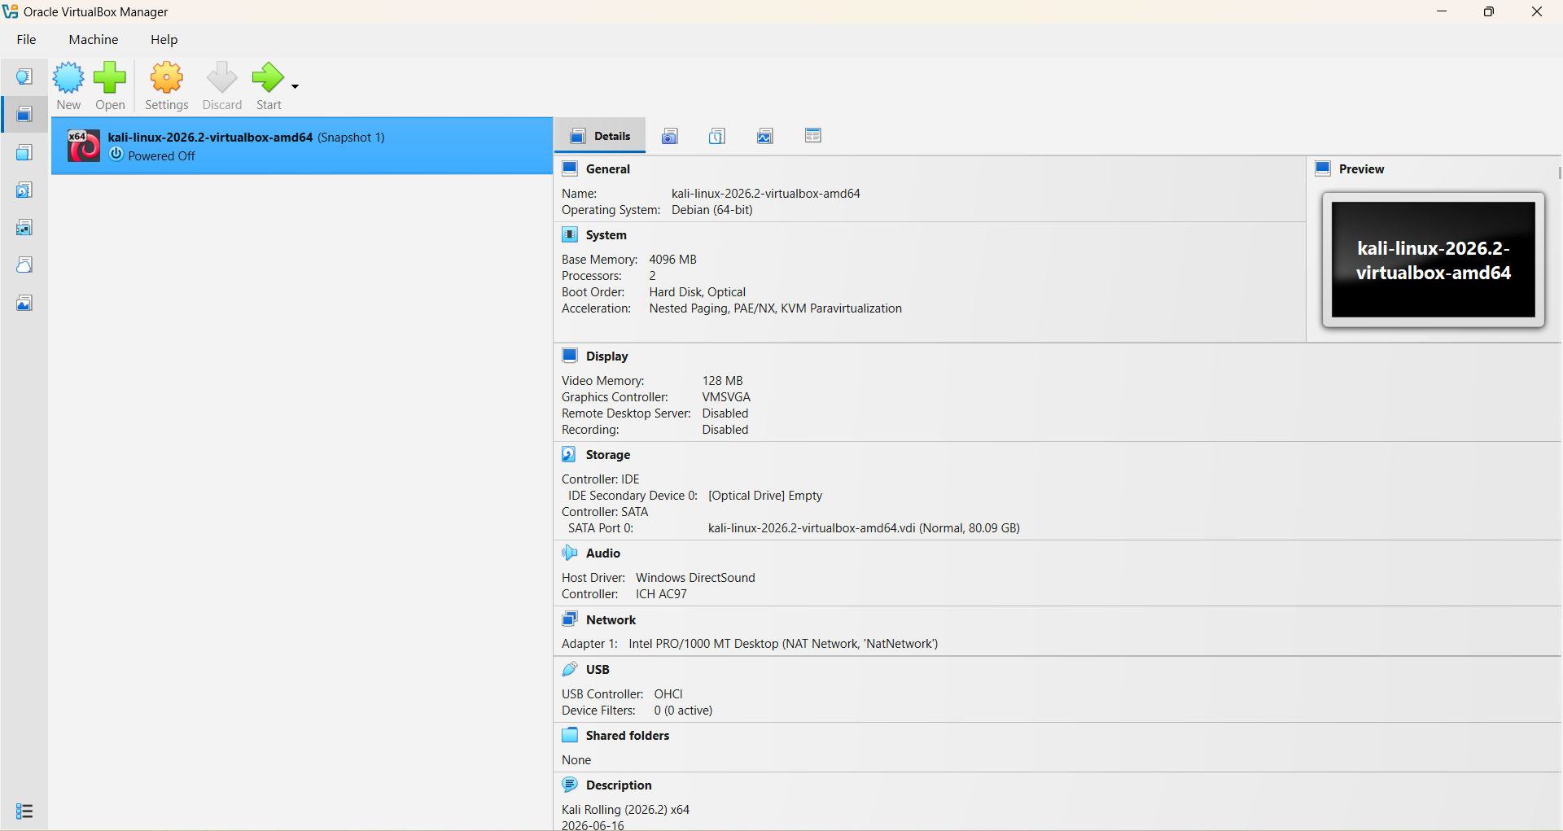
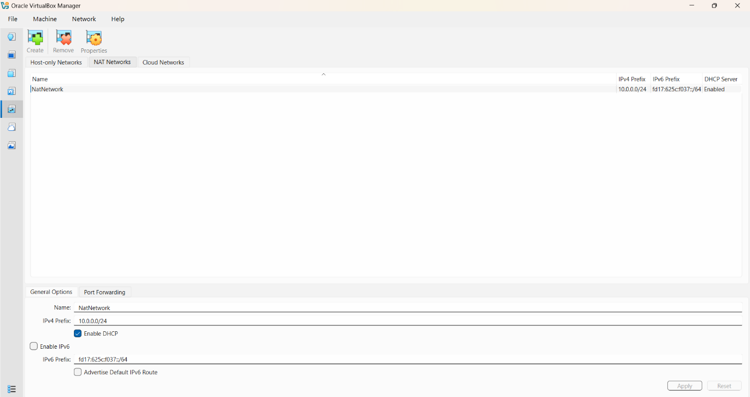

A NAT Network was selected because multiple virtual machines connected to the same NAT Network can communicate with one another while also having outbound network connectivity.
This will allow future attacker and target VMs to communicate within the lab.

Step 4. Import Kali Linux
The Kali Linux virtual machine was downloaded from the official Kali Linux website and imported into VirtualBox.
The VM network adapter was configured as follows:

The VM was allocated:
Step 5. Configure the Kali Linux Network
The Kali Linux network configuration was checked and configured with a consistent IPv4 address.
Example configuration:
A consistent IP address makes it easier to document the lab and reference the Kali machine in future exercises.
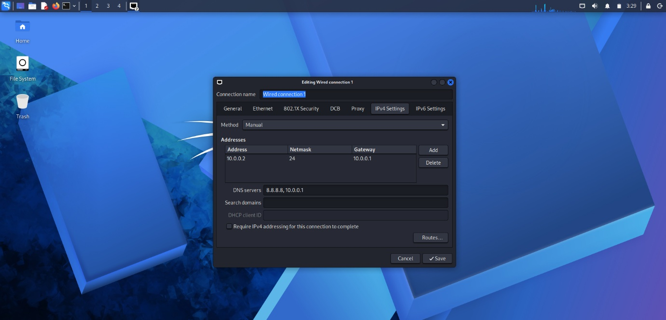

Step 6. Create a Clean VM Snapshot
After completing the initial configuration, a VirtualBox snapshot was created.
Example snapshot name:
The snapshot represents the clean baseline of the laboratory.
If a future exercise changes or damages the VM configuration, the machine can be restored to this baseline.

Lab Verification

Test | Command | Expected Result
Check IP address | ip a | Correct Kali IP displayed
Test gateway | ping 10.0.0.1 | Successful replies
Test Internet connectivity | ping 8.8.8.8 | Successful replies
Verify Nmap | nmap --version | Nmap version displayed
Verify snapshot | Restore snapshot and run ip a | Baseline configuration restored

Example Results

Problems Encountered & Solutions
I Had Problem With Internet Connectivity After Static IP Configuration
After manually configuring the IPv4 settings, my internet connectivity failed.
How I solved it:
I opened the terminal in kali linux and entered the code below:
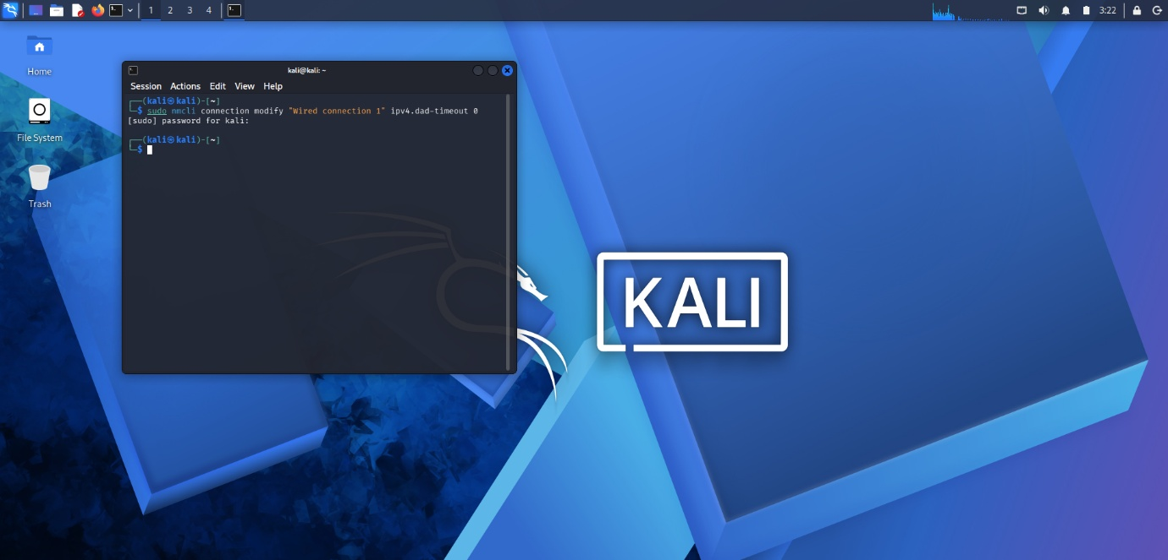
The network connection was then restarted/rebooted and connectivity was tested again.

What I Learned
Through this project, I learned how to create and configure a virtual environment for cybersecurity practice.
The most important concepts I learned include:
1. NAT vs NAT Network
A standard NAT configuration and a NAT Network serve different purposes.
A NAT Network allows multiple VMs connected to the same virtual network to communicate with one another while providing network address translation for external connectivity.
This makes it useful for building a multi-machine cybersecurity laboratory.
2. Static IP Configuration
I learned how to configure and verify IPv4 addressing, subnet masks, gateways, and DNS settings in Kali Linux.
3. VM Snapshots
I learned that a clean snapshot should be created before performing risky or experimental activities.
This provides a known-good recovery point for future cybersecurity exercises.
4. Documentation
I learned that documenting commands, configuration, screenshots, problems, and solutions is an important part of a professional cybersecurity project.

Security & Ethical Use
This laboratory is intended strictly for education purposes only.

Tools & Resources
- 7-Zip: https://7-zip.org/download.html
- VirtualBox: https://virtualbox.org/wiki/Downloads
- Kali Linux: https://kali.org/get-kali
Author
Agbango Nehemiah Awindin
Waqas Karim
Cybersecurity Professional B082
LinkedIn: https://www.linkedin.com/in/waqaskarim/
Project Information
Program Name: Cybersecurity at Networkwalks | Week: 01 | Project: Cybersecurity & Pentesting Lab Setup | Repository: GitHub

