1-bit-graphics

Targets:
1. Allow user to input binary data and output the display to the terminal
2. Use white(0) and black(1) blocks
3. Disallow invalid blocks
4. Display input chunk-by-chunk

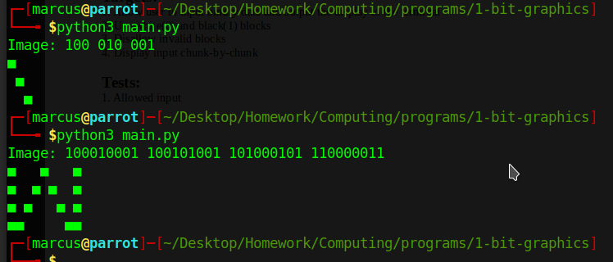
Tests:
1. Allowed input

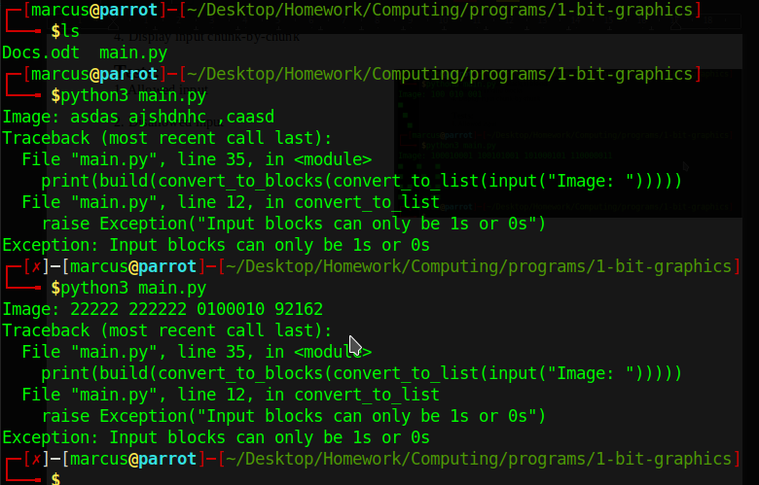
2. Disallowed input

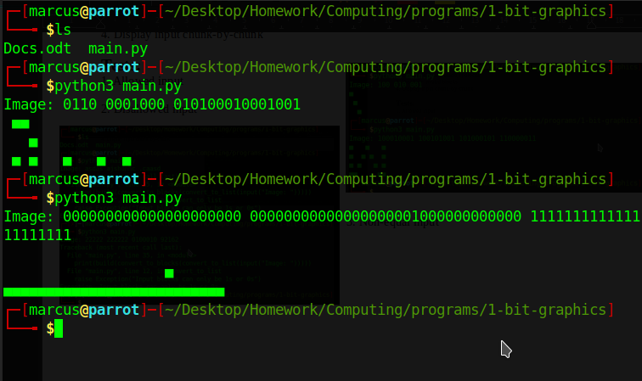
3. Non-equal input

Conclusion:

The program works as intended, all tests concluded with expected, and intended output. Possible improvements include: a command line interface, more colours, text input, multiple grids

