University:Multimedia University of Kenya

Student : Agengo Fredrick Otieno

Registration number : CIT-227-102/2024

Unit : Foundations of AI

Unit code: CCS 2226

Lecturer : Mr. Patrick Mokodir

Question One (15 marks)
- Describe the concept of Search indicating major differences between informed search and uninformed search

Search is the process of exploring a problem space to find a sequence of actions that leads from an initial state to a goal state.

Informed Search Uses domain-specific knowledge to estimate the distance to the goal focusing on the most promising paths while Uninformed Search Operates without any domain-specific knowledge about the goal’s location or cost .it explores the state space systematically according to predefined, fixed rules, often making it more computationally expensive for complex problems.
b) Write a program in python to implement A* Search Strategy that optimizes the path resources.
Import heapq

Def a_star_search(graph, heuristic, start, goal):
Open_list = []
Heapq.heappush(open_list, (0 + heuristic[start], 0, start, [start]))
Visited = set()

While open_list:
F, g, node, path = heapq.heappop(open_list)

If node == goal:
Return path, g

If node in visited:
Continue
Visited.add(node)

For neighbor, cost in graph.get(node, []):
If neighbor not in visited:
New_g = g + cost
New_f = new_g + heuristic[neighbor]
Heapq.heappush(open_list, (new_f, new_g, neighbor, path + [neighbor]))
Return None, float(‘inf’)
Graph = {
‘A’: [(‘B’, 1), (‘C’, 4)],
‘B’: [(‘D’, 2), (‘E’, 5)],
‘C’: [(‘F’, 3)],
‘D’: [(‘G’, 2)],
‘E’: [(‘G’, 1)],
‘F’: [(‘G’, 2)],
‘G’: []
}
Heuristic = {
‘A’: 7,
‘B’: 6,
‘C’: 2,
‘D’: 1,
‘E’: 2,
‘F’: 1,
‘G’: 0
}
Path, cost = a_star_search(graph, heuristic, ‘A’, ‘G’)
Print(“Shortest path:”, path)
Print(“Total cost:”, cost)

c) (i)Distinguish the following concepts: valid, satisfiable, unsatisfiable and falsible.
- valid - true under every possible assignment of truth values.
- satisfiable -true under at least one assignment.
- unsatisfiable -false under every assignment.
- falsible - false under at least one assignment.

- (ii)Using Truth Tables describe where the following formulae are valid, satisfiable, unsatisfiable, or falsible. Indicate under what conditions will each Be attained.
P^Q →┐R

The formula is not valid, because it is false for [P=T, Q=T, R=T].
The formula is satisfiable, because it is true in many cases, such as [P=T, Q=T, R=F].
The formula is falsible, because it is false in at least one case.
It is not unsatisfiable, because it is true in some cases.
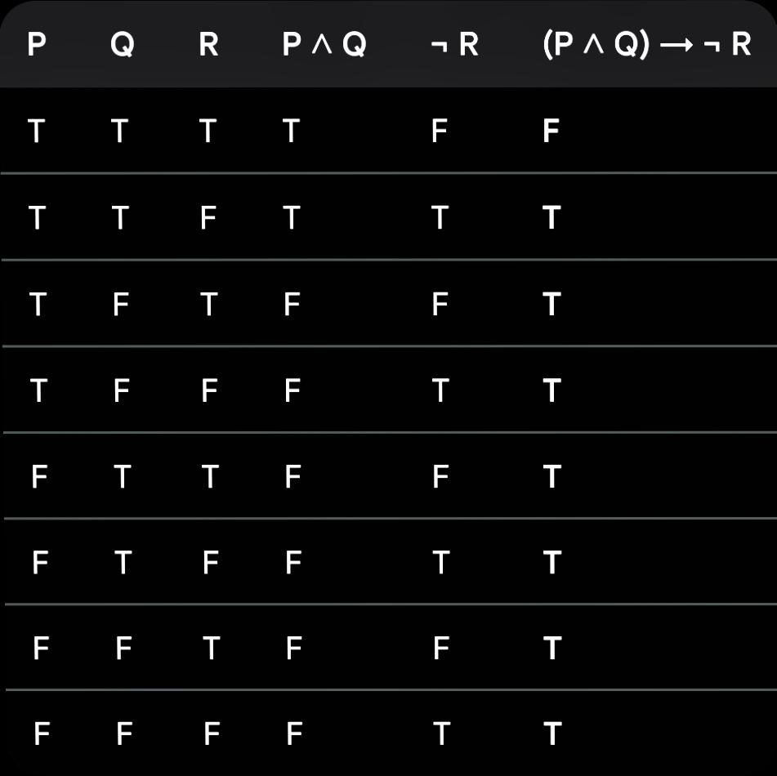

Question Two (10 marks)
- The Ministry of Health in consultation with the Ministry of Interior have asked MMU Artificial Intelligence Institute to develop agent to automate DNA and Genomic Sequencing of all Shakahola victims for faster identification based on samples harvested from corpses and their relatives. You are to come with the PEAS and PAGE of the system. Outline possible PEAS and PAGE elements of the Automatic DNA and Genomic Sequencing System.
For an intelligent agent, PEAS :
- Performance -High accuracy of DNA matching, fast processing time, low error rate, correct identification of victims, secure handling of data.
- Environment -Corpses, relatives of victims, laboratory samples, DNA database, forensic lab, hospitals, police/medical records.
- Actuators- Robotic sample handlers, DNA extraction machines, sequencing machines, database update system, alerts/reports generation system.
- Sensors - DNA sample scanners, image sensors, biochemical sensors, barcode readers, database input interfaces.

PAGE
- Perception- collects samples from corpses and relatives.
- Analysis- extracts DNA, amplifies it, and sequences it.
- Generation of result- compares sequences and identifies matches.
- Execution - outputs reports, stores results, and alerts authorities.

- Design and implement a simple Vacuum cleaner agent that cleans the various locations satisfactorily. Clearly comment your work.

Def vacuum_agent(location, status):
# If the current square is dirty, clean it
If status == “Dirty”:
Return “Suck”

# If current square is clean, move to the other square
If location == “A”:
Return “Move Right”
Elif location == “B”:
Return “Move Left”

Return “No Action”

# Test cases
Print(vacuum_agent(“A”, “Dirty”)) # Suck
Print(vacuum_agent(“A”, “Clean”)) # Move Right
Print(vacuum_agent(“B”, “Dirty”)) # Suck
Print(vacuum_agent(“B”, “Clean”)) # Move Left

