
Functional Specification Document
Version [1.0.0]

Sample Result GVN-SHP Integration / Analytical Central
Modul: SHP Integration

Prepared By
[Tim IT Digital Solution]

PT. Sanghiang Perkasa

Date
[22/07/2026]
BRD No : 2026.GVNSHP-BRD.001 |  |  |  | PID Ref. No : 2026.GVNSHP-PID.001
Revision history
Version | Date |  | Author(s) |  | Description
1.0.0 | 22 Juli 2026 |  | Tim IT Digital Solution |  | Initial Document — proses otoritatif mockup + flowapps
Document Approval
Full name |  | Job Title |  |  |  | Signature | Signature Date
Hendi Hendrasta |  | IT Digital Solution
Debby Tantika Ardi |  | IT Digital Solution
Cut Shafira Salsabila |  | Project Management
Andreas Kurnijanto |  | Project Management Lead

Daftar Isi
FUNCTIONAL SPECIFICATION DOCUMENT (FSD) 1
Modul: KICAO KDS Enhancement — Master ASS/Owner KMMD & Form Klaim 1
Sistem: KICAO KDS (Kalbe Nutritionals — Claim & Distribution System) 1
Versi Dokumen: 1.0 1
Riwayat Revisi 1
1. Pendahuluan 4
1.1 Latar Belakang 4
1.2 Tujuan Dokumen 4
1.3 Ruang Lingkup 5
1.4 Stakeholder 5
1.5 Glosarium 5
2. Ringkasan Business Flow End-to-End 6
2.1 Konteks Posisi Modul dalam Ekosistem KICAO KDS 6
2.2 Flow Diagram — Proses End-to-End Enhancement 7
2.3 Status Dokumen Klaim (Enhancement) 9
2.4 Status Dokumen Master ASS/Owner 9
3. Master — Halaman ASS/Owner KMMD 9
3.1 Content Header & Toolbar 10
3.2 Box Header Dokumen 11
3.3 Box Mapping Owner KMMD & ASS 12
3.4 Box Riwayat Perubahan 14
3.5 Business Rules Index Master 15
4. Master — LOV & Modal 15
4.1 LOV Group Account 15
4.2 LOV Supplier 15
4.3 LOV Find (Cari Mapping) 16
4.4 Pesan Validasi & Error Master 16
5. Klaim — Halaman Form (Header) 16
5.1 Toolbar Actions 17
5.2 Section Header Form 18
5.3 Banner & Kontrol Khusus 20
6. Klaim — Grid Detail (28 Kolom) 20
6.1 Daftar Kolom Grid Detail (Urutan Kiri ke Kanan) 20
6.2 Rumus Kalkulasi per Baris 22
6.3 Kondisi Edit Kolom Payment 22
6.4 CRUD — Grid Detail 23
6.5 Validasi per Baris Detail (Save/Submit) 23
7. Klaim — Fitur Enhancement 23
7.1 Kolom Payment & DPP+PPN 23
7.2 E-Materai 24
7.3 Validasi Silang PPN ↔ Faktur Pajak 25
7.4 BosNet Period Quartal 25
7.5 Approval Eksternal OTP 26
8. Aturan Bisnis (Business Rules) 29
8.1 Aturan Bisnis — Master ASS/Owner KMMD (BR-M) 29
8.2 Aturan Bisnis — Form Klaim (BR-K) 31
8.3 Aturan Bisnis — Enhancement & Integrasi (BR-X) 31
9. Hak Akses & Peran Pengguna (RBAC) 32
9.1 Daftar Role Sistem 32
9.2 Matrix Permission — Master ASS/Owner 32
9.3 Matrix Permission — Form Klaim 32
9.4 Matrix Akses Field per Role & Status — Form Klaim 32
9.5 Filter Find per Role 33
10. Alur Persetujuan (Approval Flow) 33
10.1 Diagram Approval Workflow Enhancement 33
10.2 Tabel Langkah Approval 33
10.3 Handler Workflow (In-App) 34
10.4 Riwayat Approval (Approval History) 34
10.5 Notifikasi (Rencana Production) 34
10.6 Perbandingan dengan Production (Falcon SKP) 34
11. Integrasi Master ASS/Owner ke Form Klaim 35
11.1 Diagram Integrasi Master → Klaim 35
11.2 API Lookup Prototype 35
11.3 Contoh Alur Integrasi 35
11.4 Ketergantungan Data 35
11.5 Rekomendasi API Production 36
12. Struktur Database & ERD 36
12.1 Tabel Utama — Master ASS/Owner (Rekomendasi Production) 36
12.2 Tabel Utama — Klaim (Existing + Enhancement) 36
12.3 Kolom Enhancement pada XXSHP_KDS_T_KLAIM_DTL 36
12.4 Combined Entity Relationship Diagram 37
12.5 Storage Prototype (localStorage / sessionStorage) 38
12.6 Seed Data Master (Prototype) 38
13. Appendix — Gap Analysis & Skenario UAT 39
13.1 Gap Analysis — BRD vs Prototype vs Produksi 39
13.2 Mapping Status Legacy → Enhancement 39
13.3 LOV Form Klaim — Ringkasan 39
13.4 Kriteria Penerimaan UAT — Master ASS/Owner 40
13.5 Kriteria Penerimaan UAT — Form Klaim Enhancement 41
13.6 Skenario Uji End-to-End 42
13.7 Keterbatasan Prototype 42
13.8 File Source Prototype 43
13.9 Production Reference (Repo KICAO KDS) 43

1. Pendahuluan

1.1 Latar Belakang
Analytical Central (KNAC) adalah portal laboratorium Kalbe Nutritionals / PT Sanghiang Perkasa untuk request analisa, review, COA, dan sinkronisasi ke Oracle SHP. Inisiatif Sample Result GVN-SHP Integration memperluas kemampuan KNAC agar pertukaran data lab tersambung ke Oracle SHP dan Oracle GVN: mulai create sample request, get specification, generate sample paralel, penarikan hasil dari OSIR, hingga sync result ke GVN.
Pada kondisi as-is, codebase analyticalcentralwebsite sudah memiliki workflow request dan sync staging SHP saat approval. Integrasi Get Spec / Generate Sample GVN / Input Result belum diimplementasi. Mockup CMS di Mockup_AnalyticalCentral dan narasi flowapps.txt menjadi acuan UI dan alur to-be untuk FSD ini.

1.2 Tujuan Dokumen
- Mendeskripsikan fungsionalitas UI modul Transaction Sample GVN dan Result Sample GVN berdasarkan mockup.
- Menjadi acuan pengembangan dan UAT untuk integrasi SHP/GVN.
- Mendokumentasikan business rules, status workflow, RBAC (inferred), disposisi Sync, serta model data konseptual.
- Mencatat gap BRD vs mockup/flowapps agar keputusan stakeholder tersurat.

1.3 Ruang Lingkup
Dalam lingkup | Di luar lingkup
Create / Edit / Submit Sample Request (Retest, Spec GVN, Manual) | Eksekusi analisa lab di aplikasi OSIR
Generate Sample ke Oracle SHP (± GVN) setelah Submit | Full rebuild master data Oracle SHP/GVN
List, Create, Edit, Sync Result Sample GVN | Fitur Master User & Total Capability (CMS existing / pelengkap mockup)
Status board, Status History, Parameter & Sample tab | BRD proyek lain (brd_text.txt Formulation Revamp)
Aturan numbering sample GVN-MN…, mutual exclusion Retest↔Spec | Hangfire / background job retry (keputusan terpisah)
Tabel 1.3.1 — Dalam lingkup

1.4 Stakeholder
Peran | Tim/Divisi | Keterlibatan
Document Approver | IT Digital Solution | Review & approval FSD (Hendi Hendrasta, Debby Tantika Ardi)
Document Approver | Project Management | Review & approval FSD (Cut Shafira Salsabila, Andreas Kurnijanto)
Requestor / Sampler | Lab / Business | Create request, submit, view result
Lab Admin | Analytical Central Admin | Monitor request, pull/map result, Sync
System Integrator | IT | Integrasi Oracle SHP, Oracle GVN, KN Global
Client | Eksternal / internal | > [TBD] — alur Client Approved ada di BRD, tidak di mockup
Tabel 1.4.1 — Peran

1.5 Sumber Kebenaran & Konvensi
Prioritas | Sumber
1 | Mockup HTML/JS: Mockup_AnalyticalCentral/*.html
2 | Documentation/flowapps.txt
3 | Documentation/BRD - GVN-SHP Integration.md (numbering, mutual exclusion, gap notes)
4 | Codebase as-is analyticalcentralwebsite (pola modul, role existing)
5 | Studi Analisis Documentation/Studi Analisis - GVN-SHP Integration.md
Tabel 1.5.1 — Prioritas
Field tanpa id/name di HTML ditulis sebagai > **[TBD]**. Handler tombol mengikuti nama fungsi JS mockup.

1.6 Istilah Singkat
Lihat Bab 9 — Glosarium untuk daftar lengkap (KNAC, SHP, GVN, OSIR, Syncronized, FGDUM001).

2. Ringkasan Business Flow
Alur to-be (otoritatif mockup + flowapps) berlangsung dalam lima fase. User membuat Sample Request di KNAC dengan salah satu basis: Retest, Get Spec (Spec GVN), atau Manual. Setelah data lengkap, user Submit Request. Sistem kemudian Generate Sample: jika Retest = No → Oracle SHP dan Oracle GVN; jika Retest = Yes → hanya Oracle SHP. Analisa lab berjalan di OSIR (di luar KNAC). Setelah hasil tersedia, user membuka menu Result Sample GVN, memetakan Sample SHP ↔ Sample GVN, lalu Sync (SYNC = YES) untuk Input Result ke Oracle GVN dengan Sample No. SHP sebagai source; atau berhenti di KNAC jika tidak di-Sync.
Gap BRD: BRD memicu generate setelah Client Approved, disposisi OK / NOT OK + auto-retest, serta Notify Sampler dan Failed Integration. Fitur tersebut belum ada di mockup/flowapps — dicatat di Bab 5 & 9 sebagai [TBD].

2.1 Lane Swimlane — Business Flow End-to-End
Lane (urutan kiri → kanan):
# | Lane ID | Label | Tipe | Sumber
1 | L1 | Requestor / Sampler | User | flowapps.txt Fase 1–2; mockup create
2 | L2 | Analytical Central (KNAC) | System | flowapps.txt Fase 2–3, 5
3 | L3 | Oracle SHP / GVN | ERP / Integrasi | flowapps.txt Fase 3, 5; BRD §2
4 | L4 | OSIR Lab | External | flowapps.txt Fase 4

2.2 Swimlane — Alur Sample Request hingga Result Sync
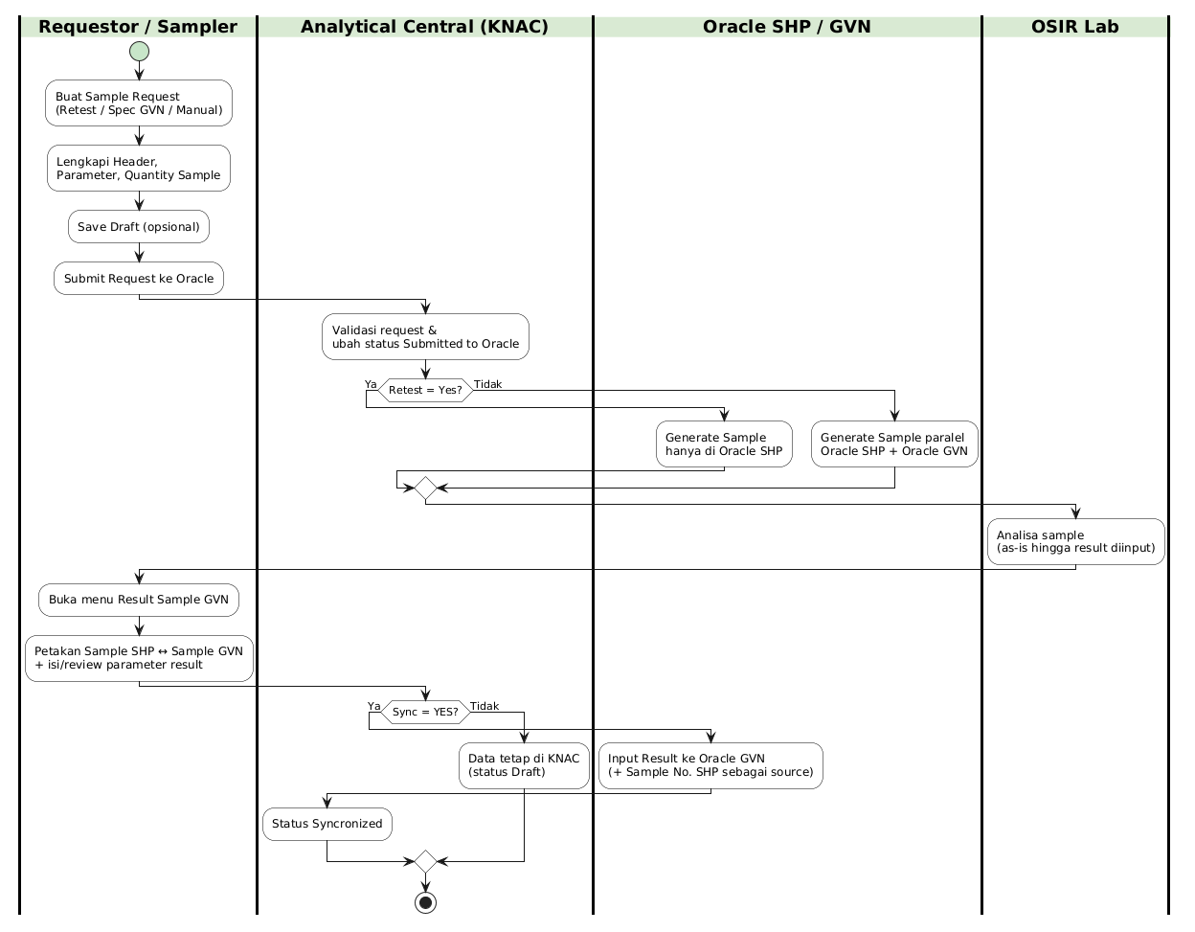
Swimlane – Business Flow Sample Result GVN-SHP
Gambar 2.1 — Swimlane – Business Flow Sample Result GVN-SHP
Hand-off antar lane:
- Requestor → KNAC: Submit Request menyimpan data dan memicu generate.
- KNAC → Oracle: Generate Sample SHP (± GVN) sesuai flag Retest.
- Oracle/OSIR → Requestor: Hasil lab tersedia untuk ditarik di menu Result (tanpa UI OSIR di KNAC).
- Requestor → KNAC → Oracle GVN: Sync Result mengirim hasil terpetakan.

2.3 Ringkasan Status Request (Mockup)
Kode Status | Label | Transisi
New | New | Saat buka form create
Draft | Draft | Setelah saveData()
Submitted to Oracle | Submitted to Oracle | Setelah submitRequest() sukses
Tabel 2.3.1 — Kode Status

2.4 Ringkasan Status Result (Mockup)
Kode Status | Label | Transisi
Draft | Draft | Create / Save result
Syncronized | Syncronized | Setelah syncResult() sukses
Tabel 2.4.1 — Kode Status

3. Transaction Sample GVN
Modul Transaction Sample GVN mencakup daftar request, form create, dan halaman detail. Sumber UI: transaction_cms.html, request_create_cms.html, request_detail_cms.html. Navigasi sidebar: Transaction → Transaction Sample GVN (assets/js/sidebar.js).

3.1 Dashboard List — Transaction Sample GVN
Halaman list menampilkan kartu ringkasan (Total / Draft / Submitted to Oracle) dan tabel request. Klik kartu memanggil filterTable dengan teks status.
Tampilan Halaman List Transaction:
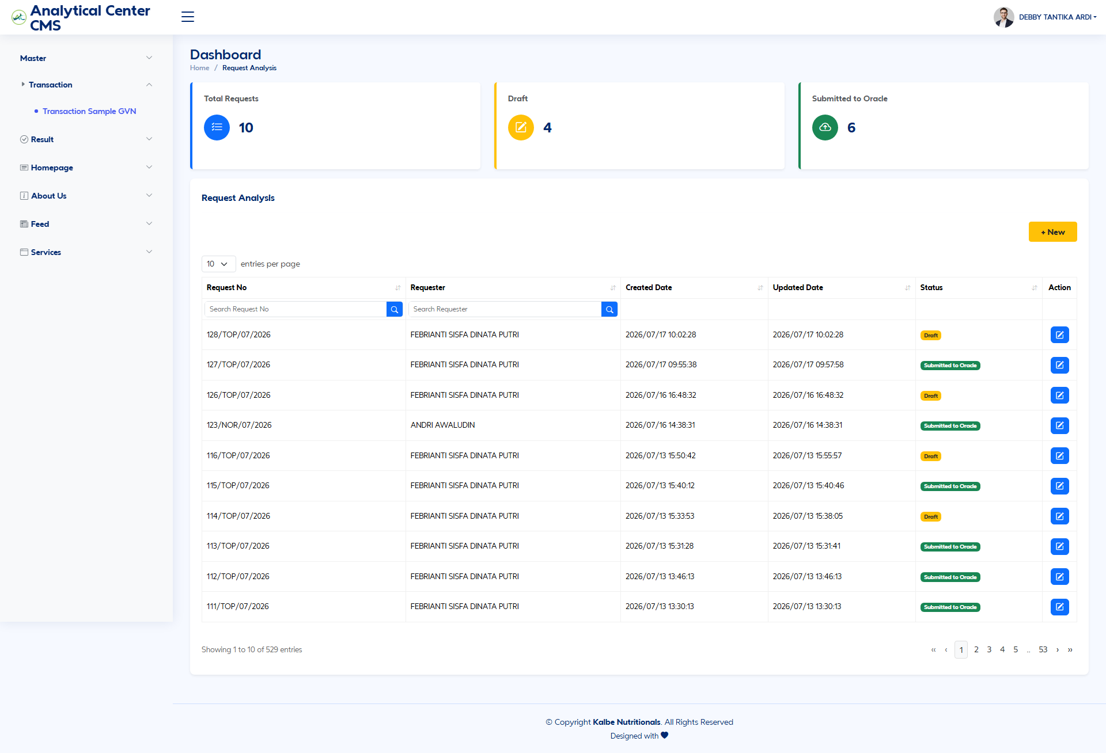
Halaman List Transaction Sample GVN
Gambar 3.1 — Halaman List Transaction Sample GVN

3.1.1 Dashboard Cards
Elemen | ID Elemen | Handler | Keterangan
Total Requests | countAll | filterTable('') | Menampilkan semua baris
Draft | countDraft | filterTable('Draft') | Filter status Draft
Submitted to Oracle | countSubmit | filterTable('Submitted to Oracle') | Filter status Submitted
Tabel 3.1.1 — Dashboard Cards

3.1.2 Kolom DataTable List
Kolom | Field Key / Entity Field | Render | Sortable | Keterangan
Request No | Request Number | Text / Link | Ya | Contoh format mock: {seq}/{NOR\|TOP}/{MM}/{YYYY}
Requester | Requester | Text | Ya | Nama user pembuat
Created Date | Created Date | DateTime | Ya | Tanggal dibuat
Updated Date | Updated Date | DateTime | Ya | Tanggal diubah
Status | Status | Badge | Ya | Draft atau Submitted to Oracle
Action | — | Icon Edit | Tidak | Navigasi ke request_detail_cms.html
Tabel 3.1.2 — Kolom DataTable List

3.1.3 Tombol Aksi — List Transaction
Tampilan | Tombol | ID / Handler | Warna/Style | Fungsi
 | + New | btnNewTransaction → request_create_cms.html | btn warning (#ffc107) | Membuka form Create Sample Request
 | Edit | Link ke detail | Icon / outline | Membuka request_detail_cms.html
Tabel 3.1.3 — Tombol Aksi — List Transaction

3.1.4 CRUD — List Transaction
Operasi | Cara | Role | Keterangan
Create | Klik + New | Requestor / Lab Admin (inferred) | Form create
Read | Buka list / filter card | Semua role terautentikasi (inferred) | Filter via filterTable
Update | Klik Edit pada baris | Requestor / Lab Admin (inferred) | Detail page
Tabel 3.1.4 — CRUD — List Transaction

3.2 Create Sample Request
Halaman create (request_create_cms.html) berisi Status Board (Alert New, Progress 0%), accordion Status History, form header dua kolom, serta tab Parameter dan Sample. Tiga jalur penentuan parameter: Retest, Spec GVN, atau Manual (+ New parameter).
Tampilan Halaman Create Request:
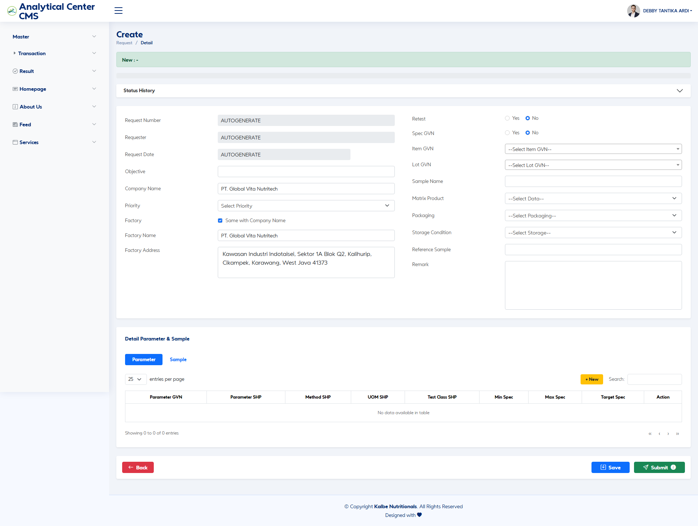
Halaman Create Sample Request
Gambar 3.2 — Halaman Create Sample Request

3.2.1 Status Board & Status History
Elemen | ID Elemen | Keterangan
Status History Accordion | statusHistoryAccordion | Riwayat status dokumen
Heading Status | headingStatus | Judul accordion
Collapse Status | collapseStatus | Konten tabel history
Tabel 3.2.1 — Status Board & Status History
Kolom history (mock): No, Status, Created By (role), Timestamp.

3.2.2 Fields – Header (Create)
Field Name | ID Elemen | Tipe | Mandatory | Default | Validasi | Keterangan
Request Number | > [TBD] — tanpa id di HTML | Text (readonly) | Ya (Auto) | AUTOGENERATE | — | Nomor request otomatis
Requester | > [TBD] | Text (readonly) | Ya (Auto) | AUTOGENERATE | — | Dari sesi login
Request Date | > [TBD] | Text (readonly) | Ya (Auto) | AUTOGENERATE | — | Tanggal pengajuan
Objective | > [TBD] | Text | Opsional | (kosong) | — | Tujuan request
Company Name | > [TBD] | Text | Ya | PT. Global Vita Nutritech | — | Nama perusahaan
Priority | > [TBD] | Dropdown/LOV | Ya | Select Priority | Normal / Urgent / Top Urgent | Prioritas request
Factory (Same with Company) | > [TBD] | Checkbox | Tidak | Checked | — | Salin nama/alamat perusahaan
Factory Name | > [TBD] | Text | Ya | Sama Company Name | — | Nama pabrik
Factory Address | > [TBD] | Textarea | Ya | Alamat demo mock | — | Alamat pabrik
Retest | retestYes / retestNo (name=retest) | Radio | Ya | No | Mutual exclusive dengan Spec GVN | Handler updateLogic()
Sample No. SHP | retestSampleNoShp (row sampleNoShpRow) | Dropdown/LOV | Ya jika Retest=Yes | (kosong) | Wajib pilih sample prior | Sumber Sample_SHP.json
Spec GVN | specGvnYes / specGvnNo (name=specGvn) | Radio | Ya | No | Mutual exclusive dengan Retest | = Use Spec BRD
Select Spec GVN | specGvnSelect (row specGvnSelectRow) | Dropdown/LOV | Ya jika Spec=Yes | (kosong) | SPEC_NAME \| SPEC_VERS | Sumber Spec_GVN.json
Item GVN | itemGvnInput (row itemGvnRow) | Dropdown/LOV (Select2, tags) | Ya | (kosong) | — | Autofill dari Spec jika Spec=Yes
Lot GVN | lotGvnInput (row lotGvnRow) | Dropdown/LOV | Opsional | (kosong) | Filter by Item | Sumber Item Lot GVN.json
Sample Name | headerSampleName | Text | Ya | Auto Item atau Item-Lot | — | Diisi updateSampleName()
Matrix Product | > [TBD] | Dropdown/LOV | Opsional | –Select Data– | — | Placeholder mock
Packaging | > [TBD] | Dropdown/LOV | Opsional | –Select Packaging– | — | Placeholder mock
Storage Condition | > [TBD] | Dropdown/LOV | Opsional | –Select Storage– | — | Placeholder mock
Reference Sample | > [TBD] | Text | Opsional | (kosong) | — | Referensi sample
Remark | > [TBD] | Textarea | Opsional | (kosong) | — | Catatan
Tabel 3.2.2 — Fields – Header (Create)

3.2.3 Tab Parameter — Kolom Grid
Tab pills-parameter / pills-parameter-tab. Body: parameterTableBody.
Kolom | Field Key | Render | Sortable | Keterangan
Parameter GVN | TEST_CODE / param | Text | Tidak | Dari Spec atau capability
Parameter SHP | TEST_CODE map | Text | Tidak | Enrich Test Code SHP.json; hilang → baris kuning
Method SHP | Method | Text | Tidak | Dari Test Code SHP
UOM SHP | Unit | Text | Tidak | Dari Test Code SHP
Test Class SHP | Class | Text | Tidak | Dari Test Code SHP
Min Spec | COMBINED_MIN | Text | Tidak | Dari Spec GVN
Max Spec | COMBINED_MAX | Text | Tidak | Dari Spec GVN
Target Spec | COMBINED_TARGET | Text | Tidak | Dari Spec GVN
Action | — | Hapus baris | Tidak | Hapus baris parameter
Tabel 3.2.3 — Tab Parameter — Kolom Grid
Sumber auto-populate:
- Spec GVN dipilih → match Spec_GVN.json; unique by TEST_CODE; enrich Method/UOM/Test Class.
- Retest Sample dipilih → baris dari Sample_SHP.json untuk SAMPLE_NO; Min/Max/Target kosong; enrich sama.
- Manual → modal addParameterModal.

3.2.4 Modal + New Parameter
Field Name | ID Elemen | Tipe | Mandatory | Default | Validasi | Keterangan
Parameter | swal-param | Dropdown/LOV (Select2) | Ya | (kosong) | Required (alert jika kosong) | Capability parameter
Jumlah Baris | qtyParam | Number | Ya | 1 | ≥ 1 | Append N baris kosong
+ Tambah | btnAddParameter | Button | — | — | — | Menambah baris ke grid
Tabel 3.2.4 — Modal + New Parameter

3.2.5 Tab Sample — Generate
Tab pills-sample / pills-sample-tab. Body: sampleTableBody.
Field Name | ID Elemen | Tipe | Mandatory | Default | Validasi | Keterangan
Quantity Sample | qtySample | Number | Ya saat Submit (tooltip) | 0 | Tooltip: minimal 1 — belum enforce di JS | Jumlah sample yang digenerate
Generate | btnGenerateSample | Button | — | — | — | Bangun N baris sample
Tabel 3.2.5 — Tab Sample — Generate
Kolom Grid Sample | Keterangan
No | Urutan
Sample No. SHP | Format baru GVN-MN[MM][YY]-[XXXXX]; retest [NOMOR]-[XX] (tooltip)
Pooling No. SHP | Format tooltip GVN-[YY]-[MM]-[XXX]
Sample No. GVN | Baru: sama konsep Sample SHP; retest: tanpa counter retest; data Oracle nyata: numerik
Sample Description for (COA) | Default = Sample Name header
Total Min Sample (g) | Mock hardcoded 125
Tabel 3.2.6 — Tab Sample — Generate

3.2.6 Tombol Aksi — Create Request
Tampilan | Tombol | ID / Handler | Warna/Style | Fungsi
 | Save | saveData() | btn-primary | Simpan sebagai Draft (konfirmasi Swal)
 | Submit | submitRequest() | btn-success | Konfirmasi submit ke Oracle → sukses → redirect list
 | Back | Link list | Outline | Kembali ke list
Tabel 3.2.7 — Tombol Aksi — Create Request
Tooltip Submit (bisnis mockup): Jika Retest = No → Create Sample di Oracle SHP dan Oracle GVN. Validasi Qty Sample minimal 1.
Gap: Tooltip tidak menyatakan Retest = Yes = SHP only (disurat di flowapps.txt). Enforce qty≥1 belum ada di submitRequest().

3.2.7 CRUD — Create Request
Operasi | Cara | Role | Keterangan
Create | Isi form → Save / Submit | Requestor | Draft atau Submitted
Read | Buka form New | Requestor | Status New
Update | Ubah field sebelum Submit | Requestor | Setelah Submit lihat detail
Tabel 3.2.8 — CRUD — Create Request

3.3 Detail Sample Request (Setelah Submit)
Halaman request_detail_cms.html menampilkan request yang sudah Submitted to Oracle. Alert meminta update Admin Review & Conclusion; Progress 100%. Header mayoritas readonly; radio Retest/Spec masih interaktif. Tab Sample: Qty readonly, btnGenerateSample disembunyikan (d-none), sample prefilled.
Tampilan Halaman Detail Request:
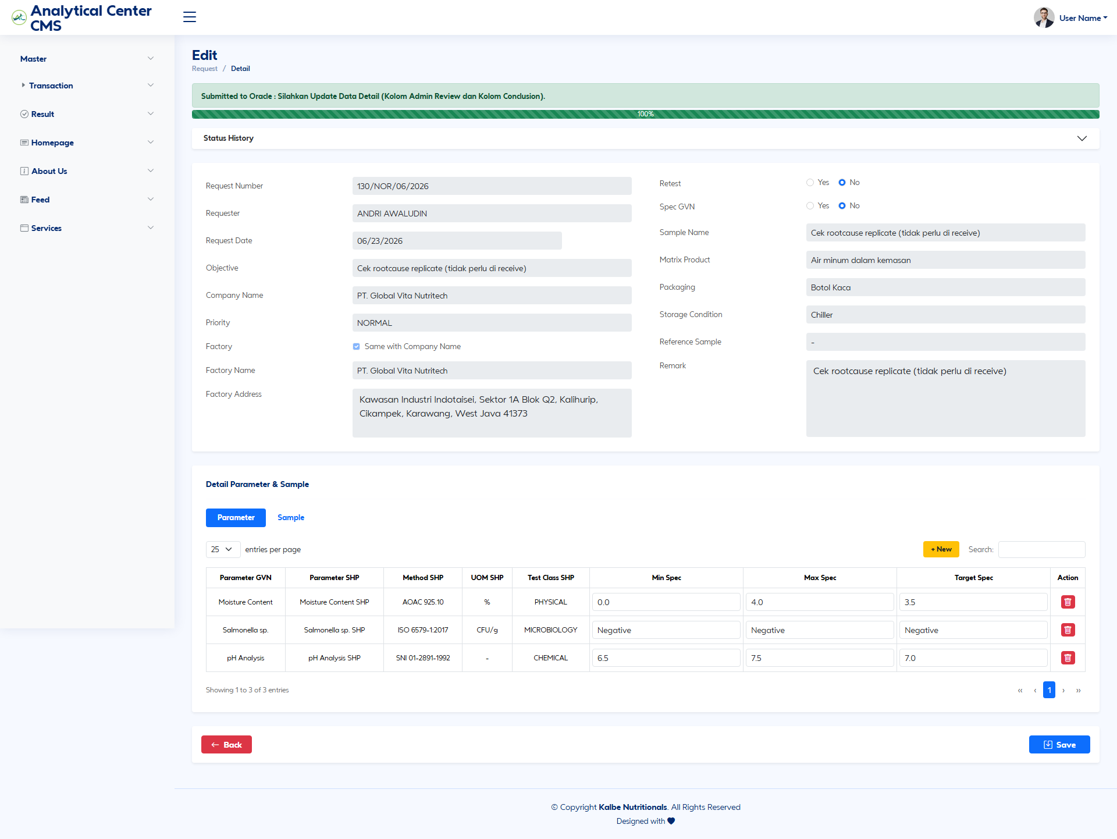
Halaman Detail Request Sample
Gambar 3.3 — Halaman Detail Request Sample

3.3.1 Fields – Detail (perbedaan vs Create)
Field Name | ID Elemen | Tipe | Mandatory | Default | Validasi | Keterangan
Sample Name | headerSampleName | Text (readonly) | Ya | Nilai tersimpan | — | Background readonly
Quantity Sample | qtySample | Number (readonly) | Ya | Nilai tersimpan | — | Generate hidden
Parameter Min/Max/Target | sel di parameterTableBody | Text | Opsional | Demo rows | — | Masih editable di mock
Admin Review / Conclusion | > [TBD] — kolom tidak ada di HTML | — | — | — | — | Bertentangan dengan teks alert
Tabel 3.3.1 — Fields – Detail (perbedaan vs Create)

3.3.2 Tombol Aksi — Detail Request
Tampilan | Tombol | ID / Handler | Warna/Style | Fungsi
 | Save | > [TBD] — onclick Save di detail | btn-primary | Simpan perubahan detail
 | Back | Link list | Outline | Kembali ke list
Tabel 3.3.2 — Tombol Aksi — Detail Request
Tidak ada tombol Submit pada halaman detail mockup.

3.3.3 CRUD — Detail Request
Operasi | Cara | Role | Keterangan
Read | Buka dari list Edit | Requestor / Lab Admin | Status Submitted
Update | Ubah field → Save | Lab Admin (inferred) | Parameter masih editable di mock
Tabel 3.3.3 — CRUD — Detail Request

4. Result Sample GVN
Modul Result mencakup list, create (mapping SHP↔GVN), dan edit/sync. Sumber: result_sample_gvn_list_cms.html, result_sample_gvn_create_cms.html, result_sample_gvn_cms.html.

4.1 Dashboard List — Result Sample GVN
Data list dimuat dari fetch('./Data/Sample_GVN.json'), distinct by SAMPLE_NO. Status Sync mock: (countAll % 3 === 0) ? 'Syncronized' : 'Draft'.
Tampilan Halaman List Result:
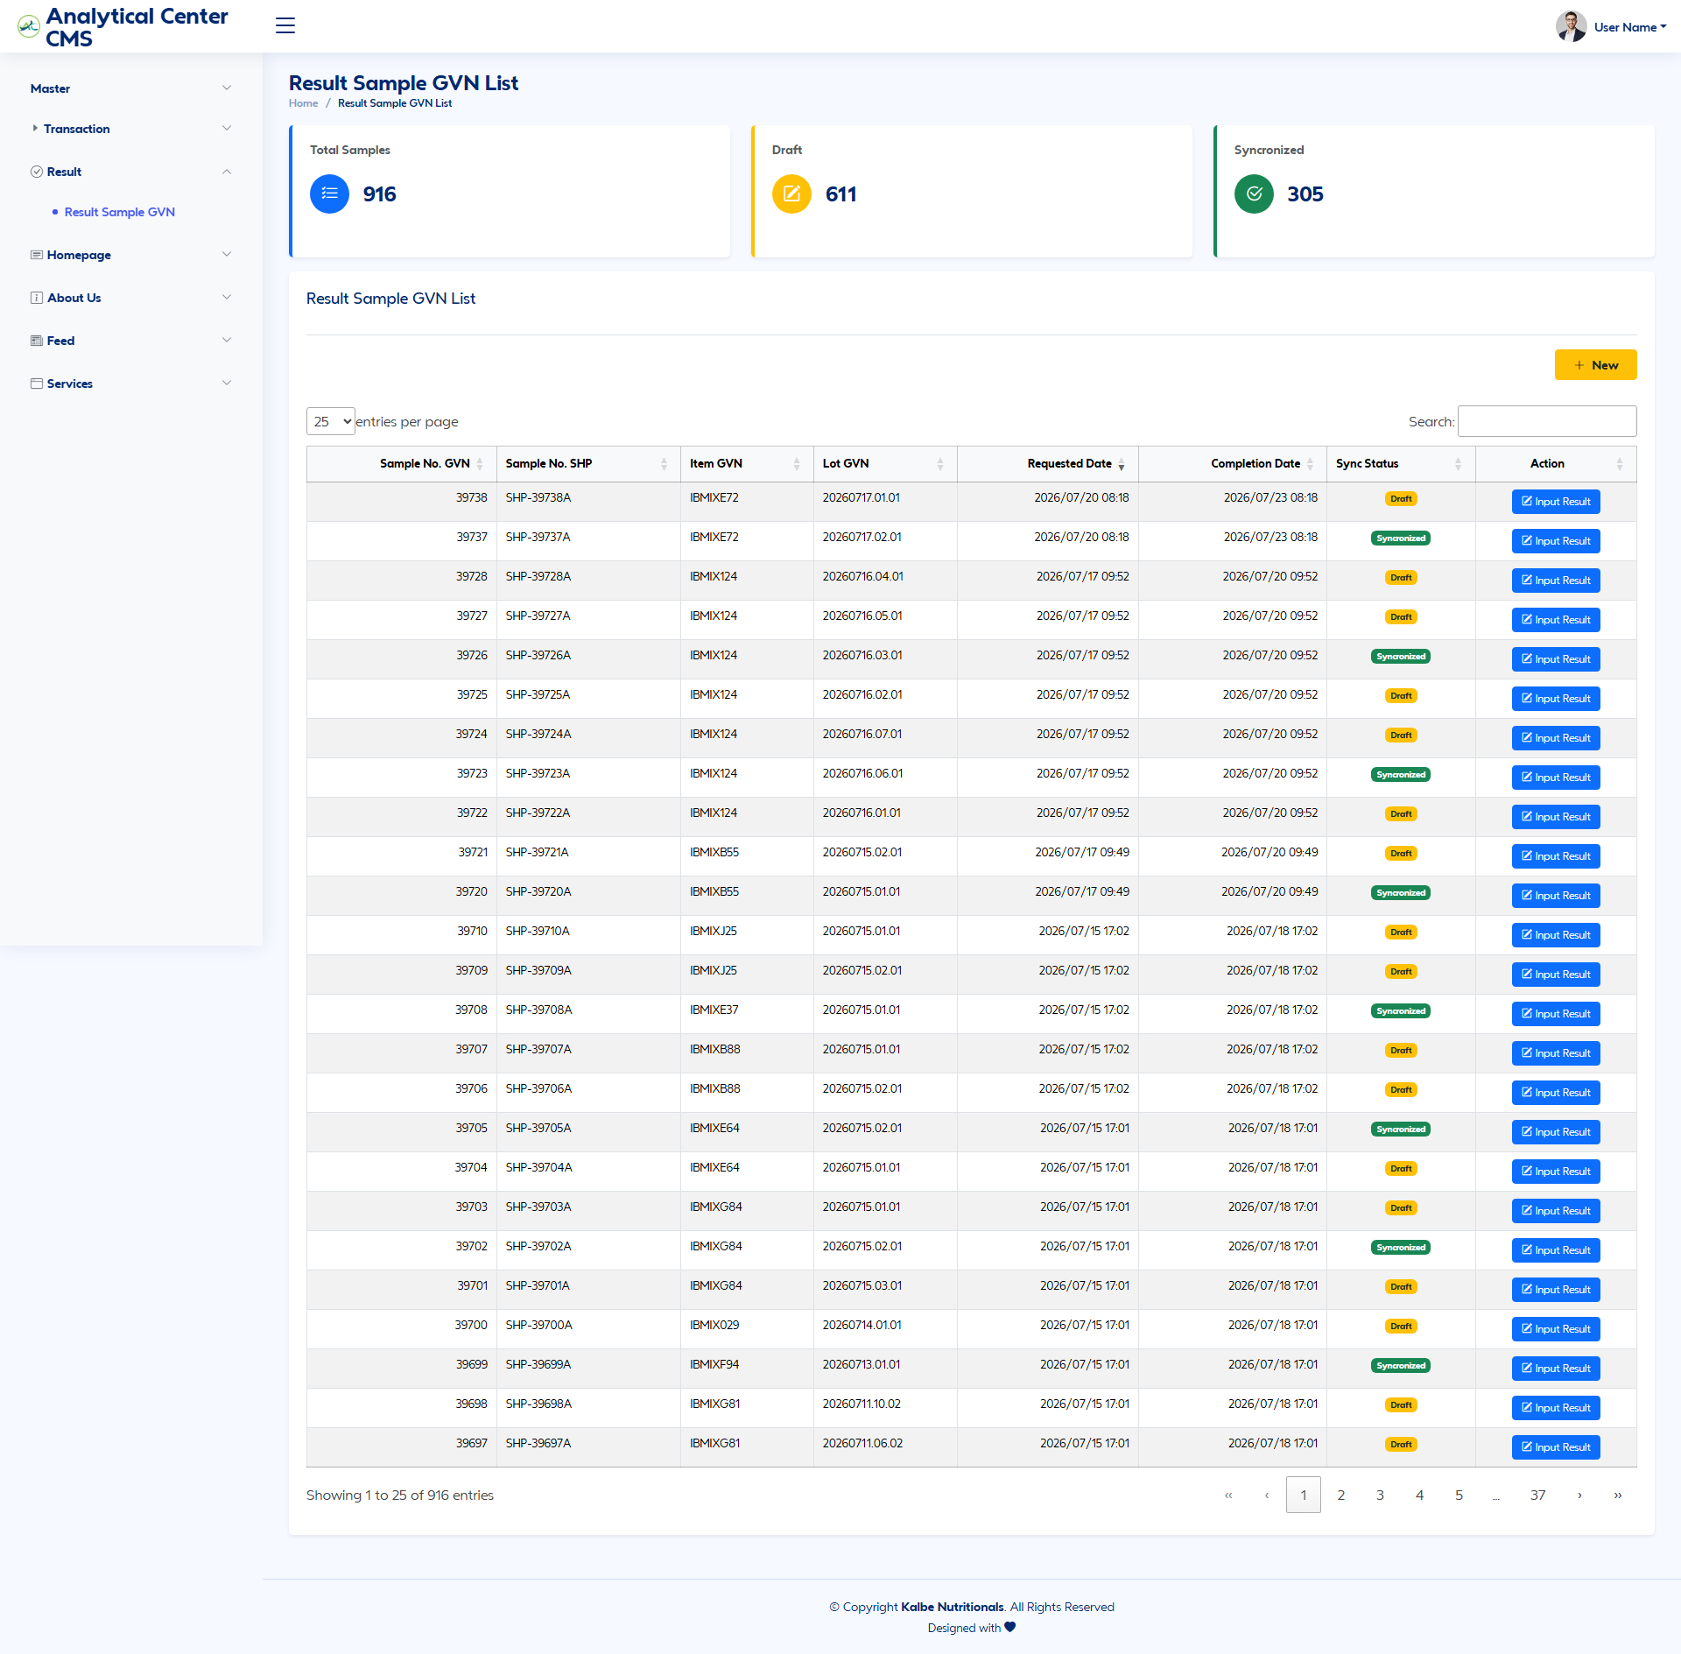
Halaman List Result Sample GVN
Gambar 4.1 — Halaman List Result Sample GVN

4.1.1 Dashboard Cards
Elemen | ID Elemen | Handler | Keterangan
Total | countAll | filterStatus('') | Semua result
Draft | countDraft | filterStatus('Draft') | Belum Sync
Syncronized | countSync | filterStatus('Syncronized') | Sudah Sync
Tabel 4.1.1 — Dashboard Cards

4.1.2 Kolom DataTable List Result
Kolom | Field Key | Render | Sortable | Keterangan
Sample No. GVN | SAMPLE_NO | Text | Ya | Nomor sample GVN
Sample No. SHP | (mock map) | Text | Ya | Relasi SHP
Item | SEGMENT1 / Item | Text | Ya | Kode item
Lot | Lot | Text | Ya | Lot number
Requested Date | Request Date | Date | Ya | Tanggal request
Completion Date | Completion Date | Date | Ya | Tanggal selesai analisa
Sync Status | Sync Status | Badge | Ya | Draft / Syncronized
Action | — | Input Result | Tidak | Ke halaman edit/detail
Tabel 4.1.2 — Kolom DataTable List Result
Tabel: tableResultSample, body tableResultSampleBody.

4.1.3 Tombol Aksi — List Result
Tampilan | Tombol | ID / Handler | Warna/Style | Fungsi
 | + New | btnNewTransaction → create | btn warning | Buka create result
 | Input Result | Link edit | Outline | Buka result_sample_gvn_cms.html
Tabel 4.1.3 — Tombol Aksi — List Result

4.1.4 CRUD — List Result
Operasi | Cara | Role | Keterangan
Create | + New | Lab Admin (inferred) | Mapping baru
Read | List + filter | Requestor / Lab Admin | filterStatus
Update | Input Result | Lab Admin | Edit + Sync
Tabel 4.1.4 — CRUD — List Result

4.2 Create Result — Mapping SHP ↔ GVN
Halaman result_sample_gvn_create_cms.html. Status Draft, Progress 50%. Section SHP Information dari Sample_SHP_Ver2.json; GVN Information dari Sample_GVN.json.
Tampilan Halaman Create Result:
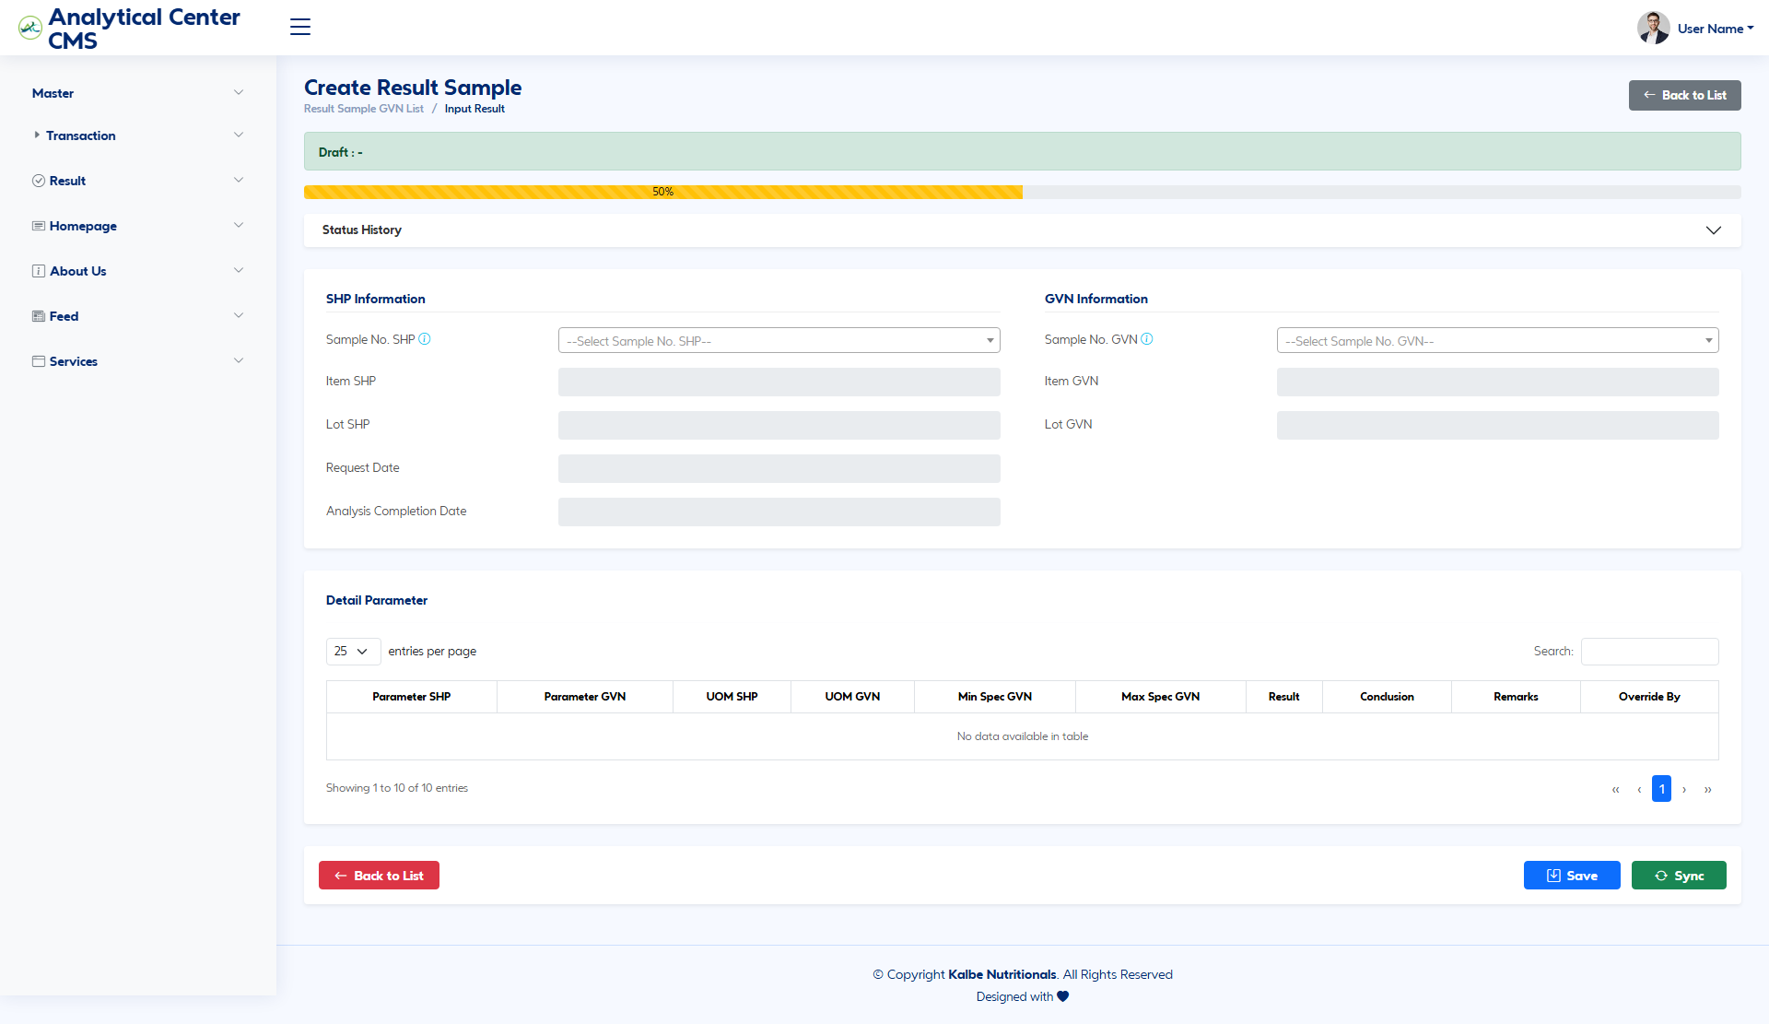
Halaman Create Result Sample GVN
Gambar 4.2 — Halaman Create Result Sample GVN

4.2.1 Fields – SHP Information
Field Name | ID Elemen | Tipe | Mandatory | Default | Validasi | Keterangan
Sample No. SHP | sampleNoShpSelectResult | Dropdown/LOV | Ya | (kosong) | Tooltip: nomor sudah dipakai tidak bisa reuse — belum enforce | Pilih sample SHP sumber result
Item | itemShpInputResult | Text (readonly) | Ya (Auto) | (kosong) | — | Autofill dari sample SHP
Lot | lotShpInputResult | Text (readonly) | Opsional | (kosong) | — | Autofill
Request Date | reqDateInputResult | Text (readonly) | Ya (Auto) | (kosong) | — | Tanggal request
Analysis Completion Date | compDateInputResult | Text (readonly) | Opsional | (kosong) | — | Tanggal selesai
Tabel 4.2.1 — Fields – SHP Information

4.2.2 Fields – GVN Information
Field Name | ID Elemen | Tipe | Mandatory | Default | Validasi | Keterangan
Sample No. GVN | sampleNoGvnSelectResult | Dropdown/LOV | Ya | (kosong) | Tooltip: exclude disposition Accept (4A) / Accept with Variance (5AV) — belum difilter di JS | Target sample GVN
Item | itemGvnInputResult | Text (readonly) | Ya (Auto) | (kosong) | — | Autofill
Lot | lotGvnInputResult | Text (readonly) | Opsional | (kosong) | — | Autofill
Tabel 4.2.2 — Fields – GVN Information

4.2.3 Kolom Grid Parameter Result (Create)
Body: parameterTableBody. Saat Sample GVN berubah, grid diisi dari TEST_CODE / RESULT_VALUE_*.
Kolom | Field Key | Render | Keterangan
Parameter SHP | TEST_CODE | Text | Belum ada map nyata SHP↔GVN di mock
Parameter GVN | TEST_CODE | Text | Duplikat kode di create
UOM | TEST_UNIT | Text | Unit uji
Min | — | Text | Mock -
Max | — | Text | Mock -
Result | RESULT_VALUE_* | Text | Nilai hasil lab
Conclusion | — | Dropdown | Conform / Not Conform
Remarks | — | Text | Catatan
Override By | — | Text | User override
Tabel 4.2.3 — Kolom Grid Parameter Result (Create)

4.2.4 Tombol Aksi — Create Result
Tampilan | Tombol | ID / Handler | Warna/Style | Fungsi
 | Save | saveData() | btn-primary | Simpan Draft
 | Sync | syncResult() | btn-success | Konfirmasi sync ke GVN → status Syncronized → list
Tabel 4.2.4 — Tombol Aksi — Create Result
Tidak ada auto-retest loop pada Sync.

4.3 Edit Result / Sync Disposition
Halaman result_sample_gvn_cms.html. Status Syncronized, Progress 100%. Mapping demo hardcoded (contoh 00040→37934). Conclusion baris: Accept | Retest (Out of Spec) — perubahan dari original mengaktifkan Remarks + Override By (user demo hardcoded).
Tampilan Halaman Edit Result:
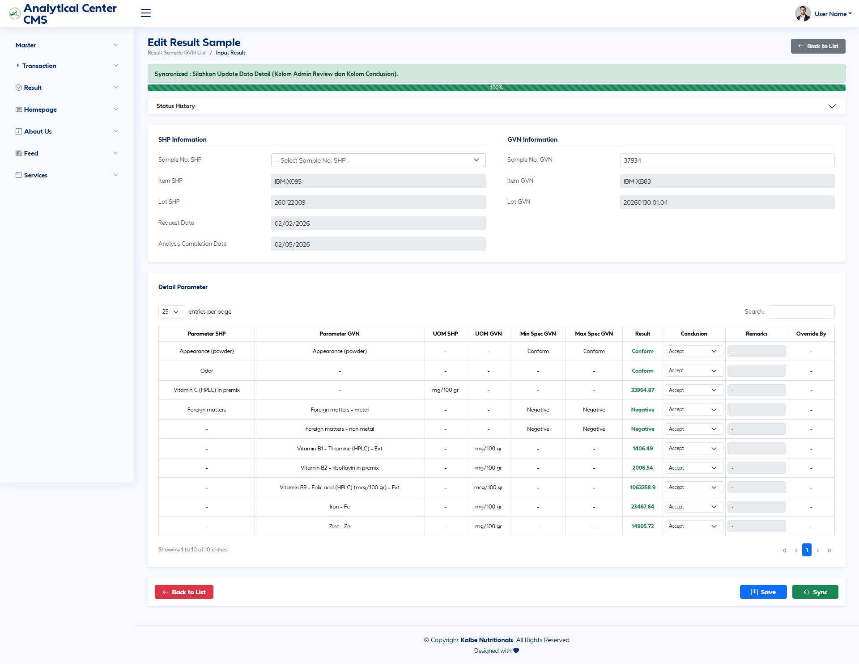
Halaman Edit Result Sample GVN
Gambar 4.3 — Halaman Edit Result Sample GVN

4.3.1 Fields – Edit Result
Field Name | ID Elemen | Tipe | Mandatory | Default | Validasi | Keterangan
Sample No. SHP | sampleNoShpSelectResult | Dropdown/LOV | Ya | Nilai tersimpan | — | Mapping SHP
Sample No. GVN | sampleNoGvnInputResult | Text | Ya | Nilai tersimpan | — | Input/teks di edit (bukan select create)
Conclusion (baris) | > [TBD] per-row select | Dropdown/LOV | Ya | Accept / Retest | Override → Remarks wajib (mock) | Bukan loop Create Sample BRD
Parameter grid | parameterTableBody | Grid | — | Demo mismatch nama | — | Dokumentasi kebutuhan mapping asimetrik
Tabel 4.3.1 — Fields – Edit Result
Modal tambah parameter sama: addParameterModal, swal-param, qtyParam, btnAddParameter.

4.3.2 Tombol Aksi — Edit Result
Tampilan | Tombol | ID / Handler | Warna/Style | Fungsi
 | Save | saveData() | btn-primary | Simpan perubahan
 | Sync | syncResult() | btn-success | Sync ulang / konfirmasi ke GVN
Tabel 4.3.2 — Tombol Aksi — Edit Result

4.3.3 CRUD — Result
Operasi | Cara | Role | Keterangan
Create | Form create → Save / Sync | Lab Admin | Draft atau Syncronized
Read | List / Edit | Requestor / Lab Admin | —
Update | Edit conclusion / remarks → Save / Sync | Lab Admin | Override logic mock
Tabel 4.3.3 — CRUD — Result

5. Aturan Bisnis
Rule ID | Aturan
BR-01 | Running Counter sample (XXXXX) dan Counter Retest (RR/XX) wajib increment berurutan, tersentralisasi, tanpa duplikasi. MM/YY mengikuti waktu pengajuan (BRD §4.1).
BR-02 | Format Sample No. baru: GVN-MN[MM][YY]-[XXXXX]. Retest: akhiran -[RR] / -[XX] sesuai tooltip mockup.
BR-03 | Format Pooling No. SHP (tooltip mockup): GVN-[YY]-[MM]-[XXX].
BR-04 | Mutual exclusion: jika Retest = Yes, maka Spec GVN dipaksa No dan sebaliknya (updateLogic(); BRD §4.2).
BR-05 | Jika Spec GVN = Yes, parameter di-populate dari Spec / Validity Rule Oracle GVN (Spec_GVN.json di mock).
BR-06 | Jika Retest = Yes, parameter di-populate dari sample SHP prior; Spec disabled; generate sample hanya di Oracle SHP (flowapps.txt).
BR-07 | Jika Retest = No pada Submit, sistem Generate Sample di Oracle SHP dan Oracle GVN (flowapps.txt + tooltip Submit).
BR-08 | Submit mengubah status request menjadi Submitted to Oracle dan memicu generate (otoritas mockup/flowapps).
BR-09 | Quantity Sample minimal 1 saat Submit (tooltip). > [TBD] — enforce server-side wajib; mock belum enforce di JS.
BR-10 | Baris parameter tanpa mapping Test Code SHP ditandai visual (baris kuning) di mock.
BR-11 | Analisa lab berlangsung di OSIR hingga result diinput; KNAC tidak menggantikan OSIR.
BR-12 | Pada Result, Sample No. SHP yang sudah dipakai tidak boleh dipilih ulang (tooltip). > [TBD] enforce.
BR-13 | Sample GVN dengan disposition Accept (4A) / Accept with Variance (5AV) dikecualikan dari pilihan (tooltip). > [TBD] enforce.
BR-14 | Sync = YES (syncResult): Input Result ke Oracle GVN + lampirkan Sample No. SHP sebagai source; status → Syncronized.
BR-15 | Sync = NO (hanya Save / tidak Sync): data tetap di KNAC berstatus Draft; proses berhenti tanpa kirim ke GVN.
BR-16 | Conclusion baris Retest (Out of Spec) pada edit result adalah disposisi line-level, bukan auto-loop Create Sample BRD.
BR-17 | Item dummy SHP untuk generate administratif: FGDUM001 (BRD); filter mock data mencakup FGDUM% / IBMIX%.
BR-18 | > [TBD] — Gap BRD: Trigger generate setelah Client Approved (bukan Submit). Belum di mockup.
BR-19 | > [TBD] — Gap BRD: Disposisi hasil OK / NOT OK dengan auto-retest -[RR]. Digantikan model Sync di FSD ini sampai keputusan stakeholder.
BR-20 | > [TBD] — Gap BRD: Notify Sampler email saat Result Approved / Ready. Tidak ada di mockup/flowapps.
BR-21 | > [TBD] — Gap BRD: Failed Integration + retry wajib, no bypass sebelum lab queue. Tidak ada di mockup.
BR-22 | > [TBD] — Gap BRD: Status request DRAFT → SUBMIT TO LAB → CLIENT FEEDBACK → APPROVED vs mockup New/Draft/Submitted to Oracle.
BR-23 | > [TBD]: Kolom Admin Review / Conclusion pada detail request (disebut alert & BRD) belum ada di HTML mockup.
BR-24 | Prefix sample di detail demo (LAB-MN…) inkonsisten vs tooltip create (GVN-MN…). Canonical untuk implementasi: GVN-MN sampai diputuskan lain.
Tabel 5.1 — Rule ID

6. RBAC
BRD tidak mendefinisikan matriks RBAC formal. Matriks berikut inferred dari label UI mockup + role existing KNAC (REQ, ADMIN_LAB, ADMIN, eksternal). Semua sel bertanda ? atau catatan TBD wajib dikonfirmasi stakeholder.

6.1 Matriks Akses Modul
Bagian / Operasi | Requestor (REQ) | Lab Admin (ADMIN_LAB) | Admin (ADMIN) | Client (eksternal) | System
List Transaction | R | R | R | > [TBD] | —
Create / Save Draft Request | C/U | C/U | C/U | > [TBD] | —
Submit Request | U | U | U | N | Trigger generate
Detail Request (post-submit) | R | R/U | R/U | > [TBD] Client approve BRD | —
List Result | R | R | R | N | —
Create / Edit Result | > [TBD] | C/U | C/U | N | —
Sync Result ke GVN | > [TBD] | U | U | N | Input Result API
Master Capability / User | N | > [TBD] | Y (inferred) | N | —
Tabel 6.1.1 — Bagian / Operasi
Keterangan: C=Create, R=Read, U=Update, N=No, Y=Yes.

6.2 Catatan As-Is KNAC
Role constants existing dipakai sebagai titik awal implementasi menu/auth via KN Global. Mockup tidak memiliki role gating.

7. Approval / Sync Disposition

7.1 Model Disposisi Otoritatif (Mockup / flowapps)
Disposisi hasil lab di KNAC diwakili oleh aksi Sync:
Keputusan | Aksi UI | Status Result | Efek Integrasi
SYNC = YES | Tombol Sync / syncResult() | Syncronized | Input Result ke Oracle GVN + Sample No. SHP sebagai source
SYNC = NO | Hanya Save / tidak Sync | Draft | Data tetap di KNAC; tidak masuk GVN
Tabel 7.1.1 — Keputusan

7.2 Lane Swimlane — Result Sync
Lane (urutan kiri → kanan):
# | Lane ID | Label | Tipe | Sumber
1 | L1 | Requestor / Lab Admin | User | mockup result create/edit
2 | L2 | Analytical Central (KNAC) | System | syncResult(), saveData()
3 | L3 | Oracle GVN | ERP | flowapps.txt Fase 5
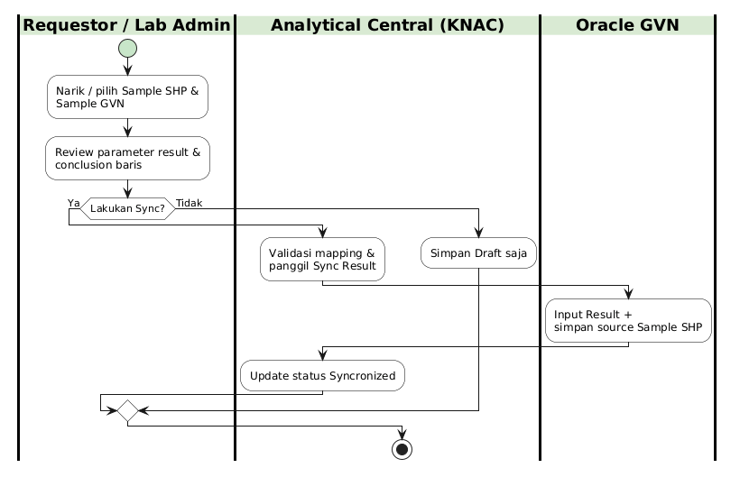
Swimlane – Result Sync Disposition
Gambar 7.1 — Swimlane – Result Sync Disposition

7.3 Gap vs BRD (Approval Client & OK/NOT OK)
Topik BRD | Perilaku BRD | Perilaku FSD (mockup) | Status
Client Approved | Syarat generate paralel | Tidak ada di mockup | > [TBD]
OK | Input Result GVN | Diganti Sync | Gap tercatat
NOT OK | Auto Create Sample retest | Tidak; conclusion Retest line-level saja | Gap tercatat
Notify Sampler | Email dari SHP | Tidak ada | > [TBD]
Submit Review lock | Kunci parameter | Belum spek di mock | > [TBD]
Tabel 7.3.1 — Topik BRD

8. Database & ERD

8.1 Catatan Sumber Data
Integrasi GVN belum memiliki tabel PostgreSQL khusus di analyticalcentralwebsite. Entity as-is terkait request: TrrequestAnalysis, TrrequestDParameter, TrrequestDSample, TrstatusHistory. Oracle as-is: XxshpKnAwcStg, package XXSHP_GMD_CRTSMPL_KNAC_PKG.run_create_sample.
Berikut model konseptual untuk modul baru. Nama tabel fisik PostgreSQL ditandai [TBD] hingga desain DAL dikunci.

8.2 Entitas Konseptual
Entitas | Deskripsi | Catatan fisik
TR_SAMPLE_REQUEST | Header request sample GVN-SHP | > [TBD] — bisa ekstensi TrrequestAnalysis atau tabel baru
TR_SAMPLE_REQUEST_PARAM | Baris parameter uji | > [TBD]
TR_SAMPLE_REQUEST_SAMPLE | Baris sample / pooling | > [TBD]
TR_STATUS_HISTORY | Histori status request/result | Pola as-is TrstatusHistory
TR_RESULT_HEADER | Header mapping result SHP↔GVN | > [TBD]
TR_RESULT_LINE | Baris result + conclusion | > [TBD]
TR_INTEGRATION_LOG | Log generate / sync / error | > [TBD] — terkait Failed Integration BRD
Spec / Sample Oracle | Sumber LOV & result | View/API Oracle GVN/SHP — bukan PG
Tabel 8.2.1 — Entitas

8.3 ERD Konseptual
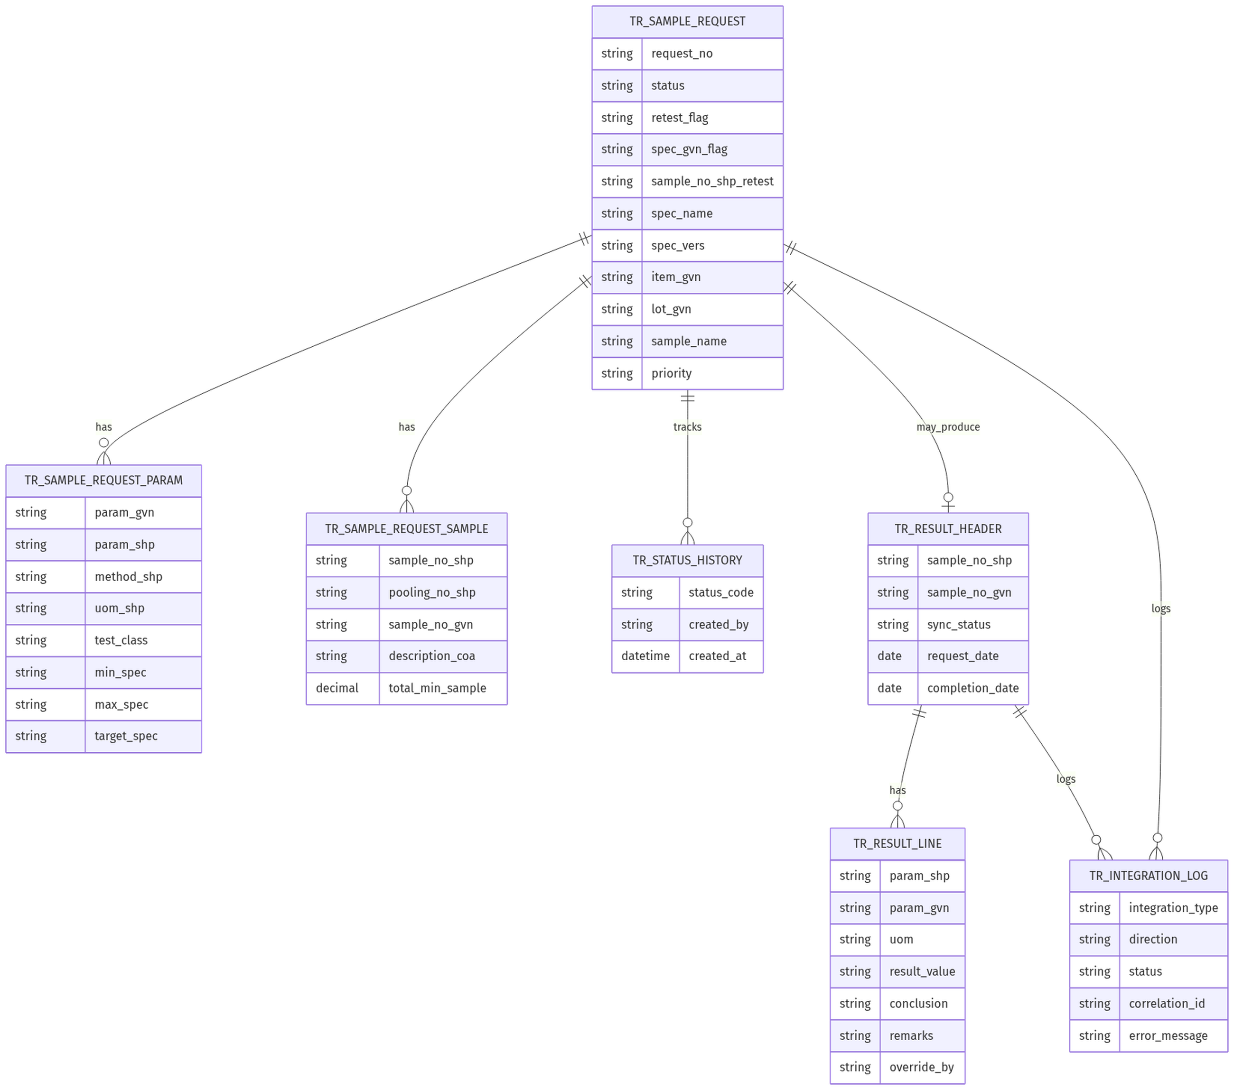
ERD – Sample Result GVN-SHP (konseptual)
Gambar 8.1 — ERD – Sample Result GVN-SHP (konseptual)

8.4 Mapping UI → Data (Konseptual)
Field UI | Entitas / Kolom Konseptual | Tipe Data | Keterangan
Request Number | TR_SAMPLE_REQUEST.request_no | string | Autogenerate
Retest | retest_flag | string Yes/No | Mutual exclusion
Spec GVN | spec_gvn_flag | string Yes/No | —
Sample No. SHP (retest) | sample_no_shp_retest | string | LOV Sample_SHP
Select Spec GVN | spec_name + spec_vers | string | LOV Spec_GVN
Sample No. SHP (result) | TR_RESULT_HEADER.sample_no_shp | string | —
Sample No. GVN (result) | TR_RESULT_HEADER.sample_no_gvn | string | —
Sync Status | sync_status | string | Draft / Syncronized
Tabel 8.4.1 — Field UI

8.5 Integrasi Oracle (Konseptual)
Integrasi | Arah | Trigger | Catatan teknis
Get Specification | GVN → KNAC | Spec GVN = Yes | Validity Rule / Spec tests
Generate Sample SHP | KNAC → SHP | Setelah Submit (FSD) | Dummy FGDUM001; fondasi as-is staging + run_create_sample
Generate Sample GVN | KNAC → GVN | Retest = No | > [TBD] package/API
Pull Result | Oracle/OSIR → KNAC | Menu Result | Sumber GMD_RESULTS mock
Input Result / Sync | KNAC → GVN | syncResult() | Sertakan Sample SHP sebagai source
Failed Integration | Internal | Error generate | > [TBD] BRD only
Tabel 8.5.1 — Integrasi

9. LOV, Appendix & Gap

9.1 LOV Status Request (Mockup)
Kode Status | Label | Warna Badge | Keterangan
New | New | > [TBD] | Form create baru
Draft | Draft | Warning / kuning (card) | Setelah Save
Submitted to Oracle | Submitted to Oracle | Success / hijau (card) | Setelah Submit
Tabel 9.1.1 — Kode Status

9.2 LOV Status Result (Mockup)
Kode Status | Label | Warna Badge | Keterangan
Draft | Draft | Warning | Belum Sync
Syncronized | Syncronized | Success | Setelah Sync sukses
Tabel 9.2.1 — Kode Status

9.3 LOV Priority
Nilai | Keterangan
Normal | Prioritas normal
Urgent | Prioritas urgent
Top Urgent | Prioritas tertinggi (contoh Request No memuat TOP)
Tabel 9.3.1 — Nilai

9.4 LOV Conclusion Result
Layar | Nilai | Keterangan
Create Result | Conform / Not Conform | Enum create
Edit Result | Accept / Retest (Out of Spec) | Enum edit — inkonsisten antar layar; > [TBD] standardisasi
Tabel 9.4.1 — Layar

9.5 Disposition Codes (Oracle — Glosarium Operasional)
Kode | Label sementara | Sumber | Keterangan
1P | > [TBD] | SQL/mock Sample | Muncul di extract
4A | Accept | Tooltip Result create | Exclude dari pilihan GVN
5AV | Accept with Variance | Tooltip Result create | Exclude dari pilihan GVN
5O | > [TBD] | Filter SQL evaluation_ind <> '5O' | Arti bisnis belum resmi
Tabel 9.5.1 — Kode

9.6 Glosarium
Istilah | Arti
KNAC / Analytical Central | Portal web request & CMS lab Kalbe Nutritionals
Oracle SHP | Ekosistem Oracle sisi SHP (sample admin, staging, dummy item)
Oracle GVN | Ekosistem Oracle sisi GVN (spec, sample numerik, input result)
OSIR | Aplikasi lab eksternal untuk eksekusi analisa
Spec / Validity Rule | Spesifikasi & aturan validitas di GVN sebagai template parameter
Pooling Number | Nomor pooling terkait sample lab
FGDUM001 | Item dummy SHP untuk generate sample (BRD)
Retest | Pengajuan ulang berbasis sample sebelumnya
Syncronized | Status result setelah Sync ke GVN sukses (ejaan mengikuti mockup)
Failed Integration | Status/log BRD saat generate gagal — > [TBD] di UI
COA | Certificate of Analysis
Capability | Master kemampuan uji lab + mapping method
Tabel 9.6.1 — Istilah

9.7 Gap BRD vs Mockup / flowapps
# | Topik | BRD | Mockup / flowapps | Keputusan FSD v1.0
1 | Disposisi hasil | OK / NOT OK + auto-retest | Sync YES/NO (Draft→Syncronized) | Ikuti Sync; BRD sebagai gap
2 | Trigger generate | Setelah Client Approved | Setelah Submit | Ikuti Submit
3 | Retest generate | Paralel kurang tegas | SHP only | Ikuti SHP only
4 | Notify Sampler | Ada | Tidak ada | > [TBD]
5 | Failed Integration | Wajib | Tidak ada | > [TBD]
6 | Status request | DRAFT→…→APPROVED | New/Draft/Submitted to Oracle | Ikuti mockup
7 | Cakupan item | Non-internal divert | Semua item | Ikuti flowapps (semua item)
Tabel 9.7.1 — #

9.8 File Mockup Acuan
File | Peran
transaction_cms.html | List Transaction Sample GVN
request_create_cms.html | Create Sample Request
request_detail_cms.html | Detail setelah submit
result_sample_gvn_list_cms.html | List Result
result_sample_gvn_create_cms.html | Create Result
result_sample_gvn_cms.html | Edit Result / Sync
assets/js/sidebar.js | Navigasi menu
Data/*.json | Kontrak data mock Oracle extracts
Tabel 9.8.1 — File

9.9 Open Questions (ringkas)
- Kapan hybrid BRD (Client Approved, Failed Integration, Notify) digabung ke UI?
- Standardisasi enum Conclusion Create vs Edit?
- Nama API/package Oracle untuk Get Spec, Generate GVN, Input Result?
- Scope counter numbering (global / per company / per matrix)?
- Apakah Sync=NO dapat di-Sync belakangan?

Dokumen ini disusun mengikuti standar FSD Generator Engine. Proses otoritatif: mockup + flowapps. Referensi BRD 2026.GVNSHP-BRD.001 untuk numbering, mutual exclusion, dan pencatatan gap.

