Table of Contents

FUNCTIONAL SPECIFICATION DOCUMENT (FSD)

NEW RM SAMPLE MANAGEMENT SYSTEM

VERSI 1.7 - FULL LOV INTEGRATION STEP 1

INFORMASI DOKUMEN
Item | Keterangan
Nama Modul | New RM Sample Management
Versi Dokumen | 1.7 (Full LOV Integration Step 1)
Tanggal | 19 Februari 2026
Status | Draft - Enhanced
Penyusun | Development Team
Perubahan v1.6 | Updated Step 3 Parameter Table (Line No, Test Code LOV, Target LOV)
Perubahan v1.7 | Implementasi LOV penuh di Step 1: Type Document, Supplier, Country, Storage Condition, Halal Category, Halal Body, GMO Status — semua menggunakan app.openLOV() modal injection system

DAFTAR ISI
- Pendahuluan
- Ringkasan Business Flow
- Spesifikasi Fungsional
- Struktur Database
- Business Rules
- UI Specifications
- Integration Points
- Reporting
- Lampiran

1. PENDAHULUAN

1.1 Tujuan Dokumen
Dokumen ini menjelaskan spesifikasi fungsional dari sistem New RM Sample Management yang merupakan revamp dari tiga modul terpisah (Document Sample, Sample Purpose, dan RM Evaluation) menjadi satu sistem terintegrasi dengan 4 tahapan proses.

1.2 Ruang Lingkup
Sistem ini mencakup: - Penerimaan dan dokumentasi sample RM dari supplier - Pendefinisian tujuan penggunaan sample - Evaluasi teknis dan pengujian laboratorium - Keputusan disposisi akhir (Approve/Reject/On Hold)

1.3 Stakeholder
- R&D Department: Pengguna utama untuk evaluasi sample
- QA/QC Department: Reviewer hasil pengujian
- Purchasing Department: Monitoring status sample untuk procurement
- Management: Approval keputusan akhir

2. RINGKASAN BUSINESS FLOW

2.1 Proses As-Is (Legacy System)
Sistem lama menggunakan 3 form terpisah: 1. Document Sample: Input data penerimaan sample 2. Sample Purpose: Definisi tujuan penggunaan 3. RM Evaluation: Evaluasi teknis dan hasil lab
Masalah: - Data terpisah-pisah - Duplikasi input - Tracking progress sulit - Tidak ada workflow approval terintegrasi

2.2 Proses To-Be (New System)

2.2.1 Simplified Flow Diagram
graph LR
A[Step 1: Document] --> B[Step 2: Purpose]
B --> C[Step 3: Evaluation]
C --> D[Step 4: Disposition]
D --> E{Decision}
E -->|Approved| F[Complete]
E -->|Rejected| G[End]
E -->|On Hold| C

2.2.2 Detailed Workflow Flowchart
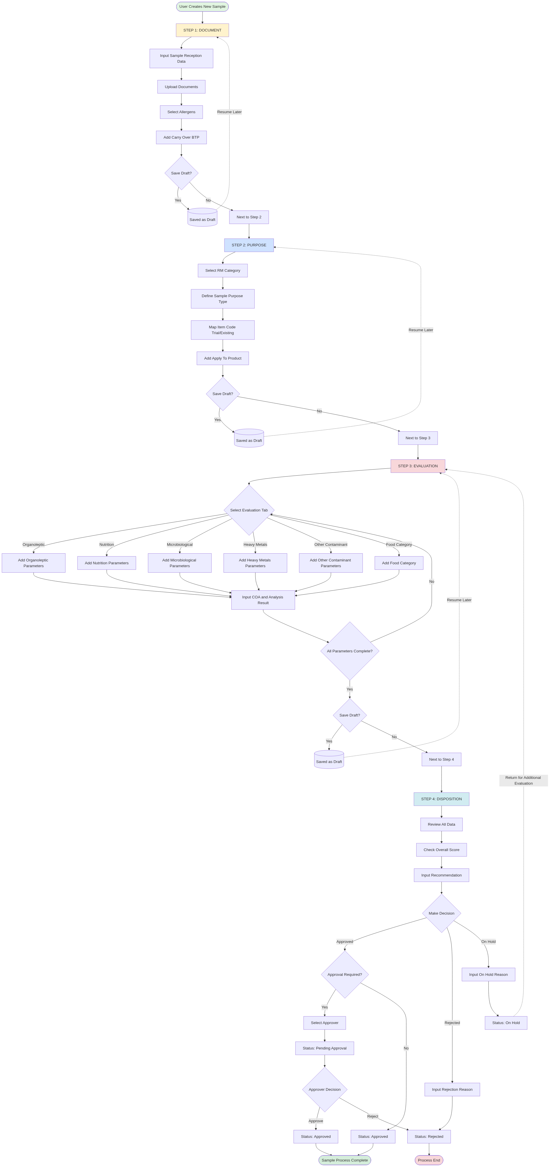
Detailed Workflow Flowchart - New RM Sample Management
Mermaid Source Code (klik untuk expand)
flowchart TD
Start([User Creates New Sample]) --> Step1[STEP 1: DOCUMENT]
Step1 --> Input1[Input Sample Reception Data]
Input1 --> Doc1[Upload Documents:<br/>COA, Spec, Halal Cert]
Doc1 --> Allergen1[Select Allergens]
Allergen1 --> BTP1[Add Carry Over BTP]
BTP1 --> Save1{Save Draft?}
Save1 -->|Yes| Draft1[(Saved as Draft)]
Save1 -->|No| Next1[Next to Step 2]
Draft1 -.->|Resume Later| Step1
Next1 --> Step2[STEP 2: PURPOSE]
Step2 --> Category2[Select RM Category]
Category2 --> Purpose2[Define Sample Purpose Type]
Purpose2 --> Item2[Map Item Code<br/>Trial/Existing]
Item2 --> Product2[Add Apply To Product]
Product2 --> Save2{Save Draft?}
Save2 -->|Yes| Draft2[(Saved as Draft)]
Save2 -->|No| Next2[Next to Step 3]
Draft2 -.->|Resume Later| Step2
Next2 --> Step3[STEP 3: EVALUATION]
Step3 --> Tab3{Select Evaluation Tab}
Tab3 -->|Organoleptic| Org3[Add Organoleptic Parameters]
Tab3 -->|Nutrition| Nut3[Add Nutrition Parameters]
Tab3 -->|Microbiological| Mic3[Add Microbiological Parameters]
Tab3 -->|Heavy Metals| Hea3[Add Heavy Metals Parameters]
Tab3 -->|Other Contaminant| Oth3[Add Other Contaminant Parameters]
Tab3 -->|Food Category| Food3[Add Food Category]
Org3 --> Result3[Input COA & Analysis Result]
Nut3 --> Result3
Mic3 --> Result3
Hea3 --> Result3
Oth3 --> Result3
Food3 --> Result3
Result3 --> Validate3{All Parameters<br/>Complete?}
Validate3 -->|No| Tab3
Validate3 -->|Yes| Save3{Save Draft?}
Save3 -->|Yes| Draft3[(Saved as Draft)]
Save3 -->|No| Next3[Next to Step 4]
Draft3 -.->|Resume Later| Step3
Next3 --> Step4[STEP 4: DISPOSITION]
Step4 --> Review4[Review All Data]
Review4 --> Score4[Check Overall Score]
Score4 --> Recommend4[Input Recommendation]
Recommend4 --> Decision4{Make Decision}
Decision4 -->|Approved| Approval4{Approval<br/>Required?}
Decision4 -->|Rejected| Reason4[Input Rejection Reason]
Decision4 -->|On Hold| ReasonHold4[Input On Hold Reason]
Approval4 -->|Yes| SelectApprover[Select Approver]
Approval4 -->|No| DirectApprove[Status: Approved]
SelectApprover --> PendingApproval[Status: Pending Approval]
PendingApproval --> ApproverReview{Approver<br/>Decision}
ApproverReview -->|Approve| FinalApprove[Status: Approved]
ApproverReview -->|Reject| FinalReject[Status: Rejected]
Reason4 --> FinalReject
ReasonHold4 --> OnHoldStatus[Status: On Hold]
OnHoldStatus -.->|Return for<br/>Additional Evaluation| Step3
DirectApprove --> Complete([Sample Process Complete])
FinalApprove --> Complete
FinalReject --> End([Process End])
style Start fill:#e1f5e1
style Step1 fill:#fff3cd
style Step2 fill:#cfe2ff
style Step3 fill:#f8d7da
style Step4 fill:#d1ecf1
style Complete fill:#d4edda
style End fill:#f8d7da
Keuntungan: - Single entry point - Progress tracking real-time - Workflow approval terintegrasi - Data consistency terjaga

3. SPESIFIKASI FUNGSIONAL
Format: Setiap form/halaman didokumentasikan dengan 4 komponen wajib: 1. Deskripsi — Nama form, tujuan, dan navigation path 2. Screenshot — Tampilan visual halaman 3. Functional Description — Detail setiap element UI beserta data source 4. Business Rules & Validation — RBAC, status permission, field validation, dan business logic

Status Transition Diagram
Semua form dalam modul ini mengikuti alur status berikut:
Draft → Waiting Approval → Approved
→ Rejected → Draft (re-submit)
→ On Hold → Step 3 (re-evaluate)

3.1 INDEX PAGE — Daftar New RM Sample

3.1.1 Deskripsi
Navigation: Sidebar > RM Selection > New RM Sample
Halaman ini menampilkan daftar seluruh data New RM Sample dalam bentuk DataTable, dilengkapi dashboard summary cards untuk monitoring status secara real-time. User dapat melakukan pencarian, filter, dan aksi (View/Edit/Delete) pada setiap record.

3.1.2 Screenshot
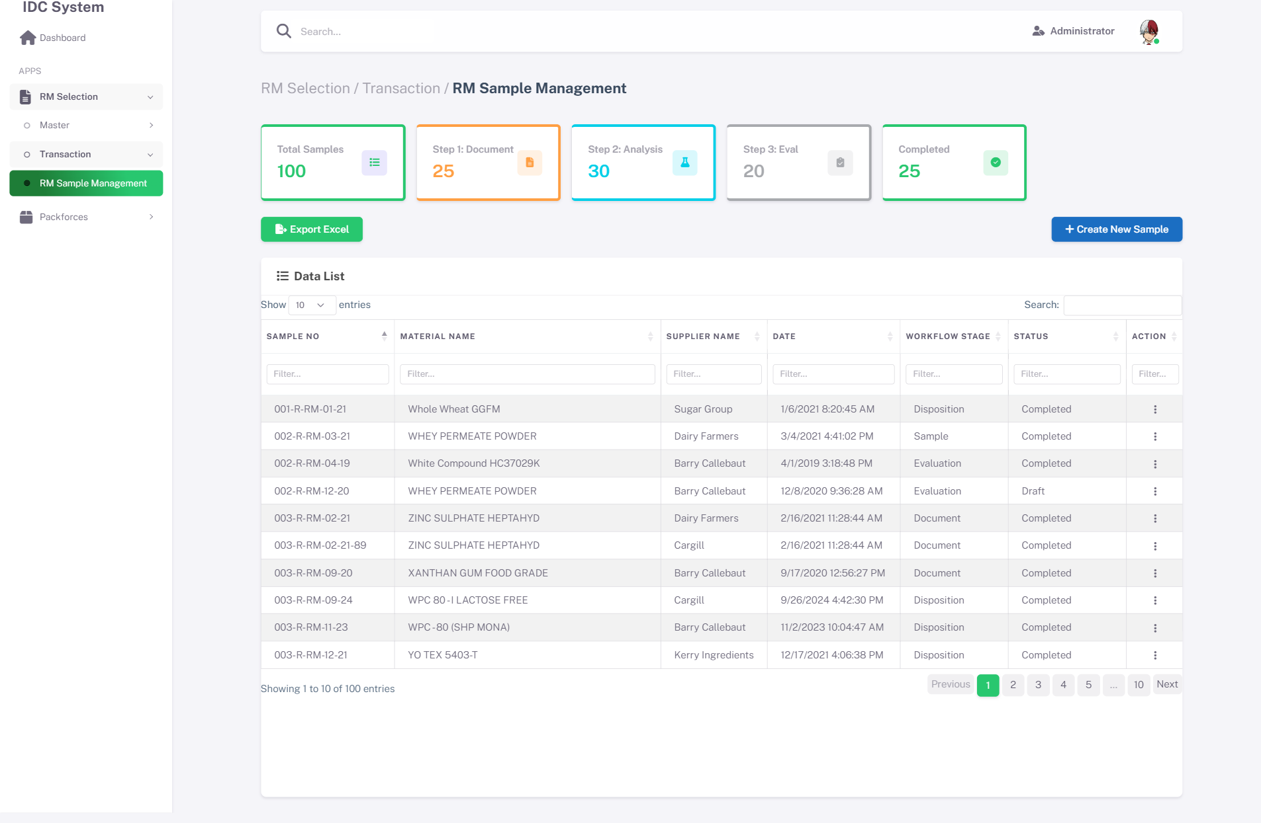
Index - Dashboard View
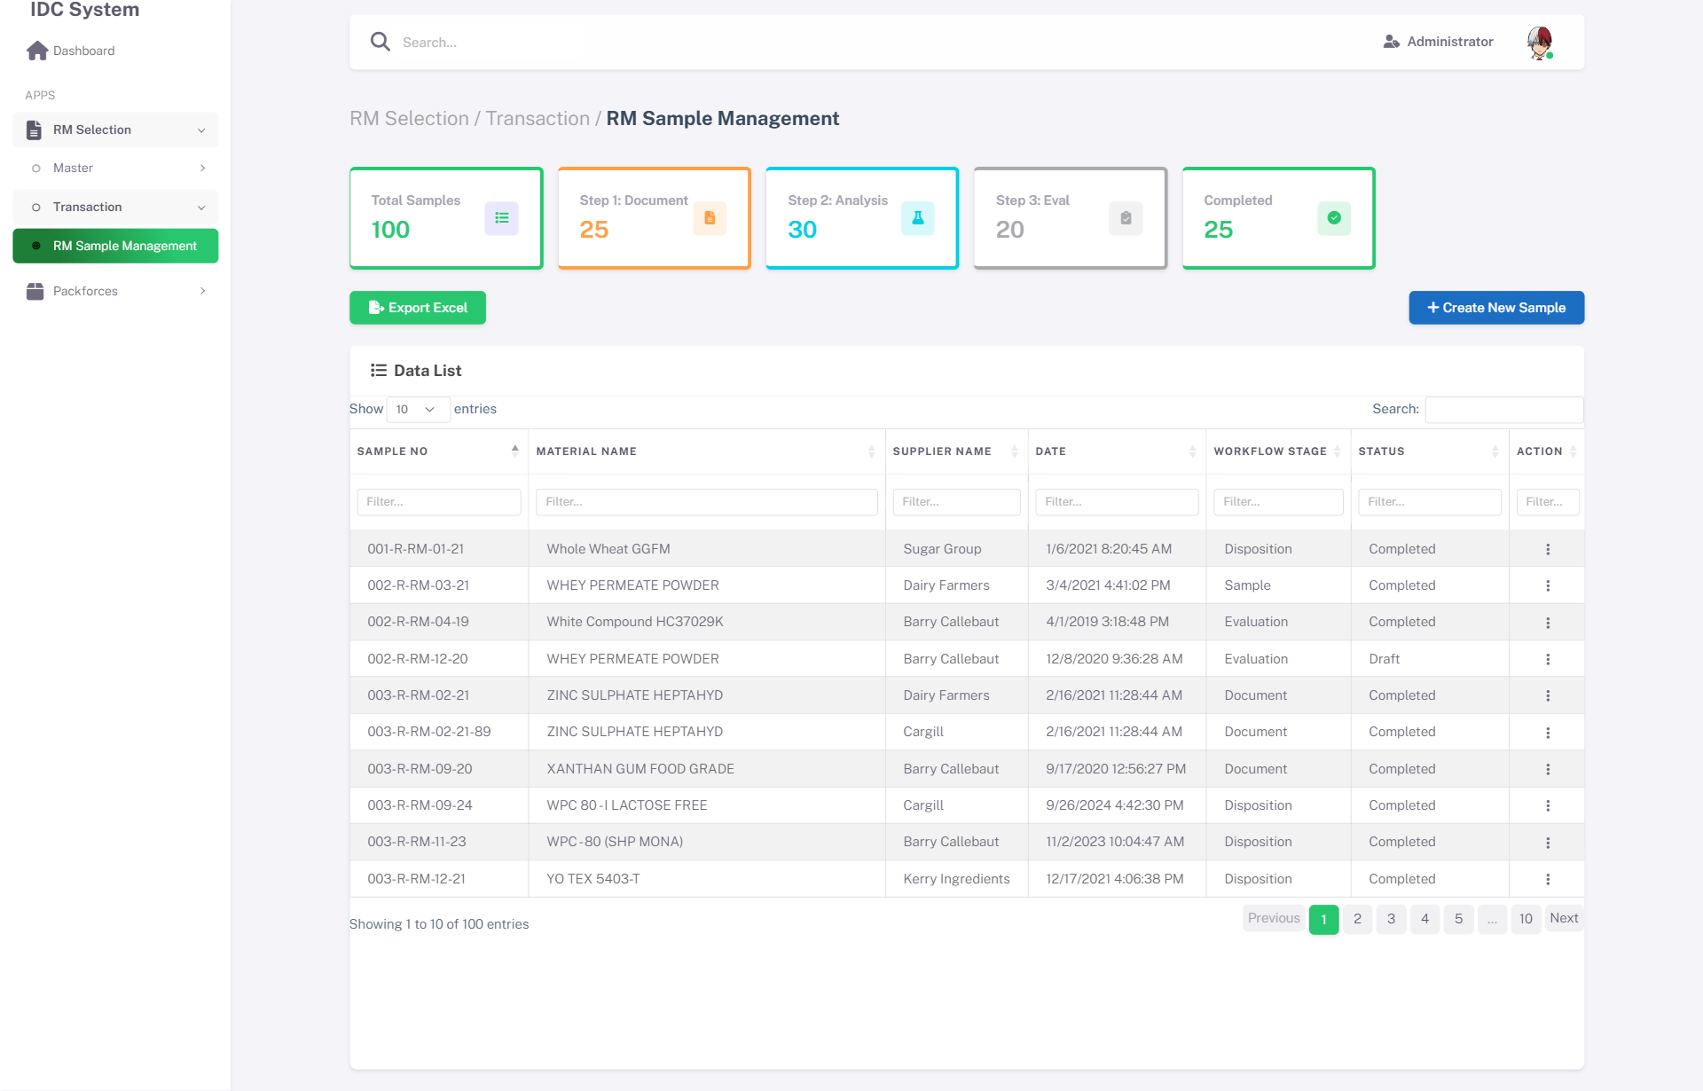
Index - DataTable View

3.1.3 Functional Description
No | Element | Type | Action / Behavior | Data Source
1 | Summary Cards | Display | Menampilkan jumlah: Total, Pending, Approved, Rejected, On Hold | Query COUNT GROUP BY status dari trRMSample_Header
2 | Btn New | Button | Buka halaman detail baru, status = Draft | -
3 | Search - Date Range | DatePicker | Filter data berdasarkan range tanggal sample | Field dtSampleDate
4 | Search - Status | Dropdown | Filter data berdasarkan status | Field intStatusId
5 | Search - Supplier | Text Input | Filter berdasarkan nama supplier | Field txtSupplierName
6 | Search - Material | Text Input | Filter berdasarkan nama material | Field txtMaterialName
7 | DataTable | Grid | Menampilkan list data dengan paging, sorting | API: /api/NewRMSample/List
8 | Btn View | Button (per-row) | Buka detail dalam mode read-only | Navigate ke Detail page by intId
9 | Btn Edit | Button (per-row) | Buka detail dalam mode edit | Navigate ke Detail page by intId
10 | Btn Delete | Button (per-row) | Confirm dialog → soft delete (bitActive = 0) | API: /api/NewRMSample/Delete/{id}
Kolom DataTable:
No | Column | Description | Sortable | Searchable
1 | Sample No | Nomor sample (SMPL-YYYY-XXXX) | Ya | Ya
2 | Material Name | Nama material dari supplier | Ya | Ya
3 | Supplier Name | Nama supplier | Ya | Ya
4 | Sample Date | Tanggal penerimaan sample | Ya | Ya
5 | Status | Badge status (Draft/Pending/Approved/Rejected) | Ya | Ya
6 | Progress | Step terakhir yang diselesaikan (1-4) | Ya | Tidak
7 | Actions | Buttons: View, Edit, Delete | Tidak | Tidak

3.1.4 Business Rules & Validation
A. RBAC & Status Permission
Role | Aksi | Kondisi
RA (Regulatory Affairs) | New, View, Edit, Delete | Status = Draft
RA | View | Status selain Draft
PCD | View | Semua status
PCD | Approve, Reject | Status = Waiting Approval
Admin | Full Access | Semua status
B. Business Logic
No | Condition | Action
1 | User klik Btn Delete | Tampilkan SweetAlert confirm: “Apakah Anda yakin menghapus data ini?”
2 | Status = Approved/Rejected | Btn Edit dan Btn Delete di-hide pada row tersebut
3 | DataTable load pertama kali | Default filter: 30 hari terakhir, semua status

3.2 DETAIL PAGE — Step 1: Document Sample

3.2.1 Deskripsi
Navigation: Sidebar > RM Selection > New RM Sample > Klik New / Edit > Step 1
Halaman detail step 1 untuk mendokumentasikan penerimaan sample dari supplier. Berisi header information (Type Document, Currency, UOM, PIC), material details, allergen checklist, carry over BTP table, dan document upload section. Halaman ini merupakan step pertama dari wizard 4-step.

3.2.2 Screenshot
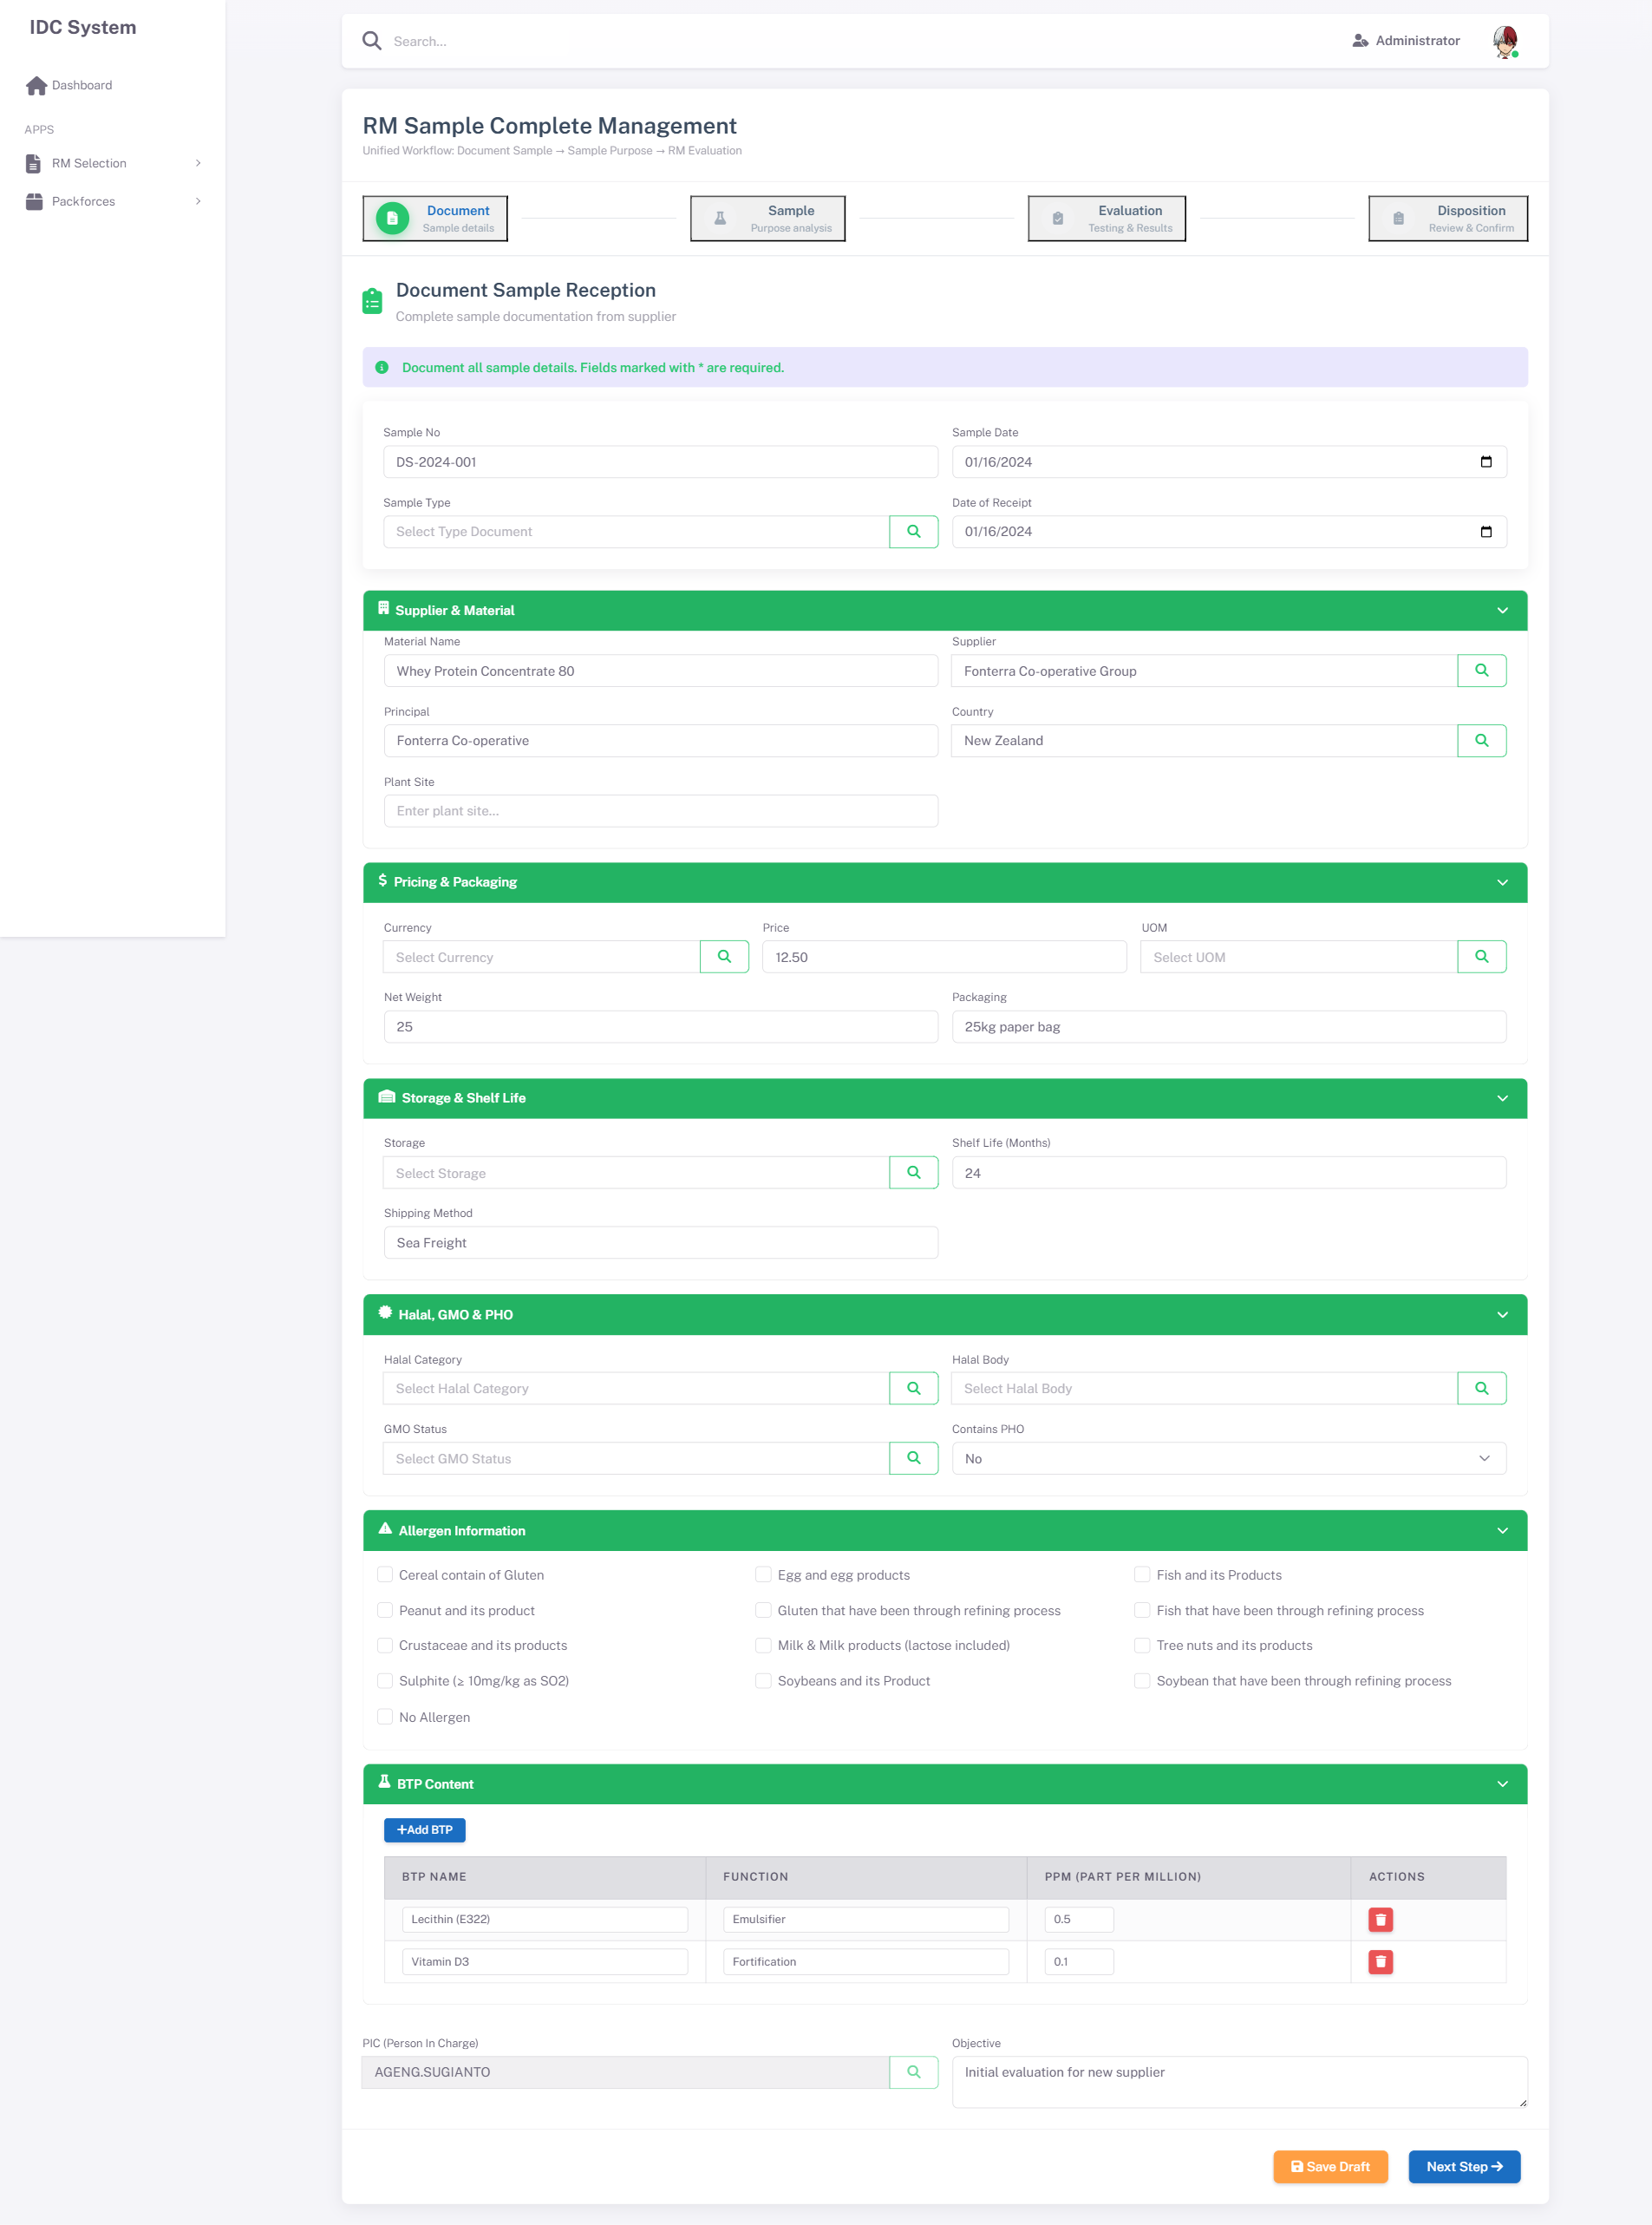
Step 1 - Header & Basic Information
Step 1 - Material Details
Step 1 - Material Details
Step 1 - Allergen Checklist
Step 1 - Allergen Checklist
Step 1 - Carry Over BTP Table
Step 1 - Carry Over BTP Table
Step 1 - Document Upload Section
Step 1 - Document Upload Section

3.2.3 Functional Description
Implementasi v1.7: Semua tombol LOV di Step 1 menggunakan mekanisme app.openLOV(modalId, renderFn) yang meng-inject modal ke DOM secara dinamis, bypassing konflik Bootstrap data-toggle.
A. Header Information
No | Element | Type | Action / Behavior | Data Source
1 | Sample No | Display (auto) | Auto-generate saat pertama kali save: SMPL-YYYY-XXXX | Sequence dari trRMSample_Header
2 | Sample Date | DatePicker | Pilih tanggal sample | -
3 | LOV Type Document | LOV Modal | Klik 🔍 → app.openLOV('lovTypeModal') → buka modal, pilih row, auto-fill nama ke txtTypeDocument | mAppParam.docTypes (static, extendable ke DB)
4 | Date of Receipt | DatePicker | Pilih tanggal penerimaan sample | -
B. Supplier & Material Information
No | Element | Type | Action / Behavior | Data Source
5 | Material Name | Text Input | Input manual, max 200 char | -
6 | LOV Supplier | LOV Modal | Klik 🔍 → app.openLOV('lovSupplierModal') → pilih row → auto-fill DocumentSample_intSupplierId + DocumentSample_txtSupplierName | Table: mSupplier WHERE bitActive = 1
7 | Principal | Text Input | Input manual | -
8 | LOV Country of Origin | LOV Modal | Klik 🔍 → app.openLOV('lovCountryModal') → pilih row → auto-fill DocumentSample_intCountryId + DocumentSample_txtCountryName | Table: mCountry WHERE bitActive = 1
9 | Plant Site | Text Input | Input manual, opsional | -
C. Pricing & Packaging
No | Element | Type | Action / Behavior | Data Source
10 | LOV Currency | LOV Modal | Klik 🔍 → app.openLOV('lovCurrencyModal') → auto-fill code + nama | Table: mCurrency WHERE bitActive = 1
11 | Price | Decimal Input | Input harga per UOM, opsional | -
12 | LOV UOM | LOV Modal | Klik 🔍 → app.openLOV('lovUOMModal') → auto-fill code + nama | Table: mUOM WHERE bitActive = 1
13 | Net Weight | Number Input | Berat bersih, opsional | -
14 | Packaging | Text Input | Input manual | -
D. Storage & Shelf Life
No | Element | Type | Action / Behavior | Data Source
15 | LOV Storage Condition | LOV Modal | Klik 🔍 → app.openLOV('lovStorageModal', 'renderStorageLOV') → render & pilih → auto-fill DocumentSample_intStorageSampleId + DocumentSample_txtStorageCondition | app.storageLOVData (static list) / Table: mStorage
16 | Shelf Life (Months) | Number Input | Input manual, numeric > 0 | -
17 | Shipping Method | Text Input | Input manual, opsional | -
E. Halal, GMO & PHO
No | Element | Type | Action / Behavior | Data Source
18 | LOV Halal Category | LOV Modal | Klik 🔍 → app.openLOV('lovHalalCatModal', 'renderHalalCatLOV') → pilih → auto-fill Halal_txtHalalCode + Halal_txtHalalDesc | app.halalCatData / Table: mHalalCategory
19 | LOV Halal Body | LOV Modal | Klik 🔍 → app.openLOV('lovHalalBodyModal', 'renderHalalBodyLOV') → pilih → auto-fill Halal_txtHalalBodyId + Halal_txtHalalBodyInst | app.halalBodyData / Table: mHalalBody
20 | LOV GMO Status | LOV Modal | Klik 🔍 → app.openLOV('lovGMOStatusModal', 'renderGmoStatusLOV') → pilih → auto-fill Halal_txtGMOStatusCode + Halal_txtGMOStatusDesc | app.gmoStatusData (static: GMO / Non-GMO / N/A)
21 | Contains PHO | Select | Dropdown: Yes / No | Static
F. LOV PIC
No | Element | Type | Action / Behavior | Data Source
22 | LOV PIC | LOV Modal (Disabled) | Auto-filled dari session user login. Field & tombol di-disable untuk data integrity | Table: mPegawai WHERE bitActive = 1
C. Allergen Checklist
No | Element | Type | Action / Behavior | Data Source
23 | Allergen Checkboxes (14 item) | Checkbox Group | Multiple select. Jika “Not contain allergen” di-check, checkbox lain di-uncheck secara otomatis | Static list: 14 allergen types
24 | Btn Select All | Button | Check semua allergen kecuali “Not contain allergen” | -
25 | Btn Clear All | Button | Uncheck semua allergen | -
D. Carry Over BTP Table
No | Element | Type | Action / Behavior | Data Source
26 | Btn Add Row | Button | Tambah row baru ke table BTP | -
27 | BTP Name | Text Input (per-row) | Input nama BTP | -
28 | Function | Text Input (per-row) | Input fungsi BTP | -
29 | Percentage (ppm) | Decimal Input (per-row) | Input persentase, format decimal | -
30 | Btn Delete Row | Button (per-row) | Hapus row dari table. Confirm dialog | -
E. Document Upload
No | Element | Type | Action / Behavior | Data Source
31 | Btn Add Document | Button | Buka modal addAttachmentModal | -
32 | Document List Table | Grid | Tampilkan list dokumen yang sudah diupload | Child table: trDocumentSample_Document
33 | Btn Download | Button (per-row) | Download file attachment | File storage path
34 | Btn Delete Document | Button (per-row) | Hapus dokumen. Confirm dialog | -
F. Navigation Buttons (Footer)
No | Element | Type | Action / Behavior | Data Source
35 | Btn Previous | Button | Disabled di Step 1 | -
36 | Btn Save Draft | Button | Simpan data sebagai Draft tanpa validasi wajib | API: /api/NewRMSample/SaveDraft
37 | Btn Next | Button | Validasi field wajib → jika lolos, pindah ke Step 2 | -

3.2.4 Business Rules & Validation
A. RBAC & Status Permission
Role | Draft | Waiting Approval | Approved | Rejected
RA | View, Edit, Save, Next | View only | View only | View, Edit (re-submit)
PCD | View only | View, Approve, Reject | View only | View only
Admin | Full Access | Full Access | Full Access | Full Access
B. Field Validation (on Next / Submit)
No | Field | Rule | Error Message
1 | Type Document | Required | “Type Document wajib dipilih”
2 | Material Name | Required, max 200 char | “Material Name wajib diisi”
3 | Principal Name | Required | “Principal Name wajib diisi”
4 | Supplier Name | Required | “Supplier Name wajib diisi”
5 | Shelf Life | Required, numeric, > 0 | “Shelf Life harus angka lebih dari 0”
6 | Packaging | Required | “Packaging wajib diisi”
7 | Storage Condition | Required | “Storage Condition wajib dipilih”
8 | Position | Required | “Position wajib dipilih”
9 | Halal Category | Required | “Halal Category wajib dipilih”
10 | Halal Body | Required | “Halal Body wajib dipilih”
11 | Date Receipt | Required, format date | “Date Receipt wajib diisi”
12 | Currency | Required | “Currency wajib dipilih”
13 | UOM | Required | “UOM wajib dipilih”
14 | PIC | Required | “PIC wajib dipilih”
15 | GMO Status | Required | “GMO Status wajib dipilih”
16 | Country of Origin | Required | “Country of Origin wajib dipilih”
17 | Allergen | Min 1 item checked | “Pilih minimal 1 allergen atau ‘Not contain allergen’”
C. Business Logic
No | Condition | Action
1 | User check “Not contain allergen” | Semua allergen checkbox lainnya di-uncheck dan di-disable
2 | User uncheck “Not contain allergen” | Semua allergen checkbox kembali enabled
3 | Type Document = “RM(BTP)” | BTP table wajib diisi minimal 1 row. Tampilkan warning jika kosong saat Next
4 | Btn Save Draft diklik | Simpan semua data tanpa validasi required. Status tetap Draft
5 | Btn Next diklik | Jalankan semua validasi field. Jika gagal, scroll ke field pertama yang error
6 | Upload dokumen | File max 10 MB. Format: PDF, DOC, DOCX, XLS, XLSX, JPG, PNG
7 | PIC field | Auto-filled dari session user saat form pertama kali dibuka. Bisa di-override

3.3 DETAIL PAGE — Step 2: Sample Purpose

3.3.1 Deskripsi
Navigation: Sidebar > RM Selection > New RM Sample > Detail > Step 2
Halaman step 2 untuk mendefinisikan tujuan penggunaan sample, mapping ke kategori RM, item code, dan produk target. User harus menentukan purpose type, objective, dan mapping product yang akan menggunakan material ini.

3.3.2 Screenshot
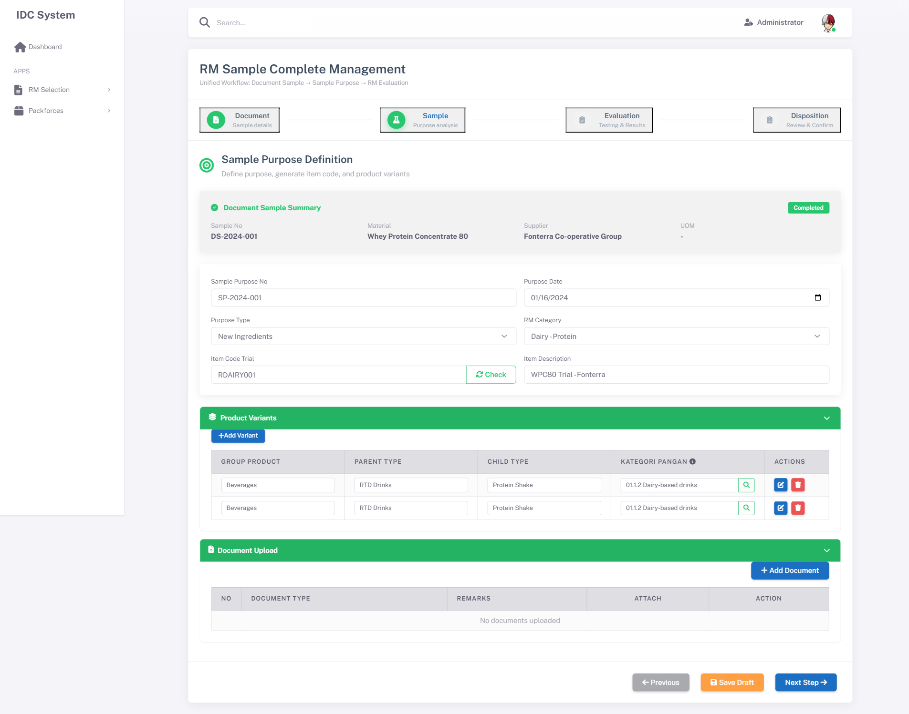
Step 2 - Category & Purpose
Step 2 - Item Mapping
Step 2 - Item Mapping
Step 2 - Apply To Product Table
Step 2 - Apply To Product Table

3.3.3 Functional Description
No | Element | Type | Action / Behavior | Data Source
1 | Sample No | Display | Read-only, dari Step 1 | trRMSample_Header.txtSampleNo
2 | LOV Category Code | LOV Modal | Pilih kategori RM → auto-fill Category Name, Sub Code, Sub Name | Table: mRMCategory WHERE bitActive = 1
3 | Category Name | Display | Auto-filled saat Category Code dipilih | mRMCategory.txtCategoryName
4 | Sub Code | Display | Auto-filled | mRMCategory.txtSubCode
5 | Sub Name | Display | Auto-filled | mRMCategory.txtSubName
6 | Sample Purpose Type | Dropdown | Pilih tipe: New Ingredients / Alternative / Reformulation / Cost Saving | Static list
7 | Item Trial | Text Input | Input kode item trial (untuk new ingredients) | -
8 | Item Trial Desc | Text Input | Deskripsi item trial | -
9 | LOV Item Code Existing | LOV Modal | Pilih item code existing → auto-fill description | Table: item master (existing system)
10 | Item Description | Display | Auto-filled dari Item Code Existing | -
11 | Objective | TextArea | Input tujuan penggunaan sample, max 500 char | -
12 | Btn Add Product | Button | Tambah row ke Apply To Product table | -
13 | LOV Group Product Type | LOV Modal (per-row) | Pilih group product → auto-fill nama | Table: product type master
14 | LOV Child Product Type | LOV Modal (per-row) | Pilih child product, filtered by group | Table: product type master (filtered)
15 | LOV Variant | LOV Modal (per-row) | Pilih variant, filtered by child | Table: variant master (filtered)
16 | BTP Calculation | Decimal (per-row) | Input nilai carry over BTP calculation | -
17 | Btn Delete Product | Button (per-row) | Hapus row dari product table. Confirm dialog | -
18 | Btn Previous | Button | Kembali ke Step 1 | -
19 | Btn Save Draft | Button | Simpan tanpa validasi | API: /api/NewRMSample/SaveDraft
20 | Btn Next | Button | Validasi → pindah ke Step 3 | -

3.3.4 Business Rules & Validation
A. RBAC & Status Permission
Sama dengan Step 1 (lihat Section 3.2.4).
B. Field Validation (on Next)
No | Field | Rule | Error Message
1 | Category Code | Required | “Category Code wajib dipilih”
2 | Sample Purpose Type | Required | “Sample Purpose Type wajib dipilih”
3 | Item Trial ATAU Item Code Existing | Salah satu wajib diisi | “Item Trial atau Item Code Existing wajib diisi”
4 | Objective | Required, max 500 char | “Objective wajib diisi”
5 | Apply To Product | Min 1 row | “Tambahkan minimal 1 product”
C. Business Logic
No | Condition | Action
1 | Purpose Type = “New Ingredients” | Field Item Trial aktif, Item Code Existing di-disable
2 | Purpose Type = “Alternative” | Field Item Code Existing aktif (LOV), Item Trial di-disable
3 | Group Product Type dipilih | Filter Child Product Type berdasarkan group yang dipilih
4 | Child Product Type dipilih | Filter Variant berdasarkan child yang dipilih

3.4 DETAIL PAGE — Step 3: RM Evaluation

3.4.1 Deskripsi
Navigation: Sidebar > RM Selection > New RM Sample > Detail > Step 3
Halaman step 3 untuk evaluasi teknis dan hasil pengujian laboratorium. Terdiri dari 6 sub-tab: Organoleptic, Nutrition & Physical, Microbiological, Heavy Metals, Other Contaminant, dan Food Category. Setiap tab memiliki tabel parameter yang sama strukturnya.

3.4.2 Screenshot
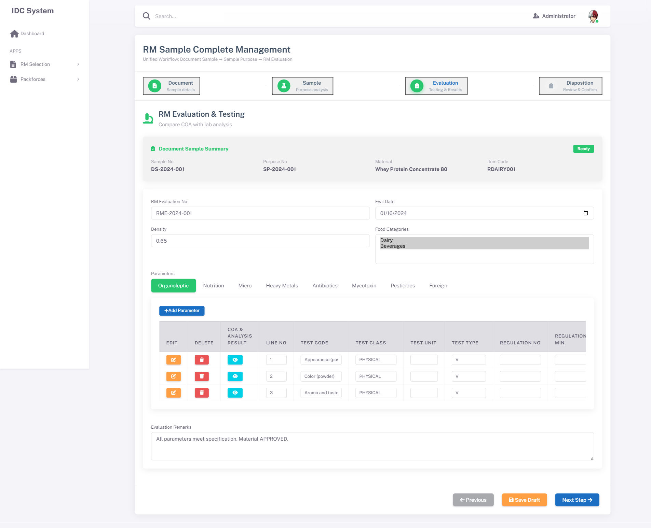
Step 3 - Tab Organoleptic
Step 3 - Tab Nutrition
Step 3 - Tab Nutrition
Step 3 - Tab Microbiological
Step 3 - Tab Microbiological
Step 3 - Tab Heavy Metals
Step 3 - Tab Heavy Metals
Step 3 - Tab Other Contaminant
Step 3 - Tab Other Contaminant
Step 3 - Tab Food Category
Step 3 - Tab Food Category

3.4.3 Functional Description
A. Tab Navigation
No | Tab Name | Deskripsi
1 | Organoleptic | Parameter: Appearance, Color, Odor, Taste, Texture
2 | Nutrition & Physical | Parameter: Protein, Fat, Moisture, Ash, pH, Water Activity, dll
3 | Microbiological | Parameter: TPC, E.coli, Salmonella, Yeast & Mold, Coliform, dll
4 | Heavy Metals | Parameter: Pb (Lead), Cd (Cadmium), Hg (Mercury), As (Arsenic), Sn (Tin)
5 | Other Contaminant | Parameter: Pesticide, Mycotoxin, Aflatoxin, Melamine, dll
6 | Food Category | Mapping ke kategori pangan (BPOM, FDA, dll)
B. Parameter Table (berlaku untuk Tab 1-5)
No | Element | Type | Action / Behavior | Data Source
1 | Btn Add Parameter | Button | Tambah row parameter baru | -
2 | Line No | Display (per-row) | Auto-generated sequence number (1, 2, 3…) | -
3 | Btn Select Test | Button (per-row) | Buka modal LOV parameter uji | -
4 | Test Code | Text IO (Read-only) | Auto-filled dari LOV Selection | Table: mParameter
5 | Test Class | Text IO (Read-only) | Auto-filled dari LOV Selection | mParameter.txtTestClass
6 | Test Method | Text IO (Read-only) | Auto-filled dari LOV Selection | mParameter.txtTestMethod
7 | Test Unit | Text IO (Read-only) | Auto-filled dari LOV Selection | mParameter.txtTestUnit
8 | Regulation No | Text Input (per-row) | Input nomor regulasi acuan | -
9 | Regulation Min | Decimal (per-row) | Batas minimum regulasi | -
10 | Regulation Max | Decimal (per-row) | Batas maximum regulasi | -
11 | Spec Supplier Min/Max | Decimal (per-row) | Spesifikasi dari supplier (dari COA) | -
12 | COA Result | Decimal (per-row) | Hasil dari Certificate of Analysis | Input manual / import
13 | Analysis Result | Decimal (per-row) | Hasil analisa laboratorium internal | Input manual
14 | Spec SHP Min/Max | Decimal (per-row) | Spesifikasi SHP | -
15 | Target | Dropdown (LOV) | Pilih: Conform / Not Conform / N/A | Static list
16 | Btn Delete Row | Button (per-row) | Hapus parameter. Confirm dialog | -
17 | Btn View COA & Analysis | Button (per-row) | Buka modal perbandingan COA vs Analysis Result | -
C. Food Category Tab (Tab 6)
No | Element | Type | Action / Behavior | Data Source
17 | Btn Add Category | Button | Tambah row food category | -
18 | LOV Food Category | LOV Modal (per-row) | Pilih kategori pangan | Table: mFoodCategory WHERE bitActive = 1
19 | Category Name | Display (per-row) | Auto-filled | mFoodCategory.txtCategoryName
20 | Regulation Body | Display (per-row) | Auto-filled: BPOM / FDA / dll | mFoodCategory.txtRegulationBody
21 | Btn Delete | Button (per-row) | Hapus mapping. Confirm dialog | -
D. Navigation Buttons
No | Element | Type | Action / Behavior | Data Source
22 | Btn Previous | Button | Kembali ke Step 2 | -
23 | Btn Save Draft | Button | Simpan tanpa validasi | API: /api/NewRMSample/SaveDraft
24 | Btn Next | Button | Validasi → pindah ke Step 4 | -

3.4.4 Business Rules & Validation
A. RBAC & Status Permission
Sama dengan Step 1 (lihat Section 3.2.4).
B. Field Validation (on Next)
No | Field | Rule | Error Message
1 | Tab Organoleptic | Min 1 parameter | “Tambahkan minimal 1 parameter Organoleptic”
2 | Tab Nutrition | Min 1 parameter | “Tambahkan minimal 1 parameter Nutrition”
3 | COA Result (setiap row) | Numeric | “COA Result harus berupa angka”
4 | Analysis Result (setiap row) | Numeric | “Analysis Result harus berupa angka”
5 | Food Category | Min 1 category | “Tambahkan minimal 1 Food Category”
C. Business Logic
No | Condition | Action
1 | Parameter ditambahkan ke tab | Overall Score di-recalculate otomatis
2 | Analysis Result > Regulation Max | Highlight row dengan warna merah (warning)
3 | Analysis Result < Regulation Min | Highlight row dengan warna merah (warning)
4 | COA Result dan Analysis Result keduanya diisi | Enable tombol “View COA & Analysis” untuk perbandingan
5 | Tab switch | Data pada tab sebelumnya otomatis di-preserve (tidak hilang)

3.5 DETAIL PAGE — Step 4: Disposition

3.5.1 Deskripsi
Navigation: Sidebar > RM Selection > New RM Sample > Detail > Step 4
Halaman step 4 (terakhir) untuk keputusan akhir terhadap sample. Menampilkan Overall Score dari evaluasi, field rekomendasi, keputusan (Approved/Rejected/On Hold), dan workflow approval. Setelah submit, status sample berubah sesuai keputusan.

3.5.2 Screenshot
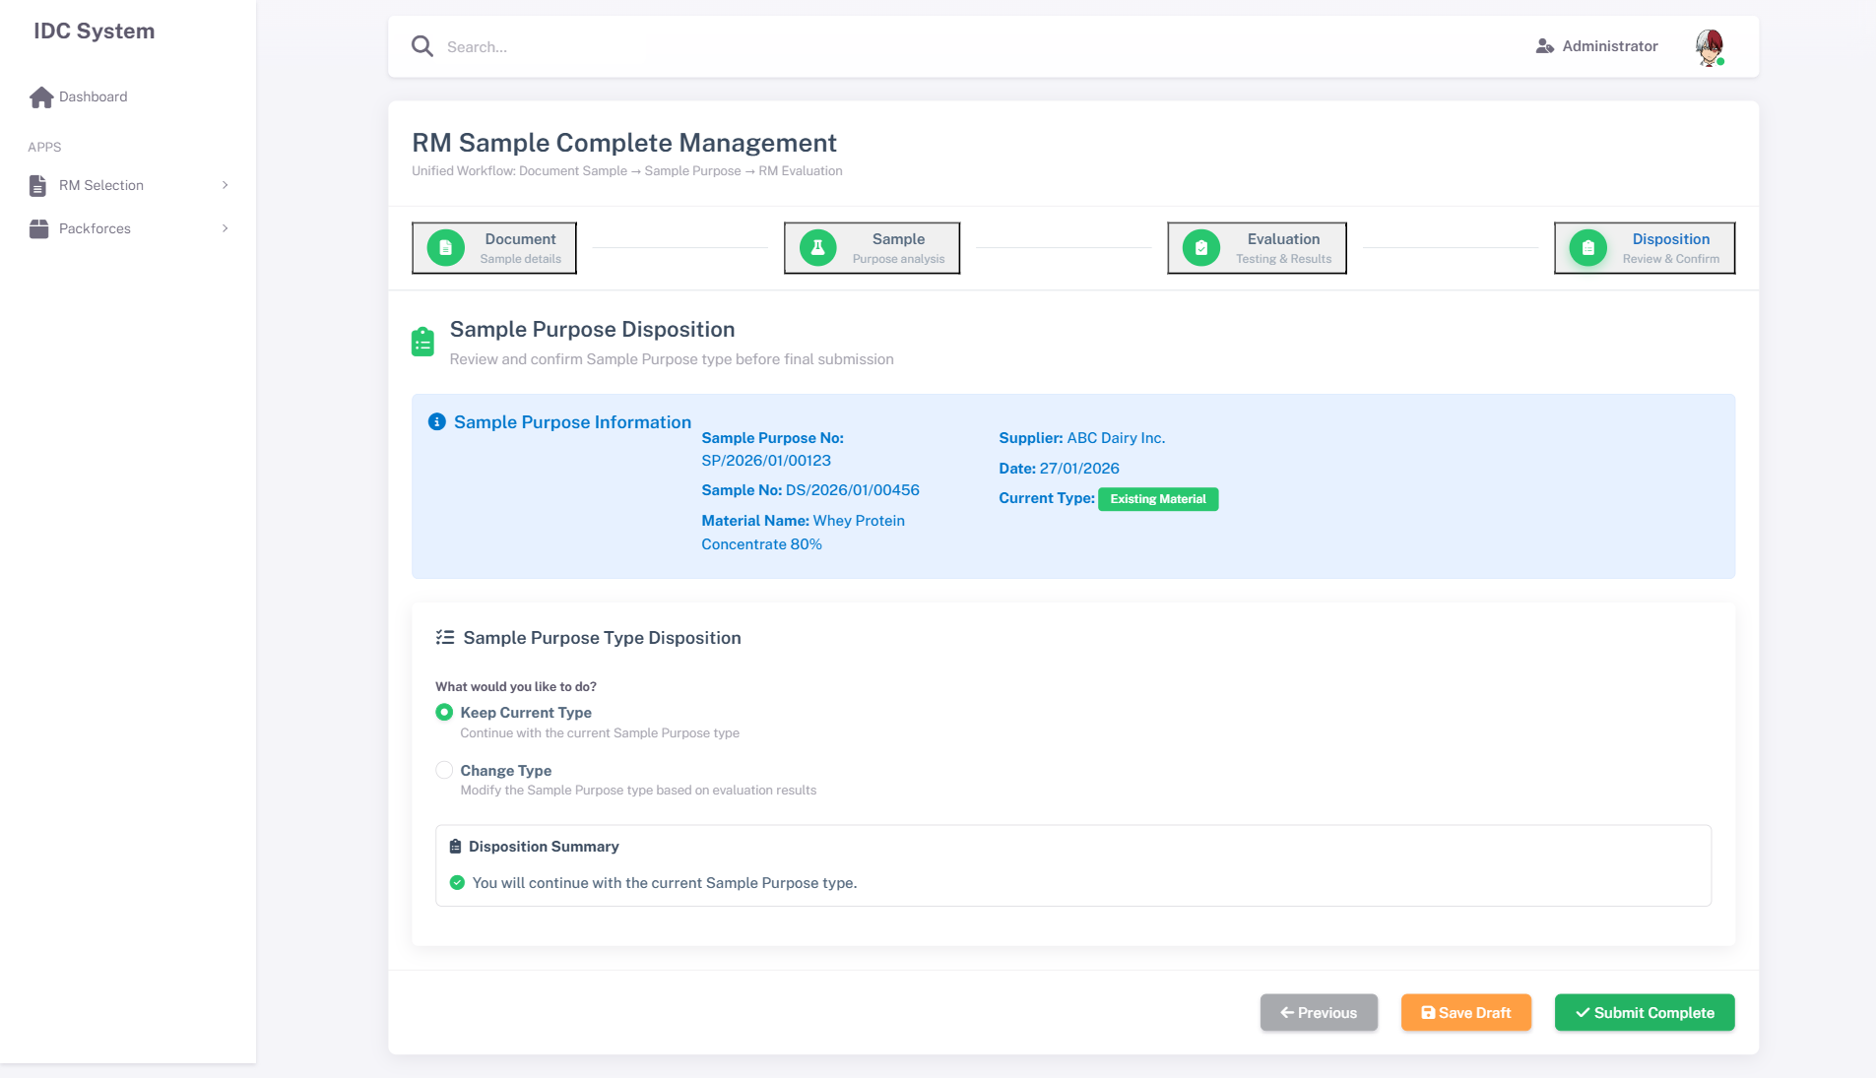
Step 4 - Disposition Form
Step 4 - Action Buttons
Step 4 - Action Buttons

3.5.3 Functional Description
No | Element | Type | Action / Behavior | Data Source
1 | Overall Score | Display | Read-only, calculated dari semua parameter Step 3 | Calculated field
2 | Recommendation | TextArea | Input rekomendasi evaluator, max 1000 char | -
3 | Decision | Radio Button | Pilih: Approved / Rejected / On Hold | -
4 | Reason | TextArea | Input alasan keputusan | -
5 | Approval Required | Checkbox | Centang jika memerlukan approval dari atasan | -
6 | LOV Approver | LOV Modal | Pilih approver. Hanya muncul jika Approval Required = checked | Table: mPegawai WHERE txtPositionCode IN ('MGR','GM') AND bitActive = 1
7 | Approval Notes | TextArea | Catatan untuk approver (opsional) | -
8 | Btn Previous | Button | Kembali ke Step 3 | -
9 | Btn Save Draft | Button | Simpan tanpa validasi | API: /api/NewRMSample/SaveDraft
10 | Btn Next | Button | Disabled di Step 4 | -
11 | Btn Submit | Button | Visible hanya di Step 4. Submit final dengan full validation | API: /api/NewRMSample/Submit

3.5.4 Business Rules & Validation
A. RBAC & Status Permission
Role | Draft | Waiting Approval | Approved | Rejected
RA | View, Edit, Save, Submit | View only | View only | View, Edit, Re-submit
PCD | View only | View, Approve, Reject | View only | View only
Admin | Full Access | Full Access | Full Access | Full Access
B. Field Validation (on Submit)
No | Field | Rule | Error Message
1 | Recommendation | Required, max 1000 char | “Recommendation wajib diisi”
2 | Decision | Required, pilih salah satu | “Decision wajib dipilih”
3 | Reason | Required jika Decision = Rejected / On Hold | “Reason wajib diisi untuk keputusan Rejected/On Hold”
4 | Approver | Required jika Approval Required = checked | “Approver wajib dipilih jika Approval Required dicentang”
5 | Step 1-3 | Semua step harus complete | “Lengkapi semua step sebelum submit”
C. Business Logic
No | Condition | Action
1 | Decision = “Approved” + Approval Required = unchecked | Status langsung berubah ke Approved. Kirim email notifikasi ke Creator
2 | Decision = “Approved” + Approval Required = checked | Status berubah ke Waiting Approval. Kirim email notifikasi ke Approver
3 | Decision = “Rejected” | Status berubah ke Rejected. Reason wajib diisi. Kirim email ke Creator
4 | Decision = “On Hold” | Status berubah ke On Hold. Reason wajib diisi. Sample dikembalikan ke Step 3 untuk evaluasi tambahan
5 | Approver klik Approve (dari Index page) | Status berubah ke Approved. Kirim email ke Creator
6 | Approver klik Reject (dari Index page) | Status berubah ke Rejected. Wajib input rejection notes. Kirim email ke Creator
7 | Status = Rejected | RA dapat Edit dan Re-submit. Status kembali ke Draft

3.6 MODALS

3.6.1 Modal — Add Document
Deskripsi: Modal untuk upload dokumen pendukung pada Step 1. Dipanggil dari Btn Add Document.
Functional Description:
No | Element | Type | Action / Behavior | Data Source
1 | Document Type | Dropdown | Pilih tipe: Specification, COA, Halal Certificate, Price List, Regulation, Flow Process | Static list
2 | Spec/Certificate No | Text Input | Nomor dokumen spesifikasi atau sertifikat | -
3 | Expired Date | DatePicker | Tanggal kadaluarsa dokumen (untuk sertifikat) | -
4 | Remarks | TextArea | Catatan tambahan | -
5 | File Attachment | File Input | Upload file. Max 10 MB. Format: PDF, DOC, DOCX, XLS, XLSX, JPG, PNG | -
6 | Btn Save | Button | Validasi → simpan dokumen ke list | -
7 | Btn Cancel | Button | Tutup modal tanpa simpan | -
Validation:
No | Field | Rule | Error Message
1 | Document Type | Required | “Document Type wajib dipilih”
2 | File Attachment | Required | “File wajib di-upload”
3 | File Size | Max 10 MB | “Ukuran file maksimal 10 MB”
4 | File Extension | Hanya PDF, DOC, DOCX, XLS, XLSX, JPG, PNG | “Format file tidak didukung”

3.6.2 Modal — LOV Type Document
Deskripsi: Modal LOV untuk memilih jenis dokumen sample pada Step 1.
Modal LOV Type Document
Modal LOV Type Document
No | Element | Type | Action / Behavior | Data Source
1 | Search Input | Text | Filter data berdasarkan keyword | -
2 | DataTable | Grid | Tampilkan list type document | Table: mTypeDocument WHERE bitActive = 1
3 | Btn Select (per-row) | Button | Pilih row → auto-fill field Type Document di parent form, tutup modal | -
4 | Btn Close | Button | Tutup modal tanpa memilih | -

3.6.3 Modal — LOV Currency
Deskripsi: Modal LOV untuk memilih mata uang pada Step 1.
No | Element | Type | Action / Behavior | Data Source
1 | Search Input | Text | Filter data berdasarkan keyword | -
2 | DataTable | Grid | Tampilkan list currency (20+ mata uang) | Table: mCurrency WHERE bitActive = 1
3 | Btn Select (per-row) | Button | Pilih row → auto-fill Currency Code + Name di parent form | -
4 | Btn Close | Button | Tutup modal tanpa memilih | -

3.6.4 Modal — LOV UOM
Deskripsi: Modal LOV untuk memilih unit of measure pada Step 1.
No | Element | Type | Action / Behavior | Data Source
1 | Search Input | Text | Filter data berdasarkan keyword | -
2 | DataTable | Grid | Tampilkan list UOM | Table: mUOM WHERE bitActive = 1
3 | Btn Select (per-row) | Button | Pilih row → auto-fill UOM Code + Name di parent form | -
4 | Btn Close | Button | Tutup modal tanpa memilih | -

4. STRUKTUR DATABASE

4.1 Konvensi Penamaan
[!IMPORTANT] PK/FK Convention yang disepakati: - PK di tabel sendiri → intId (INT IDENTITY, auto-increment) + txtId (VARCHAR(50), GUID) - FK di tabel lain → nama descriptive, e.g. intSampleHeaderId merujuk ke trRMSample_Header.intId (hanya intId, tanpa txtId) - Table names: tr{ModuleName}_{Type} (contoh: trRMSample_Header) - Column names: Hungarian notation dengan prefix int, txt, dec, dt, dtm, bit - Audit columns: txtCreatedBy, dtmCreatedDate, txtUpdatedBy, dtmUpdatedDate, bitActive - Denormalized columns: LOV names disimpan bersama ID-nya (e.g. intSupplierId + txtSupplierName) - Database: SQL Server (IDC_Formulation) - DDL Script: idc-system/Database/Scripts/03_Step1_DocumentSample_DDL.sql

4.2 Entity Relationship Diagram (ERD)
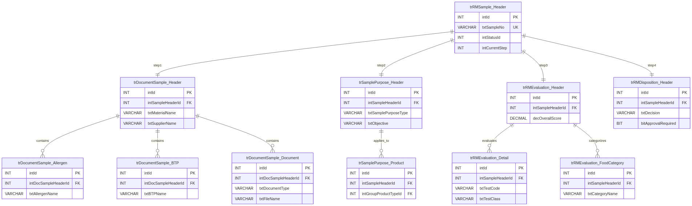
Entity Relationship Diagram - New RM Sample Database
Mermaid Source Code (klik untuk expand)
erDiagram
trRMSample_Header ||--|| trDocumentSample_Header : "step1"
trRMSample_Header ||--|| trSamplePurpose_Header : "step2"
trRMSample_Header ||--|| trRMEvaluation_Header : "step3"
trRMSample_Header ||--|| trRMDisposition_Header : "step4"
trDocumentSample_Header ||--o{ trDocumentSample_Allergen : "contains"
trDocumentSample_Header ||--o{ trDocumentSample_BTP : "contains"
trDocumentSample_Header ||--o{ trDocumentSample_Document : "contains"
trSamplePurpose_Header ||--o{ trSamplePurpose_Product : "applies_to"
trRMEvaluation_Header ||--o{ trRMEvaluation_Detail : "evaluates"
trRMEvaluation_Header ||--o{ trRMEvaluation_FoodCategory : "categorizes"
trRMSample_Header {
INT intId PK
VARCHAR txtId UK_GUID
VARCHAR txtSampleNo UK
INT intStatusId
INT intCurrentStep
VARCHAR txtCreatedBy
DATETIME dtmCreatedDate
}
trDocumentSample_Header {
INT intId PK
VARCHAR txtId UK_GUID
INT intSampleHeaderId FK
INT intTypeDocumentId FK
VARCHAR txtMaterialName
VARCHAR txtPrincipalName
INT intSupplierId FK
VARCHAR txtSupplierName
INT intStorageId FK
VARCHAR txtHalalCategoryCode
INT intHalalBodyId FK
VARCHAR txtCurrencyCode
VARCHAR txtUOMCode
DECIMAL decPricePerUOM
INT intPegawaiId FK
VARCHAR txtGMOStatus
VARCHAR intCountryId FK
BIT bitContainPHO
}
trDocumentSample_Allergen {
INT intId PK
VARCHAR txtId UK_GUID
INT intSampleHeaderId FK
INT intDocSampleHeaderId FK
VARCHAR txtAllergenCode
VARCHAR txtAllergenName
BIT bitIsChecked
}
trDocumentSample_BTP {
INT intId PK
VARCHAR txtId UK_GUID
INT intSampleHeaderId FK
INT intDocSampleHeaderId FK
VARCHAR txtBTPName
VARCHAR txtFunctionName
DECIMAL decPercentagePPM
}
trDocumentSample_Document {
INT intId PK
VARCHAR txtId UK_GUID
INT intSampleHeaderId FK
INT intDocSampleHeaderId FK
VARCHAR txtDocumentType
VARCHAR txtFileName
VARCHAR txtFilePath
DATE dtExpiredDate
}
trSamplePurpose_Header {
INT intId PK
VARCHAR txtId UK_GUID
INT intSampleHeaderId FK
INT intRMCategoryId FK
VARCHAR txtSamplePurposeType
VARCHAR txtItemCodeTrial
VARCHAR txtItemCodeExisting
VARCHAR txtObjective
}
trSamplePurpose_Product {
INT intId PK
VARCHAR txtId UK_GUID
INT intSampleHeaderId FK
INT intGroupProductTypeId FK
INT intChildProductTypeId FK
INT intVariantId FK
}
trRMEvaluation_Header {
INT intId PK
VARCHAR txtId UK_GUID
INT intSampleHeaderId FK
DECIMAL decOverallScore
}
trRMEvaluation_Detail {
INT intId PK
VARCHAR txtId UK_GUID
INT intSampleHeaderId FK
INT intLineNo
VARCHAR txtTestCode
VARCHAR txtTestClass
VARCHAR txtCOAResult
VARCHAR txtAnalysisResult
}
trRMEvaluation_FoodCategory {
INT intId PK
VARCHAR txtId UK_GUID
INT intSampleHeaderId FK
INT intCategoryId FK
VARCHAR txtCategoryName
}
trRMDisposition_Header {
INT intId PK
VARCHAR txtId UK_GUID
INT intSampleHeaderId FK
VARCHAR txtRecommendation
VARCHAR txtDecision
VARCHAR txtDecisionReason
BIT bitApprovalRequired
INT intApproverId FK
}

4.3 Tabel Detail - Step 1: Document Sample
[!NOTE] Semua tabel di bawah sudah memiliki DDL script: idc-system/Database/Scripts/03_Step1_DocumentSample_DDL.sql

1. trRMSample_Header (NEW TABLE) - Main Unified Header
Column Name | Data Type | Nullable | Description
intId | INT IDENTITY | NOT NULL | PK, Auto-increment
txtId | VARCHAR(50) | NOT NULL | GUID, Unique
txtSampleNo | VARCHAR(50) | NOT NULL | Unique, Format: SMPL-YYYY-XXXX
intStatusId | INT | NOT NULL | 0=Draft, 1=InProgress, 2=WaitingApproval, 3=Approved, 4=Rejected, 5=OnHold
intCurrentStep | INT | NOT NULL | Step aktif (1-4), default: 1
txtCreatedBy | VARCHAR(100) | NOT NULL | User pembuat
dtmCreatedDate | DATETIME | NOT NULL | Tanggal buat (default: GETDATE())
txtUpdatedBy | VARCHAR(100) | NULL | User pengubah
dtmUpdatedDate | DATETIME | NULL | Tanggal ubah
bitActive | BIT | NOT NULL | Soft delete flag, default: 1

2. trDocumentSample_Header (NEW TABLE) - Step 1: Document Sample
Column Name | Data Type | Nullable | Description
intId | INT IDENTITY | NOT NULL | PK, Auto-increment
txtId | VARCHAR(50) | NOT NULL | GUID, Unique
intSampleHeaderId | INT | NOT NULL | FK → trRMSample_Header.intId
dtSampleDate | DATE | NOT NULL | Tanggal pembuatan
intTypeDocumentId | INT | NOT NULL | FK → master type document
txtTypeDocumentName | VARCHAR(100) | NULL | Denormalized: nama type document
txtMaterialName | VARCHAR(200) | NOT NULL | Nama material
txtProductionMethod | VARCHAR(200) | NULL | Metode produksi
txtPrincipalName | VARCHAR(200) | NOT NULL | Nama principal/manufacturer
intSupplierId | INT | NULL | FK → master supplier
txtSupplierName | VARCHAR(200) | NOT NULL | Nama supplier
intShelfLifeMonth | INT | NOT NULL | Masa simpan (bulan)
txtPackaging | VARCHAR(200) | NOT NULL | Kemasan
txtShippingMethod | VARCHAR(200) | NULL | Metode pengiriman
intStorageId | INT | NOT NULL | FK → mAppParam (IDC_STORAGE_CONDITION)
txtStorageCondition | VARCHAR(200) | NULL | Denormalized: deskripsi storage
intPositionId | INT | NULL | FK → master position
txtPositionName | VARCHAR(200) | NULL | Denormalized: nama posisi
txtHalalCategoryCode | VARCHAR(10) | NOT NULL | Kode kategori halal
txtHalalCategoryName | VARCHAR(200) | NULL | Denormalized: nama kategori halal
intHalalBodyId | INT | NOT NULL | FK → master halal body
txtHalalBodyName | VARCHAR(200) | NULL | Denormalized: nama lembaga halal
dtDateReceipt | DATE | NOT NULL | Tanggal terima
txtCurrencyCode | VARCHAR(10) | NOT NULL | Kode mata uang (IDR, USD, EUR, dll)
txtCurrencyName | VARCHAR(100) | NULL | Denormalized: nama currency
txtUOMCode | VARCHAR(10) | NOT NULL | Kode UOM (KG, LTR, dll)
txtUOMName | VARCHAR(100) | NULL | Denormalized: nama UOM
decPricePerUOM | DECIMAL(18,2) | NULL | Harga per UOM
decNetWeight | DECIMAL(18,4) | NULL | Berat bersih
intPegawaiId | INT | NOT NULL | FK → user/pegawai (PIC)
txtPegawaiName | VARCHAR(200) | NULL | Denormalized: nama PIC
txtGMOStatus | VARCHAR(50) | NOT NULL | Non GMO / GMO Free / PCR Negative
intCountryId | VARCHAR(10) | NULL | Kode negara (ID, NZ, AU, dll)
txtCountryName | VARCHAR(100) | NULL | Denormalized: nama negara
bitContainPHO | BIT | NOT NULL | 0=Tidak, 1=Mengandung PHO
txtCreatedBy | VARCHAR(100) | NOT NULL | User pembuat
dtmCreatedDate | DATETIME | NOT NULL | Tanggal buat
txtUpdatedBy | VARCHAR(100) | NULL | User pengubah
dtmUpdatedDate | DATETIME | NULL | Tanggal ubah
bitActive | BIT | NOT NULL | Soft delete flag

3. trDocumentSample_Allergen (NEW TABLE) - Allergen Information
Column Name | Data Type | Nullable | Description
intId | INT IDENTITY | NOT NULL | PK
txtId | VARCHAR(50) | NOT NULL | GUID, Unique
intSampleHeaderId | INT | NOT NULL | FK → trRMSample_Header.intId
intDocSampleHeaderId | INT | NOT NULL | FK → trDocumentSample_Header.intId
txtAllergenCode | VARCHAR(50) | NOT NULL | Kode allergen (CEREAL_GLUTEN, EGG, dll)
txtAllergenName | VARCHAR(200) | NOT NULL | Nama allergen
bitIsChecked | BIT | NOT NULL | 0=Tidak, 1=Checked
txtCreatedBy | VARCHAR(100) | NOT NULL | User pembuat
dtmCreatedDate | DATETIME | NOT NULL | Tanggal buat
txtUpdatedBy | VARCHAR(100) | NULL | User pengubah
dtmUpdatedDate | DATETIME | NULL | Tanggal ubah

4. trDocumentSample_BTP (NEW TABLE) - Carry Over BTP
Column Name | Data Type | Nullable | Description
intId | INT IDENTITY | NOT NULL | PK
txtId | VARCHAR(50) | NOT NULL | GUID, Unique
intSampleHeaderId | INT | NOT NULL | FK → trRMSample_Header.intId
intDocSampleHeaderId | INT | NOT NULL | FK → trDocumentSample_Header.intId
intLineNo | INT | NOT NULL | Nomor urut baris
txtBTPName | VARCHAR(200) | NOT NULL | Nama BTP
txtFunctionName | VARCHAR(200) | NOT NULL | Fungsi
decPercentagePPM | DECIMAL(18,4) | NOT NULL | Persentase dalam ppm
txtCreatedBy | VARCHAR(100) | NOT NULL | User pembuat
dtmCreatedDate | DATETIME | NOT NULL | Tanggal buat
txtUpdatedBy | VARCHAR(100) | NULL | User pengubah
dtmUpdatedDate | DATETIME | NULL | Tanggal ubah

5. trDocumentSample_Document (NEW TABLE) - Uploaded Documents
Column Name | Data Type | Nullable | Description
intId | INT IDENTITY | NOT NULL | PK
txtId | VARCHAR(50) | NOT NULL | GUID, Unique
intSampleHeaderId | INT | NOT NULL | FK → trRMSample_Header.intId
intDocSampleHeaderId | INT | NOT NULL | FK → trDocumentSample_Header.intId
txtDocumentType | VARCHAR(50) | NOT NULL | Specification/COA/Halal Certificate/Price List/Regulation/Flow Process
txtFileName | VARCHAR(255) | NOT NULL | Nama file original
txtFilePath | VARCHAR(500) | NOT NULL | Path file di server
txtFileExtension | VARCHAR(10) | NULL | Ekstensi file (pdf, jpg, docx)
intFileSize | INT | NULL | Ukuran file (bytes)
txtSpecNumber | VARCHAR(100) | NULL | Nomor spesifikasi
txtCertificateNo | VARCHAR(100) | NULL | Nomor sertifikat
dtExpiredDate | DATE | NULL | Tanggal expired
txtRemarks | VARCHAR(MAX) | NULL | Keterangan
dtUploadDate | DATETIME | NOT NULL | Tanggal upload
txtCreatedBy | VARCHAR(100) | NOT NULL | User pembuat
dtmCreatedDate | DATETIME | NOT NULL | Tanggal buat
txtUpdatedBy | VARCHAR(100) | NULL | User pengubah
dtmUpdatedDate | DATETIME | NULL | Tanggal ubah

4.4 Tabel Detail - Step 2: Sample Purpose
[!NOTE] DDL Script: idc-system/Database/Scripts/04_Step2_SamplePurpose_DDL.sql

6. trSamplePurpose_Header (NEW TABLE) - Step 2: Sample Purpose
Column Name | Data Type | Nullable | Description
intId | INT IDENTITY | NOT NULL | PK
txtId | VARCHAR(50) | NOT NULL | GUID, Unique
intSampleHeaderId | INT | NOT NULL | FK → trRMSample_Header.intId
intRMCategoryId | INT | NULL | FK → master RM category
txtRMCategoryCode | VARCHAR(50) | NULL | Denormalized: kode kategori
txtRMCategoryName | VARCHAR(200) | NULL | Denormalized: nama kategori
txtRMSubCode | VARCHAR(50) | NULL | Denormalized: kode sub-kategori
txtRMSubName | VARCHAR(200) | NULL | Denormalized: nama sub-kategori
intSamplePurposeTypeId | INT | NULL | FK → master purpose type
txtSamplePurposeType | VARCHAR(100) | NULL | New Ingredients / Alternative / etc
txtItemCodeTrial | VARCHAR(50) | NULL | Kode item trial
txtItemDescTrial | VARCHAR(200) | NULL | Deskripsi item trial
txtItemCodeExisting | VARCHAR(50) | NULL | Kode item existing
txtItemDescExisting | VARCHAR(200) | NULL | Deskripsi item existing (auto-filled)
txtObjective | VARCHAR(MAX) | NULL | Tujuan penggunaan sample
txtCreatedBy | VARCHAR(100) | NOT NULL | User pembuat
dtmCreatedDate | DATETIME | NOT NULL | Tanggal buat
txtUpdatedBy | VARCHAR(100) | NULL | User pengubah
dtmUpdatedDate | DATETIME | NULL | Tanggal ubah
bitActive | BIT | NOT NULL | Soft delete flag

7. trSamplePurpose_Product (NEW TABLE) - Apply To Product
Column Name | Data Type | Nullable | Description
intId | INT IDENTITY | NOT NULL | PK
txtId | VARCHAR(50) | NOT NULL | GUID, Unique
intSampleHeaderId | INT | NOT NULL | FK → trRMSample_Header.intId
intSamplePurposeHeaderId | INT | NOT NULL | FK → trSamplePurpose_Header.intId
intLineNo | INT | NOT NULL | Nomor urut baris
intGroupProductTypeId | INT | NOT NULL | FK → master group product type
txtGroupProductTypeName | VARCHAR(200) | NULL | Denormalized
intChildProductTypeId | INT | NULL | FK → master child product type
txtChildProductTypeName | VARCHAR(200) | NULL | Denormalized
intVariantId | INT | NULL | FK → master variant
txtVariantName | VARCHAR(200) | NULL | Denormalized
decCarryOverBTP | DECIMAL(18,4) | NULL | Carry Over BTP calculation result
txtCreatedBy | VARCHAR(100) | NOT NULL | User pembuat
dtmCreatedDate | DATETIME | NOT NULL | Tanggal buat
txtUpdatedBy | VARCHAR(100) | NULL | User pengubah
dtmUpdatedDate | DATETIME | NULL | Tanggal ubah

4.5 Tabel Detail - Step 3: RM Evaluation
[!NOTE] DDL Script: idc-system/Database/Scripts/05_Step3_RMEvaluation_DDL.sql

8. trRMEvaluation_Header (NEW TABLE) - Step 3: Evaluation Summary
Column Name | Data Type | Nullable | Description
intId | INT IDENTITY | NOT NULL | PK
txtId | VARCHAR(50) | NOT NULL | GUID, Unique
intSampleHeaderId | INT | NOT NULL | FK → trRMSample_Header.intId
decOverallScore | DECIMAL(5,2) | NULL | Skor keseluruhan (0-100)
txtEvaluationStatus | VARCHAR(50) | NULL | Draft / Completed / Reviewed
txtEvaluationNotes | VARCHAR(MAX) | NULL | Catatan evaluasi
txtCreatedBy | VARCHAR(100) | NOT NULL | User pembuat
dtmCreatedDate | DATETIME | NOT NULL | Tanggal buat
txtUpdatedBy | VARCHAR(100) | NULL | User pengubah
dtmUpdatedDate | DATETIME | NULL | Tanggal ubah
bitActive | BIT | NOT NULL | Soft delete flag

9. trRMEvaluation_Detail (NEW TABLE) - Step 3: Testing Parameters
Column Name | Data Type | Nullable | Description
intId | INT IDENTITY | NOT NULL | PK
txtId | VARCHAR(50) | NOT NULL | GUID, Unique
intSampleHeaderId | INT | NOT NULL | FK → trRMSample_Header.intId
intEvaluationHeaderId | INT | NOT NULL | FK → trRMEvaluation_Header.intId
intLineNo | INT | NOT NULL | Nomor urut
txtTestCode | VARCHAR(50) | NOT NULL | Kode parameter uji
txtTestClass | VARCHAR(100) | NOT NULL | Organoleptic/Nutrition/Micro/HeavyMetal/Contaminant
txtTestName | VARCHAR(200) | NULL | Nama parameter uji
txtTestUnit | VARCHAR(20) | NULL | Satuan (%, ppm, cfu/g, mg/kg)
txtTestType | VARCHAR(50) | NULL | Tipe pengujian
txtRegulationNo | VARCHAR(100) | NULL | Nomor regulasi
decRegulationMin | DECIMAL(18,4) | NULL | Batas minimum regulasi
decRegulationMax | DECIMAL(18,4) | NULL | Batas maximum regulasi
decSpecSupplierMin | DECIMAL(18,4) | NULL | Spec supplier minimum
decSpecSupplierMax | DECIMAL(18,4) | NULL | Spec supplier maximum
decSpecSupplierTarget | DECIMAL(18,4) | NULL | Spec supplier target
txtCOAResult | VARCHAR(200) | NULL | Hasil dari COA document
txtAnalysisResult | VARCHAR(200) | NULL | Hasil analisa laboratorium
decSpecSHPMin | DECIMAL(18,4) | NULL | Spec SHP minimum
decSpecSHPMax | DECIMAL(18,4) | NULL | Spec SHP maximum
decTarget | DECIMAL(18,4) | NULL | Target value
txtCreatedBy | VARCHAR(100) | NOT NULL | User pembuat
dtmCreatedDate | DATETIME | NOT NULL | Tanggal buat
txtUpdatedBy | VARCHAR(100) | NULL | User pengubah
dtmUpdatedDate | DATETIME | NULL | Tanggal ubah

10. trRMEvaluation_FoodCategory (NEW TABLE) - Food Category Mapping
Column Name | Data Type | Nullable | Description
intId | INT IDENTITY | NOT NULL | PK
txtId | VARCHAR(50) | NOT NULL | GUID, Unique
intSampleHeaderId | INT | NOT NULL | FK → trRMSample_Header.intId
intEvaluationHeaderId | INT | NOT NULL | FK → trRMEvaluation_Header.intId
intCategoryId | INT | NOT NULL | FK → master food category
txtCategoryCode | VARCHAR(50) | NULL | Denormalized: kode kategori
txtCategoryName | VARCHAR(200) | NOT NULL | Denormalized: nama kategori
txtRegulationRef | VARCHAR(200) | NULL | Referensi regulasi terkait
txtCreatedBy | VARCHAR(100) | NOT NULL | User pembuat
dtmCreatedDate | DATETIME | NOT NULL | Tanggal buat
txtUpdatedBy | VARCHAR(100) | NULL | User pengubah
dtmUpdatedDate | DATETIME | NULL | Tanggal ubah

4.6 Tabel Detail - Step 4: Disposition
[!NOTE] DDL Script: idc-system/Database/Scripts/06_Step4_RMDisposition_DDL.sql

11. trRMDisposition_Header (NEW TABLE) - Step 4: Disposition/Decision
Column Name | Data Type | Nullable | Description
intId | INT IDENTITY | NOT NULL | PK
txtId | VARCHAR(50) | NOT NULL | GUID, Unique
intSampleHeaderId | INT | NOT NULL | FK → trRMSample_Header.intId
txtRecommendation | VARCHAR(MAX) | NULL | Rekomendasi dari evaluator
txtDecision | VARCHAR(20) | NULL | Approved / Rejected / On Hold
txtDecisionReason | VARCHAR(MAX) | NULL | Alasan (wajib jika Rejected/On Hold)
dtDecisionDate | DATETIME | NULL | Tanggal keputusan
bitApprovalRequired | BIT | NULL | 0=Tidak, 1=Butuh approval
intApproverId | INT | NULL | FK → master pegawai/user
txtApproverName | VARCHAR(200) | NULL | Denormalized: nama approver
txtApprovalStatus | VARCHAR(20) | NULL | Pending / Approved / Rejected
dtApprovalDate | DATETIME | NULL | Tanggal approval
txtApprovalNotes | VARCHAR(MAX) | NULL | Catatan approver
txtCreatedBy | VARCHAR(100) | NOT NULL | User pembuat
dtmCreatedDate | DATETIME | NOT NULL | Tanggal buat
txtUpdatedBy | VARCHAR(100) | NULL | User pengubah
dtmUpdatedDate | DATETIME | NULL | Tanggal ubah
bitActive | BIT | NOT NULL | Soft delete flag

4.3 Tabel Existing yang Digunakan
[!NOTE] Tabel-tabel berikut adalah tabel existing dari legacy system yang tetap digunakan oleh new RM Sample Management (sebagai FK reference). Tabel ini tidak diubah strukturnya.

1. mTypeDocument (EXISTING TABLE) - Jenis Dokumen Sample
Digunakan oleh: trDocumentSample_Header.intTypeDocumentID
Column Name | Data Type | Description
intTypeDocumentID | INT | PK
txtTypeDocumentName | VARCHAR(100) | Nama jenis: RM, RM(BTP), Vitamin & Mineral
bitActive | BOOLEAN | Status aktif

2. mStorage (EXISTING TABLE) - Kondisi Penyimpanan
Digunakan oleh: trDocumentSample_Header.intStorageID
Column Name | Data Type | Description
intStorageID | INT | PK
txtStorageName | VARCHAR(100) | Nama kondisi penyimpanan
txtDescription | VARCHAR(500) | Keterangan
bitActive | BOOLEAN | Status aktif

3. mPosition (EXISTING TABLE) - Posisi/Lokasi
Digunakan oleh: trDocumentSample_Header.intPositionID
Column Name | Data Type | Description
intPositionID | INT | PK
txtPositionName | VARCHAR(100) | Nama posisi/lokasi
bitActive | BOOLEAN | Status aktif

4. mHalalCategory (EXISTING TABLE) - Kategori Halal
Digunakan oleh: trDocumentSample_Header.txtHalalCategoryCode
Column Name | Data Type | Description
txtHalalCategoryCode | VARCHAR(10) | PK, Kode kategori (A, B, C, dll)
txtHalalCategoryName | VARCHAR(100) | Nama kategori halal
txtDescription | VARCHAR(500) | Keterangan
bitActive | BOOLEAN | Status aktif

5. mHalalBody (EXISTING TABLE) - Lembaga Sertifikasi Halal
Digunakan oleh: trDocumentSample_Header.intHalalBodyID
Column Name | Data Type | Description
intHalalBodyID | INT | PK
txtHalalBodyName | VARCHAR(200) | Nama lembaga (MUI, JAKIM, dll)
txtCountry | VARCHAR(100) | Negara lembaga
bitActive | BOOLEAN | Status aktif

6. mCurrency (EXISTING TABLE) - Mata Uang
Digunakan oleh: trDocumentSample_Header.txtCurrencyCode
Column Name | Data Type | Description
txtCurrencyCode | VARCHAR(10) | PK, Kode mata uang (IDR, USD, EUR, dll)
txtCurrencyName | VARCHAR(100) | Nama mata uang
bitActive | BOOLEAN | Status aktif

9. mRMCategory (EXISTING TABLE) - Kategori Raw Material
Digunakan oleh: trSamplePurpose_Header.intRMCategoryID
Column Name | Data Type | Description
intRMCategoryID | INT | PK
txtRMCategoryName | VARCHAR(100) | Nama kategori RM
bitActive | BOOLEAN | Status aktif

10. mRMSubGroup (EXISTING TABLE) - Sub Grup Raw Material
Digunakan oleh: Referensi di mRMCategory
Column Name | Data Type | Description
intRMSubGroupID | INT | PK
intRMCategoryID | INT | FK ke mRMCategory
txtRMSubGroupName | VARCHAR(100) | Nama sub grup
bitActive | BOOLEAN | Status aktif

11. mProductGroupType (EXISTING TABLE) - Grup Produk
Digunakan oleh: trSamplePurpose_Product.intGroupProductTypeID
Column Name | Data Type | Description
intGroupProductTypeID | INT | PK
txtGroupProductTypeName | VARCHAR(100) | Nama grup produk
bitActive | BOOLEAN | Status aktif

12. mProductChildType (EXISTING TABLE) - Sub Produk
Digunakan oleh: trSamplePurpose_Product.intChildProductTypeID
Column Name | Data Type | Description
intChildProductTypeID | INT | PK
intGroupProductTypeID | INT | FK ke mProductGroupType
txtChildProductTypeName | VARCHAR(100) | Nama sub produk
bitActive | BOOLEAN | Status aktif

13. mVariant (EXISTING TABLE) - Varian Produk
Digunakan oleh: trSamplePurpose_Product.intVariantID
Column Name | Data Type | Description
intVariantID | INT | PK
intChildProductTypeID | INT | FK ke mProductChildType
txtVariantName | VARCHAR(100) | Nama varian
bitActive | BOOLEAN | Status aktif

14. mFoodCategory (EXISTING TABLE) - Kategori Pangan
Digunakan oleh: trRMEvaluation_FoodCategory.intCategoryID
Column Name | Data Type | Description
intCategoryID | INT | PK
txtCategoryName | VARCHAR(200) | Nama kategori pangan
txtParentCategory | VARCHAR(200) | Kategori induk
txtRegulationRef | VARCHAR(200) | Referensi regulasi BPOM
bitActive | BOOLEAN | Status aktif

15. mStatus (EXISTING TABLE) - Status Workflow
Digunakan oleh: trRMSample_Header.intStatusID
Column Name | Data Type | Description
intStatusID | INT | PK
txtStatusCode | VARCHAR(20) | Kode: DRAFT, PENDING, APPROVED, REJECTED, ON_HOLD
txtStatusName | VARCHAR(100) | Nama status
txtModule | VARCHAR(50) | Nama modul (RM_SAMPLE)
bitActive | BOOLEAN | Status aktif

Ringkasan Tabel: New vs Existing
No | Nama Tabel | Status | Digunakan Di
1 | trRMSample_Header | NEW TABLE | Main header
2 | trDocumentSample_Header | NEW TABLE | Step 1
3 | trDocumentSample_Allergen | NEW TABLE | Step 1
4 | trDocumentSample_BTP | NEW TABLE | Step 1
5 | trDocumentSample_Document | NEW TABLE | Step 1
6 | trSamplePurpose_Header | NEW TABLE | Step 2
7 | trSamplePurpose_Product | NEW TABLE | Step 2
8 | trRMEvaluation_Header | NEW TABLE | Step 3
9 | trRMEvaluation_Detail | NEW TABLE | Step 3
10 | trRMEvaluation_FoodCategory | NEW TABLE | Step 3
11 | trRMDisposition_Header | NEW TABLE | Step 4
12 | mTypeDocument | EXISTING | FK Step 1
13 | mStorage | EXISTING | FK Step 1
14 | mPosition | EXISTING | FK Step 1
15 | mHalalCategory | EXISTING | FK Step 1
16 | mHalalBody | EXISTING | FK Step 1
17 | mCurrency | EXISTING | FK Step 1
18 | mUOM | EXISTING | FK Step 1
19 | mPegawai | EXISTING | FK Step 1 & 4
20 | mRMCategory | EXISTING | FK Step 2
21 | mRMSubGroup | EXISTING | FK Step 2
22 | mProductGroupType | EXISTING | FK Step 2
23 | mProductChildType | EXISTING | FK Step 2
24 | mVariant | EXISTING | FK Step 2
25 | mFoodCategory | EXISTING | FK Step 3
26 | mStatus | EXISTING | FK Header

5. BUSINESS RULES

5.1 General Rules
- Sample No auto-generated dengan format: SMPL-YYYY-XXXX
- Setiap step harus diselesaikan sebelum lanjut ke step berikutnya
- Data dapat disimpan sebagai draft di setiap step
- User dapat kembali ke step sebelumnya untuk edit (jika status masih Draft)
- PIC auto-filled dari user yang login, tidak dapat diubah

5.2 Step-Specific Rules
Step 1 (Document): - Minimal 1 dokumen COA harus diupload - Jika Halal Category dipilih, Halal Body wajib diisi - Allergen minimal 1 harus dipilih - Currency dipilih dari 20+ mata uang yang tersedia (AUD, CHF, CNY, EUR, IDR, dll) - Type Document hanya 3 pilihan: RM, RM(BTP), Vitamin & Mineral
Step 2 (Purpose): - Jika Sample Purpose Type = “New Ingredients”, Item Code Existing disabled - Minimal 1 product harus didefinisikan di Apply To Product - Objective wajib diisi
Step 3 (Evaluation): - Setiap parameter harus memiliki minimal COA Result atau Analysis Result - Jika nilai di luar range regulasi, warning ditampilkan - Overall Score dihitung otomatis dari semua parameter - User dapat add COA Result dan Analysis Result secara terpisah - User dapat view gabungan COA dan Analysis Result dalam satu modal
Step 4 (Disposition): - Jika Decision = “Rejected” atau “On Hold”, Reason wajib diisi - Jika Approval Required = Yes, Approver wajib dipilih - Jika Decision = “On Hold”, user dapat kembali ke Step 3 untuk tambah evaluasi

5.3 Workflow Rules
- Draft: User dapat edit semua field, tombol “Save Draft” aktif di semua step
- Pending Approval: Hanya approver yang dapat approve/reject
- Approved: Data read-only, tidak dapat diedit
- Rejected: Data read-only
- On Hold: User dapat edit Step 3 saja

5.4 Navigation Rules
- Tombol “Previous” disabled di Step 1
- Tombol “Next” disabled di Step 4
- Tombol “Submit Complete” hanya muncul di Step 4
- Progress indicator menunjukkan step aktif dengan highlight

6. UI SPECIFICATIONS

6.1 Index Page (NewRMSampleIndex.html)
Dashboard Cards: - Total Samples - Pending Approval - Approved - Rejected - On Hold
DataTable Columns: - Sample No - Material Name - Supplier Name - Sample Date - Status - Progress (Step 1/2/3/4) - Actions (View/Edit/Delete)
Filters: - Date Range - Status - Supplier - Material Name

6.2 Detail Page (NewRMSampleDetail.html)
Layout: 4-Step Wizard dengan progress indicator
Header: - Title: “RM Sample Complete Management” - Subtitle: “Unified Workflow: Document Sample → Sample Purpose → RM Evaluation”
Stepper Navigation:
[1] Document ──> [2] Sample ──> [3] Evaluation ──> [4] Disposition
Sample details Purpose analysis Testing & Results Review & Confirm
Action Buttons (Footer): - Previous (btnPrev): Disabled di Step 1 - Save Draft: Aktif di semua step - Next Step (btnNext): Disabled di Step 4 - Submit Complete (btnSubmit): Hanya muncul di Step 4
Modals: 1. addAttachmentModal: Upload dokumen - Document Type dropdown (selDocType) - Remarks input (txtDocRemarks) - File attachment (fileDocAttach)
- lovTypeModal: Pilih Type Document
  - Table dengan pilihan: RM, RM(BTP), Vitamin & Mineral
- lovCurrencyModal: Pilih Currency
  - Table dengan 20+ mata uang (AUD, CHF, CNY, EUR, IDR, dll)
- lovUOMModal: Pilih UOM
  - Table dengan unit of measure
- lovPICModal: Pilih PIC (disabled, auto dari login)

7. INTEGRATION POINTS

7.1 Master Data Dependencies
- Master Type Document (3 values: RM, RM(BTP), Vitamin & Mineral)
- Master Storage Condition
- Master Position
- Master Halal Category
- Master Halal Body
- Master Currency (20+ currencies)
- Master UOM
- Master Pegawai (Employee) - untuk PIC dan Approver
- Master GMO Status
- Master Country
- Master RM Category
- Master Product Type (Group dan Child)
- Master Product Variant
- Master Food Category
- Master Status (Draft, Pending Approval, Approved, Rejected, On Hold)

7.2 File Storage
- Dokumen disimpan di server file storage
- Path disimpan di database (TR_RM_SAMPLE_DOCUMENT.FILE_PATH)
- Supported formats: PDF, DOC, DOCX, XLS, XLSX, JPG, PNG
- Upload melalui modal dengan validation

7.3 User Session
- PIC auto-filled dari user login (session)
- Created By dan Modified By auto dari session user
- User role menentukan akses approval

8. REPORTING

8.1 Sample Summary Report
- List semua sample dengan status
- Filter by date range, supplier, status
- Export to Excel/PDF

8.2 Evaluation Report
- Detail evaluasi per sample
- Comparison dengan regulasi
- Export to Excel/PDF

8.3 Approval History Report
- History approval/rejection
- Approver name dan tanggal
- Reason jika rejected

9. LAMPIRAN

9.1 Screenshots
Berikut adalah screenshots dari sistem New RM Sample Management dengan semua accordion/section dalam keadaan expanded.

9.1.1 Index Page

Screenshot 1: Dashboard View

Dashboard dengan summary cards menampilkan Total Samples, Pending Approval, Approved, Rejected, dan On Hold
Deskripsi: Halaman index menampilkan dashboard dengan 5 summary cards untuk monitoring status sample secara real-time.

Screenshot 2: DataTable View

DataTable dengan kolom Sample No, Material Name, Supplier Name, Sample Date, Status, Progress, dan Actions
Deskripsi: DataTable menampilkan list semua sample dengan filter berdasarkan Date Range, Status, Supplier, dan Material Name. Kolom Progress menunjukkan step terakhir yang sudah diselesaikan.

9.1.2 Detail Page - Step 1: Document

Screenshot 3: Header & Basic Information

Step 1 header dengan stepper navigation dan basic information fields
Deskripsi: Step 1 menampilkan stepper navigation (4 steps) dan basic information fields: Type Document, Currency, UOM, dan PIC (auto-filled dari user login).

Screenshot 4: Material Details
Material details section dengan fields Material Name, Production Method, Principal Name, Supplier Name, dll
Material details section dengan fields Material Name, Production Method, Principal Name, Supplier Name, dll
Deskripsi: Section Material Details berisi informasi lengkap material: Material Name, Production Method, Principal Name, Supplier Name, Shelf Life, Packaging, Storage Condition, Halal Category & Body, dan lain-lain.

Screenshot 5: Allergen Checklist
Allergen checklist dengan 14 pilihan allergen
Allergen checklist dengan 14 pilihan allergen
Deskripsi: Allergen Information section menampilkan 14 checkbox allergen yang dapat dipilih: Cereal containing gluten, Egg, Fish, Peanuts, Crustaceae, Milk, Tree nuts, Sulphite, Soybeans, dan lain-lain.

Screenshot 6: Carry Over BTP Table
Table Carry Over BTP dengan kolom BTP Name, Function, Percentage (ppm)
Table Carry Over BTP dengan kolom BTP Name, Function, Percentage (ppm)
Deskripsi: Table Carry Over BTP untuk mencatat Bahan Tambahan Pangan yang ter-carry over dalam sample. User dapat add/delete row dengan button action.

Screenshot 7: Document Upload Section
Document upload section dengan list dokumen yang sudah diupload
Document upload section dengan list dokumen yang sudah diupload
Deskripsi: Section untuk upload dokumen pendukung: Specification, COA, Halal Certificate, Price List, Regulation, dan Flow Process. Upload dilakukan melalui modal “Add Document”.

9.1.3 Detail Page - Step 2: Sample Purpose

Screenshot 8: Category & Purpose

Step 2 dengan fields Category Code, Category Name, Sample Purpose Type
Deskripsi: Step 2 menampilkan Sample No (from Step 1), Category Code (LOV), Category Name (auto-filled), Sub Code & Name, dan Sample Purpose Type.

Screenshot 9: Item Mapping
Item mapping section dengan Item Trial dan Item Code Existing
Item mapping section dengan Item Trial dan Item Code Existing
Deskripsi: Section Item Mapping untuk mendefinisikan Item Trial (untuk new ingredients) atau Item Code Existing (untuk alternative), beserta Objective TextArea.

Screenshot 10: Apply To Product Table
Table Apply To Product dengan kolom Group Product Type, Child Product Type, Variant
Table Apply To Product dengan kolom Group Product Type, Child Product Type, Variant
Deskripsi: Table “Apply To Product” untuk mapping sample ke produk target. Satu sample dapat diaplikasikan ke multiple products.

9.1.4 Detail Page - Step 3: Evaluation

Screenshot 11: Tab Organoleptic

Tab Organoleptic dengan parameter table
Deskripsi: Tab Organoleptic menampilkan parameter table dengan kolom: Line No, Test Code, Test Class, Test Unit, Regulation, COA Result, Analysis Result, Spec SHP, Target. Button actions: Add, Edit, Delete, View COA and Analysis Result.

Screenshot 12: Tab Nutrition and Physical
Tab Nutrition and Physical dengan parameter table
Tab Nutrition and Physical dengan parameter table
Deskripsi: Tab Nutrition and Physical untuk parameter nutrisi dan fisik seperti Protein, Fat, Moisture, pH, dan lain-lain.

Screenshot 13: Tab Microbiological
Tab Microbiological dengan parameter table
Tab Microbiological dengan parameter table
Deskripsi: Tab Microbiological untuk parameter mikrobiologi seperti TPC, E.coli, Salmonella, Yeast & Mold, dan lain-lain.

Screenshot 14: Tab Heavy Metals
Tab Heavy Metals dengan parameter table
Tab Heavy Metals dengan parameter table
Deskripsi: Tab Heavy Metals untuk parameter logam berat seperti Pb (Lead), Cd (Cadmium), Hg (Mercury), As (Arsenic), dan lain-lain.

Screenshot 15: Tab Other Contaminant
Tab Other Contaminant dengan parameter table
Tab Other Contaminant dengan parameter table
Deskripsi: Tab Other Contaminant untuk parameter kontaminan lain seperti Pestisida, Mycotoxin, Aflatoxin, dan lain-lain.

Screenshot 16: Tab Food Category
Tab Food Category dengan mapping table
Tab Food Category dengan mapping table
Deskripsi: Tab Food Category untuk mapping sample ke kategori pangan sesuai regulasi (BPOM, FDA, dll). Satu sample dapat masuk ke multiple food categories.

9.1.5 Detail Page - Step 4: Disposition

Screenshot 17: Disposition Form

Step 4 dengan Overall Score, Recommendation, Decision radio buttons
Deskripsi: Step 4 menampilkan Overall Score (calculated dari Step 3), Recommendation TextArea, Decision Radio Buttons (Approved/Rejected/On Hold), Reason TextArea, Approval Required checkbox, dan Approver LOV.

Screenshot 18: Action Buttons
Footer dengan action buttons Previous, Save Draft, Next, Submit Complete
Footer dengan action buttons Previous, Save Draft, Next, Submit Complete
Deskripsi: Footer menampilkan action buttons: Previous (enabled), Save Draft, Next (disabled di Step 4), dan Submit Complete (visible di Step 4).

9.1.6 Modals

Screenshot 19: Modal - LOV Type Document
Modal LOV Type Document dengan table pilihan RM, RM(BTP), Vitamin & Mineral
Modal LOV Type Document dengan table pilihan RM, RM(BTP), Vitamin & Mineral
Deskripsi: Modal LOV Type Document menampilkan table dengan 3 pilihan: RM, RM(BTP), dan Vitamin & Mineral. User dapat select salah satu untuk field Type Document di Step 1.

[!NOTE] Screenshots yang belum ter-capture (perlu manual screenshot): - Modal - Add Document (addAttachmentModal) - Modal - LOV Currency (lovCurrencyModal) - 20+ currencies - Modal - LOV UOM (lovUOMModal)
Screenshots di atas dapat di-capture secara manual dengan membuka HTML page dan klik button yang sesuai untuk membuka modal.

9.2 Sample Data
(Akan ditambahkan contoh data untuk testing)

9.3 Change Log
Version | Date | Changes | Author
1.0 | 2024-02-17 | Initial FSD creation | Development Team
1.1 | 2024-02-17 | Added ERD, Notes Column, Detailed Flowchart | Development Team
1.2 | 2024-02-17 | Added 19 Screenshots (Index + Detail Pages) | Development Team
1.3 | 2024-02-17 | Simplified Notes Column (Existing vs NEW) | Development Team
1.4 | 2024-02-17 | Updated Database Structure (Legacy Naming Convention) | Development Team
1.5 | 2024-02-19 | Added Section 4.3: 15 Existing Reference Tables | Development Team

END OF DOCUMENT

