Table of Contents

FUNCTIONAL SPECIFICATION DOCUMENT (FSD)

Modul: Item Code Trial – Registration & Oracle Integration

Sistem: IDC System (New Formulation Module)

Atribut | Keterangan
Nama Dokumen | FSD Modul Item Code Trial – Migrasi dari KN2017_FORMULATION
Versi | 2.0
Tanggal | 17 April 2026
Divisi | R&D / Production / ICT
Status | Draft
Dibuat oleh | Tim ICT – IDC System

Riwayat Revisi
Versi | Tanggal | Diubah Oleh | Keterangan
1.0 | Apr 2026 | Tim ICT | Initial draft – Overview modul, flow bisnis, business rules, dan ERD dasar
1.1 | Apr 2026 | Tim ICT | Refinements – Eliminasi blok kode teknis, perluasan detail tabel database dan LOV
2.0 | Apr 2026 | Tim ICT | Penulisan ulang lengkap – Fokus pada modul Item Code Trial (bukan Trial Formula), analisis mendalam logic KN2017_FORMULATION, mapping field komplit, ERD akurat, business rules dari source code

Daftar Isi
- Pendahuluan
- Ringkasan Business Flow
- Sistem Lama – KN2017_FORMULATION (Existing System)
  - 3.1 Halaman Index – Item Code Trial (Lama)
  - 3.2 Halaman Detail – Item Code Trial (Lama)
  - 3.3 Halaman DetailDeactive – Read-Only Mode
  - 3.4 ViewModel – ItemCodeTrialViewModel
  - 3.5 Controller Logic – ItemCodeTrialController
- Sistem Baru – IDC System (Target Migration)
  - 4.1 Halaman Index (Baru)
  - 4.2 Halaman Detail (Baru) – 3 Tab
  - 4.3 Tab 1: Item Trial Setup
  - 4.4 Tab 2: IO Setup & Measurement
  - 4.5 Tab 3: Category Setup
- Perbedaan & Mapping Sistem Lama vs Baru
- Struktur Database & ERD
- Aturan Bisnis (Business Rules)
- List of Values (LOV) & Referensi Data
- Hak Akses & Peran Pengguna
- Alur Persetujuan & Oracle Integration
- Appendix A – Field Mapping Lengkap
- Appendix B – API Endpoints (Target IDC System)

1. Pendahuluan

1.1 Latar Belakang
Modul Item Code Trial adalah bagian dari sistem manajemen formulasi produk yang berjalan di platform KN2017_FORMULATION (ASP.NET MVC). Modul ini bertugas untuk mendaftarkan kode material percobaan (Trial Item) ke sistem Oracle ERP Inventory melalui tabel staging khusus (XXSHP_INV_MASTER_ITEM_STG).
Berbeda dengan modul Trial Formula yang berfokus pada komposisi bahan baku, modul Item Code Trial berurusan dengan pendaftaran identitas material baru yang akan digunakan dalam proses trial. Setiap material trial yang dibuat wajib memiliki:
- Item Template – kategori jenis material (BASE TRIAL, FGSA TRIAL, PREMIX MIX TRIAL, dll.)
- Item Code Trial – kode unik maksimal 8 karakter
- Primary UOM – satuan utama dari Oracle MTL_UNITS_OF_MEASURE_TL
- Kategori Inventory – LOB, Purchasing Category, GL Item Type
- Measurement Data – berat, volume, packing size, pallet size (khusus template FGSA TRIAL)
Dalam konteks pengembangan IDC System, modul ini akan dimigrasikan ke arsitektur web modern berbasis SPA (Single Page Application) dengan API-first yang terintegrasi langsung ke IDC System.

1.2 Perbedaan Mendasar dengan Modul Trial Formula
PENTING: Modul ini (Item Code Trial) berbeda dengan modul Trial Formula:
Aspek | Item Code Trial | Trial Formula
Tujuan | Mendaftarkan kode item material ke Oracle | Mendokumentasikan komposisi formula produk
Output | Record di mItemCodeTrial & Oracle STG | Record di trTrialFormula0 (header + detail)
User | R&D / Procurement / Formulation Team | R&D Formulators / Pack Developers
Integrasi | Oracle Inventory Item Registration | Internal formulation database
Controller | ItemCodeTrialController.cs | TrialFormulaController.cs

1.3 Tujuan Dokumen
Dokumen ini bertujuan untuk:
- Mendokumentasikan alur bisnis dan teknis sistem lama (KN2017_FORMULATION) khusus untuk modul Item Code Trial.
- Mendeskripsikan rancangan sistem baru (IDC System) per page dan per tab.
- Menjadi acuan pengembangan bagi tim ICT saat mengimplementasikan IDC System.
- Mendokumentasikan mapping field, status, dan logika bisnis dari sistem lama ke baru.
- Mendokumentasikan validasi, CRUD operations, LOV, dan business rules per komponen.

1.4 Ruang Lingkup
Halaman (Sistem Baru) | Tujuan
ItemCodeTrial_Index | Daftar, monitoring, dan filter dokumen Item Code Trial
ItemCodeTrial_Detail | Form input/edit dengan 3 tab terorganisir
Modul yang BUKAN ruang lingkup dokumen ini (tapi terkait): - Trial Formula (modul terpisah – TrialFormulaController) - Verification Formula, Production Formula - Item Code Production (modul terkait untuk tahap produksi resmi)

1.5 Stakeholder
Peran | Tim / Divisi | Keterlibatan
Business Owner | R&D / Formulation | Pemilik proses bisnis, validasi kebutuhan fungsional
ICT Developer | KN IT / IDC System | Pengembangan dan implementasi modul
Formulator / PIC | R&D / Produksi | Pengguna utama, membuat dan mengelola Item Code Trial
Oracle Admin | ICT / Oracle DBA | Konfigurasi staging, monitoring concurrent program
Approver | Manager R&D / Produksi | Memberikan persetujuan (K2 workflow) untuk submit ke Oracle

2. Ringkasan Business Flow

2.1 Konteks Posisi dalam Alur Formulation
New Product Development / RM Evaluation
│
▼
Pendaftaran Kode Material Baru → ITEM CODE TRIAL (modul ini)
│ ├─ BASE TRIAL (Bahan Baku Dasar)
│ ├─ FGSA TRIAL (Finished Goods Semi-Assembly)
│ ├─ PREMIX MIX TRIAL (Premix Mixing)
│ └─ PREMIX COMPILE TRIAL (Premix Compiled)
│
▼ (Setelah Approved & Registered di Oracle)
Item Code tersedia untuk Trial Formula
│
▼
Trial Formula → Production Formula → Oracle ERP

2.2 Flow Diagram Business Process – Item Code Trial
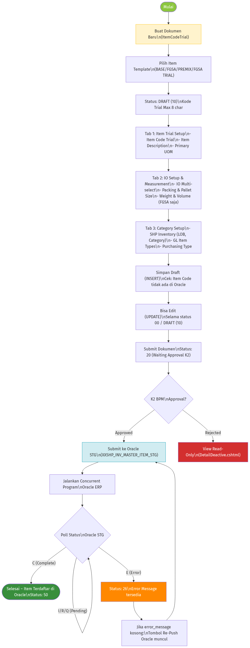
Business Flow Diagram – Item Code Trial

2.3 Status Dokumen
Kode Status | Label | Warna Badge | View yang Digunakan | Keterangan
null | NEW | Blue | Detail.cshtml | Dokumen baru belum disimpan
00 | DRAFT (New) | Amber | Detail.cshtml | Disimpan pertama kali, Item Code bisa masih diedit
10 | DRAFT | Amber | Detail.cshtml | Setelah INSERT berhasil, bisa diupdate
20 | WAITING APPROVAL | Gray | DetailDeactive.cshtml | Disubmit, menunggu K2 BPM approval
25 | APPROVED (K2) | Cyan | DetailDeactive.cshtml | Approved, tombol Download Template tersedia
26 | SUBMITTED ORACLE | Orange | DetailDeactive.cshtml | Dikirim ke Oracle STG. Jika error_message kosong: tombol Re-Push
30 | PROCESSING ORACLE | Blue | DetailDeactive.cshtml | Oracle sedang memproses concurrent, tombol Download Template ada
50 | APPROVED (ORACLE) | Emerald | DetailDeactive.cshtml | Terdaftar di Oracle Inventory. Status final.

3. Sistem Lama – KN2017_FORMULATION

3.1 Halaman Index – Item Code Trial (Lama)
Path View: Views/ItemCodeTrial/Index.cshtml Controller Action: ItemCodeTrialController.Index() (Master namespace)
Fungsi: Menampilkan daftar seluruh dokumen Item Code Trial dalam bentuk DataTable jQuery.

3.1.1 Action Bar
Elemen | Keterangan
Tombol Create | Link ke Detail tanpa parameter (mode Create baru)
Judul | “Item Code Trial”

3.1.2 Kolom DataTable
Kolom | Field (ViewModel) | Keterangan
Document Status | txtDocStatusDesc | Label deskriptif status dari kode (DRAFT, SUBMITTED, dll.)
Item Template | txtItemTemplate | Tipe template (BASE TRIAL, FGSA TRIAL, PREMIX, dll.)
Trial Code | txtItemCodeTrial | Kode item trial unik (maks 8 char)
Description | txtDescription | Deskripsi item, format UPPERCASE
Close Code Item Desc | txtCloseCodeItemDescription | Deskripsi kode penutupan (Close Code)
Primary UOM | txtPrimaryUOM | Satuan utama (Kg, Pcs, M3, dll.)
Create By | txtCreateBy | Username pembuat dokumen
Next Approver | txtNextApproval | Approver berikutnya dalam alur K2
Action | — | Link “View Detail” → Detail?ItemCode={encrypted}

3.1.3 Logika Backend Index
- SelectAll() dari clsMItemCodeTrialBL mengambil semua rekaman.
- Data dipetakan via AutoMapper ke List<ItemCodeTrialViewModel>.
- DataTable di-render di sisi klien (client-side DataTable).
- Enkripsi ID: clsRijndael.Encrypt(item.txtItemCodeTrial) sebelum ditaruh di URL.

3.2 Halaman Detail – Item Code Trial (Lama)
Path View: Views/ItemCodeTrial/Detail.cshtml Controller Action: ItemCodeTrialController.Detail(string ItemCode) (GET & POST)
Fungsi: Form untuk membuat (INSERT) atau mengedit (UPDATE) dokumen Item Code Trial. Satu halaman linear (bukan tab) dengan beberapa section.

3.2.1 Routing Logic (GET)
GET /Master/ItemCodeTrial/Detail
├── ItemCode == null → Form kosong (Create mode), tampilkan Detail.cshtml
│
└── ItemCode != null → Dekripsi → SelectOne() → Map ke ViewModel
│
├── txtDocStatus == "10" → Detail.cshtml (Editable)
├── txtDocStatus == "26" → DetailDeactive.cshtml + cek Re-Push
├── txtDocStatus == "50" → DetailDeactive.cshtml (Final)
└── Selainnya → DetailDeactive.cshtml (Read-only)

3.2.2 Section 1: Header (Status & Template)
Field | HTML Element | Tipe | Mandatory | Keterangan
Document Status | Dropdown (disabled) + Hidden | Readonly | Auto | Source: mAppParam WHERE DOCUMENTSTATUS. Default: “00”
Item Template | TextBox + LOV button (🔍) | LOV | Ya | LOV: ItemTemplateMaster. Readonly setelah dipilih
Item Code Trial | TextBox | Text | Ya | Max 8 char. Editable HANYA jika status “00” atau null
Item Description | TextBox | Text | Ya | UPPERCASE css (text-transform:uppercase)
Closed Code | TextBox (readonly) | Readonly | Tidak | Auto-fill dari sistem lain atau input manual khusus
Primary UOM | TextBox + LOV button (🔍) | LOV | Ya | LOV: PrimaryUOM dari Oracle MTL_UNITS_OF_MEASURE_TL

3.2.3 Section 2: Measurement (Weight & Volume)
Field | HTML Element | Tipe | Mandatory | Keterangan
Unit Volume | strUnitVolumeWithDecimal | AutoNumeric | Ya (jika FGSA) | Hidden field: decUnitVolume. Dikunci jika bukan FGSA
UOM Volume | TextBox + LOV button | LOV | Ya (jika FGSA) | LOV: UOMByUOMClass filter class=‘Volume’
Unit Weight | strUnitWeightWithDecimal | AutoNumeric | Ya (jika FGSA) | Hidden field: decUnitWeight. Dikunci jika bukan FGSA
UOM Weight | TextBox + LOV button | LOV | Ya (jika FGSA) | LOV: UOMByUOMClass filter class=‘Weight’
Business Rule Penting: Field Unit Volume, UOM Volume, Unit Weight, dan UOM Weight hanya aktif (enabled) jika Item Template = “FGSA TRIAL”. Untuk template lain, field dikunci (disabled) dan nilai dikosongkan/diset 0.

3.2.4 Section 3: SHP Inventory (LOB & Category)
Semua field di section ini adalah readonly — nilainya di-set otomatis oleh logika JavaScript berdasarkan Item Template yang dipilih.
Field | HTML Element | Default/Auto-fill Logic
Item Types | TextBox (readonly) | FGSA TRIAL → “FG”; BASE TRIAL → “BS”; PREMIX COMPILE → “IC”; PREMIX MIX → “PX”
Item Subtypes | TextBox (readonly) | Default hardcoded = “ALL” (dari constructor ViewModel)
Item LOB | TextBox + LOV | LOV: FlexValue filter ‘FV_LOB’
Corporate LOB | TextBox (readonly) | Default hardcoded = “SHP_NA” (dari constructor ViewModel)
Product Category | TextBox + LOV | LOV: FlexValue filter ‘FV_PRODUCT_CATEGORY’
Production Site | TextBox + LOV | LOV: FlexValue filter ‘FV_PRODUCTION_SITE’

3.2.5 Section 4: SHP Process GL Class
Field | HTML Element | Default/Auto-fill Logic
GL Item Types | TextBox (readonly) | FGSA TRIAL → “FG”; BASE/PREMIX → “RM”
Supply Method | TextBox + LOV | LOV: FlexValue filter ‘FV_SUPPLY_METHOD’
Export Countries | TextBox + LOV | LOV: FlexValue filter ‘FV_EXPORT_COUNTRIES’

3.2.6 Section 5: SHP Purchasing Type
Field | HTML Element | Default/Auto-fill Logic
Purchasing Type | TextBox (readonly) | Default hardcoded = “INDIRECT2” (dari constructor ViewModel)
Item Type (Purch.) | TextBox (readonly) | FGSA TRIAL → “FG”; lainnya → “RM”
Item Subtypes (Purch.) | TextBox (readonly) | Default hardcoded = “ALL”
SHP Future | TextBox (readonly) | Default hardcoded = “ALL”

3.2.7 Section 6: Pallet and Packing Size
Field | HTML Element | Tipe | Mandatory | Keterangan
Packing Size | strPackingSize | AutoNumeric | Ya | Hidden: decPackingSize
Pallet Size | strPalletSize | AutoNumeric | Ya | Hidden: decPalletSize. Default: 9999

3.2.8 Action Bar – Detail.cshtml (Edit Mode)
Tombol | Value btn POST | Kondisi Tampil | Fungsi
INSERT | "INSERT" | DocStatus == null | Simpan baru. Cek duplikat di Oracle
UPDATE | "UPDATE" | DocStatus == “10”/“00” | Update data. Cek duplikat di Oracle
SUBMIT | "SUBMIT" | DocStatus == “10” | Submit → status “20” (K2 waiting)
DELETE | "DELETE" | DocStatus == “10” | Hapus jika intProcessID == 0

3.3 Halaman DetailDeactive – Read-Only Mode
Path View: Views/ItemCodeTrial/DetailDeactive.cshtml
Digunakan untuk status di luar “10” (DRAFT). Semua field dalam mode read-only.

3.3.1 Tombol Khusus di DetailDeactive
Tombol | Kondisi Tampil | Fungsi
Rerun Interface Oracle | Status == “26” AND ViewBag.bitRepushOracle == true | Jalankan ulang RerunConcurrent() ke Oracle STG
Download Template | Status == “25” OR Status == “30” | Download template Excel item (UPLOAD_ITEMS_{code}.xls)

3.3.2 Logic Re-Push Oracle
Saat dokumen dimuat dengan status “26”: 1. Sistem memanggil clsXXSHP_INV_MASTER_ITEM_STGBL.GetStatusMessage(intProcessID) 2. Jika txtStatus == "" AND txtMessage == "" → ViewBag.bitRepushOracle = true 3. Tombol “Rerun Interface Oracle” muncul 4. Klik tombol → POST btn = "RERUNINTERFACEORACLE" → clsOracleItemCodeTrialBL.RerunConcurrent()

3.3.3 Download Template Excel
Endpoint: POST /Master/ItemCodeTrial/DownloadTemplateItemMaster
File output: UPLOAD_ITEMS_{ItemCode}.xls (via NPOI)
Kolom yang diisi dari tabel staging (XXSHP_INV_MASTER_ITEM_STG):
Kolom Excel | Sumber Data
SEGMENT1 | itemList[i].SEGMENT1
ORGANIZATION_CODE | itemList[i].ORGANIZATION_CODE
DESCRIPTION | itemList[i].ITEM_DESC
PRIMARY_UOM_CODE | itemList[i].PRIMARY_UOM
TEMPLATE_NAME | itemList[i].ITEM_TEMPLATE
ATTRIBUTE_CATEGORY | itemList[i].ATTRIBUTE_CATEGORY

3.4 ViewModel – ItemCodeTrialViewModel
File: ViewModels/Master/ItemCodeTrialViewModel.cs Namespace: KN2017_FORMULATION.ViewModels.Master.ItemCodeTrial

3.4.1 Property Lengkap
Property | Type | Display Name | Mandatory | Default (Constructor) | Keterangan
txtItemTemplate | string | Item Template | Ya | — | Pilih via LOV
txtItemCodeTrial | string | Item Code Trial | Ya | — | Max 8 karakter, Uppercase CSS
txtDescription | string | Item Description | Ya | — | Uppercase
txtCloseCodeItemDescription | string | Closed Code | Tidak | — | Readonly
txtPrimaryUOM | string | Primary UOM | Ya | — | Pilih via LOV Oracle
intProcessID | int | — | Auto | — | ID proses Oracle STG. 0 jika belum dipush
txtOracleStatus | string | — | Auto | — | Status dari Oracle (C/E/I/R/Q)
txtCreateBy | string | Create By | Auto | GlobalClass.dLogin.userDat.TxtUserName | Dari session user
dtCreateDate | DateTime? | — | Auto | DateTime.Now | Timestamp dibuat
txtUpdateBy | string | — | Auto | GlobalClass.dLogin.userDat.TxtUserName | Update tracking
dtUpdateDate | DateTime? | — | Auto | DateTime.Now | Timestamp update
decUnitVolume | decimal | — | Kondisional | — | Hidden input, nilai numerik volume
strUnitVolumeWithDecimal | string | Unit Volume | RequiredIf FGSA | — | AutoNumeric field
txtVolumeUOM | string | UOM Volume | RequiredIf FGSA | — | LOV UOMByUOMClass class=‘Volume’
decUnitWeight | decimal | — | Kondisional | — | Hidden input, nilai numerik berat
strUnitWeightWithDecimal | string | Unit Weight | RequiredIf FGSA | — | AutoNumeric field
txtWeightUOM | string | UOM Weight | RequiredIf FGSA | — | LOV UOMByUOMClass class=‘Weight’
txtDocStatus | string | Document Status | Auto | — | Kode status (null/10/20/25/26/30/50)
txtDocStatusDesc | string | Document Status | Auto | — | Label deskriptif status
txtNextApproval | string | Next Approver | Auto | — | Username approver berikutnya
txtItemType | string | Item Types | Tidak | — | Auto-set dari JavaScript berdasarkan Template
txtItemSubType | string | Item Subtypes | Ya | "ALL" | Hardcoded default
txtItemLOB | string | Item LOB | Ya | — | LOV FlexValue ‘FV_LOB’
txtCorporateLOB | string | Corporate LOB | Ya | "SHP_NA" | Hardcoded default
txtProductCategory | string | Product Category | Ya | — | LOV FlexValue ‘FV_PRODUCT_CATEGORY’
txtProductionSite | string | Production Site | Ya | — | LOV FlexValue ‘FV_PRODUCTION_SITE’
txtGLItemType | string | GL Item Types | Tidak | — | Auto-set: FGSA → “FG”, lainnya → “RM”
txtSupplyMethod | string | Supply Method | Tidak | — | LOV FlexValue ‘FV_SUPPLY_METHOD’
txtExportCountry | string | Export Countries | Tidak | — | LOV FlexValue ‘FV_EXPORT_COUNTRIES’
txtPurchasingType | string | Purchasing Type | Tidak | "INDIRECT2" | Hardcoded default
txtPurchasingItemType | string | Item Type (Purch.) | Tidak | — | FGSA → “FG”, lainnya → “RM”
txtPurchasingItemSubType | string | Item Subtypes (Purch.) | Tidak | "ALL" | Hardcoded default
txtPurchasingSHPFuture | string | SHP Future | Tidak | "ALL" | Hardcoded default
decPackingSize | decimal | — | Kondisional | — | Hidden input
strPackingSize | string | Packing Size | Ya | — | AutoNumeric field
decPalletSize | decimal | — | Kondisional | — | Hidden input
strPalletSize | string | Pallet Size | Ya | — | AutoNumeric field. Default UI: 9999

3.5 Controller Logic – ItemCodeTrialController
File: Controllers/Master/ItemCodeTrialController.cs Namespace: KN2017_FORMULATION.Controllers.Master

3.5.1 Daftar Action Methods
Method | HTTP | Endpoint | Keterangan
Index() | GET | /Master/ItemCodeTrial/Index | Daftar semua dokumen, AutoMapper ke ViewModel list
Detail(string ItemCode) | GET | /Master/ItemCodeTrial/Detail?ItemCode={enc} | Load form detail. Null = Create mode
Detail(obj, btn) | POST | /Master/ItemCodeTrial/Detail | Proses sesuai nilai btn
DownloadTemplateItemMaster | POST | /Master/ItemCodeTrial/DownloadTemplateItemMaster | Generate & download file XLS item staging

3.5.2 POST Action Routing (berdasarkan btn)
Nilai btn | Kondisi | Logic
"INSERT" | ModelState.IsValid | Cek Oracle → Set status “10” → clsMItemCodeTrialBL.Insert()
"UPDATE" | ModelState.IsValid | Cek Oracle → clsMItemCodeTrialBL.Update(0, objResult)
"SUBMIT" | ModelState.IsValid | Cek Oracle → Set status “20” → clsMItemCodeTrialBL.Submit()
"DELETE" | intProcessID == 0 | clsMItemCodeTrialBL.Delete(txtItemCodeTrial)
"DELETE" (gagal) | intProcessID != 0 | Exception: “This item code is already registered in ORACLE.”
"RERUNINTERFACEORACLE" | Status “26” | clsOracleItemCodeTrialBL.RerunConcurrent(txtItemCodeTrial) → Index

3.5.3 Oracle Check sebelum INSERT/UPDATE/SUBMIT
Sebelum setiap save, sistem memanggil:
clsOracleItemCodeTrialBL.CheckExistsItemCodeTrial(objResult.txtItemCodeTrial)
Jika item code sudah terdaftar di Oracle → throw Exception: “This item code is already exists in ORACLE!”

3.5.4 Business Layer Dependencies
Kelas | Fungsi
clsMItemCodeTrialBL | CRUD operasi untuk tabel mItemCodeTrial
clsOracleItemCodeTrialBL | Check Oracle, Rerun Concurrent, Submit ke Oracle STG
clsXXSHP_INV_MASTER_ITEM_STGBL | Query status & message dari Oracle staging table
clsSystemConfigurationBL | Konfigurasi sistem, kirim email error
clsRijndael | Enkripsi/dekripsi parameter URL
AutoMapper | Konversi antara Business Object dan ViewModel

3.5.5 JavaScript Logic – Template-triggered Auto-fill
Saat nilai Item Template berubah (event change), script JavaScript otomatis:
Template | txtItemType | txtGLItemType | txtPurchasingItemType | UOM Volume/Weight
FGSA TRIAL | FG | FG | FG | AKTIF (enabled)
BASE TRIAL | BS | RM | RM | Disabled (= 0)
PREMIX COMPILE TRIAL | IC | RM | RM | Disabled (= 0)
PREMIX MIX TRIAL | PX | RM | RM | Disabled (= 0)

4. Sistem Baru – IDC System (Target Migration)

4.1 Halaman Index (Baru)
File: ItemCodeTrial_Index.html (atau route setara di IDC System)

4.1.1 Dashboard Summary Cards
Terdapat 5 kartu status interaktif di bagian atas halaman:
Kartu | Filter Kode Status | Warna Ikon | Keterangan
Total Docs | ALL | Dark Gray | Semua dokumen
Draft | DRAFT (10) | Amber | Dokumen belum disubmit
Waiting Approval | WAITING (20) | Gray | Menunggu K2 BPM approval
Submitted Oracle | SUBMITTED (26) | Orange | Dikirim ke Oracle, polling status
Approved (Oracle) | APPROVED (50) | Emerald | Terdaftar dan selesai di Oracle
Behaviour Kartu: - Klik kartu → DataTable difilter otomatis berdasarkan status. - Badge counter menampilkan jumlah dokumen per status. - Default kartu aktif: Total Docs (ALL).

4.1.2 Action Bar
Tombol | Posisi | Fungsi
General View | Kiri | Tampilkan semua dokumen (filter dinonaktifkan)
My Pending Task | Kiri | Filter dokumen yang memerlukan tindakan dari user aktif
Export Excel | Kanan | Export data tabel ke format .xlsx
Refresh Data | Kanan | Reload data dari server API
Create | Kanan | Buka form pembuatan Item Code Trial baru

4.1.3 DataTable – Daftar Item Code Trial
Kolom | Field Key | Render | Filter
# | (row number) | Auto increment | —
Doc Status | docStatus | Badge warna sesuai status | Per-kolom
Item Template | itemTemplate | Text (BASE TRIAL, FGSA TRIAL, dll.) | Per-kolom
Trial Code | itemCodeTrial | Link/Text, klik buka detail | Per-kolom
Description | description | Text uppercase | Per-kolom
Primary UOM | primaryUOM | Text satuan | Per-kolom
Create By | createBy | Username | Per-kolom
Next Approver | nextApproval | Username approver | Per-kolom
Action | — | Tombol Edit (Draft) atau View (non-Draft) | —

4.1.4 Business Rules Index
Status Dokumen | Aksi Tersedia | Keterangan
DRAFT (10) | Edit / Delete | Form dalam mode edit, bisa dihapus jika intProcessID=0
WAITING APPROVAL (20) | View (Read-only) | Tidak bisa diedit atau dihapus
SUBMITTED ORACLE (26) | View + Re-Push | Re-Push jika error_message kosong di Oracle STG
APPROVED (50) | View (Read-only) | Status final, tidak bisa diedit

4.2 Halaman Detail (Baru) – 3 Tab
Fungsi: Form terorganisir dalam 3 tab untuk mendaftarkan atau mengedit Item Code Trial.
Struktur Halaman:
[Page Header]
┌───────────────────────────────────────────────────────┐
│ ← (back) | Item Code Trial – [Create/Edit Mode] │
│ [Save/Update] [Submit] [Delete] │
└───────────────────────────────────────────────────────┘
[Tab Navigation]
┌──────────────────┬──────────────────────┬─────────────────┐
│ Item Trial Setup│ IO Setup & │ Category Setup │
│ (Tab 1) │ Measurement (Tab 2) │ (Tab 3) │
└──────────────────┴──────────────────────┴─────────────────┘
[Tab Content Area]
- Konten berubah sesuai tab aktif
- Data tersimpan sementara saat berpindah tab

4.2.1 Toolbar Actions (Global)
Tombol | ID | Warna | Kondisi | Fungsi
← (back) | btn-back | Gray | Selalu ada | Kembali ke Index
Save/Update | btn-save | Emerald | Status <= DRAFT | Simpan data semua tab via API
Submit | btn-submit | Amber | Status == DRAFT (10) | Konfirmasi via SweetAlert → POST submit
Delete | btn-delete | Red | Status == DRAFT, ProcessID == 0 | Konfirmasi → Hapus dokumen
Re-Push Oracle | btn-repush | Orange | Status 26, error msg kosong | Trigger ulang concurrent Oracle
Download Tmpl | btn-download | Blue | Status 25 atau 30 | Download template Excel Oracle

4.3 Tab 1: Item Trial Setup
Tab ID: #tab-main Label: “Item Trial Setup”
Berisi identitas pokok material trial. Pilihan Item Template menentukan perilaku field di Tab 2 (measurement) dan default value di Tab 3 (category).

4.3.1 Field Definitions – Tab 1
Field Name | ID Elemen | Tipe | Mandatory | Default | Keterangan
Document Status | inp-docStatus | Text (readonly) | Auto | "NEW" | Badge warna sesuai kode status
Item Template | inp-template | Select dropdown | Ya | — | Opsi: BASE TRIAL, FGSA TRIAL, PREMIX MIX TRIAL, PREMIX COMPILE TRIAL
Item Code Trial | inp-code | Text input | Ya | — | Maks 8 karakter, UPPERCASE. Readonly jika status > DRAFT
Item Description | inp-desc | Textarea (2 rows) | Ya | — | UPPERCASE. Lebar penuh (col-span-2)
Closed Code | inp-closeCode | Text (readonly) | Tidak | — | Diisi otomatis oleh sistem atau readonly
Primary UOM | inp-primaryUOM | Searchable select | Ya | — | Source: Oracle MTL_UNITS_OF_MEASURE_TL via API

4.3.2 LOV/Dropdown – Item Template
Value | txtItemType | txtGLItemType | txtPurchasingItemType | Weight/Volume UOM
BASE TRIAL | BS | RM | RM | Disabled (= 0)
FGSA TRIAL | FG | FG | FG | Aktif (enabled)
PREMIX MIX TRIAL | PX | RM | RM | Disabled (= 0)
PREMIX COMPILE TRIAL | IC | RM | RM | Disabled (= 0)

4.3.3 LOV – Primary UOM (Searchable Dropdown)
Sumber data: Oracle MTL_UNITS_OF_MEASURE_TL
Behavior | Keterangan
Klik field | Dropdown daftar UOM tampil
Ketik teks | Filter real-time (case-insensitive)
Pilih satu opsi | Nilai terisi, dropdown menutup otomatis
Klik di luar | Dropdown menutup

4.3.4 CRUD – Tab 1
Operasi | Cara | Keterangan
Create | Buka form via openCreateForm() | Semua field kosong, status = “NEW”
Read | Buka form via openEditForm(...) | Field terisi dari API response
Update | Edit field → klik Save/Update | Validasi mandatory, lalu panggil API PATCH/PUT
Submit | Klik Submit → SweetAlert konfirmasi | Validasi semua tab, ubah status → WAITING APPROVAL (20)

4.4 Tab 2: IO Setup & Measurement
Tab ID: #tab-measurement Label: “IO Setup & Measurement”
Tab ini terbagi menjadi 4 section utama:

4.4.1 Section 1: Inventory Organization (IO)
Field | ID Elemen | Tipe | Mandatory | Keterangan
IO | ioTagContainer | Multi-select tag | Ya | Minimal 1 IO. Tag badge dengan tombol “×” hapus
Daftar IO yang Tersedia (dari sistem/database):
IO Code | IO Code | IO Code | IO Code
SHP | ISA | KMI | KAM
MBI | RTS | KNS | IDC
NIS | NDI | (dll.) | —
Business Rule IO: - Minimal 1 IO wajib dipilih. - Sistem mencegah duplikat IO yang dipilih. - Setiap IO yang di-push ke Oracle STG menghasilkan 1 baris record terpisah (looping per IO). - IO yang sudah dipilih tampil sebagai badge dengan ikon “×” untuk menghapus.

4.4.2 Section 2: Packing & Pallet Size
Field | ID Elemen | Tipe | Mandatory | Default | Validasi | Keterangan
Packing Size | inp-packing | Number | Ya | — | Angka positif | Ukuran kemasan per unit
Pallet Size | inp-pallet | Number | Ya | 9999 | ≥ Packing Size | Ukuran pallet (default: 9999 dari setter)
Validasi Pallet Size:
Jika Pallet Size < Packing Size:
→ SweetAlert Error: "Pallet Size must be ≥ Packing Size"

4.4.3 Section 3: Weight & Volume (Kondisional – FGSA TRIAL saja)
Field | ID Elemen | Unit | Kondisi | Keterangan
Unit Weight | inp-weight | — | Hanya FGSA TRIAL | Nilai desimal. Disabled (= 0) untuk non-FGSA
UOM Weight | inp-wuom | — | Hanya FGSA TRIAL | LOV filter UOM class = ‘Weight’
Unit Volume | inp-volume | — | Hanya FGSA TRIAL | Nilai desimal. Disabled (= 0) untuk non-FGSA
UOM Volume | inp-vuom | — | Hanya FGSA TRIAL | LOV filter UOM class = ‘Volume’
Validasi: Jika Template = FGSA TRIAL, keempat field di atas wajib diisi (RequiredIf di server-side).

4.4.4 CRUD – Tab 2
Operasi | Keterangan
Create | IO = kosong (pilih minimal 1). Pallet default 9999
Read | IO tags dimuat dari data. Field measurement terisi dari API
Update | Tambah/hapus IO, ubah nilai measurement, lalu Save
Delete | IO bisa dihapus satu per satu via “×” pada badge tag

4.5 Tab 3: Category Setup
Tab ID: #tab-category Label: “Category Setup”
Tab ini terbagi menjadi 3 section untuk konfigurasi Oracle Inventory, Purchasing, dan GL.

4.5.1 Section 1: Inventory Category
Field | ID Elemen | Tipe | Mandatory | Default | Source/Opsi | Keterangan
Item Types | inp-catType | Select | Ya | Auto-fill | IC, FG, PX, BS, RM (dari Template) | Diset otomatis oleh Template
Item Subtypes | inp-catSubtype | Select | Auto | ALL | ALL | Hardcoded “ALL”, disabled
Item LOB | inp-catLOB | Select | Ya | — | LOV: FlexValue ‘FV_LOB’ | Line of Business
Corporate LOB | inp-corpLOB | Select | Auto | SHP_NA | SHP_NA | Hardcoded “SHP_NA”, disabled
Product Category | inp-prodCat | Select | Ya | — | LOV: FlexValue ‘FV_PRODUCT_CATEGORY’ | Kategori produk
Production Site | inp-prodSite | Select | Ya | — | LOV: FlexValue ‘FV_PRODUCTION_SITE’ | Lokasi produksi

4.5.2 Section 2: Purchasing Type Category
Field | ID Elemen | Tipe | Mandatory | Default | Source/Opsi | Keterangan
Purchasing Type | inp-purcType | Select | Auto | INDIRECT2 | INDIRECT2 | Hardcoded, disabled
Item Type | inp-purcItemType | Select | Ya | Auto-fill | RM, FG (dari Template) | Diset otomatis oleh Template
Item Subtypes | inp-purcSubtype | Select | Auto | ALL | ALL | Hardcoded, disabled
SHP Future | inp-shpFuture | Select | Auto | ALL | ALL | Hardcoded, disabled

4.5.3 Section 3: Process GL Category
Field | ID Elemen | Tipe | Mandatory | Default | Source/Opsi | Keterangan
GL Item Types | inp-glType | Select | Ya | Auto-fill | RM, FG (dari Template) | Diset otomatis oleh Template
Supply Method | inp-supplyMethod | Select | Tidak | — | LOV: FlexValue ‘FV_SUPPLY_METHOD’ | Metode supply
Export Countries | inp-exportCountry | Select | Tidak | — | LOV: FlexValue ‘FV_EXPORT_COUNTRIES’ | Negara ekspor tujuan

4.5.4 CRUD – Tab 3
Operasi | Keterangan
Create | Default value diisi otomatis (LOB, Corporate LOB, Purchasing Type, dll.)
Read | Field terisi dari data yang tersimpan
Update | User bisa mengubah LOB, Category, Site; field hardcoded tetap locked
Delete | Tidak ada delete per field; merged dengan header delete

5. Perbedaan & Mapping Sistem Lama vs Baru

5.1 Perbandingan Arsitektur
Aspek | Sistem Lama (KN2017_FORMULATION) | Sistem Baru (IDC System)
Arsitektur | ASP.NET MVC (Server-side rendering) | SPA / API-first + HTML/JS Frontend
UI Framework | Bootstrap 3 + jQuery + FancyBox | TailwindCSS + Vanilla JS + SweetAlert2
Form Layout | Linear single-page dengan sections | Tab-based (3 tab terstruktur)
LOV/Popup | FancyBox popup dengan AJAX | Inline searchable dropdown / Modal modern
Validasi | Server-side + jQuery Validation | Client-side SweetAlert2 + Server API
Data Loading | ViewBag + Model binding | REST API + JSON
Status Workflow | Kode numerik (10/20/25/26/30/50) | Label string (DRAFT, WAITING APPROVAL, dll.)
Enkripsi URL | clsRijndael encrypt/decrypt | Tidak perlu (JWT / internal ID)
State Management | TempData server-side | Client-side state + API persistent

5.2 Field Mapping Utama
Section | Field Lama (KN2017) | Field Baru (IDC) | Keterangan
Header | txtItemTemplate | inp-template | Sama
Header | txtItemCodeTrial | inp-code | Sama, maks 8 char
Header | txtDescription | inp-desc | Sama, uppercase
Header | txtCloseCodeItemDescription | inp-closeCode | Readonly
Header | txtPrimaryUOM | inp-primaryUOM | Searchable dropdown di IDC
Tab 2 | strUnitVolumeWithDecimal | inp-volume | Kondisional FGSA saja
Tab 2 | txtVolumeUOM | inp-vuom | LOV class=‘Volume’
Tab 2 | strUnitWeightWithDecimal | inp-weight | Kondisional FGSA saja
Tab 2 | txtWeightUOM | inp-wuom | LOV class=‘Weight’
Tab 2 | strPackingSize | inp-packing | Numeric
Tab 2 | strPalletSize | inp-pallet | Default 9999
Tab 2 | (tidak ada di lama) | ioTagContainer | BARU: Multi-select IO
Tab 3 | txtItemType | inp-catType | Auto-fill dari Template
Tab 3 | txtItemSubType | inp-catSubtype | Hardcoded “ALL”
Tab 3 | txtItemLOB | inp-catLOB | LOV FlexValue
Tab 3 | txtCorporateLOB | inp-corpLOB | Hardcoded “SHP_NA”
Tab 3 | txtProductCategory | inp-prodCat | LOV FlexValue
Tab 3 | txtProductionSite | inp-prodSite | LOV FlexValue
Tab 3 | txtGLItemType | inp-glType | Auto-fill dari Template
Tab 3 | txtSupplyMethod | inp-supplyMethod | LOV FlexValue
Tab 3 | txtExportCountry | inp-exportCountry | LOV FlexValue
Tab 3 | txtPurchasingType | inp-purcType | Hardcoded “INDIRECT2”
Tab 3 | txtPurchasingItemType | inp-purcItemType | Auto-fill dari Template
Tab 3 | txtPurchasingItemSubType | inp-purcSubtype | Hardcoded “ALL”
Tab 3 | txtPurchasingSHPFuture | inp-shpFuture | Hardcoded “ALL”

6. Struktur Database & ERD

6.1 Tabel Utama: mItemCodeTrial
Kolom | Tipe Data | Nullable | Keterangan
txtItemCodeTrial | VARCHAR(8) | NOT NULL | Primary Key – Kode item trial unik (maks 8 char)
txtItemTemplate | VARCHAR(100) | NOT NULL | Template tipe item
txtDescription | VARCHAR(500) | NOT NULL | Deskripsi item (uppercase)
txtCloseCodeItemDescription | VARCHAR(200) | NULL | Deskripsi close code
txtPrimaryUOM | VARCHAR(50) | NOT NULL | Satuan utama dari Oracle
decUnitVolume | DECIMAL(18,4) | NULL | Volume (aktif hanya FGSA TRIAL)
txtVolumeUOM | VARCHAR(50) | NULL | Satuan volume
decUnitWeight | DECIMAL(18,4) | NULL | Berat (aktif hanya FGSA TRIAL)
txtWeightUOM | VARCHAR(50) | NULL | Satuan berat
intProcessID | INT | NOT NULL | ID proses Oracle STG. 0 = belum dipush
txtOracleStatus | VARCHAR(10) | NULL | Status dari Oracle (C/E/I/R/Q)
txtDocStatus | VARCHAR(5) | NULL | Status dokumen internal (10/20/25/26/30/50)
txtNextApproval | VARCHAR(100) | NULL | Username approver berikutnya (K2)
txtCreateBy | VARCHAR(100) | NOT NULL | Username pembuat
dtCreateDate | DATETIME | NOT NULL | Timestamp dibuat
txtUpdateBy | VARCHAR(100) | NULL | Username terakhir update
dtUpdateDate | DATETIME | NULL | Timestamp update terakhir

6.2 Tabel Kategori: mItemCodeTrialCategory
Kolom | Tipe Data | Nullable | Keterangan
txtItemCodeTrial | VARCHAR(8) | NOT NULL | Foreign Key → mItemCodeTrial
txtItemType | VARCHAR(20) | NULL | Tipe item inventory (FG/BS/IC/PX/RM)
txtItemSubType | VARCHAR(20) | NULL | Sub-tipe (default: “ALL”)
txtItemLOB | VARCHAR(50) | NOT NULL | Line of Business
txtCorporateLOB | VARCHAR(50) | NOT NULL | Corporate LOB (default: “SHP_NA”)
txtProductCategory | VARCHAR(100) | NOT NULL | Kategori produk
txtProductionSite | VARCHAR(100) | NOT NULL | Lokasi produksi
txtGLItemType | VARCHAR(20) | NULL | GL item type (RM/FG)
txtSupplyMethod | VARCHAR(50) | NULL | Metode supply
txtExportCountry | VARCHAR(100) | NULL | Negara ekspor
txtPurchasingType | VARCHAR(50) | NULL | Tipe purchasing (default: “INDIRECT2”)
txtPurchasingItemType | VARCHAR(20) | NULL | Item type untuk purchasing (RM/FG)
txtPurchasingItemSubType | VARCHAR(20) | NULL | Sub-tipe purchasing (default: “ALL”)
txtPurchasingSHPFuture | VARCHAR(20) | NULL | SHP Future (default: “ALL”)
decPackingSize | DECIMAL(18,4) | NOT NULL | Ukuran kemasan
decPalletSize | DECIMAL(18,4) | NOT NULL | Ukuran pallet

6.3 Tabel Oracle Staging: XXSHP_INV_MASTER_ITEM_STG
Kolom | Tipe Data | Keterangan
process_id | NUMBER | Primary Key – mapping ke intProcessID di mItemCodeTrial
p_item_template | VARCHAR2(100) | Template item (BASE TRIAL, FGSA TRIAL, dll.)
p_segment1 | VARCHAR2(40) | Kode item (= txtItemCodeTrial)
ORGANIZATION_CODE | VARCHAR2(30) | Kode IO – 1 row per IO yang ditag
ITEM_DESC | VARCHAR2(240) | Deskripsi item
PRIMARY_UOM | VARCHAR2(25) | Satuan utama
ITEM_TEMPLATE | VARCHAR2(100) | Template item Oracle
ATTRIBUTE_CATEGORY | VARCHAR2(150) | Kategori attribut Oracle
status_code | VARCHAR2(1) | Status Oracle: C=Complete, E=Error, I=Initial, R=Running, Q=Queue
error_message | VARCHAR2(4000) | Pesan error dari Oracle (kosong = Re-Push tersedia)

6.4 ERD
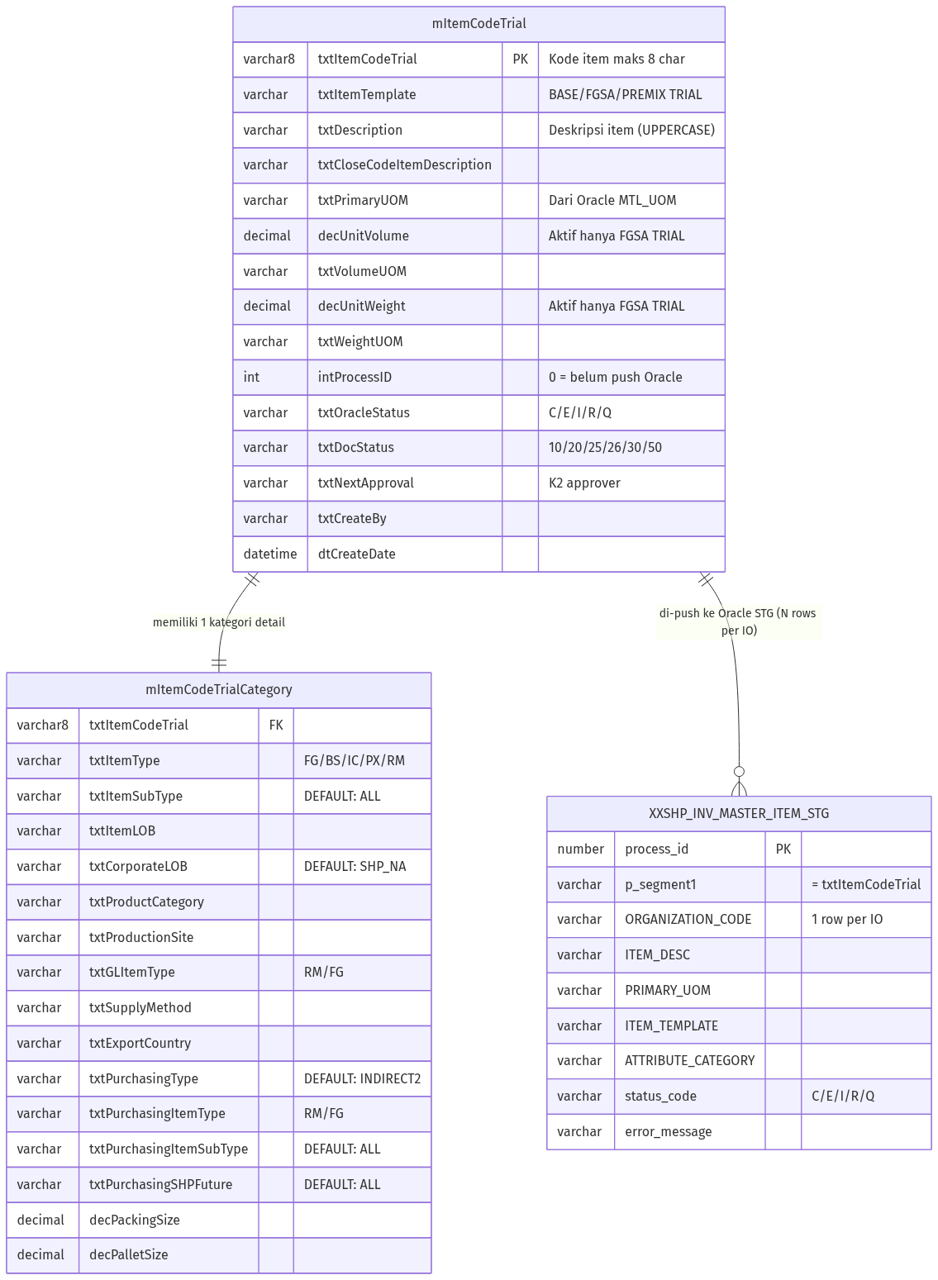
ERD – Entity Relationship Diagram Item Code Trial

7. Aturan Bisnis (Business Rules)

7.1 Validasi Item Code
Rule | Kondisi | Pesan / Tindakan
Item Code Trial = maks 8 char | txtItemCodeTrial.Length > 8 | Validasi server-side [StringLength(8)]
Item Code Trial wajib ada | txtItemCodeTrial == null | [Required] validation error
Item Code tidak duplikat di Oracle | CheckExistsItemCodeTrial() == true | Exception: “This item code is already exists in ORACLE!”
Uppercase enforced | CSS text-transform:uppercase | Tampilan selalu uppercase

7.2 Konditional Weight & Volume
Template | Unit Weight | UOM Weight | Unit Volume | UOM Volume
FGSA TRIAL | WAJIB | WAJIB | WAJIB | WAJIB
BASE TRIAL | Disabled = 0 | Disabled | Disabled = 0 | Disabled
PREMIX MIX TRIAL | Disabled = 0 | Disabled | Disabled = 0 | Disabled
PREMIX COMPILE TRIAL | Disabled = 0 | Disabled | Disabled = 0 | Disabled

7.3 Aturan Delete
Kondisi | Bisa Dihapus? | Pesan Error jika Gagal
intProcessID == 0 | Ya | —
intProcessID != 0 | Tidak | “This item code is already registered in ORACLE. Cannot be delete!”

7.4 Aturan Edit
Status Dokumen | Bisa Edit? | View yang Tampil
null / “00” | Ya | Detail.cshtml
“10” (DRAFT) | Ya | Detail.cshtml
“20” dan seterusnya | Tidak | DetailDeactive.cshtml

7.5 Multiple IO – Oracle Push
Karena format baru mendukung multi-select IO, push ke Oracle STG dilakukan secara loop: - Untuk setiap IO yang dipilih dalam ioTagContainer, sistem membuat 1 record terpisah di XXSHP_INV_MASTER_ITEM_STG dengan ORGANIZATION_CODE berbeda. - intProcessID menampung 1 nilai proses utama yang di-link ke semua batch.

7.6 Aturan Auto-fill berdasarkan Item Template
Auto-fill terjadi baik di sisi JavaScript (client-side) maupun server-side constructor ViewModel:
Field | Logika Auto-fill
txtItemSubType | Hardcoded “ALL” (constructor ViewModel)
txtCorporateLOB | Hardcoded “SHP_NA” (constructor ViewModel)
txtPurchasingType | Hardcoded “INDIRECT2” (constructor ViewModel)
txtPurchasingItemSubType | Hardcoded “ALL” (constructor ViewModel)
txtPurchasingSHPFuture | Hardcoded “ALL” (constructor ViewModel)
txtItemType | JS: FGSA→FG, BASE→BS, PM COMPILE→IC, PREMIX MIX→PX
txtGLItemType | JS: FGSA→FG, lainnya→RM
txtPurchasingItemType | JS: FGSA→FG, lainnya→RM

8. List of Values (LOV) & Referensi Data

8.1 LOV Tab 1
Field | LOV Name | Source Table/Query | Kolom Kunci
Item Template | ItemTemplateMaster | mItemTemplate WHERE bitActive = 1 | txtItemTemplate
Primary UOM | PrimaryUOM | Oracle: MTL_UNITS_OF_MEASURE_TL via linked server/API | UOM_CODE

8.2 LOV Tab 2
Field | LOV Name | Filter | Kolom Kunci
UOM Volume | UOMByUOMClass | WHERE UOM_CLASS = ‘Volume’ | UOM_CODE
UOM Weight | UOMByUOMClass | WHERE UOM_CLASS = ‘Weight’ | UOM_CODE
IO | InventoryOrg | mInventoryOrganization active = 1 | IO_CODE

8.3 LOV Tab 3
Field | LOV Name | Parameter Filter | Kolom Kunci
Item LOB | FlexValue | FV_LOB | txtFlexValue
Product Category | FlexValue | FV_PRODUCT_CATEGORY | txtFlexValue
Production Site | FlexValue | FV_PRODUCTION_SITE | txtFlexValue
Supply Method | FlexValue | FV_SUPPLY_METHOD | txtFlexValue
Export Countries | FlexValue | FV_EXPORT_COUNTRIES | txtFlexValue

8.4 Document Status (mAppParam)
ID Status | Deskripsi | Digunakan di
null | New (ui only) | Default saat form kosong
00 | New Draft | Setelah simpan pertama kali
10 | Draft | Status aktif, bisa diedit
20 | Waiting K2 Approval | Setelah Submit
25 | Approved (K2) | Setelah K2 approve
26 | Submitted to Oracle | Setelah push ke XXSHP_INV_MASTER_ITEM_STG
30 | Processing Oracle | Sedang diproses Oracle concurrent
50 | Complete (Oracle) | Oracle status = ‘C’

9. Hak Akses & Peran Pengguna

9.1 Role Matrix
Fitur | Admin ICT | Formulator R&D | Procurement | Oracle Admin
Lihat daftar | ✅ | ✅ | ✅ | ✅
Buat baru (Create) | ✅ | ✅ | ✅ | —
Edit DRAFT | ✅ | ✅ | ✅ | —
Delete DRAFT | ✅ | ✅* | ✅* | —
Submit ke Approval | ✅ | ✅ | ✅ | —
Approve (K2) | ✅ | — | — | —
Re-Push Oracle | ✅ | — | — | ✅
Download Template Excel | ✅ | ✅ | ✅ | —
View read-only | ✅ | ✅ | ✅ | ✅
*Delete hanya bisa jika intProcessID == 0 (belum pernah dipush ke Oracle)

9.2 Filter Akses (di KN2017)
Semua action di ItemCodeTrialController didekorasi dengan: - [Authorize] – Harus login - [FilterConfig.CheckSessionTimeOut()] – Validasi session - [FilterConfig.CheckUserAccess()] – Validasi hak akses modul

10. Alur Persetujuan & Oracle Integration

10.1 Approval Flow (K2 BPM)
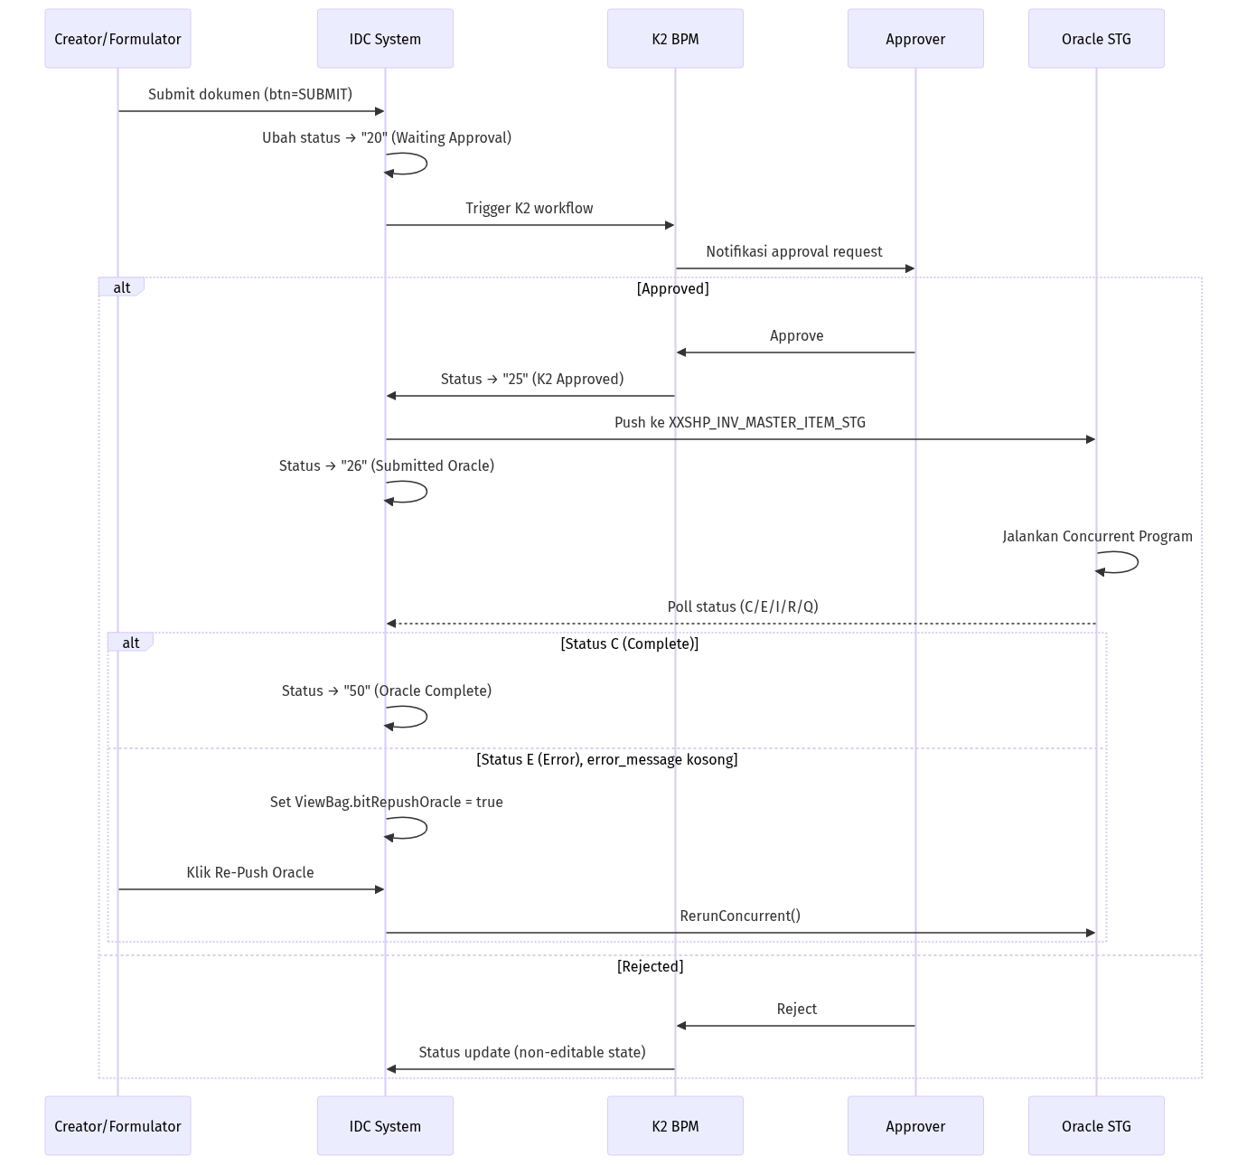
Approval & Oracle Integration Flow – Item Code Trial

10.2 Oracle Concurrent Program Flow
- Setelah status “25” (K2 Approved), sistem push data ke XXSHP_INV_MASTER_ITEM_STG.
- Per IO yang dipilih, dibuat 1 record terpisah di staging table.
- Oracle Concurrent Program membaca staging dan mendaftarkan item ke Oracle Inventory.
- Sistem polling status via GetStatusMessage(intProcessID):
  - status_code = 'C' → Item berhasil terdaftar → set status “50”
  - status_code = 'E', error_message != null → Error tampil, tombol Re-Push tidak muncul
  - status_code = 'E', error_message == null → Tombol Re-Push muncul (RerunConcurrent)
  - status_code = 'I/R/Q' → Masih diproses, polling berlanjut

10.3 Download Template Excel
Setelah status “25” atau “30”, user bisa mendownload template Excel untuk upload manual ke Oracle: - Endpoint: POST /Master/ItemCodeTrial/DownloadTemplateItemMaster - Query: clsXXSHP_INV_MASTER_ITEM_STGBL.SelectAllDownloadTemplate(txtItemCode) - Format file: .xls (NPOI HSSFWorkbook) - Nama file: UPLOAD_ITEMS_{ItemCode}.xls - 52 kolom sesuai format upload Oracle Inventory

Appendix A – Field Mapping Lengkap

A.1 Mapping: Oracle STG ← mItemCodeTrial
Kolom Oracle STG | Sumber Field | Keterangan
p_segment1 | txtItemCodeTrial | Kode item
p_item_template | txtItemTemplate | Template tipe item
ORGANIZATION_CODE | Per IO dari ioTagContainer | Loop per IO yang dipilih
ITEM_DESC | txtDescription | Deskripsi item
PRIMARY_UOM | txtPrimaryUOM | Satuan utama
WEIGHT_UOM_CODE | txtWeightUOM | (hanya FGSA) Satuan berat
UNIT_WEIGHT | decUnitWeight | (hanya FGSA) Nilai berat
VOLUME_UOM_CODE | txtVolumeUOM | (hanya FGSA) Satuan volume
UNIT_VOLUME | decUnitVolume | (hanya FGSA) Nilai volume
ATTRIBUTE_CATEGORY | Computed dari template | Kategori atribut Oracle

A.2 Mapping: Excel Template ← XXSHP_INV_MASTER_ITEM_STG
Kolom Excel | Kolom STG | Keterangan
SEGMENT1 | SEGMENT1 | Kode item
ORGANIZATION_CODE | ORGANIZATION_CODE | Kode IO
DESCRIPTION | ITEM_DESC | Deskripsi
PRIMARY_UOM_CODE | PRIMARY_UOM | Satuan utama
TEMPLATE_NAME | ITEM_TEMPLATE | Template Oracle
ATTRIBUTE_CATEGORY | ATTRIBUTE_CATEGORY | Kategori atribut
(52 kolom lainnya) | — | Kolom kosong untuk upload Oracle

Appendix B – API Endpoints (Target IDC System)

B.1 Item Code Trial CRUD
Method | Endpoint | Payload / Params | Response | Keterangan
GET | /api/formulation/item-code-trial | ?status=&page=&limit= | List + pagination | Ambil daftar dengan filter
GET | /api/formulation/item-code-trial/{code} | path param code | Single object | Ambil detail by trial code
POST | /api/formulation/item-code-trial | JSON body (full ViewModel) | Created object | Insert baru, cek Oracle duplikat
PUT | /api/formulation/item-code-trial/{code} | JSON body (full ViewModel) | Updated object | Update, cek Oracle duplikat
DELETE | /api/formulation/item-code-trial/{code} | path param code | Success/Error | Hapus jika intProcessID == 0

B.2 Workflow Actions
Method | Endpoint | Keterangan
POST | /api/formulation/item-code-trial/{code}/submit | Submit untuk approval K2
POST | /api/formulation/item-code-trial/{code}/repush | Re-push ke Oracle STG
GET | /api/formulation/item-code-trial/{code}/oracle-status | Cek status Oracle STG
GET | /api/formulation/item-code-trial/{code}/download-template | Download template XLS

B.3 LOV Endpoints
Method | Endpoint | Params | Keterangan
GET | /api/lov/item-template | — | Daftar template aktif
GET | /api/lov/primary-uom | ?search= | Oracle MTL_UNITS_OF_MEASURE_TL
GET | /api/lov/uom-by-class | ?class=Volume/Weight | UOM berdasarkan kelas
GET | /api/lov/inventory-organization | — | Daftar IO aktif
GET | /api/lov/flex-value | ?type=FV_LOB | Flex value berdasarkan tipe
GET | /api/lov/document-status | — | Daftar status dokumen

