Table of Contents
Functional Specification Document (FSD) 5
Item Specification Modules 5
KN2017 Formulation System 5
Table of Contents 5
1. Introduction 5
1.1 Purpose 5
1.2 Scope 6
1.3 Business Context 6
1.4 User Roles 6
1.5 Document Status Flow (Lifecycle) 6
2. Flow Process & ERD Diagrams 6
2.1 Document Status Lifecycle (Semua Modul) 6
2.2 Flow Process – ItemSpec 9
2.3 Flow Process – NewItemSpec 12
2.4 Flow Process – BlendingItemSpec 15
2.5 Flow Process – PackingItemSpec 18
2.6 ERD – ItemSpec & NewItemSpec 20
2.7 ERD – BlendingItemSpec & PackingItemSpec 20
3. Module: ItemSpec 21
3.1 Overview 21
3.2 Fitur Utama 21
3.3 Halaman Index (Daftar) 21
2.3.1 Tampilan 21
2.3.2 Tombol Aksi 21
2.3.3 Stored Procedures 22
3.4 Halaman Detail 22
2.4.1 Header Section 22
2.4.2 Tabs / Section Detail 22
2.4.3 Tab: Product Description 3 (Test Parameter) 23
2.4.4 Tombol Aksi di Halaman Detail 23
3.5 Business Rules 23
3.6 Stored Procedures (ItemSpec) 24
Header (mItemSpec0) 24
Product Description 1 24
Product Description 2 24
Product Description 3 24
Physical 25
Chemical 25
Heavy Metals 25
Microbiological 25
Organoleptic 25
In Process 26
Other Contaminant (Header) 26
Other Contaminant – Pesticides 26
Other Contaminant – Mycotoxin 26
Other Contaminant – Foreign Matters 27
Other Contaminant – Antibiotics 27
Utility / Validasi 27
3. Module: NewItemSpec 28
3.1 Overview 28
3.2 Perbedaan dengan ItemSpec 28
3.3 Halaman Index 28
Stored Procedures (Index) 28
3.4 Halaman Detail 28
3.4.1 Header Fields 28
3.4.2 Tabs 28
3.4.3 Tombol Aksi 28
3.5 Business Rules 28
3.6 Stored Procedures (NewItemSpec) 29
Header (mItemSpec0New) 29
Tab Detail 29
Utility Khusus NewItemSpec 29
4. Module: BlendingItemSpec 29
4.1 Overview 29
4.2 Fitur Khusus Blending 29
4.3 Halaman Index 30
4.3.1 Tampilan 30
4.3.2 Stored Procedures (Index) 30
4.4 Halaman Detail 30
4.4.1 Header Fields Tambahan (vs ItemSpec) 30
4.4.2 IC Assignment Tab 30
4.4.3 Tabs Lengkap BlendingItemSpec 31
4.4.4 Tombol Aksi 31
4.4.5 Validasi IC Assignment 31
4.5 Business Rules 31
4.6 Stored Procedures (BlendingItemSpec) 31
Header (mBlendingItemSpec0) 31
IC Assignment 32
Product Description 1 32
Product Description 2 32
Product Description 3 33
Physical 33
Chemical 33
Heavy Metals 33
Microbiological 34
Organoleptic 34
In Process 34
Other Contaminant (Header) 34
Other Contaminant – Pesticides 34
Other Contaminant – Mycotoxin 35
Other Contaminant – Foreign Matters 35
Other Contaminant – Antibiotics 35
LOV / Utility 36
5. Module: PackingItemSpec 36
5.1 Overview 36
5.2 Fitur Khusus Packing 36
5.3 Halaman Index 36
5.3.1 Tampilan 36
5.3.2 Stored Procedures (Index) 37
5.4 Halaman Detail 37
5.4.1 Header Fields Tambahan (vs ItemSpec) 37
5.4.2 Tabs Lengkap PackingItemSpec 37
5.4.3 Validasi IC Assignment (Packing) 38
5.4.4 Tombol Aksi 38
5.5 Business Rules 38
5.6 Stored Procedures (PackingItemSpec) 38
Header (mPackingItemSpec0) 38
IC Assignment 38
Product Description 1 38
Product Description 2 39
Product Description 3 39
Physical 39
Chemical 40
Heavy Metals 40
Microbiological 40
Organoleptic 40
In Process 40
Other Contaminant (Header) 41
Other Contaminant – Pesticides 41
Other Contaminant – Mycotoxin 41
Other Contaminant – Foreign Matters 41
Other Contaminant – Antibiotics 42
LOV / Utility 42
6. Appendix 42
6.1 Perbandingan Antar Modul 42
6.2 Shared Stored Procedures (Digunakan oleh Semua/Beberapa Modul) 43
6.3 Arsitektur Teknikal 43
Layer Architecture 43
Konvensi Penamaan SP 43
Operasi CRUD per Tab 43

Functional Specification Document (FSD)

Item Specification Modules

KN2017 Formulation System

Document Version: 1.0
Prepared By: System Analysis
Date: 2025
Status: Draft

Table of Contents
- Introduction
- Flow Process & ERD Diagrams
- Module: ItemSpec
- Module: NewItemSpec
- Module: BlendingItemSpec
- Module: PackingItemSpec
- Appendix: Common Stored Procedures Reference

1. Introduction

1.1 Purpose
Dokumen ini mendeskripsikan spesifikasi fungsional untuk empat modul Item Specification dalam sistem KN2017 Formulation. Modul-modul ini digunakan untuk mendokumentasikan, mengelola, dan menyetujui spesifikasi item (bahan baku dan kemasan) sebelum dikirim ke Oracle ERP.

1.2 Scope
Dokumen mencakup empat modul berikut: - ItemSpec – Spesifikasi item bahan baku (Raw Material) - NewItemSpec – Spesifikasi item baru (New Item) - BlendingItemSpec – Spesifikasi item blending (semi-finished goods) - PackingItemSpec – Spesifikasi item kemasan (Packing Material)

1.3 Business Context
Keempat modul ini adalah bagian dari sistem Formulasi yang berfungsi sebagai dokumen kontrol kualitas. Setiap Item Spec harus melalui proses approval (K2 Workflow) sebelum data dikirim ke Oracle sebagai data master spesifikasi item.

1.4 User Roles
Role | Keterangan
Formulator | Membuat dan mengisi data Item Spec
Approver | Menyetujui atau mengembalikan dokumen
Viewer | Hanya dapat melihat data
SCM | Supply Chain Management – pihak yang bertanggung jawab untuk submit ke Oracle

1.5 Document Status Flow (Lifecycle)
Semua modul menggunakan status dokumen yang sama:
[OPEN] --> [SUBMIT] --> [APPROVE] --> [DONE/Oracle Submitted]
^ |
| v
[RETURN] <--[SUBMIT]
Status Code | Keterangan
OPEN | Dokumen baru dibuat, masih dapat diedit
SUBMIT | Dokumen disubmit untuk approval
RETURN | Dokumen dikembalikan oleh approver untuk revisi
APPROVE / DONE | Dokumen telah disetujui
ORACLE_SUBMITTED | Data telah dikirim ke Oracle ERP

2. Flow Process & ERD Diagrams

2.1 Document Status Lifecycle (Semua Modul)
Diagram berikut menggambarkan siklus hidup status dokumen yang berlaku untuk semua 4 modul Item Spec:
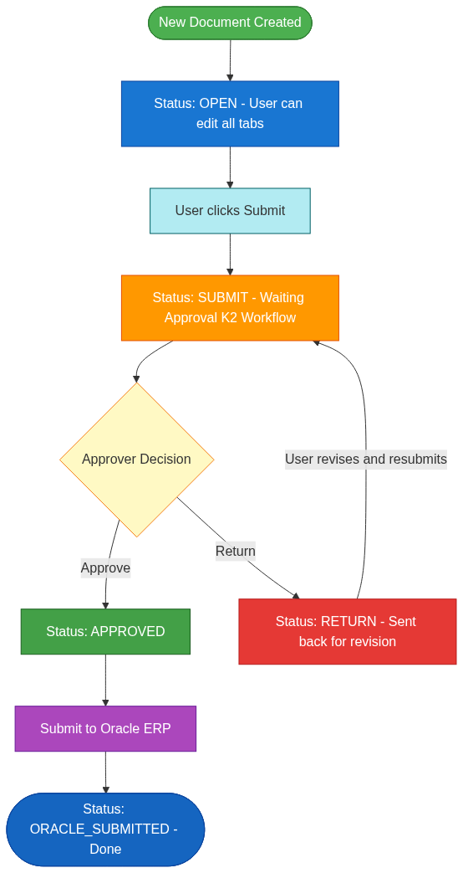
Document Status Lifecycle

2.2 Flow Process – ItemSpec
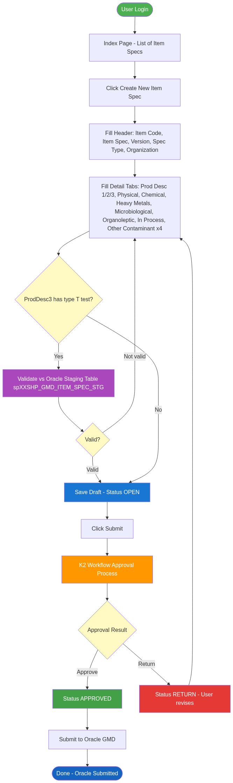

2.3 Flow Process – NewItemSpec
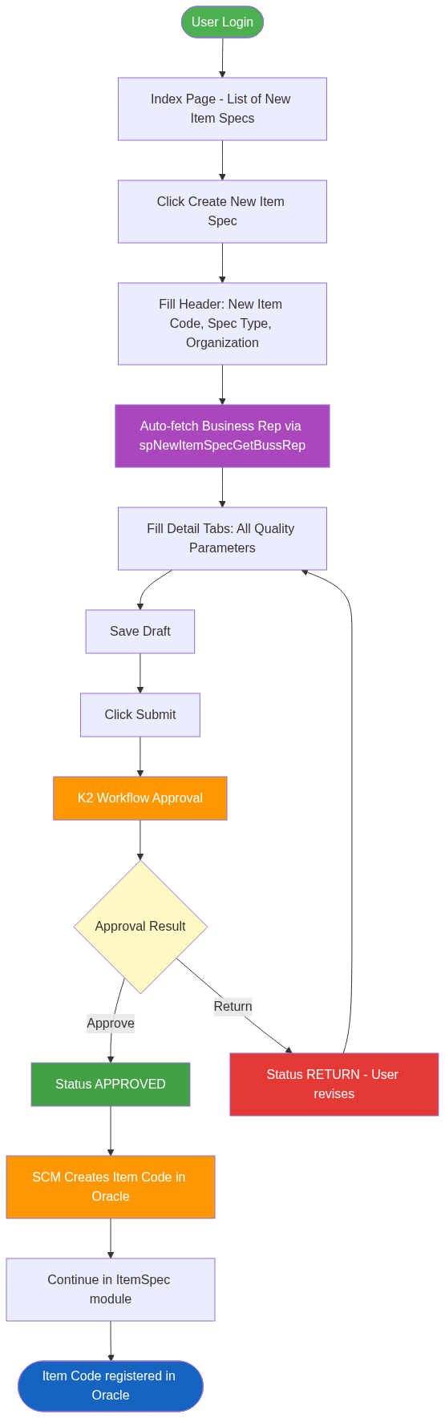
Flow Process NewItemSpec

2.4 Flow Process – BlendingItemSpec
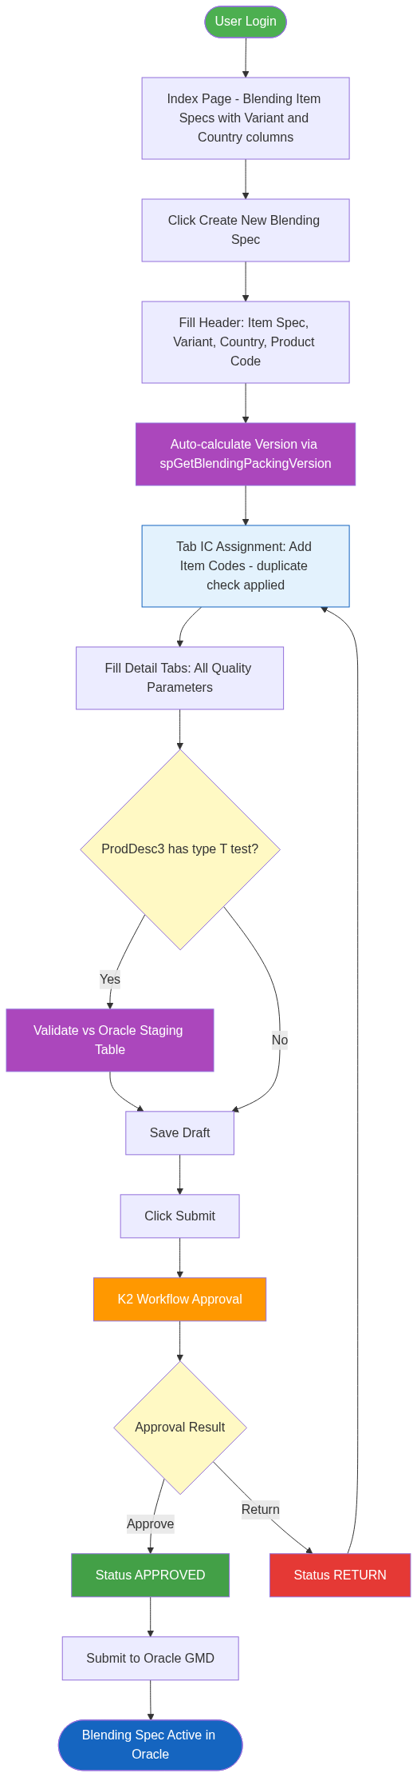
Flow Process BlendingItemSpec

2.5 Flow Process – PackingItemSpec
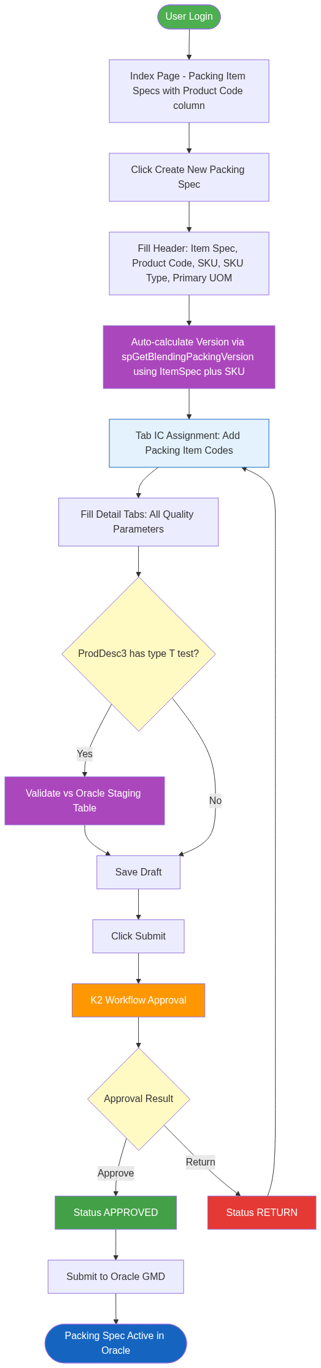
Flow Process PackingItemSpec

2.6 ERD – ItemSpec & NewItemSpec
Entity Relationship Diagram untuk modul ItemSpec dan NewItemSpec. Tabel mItemSpec0 adalah header, dengan 10+ tabel detail yang berelasi one-to-many.
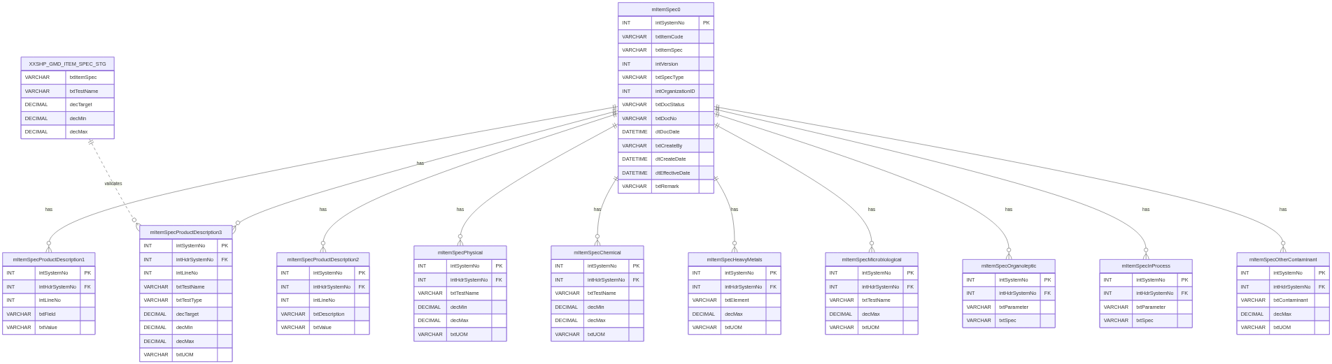
ERD ItemSpec dan NewItemSpec

2.7 ERD – BlendingItemSpec & PackingItemSpec
ERD untuk modul BlendingItemSpec dan PackingItemSpec. Kedua modul memiliki tab IC Assignment dan memvalidasi test parameter terhadap tabel Oracle staging XXSHP_GMD_ITEM_SPEC_STG.
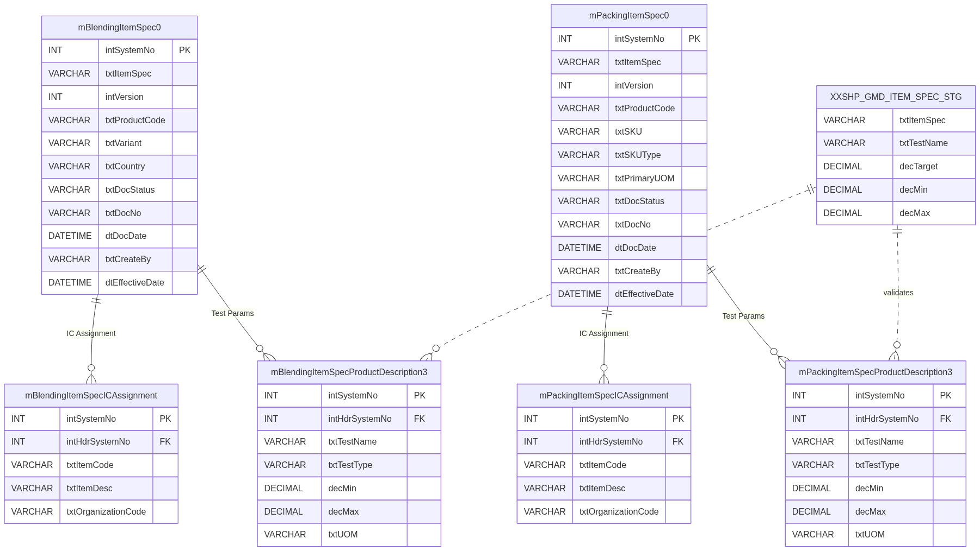
ERD BlendingItemSpec dan PackingItemSpec

3. Module: ItemSpec

3.1 Overview
Modul ItemSpec digunakan untuk membuat dan mengelola spesifikasi item bahan baku (Raw Material) yang sudah ada. Modul ini membedakan antara item yang sudah terdaftar di Oracle dan item baru yang belum ada.
Controller: ItemSpecController.cs
Base URL: /ItemSpec

3.2 Fitur Utama
- Membuat Item Specification baru berdasarkan item code yang sudah ada di Oracle
- Versioning: setiap revisi spec menghasilkan versi baru (intVersion)
- Multi-tab untuk berbagai aspek kualitas spec
- Dokumen number otomatis (txtDocNo)
- Workflow approval via K2
- Submit ke Oracle setelah approved

3.3 Halaman Index (Daftar)

2.3.1 Tampilan
Halaman Index menampilkan tabel berisi semua Item Specification dengan kolom:
No | Kolom | Keterangan
1 | Document No | Nomor dokumen unik (txtDocNo)
2 | Status | Status dokumen saat ini
3 | Date | Tanggal dokumen (dtDocDate)
4 | Item Code | Kode item Oracle
5 | Item Spec | Kode spec (txtItemSpec)
6 | Version | Versi spec (intVersion)
7 | Description | Deskripsi spec
8 | Create By | User yang membuat
9 | Next Approval | Approver berikutnya
10 | Action | Tombol Detail

2.3.2 Tombol Aksi
Tombol | Visibilitas | Keterangan
Create New Item Spec | Semua user yang login | Membuat dokumen item spec baru

2.3.3 Stored Procedures
SP Name | Fungsi
spMItemSpec0SelectAll | Mengambil semua data header Item Spec

3.4 Halaman Detail

2.4.1 Header Section
Header berisi informasi utama dokumen:
Field | Type | Keterangan
Document No | Read-only | Auto-generated
Status | Read-only | Status dokumen
Document Date | Date picker | Tanggal dokumen
Item Code | LOV + Search | Kode item dari Oracle
Item Description | Auto-fill | Terisi otomatis dari Oracle
Item Template | LOV | Template spesifikasi
Item Spec | Text | Kode spesifikasi
Version | Auto | Nomor versi (auto-increment)
Spec Description | Text | Deskripsi spesifikasi
Spec Type | Dropdown | Tipe spec
Organization | LOV | Kode organisasi
Inline | Checkbox | Apakah inline process?
Process ID | Dropdown | ID Proses
Production Site | Dropdown | Site produksi
Effective Date | Date picker | Tanggal berlaku
Remark | Textarea | Catatan
Business Partner Rep | Text | Perwakilan Business Partner
SCM User | LOV | User SCM

2.4.2 Tabs / Section Detail
Halaman Detail memiliki beberapa tab yang masing-masing mewakili aspek kualitas berbeda:
No | Tab | Keterangan
1 | Product Description 1 | Informasi dasar produk (tab pertama / header detail)
2 | Product Description 2 | Informasi tambahan produk
3 | Product Description 3 | Parameter uji kualitas (test parameter) – dapat divalidasi ke staging table
4 | Physical | Spesifikasi fisik item
5 | Chemical | Spesifikasi kimia item
6 | Heavy Metals | Batas kandungan logam berat
7 | Microbiological | Spesifikasi mikrobiologi
8 | Organoleptic | Spesifikasi organoleptik (rasa, bau, warna, dll)
9 | In Process | Spesifikasi kontrol proses
10 | Other Contaminant | Kontaminan lain (induk)
11 | Other Contaminant – Pesticides | Sub-kategori: pestisida
12 | Other Contaminant – Mycotoxin | Sub-kategori: mikotoksin
13 | Other Contaminant – ForeignMatters | Sub-kategori: benda asing
14 | Other Contaminant – Antibiotics | Sub-kategori: antibiotik

2.4.3 Tab: Product Description 3 (Test Parameter)
Tab ini adalah tab paling kompleks karena memiliki validasi tambahan: - Setiap baris merepresentasikan satu parameter uji - Untuk tipe test T (numeric/target), sistem memvalidasi nilai Target, Min, Max terhadap tabel staging Oracle (XXSHP_GMD_ITEM_SPEC_STG) - Field per baris: Test Name, Test Type, Target, Min, Max, UOM, Method

2.4.4 Tombol Aksi di Halaman Detail
Tombol | Kondisi Muncul | Fungsi
Save | Status = OPEN atau RETURN | Menyimpan perubahan header dan semua tab
Submit | Status = OPEN atau RETURN | Submit dokumen ke workflow approval
Return | Approver, status = SUBMIT | Mengembalikan dokumen ke pembuat
Delete | Status = OPEN, oleh pembuat | Menghapus seluruh dokumen
Add [Tab] | Status = OPEN/RETURN | Menambah baris ke tab yang aktif
Edit [Tab] | Status = OPEN/RETURN | Mengedit baris di tab yang aktif
Delete [Tab] | Status = OPEN/RETURN | Menghapus baris di tab yang aktif
Print / Preview | Status manapun | Mencetak dokumen spec

3.5 Business Rules
- Satu Item Code dapat memiliki banyak versi Item Spec
- Versi baru dibuat saat melakukan revisi dari spec yang sudah Approved
- Setelah dokumen di-submit, hanya approver yang dapat mengubahnya (via Return)
- Data di tab Product Description 3 dengan type T divalidasi terhadap Oracle staging table
- Dokumen yang sudah ORACLE_SUBMITTED tidak dapat diubah

3.6 Stored Procedures (ItemSpec)

Header (mItemSpec0)
SP Name | Operasi | Keterangan
spMItemSpec0Insert | INSERT | Membuat header Item Spec baru
spMItemSpec0Update | UPDATE | Mengupdate data header
spMItemSpec0Delete | DELETE | Menghapus header dan seluruh data terkait
spMItemSpec0Select | SELECT ONE | Mengambil data header by SystemNo
spMItemSpec0SelectAll | SELECT ALL | Mengambil semua header untuk list view
spMItemSpec0SelectAllAlreadySubmitOracle | SELECT | Mengambil data yang sudah disubmit ke Oracle
spGetBlendingPackingVersion | SELECT | Mengambil nomor versi terakhir

Product Description 1
SP Name | Operasi
spMItemSpecProductDescription1InsertNew | INSERT
spMItemSpecProductDescription1UpdateNew | UPDATE
spMItemSpecProductDescription1Delete | DELETE
spMItemSpecProductDescription1Select | SELECT ONE
spMItemSpecProductDescription1SelectNew | SELECT
spMItemSpecProductDescription1SelectAllNew | SELECT ALL

Product Description 2
SP Name | Operasi
spMItemSpecProductDescription2Insert | INSERT
spMItemSpecProductDescription2Update | UPDATE
spMItemSpecProductDescription2Delete | DELETE
spMItemSpecProductDescription2Select | SELECT ONE
spMItemSpecProductDescription2SelectAll | SELECT ALL
spMItemSpecProductDescription2SelectAllByIntSystemNo | SELECT by Doc

Product Description 3
SP Name | Operasi
spMItemSpecProductDescription3Insert | INSERT
spMItemSpecProductDescription3Update | UPDATE
spMItemSpecProductDescription3Delete | DELETE
spMItemSpecProductDescription3Select | SELECT ONE
spMItemSpecProductDescription3SelectAll | SELECT ALL
spMItemSpecProductDescription3SelectAllByIntSystemNo | SELECT by Doc

Physical
SP Name | Operasi
spMItemSpecPhysicalInsert | INSERT
spMItemSpecPhysicalUpdate | UPDATE
spMItemSpecPhysicalDelete | DELETE
spMItemSpecPhysicalSelect | SELECT ONE
spMItemSpecPhysicalSelectAll | SELECT ALL
spMItemSpecPhysicalSelectAllByIntSystemNo | SELECT by Doc

Chemical
SP Name | Operasi
spMItemSpecChemicalInsert | INSERT
spMItemSpecChemicalUpdate | UPDATE
spMItemSpecChemicalDelete | DELETE
spMItemSpecChemicalSelect | SELECT ONE
spMItemSpecChemicalSelectAll | SELECT ALL
spMItemSpecChemicalSelectAllByIntSystemNo | SELECT by Doc

Heavy Metals
SP Name | Operasi
spMItemSpecHeavyMetalsInsert | INSERT
spMItemSpecHeavyMetalsUpdate | UPDATE
spMItemSpecHeavyMetalsDelete | DELETE
spMItemSpecHeavyMetalsSelect | SELECT ONE
spMItemSpecHeavyMetalsSelectAll | SELECT ALL
spMItemSpecHeavyMetalsSelectAllByIntSystemNo | SELECT by Doc

Microbiological
SP Name | Operasi
spMItemSpecMicrobiologicalInsert | INSERT
spMItemSpecMicrobiologicalUpdate | UPDATE
spMItemSpecMicrobiologicalDelete | DELETE
spMItemSpecMicrobiologicalSelect | SELECT ONE
spMItemSpecMicrobiologicalSelectAll | SELECT ALL
spMItemSpecMicrobiologicalSelectAllByIntSystemNo | SELECT by Doc

Organoleptic
SP Name | Operasi
spMItemSpecOrganolepticInsert | INSERT
spMItemSpecOrganolepticUpdate | UPDATE
spMItemSpecOrganolepticDelete | DELETE
spMItemSpecOrganolepticSelect | SELECT ONE
spMItemSpecOrganolepticSelectAll | SELECT ALL
spMItemSpecOrganolepticSelectAllByIntSystemNo | SELECT by Doc

In Process
SP Name | Operasi
spMItemSpecInProcessInsert | INSERT
spMItemSpecInProcessUpdate | UPDATE
spMItemSpecInProcessDelete | DELETE
spMItemSpecInProcessSelect | SELECT ONE
spMItemSpecInProcessSelectAll | SELECT ALL
spMItemSpecInProcessSelectAllByIntSystemNo | SELECT by Doc

Other Contaminant (Header)
SP Name | Operasi
spMItemSpecOtherContaminantInsert | INSERT
spMItemSpecOtherContaminantUpdate | UPDATE
spMItemSpecOtherContaminantDelete | DELETE
spMItemSpecOtherContaminantSelect | SELECT ONE
spMItemSpecOtherContaminantSelectAll | SELECT ALL
spMItemSpecOtherContaminantSelectAllByIntSystemNo | SELECT by Doc

Other Contaminant – Pesticides
SP Name | Operasi
spMItemSpecOtherContaminantPesticidesInsert | INSERT
spMItemSpecOtherContaminantPesticidesUpdate | UPDATE
spMItemSpecOtherContaminantPesticidesDelete | DELETE
spMItemSpecOtherContaminantPesticidesSelect | SELECT ONE
spMItemSpecOtherContaminantPesticidesSelectAll | SELECT ALL
spMItemSpecOtherContaminantPesticidesSelectAllByIntSystemNo | SELECT by Doc

Other Contaminant – Mycotoxin
SP Name | Operasi
spMItemSpecOtherContaminantMycotoxinInsert | INSERT
spMItemSpecOtherContaminantMycotoxinUpdate | UPDATE
spMItemSpecOtherContaminantMycotoxinDelete | DELETE
spMItemSpecOtherContaminantMycotoxinSelect | SELECT ONE
spMItemSpecOtherContaminantMycotoxinSelectAll | SELECT ALL
spMItemSpecOtherContaminantMycotoxinSelectAllByIntSystemNo | SELECT by Doc

Other Contaminant – Foreign Matters
SP Name | Operasi
spMItemSpecOtherContaminantForeignMattersInsert | INSERT
spMItemSpecOtherContaminantForeignMattersUpdate | UPDATE
spMItemSpecOtherContaminantForeignMattersDelete | DELETE
spMItemSpecOtherContaminantForeignMattersSelect | SELECT ONE
spMItemSpecOtherContaminantForeignMattersSelectAll | SELECT ALL
spMItemSpecOtherContaminantForeignMattersSelectAllByIntSystemNo | SELECT by Doc

Other Contaminant – Antibiotics
SP Name | Operasi
spMItemSpecOtherContaminantAntibioticsInsert | INSERT
spMItemSpecOtherContaminantAntibioticsUpdate | UPDATE
spMItemSpecOtherContaminantAntibioticsDelete | DELETE
spMItemSpecOtherContaminantAntibioticsSelect | SELECT ONE
spMItemSpecOtherContaminantAntibioticsSelectAll | SELECT ALL
spMItemSpecOtherContaminantAntibioticsSelectAllByIntSystemNo | SELECT by Doc

Utility / Validasi
SP Name | Fungsi
spMItemSpec0SelectAllAlreadySubmitOracle | Select doc yang sudah submit ke Oracle
spGetBlendingPackingVersion | Get versi Blending/Packing
spGetBlendingPackingTestCodeType | Get tipe test code
spVfBpomPerka | Validasi BPOM Perka (regulasi pangan)

3. Module: NewItemSpec

3.1 Overview
Modul NewItemSpec digunakan untuk membuat spesifikasi item baru yang belum terdaftar di Oracle. Secara fungsional hampir identik dengan modul ItemSpec, namun ditujukan untuk new item registration flow.
Controller: NewItemSpecController.cs
Base URL: /NewItemSpec

3.2 Perbedaan dengan ItemSpec
Aspek | ItemSpec | NewItemSpec
Item Code | Sudah ada di Oracle | Belum ada di Oracle (new item)
BL Class | clsMItemSpec0BL | clsMItemSpec0NewBL
Buss Rep | Tidak ada SP khusus | spNewItemSpecGetBussRep
Alur | Revisi spec yang ada | Registrasi item baru

3.3 Halaman Index
Identik dengan ItemSpec, menampilkan kolom yang sama: - Document No, Status, Date, Item Code, Item Spec, Version, Description, Create By, Next Approval, Action

Stored Procedures (Index)
SP Name | Fungsi
spMItemSpec0NewSelectAll (via clsMItemSpec0NewBL) | Mengambil semua header New Item Spec
Catatan: NewItemSpec menggunakan kelas BL dan Data terpisah (clsMItemSpec0New...) yang memanggil SP dengan suffix berbeda atau menggunakan parameter option berbeda untuk membedakan data new item dari item spec reguler.

3.4 Halaman Detail

3.4.1 Header Fields
Sama dengan ItemSpec dengan tambahan:
Field | Type | Keterangan
Business Rep | Auto-fill | Diambil via spNewItemSpecGetBussRep

3.4.2 Tabs
Sama persis dengan modul ItemSpec (14 tab): Product Description 1, 2, 3 · Physical · Chemical · Heavy Metals · Microbiological · Organoleptic · In Process · Other Contaminant (+ 4 sub-kategori)

3.4.3 Tombol Aksi
Sama dengan ItemSpec: - Save, Submit, Return, Delete (header) - Add, Edit, Delete (per tab)

3.5 Business Rules
- Difokuskan untuk item yang belum punya kode Oracle
- Setelah approved, item akan dibuatkan kode Oracle oleh tim SCM
- Setelah item code Oracle ada, spec dapat dilanjutkan via modul ItemSpec

3.6 Stored Procedures (NewItemSpec)

Header (mItemSpec0New)
SP Name | Operasi | Keterangan
spMItemSpec0NewInsert | INSERT | Membuat header baru
spMItemSpec0NewUpdate | UPDATE | Update header
spMItemSpec0NewDelete | DELETE | Hapus seluruh dokumen
spMItemSpec0NewSelect | SELECT ONE | Ambil by SystemNo
spMItemSpec0NewSelectAll | SELECT ALL | List view

Tab Detail
NewItemSpec menggunakan SP yang sama dengan ItemSpec untuk semua tab detail (Product Description 1-3, Physical, Chemical, Heavy Metals, Microbiological, Organoleptic, In Process, Other Contaminant + sub-kategori), karena data spec-nya sama strukturnya.
Referensi lengkap SP tab: lihat Bagian 2.6 (ItemSpec).

Utility Khusus NewItemSpec
SP Name | Fungsi
spNewItemSpecGetBussRep | Mendapatkan data Business Representative untuk new item

4. Module: BlendingItemSpec

4.1 Overview
Modul BlendingItemSpec digunakan untuk membuat dan mengelola spesifikasi item blending (semi-finished goods / WIP). Item blending adalah bahan setengah jadi yang merupakan hasil blending/pencampuran dari beberapa raw material.
Controller: BlendingItemSpecController.cs
Base URL: /BlendingItemSpec

4.2 Fitur Khusus Blending
- Field tambahan: Variant dan Country (tidak ada di ItemSpec/NewItemSpec)
- Field Product Code (SKU)
- Version management khusus blending via spGetBlendingPackingVersion
- LOV untuk Variant dan Product Code tersedia

4.3 Halaman Index

4.3.1 Tampilan
Kolom list view BlendingItemSpec:
No | Kolom | Keterangan
1 | Document No | Nomor dokumen
2 | Status | Status dokumen
3 | Date | Tanggal dokumen
4 | Item Spec | Kode spec
5 | Description | Deskripsi
6 | Version | Versi
7 | Product Code | Kode produk (SKU)
8 | Variant | Varian produk (khusus Blending)
9 | Country | Negara target (khusus Blending)
10 | Create By | Pembuat
11 | Next Approval | Approver berikutnya
12 | Action | Tombol Detail

4.3.2 Stored Procedures (Index)
SP Name | Fungsi
spMBlendingItemSpec0SelectAll | Ambil semua header Blending Item Spec
spMBlendingItemSpecGetLOVVariantAll | Ambil semua data Variant untuk display di list
spOracleGetCountry (via clsOracleBL) | Ambil data Country dari Oracle

4.4 Halaman Detail

4.4.1 Header Fields Tambahan (vs ItemSpec)
Field | Type | Keterangan
Product Code | LOV/Search | Kode produk (SKU)
Variant | Dropdown/LOV | Varian produk (khusus Blending)
Country | Dropdown/LOV | Negara target (khusus Blending)

4.4.2 IC Assignment Tab
BlendingItemSpec memiliki tab IC Assignment yang mengelola daftar Item Code yang ter-assign ke spec blending ini:
Field | Type | Keterangan
Item Code | LOV | Kode item yang di-assign
Item Description | Auto-fill | Deskripsi item
Organization | Auto-fill | Organisasi item
Catatan: Tab IC Assignment juga ada di PackingItemSpec namun TIDAK ada di ItemSpec/NewItemSpec.

4.4.3 Tabs Lengkap BlendingItemSpec
No | Tab | Keterangan
1 | IC Assignment | Daftar item code yang ter-assign (khusus Blending)
2 | Product Description 1 | Informasi dasar produk
3 | Product Description 2 | Informasi tambahan
4 | Product Description 3 | Parameter uji kualitas
5 | Physical | Spesifikasi fisik
6 | Chemical | Spesifikasi kimia
7 | Heavy Metals | Logam berat
8 | Microbiological | Mikrobiologi
9 | Organoleptic | Organoleptik
10 | In Process | Kontrol proses
11 | Other Contaminant | Kontaminan lain
12 | Other Contaminant – Pesticides | Pestisida
13 | Other Contaminant – Mycotoxin | Mikotoksin
14 | Other Contaminant – Foreign Matters | Benda asing
15 | Other Contaminant – Antibiotics | Antibiotik

4.4.4 Tombol Aksi
Sama dengan ItemSpec + tambahan: - Add IC Assignment / Edit IC Assignment / Delete IC Assignment

4.4.5 Validasi IC Assignment
- Sistem melakukan pengecekan duplikat Item Code saat menambahkan IC Assignment baru
- Jika item code sudah ada, sistem akan memblokir penambahan

4.5 Business Rules
- Satu Blending Item Spec dapat memiliki banyak IC Assignment (banyak item code)
- Kombinasi Variant + Country menentukan target market produk blending
- Versioning menggunakan spGetBlendingPackingVersion yang mempertimbangkan ItemSpec + SKU
- Setelah approved, data blending spec dikirim ke Oracle GMD module

4.6 Stored Procedures (BlendingItemSpec)

Header (mBlendingItemSpec0)
SP Name | Operasi | Keterangan
spMBlendingItemSpec0Insert | INSERT | Membuat header baru
spMBlendingItemSpec0Update | UPDATE | Update header
spMBlendingItemSpec0Delete | DELETE | Hapus dokumen
spMBlendingItemSpec0Select | SELECT ONE | Ambil by SystemNo
spMBlendingItemSpec0SelectAll | SELECT ALL | List view
spMBlendingItemSpec0SelectAllAlreadySubmitOracle | SELECT | Sudah submit Oracle
spMBlendingItemSpec0SelectAllApproved | SELECT | Filter Approved (untuk LOV referensi)

IC Assignment
SP Name | Operasi
spmBlendingItemSpecICAssignmentInsert | INSERT
spmBlendingItemSpecICAssignmentUpdate | UPDATE
spmBlendingItemSpecICAssignmentDelete | DELETE
spmBlendingItemSpecICAssignmentSelect | SELECT ONE
spmBlendingItemSpecICAssignmentSelectAll | SELECT ALL
spmBlendingItemSpecICAssignmentSelectAllByIntSystemNo | SELECT by Doc

Product Description 1
SP Name | Operasi
spMBlendingItemSpecProductDescription1InsertNew | INSERT
spMBlendingItemSpecProductDescription1UpdateNew | UPDATE
spMBlendingItemSpecProductDescription1Delete | DELETE
spMBlendingItemSpecProductDescription1SelectNew | SELECT ONE
spMBlendingItemSpecProductDescription1SelectAllNew | SELECT ALL

Product Description 2
SP Name | Operasi
spMBlendingItemSpecProductDescription2Insert | INSERT
spMBlendingItemSpecProductDescription2Update | UPDATE
spMBlendingItemSpecProductDescription2Delete | DELETE
spMBlendingItemSpecProductDescription2Select | SELECT ONE
spMBlendingItemSpecProductDescription2SelectAll | SELECT ALL
spMBlendingItemSpecProductDescription2SelectAllByIntSystemNo | SELECT by Doc

Product Description 3
SP Name | Operasi
spMBlendingItemSpecProductDescription3Insert | INSERT
spMBlendingItemSpecProductDescription3Update | UPDATE
spMBlendingItemSpecProductDescription3Delete | DELETE
spMBlendingItemSpecProductDescription3Select | SELECT ONE
spMBlendingItemSpecProductDescription3SelectAll | SELECT ALL
spMBlendingItemSpecProductDescription3SelectAllByIntSystemNo | SELECT by Doc

Physical
SP Name | Operasi
spMBlendingItemSpecPhysicalInsert | INSERT
spMBlendingItemSpecPhysicalUpdate | UPDATE
spMBlendingItemSpecPhysicalDelete | DELETE
spMBlendingItemSpecPhysicalSelect | SELECT ONE
spMBlendingItemSpecPhysicalSelectAll | SELECT ALL
spMBlendingItemSpecPhysicalSelectAllByIntSystemNo | SELECT by Doc

Chemical
SP Name | Operasi
spMBlendingItemSpecChemicalInsert | INSERT
spMBlendingItemSpecChemicalUpdate | UPDATE
spMBlendingItemSpecChemicalDelete | DELETE
spMBlendingItemSpecChemicalSelect | SELECT ONE
spMBlendingItemSpecChemicalSelectAll | SELECT ALL
spMBlendingItemSpecChemicalSelectAllByIntSystemNo | SELECT by Doc

Heavy Metals
SP Name | Operasi
spMBlendingItemSpecHeavyMetalsInsert | INSERT
spMBlendingItemSpecHeavyMetalsUpdate | UPDATE
spMBlendingItemSpecHeavyMetalsDelete | DELETE
spMBlendingItemSpecHeavyMetalsSelect | SELECT ONE
spMBlendingItemSpecHeavyMetalsSelectAll | SELECT ALL
spMBlendingItemSpecHeavyMetalsSelectAllByIntSystemNo | SELECT by Doc

Microbiological
SP Name | Operasi
spMBlendingItemSpecMicrobiologicalInsert | INSERT
spMBlendingItemSpecMicrobiologicalUpdate | UPDATE
spMBlendingItemSpecMicrobiologicalDelete | DELETE
spMBlendingItemSpecMicrobiologicalSelect | SELECT ONE
spMBlendingItemSpecMicrobiologicalSelectAll | SELECT ALL
spMBlendingItemSpecMicrobiologicalSelectAllByIntSystemNo | SELECT by Doc

Organoleptic
SP Name | Operasi
spMBlendingItemSpecOrganolepticInsert | INSERT
spMBlendingItemSpecOrganolepticUpdate | UPDATE
spMBlendingItemSpecOrganolepticDelete | DELETE
spMBlendingItemSpecOrganolepticSelect | SELECT ONE
spMBlendingItemSpecOrganolepticSelectAll | SELECT ALL
spMBlendingItemSpecOrganolepticSelectAllByIntSystemNo | SELECT by Doc

In Process
SP Name | Operasi
spMBlendingItemSpecInProcessInsert | INSERT
spMBlendingItemSpecInProcessUpdate | UPDATE
spMBlendingItemSpecInProcessDelete | DELETE
spMBlendingItemSpecInProcessSelect | SELECT ONE
spMBlendingItemSpecInProcessSelectAll | SELECT ALL
spMBlendingItemSpecInProcessSelectAllByIntSystemNo | SELECT by Doc

Other Contaminant (Header)
SP Name | Operasi
spMBlendingItemSpecOtherContaminantInsert | INSERT
spMBlendingItemSpecOtherContaminantUpdate | UPDATE
spMBlendingItemSpecOtherContaminantDelete | DELETE
spMBlendingItemSpecOtherContaminantSelect | SELECT ONE
spMBlendingItemSpecOtherContaminantSelectAll | SELECT ALL
spMBlendingItemSpecOtherContaminantSelectAllByIntSystemNo | SELECT by Doc

Other Contaminant – Pesticides
SP Name | Operasi
spMBlendingItemSpecOtherContaminantPesticidesInsert | INSERT
spMBlendingItemSpecOtherContaminantPesticidesUpdate | UPDATE
spMBlendingItemSpecOtherContaminantPesticidesDelete | DELETE
spMBlendingItemSpecOtherContaminantPesticidesSelect | SELECT ONE
spMBlendingItemSpecOtherContaminantPesticidesSelectAll | SELECT ALL
spMBlendingItemSpecOtherContaminantPesticidesSelectAllByIntSystemNo | SELECT by Doc

Other Contaminant – Mycotoxin
SP Name | Operasi
spMBlendingItemSpecOtherContaminantMycotoxinInsert | INSERT
spMBlendingItemSpecOtherContaminantMycotoxinUpdate | UPDATE
spMBlendingItemSpecOtherContaminantMycotoxinDelete | DELETE
spMBlendingItemSpecOtherContaminantMycotoxinSelect | SELECT ONE
spMBlendingItemSpecOtherContaminantMycotoxinSelectAll | SELECT ALL
spMBlendingItemSpecOtherContaminantMycotoxinSelectAllByIntSystemNo | SELECT by Doc

Other Contaminant – Foreign Matters
SP Name | Operasi
spMBlendingItemSpecOtherContaminantForeignMattersInsert | INSERT
spMBlendingItemSpecOtherContaminantForeignMattersUpdate | UPDATE
spMBlendingItemSpecOtherContaminantForeignMattersDelete | DELETE
spMBlendingItemSpecOtherContaminantForeignMattersSelect | SELECT ONE
spMBlendingItemSpecOtherContaminantForeignMattersSelectAll | SELECT ALL
spMBlendingItemSpecOtherContaminantForeignMattersSelectAllByIntSystemNo | SELECT by Doc

Other Contaminant – Antibiotics
SP Name | Operasi
spMBlendingItemSpecOtherContaminantAntibioticsInsert | INSERT
spMBlendingItemSpecOtherContaminantAntibioticsUpdate | UPDATE
spMBlendingItemSpecOtherContaminantAntibioticsDelete | DELETE
spMBlendingItemSpecOtherContaminantAntibioticsSelect | SELECT ONE
spMBlendingItemSpecOtherContaminantAntibioticsSelectAll | SELECT ALL
spMBlendingItemSpecOtherContaminantAntibioticsSelectAllByIntSystemNo | SELECT by Doc

LOV / Utility
SP Name | Fungsi
spMBlendingItemSpecGetLOVProductCode | LOV Product Code
spMBlendingItemSpecGetLOVVariant | LOV Variant
spMBlendingItemSpecGetLOVVariantAll | LOV Variant All (untuk index)
spGetBlendingPackingVersion | Versioning
spGetBlendingPackingTestCodeType | Tipe test code

5. Module: PackingItemSpec

5.1 Overview
Modul PackingItemSpec digunakan untuk membuat dan mengelola spesifikasi item kemasan (Packing Material). Item kemasan adalah semua material pembungkus produk seperti botol, tutup, karton, label, dll.
Controller: PackingItemSpecController.cs
Base URL: /PackingItemSpec

5.2 Fitur Khusus Packing
- Field tambahan: Product Code, SKU, SKU Type, Primary UOM
- Tab IC Assignment (sama seperti Blending)
- Version management via spGetBlendingPackingVersion

5.3 Halaman Index

5.3.1 Tampilan
Kolom list view PackingItemSpec:
No | Kolom | Keterangan
1 | Document No | Nomor dokumen
2 | Status | Status dokumen
3 | Date | Tanggal
4 | Item Spec | Kode spec
5 | Description | Deskripsi
6 | Version | Versi
7 | Product Code | Kode produk (SKU)
8 | Create By | Pembuat
9 | Next Approval | Approver
10 | Action | Tombol Detail

5.3.2 Stored Procedures (Index)
SP Name | Fungsi
spMPackingItemSpec0SelectAll | Ambil semua header Packing Item Spec
spMPackingItemSpecGetLOVProductCode | LOV Product Code

5.4 Halaman Detail

5.4.1 Header Fields Tambahan (vs ItemSpec)
Field | Type | Keterangan
Product Code | LOV/Search | Kode produk (txtProductCode)
SKU | Text/LOV | Stock Keeping Unit (txtSKU)
SKU Type | Dropdown | Tipe SKU (txtSKUType)
Primary UOM | Text | Unit of Measure utama (txtPrimaryUOM)

5.4.2 Tabs Lengkap PackingItemSpec
No | Tab | Keterangan
1 | IC Assignment | Daftar item code yang ter-assign (khusus Packing)
2 | Product Description 1 | Informasi dasar produk
3 | Product Description 2 | Informasi tambahan
4 | Product Description 3 | Parameter uji kualitas
5 | Physical | Spesifikasi fisik
6 | Chemical | Spesifikasi kimia
7 | Heavy Metals | Logam berat
8 | Microbiological | Mikrobiologi
9 | Organoleptic | Organoleptik
10 | In Process | Kontrol proses
11 | Other Contaminant | Kontaminan lain
12 | Other Contaminant – Pesticides | Pestisida
13 | Other Contaminant – Mycotoxin | Mikotoksin
14 | Other Contaminant – Foreign Matters | Benda asing
15 | Other Contaminant – Antibiotics | Antibiotik

5.4.3 Validasi IC Assignment (Packing)
Sama dengan Blending – sistem cek duplikat item code sebelum insert.

5.4.4 Tombol Aksi
Sama dengan BlendingItemSpec (termasuk Add/Edit/Delete IC Assignment).

5.5 Business Rules
- Satu Packing Item Spec diidentifikasi oleh kombinasi Item Spec + SKU untuk versioning
- Versioning menggunakan spGetBlendingPackingVersion dengan parameter SKU
- Tab IC Assignment memungkinkan satu spec digunakan untuk beberapa item code kemasan
- Setelah approved, data packing spec dikirim ke Oracle GMD module

5.6 Stored Procedures (PackingItemSpec)

Header (mPackingItemSpec0)
SP Name | Operasi | Keterangan
spMPackingItemSpec0Insert | INSERT | Membuat header baru
spMPackingItemSpec0Update | UPDATE | Update header
spMPackingItemSpec0Delete | DELETE | Hapus dokumen
spMPackingItemSpec0Select | SELECT ONE | Ambil by SystemNo
spMPackingItemSpec0SelectAll | SELECT ALL | List view
spMPackingItemSpec0SelectAllAlreadySubmitOracle | SELECT | Sudah submit Oracle
spMPackingItemSpec0SelectAllApproved | SELECT | Filter Approved (LOV)

IC Assignment
SP Name | Operasi
spmPackingItemSpecICAssignmentInsert | INSERT
spmPackingItemSpecICAssignmentUpdate | UPDATE
spmPackingItemSpecICAssignmentDelete | DELETE
spmPackingItemSpecICAssignmentSelect | SELECT ONE
spmPackingItemSpecICAssignmentSelectAll | SELECT ALL
spmPackingItemSpecICAssignmentSelectAllByIntSystemNo | SELECT by Doc

Product Description 1
SP Name | Operasi
spMPackingItemSpecProductDescription1Insert | INSERT
spMPackingItemSpecProductDescription1Update | UPDATE
spMPackingItemSpecProductDescription1Delete | DELETE
spMPackingItemSpecProductDescription1Select | SELECT ONE
spMPackingItemSpecProductDescription1SelectAll | SELECT ALL

Product Description 2
SP Name | Operasi
spMPackingItemSpecProductDescription2Insert | INSERT
spMPackingItemSpecProductDescription2Update | UPDATE
spMPackingItemSpecProductDescription2Delete | DELETE
spMPackingItemSpecProductDescription2Select | SELECT ONE
spMPackingItemSpecProductDescription2SelectAll | SELECT ALL
spMPackingItemSpecProductDescription2SelectAllByIntSystemNo | SELECT by Doc

Product Description 3
SP Name | Operasi
spMPackingItemSpecProductDescription3Insert | INSERT
spMPackingItemSpecProductDescription3Update | UPDATE
spMPackingItemSpecProductDescription3Delete | DELETE
spMPackingItemSpecProductDescription3Select | SELECT ONE
spMPackingItemSpecProductDescription3SelectAll | SELECT ALL
spMPackingItemSpecProductDescription3SelectAllByIntSystemNo | SELECT by Doc

Physical
SP Name | Operasi
spMPackingItemSpecPhysicalInsert | INSERT
spMPackingItemSpecPhysicalUpdate | UPDATE
spMPackingItemSpecPhysicalDelete | DELETE
spMPackingItemSpecPhysicalSelect | SELECT ONE
spMPackingItemSpecPhysicalSelectAll | SELECT ALL
spMPackingItemSpecPhysicalSelectAllByIntSystemNo | SELECT by Doc

Chemical
SP Name | Operasi
spMPackingItemSpecChemicalInsert | INSERT
spMPackingItemSpecChemicalUpdate | UPDATE
spMPackingItemSpecChemicalDelete | DELETE
spMPackingItemSpecChemicalSelect | SELECT ONE
spMPackingItemSpecChemicalSelectAll | SELECT ALL
spMPackingItemSpecChemicalSelectAllByIntSystemNo | SELECT by Doc

Heavy Metals
SP Name | Operasi
spMPackingItemSpecHeavyMetalsInsert | INSERT
spMPackingItemSpecHeavyMetalsUpdate | UPDATE
spMPackingItemSpecHeavyMetalsDelete | DELETE
spMPackingItemSpecHeavyMetalsSelect | SELECT ONE
spMPackingItemSpecHeavyMetalsSelectAll | SELECT ALL
spMPackingItemSpecHeavyMetalsSelectAllByIntSystemNo | SELECT by Doc

Microbiological
SP Name | Operasi
spMPackingItemSpecMicrobiologicalInsert | INSERT
spMPackingItemSpecMicrobiologicalUpdate | UPDATE
spMPackingItemSpecMicrobiologicalDelete | DELETE
spMPackingItemSpecMicrobiologicalSelect | SELECT ONE
spMPackingItemSpecMicrobiologicalSelectAll | SELECT ALL
spMPackingItemSpecMicrobiologicalSelectAllByIntSystemNo | SELECT by Doc

Organoleptic
SP Name | Operasi
spMPackingItemSpecOrganolepticInsert | INSERT
spMPackingItemSpecOrganolepticUpdate | UPDATE
spMPackingItemSpecOrganolepticDelete | DELETE
spMPackingItemSpecOrganolepticSelect | SELECT ONE
spMPackingItemSpecOrganolepticSelectAll | SELECT ALL
spMPackingItemSpecOrganolepticSelectAllByIntSystemNo | SELECT by Doc

In Process
SP Name | Operasi
spMPackingItemSpecInProcessInsert | INSERT
spMPackingItemSpecInProcessUpdate | UPDATE
spMPackingItemSpecInProcessDelete | DELETE
spMPackingItemSpecInProcessSelect | SELECT ONE
spMPackingItemSpecInProcessSelectAll | SELECT ALL
spMPackingItemSpecInProcessSelectAllByIntSystemNo | SELECT by Doc

Other Contaminant (Header)
SP Name | Operasi
spMPackingItemSpecOtherContaminantInsert | INSERT
spMPackingItemSpecOtherContaminantUpdate | UPDATE
spMPackingItemSpecOtherContaminantDelete | DELETE
spMPackingItemSpecOtherContaminantSelect | SELECT ONE
spMPackingItemSpecOtherContaminantSelectAll | SELECT ALL
spMPackingItemSpecOtherContaminantSelectAllByIntSystemNo | SELECT by Doc

Other Contaminant – Pesticides
SP Name | Operasi
spMPackingItemSpecOtherContaminantPesticidesInsert | INSERT
spMPackingItemSpecOtherContaminantPesticidesUpdate | UPDATE
spMPackingItemSpecOtherContaminantPesticidesDelete | DELETE
spMPackingItemSpecOtherContaminantPesticidesSelect | SELECT ONE
spMPackingItemSpecOtherContaminantPesticidesSelectAll | SELECT ALL
spMPackingItemSpecOtherContaminantPesticidesSelectAllByIntSystemNo | SELECT by Doc

Other Contaminant – Mycotoxin
SP Name | Operasi
spMPackingItemSpecOtherContaminantMycotoxinInsert | INSERT
spMPackingItemSpecOtherContaminantMycotoxinUpdate | UPDATE
spMPackingItemSpecOtherContaminantMycotoxinDelete | DELETE
spMPackingItemSpecOtherContaminantMycotoxinSelect | SELECT ONE
spMPackingItemSpecOtherContaminantMycotoxinSelectAll | SELECT ALL
spMPackingItemSpecOtherContaminantMycotoxinSelectAllByIntSystemNo | SELECT by Doc

Other Contaminant – Foreign Matters
SP Name | Operasi
spMPackingItemSpecOtherContaminantForeignMattersInsert | INSERT
spMPackingItemSpecOtherContaminantForeignMattersUpdate | UPDATE
spMPackingItemSpecOtherContaminantForeignMattersDelete | DELETE
spMPackingItemSpecOtherContaminantForeignMattersSelect | SELECT ONE
spMPackingItemSpecOtherContaminantForeignMattersSelectAll | SELECT ALL
spMPackingItemSpecOtherContaminantForeignMattersSelectAllByIntSystemNo | SELECT by Doc

Other Contaminant – Antibiotics
SP Name | Operasi
spMPackingItemSpecOtherContaminantAntibioticsInsert | INSERT
spMPackingItemSpecOtherContaminantAntibioticsUpdate | UPDATE
spMPackingItemSpecOtherContaminantAntibioticsDelete | DELETE
spMPackingItemSpecOtherContaminantAntibioticsSelect | SELECT ONE
spMPackingItemSpecOtherContaminantAntibioticsSelectAll | SELECT ALL
spMPackingItemSpecOtherContaminantAntibioticsSelectAllByIntSystemNo | SELECT by Doc

LOV / Utility
SP Name | Fungsi
spMPackingItemSpecGetLOVProductCode | LOV Product Code
spMPackingItemSpecGetLOVVariant | LOV Variant
spGetBlendingPackingVersion | Versioning
spGetBlendingPackingTestCodeType | Tipe test code

6. Appendix

6.1 Perbandingan Antar Modul
Fitur | ItemSpec | NewItemSpec | BlendingItemSpec | PackingItemSpec
Item Code dari Oracle | ✅ | ❌ (new item) | ✅ | ✅
Tab IC Assignment | ❌ | ❌ | ✅ | ✅
Field Variant | ❌ | ❌ | ✅ | ❌
Field Country | ❌ | ❌ | ✅ | ❌
Field SKU | ❌ | ❌ | ❌ | ✅
Field SKU Type | ❌ | ❌ | ❌ | ✅
Field Primary UOM | ❌ | ❌ | ❌ | ✅
Product Code | ❌ | ❌ | ✅ | ✅
Versioning Custom | ❌ | ❌ | ✅ | ✅
Jumlah Tabs Detail | 14 | 14 | 15 | 15

6.2 Shared Stored Procedures (Digunakan oleh Semua/Beberapa Modul)
SP Name | Digunakan Oleh | Fungsi
spGetBlendingPackingVersion | Blending, Packing | Mendapatkan versi terbaru
spGetBlendingPackingTestCodeType | Blending, Packing | Mendapatkan tipe test code
spVfBpomPerka | ItemSpec, NewItemSpec | Validasi regulasi BPOM
spXXSHP_GMD_ITEM_SPEC_STG_SelectAll | Semua | Validasi test parameter terhadap Oracle staging

Lampiran A: Flow Bisnis — Item Specification
KN2017_FORMULATION · Laporan Analisis Modul · 27 Feb 2026

A.1 Sejarah Perkembangan Sistem

Era 2018 — Sistem Awal: 3 Modul Terpisah
Dibangun 3 form independen: Item Spec Blending (Prodev), Item Spec Packing (Packdev), dan Item Spec (NPC Team). Sistem ini berjalan baik untuk produk bertipe Base / Premix karena kedua tim bekerja secara independen.
Masalah muncul pada produk FG / Intermediate: Blending Spec dan Packing Spec saling bergantung — keduanya harus selesai sebelum Item Spec final bisa dibuat. Akibatnya terjadi bottleneck: saling tunggu-menunggu, dan tidak ada mekanisme 'merge' data dari kedua spec ke satu dokumen final.

Era 2019 — Solusi: Modul Item Spec New
Lahir modul baru Item Spec New sebagai solusi bottleneck FG/Intermediate. Cara kerjanya: Prodev dan Packdev membuat spec-nya masing-masing secara independen. Setelah keduanya selesai (approved), NPC Team memilih kedua spec sebagai referensi, data langsung ter-link, lalu dikirim ke Oracle sebagai satu dokumen final.
Keunggulan: Prodev dan Packdev tidak perlu saling tunggu lagi. Masing-masing bisa mengerjakan spec-nya kapan saja — ketika keduanya selesai, Item Spec New tinggal link dan submit.

A.2 Alur Proses Berdasarkan Tipe Transaksi

Tipe 1 — Base / Premix
Proses sederhana dan independen. NPC Team membuat Item Spec langsung tanpa bergantung pada modul lain.
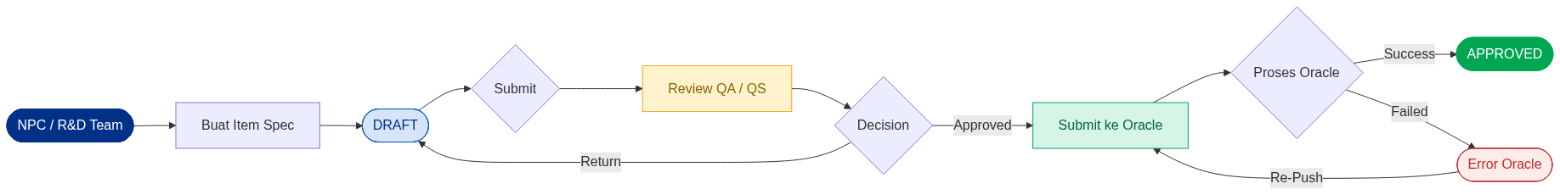
Gambar A.1: Alur Proses Item Spec — Tipe Base / Premix

Tipe 2 — FG / Intermediate (3 Jalur Paralel)
Prodev dan Packdev bekerja paralel secara independen. Setelah keduanya approved, NPC Team baru bisa membuat Item Spec New.
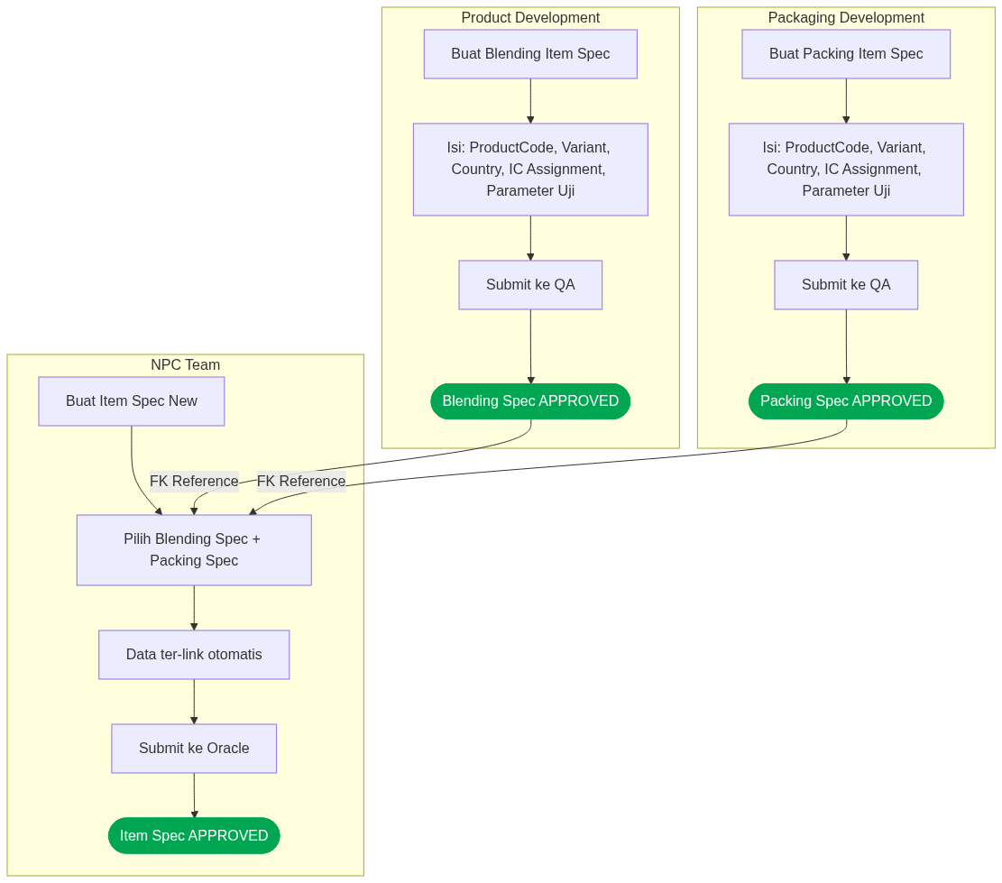
Gambar A.2: Alur Proses Item Spec New — Tipe FG / Intermediate (3 jalur paralel)

A.3 Detail Setiap Modul
Modul | Era | Tim | Tipe Transaksi | IC Assignment | Butuh Ref Spec Lain | Kirim ke Oracle
Item Spec | 2018 | NPC / QC | Base / Premix | Tidak | Tidak | Ya
Blending Spec | 2018 | Product Dev | FG/Intermediate | Ya | Ya | Tidak
Packing Spec | 2018 | Packaging Dev | FG/Intermediate | Ya | Ya | Tidak
Item Spec New | 2019 | NPC Team | FG/Intermediate | Tidak | Tidak | Ya

Alur Approval — Item Spec Blending / Packing
Berlaku juga untuk Packing Spec. IC Assignment wajib ada sebelum submit.
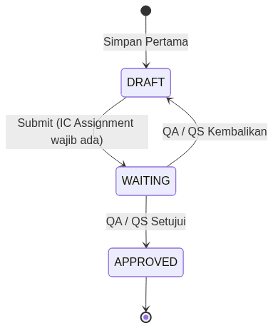
Gambar A.3: State Diagram Approval Blending / Packing Spec

Alur Submit Oracle — Item Spec / Item Spec New
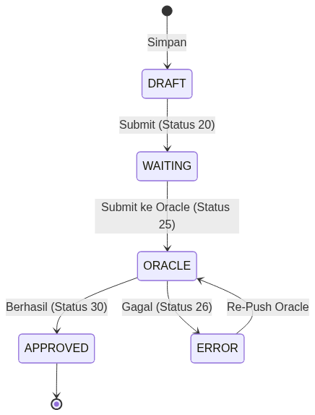
Gambar A.4: State Diagram Submit ke Oracle EBS

A.4 Kode Status Dokumen
Semua modul menggunakan kode status yang sama:
Kode | Status | Keterangan
00 | NEW | Dokumen baru, belum pernah disimpan
10 | DRAFT | Sudah disimpan, belum disubmit
20 | WAITING TO BE APPROVED | Sudah submit, menunggu approval
24 | SUBMITTED TO QA/QS | Dikirim ke QA atau QS untuk review
25 | SUBMITTING TO ORACLE | Sedang dikirim ke Oracle EBS
26 | ERROR IN ORACLE | Gagal masuk Oracle — bisa di-re-push
30 | APPROVED | Disetujui
40 | CANCELED | Dibatalkan
50 | REJECTED | Ditolak

A.5 Perbandingan 4 Modul
Aspek | Item Spec | Blending | Packing | Item Spec New
Era Dibuat | 2018 | 2018 | 2018 | 2019
Tipe Transaksi | Base / Premix | FG / Intermediate | FG / Intermediate | FG / Intermediate
Tim Pembuat | NPC / QC | Product Dev | Packaging Dev | NPC Team
Butuh Ref Spec Lain | Tidak | Tidak | Tidak | Ya (Blending + Packing)
IC Assignment | Tidak | Ya (Wajib) | Ya (Wajib) | Tidak
Fitur Inline / Non-Inline | Ada | Tidak | Tidak | Tidak
Kirim ke Oracle EBS | Ya | Tidak | Tidak | Ya
Re-Push jika Error Oracle | Ya | N/A | N/A | Ya

A.6 Rencana Revamp — IDC System
Ide utama: Semua modul Item Spec digabung menjadi 1 form tunggal di IDC System. User cukup pilih tipe transaksi di awal, form secara otomatis menampilkan field dan seksi yang relevan.

Perbedaan Tampilan Berdasarkan Tipe
Tipe Transaksi | Field yang Muncul
Base / Premix | Input ingredient secara manual, atau copy dari Item Spec yang sudah ada. Tidak ada pilihan Blending/Packing Spec.
Intermediate / FG | Dropdown untuk Get data Blending Spec dan Get data Packing Spec. Data parameter uji otomatis ter-populate dari kedua spec yang dipilih.

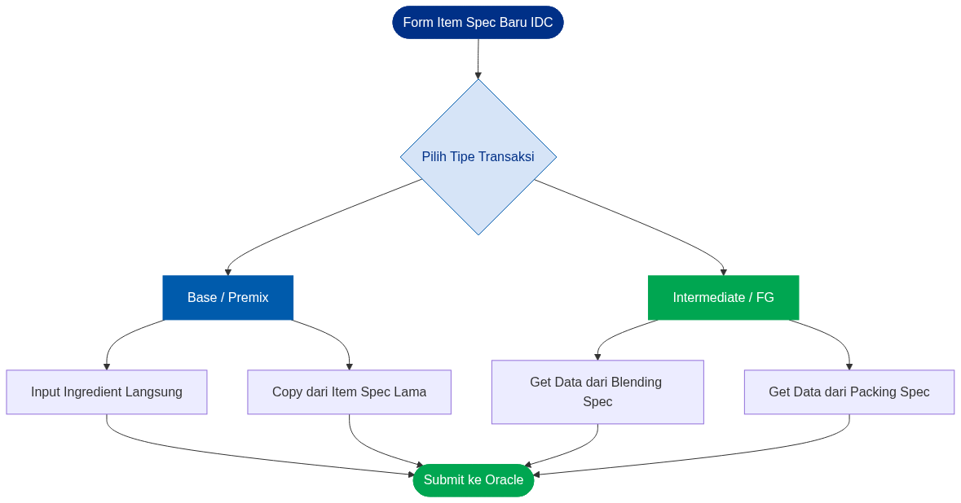
Gambar A.5: Rencana Alur Form Item Spec Tunggal di IDC System

