
Functional Specification Document
Version [1.0.0]

KICAO KDS
Modul: E-Materai

Prepared By
[Ageng Kurniawan Sugianto]

PT. Sanghiang Perkasa

Date
[06/07/2026]
BRD No : 2026.SHP-FSD.0040 |  |  |  | PID Ref. No : 2026.SHP-PID.0040
Revision history
Version | Date |  | Author(s) |  | Description
1.0.0 | 7 July 2026 |  | Ageng Kurniawan Sugianto |  | Initial Document
Document Approval
Full name |  | Job Title |  |  |  | Signature | Signature Date
Roy Alexander |  | SHP Commercial Sales Development
Ageng Kurniawan Sugianto |  | IT Product
Theresia Febrianti Magdalena Butarbutar |  | IT Product – Finance Specialist

Daftar Isi
FUNCTIONAL SPECIFICATION DOCUMENT (FSD) 1
Modul: KICAO KDS Enhancement — Master ASS/Owner KMMD & Form Klaim 1
Sistem: KICAO KDS (Kalbe Nutritionals — Claim & Distribution System) 1
Versi Dokumen: 1.0 1
Riwayat Revisi 1
1. Pendahuluan 4
1.1 Latar Belakang 4
1.2 Tujuan Dokumen 4
1.3 Ruang Lingkup 5
1.4 Stakeholder 5
1.5 Glosarium 5
2. Ringkasan Business Flow End-to-End 6
2.1 Konteks Posisi Modul dalam Ekosistem KICAO KDS 6
2.2 Flow Diagram — Proses End-to-End Enhancement 7
2.3 Status Dokumen Klaim (Enhancement) 9
2.4 Status Dokumen Master ASS/Owner 9
3. Master — Halaman ASS/Owner KMMD 9
3.1 Content Header & Toolbar 10
3.2 Box Header Dokumen 11
3.3 Box Mapping Owner KMMD & ASS 12
3.4 Box Riwayat Perubahan 14
3.5 Business Rules Index Master 15
4. Master — LOV & Modal 15
4.1 LOV Group Account 15
4.2 LOV Supplier 15
4.3 LOV Find (Cari Mapping) 16
4.4 Pesan Validasi & Error Master 16
5. Klaim — Halaman Form (Header) 16
5.1 Toolbar Actions 17
5.2 Section Header Form 18
5.3 Banner & Kontrol Khusus 20
6. Klaim — Grid Detail (28 Kolom) 20
6.1 Daftar Kolom Grid Detail (Urutan Kiri ke Kanan) 20
6.2 Rumus Kalkulasi per Baris 22
6.3 Kondisi Edit Kolom Payment 22
6.4 CRUD — Grid Detail 23
6.5 Validasi per Baris Detail (Save/Submit) 23
7. Klaim — Fitur Enhancement 23
7.1 Kolom Payment & DPP+PPN 23
7.2 E-Materai 24
7.3 Validasi Silang PPN ↔ Faktur Pajak 25
7.4 BosNet Period Quartal 25
7.5 Approval Eksternal OTP 26
8. Aturan Bisnis (Business Rules) 29
8.1 Aturan Bisnis — Master ASS/Owner KMMD (BR-M) 29
8.2 Aturan Bisnis — Form Klaim (BR-K) 31
8.3 Aturan Bisnis — Enhancement & Integrasi (BR-X) 31
9. Hak Akses & Peran Pengguna (RBAC) 32
9.1 Daftar Role Sistem 32
9.2 Matrix Permission — Master ASS/Owner 32
9.3 Matrix Permission — Form Klaim 32
9.4 Matrix Akses Field per Role & Status — Form Klaim 32
9.5 Filter Find per Role 33
10. Alur Persetujuan (Approval Flow) 33
10.1 Diagram Approval Workflow Enhancement 33
10.2 Tabel Langkah Approval 33
10.3 Handler Workflow (In-App) 34
10.4 Riwayat Approval (Approval History) 34
10.5 Notifikasi (Rencana Production) 34
10.6 Perbandingan dengan Production (Falcon SKP) 34
11. Integrasi Master ASS/Owner ke Form Klaim 35
11.1 Diagram Integrasi Master → Klaim 35
11.2 API Lookup Prototype 35
11.3 Contoh Alur Integrasi 35
11.4 Ketergantungan Data 35
11.5 Rekomendasi API Production 36
12. Struktur Database & ERD 36
12.1 Tabel Utama — Master ASS/Owner (Rekomendasi Production) 36
12.2 Tabel Utama — Klaim (Existing + Enhancement) 36
12.3 Kolom Enhancement pada XXSHP_KDS_T_KLAIM_DTL 36
12.4 Combined Entity Relationship Diagram 37
12.5 Storage Prototype (localStorage / sessionStorage) 38
12.6 Seed Data Master (Prototype) 38
13. Appendix — Gap Analysis & Skenario UAT 39
13.1 Gap Analysis — BRD vs Prototype vs Produksi 39
13.2 Mapping Status Legacy → Enhancement 39
13.3 LOV Form Klaim — Ringkasan 39
13.4 Kriteria Penerimaan UAT — Master ASS/Owner 40
13.5 Kriteria Penerimaan UAT — Form Klaim Enhancement 41
13.6 Skenario Uji End-to-End 42
13.7 Keterbatasan Prototype 42
13.8 File Source Prototype 43
13.9 Production Reference (Repo KICAO KDS) 43

1. Pendahuluan

1.1 Latar Belakang
Sistem KICAO KDS (Kalbe Integrated Claim & Outlet — Key Distribution System) digunakan oleh distributor dan partner Kalbe Nutritionals untuk mengelola transaksi klaim reimbursement atas aktivitas promosi dan program marketing. Enhancement yang didokumentasikan dalam FSD ini merupakan kelanjutan dari BRD KICAO KDS Enhancement (Juni 2026) yang mencakup dua modul utama:
- Master — Form ASS/Owner KMMD — modul master data yang memetakan Supplier Subdistributor ke Owner KMMD (approval level 1 via email/OTP eksternal) dan ASS (Area Sales Supervisor, auto-approve level 2).
- Klaim — Form Enhancement — peningkatan modul transaksi klaim dengan kolom payment, E-Materai, validasi PPN, periode BosNet quartal, serta alur approval eksternal Owner/ASS.
Modul Master ASS/Owner KMMD merupakan prasyarat operasional modul Klaim. Tanpa mapping supplier → Owner/ASS yang valid, sistem tidak dapat menentukan penerima notifikasi email Owner maupun identitas ASS untuk auto-approve.
Prototype implementasi tersedia di repositori kicaokds.kalbenutritionals sebagai HTML5 statis + JavaScript, meniru UI/UX aplikasi production KN2022_KCO_KDS.MVC.

1.2 Tujuan Dokumen
Dokumen ini bertujuan untuk:
- Mendeskripsikan fungsionalitas per komponen (header, grid, modal, LOV, tombol aksi) dari modul Master ASS/Owner KMMD dan Form Klaim Enhancement.
- Menjadi acuan pengembangan bagi tim IT KICAO KDS untuk implementasi production (ASP.NET MVC + Oracle).
- Mendokumentasikan alur proses bisnis end-to-end, desain layar, CRUD per section, LOV, dan aturan bisnis.
- Mendokumentasikan role-based access control per role dan per status dokumen klaim.
- Mendokumentasikan integrasi Master → Klaim untuk lookup Owner/ASS dan approval eksternal OTP.
- Menjadi referensi bagi tim KMMD, Finance, dan QA/UAT untuk memahami alur kerja enhancement.

1.3 Ruang Lingkup
Modul / Halaman | Path Prototype | Tujuan
Form Master ASS/Owner KMMD | Views/Master/AssOwnerKMMD/Index.html | CRUD mapping Supplier → Owner KMMD & ASS
Form Klaim | Views/Klaim/Index.html | Transaksi klaim + enhancement payment, E-Materai, approval
Approval Email (simulasi) | Views/Klaim/ApprovalEmail.html | Simulasi email OTP ke Owner KMMD
Approval OTP (eksternal) | Views/Klaim/ApprovalOtp.html | Landing page verifikasi OTP Owner
Popup Umbrand / Brand / SKU | Views/Klaim/Umbrand.html, Brand.html, SKU.html | Alokasi produk per baris detail
Scan Faktur Pajak | Views/Klaim/ScanFakturPajak.html | Parse URL faktur pajak elektronik DJP
Di luar lingkup (Out of Scope) dokumen ini:
ID BRD | Fitur | Keterangan
C.1 | Report Claim Outstanding | Belum diimplementasi di prototype
C.2 | Report Claim to Payment | Belum diimplementasi di prototype
D | RFP/RFS merge PDF ke SMART | Belum diimplementasi di prototype

1.4 Stakeholder
Peran | Tim / Divisi | Keterlibatan
Business Owner | KMMD / Finance | Pemilik proses bisnis, validasi kebutuhan fungsional
IT Developer | Tim IT – KICAO KDS | Pengembangan dan implementasi modul
Admin KMMD | KMMD Operations | Pembuat & maintain mapping ASS/Owner; input klaim awal
Owner KMMD | KMMD Management | Approval level 1 via email/OTP eksternal
ASS | Area Sales | Auto-approve level 2 setelah Owner approve
RSM | Regional Sales Manager | Review & Ready To Submit
CF (Finance) | Finance / Claim Finance | Submit final + input kolom payment
QA / UAT | QA | Verifikasi skenario uji berdasarkan dokumen ini

1.5 Glosarium
Istilah | Definisi
KMMD | Distributor Modern Trade — salah satu Group Account
ASS | Area Sales Supervisor — supervisor area yang di-auto-approve setelah Owner approve
Owner KMMD | Pemilik approval level 1 pada dokumen klaim; menerima email notifikasi
Mapping | Dokumen hubungan supplier → Owner + ASS di modul Master
Baris aktif | Baris Owner/ASS dengan radio terpilih — dipakai operasional lookup
Arsip | Baris non-aktif yang tetap disimpan untuk jejak historis
E-Materai | Dokumen materai elektronik — generate PDF Kwitansi + Surat Pengantar Klaim
BosNet | Sumber dokumen klaim dari integrasi BosNet API (push per quartal)
DPP+PPN | Kalkulasi tampilan: Invoice Amount + PPN Amount
OTP | One-Time Password — kode 6 digit untuk approval eksternal Owner

2. Ringkasan Business Flow End-to-End

2.1 Konteks Posisi Modul dalam Ekosistem KICAO KDS
Master ASS/Owner KMMD (Setup mapping Supplier → Owner + ASS)
│
▼ (Lookup saat Submit / Approval)
Form Klaim — Admin KMMD buat & Save (DRAFT)
│
▼ (Owner OTP eksternal + ASS auto)
DRAFT WITH APPROVE
│
▼ (RSM Ready To Submit)
Ready to Submit
│
▼ (CF Submit)
APPROVED → Input Payment (CF) → E-Materai (jika >= Rp 5 juta)

2.2 Flow Diagram — Proses End-to-End Enhancement
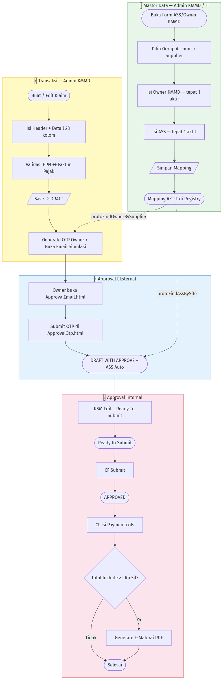
Business Flow End-to-End — KICAO KDS Enhancement

2.3 Status Dokumen Klaim (Enhancement)
Kode Status | Label Tampilan | Warna Label | Keterangan
NEW | NEW | Biru | Form baru, belum disimpan
DRAFT | DRAFT | Kuning | Setelah Admin KMMD Save; menunggu Owner OTP
DRAFT WITH APPROVE | DRAFT WITH APPROVE | Teal | Setelah Owner OTP (+ ASS auto-approve)
Ready to Submit | Ready to Submit | Ungu | Setelah RSM klik Ready To Submit
APPROVED | APPROVED | Biru | Setelah CF Submit final
CLOSED | CLOSED | Merah | Dokumen ditutup (legacy production)
REJECTED | REJECTED | Merah | Dokumen ditolak (legacy production)
Normalisasi status legacy (normKlaimStatus()): APPROVE 1 - DRAFT, APPROVE 2 - DRAFT, DRAFT WITH 2 APPROVE → DRAFT WITH APPROVE; DRAFT WITH 3 APPROVE, READY TO SUBMIT → Ready to Submit.

2.4 Status Dokumen Master ASS/Owner
Kode Registry | Label UI | Keterangan
NEW | BARU | Dokumen baru, belum pernah disimpan
ACTIVE | AKTIF | Mapping aktif, dipakai lookup klaim

3. Master — Halaman ASS/Owner KMMD
Path File: Views/Master/AssOwnerKMMD/Index.html
Menu Navigasi: Master Data → Form ASS/Owner KMMD (#menu-master-ass-owner)
Tujuan: Mengelola mapping Supplier Subdistributor (per Group Account) ke Owner KMMD dan ASS yang digunakan pada alur approval klaim. Modul ini harus dikonfigurasi sebelum klaim dapat melalui rantai approval Owner → ASS.
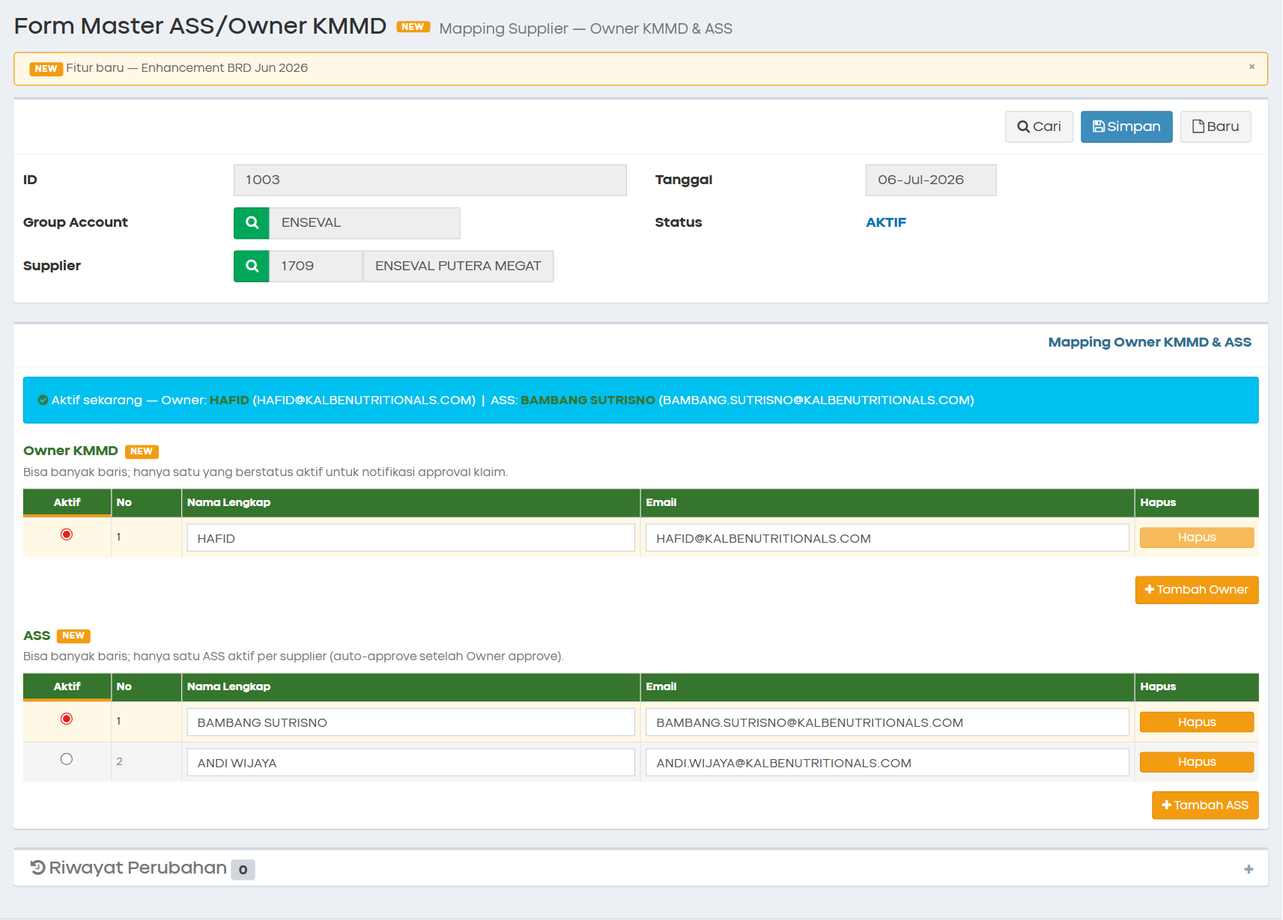
Tampilan Full Page — Master ASS/Owner KMMD
Toolbar Master ASS/Owner KMMD

3.1 Content Header & Toolbar
Halaman menggunakan layout AdminLTE dengan content header berisi judul modul dan badge enhancement.
Elemen UI | Keterangan
Judul halaman | Form Master ASS/Owner KMMD
Subtitle | Mapping Supplier — Owner KMMD & ASS
Badge NEW | Fitur enhancement BRD Juni 2026 — dismissible
Legenda | #protoNewLegend — menjelaskan penanda kolom/fitur baru

3.1.1 Toolbar Actions
Tombol | ID Elemen | Style | Permission Key | Fungsi
Cari | #btnFind | btn-default | master.assOwner.find | Buka LOV Find mapping existing
Simpan | #btnSave | btn-primary | master.assOwner.save | Validasi + persist ke registry
Baru | #btnNew | btn-default | master.assOwner.new | Reset form ke kondisi kosong
Tombol Aksi Header Master
CRUD — Toolbar Master:
Operasi | Cara | Keterangan
Create | Klik Baru → isi form → Simpan | ID auto-generate, status BARU → AKTIF
Read | Klik Cari → pilih record dari LOV | Load header + Owner + ASS + riwayat
Update | Buka record → edit → Simpan | Diff vs data lama → batch riwayat baru
Delete | Tidak tersedia di UI | Baris Owner/ASS dapat dihapus; header tidak dihapus

3.2 Box Header Dokumen
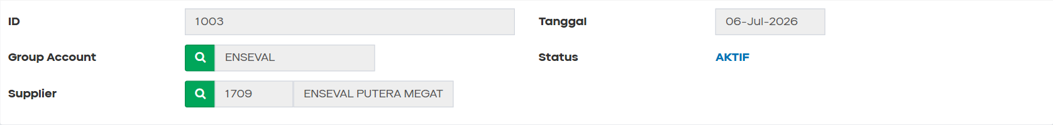
Box Header Dokumen Master
Box pertama berisi identitas dokumen mapping dan referensi supplier.

3.2.1 Fields — Header Dokumen
Field Name | ID Elemen | Tipe | Mandatory | Default | Validasi | Keterangan
ID | #txtID | Text (readonly) | — | [OTOMATIS] | — | Diisi saat simpan pertama; format prototype: angka 4 digit
Tanggal | #dtmDate | Text (readonly) | — | Hari ini | — | Format tampilan: DD-MMM-YYYY
Group Account | #txtGroupAccount | Text + LOV | Ya | (kosong) | Wajib sebelum Supplier | Tombol search hijau; ganti GA → kosongkan Supplier
Status | #lblStatus | Label | — | BARU | — | Tampilan: BARU / AKTIF; registry: NEW / ACTIVE
Supplier ID | #txtSupplierID | Text (readonly) | Ya | (kosong) | Wajib sebelum Simpan | Terisi via LOV Supplier; read-only setelah pilih
Nama Supplier | #txtSupplierName | Text (readonly) | Ya | (kosong) | — | Tooltip title = nama penuh supplier
Business Rules — Header Master:
- Group Account wajib dipilih sebelum Supplier (BR-M03).
- Supplier wajib dipilih sebelum Simpan (BR-M04).
- Satu supplier hanya boleh punya satu mapping aktif di registry (BR-M01).
- ID dokumen auto-generate saat simpan pertama (BR-M05).
- Status BARU → AKTIF setelah simpan pertama berhasil (BR-M06).
CRUD — Header Master:
Operasi | Cara | Keterangan
Create | Baru → pilih GA + Supplier via LOV | Field ID kosong, status BARU
Read | Cari → pilih record | Semua field header terisi
Update | Edit GA/Supplier hanya saat record baru | Supplier existing tidak dapat diganti duplikat
Delete | Tidak ada | —

3.3 Box Mapping Owner KMMD & ASS
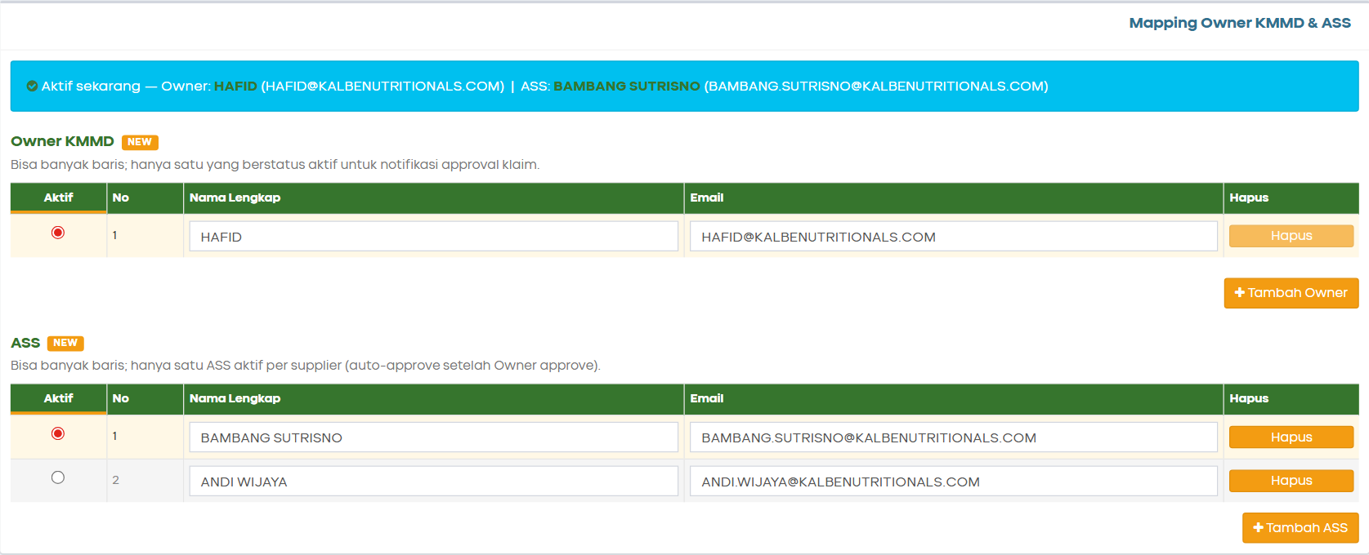
Box Mapping Owner & ASS
Box kedua berisi summary bar aktif dan dua tabel grid: Owner KMMD dan ASS.

3.3.1 Summary Bar Aktif
Elemen | ID Elemen | Keterangan
Summary bar | #activeSummary | Menampilkan nama + email Owner & ASS yang sedang aktif; update real-time saat radio berubah
Summary Bar Owner ASS Aktif

3.3.2 Tabel Owner KMMD
ID Tabel: #dtOwner
ID Body: #dtBodyOwner
Kolom Grid | ID/Class Elemen | Tipe | Mandatory (baris aktif) | Default | Validasi | Keterangan
Aktif | name=ownerActive | Radio | Ya (tepat 1) | Baris 1 | Tepat satu radio terpilih | Lebar 50px
No | — | Text (auto) | — | 1-based | — | Urutan baris
Nama Lengkap | .owner-name | Text (freetext) | Ya | (kosong) | Uppercase on blur | Lebar 260px; disimpan UPPERCASE
Email | .owner-email | Text (freetext) | Ya | (kosong) | Format email + uppercase | Regex: /^[^\s@]+@[^\s@]+\.[^\s@]+$/
Hapus | .btn-del-owner | Button | — | — | Disabled jika 1 baris saja | Konfirmasi khusus jika baris aktif
Tombol: Tambah Owner — menambah baris kosong (non-aktif default); prasyarat Group Account terisi.
Visual state baris:
State | Background
Aktif | #fff8e6 (kuning muda)
Tidak aktif / arsip | #f5f5f5 (abu)

3.3.3 Tabel ASS
ID Tabel: #dtAss
ID Body: #dtBodyAss
Struktur identik dengan tabel Owner; radio name=assActive.
Kolom Grid | ID/Class Elemen | Tipe | Mandatory (baris aktif) | Default | Validasi | Keterangan
Aktif | name=assActive | Radio | Ya (tepat 1) | Baris 1 | Tepat satu radio terpilih | —
No | — | Text (auto) | — | 1-based | — | —
Nama Lengkap | .ass-name | Text (freetext) | Ya | (kosong) | Uppercase on blur | ASS aktif = pegawai auto-approve klaim
Email | .ass-email | Text (freetext) | Ya | (kosong) | Format email + uppercase | —
Hapus | .btn-del-ass | Button | — | — | Disabled jika 1 baris saja | —
Tombol: Tambah ASS
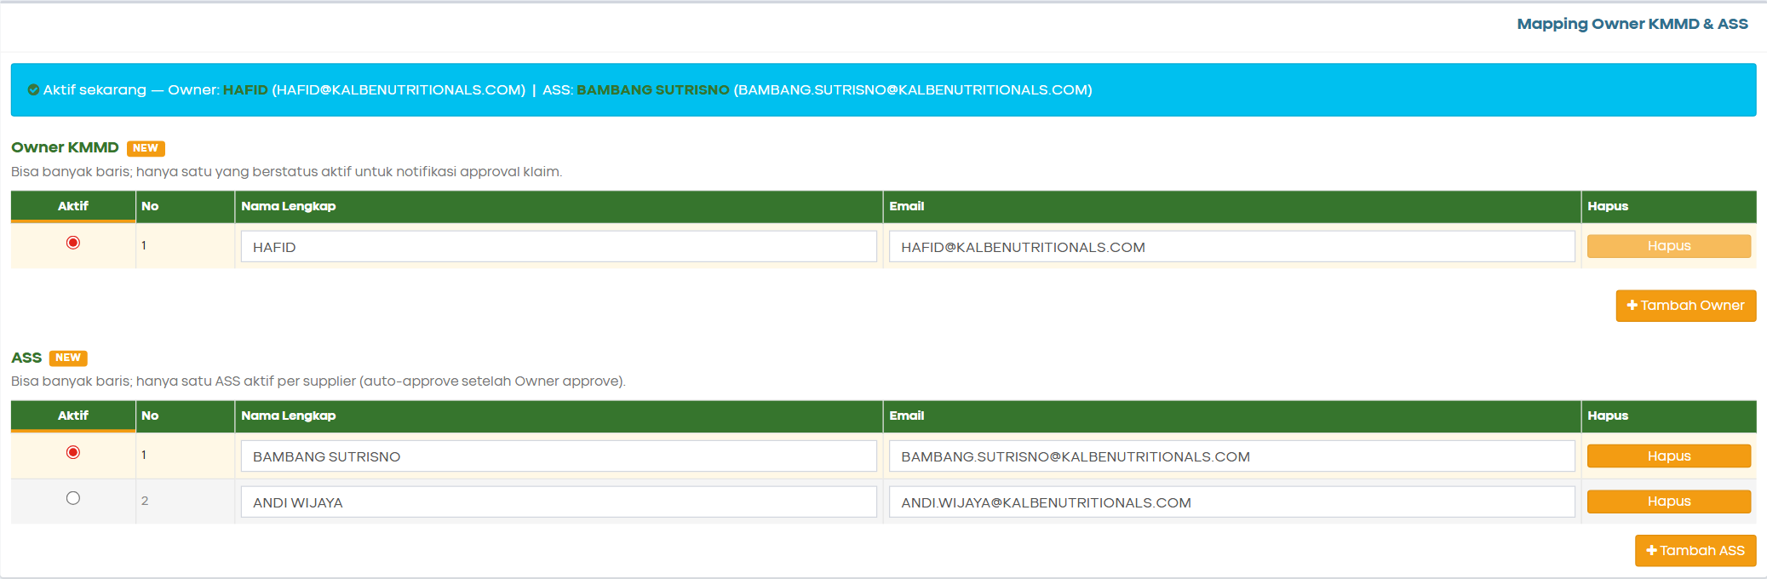
Tabel Owner dan ASS
CRUD — Grid Owner & ASS:
Operasi | Cara | Keterangan
Create | Klik Tambah Owner / Tambah ASS | Baris baru non-aktif; minimal 1 baris per tabel
Read | Load via Cari atau inisialisasi | Radio aktif + summary bar ter-update
Update | Edit nama/email; ganti radio aktif | Baris lama menjadi arsip; diff tercatat di riwayat
Delete | Klik Hapus pada baris | Jika hapus baris aktif → baris pertama jadi aktif

3.4 Box Riwayat Perubahan
ID Box: #boxHistory (accordion AdminLTE, default tertutup)
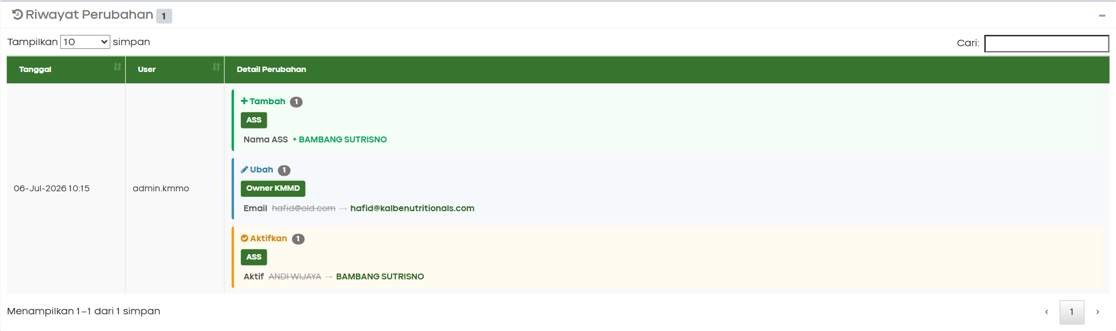
Riwayat Perubahan Master
Properti | Nilai
Badge jumlah | #historyCountBadge — jumlah aksi simpan (bukan field)
Tabel riwayat | #dtHistory — DataTables dengan search, sort, pagination
Default sort | Tanggal descending
Page size | 5 / 10 / 25 / 50 / Semua

3.4.1 Kolom DataTables Riwayat
Kolom | Keterangan
Tanggal | Format DD-MMM-YYYY HH:mm
User | Label role pengguna (rbacGetRoleMeta().label)
Detail Perubahan | HTML — kelompok aksi: Tambah / Hapus / Ubah / Aktifkan

3.4.2 Jenis Aksi Riwayat (Audit Trail)
Action Code | Label UI | Warna Grup | Kapan Tercatat
add | Tambah | Hijau | Baris Owner/ASS baru ditambahkan & terisi
delete | Hapus | Merah | Baris dihapus dari form
edit | Ubah | Biru | Nama atau email berubah pada baris sama
aktif | Aktifkan | Kuning | Radio aktif berubah / pindah orang aktif
Konsep batch: Satu aksi Simpan = satu batch riwayat (changeHistory[]); batch terbaru di indeks 0.
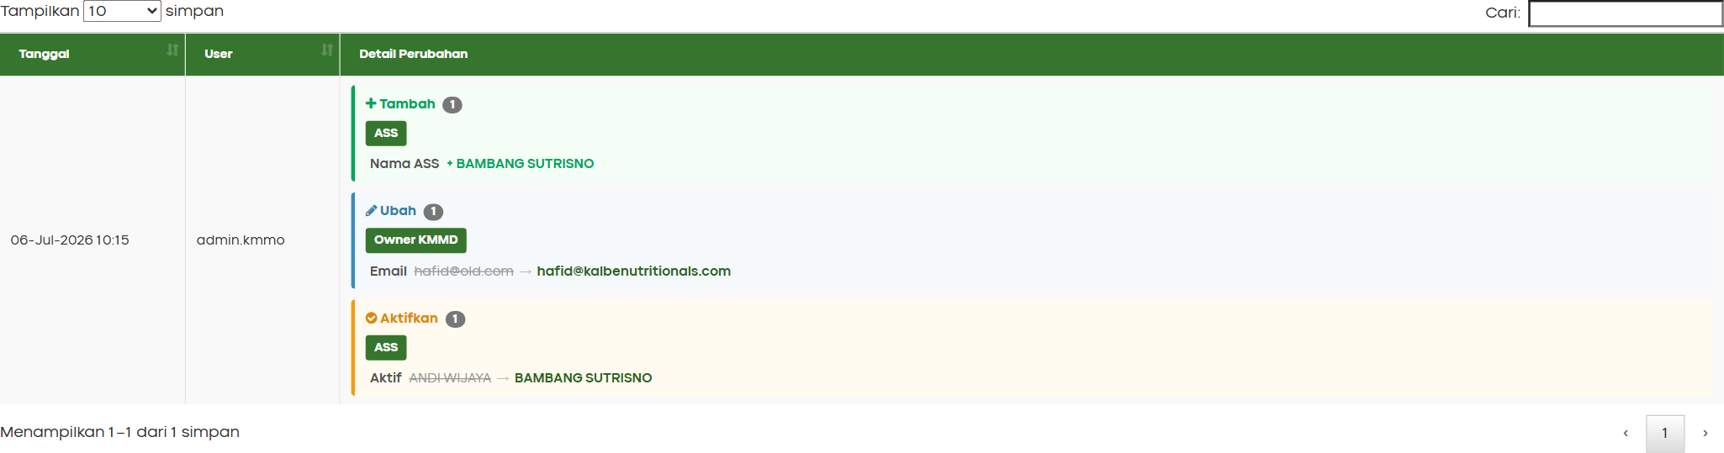
Detail Batch Riwayat

3.5 Business Rules Index Master
Status Mapping | Action Tersedia | Keterangan
BARU | Simpan (create) | Belum ada di registry
AKTIF | Simpan (update), Cari, Baru | Dapat diedit; perubahan tercatat di riwayat

4. Master — LOV & Modal
ID Modal: #lovModal (harus berada di dalam #app-content)
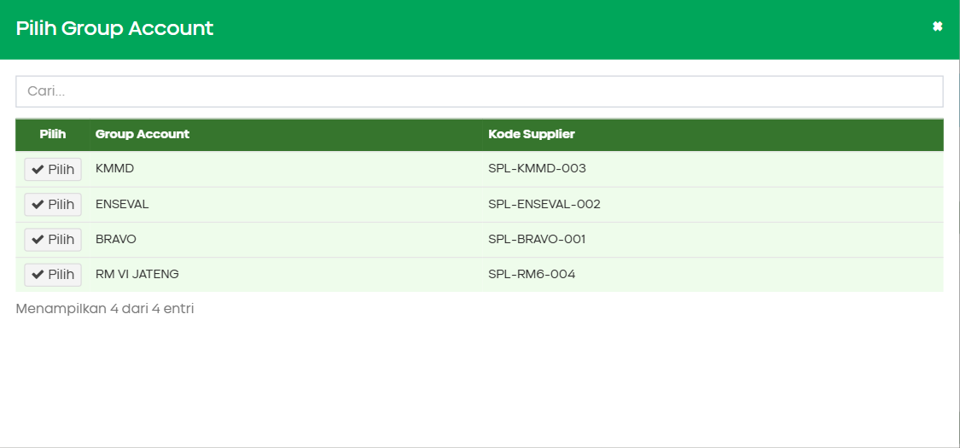
Modal LOV Master
Properti Modal | ID Elemen | Keterangan
Judul dinamis | #lovModalTitle | Berubah sesuai jenis LOV
Search | #lovSearch | Filter client-side live
Header kolom | #lovHeadRow | Dinamis per LOV
Body data | #lovBody | Baris data + tombol Pilih
Info jumlah | #lovInfo | “Menampilkan X dari Y entri”

4.1 LOV Group Account
Properti | Nilai
Trigger | Tombol search di field #txtGroupAccount
Judul modal | Pilih Group Account
Kolom | Group Account, Kode Supplier
On pick | Isi Group Account; kosongkan Supplier ID & Nama
Data mock prototype:
Group Account | Kode Supplier
KMMD | SPL-KMMD-003
ENSEVAL | SPL-ENSEVAL-002
BRAVO | SPL-BRAVO-001
RM VI JATENG | SPL-RM6-004

4.2 LOV Supplier
Properti | Nilai
Prasyarat | Group Account (#txtGroupAccount) terisi
Judul modal | Pilih Supplier
Filter | supplier.group === txtGroupAccount
Kolom | ID Supplier, Nama Supplier, Group Account
On pick | Isi #txtSupplierID & #txtSupplierName; set tooltip nama

4.3 LOV Find (Cari Mapping)
Properti | Nilai
Trigger | Tombol #btnFind
Judul modal | Cari Mapping ASS/Owner
Sort | ID descending
Kolom | ID, Group Account, ID Supplier, Nama Supplier
On pick | Load full record ke form; clear flag formDirty
Peringatan | Jika formDirty: konfirmasi “Ada perubahan yang belum disimpan. Buka data lain?”

4.4 Pesan Validasi & Error Master
Urutan | Kondisi | Pesan Error
1 | Group Account kosong | Group Account wajib diisi!
2 | Supplier kosong | Supplier wajib dipilih!
3 | Format email invalid (baris manapun) | Periksa format email yang ditandai merah.
4 | Owner aktif != 1 | Harus ada tepat satu Owner KMMD aktif (pilih radio).
5 | Nama Owner aktif kosong | Nama Owner KMMD aktif wajib diisi!
6 | Email Owner aktif kosong/invalid | Pesan spesifik format email
7 | ASS aktif != 1 | Harus ada tepat satu ASS aktif (pilih radio).
8 | Nama/Email ASS aktif kosong/invalid | Pesan spesifik
9 | Supplier duplikat | Supplier ini sudah memiliki mapping ASS/Owner. Gunakan Cari untuk membuka data yang ada.
10 | Tambah Owner/ASS tanpa GA | Group Account harus diisi terlebih dahulu!
11 | Hapus baris aktif | Baris ini sedang AKTIF. Setelah dihapus, baris pertama akan menjadi aktif.
Pesan sukses Simpan:
Data mapping Owner KMMD & ASS berhasil disimpan!
{N} field diubah — tercatat 1 baris riwayat.
Riwayat accordion auto-buka jika ada perubahan baru.

5. Klaim — Halaman Form (Header)
Path File: Views/Klaim/Index.html
Menu Navigasi: Transaksi → Form Klaim
Tujuan: Halaman utama transaksi klaim reimbursement. Mencakup header dokumen, grid detail 28 kolom, tombol aksi workflow, serta fitur enhancement (payment, E-Materai, validasi PPN, BosNet quartal, approval OTP).
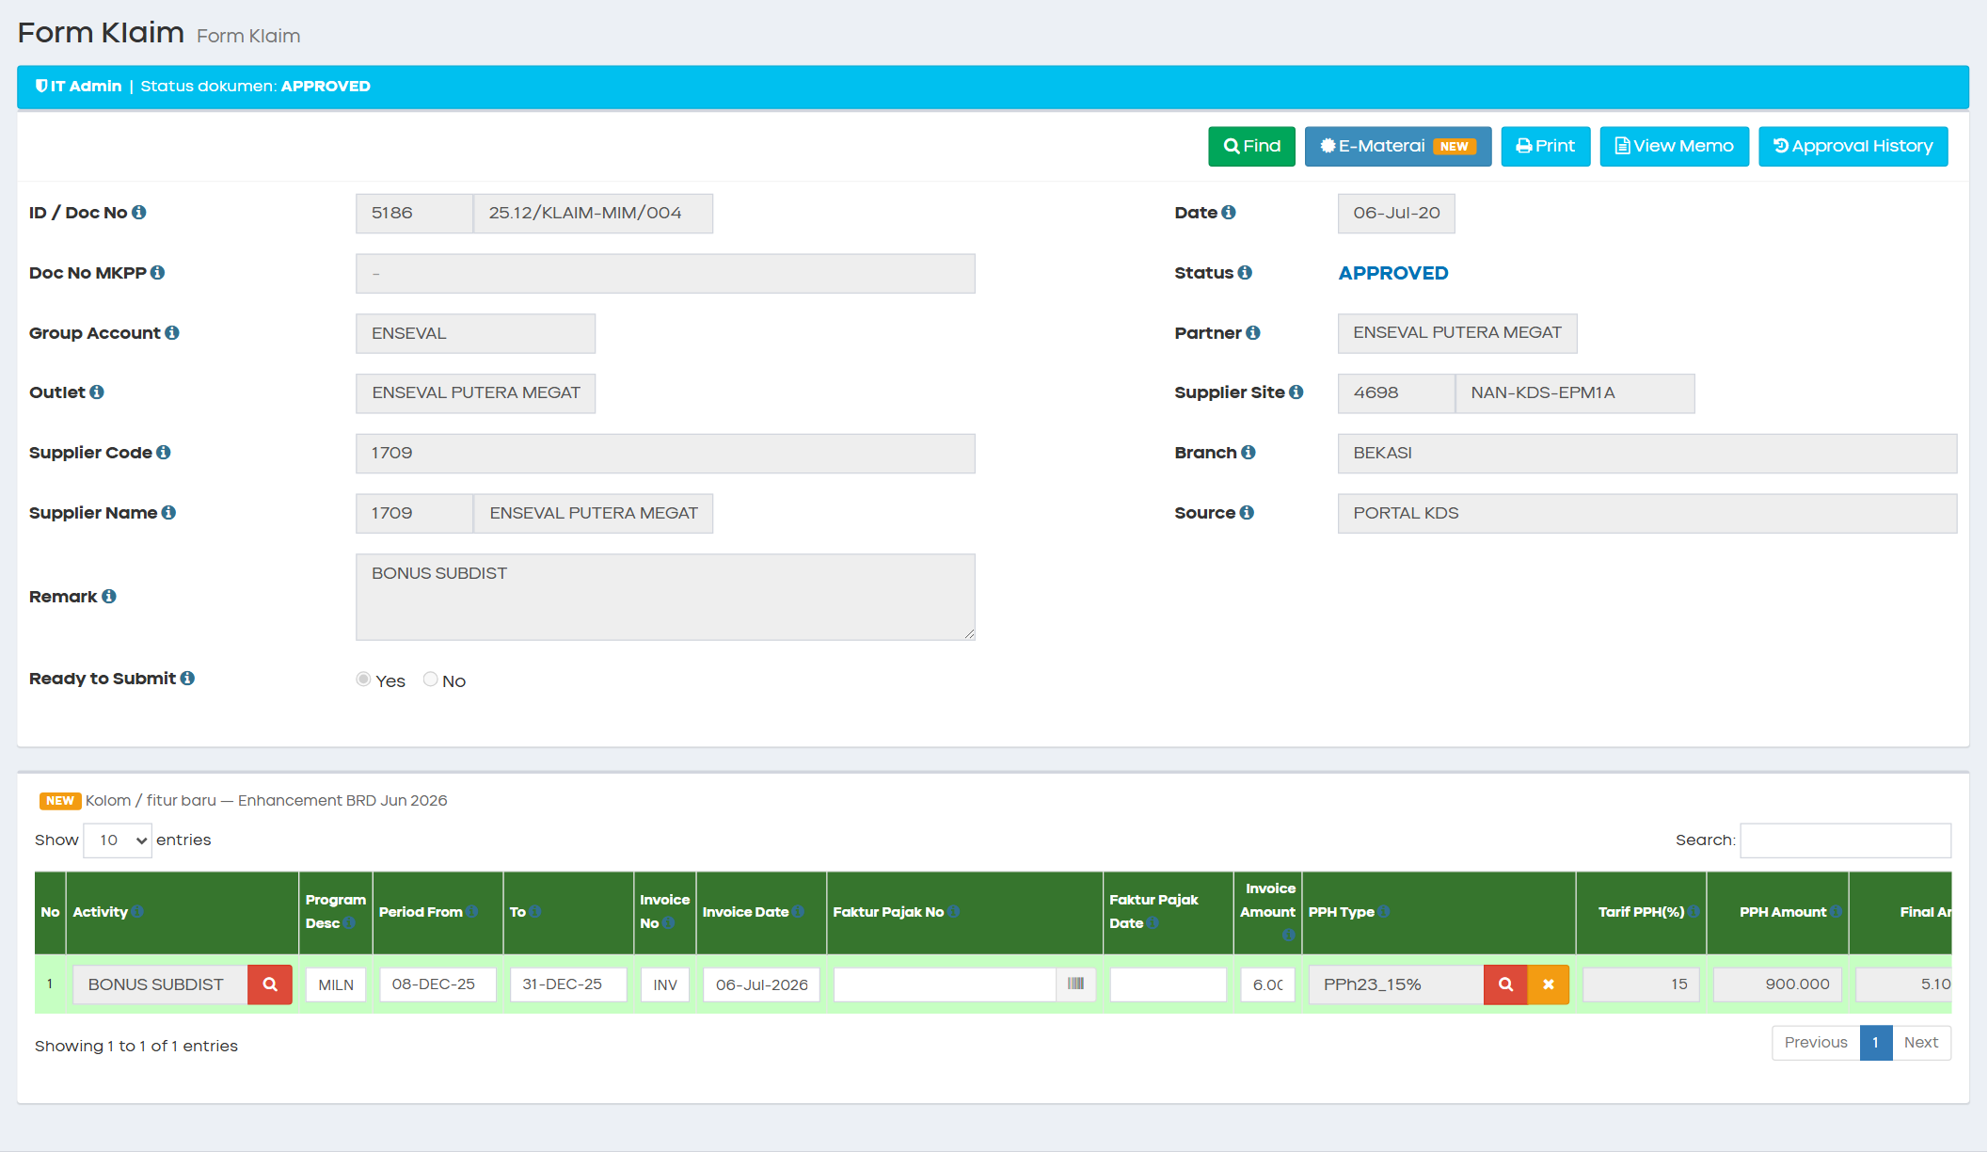
Tampilan Full Page — Form Klaim
Toolbar Form Klaim

5.1 Toolbar Actions
Tombol | ID Elemen | Warna/Style | Permission Key | Kondisi Tampil | Fungsi
Find | #btnFind | btn-success | klaim.find | Selalu | Buka LOV Find klaim (filter per role)
Save | #btnSave | btn-success | klaim.save | NEW / DRAFT (Admin KMMD) | Simpan draft + trigger OTP email Owner
New | #btnNew | btn-warning | klaim.new | Sesuai role | Reset form baru
Email / Approve | #btnOwnerApprove | btn-info | klaim.ownerApprove | Status DRAFT (Owner KMMD in-app) | Simulasi approve Owner tanpa email
Ready To Submit | #btnRsmReadySubmit | btn-warning | klaim.rsmReadySubmit | DRAFT WITH APPROVE (RSM) | RSM finalisasi → Ready to Submit
Submit | #btnSubmit | btn-success | klaim.cfSubmit | Ready to Submit (CF) | Submit final → APPROVED
E-Materai | #btnEMaterai | btn-primary btn-proto-new | — | Enabled jika total >= Rp 5 juta | NEW — Generate PDF Kwitansi + Surat Pengantar
Print | #btnPrintout | btn-info | — | Selalu | Cetak mock PDF klaim
View Memo | #btnViewMemo | btn-info | — | Selalu | Preview memo klaim
Approval History | #btnApprovalHistory | btn-info | klaim.approvalHistory | Setelah apply/approve | Tampilkan riwayat 5 langkah approval
Close | #btnClose | btn-danger | — | Kondisi legacy | Tutup dokumen + alasan
Reject | #btnReject | btn-danger | — | Kondisi legacy | Tolak dokumen + alasan
Copy | #btnCopy | btn-warning | — | Kondisi legacy | Duplikasi klaim

Tombol E-Materai dengan Badge NEW
CRUD — Toolbar Klaim:
Operasi | Cara | Role | Keterangan
Create | New → isi header + Add Detail → Save | Admin KMMD | Status NEW → DRAFT
Read | Find → pilih record | Semua role | Filter Find sesuai role
Update | Edit field → Save / Ready To Submit | Admin / RSM | Payment hanya CF saat APPROVED
Delete | Hapus baris detail (kolom Delete) | Admin / RSM | Header tidak dihapus dari UI

5.2 Section Header Form
ID Form: #frmTrKlaim
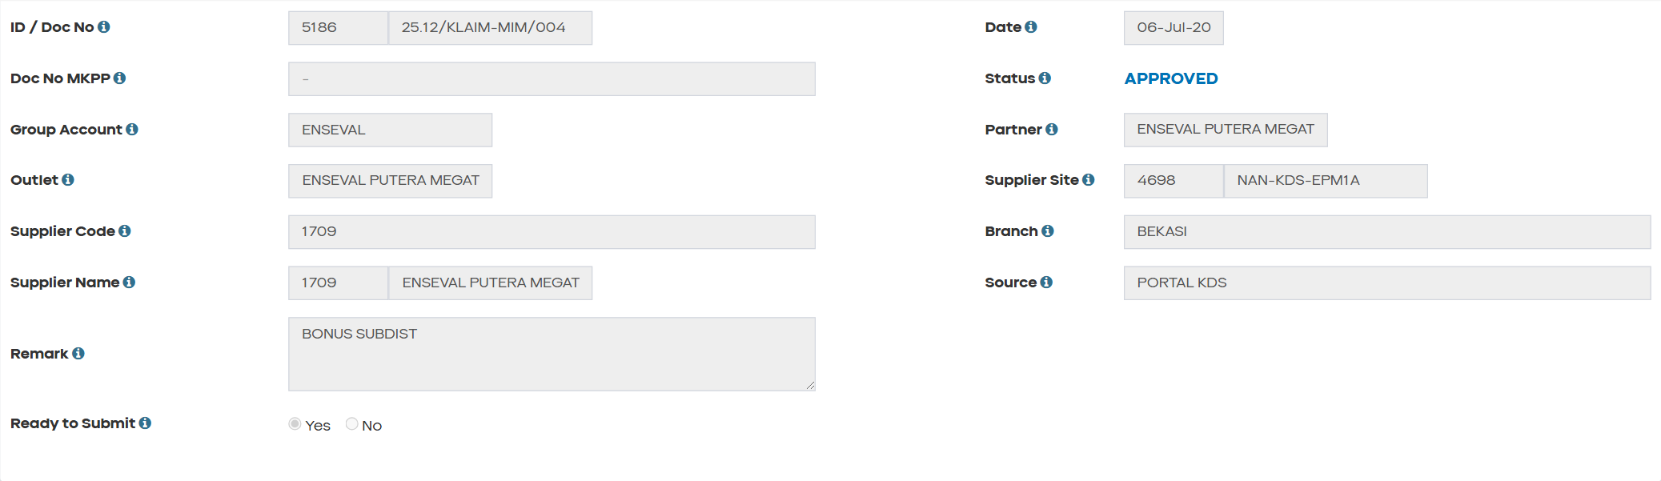
Section Header Form Klaim

5.2.1 Fields — Header Klaim
Field Name | ID Elemen | Tipe | Mandatory | Default | Validasi | Keterangan
ID | #txtID | Text (disabled) | — | [AUTO] | — | INT_KLAIM_HDR_ID — auto saat save
Doc No | #txtDocNo | Text (disabled) | — | [AUTO] | — | TXT_DOC_NO — format: 26.03/KLAIM-XXX/NNN
Date | #dtmDate | Text (disabled) | — | Hari ini | — | CREATION_DATE — format DD-MMM-YYYY
Doc No MKPP | #txtDocNoMkpp | Text (disabled) | Tidak | - | — | TXT_DOCNO_MKPP — referensi MKPP
Status Flow | #lblStatusFlow | Label | — | NEW | — | TXT_STATUSFLOW — warna dinamis per status
Group Account | #txtGroupAccount | Text + LOV | Ya | (kosong) | Wajib | #btnLOVGroupAccount → lovGroupAccountModal
Partner | #txtPartner | Text + LOV | Kondisional | (kosong) | Wajib jika GA = ENSEVAL | #btnLOVPartner — hanya tampil untuk ENSEVAL
Outlet | #txtOutlet | Text + LOV | Ya | (kosong) | Wajib | #btnLOVOutlet — auto isi supplier & branch
Supplier Site ID | #txtSupplierSiteID | Text (disabled) | — | (auto) | — | INT_SUPPLIER_SITE_ID
Supplier Site Name | #txtSupplierSiteName | Text (disabled) | — | (auto) | — | TXT_SUPPLIER_SITE_NAME
Supplier Code | #txtSupplierCode | Text (disabled) | — | (auto) | — | TXT_SUPPLIER_CODE — dipakai lookup Owner/ASS
Branch Name | #txtBranchName | Text (disabled) | — | (auto) | — | TXT_BRANCH
Supplier ID | #txtSupplierID | Text (disabled) | — | (auto) | — | INT_SUPPLIER_ID
Supplier Name | #txtSupplierName | Text (disabled) | — | (auto) | — | TXT_SUPPLIER_NAME
Source Doc | #txtSourceDoc | Text (disabled) | — | PORTAL KDS | — | TXT_SOURCE_DOC — BOSNET untuk push quartal
Remark | #txtRemark | Textarea | Ya | (kosong) | Wajib; uppercase | TXT_REMARK
Ready to Submit | #rdoReadySubmitYes / #rdoReadySubmitNo | Radio | Kondisional | No | Alasan wajib jika No | BIT_READY_SUBMIT Y/N
Reason Ready Submit | #txtReasonReadySubmit | Text | Kondisional | (kosong) | Wajib jika Ready = No | TXT_REASON_READY_SUBMIT

5.2.2 Flag State Internal (claimFormState)
Flag JS | Field DB | Nilai | Keterangan
BIT_APPLY | BIT_APPLY | Y/N | Sudah pernah submit/apply
BIT_APPROVED | BIT_APPROVED | Y/N | Fully approved — payment fields editable (CF)
BIT_REJECTED | BIT_REJECTED | Y/N | Ditolak — form read-only
BIT_CLOSED | BIT_CLOSED | Y/N | Ditutup — banner merah #divClose
TXT_STATUSFLOW | TXT_STATUSFLOW | string | Status alur enhancement
CRUD — Header Klaim:
Operasi | Cara | Keterangan
Create | New → pilih LOV header → isi remark | Status NEW, detail kosong
Read | Find → load loadClaimFromFind(item) | Semua field terisi dari registry/findData
Update | Edit → Save (Admin) / Ready To Submit (RSM) | LOV header terkunci setelah apply
Submit | CF klik Submit saat Ready to Submit | Status → APPROVED

5.3 Banner & Kontrol Khusus
Elemen | ID Elemen | Keterangan
RBAC Banner | #rbacKlaimBanner | Info role aktif — tampil sesuai rbacApplyKlaimPage()
Banner Closed | #divClose | Tampil jika BIT_CLOSED=Y; teks #txtReasonClose
Legenda NEW | .proto-new-legend | Penjelasan badge oranye NEW pada kolom enhancement
Banner RBAC dan Status

6. Klaim — Grid Detail (28 Kolom)
ID Tabel: #dtDetail
ID Body: #dtBodyKlaim
ID Info: #dtDetailInfo
Tombol Add Detail: #btnAddDetail
Grid detail menampilkan 28 kolom (empty state colspan="28"). Kolom enhancement ditandai badge NEW (class .proto-new-header, .proto-new-cell).
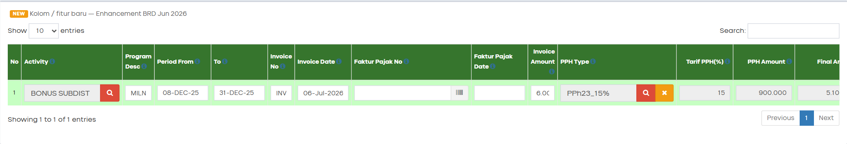
Grid Detail Klaim Full

6.1 Daftar Kolom Grid Detail (Urutan Kiri ke Kanan)
# | Kolom Grid | Field DB / JS Property | Baru? | Tipe UI | Mandatory | Default | Validasi | Keterangan
1 | No | — |  | Text (auto) | — | 1-based | — | Nomor urut baris
2 | Activity | TXT_ACTIVITY / activity |  | Text + LOV | Ya | (kosong) | Wajib; LOV merah | Default kosong saat Add Detail (bukan ACT-KCO-01)
3 | Program Desc | TXT_PROGRAM_DESC / programDesc |  | Text | Ya | (kosong) | Wajib | Deskripsi program marketing
4 | Period From | DTM_PERIOD_FROM / periodFrom |  | Datepicker | Ya | Hari ini* | Period To >= From | *BosNet: quartal via getBosnetQuarterPeriod
5 | Period To | DTM_PERIOD_TO / periodTo |  | Datepicker | Ya | +30 hari* | >= Period From | *BosNet: akhir quartal
6 | Invoice No | TXT_INVOICE_NO / invoiceNo |  | Text | Ya | (kosong) | Unik case-insensitive | —
7 | Invoice Date | DTM_INVOICE / invoiceDate |  | Datepicker | Tidak | (kosong) | — | —
8 | Faktur Pajak No | TXT_FKT_PJK_NO / fakturNo |  | Text + Scan | Kondisional | (kosong) | Wajib jika PPN > 0% | Tombol scan barcode → popup ScanFakturPajak
9 | Faktur Pajak Date | DTM_FKT_PJK / fakturDate |  | Datepicker | Kondisional | (kosong) | Wajib jika PPN > 0% | —
10 | Invoice Amount | DEC_INVOICE_AMT / invoiceAmount |  | Autonumeric | Ya | 0 | > 0 | Basis kalkulasi PPH/PPN
11 | PPH Type | TXT_PPH_JENIS / pphType |  | Text + LOV | Tidak | (kosong) | — | LOV lovDetailPphTypeModal
12 | Tarif PPH(%) | DEC_PERSEN_PPH / pphTarif |  | Text (readonly) | — | 0 | — | Auto dari LOV PPH
13 | PPH Amount | DEC_PPH / (kalkulasi) |  | Text (readonly) | — | 0 | floor(Invoice × Tarif / 100) | —
14 | Final Amount | (kalkulasi) |  | Text (readonly) | — | 0 | Invoice − PPH | —
15 | PPN Type | TXT_PPNTAXRATE_CODE / ppnType |  | Dropdown | Kondisional | NON PPN | Wajib jika faktur diisi | Contoh: NON PPN, PPN 11%
16 | PPN Amount | DEC_PPN / ppnAmount |  | Autonumeric | Kondisional | 0 | Silang dengan faktur | —
17 | DPP+PPN | (kalkulasi) | NEW | Text (readonly) | — | 0 | Invoice Amount + PPN Amount | Class .txtDppPpn; badge NEW
18 | Total Amount | (kalkulasi) |  | Text (readonly) | — | 0 | Final + PPN | —
19 | All Brand | BIT_ALLBRAND / allBrand |  | Checkbox | Tidak | false | — | Jika unchecked → wajib alokasi Umbrand
20 | Umbrand | XXSHP_KDS_T_KLAIM_UMB / umbrandData |  | Button | Kondisional | — | Total alokasi = Invoice Amount | Popup iframe Umbrand → Brand → SKU
21 | Attachment | XXSHP_KDS_T_KLAIM_DTL_ATT / attachmentName |  | File upload | Ya | (kosong) | Wajib (mock nama file) | #fileDetail{N}
22 | Delete | — |  | Button | — | — | — | Hapus baris detail
23 | Status | TXT_STATUSKLAIM / status |  | Dropdown | Tidak | (kosong) | — | Status per baris detail
24 | Description | TXT_STATUS_DESC / description |  | Text | Tidak | (kosong) | — | Deskripsi status baris
25 | Include | BIT_INCLUDE / include |  | Checkbox | Tidak | false | — | Mempengaruhi grand total & E-Materai threshold
26 | Status Payment | TXT_PAYMENT_STATUS / paymentStatus | NEW | Dropdown .ddlPaymentStatus | Kondisional | (kosong) | Editable CF saat APPROVED | PENDING / PAID / CANCELLED
27 | Paid Date | DTM_PAID_DATE / paidDate | NEW | Datepicker .txtPaidDate | Kondisional | (kosong) | Editable CF saat APPROVED | —
28 | Bank | TXT_BANK_NAME / bank | NEW | Dropdown .ddlBank | Kondisional | (kosong) | Editable CF saat APPROVED | BCA, MANDIRI, BNI, BRI, CIMB

Kolom Payment dengan Badge NEW

6.2 Rumus Kalkulasi per Baris
PPH Amount = floor(Invoice Amount × Tarif PPH / 100)
Final Amount = Invoice Amount − PPH Amount
DPP+PPN = Invoice Amount + PPN Amount [NEW — kolom tampilan]
Total Amount = Final Amount + PPN Amount
Grand Total = Σ ((Invoice − PPH) + PPN) untuk baris Include = true

6.3 Kondisi Edit Kolom Payment
Fungsi: canEditPaymentFields() / permission klaim.payment.edit
return claimFormState.BIT_APPROVED === 'Y' && claimFormState.BIT_CLOSED !== 'Y';
Kondisi | Payment Fields (kolom 26–28)
Status APPROVED + role CF | ✅ Editable
Status APPROVED + BIT_CLOSED = Y | ❌ Disabled
Status selain APPROVED | ❌ Disabled
Role selain CF / IT_ADMIN | ❌ Disabled
setDetailFieldsDisabled(true) mengunci kolom lain tetapi mengecualikan .ddlPaymentStatus, .txtPaidDate, .ddlBank.

6.4 CRUD — Grid Detail
Operasi | Cara | Role | Keterangan
Create | #btnAddDetail → handleAddDetail() | Admin KMMD | Push baris baru; activity kosong
Read | Render via renderTable() | Semua | Data dari detailRows[]
Update | Edit inline / LOV / popup | Admin / RSM | Sync via syncToStorage()
Delete | Klik tombol Delete pada baris | Admin / RSM | Hapus dari detailRows[]

6.5 Validasi per Baris Detail (Save/Submit)
# | Validasi | Pesan Error (contoh)
1 | Activity wajib | Baris N: Activity wajib diisi
2 | Program Desc wajib | Baris N: Program Desc wajib diisi
3 | Invoice No wajib & unik | Baris N: Invoice No duplikat
4 | Invoice Amount > 0 | Baris N: Invoice Amount harus > 0
5 | Period To >= Period From | Baris N: Period To harus >= Period From
6 | Attachment wajib | Baris N: Attachment wajib diupload
7 | All Brand = false → alokasi Umbrand valid | Baris N: Total alokasi tidak sesuai Invoice Amount
8 | PPN ↔ Faktur silang (lihat §7.3) | Border merah baris — tr-klaim-validation-error
Validasi Error Border Merah

7. Klaim — Fitur Enhancement

7.1 Kolom Payment & DPP+PPN
Referensi BRD: A.1 — Tambah kolom payment tracking pada grid detail klaim.
Legenda Badge NEW di Grid

7.1.1 Penanda Visual NEW
Class CSS | Penerapan | Keterangan
.proto-new-badge | Label teks NEW oranye | Pada header kolom & tombol E-Materai
.proto-new-header | Header kolom 17, 26, 27, 28 | Garis oranye di header
.proto-new-cell | Sel input kolom NEW | Background krem
.proto-new-legend | Di atas grid detail | Penjelasan arti badge

7.1.2 Opsi Status Payment
Nilai Dropdown | Label UI | Keterangan
(kosong) | - | Belum diisi
PENDING | PENDING | Menunggu pembayaran
PAID | PAID | Sudah dibayar — isi Paid Date & Bank
CANCELLED | CANCELLED | Pembayaran dibatalkan

7.1.3 Opsi Bank
Nilai Dropdown | Label UI
BCA | BCA
MANDIRI | MANDIRI
BNI | BNI
BRI | BRI
CIMB | CIMB

7.1.4 Mapping Storage
Property JS | Field DB Mock | Sinkronisasi
paymentStatus | TXT_PAYMENT_STATUS | syncToStorage() / syncFromStorage()
paidDate | DTM_PAID_DATE | idem
bank | TXT_BANK_NAME | idem
Record uji Find:
ID | Status | Payment Mock | Kegunaan Uji
5190 | APPROVED | PENDING | Payment editable (CF)
5191 | CLOSED | PAID / BCA | Payment read-only (closed)
5186 | APPROVED | PAID / BNI | E-Materai + payment

7.2 E-Materai
Referensi BRD: A.2 — Generate dokumen E-Materai (Kwitansi + Surat Pengantar Klaim).
Tombol: #btnEMaterai — class btn-proto-new, badge NEW
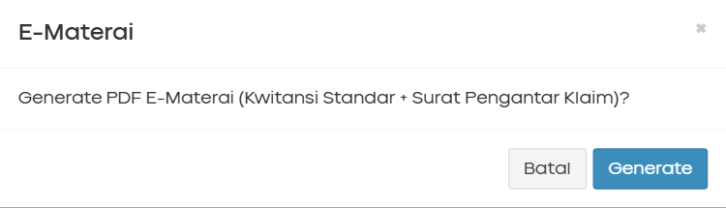
Dialog Konfirmasi E-Materai

7.2.1 Konstanta & Kondisi Aktif
Konstanta | Nilai | Keterangan
EMATERAI_THRESHOLD | 5.000.000 | Rp 5 juta — minimum grand total include
Tombol ENABLED jika:
- Grand total baris include === true >= Rp 5.000.000
Rumus per baris: (invoiceAmount - PPH) + ppnAmount
- Status dokumen minimal DRAFT (termasuk APPROVED, SUBMITTED, dll.)
Fungsi: updateEMateraiButton() — dipanggil dari renderTable() dan enableKlaimControls()

7.2.2 Output Generate
Aspek | Nilai
Handler | handleEMaterai()
Library | jsPDF 2.5.1 (CDN)
Halaman PDF | 2 halaman: (1) Kwitansi Standar, (2) Surat Pengantar Klaim
Nama file | EMaterai_{DocNo}_{YYYYMMDD}.pdf
Template referensi | Excel 170914 Kwitansi Standard SHP Sep 17.xlsx (production)
Batasan prototype | Mock teks di PDF — bukan render Excel asli
Record uji: ID 5192 (Rp 6.500.000, BOSNET), ID 5187 (Rp 2.500.002), ID 5186 (Rp 6.000.000)
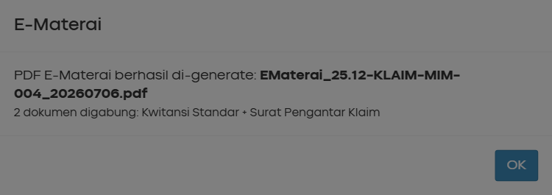
Preview PDF E-Materai

7.3 Validasi Silang PPN ↔ Faktur Pajak
Referensi BRD: A.4 — Validasi konsistensi PPN dan Faktur Pajak.
Implementasi: validateKlaimInput() — helper rowHasPpn(row)
rowHasPpn(row) → true jika ppnTarif > 0 ATAU ppnType !== 'NON PPN'
Kondisi | Error Message
hasPpn && faktur no kosong | Baris N: Faktur Pajak No wajib diisi jika PPN tidak 0%
hasPpn && faktur date kosong | Baris N: Faktur Pajak Date wajib diisi jika PPN tidak 0%
(faktur no ATAU date diisi) && !hasPpn | Baris N: PPN harus diisi (tarif > 0%) jika Faktur Pajak No/Date diisi
Saat gagal: validationErrorRows = [index] → renderTable() — class tr-klaim-validation-error (border merah).

7.4 BosNet Period Quartal
Referensi BRD: A.5 — Penyesuaian periode detail untuk sumber BOSNET (push per quartal).
Masalah bisnis: BosNet push data per quartal, sedangkan KICAO KDS input manual per bulan.
Solusi: Jika item.source === 'BOSNET', field #txtSourceDoc = BOSNET dan periode detail diisi quartal via getBosnetQuarterPeriod(quarter, year).
Quarter | Period From | Period To
Q1 | 01-Jan-{year} | 31-Mar-{year}
Q2 | 01-Apr-{year} | 30-Jun-{year}
Q3 | 01-Jul-{year} | 30-Sep-{year}
Q4 | 01-Oct-{year} | 31-Dec-{year}
Add Detail manual tetap pakai period bulanan default (hari ini s/d +30 hari) — hanya data push BosNet yang pakai quartal.
Record uji: ID 5192 — 26.03/KLAIM-BOS/001, bosnetQuarter: Q1, bosnetYear: 2026 → Period From 01-Jan-2026, Period To 31-Mar-2026
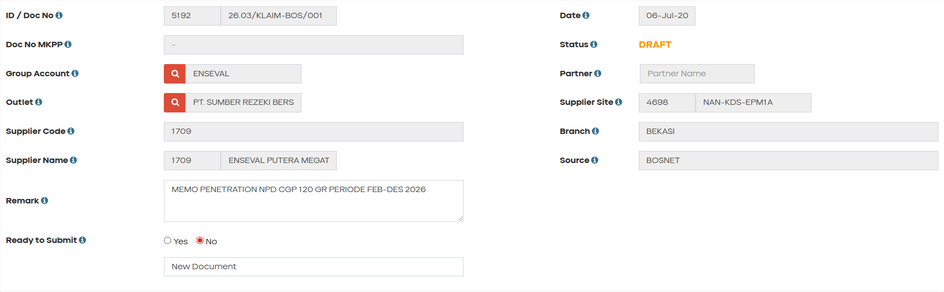
BosNet Quartal Period

7.5 Approval Eksternal OTP
Referensi BRD: A.3 — Upgrade approval dengan Owner KMMD (email/OTP) + ASS auto-approve.

7.5.1 File Terkait
File | Fungsi
Views/Klaim/ApprovalEmail.html | Simulasi email ke Owner — ringkasan klaim + OTP
Views/Klaim/ApprovalOtp.html | Landing page verifikasi OTP (semua OTP diterima)
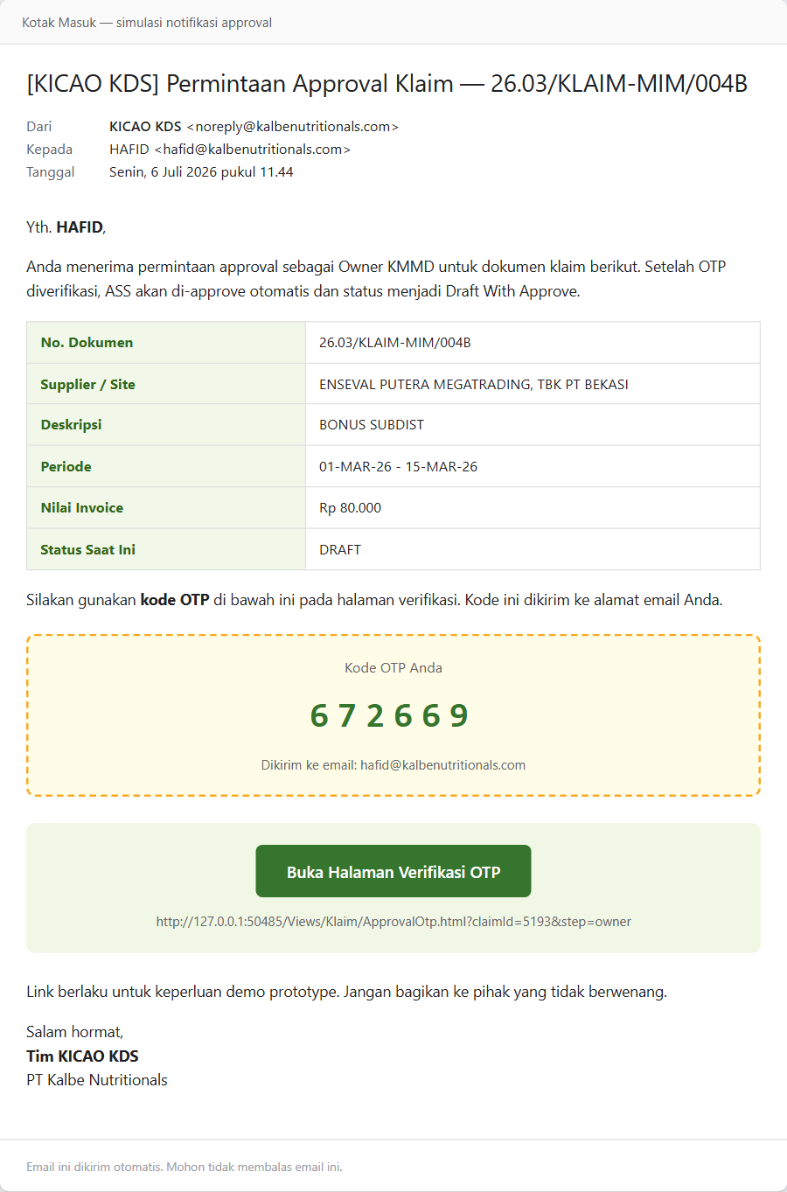
Simulasi Email Approval Owner

7.5.2 Alur setelah Admin Save
Admin KMMD klik Save
├─► Status tetap DRAFT
├─► persistActiveClaimToRegistry()
├─► protoEnsureKlaimOtp(claimId, 'owner') — OTP 6 digit
└─► window.open('ApprovalEmail.html?claimId=...&step=owner')

7.5.3 Alur Owner OTP
Owner buka link → ApprovalOtp.html?claimId=...&step=owner
└─► Submit OTP (apa pun valid di prototype)
├─► protoApplyKlaimStatus(claimId, 'DRAFT WITH APPROVE')
├─► History: Owner — OTP Approve (External)
└─► History: ASS — Auto Approve
ASS tidak punya langkah OTP terpisah — auto-approve bersamaan saat Owner OTP sukses.

Halaman OTP Approval

7.5.4 Simulasi In-App
Owner KMMD yang login dapat klik #btnOwnerApprove (handleOwnerApprove()) — hasil sama: status DRAFT WITH APPROVE + ASS auto di history.

7.5.5 Sinkronisasi Form Aktif
- protoApplyKlaimStatus() memperbarui registry dan sessionStorage.klaimPrototypeData
- Form Klaim mendengarkan window.focus dan event storage → reloadActiveClaimFromRegistry()
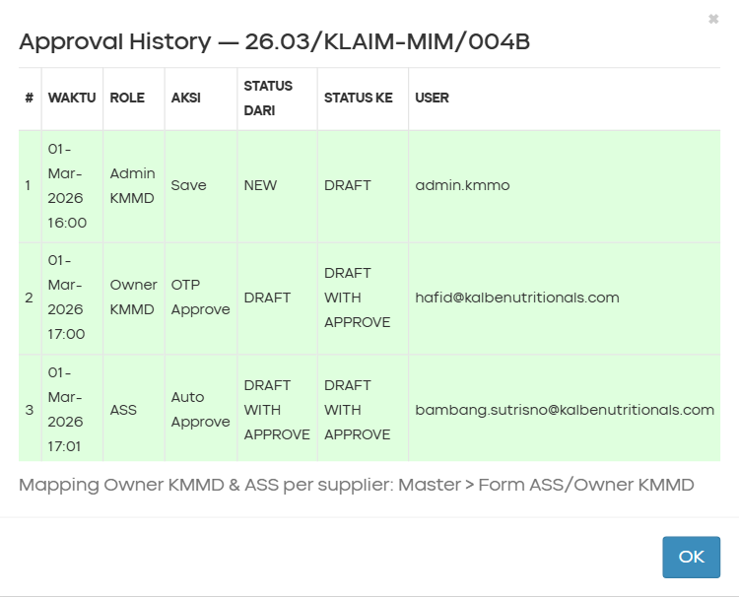
Approval History 5 Langkah

8. Aturan Bisnis (Business Rules)
Aturan bisnis dikelompokkan dengan prefix: - BR-Mxx — Master ASS/Owner KMMD - BR-Kxx — Form Klaim (umum & legacy) - BR-Xxx — Enhancement & integrasi lintas modul

8.1 Aturan Bisnis — Master ASS/Owner KMMD (BR-M)

8.1.1 Aturan Header Dokumen
Rule ID | Aturan
BR-M01 | Satu supplier hanya boleh punya satu mapping aktif di registry
BR-M02 | Group Account wajib dipilih sebelum Supplier
BR-M03 | Supplier wajib dipilih sebelum Simpan
BR-M04 | ID dokumen auto-generate saat simpan pertama (prototype: angka 4 digit random 1000–9999)
BR-M05 | Tanggal dokumen = tanggal hari ini (read-only), format DD-MMM-YYYY
BR-M06 | Status BARU → AKTIF setelah simpan pertama berhasil

8.1.2 Aturan Owner KMMD
Rule ID | Aturan
BR-M07 | Boleh ada banyak baris Owner per supplier (untuk arsip pegawai lama)
BR-M08 | Tepat satu baris Owner berstatus aktif (radio) — dipakai notifikasi approval klaim
BR-M09 | Baris Owner aktif: nama & email wajib diisi
BR-M10 | Baris Owner tidak aktif boleh kosong (arsip) atau terisi
BR-M11 | Minimal satu baris Owner — tombol Hapus disabled jika hanya 1 baris
BR-M12 | Nama & email disimpan UPPERCASE — normalisasi saat blur & simpan

8.1.3 Aturan ASS
Rule ID | Aturan
BR-M13 | Boleh ada banyak baris ASS per supplier
BR-M14 | Tepat satu baris ASS berstatus aktif — dipakai auto-approve klaim
BR-M15 | Baris ASS aktif: nama & email wajib diisi
BR-M16 | Minimal satu baris ASS
BR-M17 | ASS aktif = pegawai yang di-auto-approve setelah Owner approve klaim

8.1.4 Aturan Penghapusan & Aktivasi
Rule ID | Aturan
BR-M18 | Hapus baris aktif: baris pertama otomatis jadi aktif (dengan konfirmasi)
BR-M19 | Ganti radio aktif tidak menghapus baris lain — baris lama menjadi arsip (abu-abu)
BR-M20 | Tambah Owner/ASS memerlukan Group Account sudah terisi

8.1.5 Aturan Riwayat (Audit Trail)
Rule ID | Aturan
BR-M21 | Satu aksi Simpan = satu batch riwayat (changeHistory[])
BR-M22 | Batch terbaru di indeks 0 (prepend)
BR-M23 | Diff baris by fingerprint NAMA|EMAIL uppercase
BR-M24 | Riwayat accordion auto-buka setelah simpan dengan perubahan

8.2 Aturan Bisnis — Form Klaim (BR-K)

8.2.1 Aturan Header
Rule ID | Aturan
BR-K01 | Group Account wajib diisi sebelum Save/Submit
BR-K02 | Supplier Code wajib (auto dari Outlet LOV)
BR-K03 | Remark wajib diisi
BR-K04 | Jika Group Account = ENSEVAL → Partner wajib diisi
BR-K05 | Jika Ready to Submit = No → txtReasonReadySubmit wajib
BR-K06 | Minimal 1 baris detail sebelum Save/Submit
BR-K07 | Ganti Group Account → reset Partner, Outlet, Branch
BR-K08 | Outlet LOV difilter by group_account

8.2.2 Aturan Detail & Pajak
Rule ID | Aturan
BR-K09 | Activity, Program Desc, Invoice No wajib per baris
BR-K10 | Invoice Amount > 0 per baris
BR-K11 | Invoice No tidak boleh duplikat dalam satu dokumen (case insensitive)
BR-K12 | Period To >= Period From
BR-K13 | Attachment wajib per baris (mock: attachmentName tidak kosong)
BR-K14 | Jika All Brand = false → total alokasi Umbrand/Brand/SKU harus = Invoice Amount
BR-K15 | PPH Amount = floor(Invoice Amount × Tarif PPH / 100)
BR-K16 | Final Amount = Invoice Amount − PPH Amount
BR-K17 | Total Amount = Final Amount + PPN Amount
BR-K18 | Add Detail: activity default kosong (bukan ACT-KCO-01)

8.2.3 Aturan Status & Kontrol UI
Rule ID | Aturan
BR-K19 | BIT_APPLY='Y' → LOV header disembunyikan, dokumen sudah pernah apply
BR-K20 | BIT_APPROVED='Y' → Save disembunyikan, detail read-only kecuali payment (CF)
BR-K21 | BIT_REJECTED='Y' → Save/Submit disembunyikan
BR-K22 | BIT_CLOSED='Y' → tampilkan banner #divClose; payment read-only
BR-K23 | Submit (isSubmit=true) → Ready to Submit harus Yes

8.3 Aturan Bisnis — Enhancement & Integrasi (BR-X)
Rule ID | Aturan
BR-X01 | Lookup Owner: groupAccount + supplierId → Owner aktif dari Master (protoFindOwnerBySupplier)
BR-X02 | Lookup ASS: groupAccount + supplierId (+ outlet) → ASS aktif (protoFindAssBySite)
BR-X03 | Mapping dengan status != ACTIVE tidak dipakai lookup
BR-X04 | Setelah Admin Save → generate OTP Owner + buka simulasi email
BR-X05 | Owner OTP sukses → status DRAFT WITH APPROVE + ASS auto-approve (tanpa OTP ASS)
BR-X06 | RSM hanya edit saat DRAFT WITH APPROVE; tidak ada tombol Save — persist saat Ready To Submit
BR-X07 | CF Find hanya menampilkan klaim status Ready to Submit
BR-X08 | Kolom payment editable hanya jika BIT_APPROVED='Y' AND BIT_CLOSED!='Y' AND role CF
BR-X09 | E-Materai aktif jika grand total include >= Rp 5.000.000 dan status >= DRAFT
BR-X10 | Validasi silang PPN ↔ Faktur Pajak wajib lulus sebelum Save/Submit (BRD A.4)
BR-X11 | Sumber BOSNET → periode detail diisi quartal, bukan bulanan
BR-X12 | DPP+PPN = Invoice Amount + PPN Amount (kolom tampilan readonly, tidak disimpan terpisah)
BR-X13 | Tanpa mapping Owner/ASS → email simulasi pakai placeholder owner@external.com

9. Hak Akses & Peran Pengguna (RBAC)
Definisi role di Scripts/customs/prototype/rbac-prototype.js. Role dipilih setelah login di Views/Account/ChooseRole.html, disimpan di localStorage.kds_active_role.

9.1 Daftar Role Sistem
Role ID | Label | Deskripsi Singkat
IT_ADMIN | IT Admin | Akses penuh (demo/testing)
ADMIN_KMMD | Admin KMMD | Buat & simpan klaim → DRAFT; maintain Master ASS/Owner
OWNER_KMMD | Owner KMMD | Approve eksternal / in-app → Draft With Approve
ASS | ASS | Auto approve bersama Owner (tanpa aksi manual)
RSM | RSM | Edit klaim + Ready To Submit
CF | CF (Finance) | Submit final + input kolom payment

9.2 Matrix Permission — Master ASS/Owner
Permission | IT_ADMIN | ADMIN_KMMD | Role Lain
menu.master.assOwner | ✅ | ✅ | ❌
master.assOwner.find | ✅ | ✅ | ❌
master.assOwner.save | ✅ | ✅ | ❌
master.assOwner.new | ✅ | ✅ | ❌
Implementasi: rbacApplyAssOwnerPage() di rbac-prototype.js

9.3 Matrix Permission — Form Klaim
Permission | IT_ADMIN | ADMIN_KMMD | OWNER_KMMD | ASS | RSM | CF
klaim.find | ✅ | ✅ | ✅ | ✅ | ✅ | ✅
klaim.save | ✅ | ✅ | ❌ | ❌ | ❌ | ❌
klaim.new | ✅ | ✅ | ❌ | ❌ | ❌ | ❌
klaim.editHeader | ✅ | ✅ | ❌ | ❌ | ❌ | ❌
klaim.addDetail | ✅ | ✅ | ❌ | ❌ | ❌ | ❌
klaim.ownerApprove | ✅ | ❌ | ✅ | ❌ | ❌ | ❌
klaim.rsmEdit | ✅ | ❌ | ❌ | ❌ | ✅ | ❌
klaim.readySubmit.edit | ✅ | ✅ | ❌ | ❌ | ✅ | ❌
klaim.rsmReadySubmit | ✅ | ❌ | ❌ | ❌ | ✅ | ❌
klaim.cfSubmit | ✅ | ❌ | ❌ | ❌ | ❌ | ✅
klaim.payment.edit | ✅ | ❌ | ❌ | ❌ | ❌ | ✅
klaim.approvalHistory | ✅ | ✅ | ✅ | ✅ | ✅ | ✅

9.4 Matrix Akses Field per Role & Status — Form Klaim
Area Form | Admin (NEW/DRAFT) | Owner (DRAFT) | RSM (Draft With Approve) | CF (Ready to Submit / APPROVED)
Header (GA, Outlet, Partner, dll.) | ✅ editable + LOV | ❌ readonly | ❌ readonly | ❌ readonly
Remark | ✅ | ❌ | ✅ | ❌
Grid detail (activity, amount) | ✅ | ❌ | ✅ | ❌ (payment saja jika APPROVED)
Tambah / hapus baris detail | ✅ | ❌ | ✅ | ❌
Ready to Submit Y/N + alasan | ✅ | ❌ | ✅ | ❌
Payment fields (kolom 26–28) | ❌ | ❌ | ❌ | ✅ (saat APPROVED)
Tombol E-Materai | ✅ (jika threshold) | ❌ | ✅ (jika threshold) | ✅ (jika threshold)

9.5 Filter Find per Role
Role | Hanya Menampilkan Status
OWNER_KMMD | DRAFT
RSM | DRAFT WITH APPROVE
CF | Ready to Submit
IT_ADMIN, ADMIN_KMMD, ASS | Semua status
Fungsi: getFindRowsForRole() di Index.html
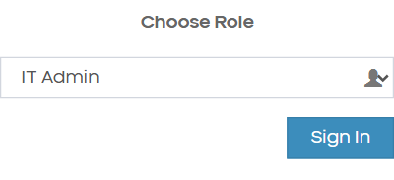
RBAC Role Selector

10. Alur Persetujuan (Approval Flow)

10.1 Diagram Approval Workflow Enhancement
Approval Flow — Form Klaim

10.2 Tabel Langkah Approval
Urutan | Role | Aksi UI | Status Hasil | Lokasi
1 | Admin KMMD | Save | DRAFT | Form Klaim (in-app)
2 | Owner KMMD | OTP (email eksternal) | DRAFT WITH APPROVE | ApprovalEmail → ApprovalOtp
2b | ASS | (Auto) — tidak perlu OTP | DRAFT WITH APPROVE | Otomatis saat Owner OTP
3 | RSM | Edit + Ready To Submit | Ready to Submit | Form Klaim (in-app)
4 | CF | Submit | APPROVED | Form Klaim (in-app)
5 | CF | Input Payment (opsional) | APPROVED | Grid detail kolom 26–28
6 | User | E-Materai (jika >= Rp 5 jt) | — | Tombol #btnEMaterai

10.3 Handler Workflow (In-App)
Handler | Role | Prasyarat Status | Status Hasil
handleSave() | Admin KMMD | validasi form | DRAFT
handleOwnerApprove() | Owner KMMD | DRAFT | DRAFT WITH APPROVE
handleRsmReadySubmit() | RSM | DRAFT WITH APPROVE | Ready to Submit
handleCfSubmit() | CF | Ready to Submit | APPROVED

10.4 Riwayat Approval (Approval History)
Tabel history menampilkan 5 langkah simulasi:
# | Role | Aksi | From Status | To Status
1 | Admin KMMD | Save | NEW | DRAFT
2 | Owner KMMD | OTP Approve (External) | DRAFT | DRAFT WITH APPROVE
3 | ASS | Auto Approve | DRAFT WITH APPROVE | DRAFT WITH APPROVE
4 | RSM | Ready To Submit | DRAFT WITH APPROVE | Ready to Submit
5 | CF | Submit | Ready to Submit | APPROVED

10.5 Notifikasi (Rencana Production)
Event | Penerima Notifikasi | Channel (Production)
Admin Save klaim | Owner KMMD (dari Master) | Email + link OTP
Owner OTP sukses | RSM, Admin KMMD | Email + in-app
RSM Ready To Submit | CF | Email + in-app
CF Submit (APPROVED) | Admin KMMD, Supplier | Email + in-app
Prototype: Simulasi via window.open(ApprovalEmail.html) + bootbox alert; tidak ada email engine nyata.

10.6 Perbandingan dengan Production (Falcon SKP)
Aspek | Production (Falcon) | Prototype KICAO KDS
Channel OTP | Email/SMS via PRM Adapter | Email simulasi HTML
Validasi OTP | Server-side | Semua OTP diterima
ASS approval | Config-dependent | Selalu auto bersama Owner
Persistensi | Database + CAP events | localStorage browser
Workflow Status Diagram

11. Integrasi Master ASS/Owner ke Form Klaim

11.1 Diagram Integrasi Master → Klaim
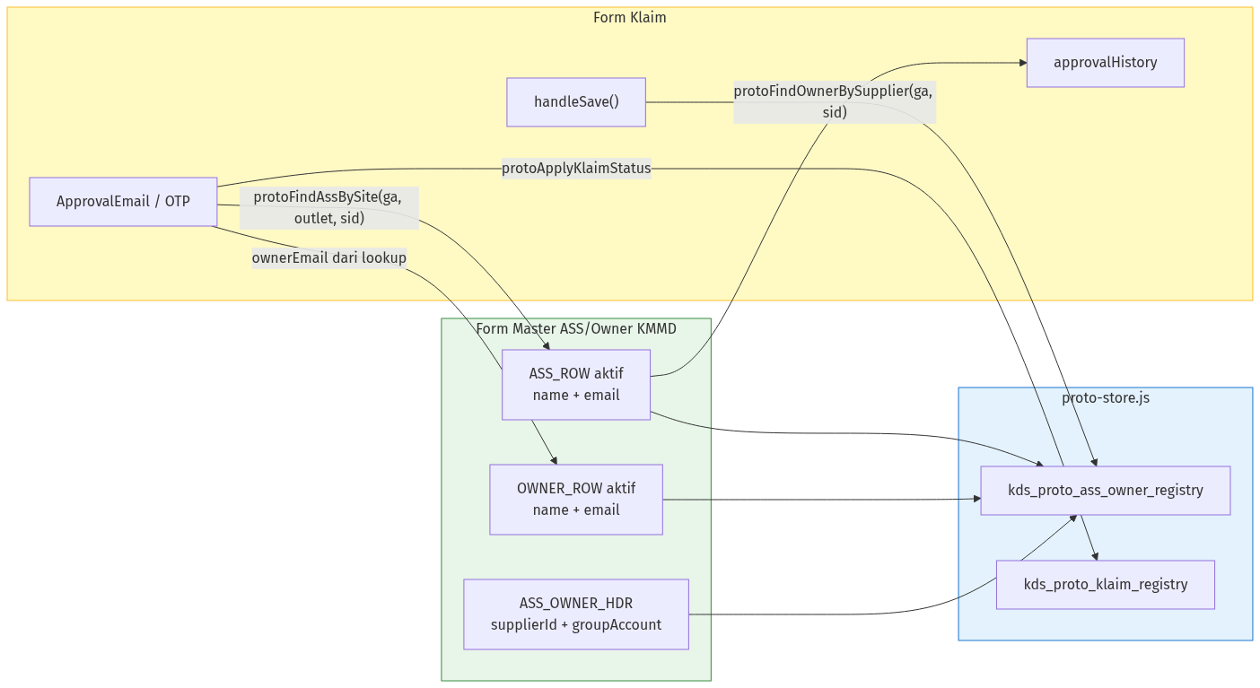
Integrasi Master ASS/Owner ke Form Klaim

11.2 API Lookup Prototype
Fungsi | Parameter | Return | Dipakai di
protoFindOwnerBySupplier | groupAccount, supplierId | { ownerId, ownerName, ownerEmail, mappingId } | Save, Owner Approve, Email
protoFindAssBySite | groupAccount, outlet, supplierId? | { assId, assName, assEmail, mappingId } | Auto-approve setelah Owner OTP
protoGetAssOwnerRegistry | — | AssOwnerRecord[] | Master form, seed data
protoUpsertAssOwner | record | AssOwnerRecord | Master Save

11.3 Contoh Alur Integrasi
- Admin buat mapping supplier ENSEVAL 1709 → Owner HAFID, ASS BAMBANG (record 1003)
- Admin buat klaim untuk supplier yang sama → Save
- Sistem lookup Owner → email HAFID untuk simulasi ApprovalEmail
- Owner submit OTP → ASS BAMBANG tercatat auto-approve di approvalHistory

11.4 Ketergantungan Data
Tanpa Mapping Valid | Perilaku Prototype
Owner tidak ditemukan | Email simulasi pakai owner@external.com
ASS tidak ditemukan | History ASS tetap tercatat dengan placeholder
Supplier duplikat di Master | Simpan Master gagal (BR-M01)

11.5 Rekomendasi API Production
Method | Endpoint (usulan) | Fungsi
GET | /api/master/ass-owner/lookup/owner | Query: groupAccount, supplierId
GET | /api/master/ass-owner/lookup/ass | Query: groupAccount, supplierId, site?
POST | /api/klaim/{id}/owner-otp | Generate & kirim OTP Owner
POST | /api/klaim/{id}/verify-otp | Verifikasi OTP + trigger ASS auto

Integrasi Master Klaim

12. Struktur Database & ERD

12.1 Tabel Utama — Master ASS/Owner (Rekomendasi Production)
Tabel | Keterangan
XXSHP_KDS_M_ASS_OWNER_HDR | Header mapping supplier → Owner/ASS aktif
XXSHP_KDS_M_ASS_OWNER_OWNER_DTL | Baris Owner KMMD (multi-baris, flag aktif)
XXSHP_KDS_M_ASS_OWNER_ASS_DTL | Baris ASS (multi-baris, flag aktif)
XXSHP_KDS_M_ASS_OWNER_HIST | Batch riwayat perubahan per simpan

12.2 Tabel Utama — Klaim (Existing + Enhancement)
Tabel | Keterangan
XXSHP_KDS_T_KLAIM_HDR | Header dokumen klaim
XXSHP_KDS_T_KLAIM_DTL | Detail baris klaim (+ kolom payment NEW)
XXSHP_KDS_T_KLAIM_UMB | Alokasi umbrand
XXSHP_KDS_T_KLAIM_BRAN | Alokasi subbrand
XXSHP_KDS_T_KLAIM_SKU | Alokasi SKU/item
XXSHP_KDS_T_KLAIM_DTL_ATT | Lampiran per baris detail
XXSHP_KDS_T_KLAIM_APPROVAL_HIST | Riwayat approval (rekomendasi baru)

12.3 Kolom Enhancement pada XXSHP_KDS_T_KLAIM_DTL
Field Baru | Tipe Data | Keterangan
TXT_PAYMENT_STATUS | VARCHAR(20) | PENDING / PAID / CANCELLED
DTM_PAID_DATE | DATE | Tanggal pembayaran
TXT_BANK_NAME | VARCHAR(50) | Nama bank pembayaran
Kolom DPP+PPN tidak disimpan — kalkulasi tampilan: DEC_INVOICE_AMT + DEC_PPN

12.4 Combined Entity Relationship Diagram
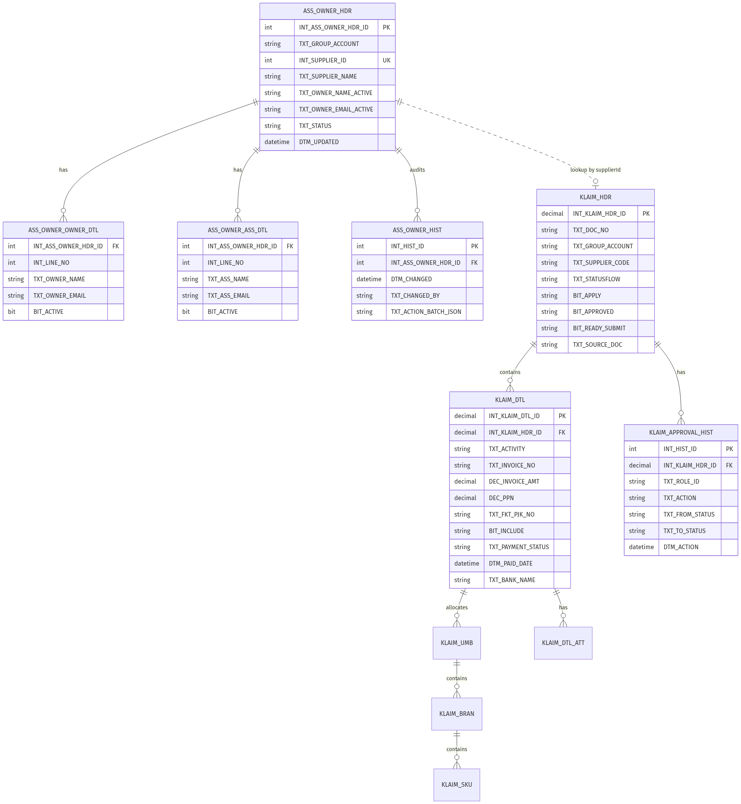
ERD Gabungan — Master ASS/Owner & Klaim

ERD Diagram Combined

12.5 Storage Prototype (localStorage / sessionStorage)
Key | Tipe | Isi
kds_proto_ass_owner_registry | localStorage | Array mapping ASS/Owner
kds_proto_klaim_registry | localStorage | Array record klaim + approval history
kds_proto_active_claim_id | localStorage | ID klaim terbuka (resume)
klaimPrototypeData | sessionStorage | Header dokumen sedang diedit
kds_active_role | localStorage | Role RBAC aktif
kds_logged_in | localStorage | Flag login prototype

12.6 Seed Data Master (Prototype)
ID | Group | Supplier ID | Supplier Name
1001 | KMMD | 3102 | AGUS JUSAK KURNIAWAN…
1002 | KMMD | 3105 | BINTANG LIMA IMADA, PT
1003 | ENSEVAL | 1709 | ENSEVAL PUTERA MEGATRADING, TBK PT
1004 | KMMD | 3108 | KOMPAS SEJAHTERA, CV
1005 | KMMD | 3106 | ANDARIA NIAGA, CV
1006 | BRAVO | 2201 | PT BRAVO HUSADA

13. Appendix — Gap Analysis & Skenario UAT

13.1 Gap Analysis — BRD vs Prototype vs Produksi

13.1.1 Master ASS/Owner KMMD
Aspek | BRD Asli | Prototype Final | Rekomendasi Produksi
Granularitas | Per site/branch | Per supplier | Konfirmasi bisnis — site masih diperlukan?
Input Owner/ASS | LOV pegawai HRESS | Freetext nama+email | LOV HRESS + override manual
Owner di header | Field tunggal | Denormalized dari aktif | Sama — denormalize untuk lookup cepat
Detail grid site | Ada | Dihapus | Tabel terpisah jika bisnis tetap butuh
ID Owner/ASS | Oracle employee ID | Kosong | Wajib di produksi
Storage | Oracle | localStorage | Oracle + REST API
Find | — | Modal LOV | Index page + filter grid
Delete dokumen | — | Tidak ada | Soft delete dengan konfirmasi
Email notifikasi | Email nyata | Simulasi alert/HTML | Integration email service + K2

13.1.2 Form Klaim Enhancement
Aspek | BRD | Prototype | Rekomendasi Produksi
A.1 Payment cols | 3 kolom + DPP+PPN | ✅ Selesai (badge NEW) | ALTER TABLE + UI production
A.2 E-Materai | Template Excel asli | Mock jsPDF 2 halaman | Integrasi template Excel / doc engine
A.3 Approval | Owner + ASS + K2 | OTP email + ASS auto | PRM Adapter OTP + K2 workflow
A.4 PPN validasi | Silang faktur | ✅ validateKlaimInput | BL layer clsXXSHP_KCO_T_KLAIM_HDRBL
A.5 BosNet quartal | Period quartal | ✅ Mock Find | API BosNet push + mapping quartal
C Report | Outstanding & Payment | ❌ Belum | FSD terpisah
D RFP/RFS merge | PDF ke SMART | ❌ Belum | FSD terpisah

13.2 Mapping Status Legacy → Enhancement
Status Lama (Production) | Status Enhancement
APPROVE 1 - DRAFT | DRAFT WITH APPROVE
APPROVE 2 - DRAFT | DRAFT WITH APPROVE
DRAFT WITH 2 APPROVE | DRAFT WITH APPROVE
DRAFT WITH 3 APPROVE | Ready to Submit
READY TO SUBMIT | Ready to Submit

13.3 LOV Form Klaim — Ringkasan
LOV | Modal ID | Trigger | Filter
Group Account | #lovGroupAccountModal | #btnLOVGroupAccount | —
Partner | #lovPartnerModal | #btnLOVPartner | Hanya GA = ENSEVAL
Outlet | #lovOutletModal | #btnLOVOutlet | By group_account
Activity (detail) | #lovDetailActivityModal | Per baris detail | —
PPH Type (detail) | #lovDetailPphTypeModal | Per baris detail | —
Find Klaim | #lovFindModal | #btnFind | By role (getFindRowsForRole)
Umbrand/Brand/SKU | #klaimPopupModal (iframe) | Tombol Umbrand | Per baris detail
Scan Faktur Pajak | #klaimPopupModal (iframe) | Tombol scan di kolom faktur | —
Standar UI Modal LOV Klaim: lebar 90%, max 1100px, header hijau #00a65a, tombol Pilih di kolom pertama, live search.
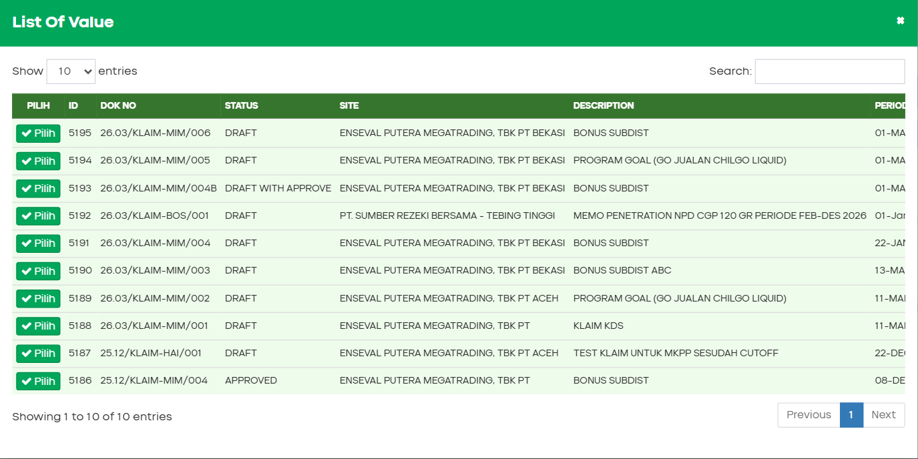
LOV Find Klaim

13.4 Kriteria Penerimaan UAT — Master ASS/Owner
ID | Kriteria | Pass?
UAT-M01 | User dapat memilih Group Account dari LOV | [ ]
UAT-M02 | Supplier LOV hanya menampilkan supplier pada group terpilih | [ ]
UAT-M03 | Ganti Group Account mengosongkan supplier | [ ]
UAT-M04 | ID terisi otomatis setelah simpan pertama | [ ]
UAT-M05 | Status berubah BARU → AKTIF setelah simpan | [ ]
UAT-M06 | User dapat menambah banyak baris Owner dan ASS | [ ]
UAT-M07 | Hanya satu radio aktif per tabel | [ ]
UAT-M08 | Baris aktif tampil kuning, tidak aktif abu | [ ]
UAT-M09 | Summary bar menampilkan Owner & ASS aktif | [ ]
UAT-M10 | Tidak bisa hapus jika hanya tersisa 1 baris | [ ]
UAT-M11 | Hapus baris aktif → konfirmasi + baris pertama jadi aktif | [ ]
UAT-M12 | Simpan gagal jika supplier duplikat | [ ]
UAT-M13 | Simpan gagal jika email format invalid | [ ]
UAT-M14 | Peringatan unsaved saat Cari/Baru | [ ]
UAT-M15 | Satu simpan = satu baris riwayat dengan grup aksi berwarna | [ ]
UAT-M16 | Klaim ENSEVAL 1709 menemukan Owner HAFID dari mapping 1003 | [ ]
UAT-M17 | ASS aktif BAMBANG tercatat saat auto-approve klaim | [ ]
UAT-M18 | Role non-admin tidak melihat menu Master | [ ]

13.5 Kriteria Penerimaan UAT — Form Klaim Enhancement
ID | Kriteria | Pass?
UAT-K01 | Find load record APPROVED — kolom payment NEW tampil dengan badge | [ ]
UAT-K02 | Role CF dapat edit Status Payment, Paid Date, Bank saat APPROVED | [ ]
UAT-K03 | Record CLOSED — kolom payment disabled | [ ]
UAT-K04 | DPP+PPN = Invoice Amount + PPN Amount (readonly) | [ ]
UAT-K05 | Find 5192 — tombol E-Materai enabled (>= Rp 5 jt) | [ ]
UAT-K06 | Klik E-Materai → PDF 2 halaman ter-download | [ ]
UAT-K07 | Amount < Rp 5 jt → tombol E-Materai disabled | [ ]
UAT-K08 | PPN 11% tanpa Faktur No → Save gagal + baris merah | [ ]
UAT-K09 | Faktur diisi tanpa PPN → Save gagal + baris merah | [ ]
UAT-K10 | Find 5192 BOSNET — Period Q1 2026 = 01-Jan s/d 31-Mar | [ ]
UAT-K11 | Admin Save → DRAFT + tab email Owner terbuka | [ ]
UAT-K12 | Owner OTP → DRAFT WITH APPROVE + ASS auto di history | [ ]
UAT-K13 | RSM edit remark + Ready To Submit → status Ready to Submit | [ ]
UAT-K14 | CF Find hanya menampilkan Ready to Submit | [ ]
UAT-K15 | CF Submit → APPROVED | [ ]
UAT-K16 | ENSEVAL → tombol Partner muncul; KMMD → Partner hilang | [ ]
UAT-K17 | Add Detail — activity kosong (bukan default ACT-KCO-01) | [ ]
UAT-K18 | Find/Save/New tetap aktif setelah tutup modal Find (no backdrop stuck) | [ ]

13.6 Skenario Uji End-to-End

Skenario 1 — Setup Master + Klaim Baru
Step | Aksi | Ekspektasi
1 | Login sebagai Admin KMMD | Menu Master & Klaim tampil
2 | Buka Master ASS/Owner → Baru | Form kosong, 1 baris Owner & ASS aktif
3 | Pilih KMMD → Supplier 3102 → isi Owner & ASS | Summary bar ter-update
4 | Simpan | ID terisi, status AKTIF, riwayat tercatat
5 | Buka Form Klaim → New → isi header + 1 detail | Status NEW
6 | Save | DRAFT; email Owner simulasi terbuka

Skenario 2 — Approval Chain Lengkap
Step | Aksi | Ekspektasi
1 | Login Owner KMMD → Find klaim DRAFT | Hanya klaim DRAFT tampil
2 | Email/Approve atau OTP eksternal | DRAFT WITH APPROVE; ASS auto di history
3 | Login RSM → Find → edit remark → Ready To Submit | Ready to Submit
4 | Login CF → Find → Submit | APPROVED
5 | Isi Payment PAID + Paid Date + Bank BCA | Tersimpan di registry

Skenario 3 — Validasi PPN & E-Materai
Step | Aksi | Ekspektasi
1 | New klaim → detail: PPN 11%, faktur kosong | —
2 | Save | Error + baris border merah
3 | Isi faktur no & date → Save | Berhasil (jika field lain lengkap)
4 | Find 5192 → E-Materai | PDF ter-download

Skenario 4 — Duplikat Supplier Master
Step | Aksi | Ekspektasi
1 | Buat mapping baru supplier 3102 (sudah ada 1001) | —
2 | Simpan | Alert duplikat; data tidak tersimpan

Skenario 5 — Rotasi ASS dengan Arsip
Step | Aksi | Ekspektasi
1 | Cari record 1003 (2 baris ASS) | BAMBANG aktif, ANDI arsip
2 | Tambah ASS #3 RIZKY → pindah radio aktif ke RIZKY | Summary update
3 | Simpan | Riwayat: Tambah + Aktifkan dalam 1 batch
4 | Buat klaim supplier 1709 → Owner approve | ASS RIZKY tercatat di history (bukan BAMBANG)

13.7 Keterbatasan Prototype
# | Keterbatasan
1 | Tidak ada API backend — data di localStorage / sessionStorage
2 | E-Materai = PDF mock jsPDF, bukan template Excel asli
3 | OTP semua kode diterima — tidak ada validasi server-side
4 | Role via localStorage — bukan login production AD/LDAP
5 | Report Outstanding & Claim to Payment belum ada
6 | RFP/RFS merge PDF ke SMART belum ada
7 | Attachment upload mock — tidak menyimpan file ke server
8 | jsPDF memerlukan koneksi internet saat pertama generate
9 | Modal LOV Master harus di dalam #app-content agar tidak hilang dari DOM

13.8 File Source Prototype
File | Fungsi Utama
Views/Master/AssOwnerKMMD/Index.html | UI + logic Master ASS/Owner
Views/Klaim/Index.html | UI + logic Form Klaim
Views/Klaim/ApprovalEmail.html | Simulasi email OTP Owner
Views/Klaim/ApprovalOtp.html | Landing page OTP
Scripts/customs/prototype/proto-store.js | Registry, lookup, OTP, seed data
Scripts/customs/prototype/rbac-prototype.js | Role & permission matrix
Scripts/customs/prototype/klaim-prototype.js | Session storage helper klaim
Scripts/layout.js | Sidebar, login guard, modal fix
Docs/BRD-KICAO-KDS-Enhancement.md | BRD resmi enhancement
Docs/AssOwnerKMMD/01-complete-specification.md | Spesifikasi lengkap Master
Docs/Klaim/05-progress-log.md | Living document status prototype
Docs/Klaim/07-workflow-rbac-external-approval.md | Workflow RBAC & OTP

13.9 Production Reference (Repo KICAO KDS)
Topik | File Production
Script klaim | KN2022_KCO_KDS.MVC/Scripts/customs/transactions/klaim/klaimscript.js
View Index | KN2022_KCO_KDS.MVC/Views/Klaim/Index.cshtml
Validasi BL | clsXXSHP_KCO_T_KLAIM_HDRBL.cs
Falcon OTP ref | falcon.frontend.web — landing page SKP
Falcon document | falcon.backend.document — event approval

Dokumen ini dibuat sebagai FSD KICAO KDS Enhancement — Master ASS/Owner KMMD & Form Klaim · Versi 1.0 · 06 Juli 2026 · Tim IT – KICAO KDS

