
Functional Specification Document
Version [2.0.0]

Development Fund Subdist — Kalbe Nutritionals (SHP)
Modul: Master Data

Prepared By
[Tim IT KN — Kalbe Nutritionals]

PT. Sanghiang Perkasa

Date
[29/07/2026]
BRD No : 2026.SHP-FSD.001 |  |  |  | PID Ref. No : 2026.SHP-PID.001
Revision history
Version | Date |  | Author(s) |  | Description
2.0.0 | 29 Juli 2026 |  | Tim IT KN |  | Revisi ShipTo/OutletID — kunci matching Monitoring; LOV Bosnet; DDL & integrasi diperbarui
Document Approval
Full name |  | Job Title |  |  |  | Signature | Signature Date
Reza Hebrida Hasni |  | SHP Commercial Sales Development
Septiawan Arif Wibowo |  | SHP Accounting
Roy Alexander |  | SHP Commercial Sales Development
Albet |  | IT Digital Solution
Ageng Kurniawan Sugianto |  | IT Digital Solution

Daftar Isi
FUNCTIONAL SPECIFICATION DOCUMENT (FSD) 1
Modul: KICAO KDS Enhancement — Master ASS/Owner KMMD & Form Klaim 1
Sistem: KICAO KDS (Kalbe Nutritionals — Claim & Distribution System) 1
Versi Dokumen: 1.0 1
Riwayat Revisi 1
1. Pendahuluan 4
1.1 Latar Belakang 4
1.2 Tujuan Dokumen 4
1.3 Ruang Lingkup 5
1.4 Stakeholder 5
1.5 Glosarium 5
2. Ringkasan Business Flow End-to-End 6
2.1 Konteks Posisi Modul dalam Ekosistem KICAO KDS 6
2.2 Flow Diagram — Proses End-to-End Enhancement 7
2.3 Status Dokumen Klaim (Enhancement) 9
2.4 Status Dokumen Master ASS/Owner 9
3. Master — Halaman ASS/Owner KMMD 9
3.1 Content Header & Toolbar 10
3.2 Box Header Dokumen 11
3.3 Box Mapping Owner KMMD & ASS 12
3.4 Box Riwayat Perubahan 14
3.5 Business Rules Index Master 15
4. Master — LOV & Modal 15
4.1 LOV Group Account 15
4.2 LOV Supplier 15
4.3 LOV Find (Cari Mapping) 16
4.4 Pesan Validasi & Error Master 16
5. Klaim — Halaman Form (Header) 16
5.1 Toolbar Actions 17
5.2 Section Header Form 18
5.3 Banner & Kontrol Khusus 20
6. Klaim — Grid Detail (28 Kolom) 20
6.1 Daftar Kolom Grid Detail (Urutan Kiri ke Kanan) 20
6.2 Rumus Kalkulasi per Baris 22
6.3 Kondisi Edit Kolom Payment 22
6.4 CRUD — Grid Detail 23
6.5 Validasi per Baris Detail (Save/Submit) 23
7. Klaim — Fitur Enhancement 23
7.1 Kolom Payment & DPP+PPN 23
7.2 E-Materai 24
7.3 Validasi Silang PPN ↔ Faktur Pajak 25
7.4 BosNet Period Quartal 25
7.5 Approval Eksternal OTP 26
8. Aturan Bisnis (Business Rules) 29
8.1 Aturan Bisnis — Master ASS/Owner KMMD (BR-M) 29
8.2 Aturan Bisnis — Form Klaim (BR-K) 31
8.3 Aturan Bisnis — Enhancement & Integrasi (BR-X) 31
9. Hak Akses & Peran Pengguna (RBAC) 32
9.1 Daftar Role Sistem 32
9.2 Matrix Permission — Master ASS/Owner 32
9.3 Matrix Permission — Form Klaim 32
9.4 Matrix Akses Field per Role & Status — Form Klaim 32
9.5 Filter Find per Role 33
10. Alur Persetujuan (Approval Flow) 33
10.1 Diagram Approval Workflow Enhancement 33
10.2 Tabel Langkah Approval 33
10.3 Handler Workflow (In-App) 34
10.4 Riwayat Approval (Approval History) 34
10.5 Notifikasi (Rencana Production) 34
10.6 Perbandingan dengan Production (Falcon SKP) 34
11. Integrasi Master ASS/Owner ke Form Klaim 35
11.1 Diagram Integrasi Master → Klaim 35
11.2 API Lookup Prototype 35
11.3 Contoh Alur Integrasi 35
11.4 Ketergantungan Data 35
11.5 Rekomendasi API Production 36
12. Struktur Database & ERD 36
12.1 Tabel Utama — Master ASS/Owner (Rekomendasi Production) 36
12.2 Tabel Utama — Klaim (Existing + Enhancement) 36
12.3 Kolom Enhancement pada XXSHP_KDS_T_KLAIM_DTL 36
12.4 Combined Entity Relationship Diagram 37
12.5 Storage Prototype (localStorage / sessionStorage) 38
12.6 Seed Data Master (Prototype) 38
13. Appendix — Gap Analysis & Skenario UAT 39
13.1 Gap Analysis — BRD vs Prototype vs Produksi 39
13.2 Mapping Status Legacy → Enhancement 39
13.3 LOV Form Klaim — Ringkasan 39
13.4 Kriteria Penerimaan UAT — Master ASS/Owner 40
13.5 Kriteria Penerimaan UAT — Form Klaim Enhancement 41
13.6 Skenario Uji End-to-End 42
13.7 Keterbatasan Prototype 42
13.8 File Source Prototype 43
13.9 Production Reference (Repo KICAO KDS) 43

1. Pendahuluan

1.1 Latar Belakang
Program Development Fund (DF) Subdistributor membutuhkan daftar Subdist yang ikut program, relasi Parent–Child (Joint Group), serta daftar Activity yang boleh dipakai tiap Parent. Identitas Subdist bersumber dari data Bosnet (KMMD), serta ShipTo Site Use ID (txtShipToSiteUseId) dari Bosnet OutletID sebagai kunci utama mencocokkan data pantauan Claim EPM (SHIP_TO_SITE_USE_ID pada CSV LISTING_CLAIM). Kode Branch EPM tetap disimpan sebagai atribut identitas cabang.
Tanpa master mapping yang terstandar, tim CSD / RAS sulit memastikan Subdist mana yang masuk program, child mana yang tergabung dalam group, dan activity mana yang diizinkan. Modul Mapping Subdist di MAVEN menjadi pusat setting master tersebut.
Dokumen ini merupakan FSD ke-1 dari rangkaian Development Fund Subdist. FSD ke-2 (Monitoring Subdist) mencakup ingest LISTING_CLAIM dari Aries Enseval dan halaman Monitoring; keduanya memakai matching ShipTo = OutletID ke mapping Parent.

1.2 Tujuan Dokumen
Dokumen ini bertujuan untuk:
- Menjelaskan fungsionalitas lengkap modul Mapping Subdist di sistem MAVEN.
- Menjadi acuan development reference bagi tim IT KN.
- Mendeskripsikan alur proses, desain layar, struktur data, serta aturan bisnis yang berlaku.
- Menjadi bahan approval dan serah terima fitur kepada stakeholder bisnis.

1.3 Ruang Lingkup
Dokumen ini mencakup:
- Halaman Index — daftar Subdist Parent dengan filter Region dan Tipe Group.
- Halaman Form — tambah / ubah Parent dari LOV Bosnet.
- Tab Mapping Child — tautkan / lepas child (termasuk periode historis + koreksi BI mock).
- Tab Mapping Activity — tautkan / lepas activity dari Master Activity (LOV).
Berikut ini di luar cakupan dokumen ini:
Item | Keterangan
Master Vendor + flag jalur klaim | Disebut di dokumen bisnis; belum ada di UI prototype — backlog terpisah
CRUD Master Jenis Activity (menu sendiri) | Activity hanya dipilih via LOV; menu CRUD dihapus dari prototype
Field NPWP, PPN, PPh pada form Subdist | Ada di dokumen bisnis awal; tidak ada di form prototype (revisi UI)
Monitoring Claim EPM | FSD Transaction terpisah
Claim EPM Sync (ingest) | FSD Claim EPM Sync terpisah
Inject delta BI production API | FSD Inject Delta BI; di modul ini hanya mock saat Add/Lepas child
Tabel 1.3.1 — Item

1.4 Stakeholder
Peran | Tim / Divisi | Keterlibatan
Business Owner | Commercial Sales Development (CSD / RAS) | PIC master mapping; validasi aturan Parent–Child–Activity
Financial Analyst | Accounting (CCD / FA) | Koreksi periode ke BI saat lepas child berdampak
IT Developer | IT KN | Pengembangan dan implementasi
IT Product Owner | IT KN | Review arsitektur dan delivery
Operasional ABM | Commercial | View detail mapping bila perlu klarifikasi
Tabel 1.4.1 — Peran

2. Business Flow

2.1 Konteks Bisnis
Mapping Subdist menjawab: Subdist mana yang ikut DF, siapa Parent-nya, child mana yang tergabung, dan activity apa yang boleh dipakai?
Hasil mapping dipakai Monitoring Claim EPM untuk filter mapped only, dan dipakai proses inject / koreksi DF (mock di prototype; production lewat BI).

2.2 Alur Utama — Kelola Parent & Mapping
Lane (urutan kiri → kanan):
# | Lane ID | Label | Tipe | Sumber
1 | L1 | CSD / RAS | User | PIC Mapping Subdist
2 | L2 | MAVEN (Mapping Subdist) | System | Prototype / MAVEN UI
3 | L3 | Bosnet / Master Activity | External | LOV identitas & activity
4 | L4 | BI (mock / production) | External | Mutasi inject / koreksi saat historis & lepas
Alur kelola mapping:
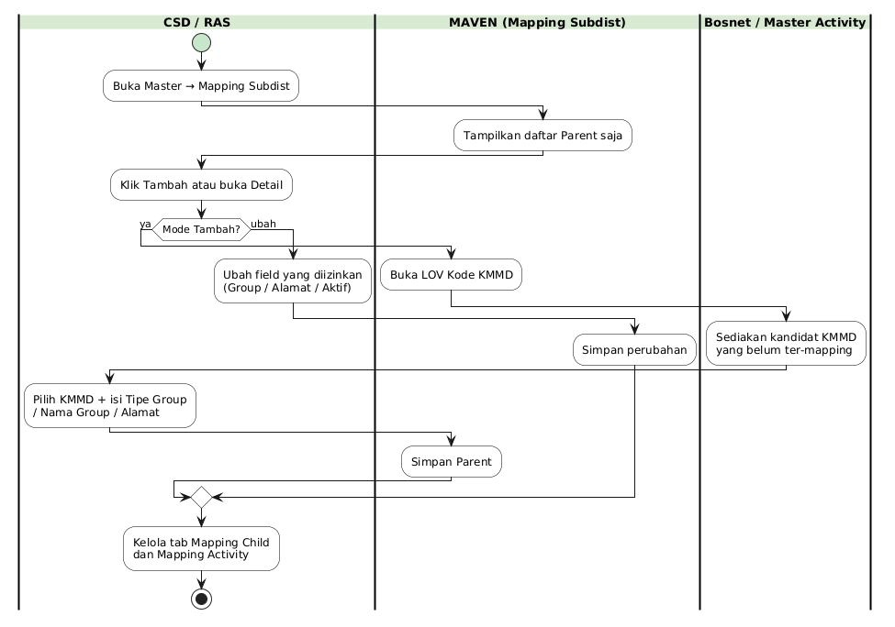
Alur Utama
Gambar 2.1 — Alur Utama

2.3 Alur Add Child (Bulan Ini vs Historis)
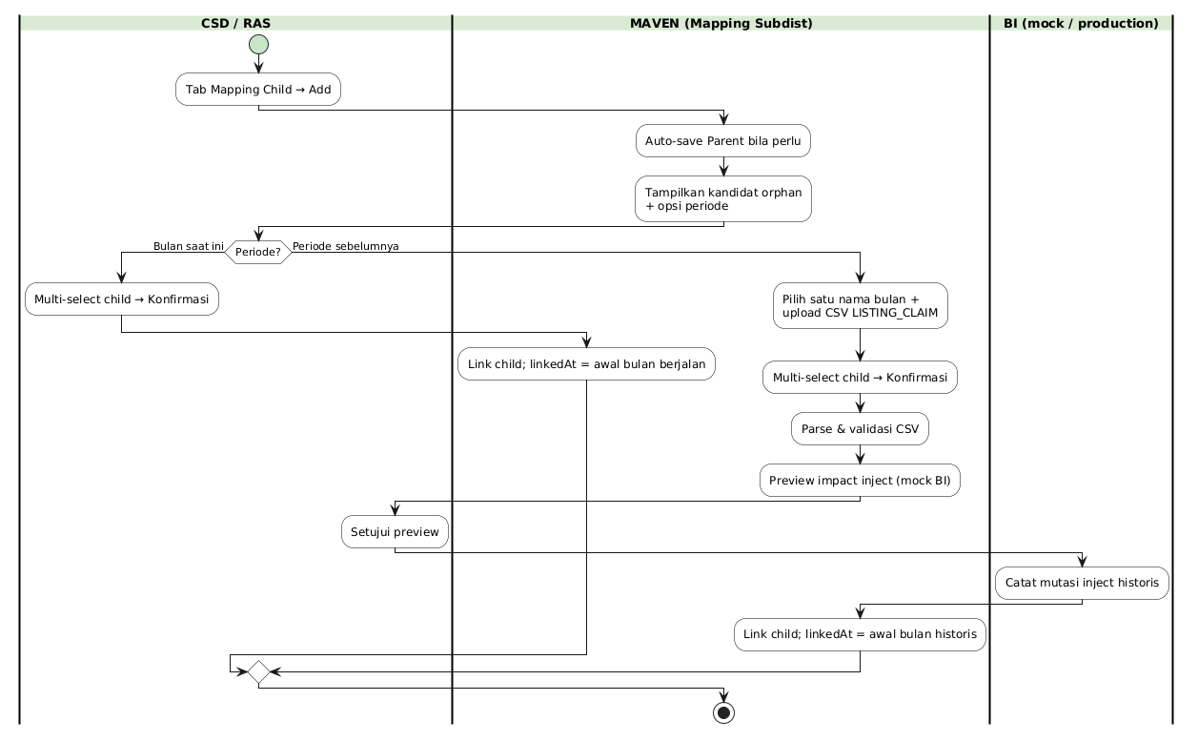
Alur Add Child
Gambar 2.2 — Alur Add Child

2.4 Alur Lepas Child (dengan / tanpa dampak BI)
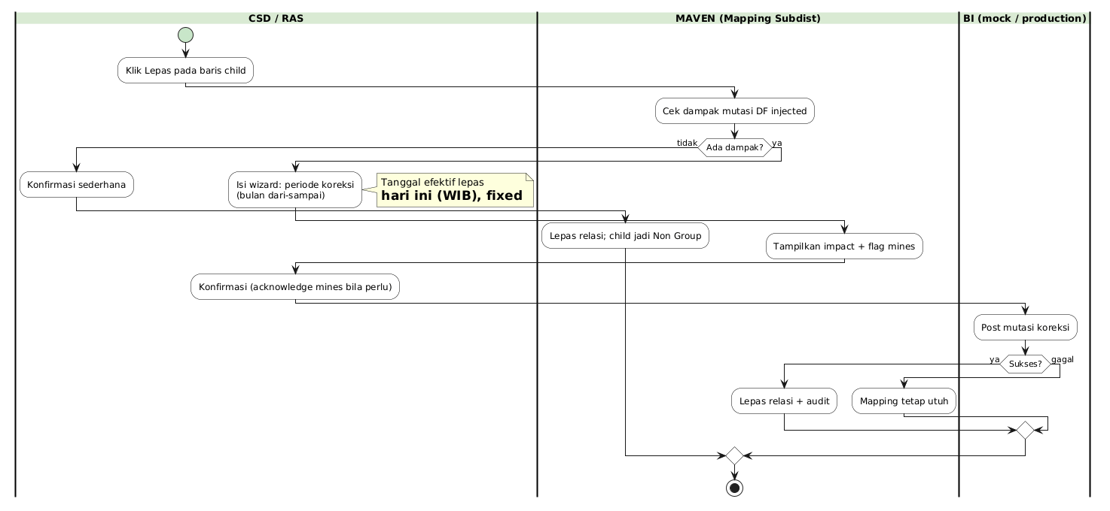
Alur Lepas Child
Gambar 2.3 — Alur Lepas Child

3. Halaman Index — Mapping Subdist

3.1 Deskripsi
Halaman Index menampilkan daftar Parent Mapping Subdist saja. Child tidak ditampilkan di list. User dapat memfilter Region dan Tipe Group, lalu membuka detail.
Item | Nilai
Menu | Master → Mapping Subdist
Path | masters/mapping-subdist.html
Tabel 3.1.1 — Item
Tampilan Halaman Index:
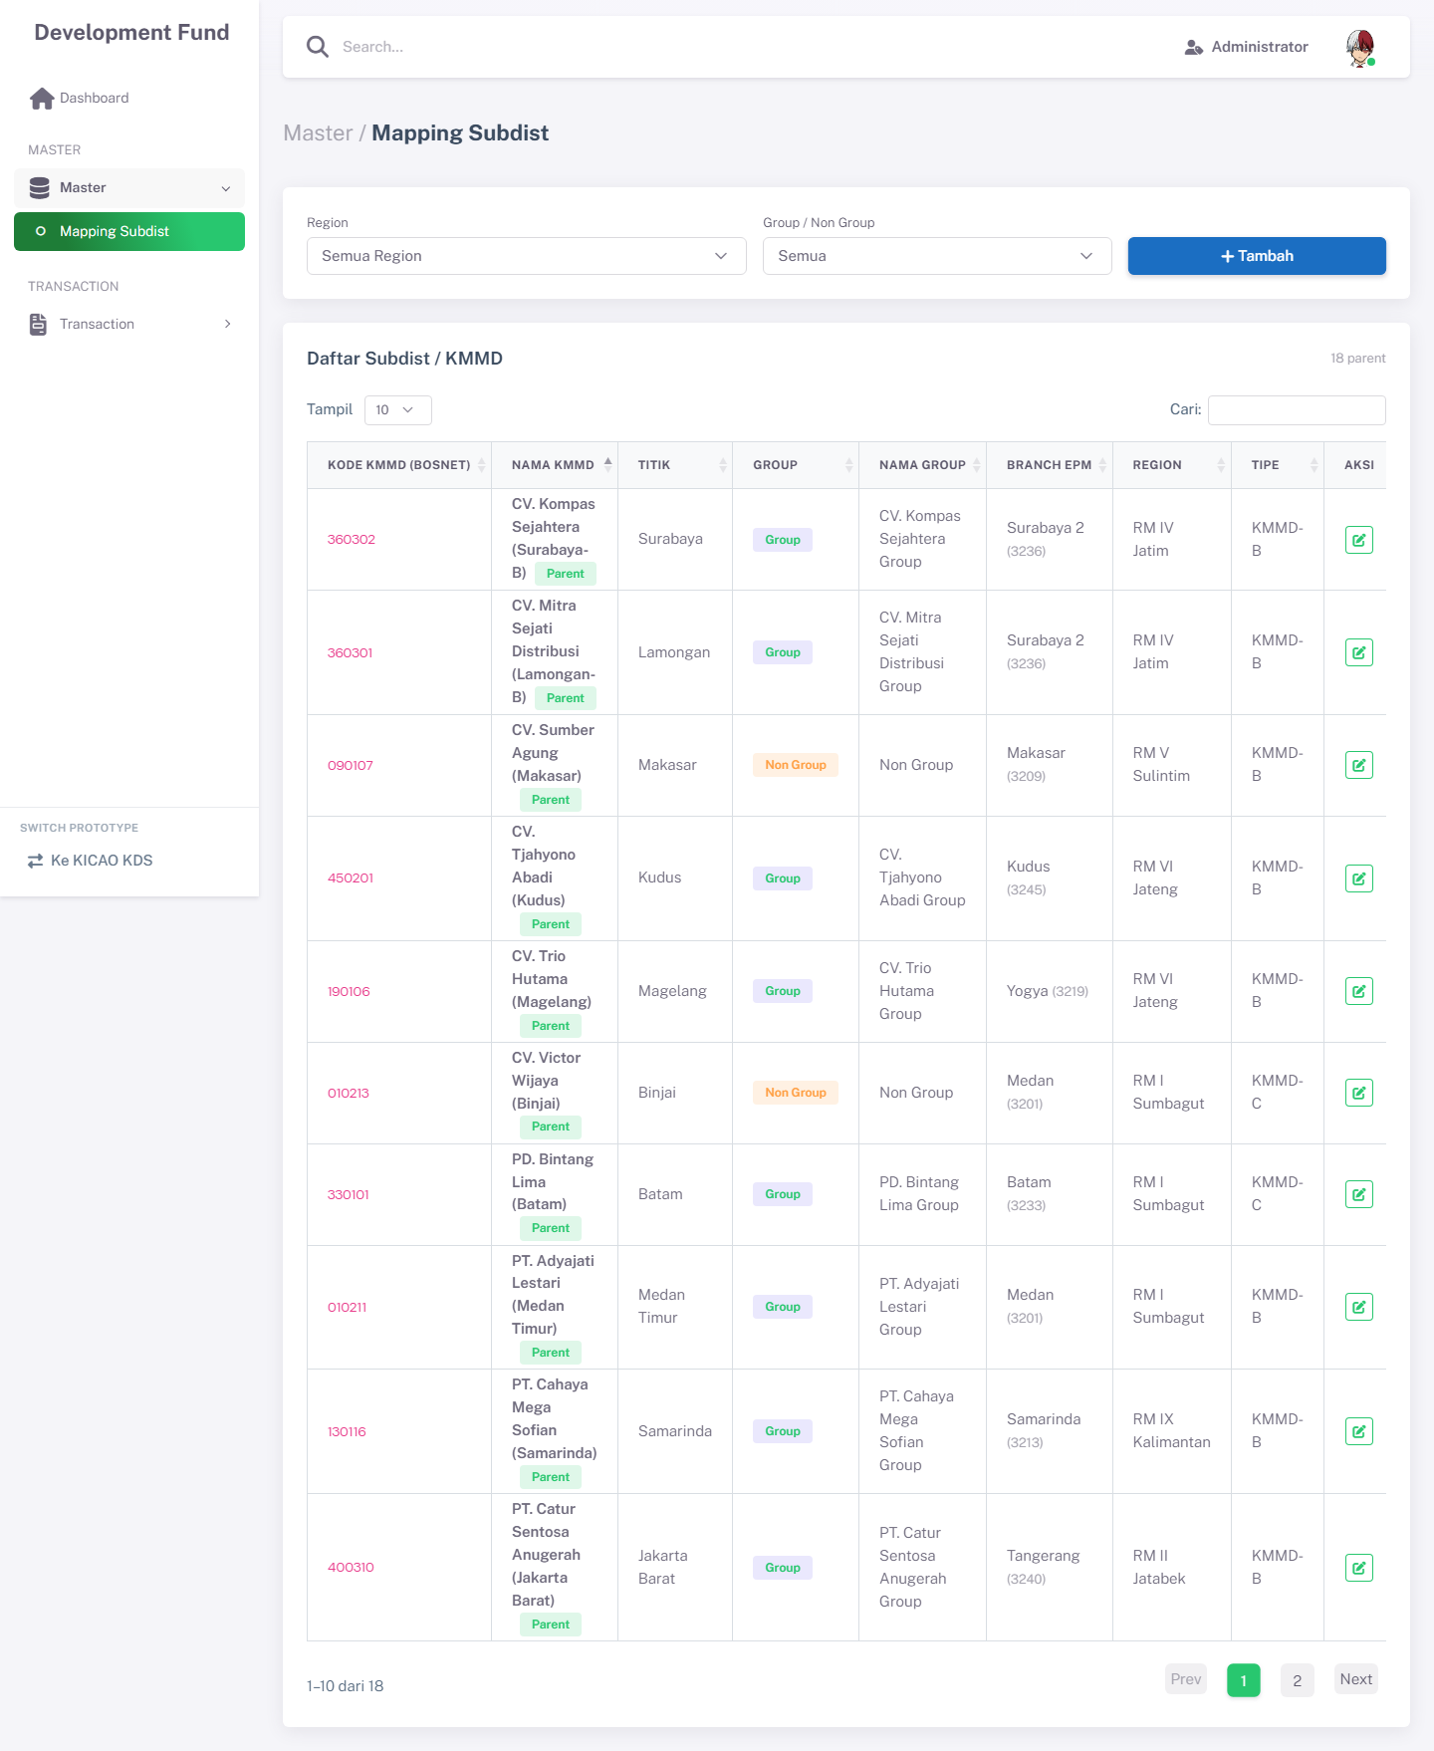
Halaman Index Mapping Subdist
Gambar 3.1 — Halaman Index Mapping Subdist

3.2 Filter & Action Bar
Field Name | ID Elemen | Tipe | Mandatory | Default | Validasi | Keterangan
Region | filterRegion | Dropdown | Tidak | Semua | — | Filter daftar Parent
Tipe Group | filterGroupType | Dropdown | Tidak | Semua | — | Group / Non Group
Tambah | btnAddSubdist | Tombol | — | — | Role edit | Navigasi ke form create
Tabel 3.2.1 — Field Name
Tabel Tombol Aksi — Index:
Jenis | Label | Control ID | Style | Keterangan
Tombol | Tambah | btnAdd / btnAddSubdist | Success + ikon plus | Buka form create
Link | Kode KMMD | — | Hyperlink di kolom | Buka Detail (tidak ada kolom Aksi Edit)
Tabel 3.2.2 — Tabel Tombol Aksi — Index:
Tabel Kolom — Index:
Label | Field | Tipe | Sort | Keterangan
Kode KMMD | kodeKmmd | Link | Ya | SubdistID Bosnet
Nama KMMD | namaKmmd | Text | Ya
Group | groupType | Badge | Ya | Group / Non Group
Nama Group | namaGroup | Text | Ya
Region | region | Text | Ya
Child | childCount | Number | Ya | Jumlah child
Activity | activityCount | Number | Ya | Jumlah activity
Tabel 3.2.3 — Tabel Kolom — Index:
Field Titik dan kolom Aksi Edit dihapus dari Index (aligned MAVEN Jul 2026). Navigasi detail via hyperlink Kode KMMD.

3.3 Business Rules — Index
Rule ID | Aturan
BR-MD-01 | Index hanya menampilkan record Parent (parent = YA).
BR-MD-07 | Tombol Delete tidak tersedia di index; hapus fisik tidak didukung di UI.
Tabel 3.3.1 — Rule ID

3.4 CRUD — Index
Operasi | Cara | Role | Keterangan
Create | Klik Tambah | Administrator, CSD / RAS | Form create
Read | Buka Detail | Semua role dengan akses menu | View only untuk role non-edit
Tabel 3.4.1 — Operasi

4. Halaman Form — Tambah / Ubah Parent

4.1 Deskripsi
Form dipakai untuk mendaftarkan Parent baru dari LOV Bosnet, atau mengubah data Parent yang sudah ada. Identitas KMMD tidak diketik manual.
Item | Nilai
Path create | masters/mapping-subdist-form.html
Path edit | masters/mapping-subdist-form.html?id={id}
Tabel 4.1.1 — Item
Tampilan Halaman Form:
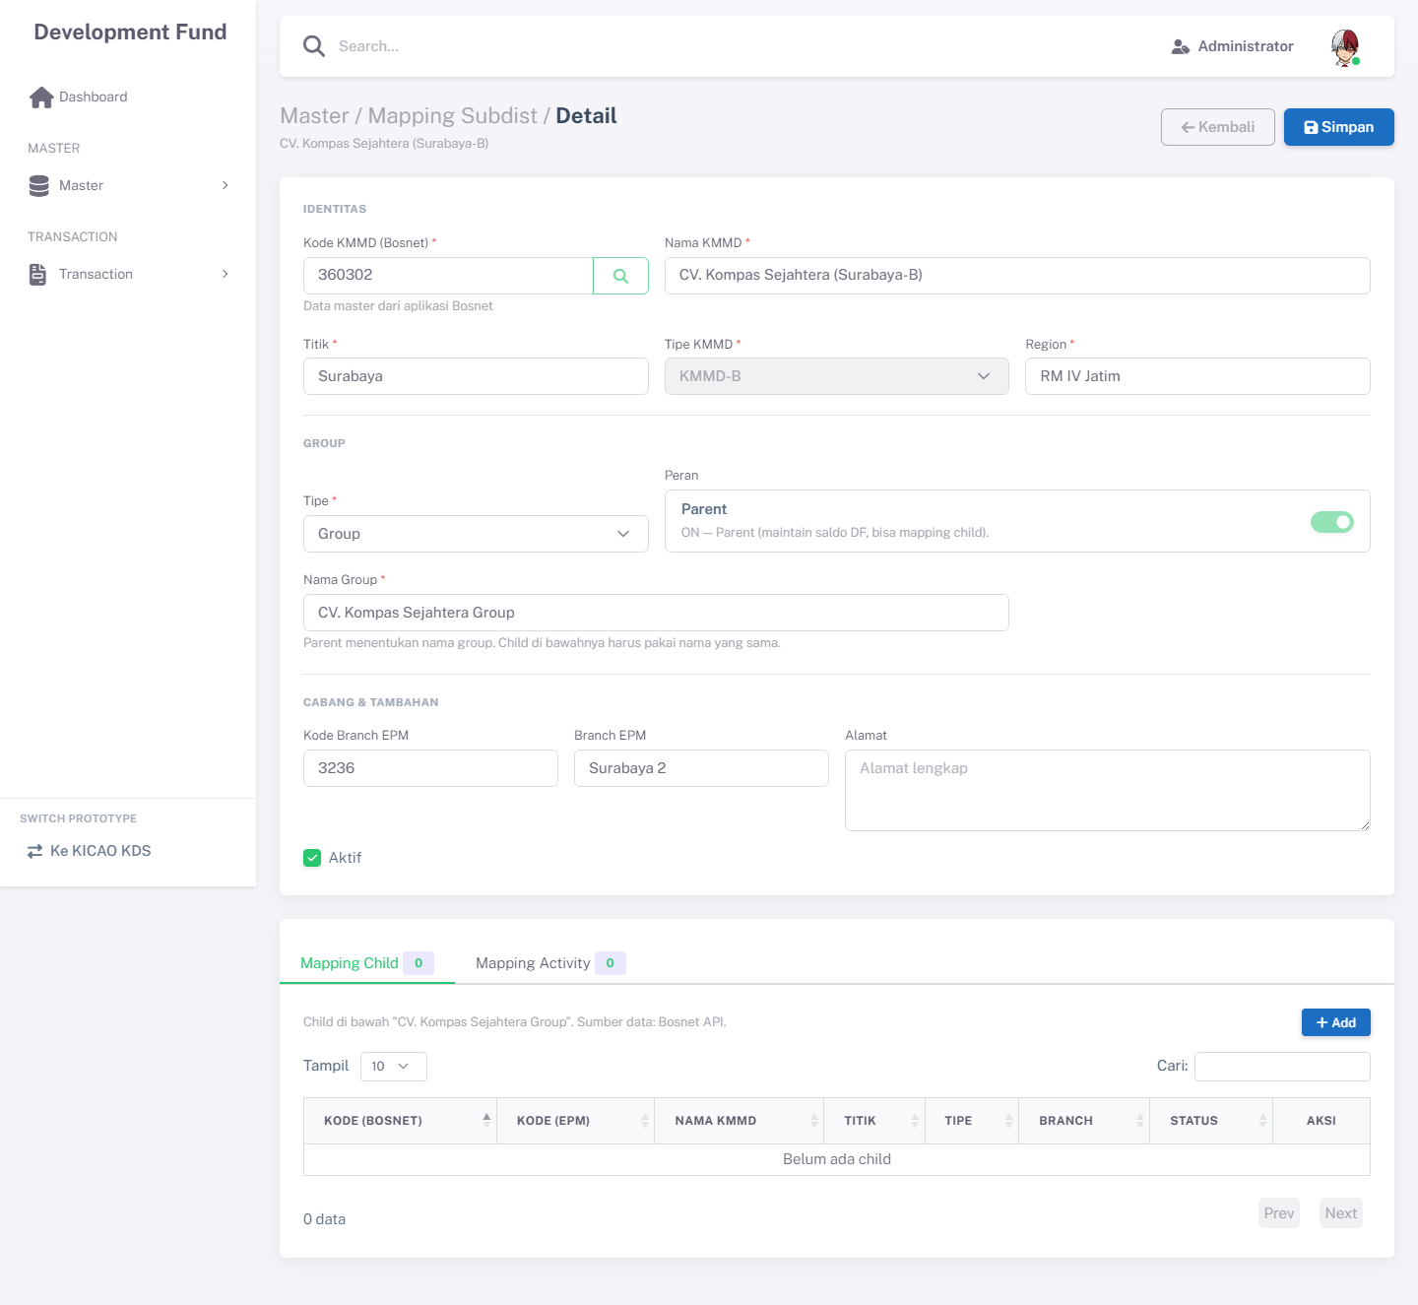
Halaman Form Mapping Subdist
Gambar 4.1 — Halaman Form Mapping Subdist

4.2 Section Identitas (dari Bosnet)
Section ini berisi identitas Subdist yang diisi otomatis setelah user memilih Kode KMMD dari LOV Bosnet.

4.2.1 Fields — Identitas
Field Name | ID Elemen | Tipe | Mandatory | Default | Validasi | Keterangan
ShipTo Site Use ID | fldShipToSiteUseId | Hidden | Ya (auto) | (kosong) | Dari Bosnet OutletID | Diset saat pilih LOV; tidak ditampilkan di form
Kode KMMD | fldKodeKmmd | Text + LOV Button | Ya | (kosong) | Harus dari Bosnet | btnLovKmmd; disabled + placeholder Autopopulate
Nama KMMD | fldNamaKmmd | Text (disabled) | Ya | Auto | — | Auto-fill dari Bosnet
Tipe KMMD | fldTipeKmmd | Text (disabled) | Tidak | Auto | — | Dari TypeSubDistID
Region | fldRegion | Text (disabled) | Tidak | Auto | — | Auto-fill
Kode Branch EPM | fldKodeBranch | Text (disabled) | Tidak | Auto | — | Dari BranchESI; atribut cabang (bukan kunci match Monitoring)
Branch EPM | fldBranchEpm | Text (disabled) | Tidak | Auto | — | Dari BranchNameESI; atribut cabang (bukan kunci match Monitoring)
Tabel 4.2.1 — Fields — Identitas

4.2.2 Fields — Group & Status
Field Name | ID Elemen | Tipe | Mandatory | Default | Validasi | Keterangan
Tipe Group | fldGroupType | Dropdown | Ya | (kosong) | Group / Non Group | Menentukan UI Nama Group
Parent | fldParentToggle / fldParent | Switch + Hidden | Ya (Auto) | YA | — | Non Group memaksa Parent; mode edit terkunci
Nama Group | fldNamaGroup | Text + datalist | Ya jika Group | (kosong) / Non Group | Wajib jika Group | Datalist nama group existing
Alamat | fldAlamat | Textarea | Tidak | Autopopulate | — | Dari Address; tetap editable
Aktif | fldActive | Checkbox | Tidak | Checked | — | Status aktif
Tabel 4.2.2 — Fields — Group & Status

4.3 Tombol Aksi — Form
Tabel Tombol Aksi:
Tampilan | Tombol | ID / Handler | Warna/Style | Fungsi
Ikon + Label | Kembali | link ke index | Outline Secondary | Kembali ke list
Ikon + Label | Simpan | btnSave | Biru Primary | Simpan Parent
Tabel 4.3.1 — Tabel Tombol Aksi:

4.4 Business Rules — Form
Rule ID | Aturan
BR-MD-02 | Identitas Subdist bersumber dari Bosnet; tidak diinput bebas.
BR-MD-03 | Satu kodeKmmd hanya boleh sekali di mapping; LOV tidak menampilkan yang sudah ada.
BR-MD-08 | NPWP / PPN / PPh tidak dikelola di form Mapping Subdist.
BR-MD-19 | Setelah tersimpan / mode edit: identitas Bosnet + toggle Parent terkunci.
BR-MD-20 | Non Group: sistem memaksa peran Parent; Nama Group = Non Group.
BR-MD-24 | Saat pilih LOV Bosnet, OutletID disimpan ke txtShipToSiteUseId (hidden fldShipToSiteUseId).
BR-MD-25 | Satu ShipTo aktif hanya boleh dipetakan sekali (unique index mDfMappingSubdist_txtShipToSiteUseId_uq).
BR-MD-26 | Mode edit: ShipTo dan identitas Bosnet tidak diubah; hanya Group / Alamat / Aktif.
BR-MD-27 | Mapping tanpa ShipTo tidak akan match di Monitoring sampai diisi via LOV Bosnet.
Tabel 4.4.1 — Rule ID

4.5 CRUD — Form
Operasi | Cara | Role | Keterangan
Create | Pilih LOV → isi Group → Simpan | Administrator, CSD / RAS | Parent baru
Read | Buka dari Index | Semua role akses | Field read-only untuk view
Update | Ubah Group/Alamat/Aktif → Simpan | Administrator, CSD / RAS | Identitas Bosnet tidak diubah
Tabel 4.5.1 — Operasi

4.6 LOV Bosnet
Tampilan Modal LOV Bosnet:
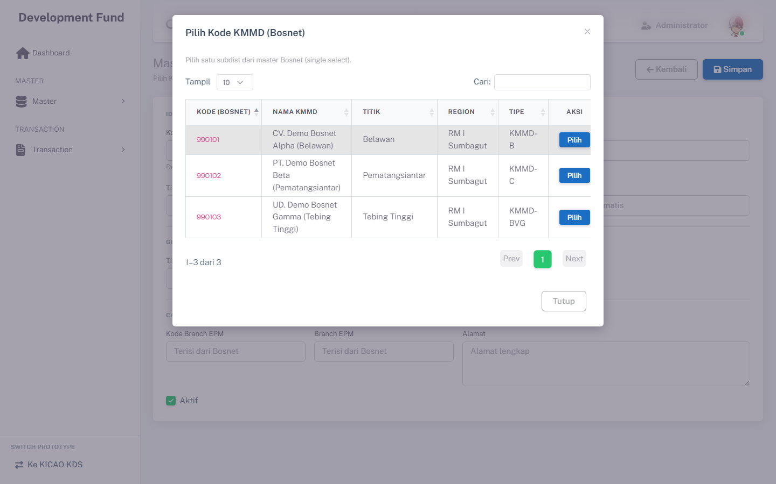
Modal LOV Kode KMMD Bosnet
Gambar 4.2 — Modal LOV Kode KMMD Bosnet
Modal modalLovBosnet menampilkan grid kandidat dari vw_Outlet_Bosnet yang belum ada di mapping (SubdistID belum terpakai). Kolom: Action (kiri), OutletID (→ txtShipToSiteUseId), OutletName, SubdistID (→ txtKodeKmmd), SubdistName, Active (badge true/false). Payload tambahan: typeSubDistId, region, branchEsi, branchNameEsi, address. DataTables + pagination.

5. Tab Mapping Child

5.1 Deskripsi
Tab Mapping Child mengelola relasi Parent–Child. Tersedia setelah Parent tersimpan (mode Parent). Ditampilkan dalam card cardMappingTabs.
Tampilan Tab Mapping Child:
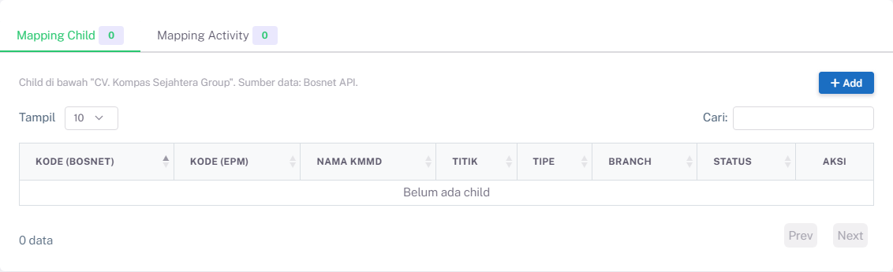
Tab Mapping Child
Gambar 5.1 — Tab Mapping Child

5.2 Grid Child
Kolom | Field Key | Render | Keterangan
Action | — | Tombol Lepas + ikon | Kolom kiri; SweetAlert konfirmasi
Kode KMMD | kodeKmmd | Text | Child
Nama KMMD | namaKmmd | Text | —
Linked At | linkedAt | Date | Awal bulan efektif (YYYY-MM-01)
Tabel 5.2.1 — Kolom
DataTables + pagination + empty state. Field Titik / Branch EPM tidak ditampilkan di grid Child (aligned MAVEN). Saat Add Child, outletId dari Bosnet disimpan ke txtShipToSiteUseId child.
Tabel Tombol Aksi — Child:
Tampilan | Tombol | ID / Handler | Warna/Style | Fungsi
Ikon + Label | Add | btnAddChild | Success + plus | Buka modal pilih child
Ikon + Label | Lepas | tombol baris Action | Outline Danger | Lepas child (+ wizard bila berdampak)
Tabel 5.2.2 — Tabel Tombol Aksi — Child:

5.3 Modal Add Child
Tampilan Modal Add Child:
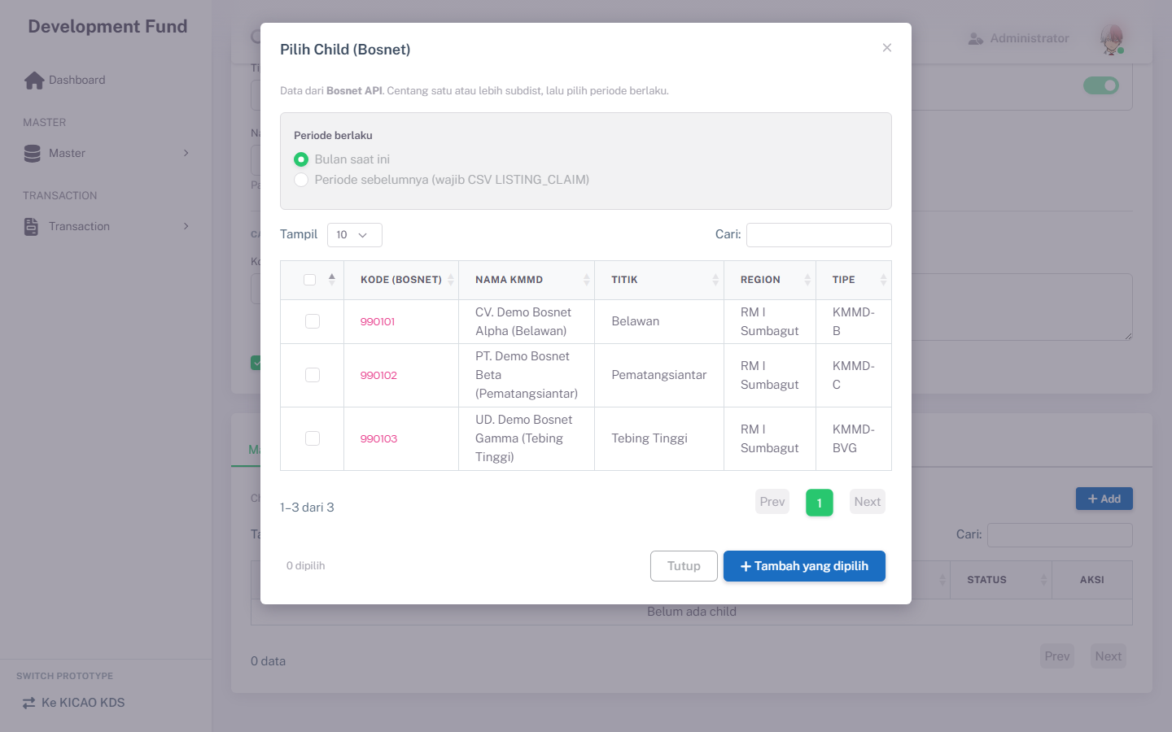
Modal Add Child dengan pilihan periode
Gambar 5.2 — Modal Add Child dengan pilihan periode
Field Name | ID Elemen | Tipe | Mandatory | Default | Validasi | Keterangan
Periode | childPeriodCurrent / childPeriodHistorical | Radio | Ya | Bulan saat ini | — | current / historical
Bulan historis | childPeriodMonth | Dropdown | Ya jika historis | (kosong) | Sebelum bulan berjalan | Satu nama bulan
File CSV | childPeriodCsv | File Upload | Ya jika historis | — | Format LISTING_CLAIM | Sama Monitoring Claim EPM
Pilih child | checkbox di tblOrphan | Multi-select | Ya | — | Minimal 1 | Filter kandidat orphan
Tabel 5.3.1 — Tampilan Modal Add Child:

5.4 Business Rules — Child
Rule ID | Aturan
BR-MD-04 | Group Parent dan Non Group sama-sama dapat memetakan child.
BR-MD-05 | Kandidat popup = belum punya parent; bukan diri sendiri; bukan Non Group / Parent Group lain; belum ter-link ke parent ini.
BR-MD-06 | Lepas child wajib konfirmasi user.
BR-MD-09 | Lepas dengan dampak: wizard wajib; efektif lepas = hari ini (WIB) fixed; koreksi = bulan dari–sampai.
BR-MD-10 | Rentang bulan koreksi hanya dalam masa child ter-link s/d bulan berjalan.
BR-MD-11 | Unmap dengan dampak hanya setelah mutasi koreksi BI sukses (atomic).
BR-MD-12 | Koreksi unmap = mutasi ledger, bukan hard-delete.
BR-MD-13 | Proyeksi sisa < 0 → warning mines; lanjut hanya dengan acknowledge.
BR-MD-14 | Add child: wajib pilih Bulan saat ini atau Periode sebelumnya.
BR-MD-15 | Periode sebelumnya: wajib satu nama bulan + upload CSV LISTING_CLAIM.
BR-MD-16 | CSV historis divalidasi cocok identity branch/child; mayoritas TRX_DATE di bulan dipilih.
BR-MD-17 | Add historis: preview impact wajib sebelum commit link + inject.
BR-MD-18 | linkedAt = YYYY-MM-01 bulan efektif.
Tabel 5.4.1 — Rule ID

5.5 CRUD — Child Mapping
Operasi | Cara | Role | Keterangan
Create | Add → pilih periode → pilih child | Administrator, CSD / RAS | Link Parent–Child
Read | Lihat grid tab Child | Semua role akses | —
Delete | Lepas (+ wizard bila berdampak) | Admin / CSD; koreksi BI: CCD / FA | Soft unlink, bukan hapus KMMD
Tabel 5.5.1 — Operasi

6. Tab Mapping Activity

6.1 Deskripsi
Tab Mapping Activity mengatur jenis activity yang boleh dipakai Parent. Sumber LOV = Master Activity (prototype: seed; production: Master Data API).
Tampilan Tab Mapping Activity:
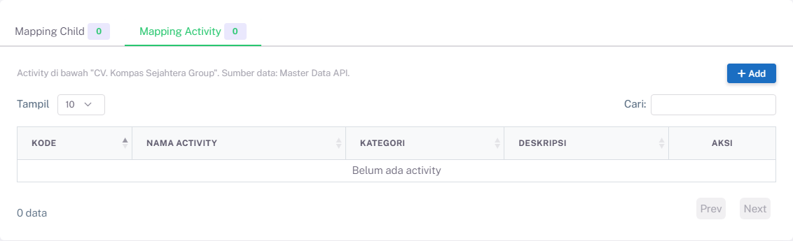
Tab Mapping Activity
Gambar 6.1 — Tab Mapping Activity

6.2 Grid & Modal
Kolom | Field Key | Keterangan
Action | — | Tombol Lepas + ikon (kolom kiri); SweetAlert
Kode | kode | Kode activity
Nama | nama | Nama activity
Kategori | kategori | Mis. Promotion, Trade, Digital
Deskripsi | deskripsi | Opsional
Tabel 6.2.1 — Kolom
DataTables + pagination + empty state.
Tabel Tombol Aksi — Activity:
Tampilan | Tombol | ID / Handler | Warna/Style | Fungsi
Ikon + Label | Add | btnAddActivity | Success + plus | Buka LOV activity
Ikon + Label | Lepas | tombol baris Action | Outline Danger | Lepas activity dari parent
Tabel 6.2.2 — Tabel Tombol Aksi — Activity:

6.3 Business Rules — Activity
Rule ID | Aturan
BR-MD-21 | Hanya activity aktif yang belum ter-mapping ke parent ini yang muncul di LOV.
BR-MD-22 | Lepas activity memakai konfirmasi sederhana (tanpa wizard koreksi BI).
BR-MD-23 | Tidak ada menu CRUD Jenis Activity terpisah di prototype; activity hanya via LOV.
Tabel 6.3.1 — Rule ID

6.4 CRUD — Activity Mapping
Operasi | Cara | Role | Keterangan
Create | Add → pilih activity | Administrator, CSD / RAS | Simpan di array activities parent
Read | Lihat grid tab Activity | Semua role akses | —
Delete | Lepas + konfirmasi | Administrator, CSD / RAS | Unlink dari parent
Tabel 6.4.1 — Operasi

7. Aturan Bisnis
Rule ID | Aturan
BR-MD-01 | Index hanya menampilkan Parent (parent = YA).
BR-MD-02 | Identitas Subdist bersumber dari Bosnet; tidak diinput bebas.
BR-MD-03 | Satu kodeKmmd hanya boleh sekali di mapping.
BR-MD-04 | Group Parent dan Non Group sama-sama dapat memetakan child & activity.
BR-MD-05 | Kandidat child popup = belum punya parent dan bukan Non Group / Parent Group lain.
BR-MD-06 | Lepas child/activity wajib konfirmasi user.
BR-MD-07 | Tidak ada delete record dari index.
BR-MD-08 | NPWP / PPN / PPh tidak dikelola di form Mapping Subdist.
BR-MD-09 | Lepas child dengan dampak: wizard wajib; efektif lepas = hari ini; koreksi = bulan dari–sampai.
BR-MD-10 | Rentang bulan koreksi hanya dalam masa child ter-link s/d bulan berjalan.
BR-MD-11 | Unmap dengan dampak hanya setelah mutasi koreksi BI sukses.
BR-MD-12 | Koreksi unmap = mutasi ledger, bukan hard-delete.
BR-MD-13 | Proyeksi sisa < 0 → warning mines; lanjut hanya dengan acknowledge.
BR-MD-14 | Add child: wajib pilih Bulan saat ini atau Periode sebelumnya.
BR-MD-15 | Periode sebelumnya: wajib satu nama bulan + upload CSV LISTING_CLAIM.
BR-MD-16 | CSV historis divalidasi cocok identity; mayoritas TRX_DATE di bulan dipilih.
BR-MD-17 | Add historis: preview impact wajib sebelum commit.
BR-MD-18 | linkedAt = YYYY-MM-01 bulan efektif.
BR-MD-19 | Mode edit: identitas Bosnet + toggle Parent terkunci.
BR-MD-20 | Non Group memaksa Parent; Nama Group = Non Group.
BR-MD-21 | LOV Activity hanya yang aktif dan belum ter-mapping.
BR-MD-22 | Lepas activity = konfirmasi sederhana.
BR-MD-23 | Tidak ada menu CRUD Jenis Activity terpisah.
BR-MD-24 | LOV Bosnet: OutletID → txtShipToSiteUseId.
BR-MD-25 | Unique ShipTo aktif per mapping.
BR-MD-26 | Edit tidak mengubah ShipTo / identitas Bosnet.
BR-MD-27 | Tanpa ShipTo, baris tidak match Monitoring.
Tabel 7.1 — Rule ID

8. Hak Akses & Peran Pengguna
Matrix Hak Akses:
Fitur | Administrator | CSD / RAS | CCD / FA | Role lain
Lihat Index / Detail | Ya | Ya | Ya | Ya (view)
Tambah / Ubah Parent | Ya | Ya | Tidak | Tidak
Add / Lepas Child (tanpa dampak BI) | Ya | Ya | Tidak | Tidak
Lepas Child + koreksi periode BI | Ya | View impact | Ya | Tidak
Add / Lepas Activity | Ya | Ya | Tidak | Tidak
Tabel 8.1 — Matrix Hak Akses:
Prototype: role dari localStorage.currentRole. Production: sesuaikan matrix otorisasi MAVEN.

9. Database & ERD

9.1 Konvensi Penamaan MAVEN
Penamaan tabel dan kolom mengikuti standar MAVEN.DAL (acuan: mPelanggan, trClaimEpmSync):
Aspek | Konvensi | Contoh
Tabel master | m + PascalCase | mDfMappingSubdist, mDfActivity
Tabel relasi / transaksi | tr + PascalCase | trDfMappingSubdistActivity
Primary key | Prefix pk pada nama kolom | pkDfMappingSubdistId
Foreign key | Prefix ref pada nama kolom | refParentDfMappingSubdistId
Teks | txt | txtKodeKmmd, txtNamaGroup
Tanggal | dt | dtLinkedAt, dtInserted
Boolean | bol / bit | bolIsParent, bolActive
Numerik | int / dec | intDfActivityId
Audit | refInsertedBy, dtInserted, refUpdatedBy, dtUpdated | Sama pola trClaimEpmSync
Tabel 9.1.1 — Aspek
Catatan ERD: Pada diagram Mermaid, label PK di ujung atribut adalah penanda constraint gambar saja, bukan bagian nama kolom. Nama kolom di database tetap pkDfMappingSubdistId, refParentDfMappingSubdistId, dst. — tanpa sufiks PK/FK. Relasi foreign key digambarkan oleh garis antar tabel.

9.2 Entity Relationship Diagram
Model target production PostgreSQL (MavenDB). Prototype saat ini masih memakai localStorage.
ERD — Master Data Mapping Subdist:
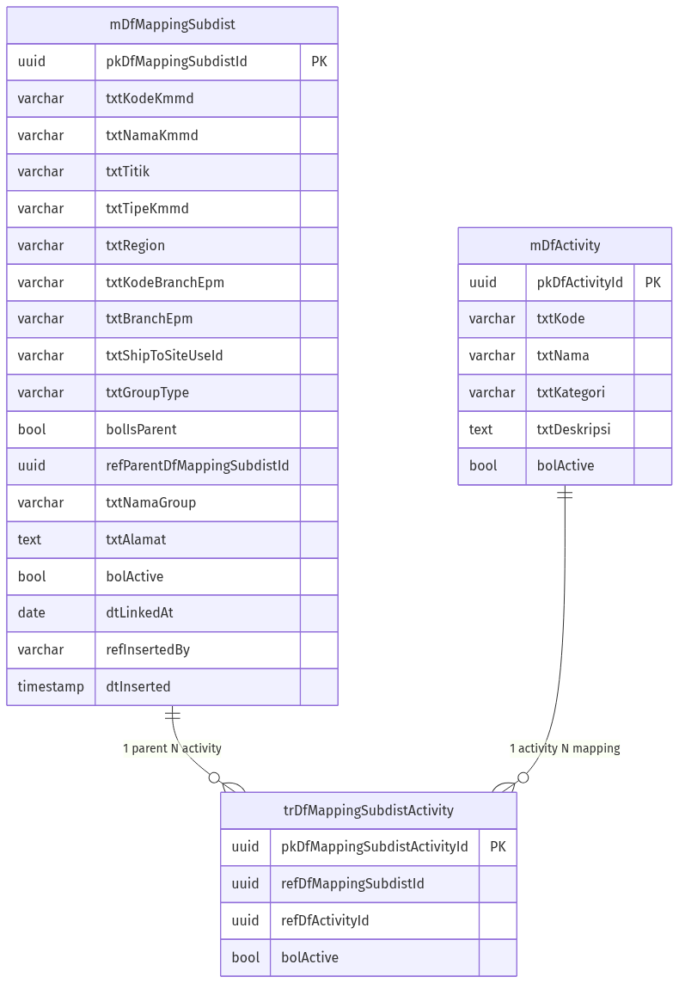
ERD — Master Data Mapping Subdist
Gambar 9.1 — ERD — Master Data Mapping Subdist
Relasi Parent–Child memakai kolom refParentDfMappingSubdistId (self-reference pada mDfMappingSubdist); digambarkan di narasi tabel, tidak dilipat ganda di garis ERD agar diagram tetap ringkas.

9.3 Deskripsi Tabel

9.3.1 mDfMappingSubdist
Tabel utama mapping Subdist (Parent dan Child dalam satu tabel; Parent = bolIsParent = true).
Mapping Database — mDfMappingSubdist:
Field UI | Kolom DB | Tipe Data | Keterangan
Kode KMMD | txtKodeKmmd | varchar(50) | Unique; dari Bosnet
Nama KMMD | txtNamaKmmd | varchar(255) | Dari Bosnet
Titik | txtTitik | varchar(100) | Kolom DB tetap ada; tidak ditampilkan di UI (tidak ada di vw_Outlet_Bosnet)
Tipe KMMD | txtTipeKmmd | varchar(20) | KMMD-B / C / BVG
Region | txtRegion | varchar(100) | Dari Bosnet
Kode Branch EPM | txtKodeBranchEpm | varchar(50) | Atribut cabang EPM (display)
Branch EPM | txtBranchEpm | varchar(200) | Atribut cabang EPM (display)
ShipTo Site Use ID | txtShipToSiteUseId | varchar(50) | Bosnet OutletID; kunci match SHIP_TO_SITE_USE_ID CSV
Tipe Group | txtGroupType | varchar(20) | Group / Non Group
Parent (YA/TIDAK) | bolIsParent | boolean | true = tampil di Index
Parent Kode | refParentDfMappingSubdistId | uuid | Foreign key ke Parent; null jika standalone Parent
Nama Group | txtNamaGroup | varchar(200) | Joint group
Alamat | txtAlamat | text | Input user
Aktif | bolActive | boolean | Status aktif
Linked At | dtLinkedAt | date | Awal bulan efektif link child (YYYY-MM-01)
ID | pkDfMappingSubdistId | uuid | Primary key
Inserted By | refInsertedBy | varchar(100) | Audit
Inserted At | dtInserted | timestamp | Audit
Updated By | refUpdatedBy | varchar(100) | Audit
Updated At | dtUpdated | timestamp | Audit
Tabel 9.3.1 — Mapping Database — mDfMappingSubdist:

9.3.2 mDfActivity
Master referensi jenis activity (production: Master Data API).
Mapping Database — mDfActivity:
Field UI | Kolom DB | Tipe Data | Keterangan
Kode | txtKode | varchar(50) | Unique
Nama | txtNama | varchar(200) | —
Kategori | txtKategori | varchar(100) | Promotion / Trade / Digital
Deskripsi | txtDeskripsi | text | Opsional
Aktif | bolActive | boolean | Hanya aktif di LOV
ID | pkDfActivityId | uuid | Primary key
Tabel 9.3.2 — Mapping Database — mDfActivity:

9.3.3 trDfMappingSubdistActivity
Tabel relasi Parent–Activity (many-to-many).
Mapping Database — trDfMappingSubdistActivity:
Field UI | Kolom DB | Tipe Data | Keterangan
Parent | refDfMappingSubdistId | uuid | Foreign key ke mDfMappingSubdist
Activity | refDfActivityId | uuid | Foreign key ke mDfActivity
Aktif | bolActive | boolean | Soft-unlink
ID | pkDfMappingSubdistActivityId | uuid | Primary key
Tabel 9.3.3 — Mapping Database — trDfMappingSubdistActivity:

9.4 Mapping Field UI → Kolom DB (ringkas)
ID Elemen UI | Kolom DB (mDfMappingSubdist)
fldKodeKmmd | txtKodeKmmd
fldNamaKmmd | txtNamaKmmd
(tidak di UI) | txtTitik
fldTipeKmmd | txtTipeKmmd
fldRegion | txtRegion
fldKodeBranch | txtKodeBranchEpm
fldBranchEpm | txtBranchEpm
fldShipToSiteUseId | txtShipToSiteUseId
fldGroupType | txtGroupType
fldParent / fldParentToggle | bolIsParent
fldNamaGroup | txtNamaGroup
fldAlamat | txtAlamat
fldActive | bolActive
Tabel 9.4.1 — ID Elemen UI

9.5 Persistensi Prototype vs Production
Aspek | Prototype | Production (target)
Storage | localStorage key df_mapping_subdist_v2 | PostgreSQL — mDfMappingSubdist, mDfActivity, trDfMappingSubdistActivity
Bosnet | Seed + mock | API Bosnet (kontrak TBD)
Activity | MasterActivitySeed | Master Data API / tabel mDfActivity
BI mutasi | MockBiLedger | API BI
Script SQL / migrate ShipTo | — | Documentation/Script SQL/mDfMappingSubdist.sql, migrate_mDfMappingSubdist_shipTo.sql, migrate_shipTo_all.sql
Tabel 9.5.1 — Aspek

9.6 Script SQL — Create Table
Script DDL production tersimpan di:
QP Kalbe Nutritionals/Documentation/Script SQL/mDfMappingSubdist.sql
Jalankan sekali di MavenDB (PostgreSQL). File berisi tiga tabel berurutan.
-- 1. mDfActivity — master jenis activity (LOV)
CREATE TABLE IF NOT EXISTS "mDfActivity" (
"pkDfActivityId" uuid PRIMARY KEY DEFAULT gen_random_uuid(),
"txtKode" varchar(50) NOT NULL,
"txtNama" varchar(200) NOT NULL,
"txtKategori" varchar(100) NULL,
"txtDeskripsi" text NULL,
"bolActive" boolean NOT NULL DEFAULT true,
"refInsertedBy" varchar(100) NULL,
"dtInserted" timestamp without time zone DEFAULT CURRENT_TIMESTAMP,
"refUpdatedBy" varchar(100) NULL,
"dtUpdated" timestamp without time zone NULL
);
CREATE UNIQUE INDEX IF NOT EXISTS "mDfActivity_txtKode_uq"
ON "mDfActivity" ("txtKode")
WHERE "bolActive" = true;
-- 2. mDfMappingSubdist — Parent & Child (satu tabel)
CREATE TABLE IF NOT EXISTS "mDfMappingSubdist" (
"pkDfMappingSubdistId" uuid PRIMARY KEY DEFAULT gen_random_uuid(),
"txtKodeKmmd" varchar(50) NOT NULL,
"txtNamaKmmd" varchar(255) NOT NULL,
"txtTitik" varchar(100) NULL,
"txtTipeKmmd" varchar(20) NULL,
"txtRegion" varchar(100) NULL,
"txtKodeBranchEpm" varchar(50) NULL,
"txtBranchEpm" varchar(200) NULL,
"txtGroupType" varchar(20) NOT NULL,
"bolIsParent" boolean NOT NULL DEFAULT true,
"refParentDfMappingSubdistId" uuid NULL
REFERENCES "mDfMappingSubdist" ("pkDfMappingSubdistId"),
"txtNamaGroup" varchar(200) NULL,
"txtAlamat" text NULL,
"txtShipToSiteUseId" varchar(50) NULL,
"bolActive" boolean NOT NULL DEFAULT true,
"dtLinkedAt" date NULL,
"refInsertedBy" varchar(100) NULL,
"dtInserted" timestamp without time zone DEFAULT CURRENT_TIMESTAMP,
"refUpdatedBy" varchar(100) NULL,
"dtUpdated" timestamp without time zone NULL,
CONSTRAINT "mDfMappingSubdist_txtGroupType_chk"
CHECK ("txtGroupType" IN ('Group', 'Non Group'))
);
CREATE UNIQUE INDEX IF NOT EXISTS "mDfMappingSubdist_txtKodeKmmd_uq"
ON "mDfMappingSubdist" ("txtKodeKmmd")
WHERE "bolActive" = true;
CREATE INDEX IF NOT EXISTS "idx_mDfMappingSubdist_parent"
ON "mDfMappingSubdist" ("refParentDfMappingSubdistId")
WHERE "bolActive" = true;
CREATE INDEX IF NOT EXISTS "idx_mDfMappingSubdist_isParent"
ON "mDfMappingSubdist" ("bolIsParent")
WHERE "bolIsParent" = true AND "bolActive" = true;
CREATE INDEX IF NOT EXISTS "idx_mDfMappingSubdist_branch"
ON "mDfMappingSubdist" ("txtKodeBranchEpm", "txtBranchEpm");
CREATE INDEX IF NOT EXISTS "idx_mDfMappingSubdist_shipTo"
ON "mDfMappingSubdist" ("txtShipToSiteUseId")
WHERE "bolActive" = true
AND "txtShipToSiteUseId" IS NOT NULL
AND "txtShipToSiteUseId" <> '';
CREATE UNIQUE INDEX IF NOT EXISTS "mDfMappingSubdist_txtShipToSiteUseId_uq"
ON "mDfMappingSubdist" ("txtShipToSiteUseId")
WHERE "bolActive" = true
AND "txtShipToSiteUseId" IS NOT NULL
AND "txtShipToSiteUseId" <> '';
-- 3. trDfMappingSubdistActivity — relasi Parent ↔ Activity
CREATE TABLE IF NOT EXISTS "trDfMappingSubdistActivity" (
"pkDfMappingSubdistActivityId" uuid PRIMARY KEY DEFAULT gen_random_uuid(),
"refDfMappingSubdistId" uuid NOT NULL
REFERENCES "mDfMappingSubdist" ("pkDfMappingSubdistId"),
"refDfActivityId" uuid NOT NULL
REFERENCES "mDfActivity" ("pkDfActivityId"),
"bolActive" boolean NOT NULL DEFAULT true,
"refInsertedBy" varchar(100) NULL,
"dtInserted" timestamp without time zone DEFAULT CURRENT_TIMESTAMP,
"refUpdatedBy" varchar(100) NULL,
"dtUpdated" timestamp without time zone NULL
);
CREATE UNIQUE INDEX IF NOT EXISTS "trDfMappingSubdistActivity_uq"
ON "trDfMappingSubdistActivity" ("refDfMappingSubdistId", "refDfActivityId")
WHERE "bolActive" = true;
Urutan | Tabel | Keterangan
1 | mDfActivity | Master LOV activity
2 | mDfMappingSubdist | Parent/Child Subdist + self-FK parent
3 | trDfMappingSubdistActivity | Relasi many-to-many Parent–Activity
Tabel 9.6.1 — Urutan

10. Integrasi Sistem

10.1 Peta Integrasi
Integrasi | Arah | Keterangan
Bosnet (KMMD) | Inbound LOV | Sumber identitas Subdist
Master Activity | Inbound LOV | Jenis activity
Claim EPM Monitoring | Outbound baca | Matching txtShipToSiteUseId = CSV SHIP_TO_SITE_USE_ID (case-insensitive); ringkasan Parent-only
BI / Inject DF | Outbound mutasi | Inject historis Add child; koreksi saat Lepas berdampak
Tabel 10.1.1 — Integrasi
Lane (urutan kiri → kanan):
# | Lane ID | Label | Tipe | Sumber
1 | L1 | Mapping Subdist (MAVEN) | System | Modul ini
2 | L2 | Bosnet / Activity | External | LOV
3 | L3 | Monitoring Claim EPM | System | Konsumen mapping
4 | L4 | BI | External | Mutasi DF
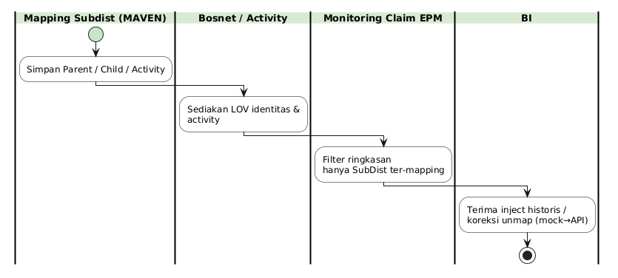
Peta Integrasi
Gambar 10.1 — Peta Integrasi

10.2 Keterkaitan FSD Lain
Dokumen | Hubungan
FSD Monitoring Subdist v2.0 | Sumber rekap LISTING_CLAIM; matching ShipTo ke mapping Parent
(digabung ke FSD Monitoring Subdist v2.0) | UI pantau memakai hasil mapping (mapped only)
FSD Inject Delta BI | Mutasi inject/koreksi mock saat Add historis & Lepas berdampak
Tabel 10.2.1 — Dokumen

11. Appendix

11.1 Glosarium
Istilah | Definisi
KMMD | Kode / identitas Subdist di Bosnet
Parent | Subdist yang tampil di Index (bolIsParent = true) dan dapat memetakan child/activity
Child | Subdist ter-link ke Parent (bolIsParent = false, refParentDfMappingSubdistId terisi)
Joint Group | Kumpulan Parent–Child dalam satu namaGroup
Non Group | Standalone Parent tanpa nama group joint
linkedAt | Tanggal awal bulan efektif link child (YYYY-MM-01)
LISTING_CLAIM | CSV EPM yang dipakai Add child historis & Monitoring
Mines | Kondisi proyeksi sisa budget < 0 saat koreksi/unmap
Bosnet | Sumber master identitas KMMD
OutletID | Identitas outlet Bosnet; disimpan sebagai txtShipToSiteUseId
ShipTo | txtShipToSiteUseId / SHIP_TO_SITE_USE_ID — kunci match Claim EPM
MockBiLedger | Ledger BI tiruan di prototype
Tabel 11.1.1 — Istilah

11.2 Open Points
No | Pertanyaan
1 | Apakah NPWP / PPN / PPh tetap wajib di MAVEN production?
2 | Apakah child boleh dipindah antar parent, atau hanya orphan?
3 | (Ditutup v2.0) Matching Monitoring memakai ShipTo (OutletID) per baris mapping, bukan branch.
4 | Jadwal & owner Master Vendor + flag jalur klaim
5 | Kontrak API Bosnet (field, auth, paging) untuk production
Tabel 11.2.1 — No

11.3 Lampiran File Prototype
Area | Path
Index | masters/mapping-subdist.html
Form | masters/mapping-subdist-form.html
Logic list | js/masters/MappingSubdist/MappingSubdist.js
Logic form | js/masters/MappingSubdist/MappingSubdistForm.js
Store / rules | js/masters/MappingSubdist/MappingSubdistStore.js
Seed | js/masters/MappingSubdist/seed-data.js, activity-seed.js
Mock BI | js/shared/MockBiLedger.js
Parser CSV | js/shared/ListingClaimCsv.js
Tabel 11.3.1 — Area

