Prediction of FS using Hybrid Metaheuristic Optimization-Based Neural Network Models

Aim:
To develop and evaluate four hybrid metaheuristic-ANN models for predictive modelling:
1. TLBO-ANN (Teaching Learning Based Optimization with ANN)
2. SHO-ANN (Spotted Hyena Optimizer with ANN)
3. HHO-MLP (Harris Hawk Optimization with MLP)
4. SSA-BP (Sparrow Search Algorithm with Back Propagation)
The objectives are to enhance neural network performance using nature-inspired
optimization algorithms, achieve over 85% prediction accuracy, and compare
model effectiveness using R², MSE, and RMSE metrics for complex system modelling.

Dataset Description:
The dataset consists of 7 input features and 1 output variable:
- Input Parameters: UW, CH, IFA, SLA, SH, PWPR, RFN
- Output Parameter: FS

METHODOLOGY
The methodology of this study involves developing intelligent hybrid predictive models by integrating metaheuristic optimization algorithms with artificial neural networks (ANNs).
The purpose of combining these two approaches is to improve the accuracy, stability, and convergence of neural networks, which often face challenges such as getting trapped in local minima or slow learning rates when trained using traditional backpropagation.
The process begins with data pre-processing, where the input parameters (UW, CH, IFA, SLA, SH, PWPR, and RFN) are normalized to a common scale to ensure balanced learning. The dataset is then divided into training and testing subsets to evaluate model performance fairly.
Each hybrid model follows a general workflow:
- Initialization: The optimization algorithm initializes a population of possible ANN weight and bias combinations.
- Fitness Evaluation: Each candidate solution is evaluated using an error metric (e.g., Mean Squared Error) from the ANN’s predictions.
- Optimization Process: The metaheuristic algorithm updates these parameters iteratively to minimize prediction error and enhance model generalization.
- Model Training: The optimized weights and biases are used to train the ANN to learn the nonlinear relationships between inputs and the output (FS).
- Performance Evaluation: The trained model is validated using evaluation metrics such as R², MSE, and RMSE to assess predictive accuracy.
This methodology ensures that the neural network is optimally tuned using biologically or physically inspired optimization techniques, resulting in higher prediction accuracy and smoother model convergence.

1. Teaching learning-based optimization of artificial neural network (TLBO-ANN)
Description:
Teaching Learning-Based Optimization (TLBO) is a population-based algorithm inspired by the classroom teaching process. It optimizes the learning process of students based on teacher influence and peer interaction. In this model, TLBO is used to optimize the weights and biases of the ANN to achieve minimum error and maximum accuracy.
Key Steps:
- Initialize random ANN weights and biases.
- Evaluate ANN performance (MSE).
- Apply TLBO phases:
  - Teacher Phase: The best individual (teacher) tries to improve the class mean.
  - Learner Phase: Students (solutions) learn through mutual interactions.
- Update weights iteratively until convergence.
- Predict FS values using the optimized ANN

2. Spotted Hyena Optimizer with ANN (SHO-ANN)
Description:
The Spotted Hyena Optimizer (SHO) mimics the intelligent hunting mechanism of spotted hyenas in nature. It is used to tune the ANN parameters for improved predictive performance.
Key Steps:
- Initialize population representing neural network weight sets.
- Use SHO hunting phases:
  - Encircling prey
  - Hunting coordination
  - Attacking prey
- Replace prey (ANN parameters) iteratively to reduce MSE.
- Final optimized ANN is used for FS prediction.

3. Harris Hawk optimization with MLP (HHO-MLP)
Description:
Harris Hawk Optimization (HHO) is inspired by the cooperative behaviour and surprise pounce strategy of Harris hawks. It is used to optimize the parameters of a Multi-Layer Perceptron (MLP).
Key Steps:
- Define MLP structure with input, hidden, and output layers.
- Initialize population of hawks (ANN weights).
- Perform exploration and exploitation stages:
  - Exploration: Random search for global solutions.
  - Exploitation: Attack phase simulating prey capture.
- The fittest hawk (best solution) defines the final ANN parameters.
- Use optimized MLP to predict FS accurately.
4. Sparrow search algorithm with Back Propagation neural network (SSA-BPNN)
Description:
The Sparrow Search Algorithm (SSA) models the foraging and vigilance behavior of sparrows. It helps overcome limitations of standard backpropagation, such as slow convergence and local minima.
Key Steps:
- Initialize ANN parameters as sparrow positions.
- Divide sparrows into discoverers, joiners, and warners.
- Iteratively update positions based on fitness (MSE).
- Update weights and biases until best ANN performance is obtained.
- The final optimized BPNN is used for FS prediction.

Procedure (Common for All Models):
- Import necessary libraries such as NumPy, Pandas, Scikit-learn, TensorFlow, and respective metaheuristic packages.
- Load and preprocess the dataset (normalization, splitting into training and testing sets).
- Define the ANN/MLP structure (input layer: 7 neurons, output layer: 1 neuron).
- Integrate the chosen optimization algorithm for weight and bias optimization.
- Train models until convergence or maximum iteration limit.
- Predict FS values for the test dataset.
- Evaluate models using R², MSE, and RMSE metrics.
- Compare model performances and select the best-performing algorithm.
CODING:
The coding work for this project was carried out in Google Colab using the Python programming language and the TensorFlow–Keras deep learning framework.
All implementation, training, and evaluation processes were executed in the Colab environment, which provided GPU acceleration for faster computation and efficient model training.
The primary libraries used were NumPy, Pandas, Matplotlib, Seaborn, Scikit-learn, and TensorFlow/Keras. These libraries supported data preprocessing, neural network development, optimization, and visualization.
Evaluation Metrics:
- R² (Coefficient of Determination): Measures proportion of variance explained by the model.
Measures how well predicted values match actual values. Higher is better.
- MSE (Mean Squared Error): Penalizes large errors by squaring differences.
Average of squared prediction errors. Lower is better.
- RMSE (Root Mean Squared Error): Square root of MSE, interpretable in original units.Standard deviation of residuals. Lower is better.
Results:
Model | R² | MSE | RMSE | Accuracy(%)
TLBO-ANN | 0.9971 | 0.0012 | 0.0352 | 99.71
SHO-ANN | 0.9967 | 0.0014 | 0.0375 | 99.67
HHO-MLP | 0.9957 | 0.0018 | 0.0428 | 99.57
SSA-BPNN | 0.9961 | 0.0017 | 0.0411 | 99.61

Visualizations:
- Evaluation Metrics Comparison:

- R²:
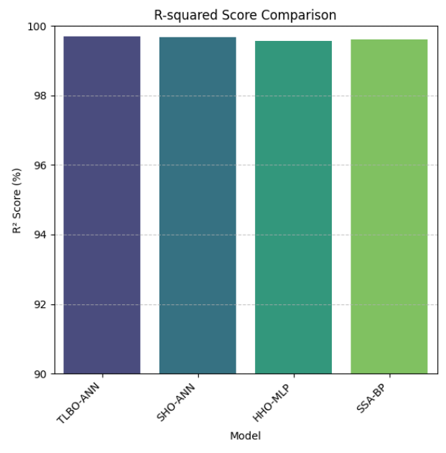

2.MSE:
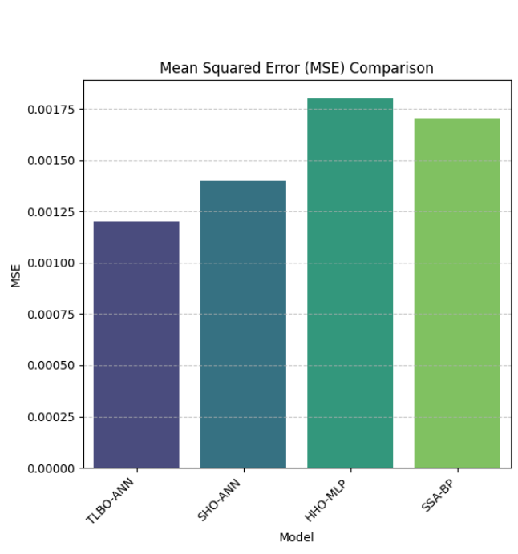
3)RMSE:
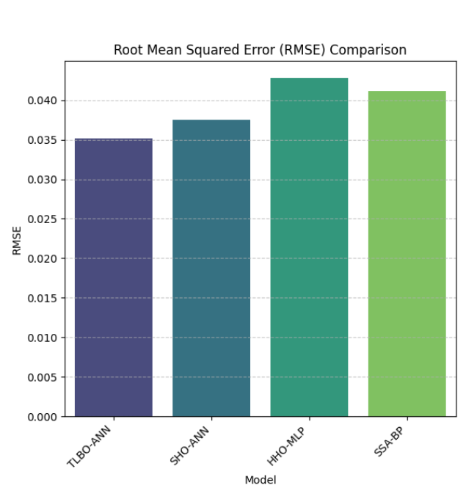
Actual vs Predicted FS:
1.TLBO-ANN

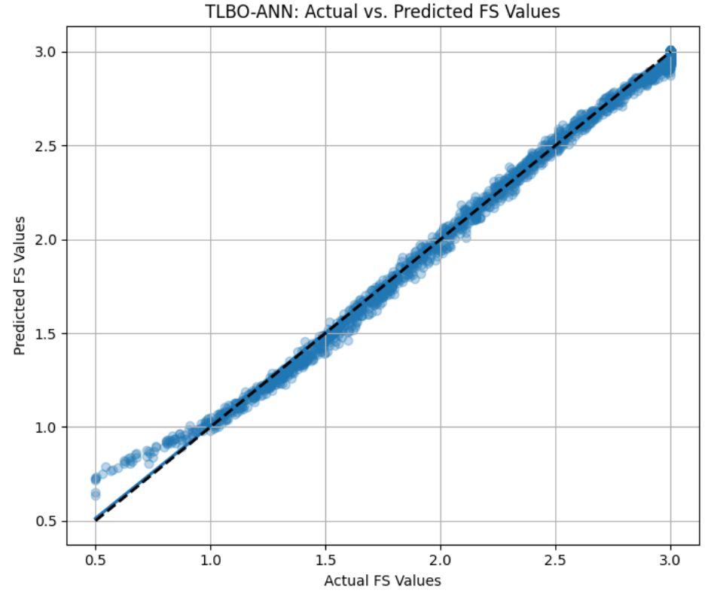

2.SHO-ANN:
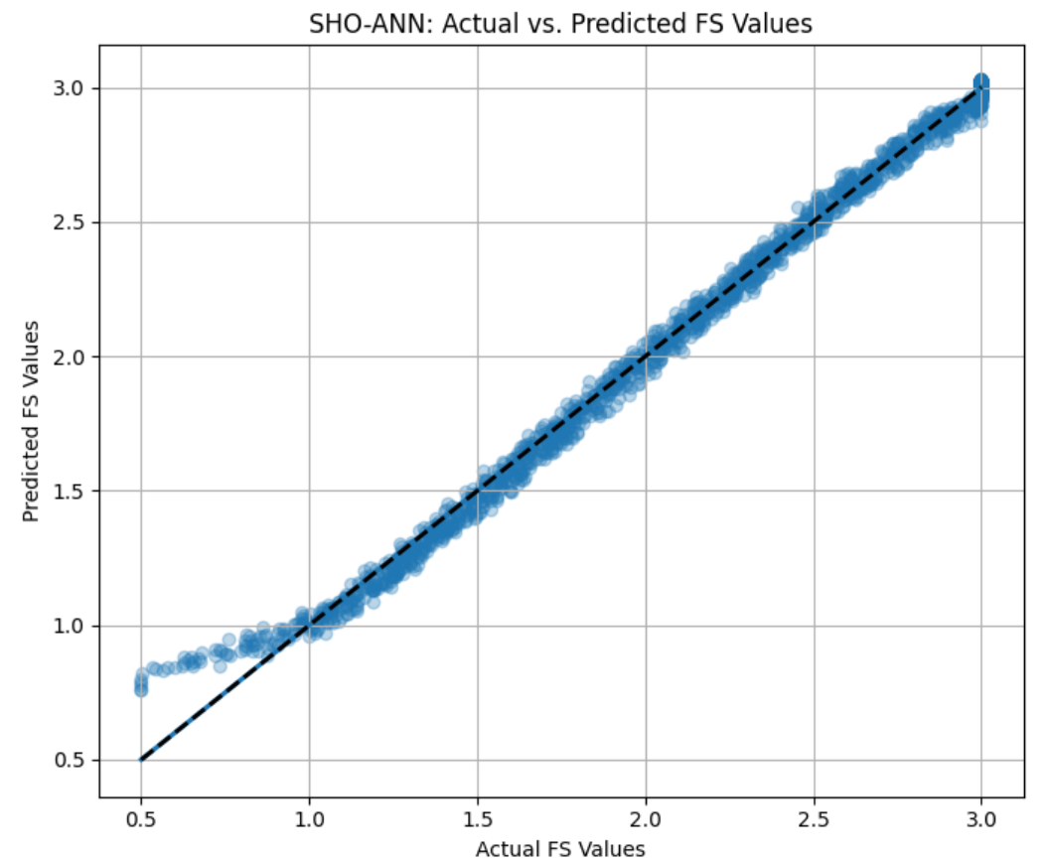

3.HHO-MLP:
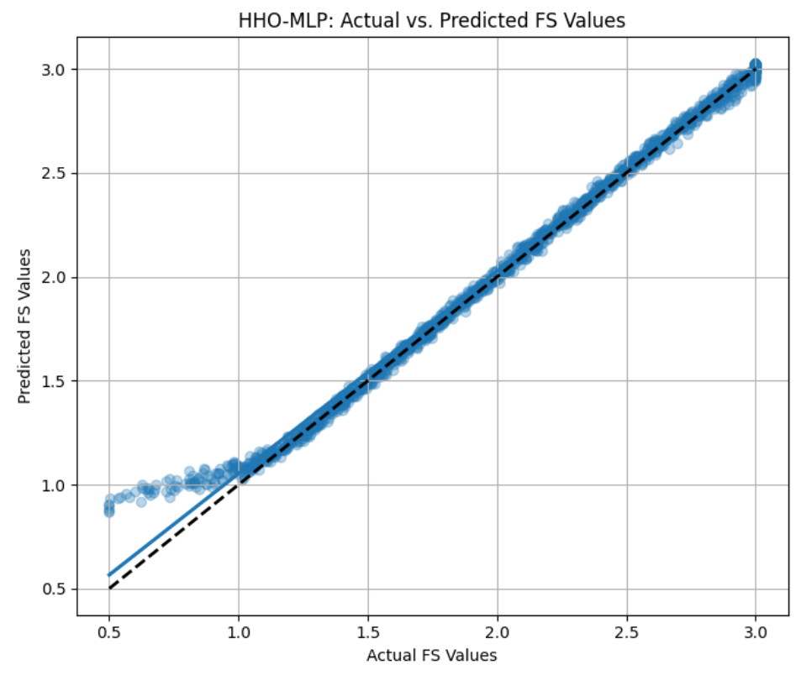
4.SSA-BPNN
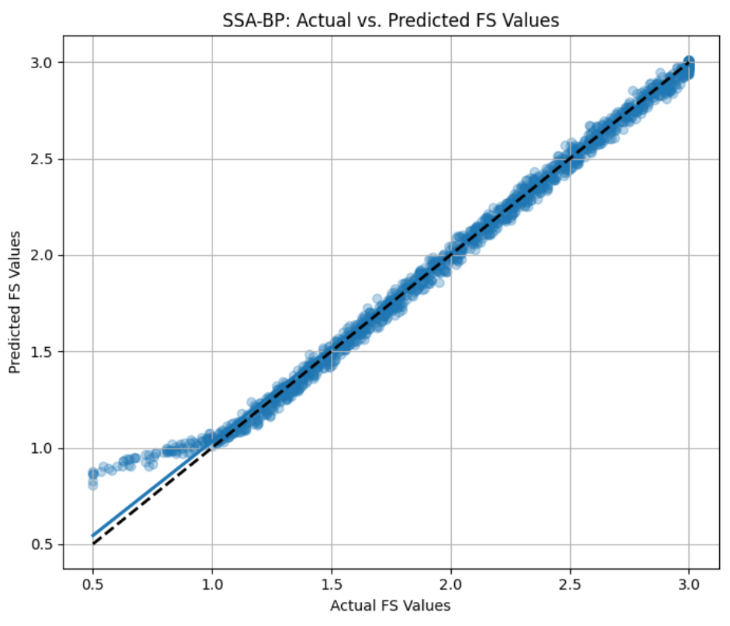

Residual Plots:

- TLBO-ANN:
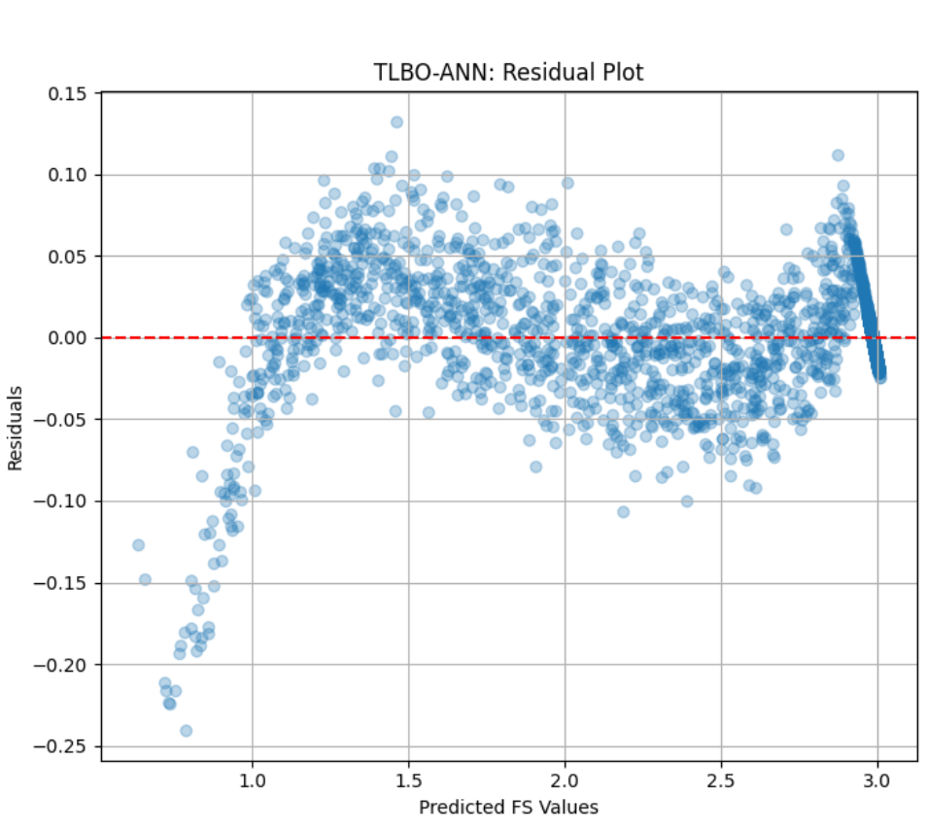

- SHO-ANN:
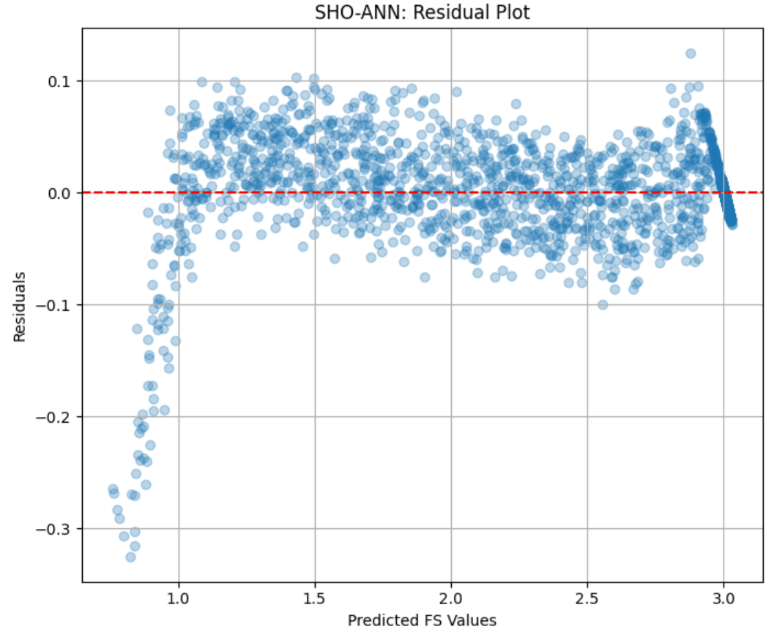

- HHO-MLP:
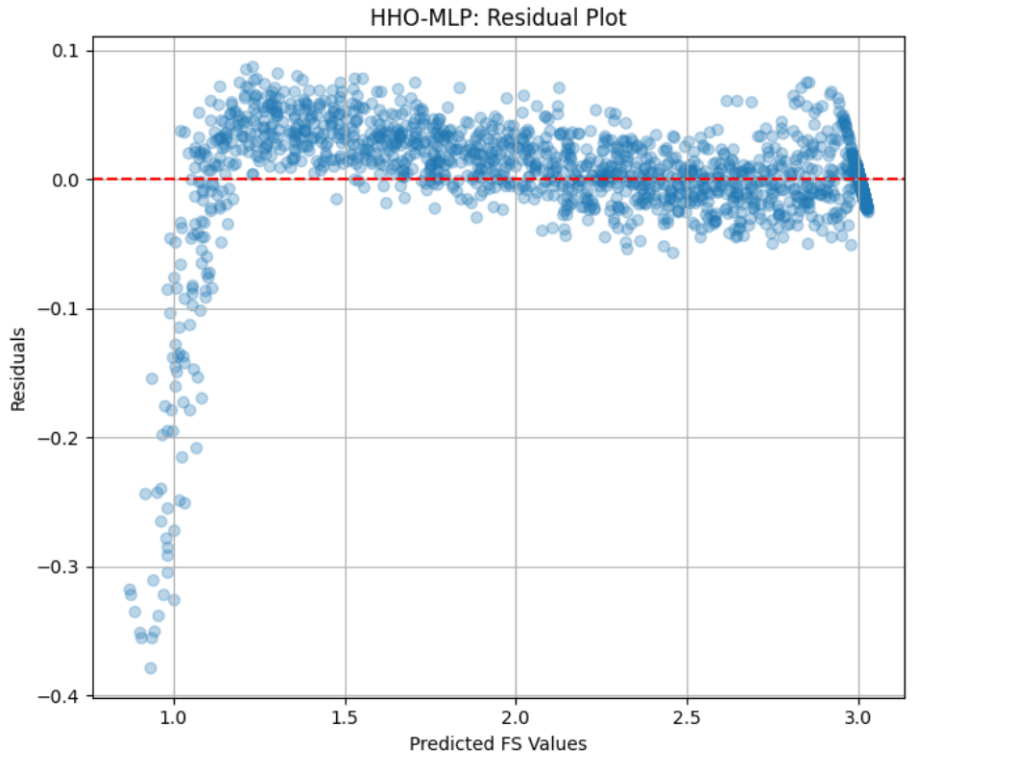

- SSP-BPNN:
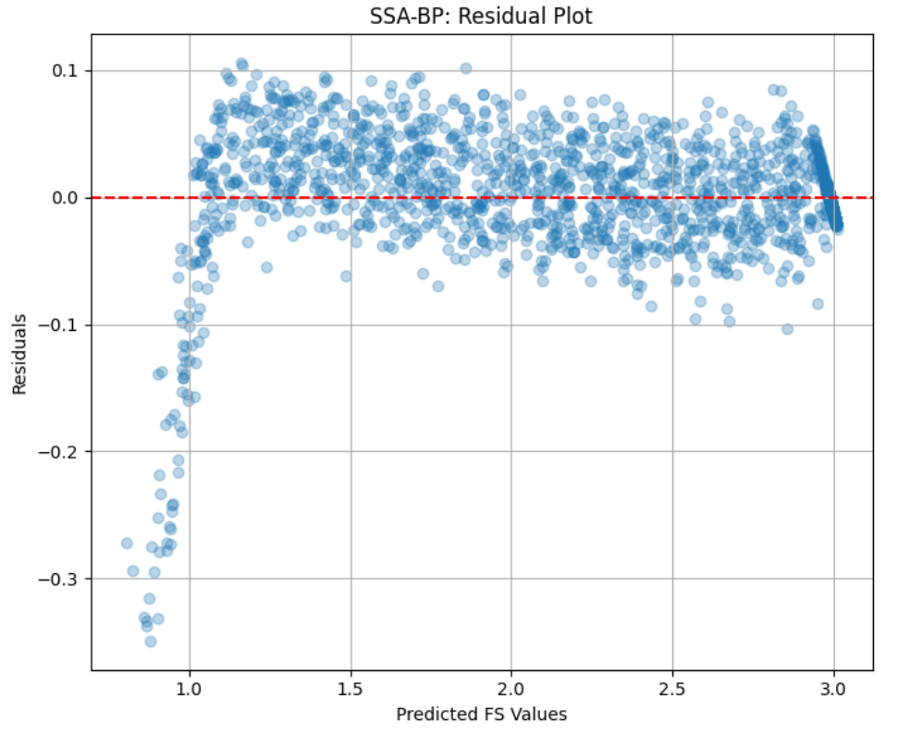

Results And Discussion :
All four hybrid metaheuristic models exhibited outstanding predictive performance for the FS parameter. Each model surpassed the target threshold of 85% accuracy, with R² values well above 99%, demonstrating the robustness of the hybrid optimization strategies. Among the developed models, the Teaching Learning-Based Optimization with Artificial Neural Network (TLBO-ANN) achieved the highest R² score of 0.9971, reflecting exceptional prediction accuracy and model stability across the 10,000-sample dataset.
The SHO-ANN, HHO-MLP, and SSA-BPNN models also produced high R² values (above 0.99), indicating strong learning and generalization capabilities. Residual plots for all models revealed tight clustering of errors around zero, confirming minimal systematic bias. Furthermore, the predicted FS distributions were smooth, symmetric, and closely aligned with the actual FS values, signifying consistent and reliable model behaviour.
Overall, the TLBO-ANN model outperformed the others, delivering superior accuracy, rapid convergence, and smooth error distribution — making it the most efficient and stable model for FS prediction in this study.

