Sean Myers
Project 3- VM Simulator
Results:
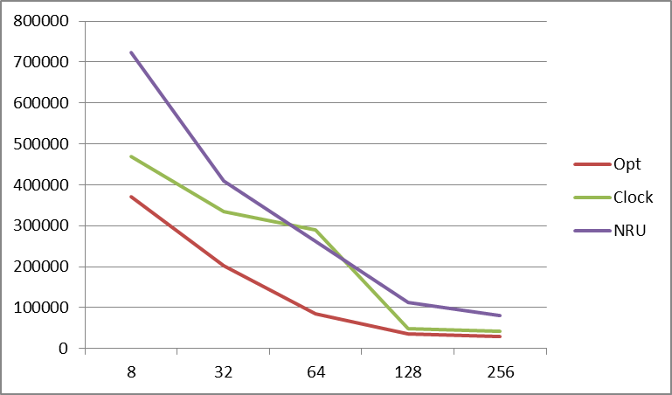
Graph of results;
Page # | 8 | 32 | 64 | 128 | 256
Opt | 371156 | 201629 | 84752 | 36860 | 30060
Clock | 470268 | 334886 | 290773 | 48071 | 42349
NRU | 723786 | 410362 | 261929 | 112417 | 81425

Based on these results, I would have to conclusively say that the best algorithm out of the ones that were tested (excluding the Opt algorithm) is the Clock algorithm. In nearly all cases, it outperformed the NRU algorithm by a large margin. Even though it does take some memory to keep a circular queue data structure, the speed up on, say the 256 frame tests, is nearly a 2x speed performance boost from NRU.
Instructions for the VM Page Replacement program:
java vmsim -n <numframes> -a <opt|nru|clock> <tracefile>
e.g. java vmsim –n 8 –a opt bzip.trace
Files included:
Vmsim- the actual simulator(just creates the necessary objects), handles some simple conditions for mistakes.
Each algorithm- Each one has a class associated with it. I supposed I could have had a bunch of if’s and one class for all algorithms, but this felt a lot more organized to me.
Page/PageOp- Page is the object representing each individual instruction. They are the main objects being passed around in each algorithm implementation. PageOp is extended to handle the position needed to be known for the Opt algorithm to work.

