Solution Architecture Document
AgentCert – AI Agent Chaos Engineering & Certification Platform
Version: 0.9 (Draft)
Prepared by: Microsoft
Confidentiality: Microsoft & Partner Confidential

Revision History
Date | Version | Description
12‑04‑2026 | 0.1 | Initial Draft
13‑04‑2026 | 0.9 | Detailed Architecture & Data Flow
14‑04‑2026 | 1.0 | Updated to reflect current AgentCert repo architecture, Azure deployment model, and observability flows
14‑04‑2026 | 1.1 | Expanded with detailed Azure deployment topology, namespace mapping, and operational guidance
14‑04‑2026 | 1.2 | Added certification context, cognitive-chaos methodology, metric framework, and mitigation guidance from the demo presentation

Contents
Table of Contents 1
1. Introduction 3
2. Scope 3
2.1 In Scope 3
2.2 Out of Scope 3
3. Business Context 4
3.1 Business Objectives 4
4. Technology Stack 4
Languages & Runtime 4
Platform & Infrastructure 4
Core Components 4
Observability & Monitoring 4
5. Solution Overview 4
6. Solution Architecture 4
6.1 Architectural Principles 4
6.2 High‑Level Architecture (Logical) 4
6.3 Access Layer 5
6.4 Control Plane 5
6.5 Execution Plane 5
6.6 Observer Plane 6
6.7 Benchmarking Layer 6
6.8 Data Plane 7
7. Process Flow 7
7.1 High‑Level Flow 7
8. Data Design 8
8.1 Logical Data Categories 8
8.2 Key Design Choices 8
9. Key Design Decisions 8
10. Non‑Functional Considerations 8
11. Security & Governance 9
12. Assumptions & Constraints 9
Assumptions 9
Constraints 9
13. Summary 9

1. Introduction
This document describes the solution architecture for AgentCert, an AI agent benchmarking and certification platform built on LitmusChaos, a Go-based GraphQL control plane, a React web UI, MongoDB-backed registries, Langfuse and OpenTelemetry observability, and Azure OpenAI-backed agent execution paths.
The document serves as the authoritative architectural reference for:
- Customer architects
- Security and governance reviewers
- Platform engineering teams
- Solution delivery teams

2. Scope

2.1 In Scope
- Chaos‑driven experiment of AI agent behaviour.
- Definition and execution of controlled failure experiments.
- External, non‑intrusive observability of agent behaviour.
- Objective scoring and benchmarking of agent outcomes.
- Certification evidence generation and audit trail.

2.2 Out of Scope
- Agent development or training
- Prompt or model fine tuning
- Runtime intervention or overriding agent decisions
- Business workflow orchestration outside certification
- Unsupported custom agent onboarding paths that do not expose the required REST, Helm, or tracing contract are out of scope.

3. Business Context

3.1 Business Objectives
- Provide evidence‑based trust in AI agents before production
- Detect reasoning failures early, not post‑deployment
- Enable objective, repeatable agent comparison
- Support governance, risk, and compliance reviews
- Reduce reliance on anecdotal or manual validation

4. Core Components and Technology Stack

Languages & Runtime
- Go 1.24 for control-plane services and Python 3.12 for agent-side runtimes, sidecars, and automation utilities.
- Go services for GraphQL, auth, and event tracking; Python services for sidecar proxying and agent integrations.
- React 17 and TypeScript for the operator web UI.
Area | Stack | Evidence / Notes
Primary domain | AI agent benchmarking for chaos engineering | Built on LitmusChaos with agent evaluation and observability layers
Core backend | Go 1.24 | GraphQL server and event-tracker use Go modules
Backend web/API | GraphQL, Gin, gqlgen | Go server depends on github.com/99designs/gqlgen and github.com/gin-gonic/gin
Frontend | React 17, TypeScript 4, Webpack 5 | Web app uses React, TS, webpack, Jest, ESLint, Prettier
UI libraries | Harness UI, BlueprintJS, Visx, Highcharts | Frontend package includes @harnessio/*, BlueprintJS, Visx, Highcharts
Data store | MongoDB | Go backend uses Mongo driver; Python side uses pymongo and motor
Kubernetes integration | Kubernetes client-go, kubectl, Helm | Backend Docker image installs Helm and kubectl; Go modules use k8s client libraries
Chaos platform | LitmusChaos, Argo Workflows | README and Go deps reference LitmusChaos and Argo Workflows
Observability | OpenTelemetry, Langfuse | Go backend uses OTEL SDK/exporters; LiteLLM config sends success/failure callbacks to Langfuse
LLM gateway | LiteLLM proxy | litellm-config.yaml routes model calls and traces via Langfuse
LLM provider | Azure OpenAI | LiteLLM config maps models through Azure endpoints
Python agent runtime | Python 3.12 | Used by the sidecar proxy and Python-based agent services; sidecar Dockerfile is based on python:3.12-slim
Python API/services | FastAPI, Uvicorn, aiohttp | Present in requirements.txt
Agent frameworks | Azure AI Agents, MCP, Agent Framework | Python deps include azure-ai-agents, mcp, agent-framework
Azure integrations | Azure Identity, Blob Storage, Search, Functions, Azure Monitor OTEL | Present in Python requirements
Sidecar/proxy | Python proxy sidecar | proxy.py packaged in its own Docker image
Packaging / deployment | Docker, Helm charts, YAML manifests | Multiple Dockerfiles, agent-chart, deployment YAMLs
Dev Runtime | WSL Ubuntu, minikube, Docker driver | Current local workflow uses WSL Ubuntu plus minikube and Docker image loading scripts
Testing / validation | Jest, Testing Library, Python schema smoke scripts | Frontend has Jest; repo has Python and shell validation scripts
Build tooling | Shell scripts, PowerShell scripts, Go tooling, Yarn/Webpack | build-all.sh orchestrates build-and-deploy flows, LiteLLM, install-agent, sidecar, and flash-agent builds

Layer | Azure Service / Prod Choice | What Runs There | Purpose
Edge / DNS | Azure DNS | Public DNS records | Resolves the AgentCert production domain
Edge / Security | Azure Application Gateway with WAF | TLS termination, WAF, L7 routing | Secure public entry point for UI and APIs
Kubernetes ingress | Application Gateway Ingress Controller or NGINX Ingress on AKS | Ingress routing to services | Routes traffic from App Gateway into AKS workloads
Primary compute | Azure Kubernetes Service (AKS) | Core platform workloads | Main production runtime for AgentCert
Frontend | AKS Deployment | AgentCert Web UI, React/TypeScript bundle | Serves the operator-facing web app
API layer | AKS Deployment | GraphQL server, Go + gqlgen + Gin | Central API, orchestration, agent control, trace bridge
Authentication | AKS Deployment | Auth service, Go REST/gRPC | Login, JWT issuance, user auth flows
Event processing | AKS Deployment | subscriber, event-tracker, and supporting infra services | Watches infra events, feeds experiment state, and supports execution-plane coordination
Chaos orchestration | AKS Deployments / controllers | LitmusChaos, Argo Workflows, chaos-operator, workflow-controller, chaos-exporter | Runs experiments and benchmark workflows
Agent runtime | AKS Deployments via Helm | Flash agent, install agent, custom agents | Executes remediation and evaluation logic
Agent proxy | AKS sidecar container | Python sidecar proxy | Injects stable LLM trace metadata and agent context
LLM gateway | AKS Deployment | LiteLLM proxy | Centralizes model access, retries, auth abstraction, Langfuse callbacks
LLM provider | Azure OpenAI | GPT and embedding deployments | Production inference for agents and evaluation paths
Primary database | Azure Cosmos DB for MongoDB API or MongoDB on Azure VM | AgentCert application data | Stores users, runs, experiment metadata, config
Container registry | Azure Container Registry | All platform images | Stores backend, frontend, sidecar, LiteLLM, and agent images
Secrets | Azure Key Vault | API keys, DB creds, JWT secret, Langfuse keys | Central secret management for production
Observability | Azure Monitor + Log Analytics | Metrics, logs, dashboards, alerts | Infra and app monitoring for AKS workloads
Tracing / LLM observability | Langfuse on AKS or managed external deployment | LLM traces, scores, evaluations | End-to-end agent and LLM observability with OTEL-linked Langfuse traces
Artifact / workflow storage | Azure Storage Account / Blob | Workflow artifacts, exports, backups | Durable storage for generated outputs and archives
CI/CD | GitHub Actions or Azure DevOps + ACR + AKS deploy | Build, push, release automation | Builds images and promotes deployments
Optional identity | Microsoft Entra ID | SSO for operators and service identities | Enterprise auth for UI/admin access
Optional private networking | VNet, Private Endpoints, NSGs | Private service access | Locks down DB, Key Vault, and Azure OpenAI traffic

Platform & Infrastructure
- AKS for production deployments and WSL + minikube + Docker driver for local development.
- Container-based deployment with Helm charts, Kubernetes YAML manifests, and script-driven environment synchronization.

Core Components
- GraphQL API and Go control-plane handlers.
- LitmusChaos, Argo Workflows, chaos-operator, subscriber, event-tracker, workflow-controller, and chaos-exporter.
- OpenTelemetry, Langfuse, LiteLLM callbacks, and OTEL-to-Langfuse trace stitching.
- Custom benchmarking and verdict flows for TTD, TTR, remediation success, and trace-linked scoring.
- MongoDB for platform state and Langfuse for LLM traces, observations, and scores.

Observability & Monitoring
- OpenTelemetry spans and Langfuse traces.
- Platform dashboards across GraphQL, agents, chaos infrastructure, and evaluation results.

5. Solution Overview
AgentCert is an agent-neutral benchmarking platform that validates how onboarded agents detect failures, reason over cluster state, invoke remediation workflows, and produce traceable evidence under controlled chaos scenarios.
- How an agent detects failures
- How it reasons under uncertainty
- How it recovers or compensates
- Whether its decisions meet defined safety and quality thresholds
The platform separates chaos execution, telemetry capture, and scoring while still using lightweight sidecar and metadata contracts for trace correlation and custom agent onboarding.

6. Solution Architecture
Solution Components + Enhancements
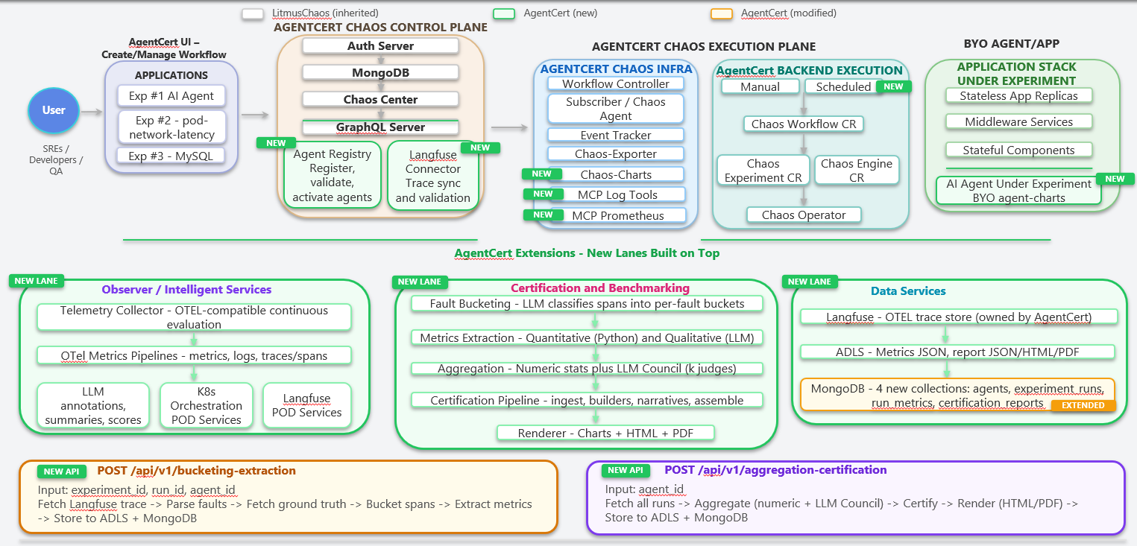
Solution Flow
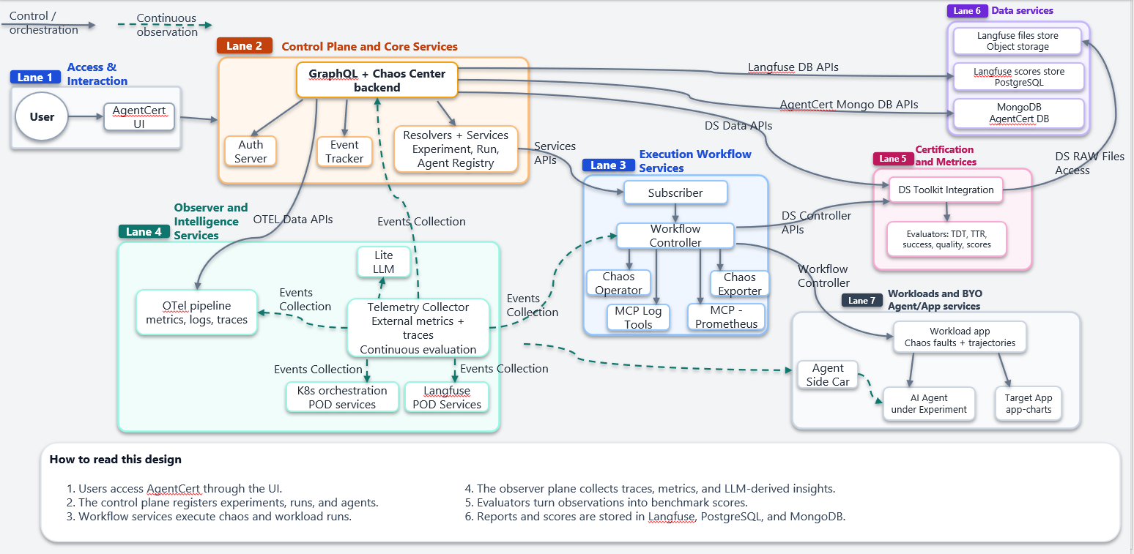

6.1 Architectural Principles
Principle | Description
Separation of Concerns | Control, execution, observability, evaluation isolated
Agent Neutrality | Supports custom agents through REST, Helm, and env-based onboarding without coupling the platform to one model vendor
Deterministic Execution | Chaos policies are repeatable
External Observation | Primary telemetry is external; optional sidecar and metadata integration is used only for trace correlation
Auditability | Every run is traceable

6.2 High‑Level Architecture (Logical)
Layers:
- Access Layer
- Control Plane
- Execution Plane
- Observer Plane
- Benchmarking Layer
- Data Plane
- Customer Workloads
The logical architecture is layered around an access layer (UI and ingress), a Go control plane (GraphQL and auth), a Litmus execution plane, an observer plane (Langfuse, OTEL, LiteLLM, sidecar, MCP integrations), a benchmarking layer, and a MongoDB/Langfuse data plane.

6.3 Access Layer
Responsibilities:
- Accept experiment, agent, and target application definitions from the UI and APIs.
- Support operator-driven workflows plus scripted onboarding, builds, and local deployment automation.
Interfaces:
- React web UI served through ingress and optionally Azure Application Gateway in production.
- Shell and PowerShell automation, Helm-based onboarding, and CI/CD-driven deployment entrypoints.

6.4 Control Plane
Responsibilities:
- Validate experiment requests, registry metadata, and environment configuration.
- Enforce authentication, RBAC, namespace scoping, and deployment-time configuration policy.
- Orchestrate downstream Litmus workflows, Helm deployments, and trace-linked scoring flows.
Key Components:
- GraphQL API
- Authentication service, JWT issuance, and cluster RBAC bootstrapping.
- Experiment and app registries stored in MongoDB.
- Agent registry plus Helm-driven install-agent and install-app orchestration.
- Event publisher and integration points into subscriber, event-tracker, and MCP services.
Design Note:
This plane owns intent but never executes chaos directly.

6.5 Execution Plane
Responsibilities:
- Execute repeatable Litmus chaos workflows against Kubernetes workloads and supporting services.
- Apply faults to registered applications and benchmark targets without changing core control-plane logic.
Key Components:
- Argo workflow-controller.
- Litmus chaos-operator and related CRDs/controllers.
- Chaos exporter, subscriber, and event-tracker services.
Characteristics:
- Runs primarily in litmus-chaos and litmus-exp namespaces with RBAC isolation.
- Targets application and cluster behaviour; agents integrate via APIs, Helm onboarding, and sidecar metadata rather than intrusive runtime patching.
- Driven by manifests, registries, workflow policies, and environment-configured images.

6.6 Observer Plane
Responsibilities:
- Capture platform, experiment, and LLM telemetry with correlated run keys and trace IDs.
Collected Signals:
- Traces
- Kubernetes logs, workflow logs, and agent/runtime logs.
- Kubernetes metrics, Prometheus targets, and evaluation timing metrics.
Key Components:
- Langfuse clients, OTEL exporters, and GraphQL observability handlers.
- Kubernetes and Prometheus MCP services plus agent tool integrations.
- OTEL pipelines bridged with Langfuse REST traces and LiteLLM callbacks.

6.7 Benchmarking Layer
Responsibilities:
- Convert telemetry into objective run scores, verdicts, and audit evidence.
Typical Metrics:
Metric | Description
TTD | Time to Detect the injected or observed fault
TTR | Time to Recover or remediate after detection
Success Rate | Benchmark goal completion and remediation success
Quality Score | Decision quality, trace quality, and verdict correctness
Important:
Scoring logic is implemented in code, not LLM judgment.

6.8 Data Plane
Responsibilities:
- Persist experiment definitions, agent registry data, and run metadata in MongoDB.
- Store scores, verdict context, and LLM trace artifacts across MongoDB and Langfuse.
- Enable replay, trace drill-down, and certification evidence audits.
Stored Artefacts:
- Experiment definitions, manifests, and deployment parameters.
- Run history, verdict history, and agent execution details.
- Trace spans, observations, logs, and metrics slices.
- TTD, TTR, success, and scoring outputs.

7. Process Flow

7.1 High‑Level Flow
Step | Description
1 | Experiment, target application, and agent are defined or selected
2 | GraphQL control plane validates inputs and persists run metadata
3 | Litmus workflows and infra services are triggered
4 | Chaos fault is injected and the agent responds through registered interfaces
5 | OTEL, Langfuse, logs, and metrics are captured with run correlation
6 | Custom evaluators compute TTD, TTR, success, and verdict context
7 | Results, traces, and audit evidence are persisted and shown in the UI
End-to-end flow: operator defines a benchmark, GraphQL persists and validates it, Litmus workflows and infra services execute the fault, the agent responds through registered interfaces and LiteLLM/Azure OpenAI paths, OTEL/Langfuse capture telemetry, and results are stored for audit and display.

8. Data Design

8.1 Logical Data Categories
Category | Purpose
Experiment Metadata | Definition & configuration
Execution Logs | Chaos execution trace
Telemetry | Traces, metrics, logs
Evaluation Results | Scores & verdicts
Audit Records | Governance evidence

8.2 Key Design Choices
- Append‑only execution history
- Immutable evaluation records
- Separation of raw telemetry and derived scores

9. Key Design Decisions
Decision | Rationale
External observability | Prevent agent bias
Two‑phase evaluation | Detection vs recovery clarity
Chaos isolated from judgement | Keeps benchmark execution repeatable and scoring independently auditable
Deterministic scoring | Auditability
Minimal agent-side integration | Allows trace stitching and onboarding without rewriting core agent remediation logic

10. Non‑Functional Considerations
Concern | Approach
Scalability | Parallel executions
Reliability | Controller retries, rollout validation, namespace bootstrapping, and recoverable script automation
Performance | Minimal workload impact
Observability | OTEL, Langfuse, Kubernetes logs, and Azure Monitor in production
Cost | Controlled chaos scope

11. Security & Governance
- Central authentication, JWT-based access, and Kubernetes RBAC bootstrapping for litmus-chaos and litmus-exp.
- Role-based experiment access with namespace-scoped execution identities and service accounts.
- Run outcomes and score records are treated as append-only evidence for certification review.
- Full lineage from experiment → score → verdict
- No deep access to proprietary agent internals is required; optional sidecar and metadata integration is used for trace correlation only.

12. Assumptions & Constraints

Assumptions
- Agents expose observable behaviour through APIs, traces, or supported onboarding contracts.
- Target systems permit chaos safely
- Langfuse and OTEL paths are available or can be enabled for scoring-quality visibility.

Constraints
- Core agent remediation logic is not rewritten by the platform, though deployment-time sidecars, env vars, or metadata contracts may be used.
- Chaos limited to defined policies
- Certification is evidence‑based only

13. Summary
AgentCert provides a structured, auditable, and scalable architecture for benchmarking AI agents under chaos conditions. By combining a Go control plane, Litmus execution services, Langfuse and OTEL observability, LiteLLM and Azure OpenAI integrations, and MongoDB-backed run state, the platform moves teams from trust-by-assumption to trust-by-evidence.

Appendix A. Detailed Azure Deployment Diagram
The following deployment view expands the high-level production topology and shows the primary north-south traffic path, the workload split across namespaces, and the external services used for model access, secrets, image delivery, and observability.
Enterprise Users / Operators / CI-CD Pipelines
|
Azure DNS
|
Azure Application Gateway + WAF
|
AGIC or NGINX Ingress Controller on AKS
|
AKS Cluster
|-- Namespace: litmus-chaos
| |-- litmusportal-frontend
| |-- litmusportal-auth-server
| `-- litmusportal-server (GraphQL / control plane)
|
|-- Namespace: litmus-exp
| |-- subscriber
| |-- event-tracker
| |-- workflow-controller
| |-- chaos-operator
| |-- chaos-exporter
| |-- kubernetes-mcp-server
| `-- prometheus-mcp-server
|
`-- Agent / benchmark namespaces
|-- flash-agent deployments
|-- install-agent and install-app workloads
|-- target applications under test
`-- agent-sidecar proxy containers where enabled
AKS integrations
|-- Azure Container Registry for images
|-- Azure Key Vault for secrets and certificates
|-- Azure OpenAI accessed through LiteLLM and agent runtimes
|-- MongoDB or Azure Cosmos DB for MongoDB for platform state
|-- Langfuse for LLM traces and evaluation observations
|-- Azure Monitor / Log Analytics for platform telemetry
`-- Azure Storage for exported artifacts, reports, and backups
- North-south traffic enters through Azure DNS and Application Gateway, while east-west traffic remains inside the AKS virtual network and namespace boundaries.
- The Go control plane in litmus-chaos owns operator APIs, auth, experiment registration, app and agent registry data, and coordination with Litmus execution services.
- Litmus execution services remain isolated in litmus-exp so that fault injection, workflow execution, and execution-plane eventing do not share the same blast radius as the user-facing API tier.
- Agent workloads can be deployed in dedicated namespaces, which allows per-team network policies, service accounts, quota boundaries, and cleanup automation.
- Observability data fans out to OTEL, Langfuse, Azure Monitor, and Kubernetes-native logs so that every benchmark run can be reconstructed during review.

Appendix B. Namespace and Workload Mapping
The platform relies on a stable namespace split so that control-plane changes, experiment-plane operations, and agent-specific workloads can be versioned and scaled independently.
Namespace / Scope | Primary Workloads | Purpose | Operational Notes
litmus-chaos | Frontend, auth server, GraphQL server | User-facing access layer and control-plane coordination | Scale horizontally behind ingress; back with MongoDB connectivity, TLS termination, and RBAC-aware service accounts
litmus-exp | subscriber, event-tracker, workflow-controller, chaos-operator, chaos-exporter | Experiment execution, workflow orchestration, and event propagation | Treat as execution plane; watch controller health, workflow backlog, and CRD availability
agent namespaces | flash-agent, install-agent, install-app targets, sidecars | Host benchmarked agents and application workloads under test | Use namespace-per-team or namespace-per-benchmark patterns for cleanup and quota control
monitoring | Prometheus, exporters, optional dashboards | Metrics collection and MCP-backed tool access | Expose only internal endpoints; retain metrics long enough to investigate failed benchmark runs
platform integrations | LiteLLM, Langfuse, storage, secrets providers | External dependencies for model access, traces, and persistent evidence | Prefer private endpoints, managed identity, and secret rotation through Key Vault

Appendix C. Detailed Deployment and Runtime Flow
- Build and packaging: images for the control plane, sidecar, install-agent, flash-agent, and LiteLLM are built from the repository scripts and pushed to Azure Container Registry or loaded into local minikube during development.
- Configuration and secrets: Helm values, Kubernetes manifests, and runtime environment variables define image tags, registry URLs, Langfuse endpoints, Azure OpenAI credentials, MongoDB connectivity, and sidecar metadata such as agent name and agent role.
- Cluster bootstrap: namespaces, RBAC, service accounts, CRDs, and Litmus controllers must be present before rollout logic can safely restart or patch workloads, which is why the deployment scripts now include namespace and first-install guards.
- Application rollout: the frontend, auth server, and GraphQL server are deployed first so the control plane becomes available before experiment services, MCP services, or benchmark agents begin registering themselves.
- Execution flow: once an experiment is created, GraphQL persists the request, Litmus workflows execute the fault, the target agent reacts through its supported interfaces, and the result is evaluated against time-to-detect, time-to-recover, and remediation-success signals.
- Observability flow: OTEL spans, Langfuse traces, LiteLLM callbacks, Kubernetes logs, and event-tracker updates share run identifiers so investigators can correlate one benchmark from UI request to final verdict.
- Evidence retention: MongoDB stores platform state and benchmark metadata, while Langfuse and optional storage exports preserve detailed trace evidence for certification review and replay.

Appendix D. Security and Operations Notes
- Place Application Gateway, AKS node pools, MongoDB endpoints, and observability backends inside approved VNets and private endpoint boundaries for production deployments.
- Use Key Vault-backed secret injection or sealed-secret patterns instead of embedding credentials in manifests or script files.
- Separate node pools for control-plane pods, execution-plane pods, and heavier benchmark workloads when agent or chaos runs have materially different CPU and memory profiles.
- Monitor controller health, ReplicaSet creation, rollout progress, and namespace-level quotas because deployment failures can originate from cluster control-plane issues rather than only from manifest errors.
- Retain backup and restore procedures for MongoDB state, Langfuse data, Helm values, and generated benchmark evidence so production certification records remain recoverable.
- Document supported onboarding contracts for third-party agents, including REST endpoints, Helm packaging expectations, required env vars, and optional sidecar tracing fields, so platform assumptions remain explicit.

Appendix E. Enterprise Trust Gap and Certification Context
The demo presentation adds important context beyond infrastructure design: enterprises do not only need a deployment topology for AgentCert, they need a repeatable answer to the trust gap created by autonomous AI agent behaviour in production.
- AI agents make autonomous decisions in production, yet those decisions are non-deterministic and difficult to reproduce after the fact.
- Organizations already certify people, software, and infrastructure, but they typically do not certify AI agents before those agents touch customers, SLAs, or regulated processes.
- AgentCert addresses this gap by replacing anecdotal trust with evidence-backed benchmark outcomes, certification scorecards, and repeatable audit trails.
- The platform goal is not only fault execution; it is pre-production confidence building for agent behaviour, tool selection, remediation quality, and safety posture.

Appendix F. Cognitive Chaos Benchmarking Model
The demo deck distinguishes traditional chaos engineering from AgentCert's cognitive-chaos model. This distinction should remain explicit in the architecture narrative because it explains why the platform includes evaluation, ground truth, and trace-linked certification outputs instead of fault injection alone.
Dimension | Traditional Chaos Engineering | AgentCert Cognitive Chaos
Primary subject | System components such as pods, networks, or infrastructure | Agent reasoning, decision quality, tool use, and remediation behaviour
Core question | Did the system survive the fault? | Did the agent detect, interpret, and respond correctly under the fault?
Loop structure | Open-loop fault injection and observation | Closed-loop benchmark flow with adaptive evaluation and post-run scoring
Output | Resilience signal for the target environment | Certification evidence, scorecards, risk profile, and weakness analysis

Appendix G. Fault Families and Evaluation Metrics
The demo deck also broadens the evaluation model. AgentCert is not limited to a single resiliency score; it measures agent behaviour across multiple fault families and metric categories that should be reflected in the formal architecture document.
- Fault families include network, compute, application, database, and security disruptions, implemented through LitmusChaos experiments and workflow orchestration.
- Detection and resolution metrics include TTD, TTM or MTTR-style remediation timing, false positive or false negative rate, and successful resolution rate.
- Reasoning-quality metrics include root-cause accuracy, explanation quality, decision quality, and consensus-based LLM judge outputs where qualitative review is needed.
- Behavioural metrics include tool-selection accuracy, plan adherence, collateral damage, rollback actions, exploration versus exploitation balance, and confidence signals.
- Security and efficiency metrics include PII handling, content-safety posture, authentication correctness, token usage, API call volume, and execution cost.
Metric Family | Representative Measures | Why It Matters
Detection and recovery | TTD, TTR, detection accuracy, remediation success | Confirms whether the agent can identify and recover from injected faults within acceptable windows
Reasoning quality | Root-cause accuracy, reasoning quality score, explanation clarity | Assesses whether the agent reached the right conclusion for the right reason
Action quality | Tool-selection accuracy, argument accuracy, plan adherence, collateral damage | Measures execution correctness and the cost of wrong actions
Security and governance | PII redaction, malicious prompt handling, auth correctness | Ensures the agent behaves safely under stress and adversarial conditions
Efficiency | Token usage, API call count, latency, model cost | Quantifies the operational footprint of the benchmarked agent

Appendix H. Evaluation Method and Challenge Mitigations
- Faults are expected to run repeatedly, often around thirty executions per scenario, so certification outcomes are based on statistical aggregation rather than one-off anecdotes.
- Ground truth should not be exposed to the benchmarked agent; it remains an evaluator-side construct used for comparison against the ideal response trajectory.
- Qualitative review can use an LLM council pattern with multiple independent judges, while all arithmetic and score aggregation should remain deterministic and code-driven.
- Certification outputs should include a scorecard, trust or risk profile, weakness analysis, and full trace linkage in Langfuse for review and replay.
Challenge | Mitigation Strategy
Non-determinism across agent runs | Run each fault multiple times and use statistical aggregation rather than single-pass scoring
Single-judge bias | Use a council of independent models or evaluators for qualitative review
Arithmetic mistakes in qualitative evaluators | Keep all score calculations and aggregation in deterministic code paths
Context-window pressure during long traces | Batch traces and observations into controlled evaluation windows
No standard agent workflow | Benchmark observable outputs and supported interfaces rather than framework-specific internals
Streaming or multi-fault complexity | Sequence faults in a controlled orchestration model and isolate scenarios for reproducibility

Appendix I. Certification Outputs and Adoption Path
- Near-term enterprise value includes evidence-based deployment approvals, version-to-version agent comparisons, and pre-production discovery of reasoning or remediation weaknesses.
- Certification artifacts should enable governance teams to define approval tiers, track risk profiles, and compare agents against shared benchmark scenarios.
- The long-term platform direction can support cross-team agent benchmarking, marketplace-style comparison, and standardized resilience or safe-action scores, provided the benchmark methodology stays auditable and reproducible.

