**EE219 Project 5**

**Popularity Prediction on Twitter**

**Winter 2017**

Xiongfeng Hu, 304753117

Yanming Zhang, 004761717

Cong Peng, 904760493



**Content**

i) Popularity Prediction 3

Problem(1) 3

Problem(2) 4

Problem(3) 5

3.1 Superbowl 5

3.2 NFL 6

Problem(4) 8

4.1 Superbowl 8

4.2 NFL 8

Problem(5) 9

5.1 Superbowl 9

5.2 NFL 9

ii) Fan Base Prediction 10

Problem (6) 10

6.1 Problem statement 10

6.2 Dataset and preprocessing 10

6.3 Modeling Text Data, Feature Extraction and Selection 11

6.4 Building Classifiers Using Different Learning Algorithms 11

SVM 11

Soft Margin SVM 13

Naive Bayes 14

Logistic Regression 16

iii) Define your own Project 19

Problem (7) 19

7.1 Problem statement 19

7.2 Topic1: Find out top words about superbowl before, during and after the event 19

Solution 19

Preprocessing 19

Feature Extraction and results 19

7.3 Topic 2: Use Spark MLlib to implement problem6 20

Solution 20

# i) Popularity Prediction

## Problem(1)

In this problem, we first calculated the following statistics for each hashtag (average number of tweets per hour, average number of followers of users posting the tweets, and average number of retweets). We gave the table below shows the statistics.

***Table 1. Hashtag statistics***

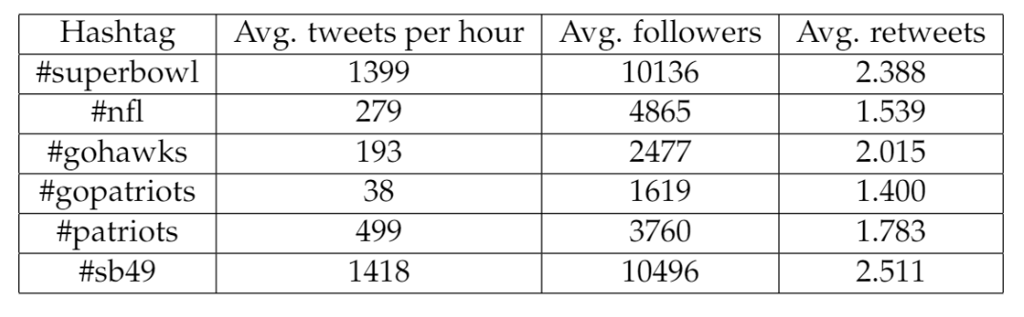

As required, we collected the number of tweets in hour over time for two specific hashtags (#SuperBowl and #NFL) and plot a histogram with 1-hour window.

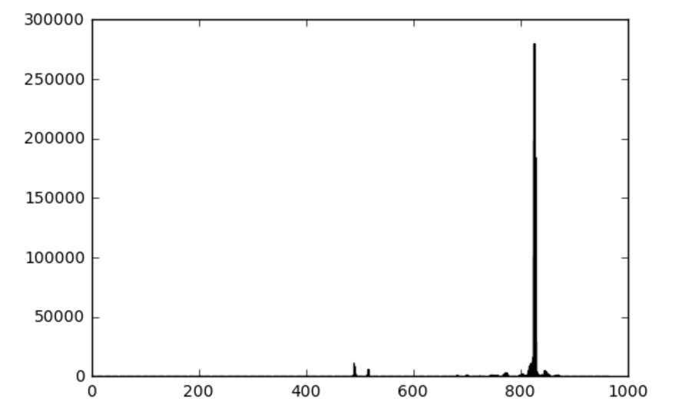

***Figure 1. Number of tweets in hour for #SuperBowl***

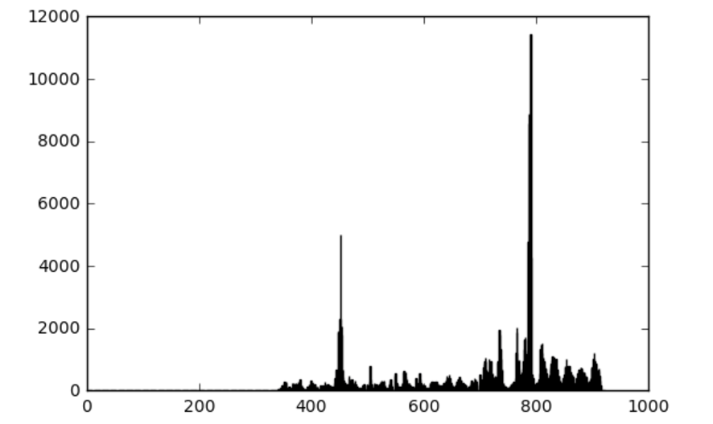

***Figure 2. Number of tweets in hour for #NFL***

## Problem(2)

In this part, we fitted a linear regression model using five features to predict numbers of tweets in the next hour with features extracted from tweet data in the previous hour. The features required are ‘number of tweets’, ‘total number of retweets’, ‘sum of the number of followers of the users posting the hashtag’, ‘maximum number of followers of the users posting the hashtag’ and ‘time of the day’.

Here, we only analyzed the regression model of #superbowl with OLS and showed the result of linear regression model given the training data in file’~/ tweet_data/tweets_#superbowl.txt’.

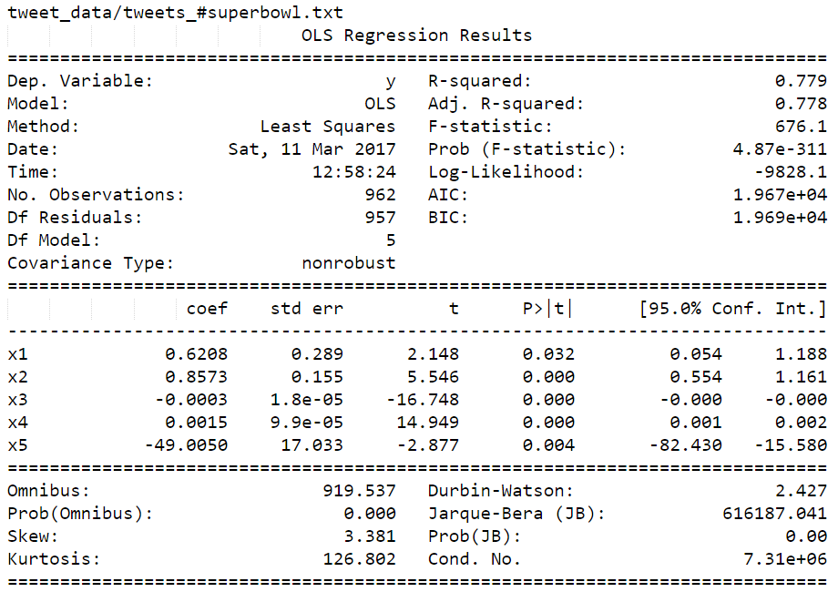

***Figure 3. OLS of #Superbowl***

The model for number of tweets with hashtag #superbowl is:

Note that, x1 denotes the number of tweets, x2 denotes total number of retweets, x3 denotes sum of the number of followers of the users posting the hashtag, x4 denotes maximum number of followers of the users posting the hashtag and x5 denotes time of the day.

Judging by R-squared is 0.779, we can conclude that the regression model given these features doesn’t perform well. Also, t-value is not satisfying as expected.

## Problem(3)

In this part, we introduced three new features, ranking score, user mentions and number of authors, to fit the linear regression model. Ranking score shows the presence of query keywords and recency of one tweet. User mention measures the popularity of tweet, that is to say, the more times people are mentioned, the more popular this tweet is. Number of authors is also an index on popularity. Besides, we deleted the feature maximum number of followers in this part, for the result in part 2 shows that it is rather irrelavent to the prediction of tweet numbers. Figure 5 is the scatter plots for two models, where we choose retweet number, ranking score and user mention as the outstanding features.

### 3.1 Superbowl

Here, the result of linear regression model for #superbowl is shown as below.

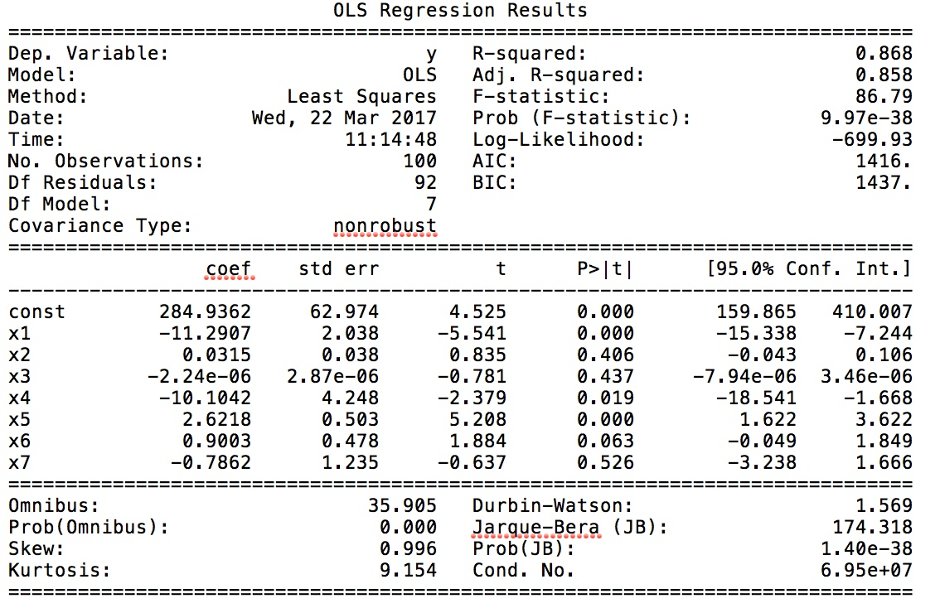

***Figure 4. OLS of #Superbowl***

After fitting the linear regression model for #superbowl, we have a equation as below to predict the tweet number for this hashtag:

y = 285 − 11.3x1 + 0.0315x2 − 2.24 × 10−6x3 − 10.1x4 + 2.62x5 + 0.900x6 − 0.786x7

where x1-x7 represents number of tweets, total number of retweets, sum of number of followers, time of the day, sum of ranking scores, sum of user mentions, number of authors for current hour separately, and y denotes the number of tweets for next hour.

### 3.2 NFL

The model analysis results for #NFL is as below:

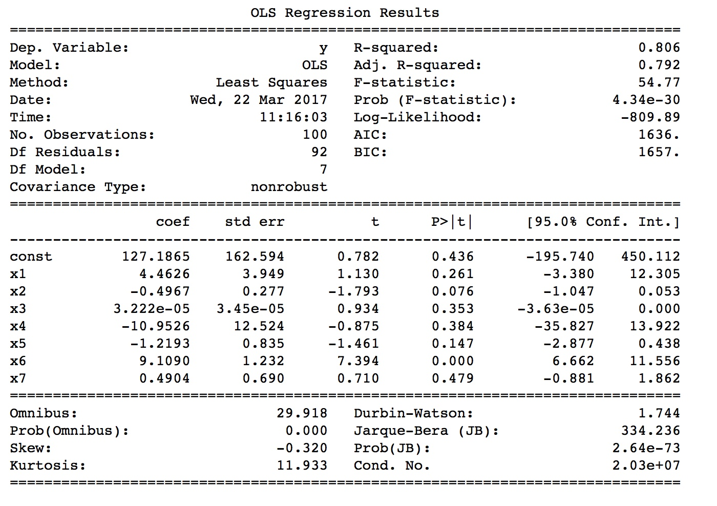

***Figure 5. OLS of #NFL***

Similarly we can derive the prediction equation for #NFL:

y = 127 + 4.46x1 − 0.497x2 + 3.22 × 10−5x3 − 11.0x4 − 1.22x5 + 9.11x6 + 0.490x7

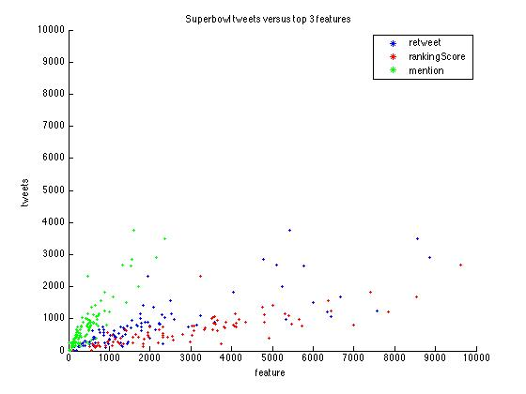

***Figure 6. Scatter plot of #Superbowl***

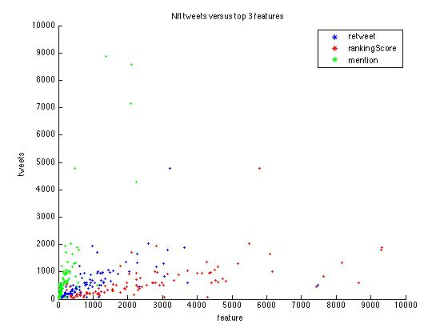

***Figure 7. Scatter plot of #NFL***

As we could see from the figures, each of our three features and the number of tweets are linear related hence our prediction model based on OLS makes sense.

## Problem(4)

For #Superbowl and #NFL, we train regression models for three time periods, each period using cross-fold validation.

1 Before Feb. 1, 8:00 a.m.

2 Between Feb. 1, 8:00 a.m. and 8:00 p.m.

3 After Feb. 1, 8:00 p.m.

### 4.1 Superbowl

The average errors are calculated as:



Total Error : The error in the second period is apparently larger than the others, the reason may be the amount of time in the second period is much less than others, making the prediction more difficult.

For each period, the best model can be expressed as follows:

y = 1.2705 + 0.0735x1 + 0.3280x2 − 1.1359x3

y = 7.5027 × 103 + 6.7699x1 − 0.3633x2 − 43.8255x3

 y = 2.2359 × 102 − 6.4481 × 10−3x1 − 0.1230x2 + 2.4670x3

Here x1 denotes the retweet feature, x2 denotes the rankingScore feature and x3 denotes the mention feature. These features can be used to make better predictions.

### 4.2 NFL

The average errors are calculated as:



Also, the error in the second period is apparently larger than the others due to the relatively shorter time period, making the prediction more difficult.

For each period, the best model can be expressed as follows:



Similarly, x1 denotes the retweet feature, x2 denotes the rankingScore feature and x3 denotes the mention feature. These features can be used to make better predictions.

## Problem(5)

In this part, we use the best model calculated in problem 4 to predict the 10 testing samples, we applied both NFL and Superbowl model to implement our predictions. The predicted numbers of tweets are shown as following:

### 5.1 Superbowl

***Table 2. Predicted numbers of tweets for #Superbowl***

|  |  |  |  |  |  |
| --- | --- | --- | --- | --- | --- |
| Hour | 2 | 3 | 4 | 5 | 6 |
| Sample1 | 3.32 | 3.09 | 3.82 | 39.58 | 53.87 |
| Sample2 | 52199 | 63988 | 52329 | 90861 | 163550 |
| Sample3 | 75.52 | 11.94 | 70.18 | 33.67 | 12.23 |
| Sample4 | 206.16 | 25.45 | 55.09 | 74.01 | 56.64 |
| Sample5 | 51.86 | 116.79 | 5.18 | 16.97 | 8.94 |
| Sample6 | 13151 | 749490 | 4642082 | 3967817 | 2957552 |
| Sample7 | 166.72 | 141.08 | 173.56 | 141.18 | 173.12 |
| Sample8 | 16.30 | 24.17 | 19.78 | 9.48 |  |
| Sample9 | 8074 | 9356 | 8223 | 6998 | 22169 |
| Sample10 | 136.93 | 165.74 | 137.11 | 140.52 | 146.84 |

### 5.2 NFL

***Table 3. Predicted numbers of tweets for #Superbowl***

|  |  |  |  |  |  |
| --- | --- | --- | --- | --- | --- |
| Hour | 2 | 3 | 4 | 5 | 6 |
| Sample1 | 3.32 | 3.09 | 3.82 | 39.58 | 53.87 |
| Sample2 | 52199 | 63988 | 52329 | 90861 | 163550 |
| Sample3 | 75.52 | 11.94 | 70.18 | 33.67 | 12.23 |
| Sample4 | 206.16 | 25.45 | 55.09 | 74.01 | 56.64 |
| Sample5 | 51.86 | 116.79 | 5.18 | 16.97 | 8.94 |
| Sample6 | 13151 | 749490 | 4642082 | 3967817 | 2957552 |
| Sample7 | 166.72 | 141.08 | 173.56 | 141.18 | 173.12 |
| Sample8 | 16.30 | 24.17 | 19.78 | 9.48 |  |
| Sample9 | 8074 | 9356 | 8223 | 6998 | 22169 |
| Sample10 | 136.93 | 165.74 | 137.11 | 140.52 | 146.84 |

# ii) Fan Base Prediction

## Problem (6)

### 6.1 Problem statement

Use different classification algorithm to train a classifier to predict the location of the author of a tweet given only the textual content of the tweet. Specifically, we consider all the tweets including #superbowl, posted by the users whose specified location is either in the state of Washington or Massachusetts. To evaluate our classifiers, we plot the ROC curve, report the confusion matrix and calculate the accuracy, recall and precision of the classifiers.

### 6.2 Dataset and preprocessing

In this problem, we use tweets_#superbowl.txt as the dataset. The size of the dataset is 5.78GB, which is so big that makes it inconvenient for us to manipulate the data. The data set contains many attributes of tweets, but we only care about two of them, which are the title of tweet and the location of the user. Therefore, we decide to first retrieve the necessary data from the original dataset to speed up our program.

We use Spark as our tool to retrieve the required data. Spark is a fast, expressive cluster computing system compatible with Apache Hadoop. It improves efficiency through in-memory computing primitives and general computation graphs, which is up to 100x faster than Hadoop. Spark also improves usability through its Rich APIs in Java, Scala, Python and Interactive shell. What’s more, Spark’s machine learning (ML) library, MLlib, is also powerful, which is aiming to make practical machine learning scalable and easy. Spark-SQL is also convenient for us to retrieve related data from the whole data set. Therefore, Spark is more efficient and easier to manipulate large-scale data.

We load the json-format text file as a table in database and then use SQL statement to select title and location from the table. Then we use regular expression in SQL, REGEXP, to select related locations, which are '.*MA.*' , '.*Mass.*' for Massachusetts State and '.*WA.*' , '.*Wash.*' for Washington State. Because ‘Washington D.C.’ is also a match for pattern '.*Wash.*', we need to further remove ‘Washington D.C.’ from our data. Therefore, we use '.*DC.*' and '.*D\\.C\\..*' to filter our dataset and get the final necessary dataset. The size of the final dataset is only 4.4MB, which is over 1,200 times smaller than the size of original one. In detail, the final dataset contains 17,678 rows of Massachusetts State and 15,188 rows of Washington State, 32,866 rows in total.

With the help of previous step, we can easily load the dataset and map locations to labels within a second.

Note that, there are still some incorrect data, such as “High Street Mall”,

“KARMA”, “Fort Washington, PA”. Also, there are some users in WA state that support team Patriots. These data may affect the performance of our classifiers.

### 6.3 Modeling Text Data, Feature Extraction and Selection

We use Term Frequency-Inverse Document Frequency (TFxIDF) metric to capture the importance of a word to a document in a corpus. We also tokenize the documents and exclude the stop words, punctuations, and different stems of a word. The shapes of training set and test set are

(29579, 100), (3287, 100).

Then we use Latent Semantic Indexing (LSI) to find the optimal representation of the data in a lower dimensional space. We use TruncatedSVD from sklearn’s decomposition package to decompose the vectors with 50 as the number of elements. Therefore, we get the selected features for our learning algorithms.

### 6.4 Building Classifiers Using Different Learning Algorithms

In this part, we use different learning algorithms to build classifiers including SVM, Soft Margin SVM, Naïve Bayes, Logistic Regression with L1 and L2 norm regularizations, and evaluate them with ROC curve, confusion matrix and the accuracy, recall and precision score. The following figures and tables show the details of each classifier.

#### SVM

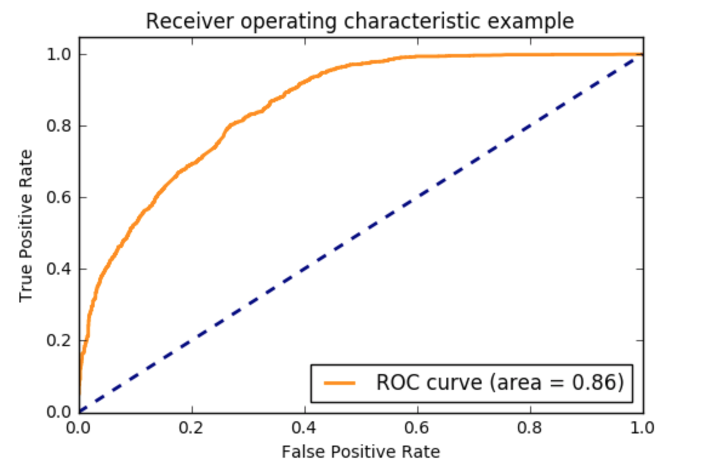

*Figure 8. ROC curve of SVM classifier*

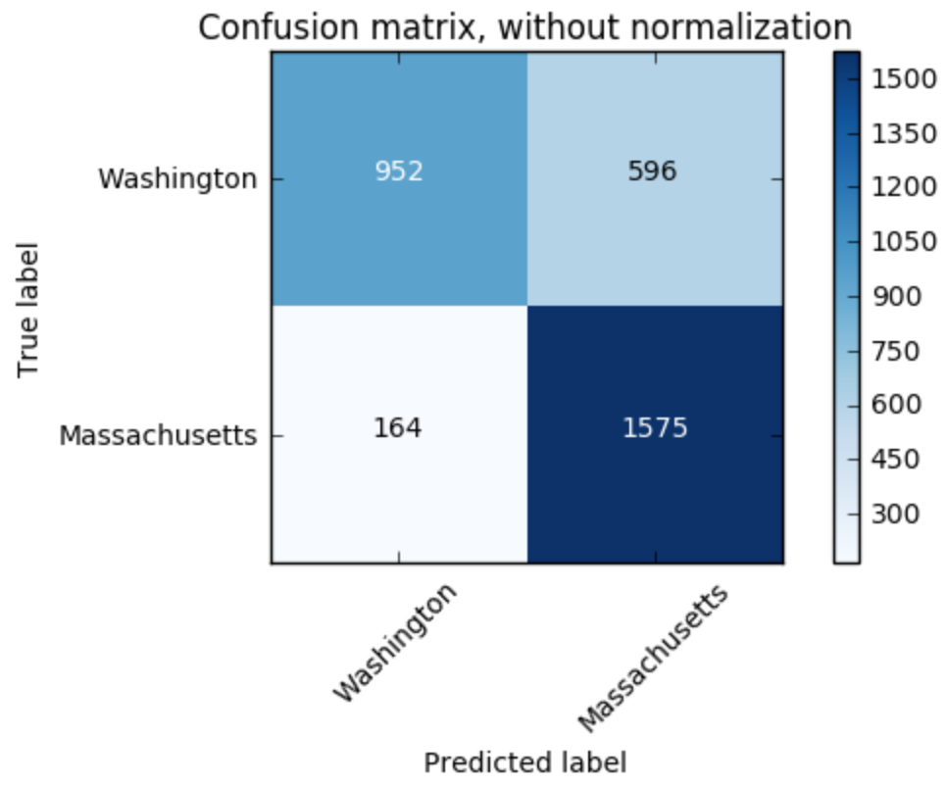

*Figure 9. Confusion Matrix of SVM classifier, without normalization*

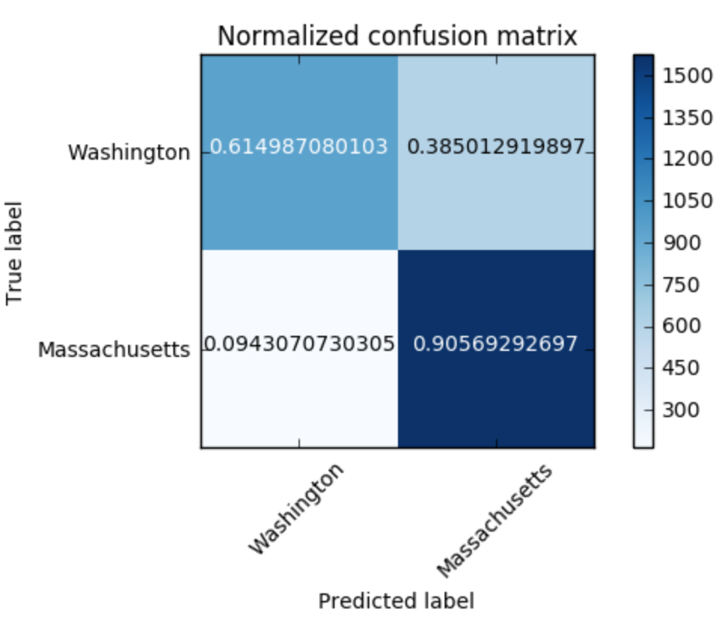

*Figure 10. Confusion Matrix of SVM classifier, with normalization*

*Table 4. Accuracy, Recall and Precision of SVM classifier*

|  |  |  |
| --- | --- | --- |
| Accuracy | Recall | Precision |
| 0.768786127168 | 0.90569292697 | 0.725472132658 |

#### Soft Margin SVM

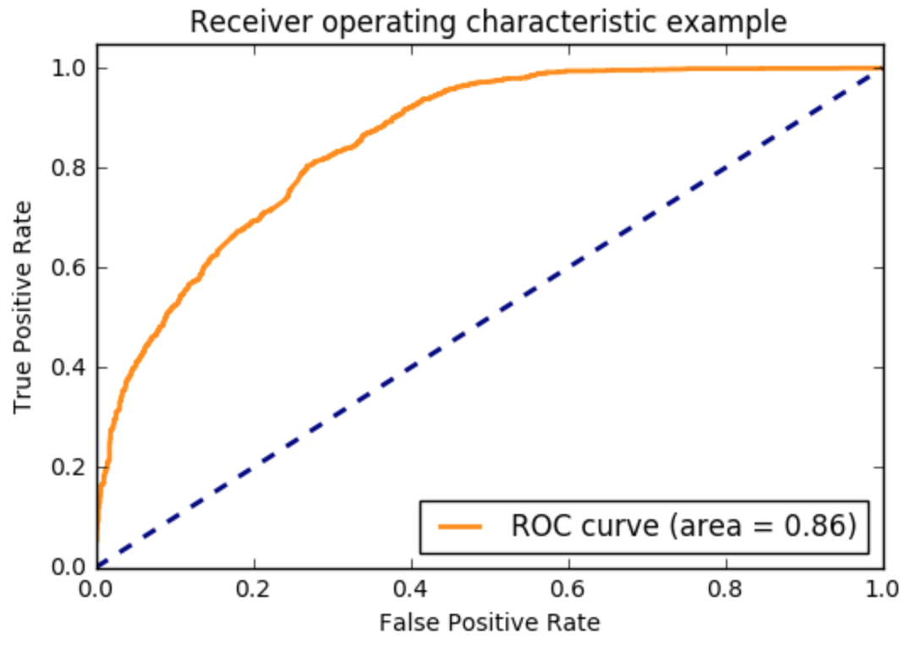

*Figure 11. ROC curve of Soft Margin SVM classifier*

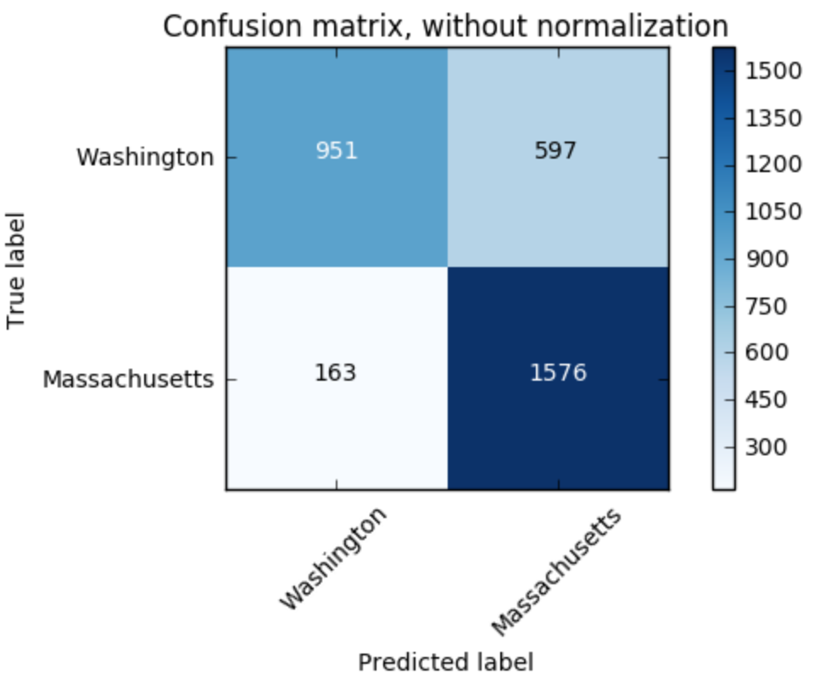

*Figure 12. Confusion Matrix of Soft Margin SVM classifier, without normalization*

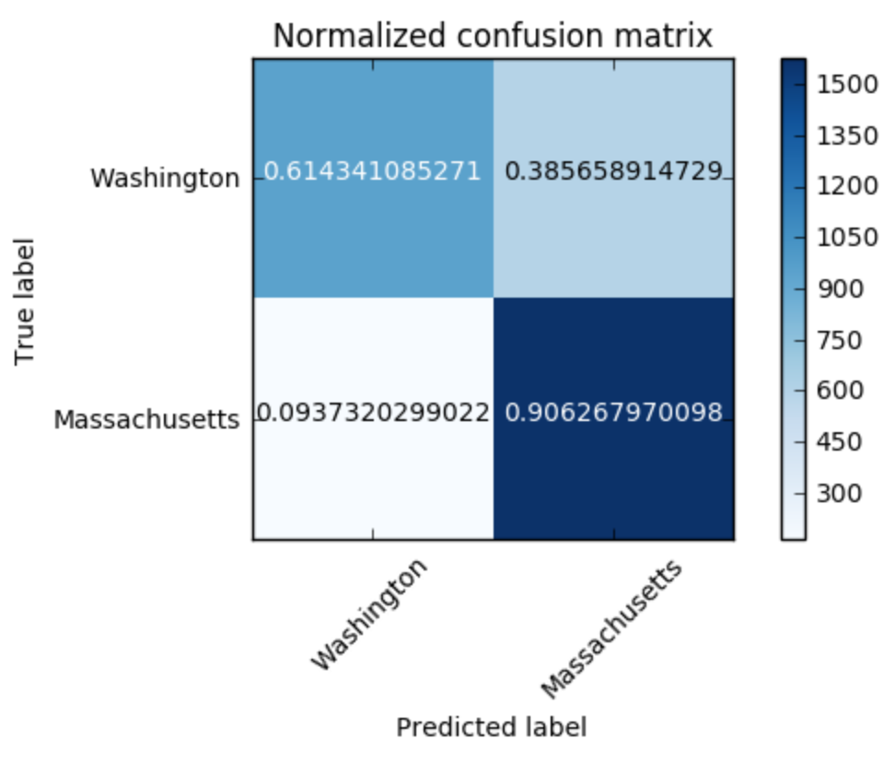

*Figure 13. Confusion Matrix of Soft Margin SVM classifier, with normalization*

*Table 5. Accuracy, Recall and Precision of Soft Margin SVM classifier*

|  |  |  |
| --- | --- | --- |
| Accuracy | Recall | Precision |
| 0.768786127168 | 0.906267970098 | 0.725264611137 |

#### Naive Bayes

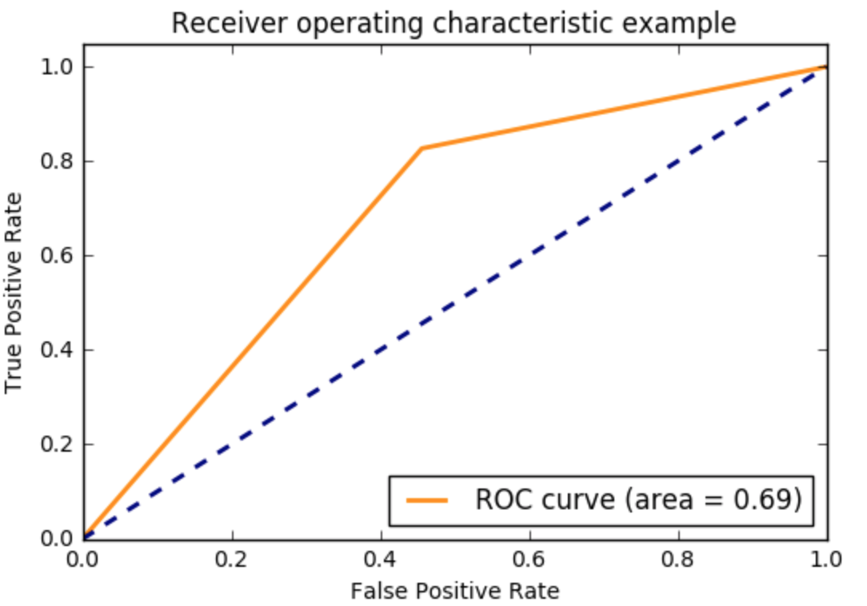

*Figure 14. ROC curve of Naïve Bayes classifier*

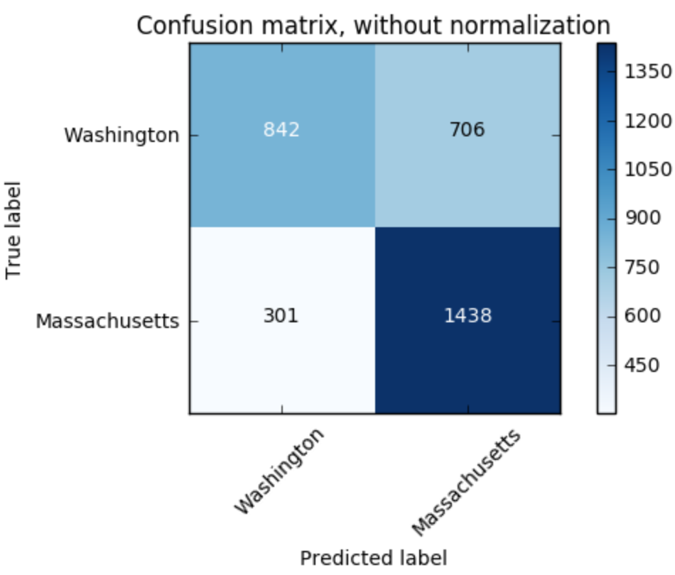

*Figure 15. Confusion Matrix of Naïve Bayes classifier, without normalization*

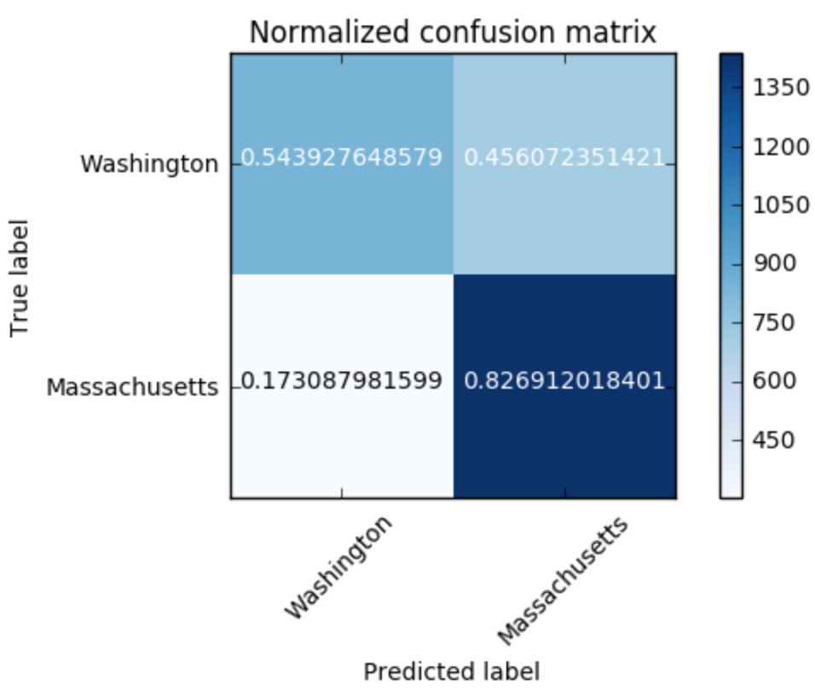

*Figure 16. Confusion Matrix of Naïve Bayes classifier, with normalization*

***Table 6. Accuracy, Recall and Precision of Naive Bayes classifier***

|  |  |  |
| --- | --- | --- |
| Accuracy | Recall | Precision |
| 0.693641618497 | 0.826912018401 | 0.670708955224 |

#### Logistic Regression

L1 Norm Regularization

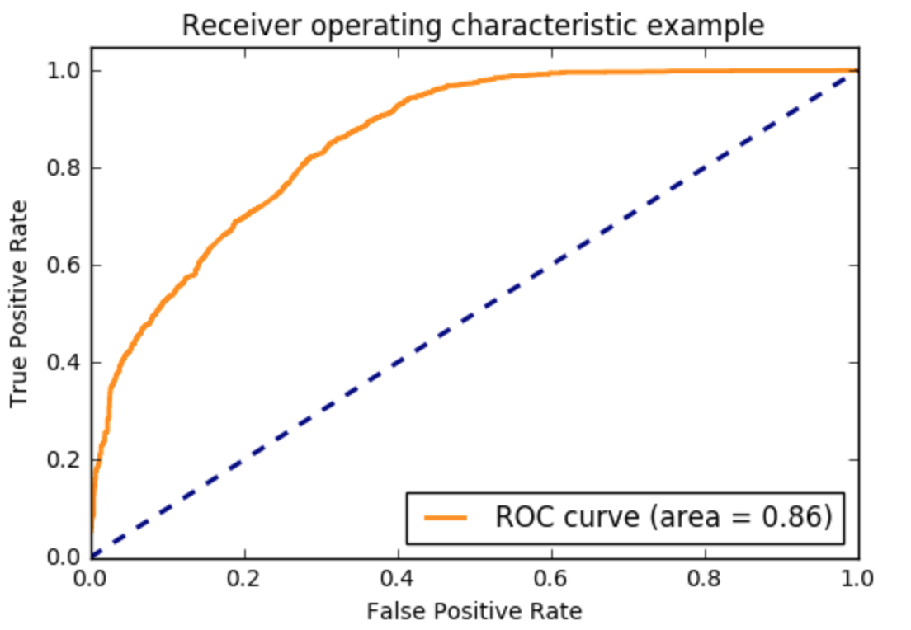

*Figure 17. ROC curve of l-1 norm logistic regression classifier*

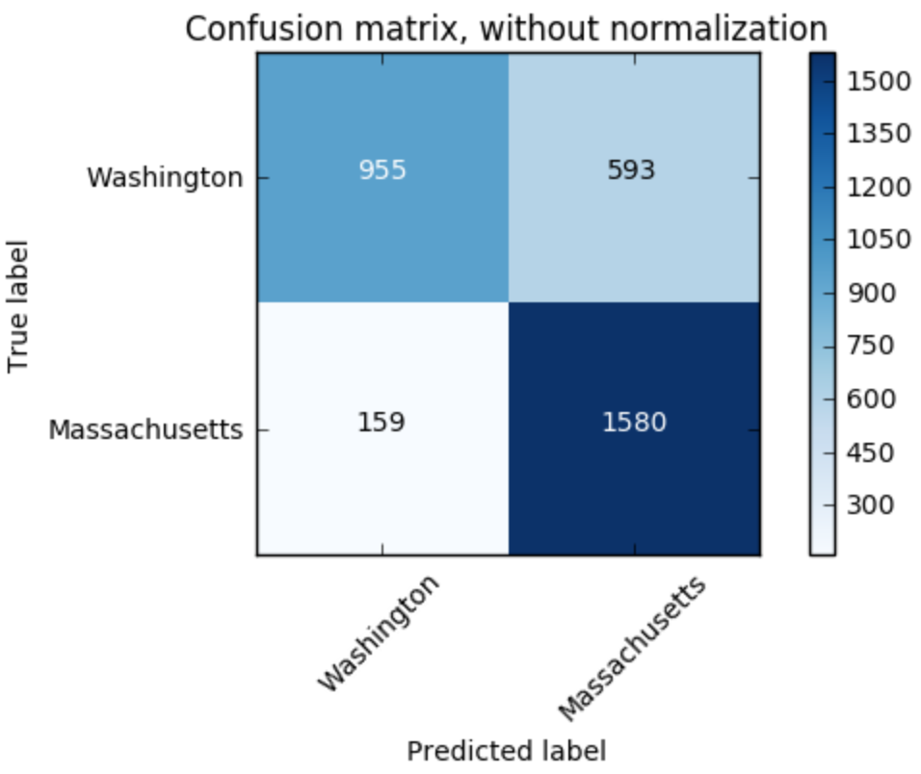  
*Figure 18. Confusion Matrix of l-1 norm logistic regression classifier, without normalization*

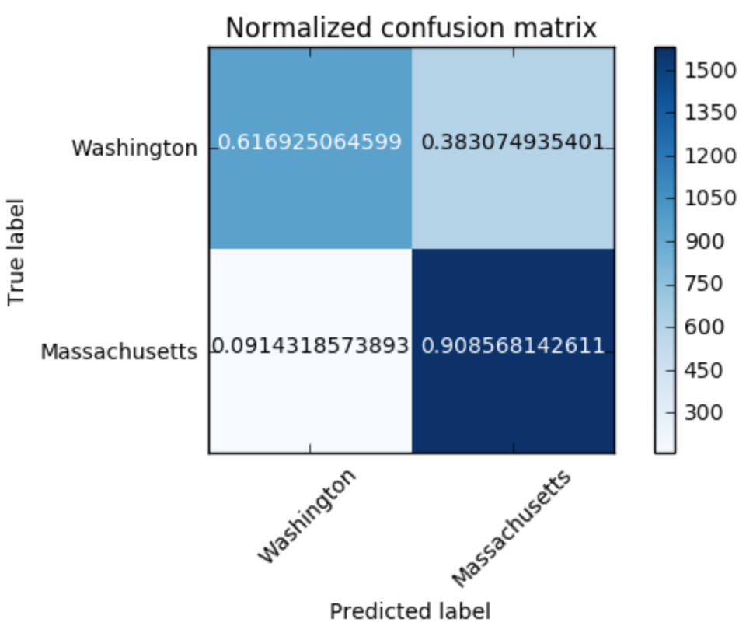

***Figure 19. Confusion Matrix of l-1 norm logistic regression classifier, with normalization***

***Table 7. Accuracy, Recall and Precision of L1 Norm Logistic Regression***

|  |  |  |
| --- | --- | --- |
| Accuracy | Recall | Precision |
| 0.771219957408 | 0.908568142611 | 0.727105384261 |

L2 Norm Regularization

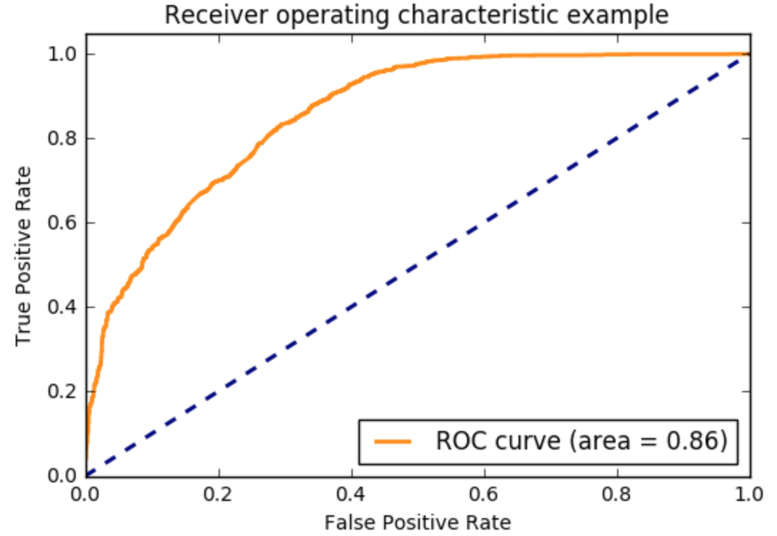

*Figure 20. ROC curve of l-2 norm logistic regression classifier*

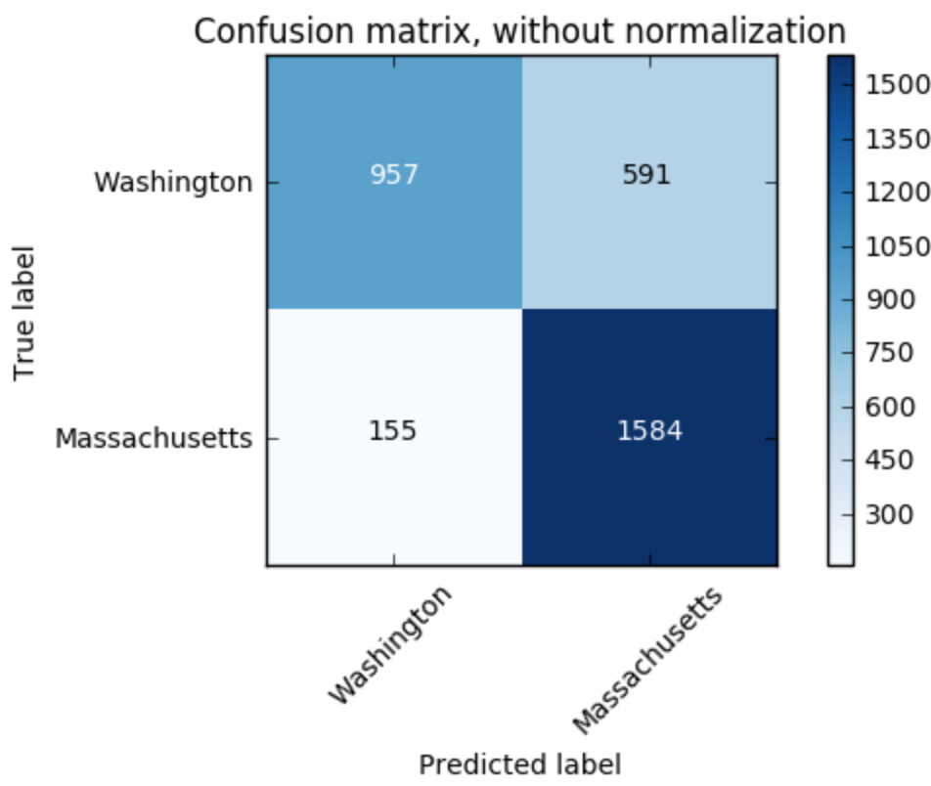

*Figure 21. Confusion Matrix of l-2 norm logistic regression classifier, without normalization*

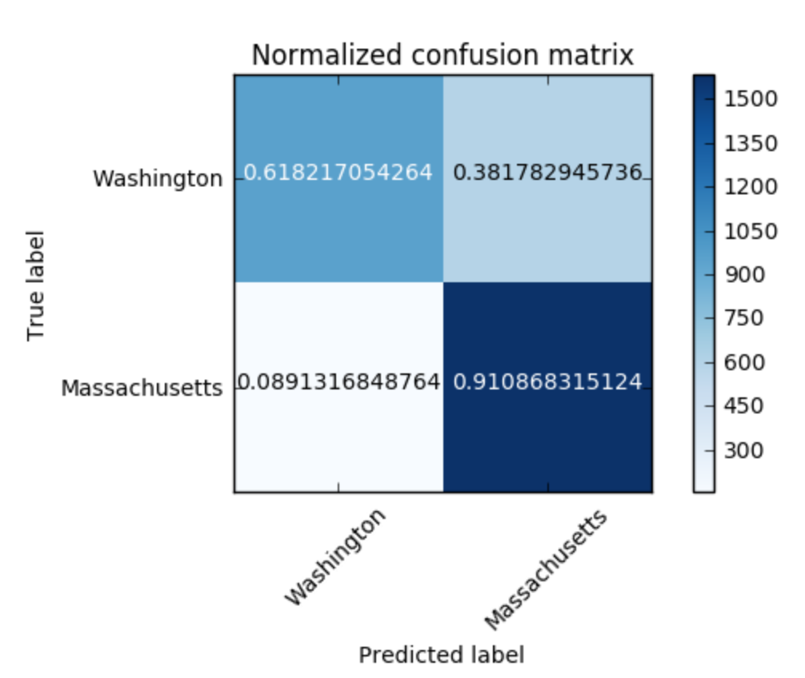

*Figure 22. Confusion Matrix of l-2 norm logistic regression classifier, with normalization*

*Table 8. Accuracy, Recall and Precision of L2 Norm Logistic Regression*

|  |  |  |
| --- | --- | --- |
| Accuracy | Recall | Precision |
| 0.773045330088 | 0.910868315124 | 0.728275862069 |

As we can see, logistic regression with l2 norm regularization has the best performance. From the performance, we say that we can predict the location of the author of a tweet given only the textual content of the tweet.

# iii) Define your own Project

## Problem (7)

### 7.1 Problem statement

The dataset in hands is very rich as there is a lot of metadata to a tweet. Be creative and propose a new problem (something interesting that can be inferred from this dataset) other than popularity prediction.

Here, we raise two topics. The first one is to find out the top words before, during and after the event. The second one is to implement problem 6 by Spark MLlib to explore more about this powerful and popular framework.

### 7.2 Topic1: Find out top words about superbowl before, during and after the event

#### Solution

#### Preprocessing

We first want to use the second dataset which is collected in three periods. However, the dataset does not contain title information so that we cannot use it for our problem and have to split the dataset by ourselves. We first use Spark to retrieve the title and first_post_date from the original tweets_#superbowl.txt and then split the dataset to three periods by python datetime, time.

#### Feature Extraction and results

We use tf-idf to analyze the tweet’s title and get the top 20 words in the three time periods defined in problem 4.

Period1: [u'http', u'el', u'en', u'win', u'patriots', u'seahawks', u'superbowlxlix', u'super', u'amp', u'game', u'bowl', u'sunday', u'nfl', u'going', u'seattle', u'que', u'vs', u'gohawks', u'superbowl', u'just']

Period2: [u'rt', u'tomorrow', u'amp', u'party', u'http', u'football', u'seahawks', u'el', u'sunday', u'nfl', u'game', u'win', u'ready', u'patriots', u'superbowlxlix', u'https', u'super', u'day', u'sb49', u'bowl']

Period3: [u'perry', u'halftime', u'super', u'katyperry', u'katy', u'bowl', u'sb49', u'brady', u'superbowl', u'just', u'patriots', u'superbowlxlix', u'nfl', u'superbowlcommercials', u'commercial', u'http', u'el', u'seahawks', u'game', u'time']

We can see that after the game, some new top words appeared, such as 'katyperry' and 'brady', who are two important person in the game.

### 7.3 Topic 2: Use Spark MLlib to implement problem6

MLlib is Spark’s machine learning (ML) library. Its goal is to make practical machine learning scalable and easy. At a high level, it provides tools such as:

* ML Algorithms: common learning algorithms such as classification, regression, clustering, and collaborative filtering
* Featurization: feature extraction, transformation, dimensionality reduction, and selection
* Pipelines: tools for constructing, evaluating, and tuning ML Pipelines
* Persistence: saving and load algorithms, models, and Pipelines
* Utilities: linear algebra, statistics, data handling, etc.

As we can see, Spark MLlib can be used to solve machine learning problems. In this topic, we try to use Spark MLlib and scala as our programming language to solve problem6 to get a taste of Spark.

#### Solution

We first load the preprocessed dataset in the problem6 and the schema of the dataframe is like below:

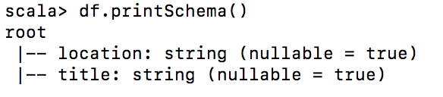

Then we add a column of label based on the location. A sample of the dataset after this step is like below:

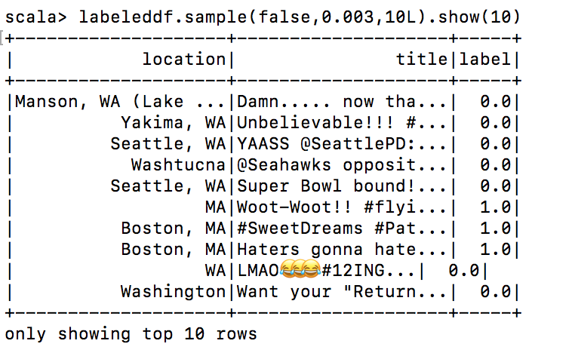

Then we randomly split the dataset to training and test parts.

Total Document Count = 32866

Training Count = 29534, 89.86186332379967%

Test Count = 3332, 10.138136676200329%

Then we build a pipeline containing Tokenizer(), StopWordsRemover(), HashingTF(), IDF() and LogisticRegression().

Then we use the pipeline and the training dataset to train the model and make predictions for the test dataset. A sample prediction result is shown as below:

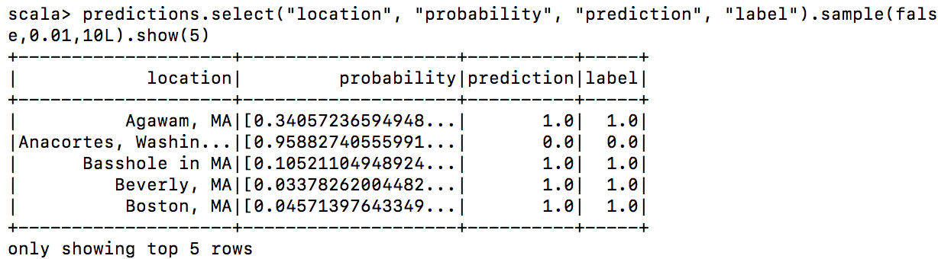

At last, we evaluate our model by ROC curve. The area under the ROC curve is 0.846442610746119.

