Computer Science 571 2nd Exam
Prof. Papa

Thursday, December 6, 2011, 5:30pm – 6:40pm

Name: Student ID Number:

- This is a closed book exam.
- Please answer all questions on the test

JSON Question [20 pts]

The REST Flickr Service includes a “test” API, flickr.test.echo, which echoes back its parameters (name and values). A sample REST call is shown below:

http://api.flickr.com/services/rest/?method=flickr.test.echo&name=value&format=json&api_key=6915

When the “format=JSON”, a JSONP response is returned, echoing all name/values pairs, starting with “method”. Please fill in the missing code:

jsonFlickrApi(

"stat":"ok"})

XML Schema Questions [20 pts]

<?xml version="1.0"?>
<xsd:schema xmlns:xsd="http://www.w3.org/2001/XMLSchema"
targetNamespace="http://www.books.org"
xmlns="http://www.books.org"
elementFormDefault="qualified">
<xsd:element name="BookStore">
<xsd:complexType>
<xsd:sequence>
<xsd:element name="Book" maxOccurs="unbounded">
<xsd:complexType>
<xsd:sequence>
<xsd:element name="Title" type="xsd:string"/>
<xsd:element name="Author" type="xsd:string"/>
<xsd:element name="Date" type="xsd:string"/>
<xsd:element name="ISBN" type="xsd:string"/>
<xsd:element name="Publisher" type="xsd:string"/>
</xsd:sequence>
</xsd:complexType>
</xsd:element>
</xsd:sequence>
</xsd:complexType>
</xsd:element>
</xsd:schema>

Above is an XML Schema.

[10 pts] Rewrite the XML Schema, so that the element named Book has a type that can be reused. An unlimited number of Book(s) can be defined. Fill in the missing sections of the file below.

<?xml version="1.0"?>
<xsd:schema xmlns:xsd="http://www.w3.org/2001/XMLSchema"
targetNamespace="http://www.books.org"
xmlns="http://www.books.org"
elementFormDefault="qualified">
<xsd:element name="BookStore">
<xsd:complexType>

</xsd:complexType>
</xsd:element>

</xsd:schema>

[10 pts] Rewrite the definition of the ISBN element, creating a new type, “ISBNType2007”, using the new format of ISBN numbers, adopted on January 1, 2007, and consisting of a sequence of 13 digits, with dashes between fields separating EAN, Group, Publisher, Title and Checksum. Valid sequences are 3,1,3,5,1 digits, as in “978-0-470-10554-2” and 3,2,4,3,1 digits, as in “978-04-7010-554-2”. Fill in the missing lines below.
<xsd:simpleType name="ISBNType2007">

</xsd:simpleType>

Java Servlet Questions [20 pts]

Below is snapshot of a web page that includes a text box and a button labeled Yahoo Search. When a query is entered and the button clicked, a Java Servlet is called that accepts the query and sends it to Yahoo to produce the results.

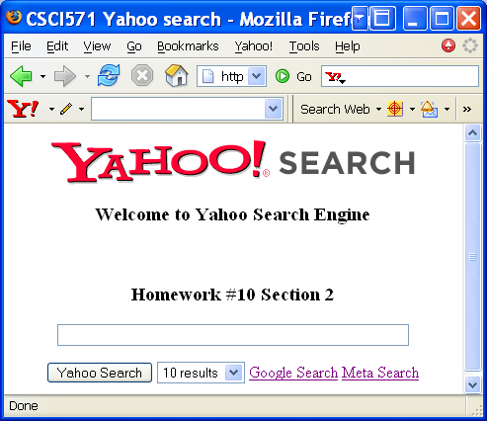

Below is part of the servlet.

public class WebSearch extends HttpServlet {
public void doGet(HttpServletRequest request, HttpServletResponse res)
throws IOException, ServletException
{ res.setContentType("text/html;charset=UTF-8");
String query=request.getParameter("q");
int max=Integer.parseInt(request.getParameter("maxresult"));
int i =Integer.parseInt(request.getParameter("start"));
PrintWriter out = res.getWriter ();
SearchClient client = new SearchClient("amadeust94");
WebSearchRequest request1 = new WebSearchRequest(query);
request1.setResults(50);
try {
WebSearchResults results = client.webSearch(request1);
out.println("<html>");
out.println("<!-- <body> </body> -->"); //remove string
out.println("<head>");
out.println("<title>csci571 hw10 Yahoo Search Result</title>");
out.println("</head>");
out.println("<body>");
// Print out how many hits were found.
out.println("<br><h2>Found " + results.getTotalResultsAvailable() +
" hits for "+query+" Displaying the first " +
results.getTotalResultsReturned() + ".</h2><p>");
// Iterate over the results.
for (int j=0; j < max; j++) {
WebSearchResult result = results.listResults()[i];
String url=result.getUrl();
String cacheUrl="";
String cacheSize="";
out.println("<br><a href="+url+"> " + (i + 1) + ": " + result.getTitle() + "</a> <br>"+result.getSummary()+"<br><font color=green><b> URL: " + url+"</font>");
i++;
if(result.getCache()!=null){
cacheUrl=result.getCache().getUrl();
cacheSize=result.getCache().getSize();
out.println("<font color=blue> Cache Size: "+cacheSize+"<a href="+cacheUrl+"> Cached</a></font>");
}
}
out.println("<p><a href=\"http://csci351.usc.edu:16540/examples/servlet/yy?q="+query+"&start="+i+"&maxresult="+max+"\">More Result</a>");
}
catch (IOException e) { }
catch (SearchException e) { }
catch (Exception e) { } }}

The above Java servlet makes use of the Yahoo API for accessing web search results from a program. List any 5 Yahoo provided functions that the WebSearch class implements and for each one provide a short explanation of the input arguments and the output for each function you identify.

Web Performance Questions [20 pts]

List the 3 rules out of the 14 rules for faster Web pages from Yahoo‘s Steve Souders that help speed up delivery of HTML (3 rules) and improve caching using HTTP headers (2 rules).

HTML:

Caching:

Tomcat Questions [20 pts]

[3 pts] Define the acronym JAR and in one sentence give its definition:

[3 pts] Define the acronym WAR and in one sentence give its definition:

[3 pts] What is a major difference between Tomcat and Apache?

[3 pts] In what folder of Tomcat does one place Java servlets that are part of a user-developed application?

[3 pts] What is the name of the deployment descriptor file that must be modified to deploy a Java servlet?

[3 pts] Below are 4 possible addresses of Tomcat servers for this class, but only one is correct. Choose the correct one.
- http://csci571.usc.edu:9980/index.jsp
- http://csci571.usc.edu:80/index.jsp
- http://www-scf.usc.edu/~csci571/index.jsp
- http://www-scf.usc.edu/tomcat/index.jsp

[2 pts] What is the name of the folder where the Tomcat server is configured? And what is the name of the file that must be edited with port settings?

