CradlEaSE: Embedded System-Based Baby Cradle with Sound Sensor and Raindrop Sensor for Real-Time Baby Cry and Diaper Wetness Level Detection

**Abstract.** This research develops CradlEaSE, an automatic baby cradle system embedded with an LM393 sound sensor and a raindrop sensor module for real-time detection of baby cries and diaper wetness levels. The background for the development was the high cost of infant care for low-income families, where the limitations of time and cost result in insufficient attention to baby cries and wet diapers. CradlEaSE is developed using an Arduino Uno as the microcontroller, integrated with an SG90 micro servo to swing the automatic baby cradle when a baby cry is detected, and a buzzer to alarm parents when the baby diaper is wet. The test results show an average response of 0.402 to 3.064 seconds to baby cries and 1.396 seconds to wet diapers. The development of CradlEaSE is cost-effective, efficient, and affordable, reducing the burden of infant care for parents and preventing the risk of diaper rash while also supporting the Sustainable Development Goals (SDGs), specifically the third (Good Health and Well-being) and the tenth (Reduced Inequalities) SDGs. The main drawback of this research lies in CradlEaSE's inability to detect low-volume baby cries, and it is still not IoT-integrated.

**Keywords:** Embedded System, Real-Time Detection, Baby Cradle, Low-Cost Automation, Raindrop Sensor, Sound Sensor, Infant Health, Reduce Inequality.

1. Introduction
   1. Background

The world population growth has reached 8 billion people in 2023, resulting in the baby boom phenomenon in several countries, including Indonesia and Africa, with significant increases in birth rates [1]. The data from the World Bank shows that in 2023, almost 82% of the world's population live in low to average-income countries [2]. Amid this phenomenon, urbanisation and modern lifestyle in large cities influence parenting style in the 21st century. This social change causes many families to adopt dual-income households, where two parents work, which causes less contribution from parents for infant care [3].

The pressure to multitask between jobs, household chores, and parenting is a struggle for modern parents, leading to increased stress, fatigue, and unfocused parenting, with insufficient attention to baby cries and wet diapers [4]. This phenomenon becomes critical, given that 44% of mothers are obliged to return to work six months after giving birth, while the other 33%, three months after giving birth, often neglecting care given to babies [5]. The infant period (the first twelve months) is a critical development period, requiring sufficient nutrition, stimulation, and optimal skincare for babies [6], preventing problems such as diaper rash experienced by 25% of a million babies [7].

Furthermore, real-time monitoring of babies is also a crucial challenge; parents often do not know if their baby cries while they are at work [8]. Meanwhile, the modern era of Industry 4.0 presents the potential to integrate many automated devices, reducing human involvement while increasing efficiency and effectiveness [9, 10]. Although technology has improved significantly, many parents are unable to purchase technological devices due to cost limitations. For instance, in infant care, many parents still rely on conventional baby cradles, which are no longer as effective because they require human intervention, presenting a challenge for parents to manage between work and parenting [9, 11].

Infant care for parents is getting more costly. Diapers can consume up to 14% of income for low-income families [12]. This situation causes low-income families to resort to lower-quality diapers to reduce the frequency of changing diapers, not knowing how it would cause long-term health problems for their babies [13].

To overcome the previously stated challenges, the development of an embedded system-based baby cradle becomes a relevant solution, allowing real-time baby monitoring through sensors and automatic cradle swing without manual control. An embedded system is a system of electronic components, a combination of hardware and a Real-Time Operating System. In the context of automatic baby cradle development, the embedded system ensures real-time response in detection and automation for the baby cradle. [14]. The development of an embedded system-based baby cradle aims to propose an innovative solution in infant care for low-income dual-income families through real-time monitoring and cradle swing automation.

This technology can reduce the risk of neglect for basic baby needs and helps prevent health problems, such as diaper rash, through early detection [4, 7, 8]. With low-cost and energy-efficient design, this technology aims to be affordable for low-income families and contributes to achieving the Sustainable Development Goals (SDGs), specifically the third (Good Health and Well-being) and the tenth (Reduced Inequalities) SDGs [14, 15]. Therefore, the research objectives are to develop an embedded system-based baby cradle that can detect baby cries and wetness in baby diapers in real-time and to produce a cheap automatic system to ease the parenting burden for low-income dual-income families.

1. Literature Review
   1. Sensor and Actuators for Automatic Baby Cradle

### **Arduino and Microcontroller**. Arduino is a free-to-use and free-to-program microcontroller utilised for sensor-based device development, handling inputs and outputs with GPIO pins. [16].

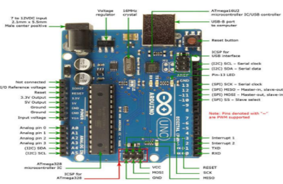

**Fig. 1.** A labelled diagram of an Arduino and IDE [16].

The programming of an Arduino consists of only two main functions: void setup() for hardware initialisation and void loop() for handling program logic. Built-in functions such as digitalWrite(), digitalRead(), analogWrite(), and analogRead() are used to access the I/O pins. Arduino provides various boards and specifications. The table below lists the comparisons between different Arduino board types:

**Table 1.** Comparisons of Arduino board types [16].

|  |  |  |  |
| --- | --- | --- | --- |
| Arduino type | Microcontroller | Clock speed | Auto-reset |
| Arduino-uno | ATmega 328 | 16 MHz | ü |
| Arduino-nano | ATmega 328 | 16 MHz | ü |
| Arduino-mega 2560 | ATmega 2560 | 16 MHZ | ü |
| Arduino-leonardo | ATmega32u4 | 16 MHz | ü |

### **Raindrop Sensor**. A raindrop sensor detects water by reading the resistance difference in its nickel line. In dry conditions, high resistance produces high voltage. When the water touches the sensor, its resistance decreases, resulting in low voltage. The LM393 module in this sensor serves as a comparator to process resistance differences as digital or analogue signals, transmitted to Arduino Uno for further processing [17].

**Fig. 2.** A block diagram of a raindrop sensor [17].

### Buzzer. A buzzer is an electric component that converts electrical signals to sound. A buzzer functions as an alarm for an action [18].

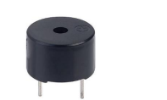

**Fig. 3.** A **b**uzzer [18].

### **LM393 Sound Sensor**. LM393 sound sensor integrates an electret microphone with an LM393 comparator to convert analogue to digital signals when the sound input exceeds a pre-defined threshold [19].

**Fig. 4.** An LM393 sound sensor [19].

### **SG90 Micro Servo.** This servo has three cables: a positive (+5V) cable, a negative (ground) cable, and a control signal cable. The lever position is controlled by PWM signals every 20ms. The PWM also states the rotation angle: a 1 ms pulse for a 90-degree clockwise rotation, a 1.5 ms pulse for a 0-degree rotation, and a 2 ms pulse for a 90-degree counterclockwise rotation.

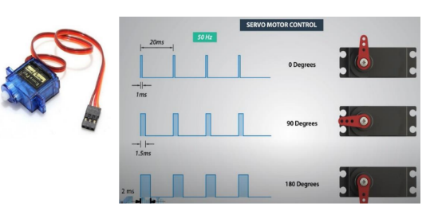

**Fig. 5.** PWM pulse signal applied to a SG90 micro servo [20].

* 1. Comparison with Other Research

|  |  |  |  |  |  |
| --- | --- | --- | --- | --- | --- |
| Research | Sensor type | Platform | Automation | Cost & target user | Real-time |
| This research | Audio & wetness level | Arduino | Semi-auto | Low & low-income families | ü |
| [21] | Audio & moisture | Raspberry pi | Full auto | Average & parents who work or are not at home | ü |
| [22] | Audio | Arduino | Semi-auto | Low & low-income families | ü |
| [23] | Moisture | Arduino | Full auto | Low & neonatal hospital | ü |

1. Research Methodology
   1. Conceptual Framework

**Table 2**. Input-Process-Output of sound-based baby cradle system

|  |  |  |
| --- | --- | --- |
| Input | Process | Output |
| A blue sound wave  AI-generated content may be incorrect.Sound wave [24]. | A red and silver electronic device  AI-generated content may be incorrect.LM393 sound sensor[19]. | The SG90 micro servo swings the baby cradle when the baby cries. |
| A close-up of a blue circuit board  AI-generated content may be incorrect.Arduino Uno Atmega328P[25]. |
| A small blue device with a red wire  AI-generated content may be incorrect.SG90 micro servo [20]. |

The process above is the logical framework for our baby cry detection system utilising the LM393 sound sensor. When a cry is detected, a digital signal is sent to the Arduino, producing a PWM signal to rotate the SG90 micro servo. This servo motor will automatically swing the cradle [16, 19, 20, 22, 23].

**Table 3**. Input-Process-Output of raindrop sensor for detecting wet baby diaper

|  |  |  |
| --- | --- | --- |
| Input | Process | Output |
| A close-up of a diaper  AI-generated content may be incorrect.Wet diaper [26]. | Raindrop sensor [27]. | The buzzer sounds when the raindrop sensor is wet. |
| A close-up of a blue circuit board  AI-generated content may be incorrect.Arduino Uno Atmega328P[25]. |
| Buzzer [18]. |

The logical framework above explains the usage of the raindrop sensor to detect wetness in a baby's diaper. The sensor detects a resistance difference when water makes contact, which is then converted to a digital signal by the LM393 module. The Arduino Uno processes the signal, and if the wetness level exceeds the predefined threshold, the buzzer sounds to indicate that the baby's diaper is wet [18, 19, 23].

* 1. System State Diagram

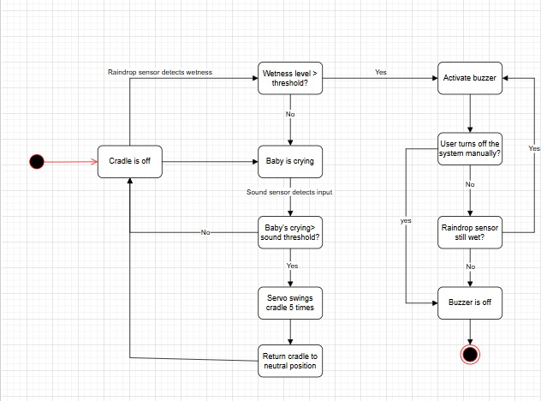

**Fig. 6.** The state diagram of the baby cry & wet diaper detection

* 1. Embedded System Circuit

**Fig. 7** The embedded system circuit for the automatic baby cradle

* 1. System Design

### **Hardware Design.** The authors agree to name the automatic baby cradle system "CradlEaSE". The development of CradlEaSE is first designed by the following steps:

1. Designing the 3D prototype

The figures below show the 3D prototype for the baby cradle made with Blender:

1. Perspective view

**Fig. 8.** 3D prototype of the baby cradle fromperspective view

1. Top view

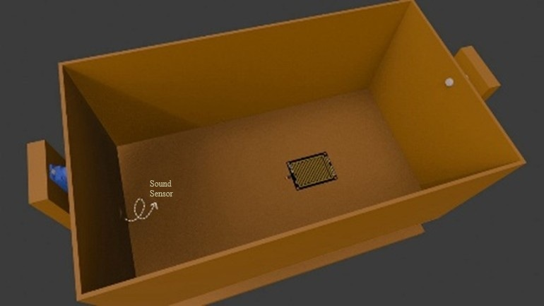

**Fig. 9.** 3D prototype of the baby cradle from top view

1. Side view

**Fig. 10.** 3D prototype of the baby cradle from side view

1. Bottom view

**Fig. 11.** 3D prototype of the baby cradle from bottom view

1. Constructing the automatic baby cradle

In this step, the authors construct the baby cradle as a rectangular box embedded with the necessary sensors and components for the baby cry and diaper wetness detection system. The figures below show the details for the baby cradle:

1. The cradle (internal components)

**Fig. 12** Dimension of the box, with 46 cm length, 25 cm width, and 15 cm height to put the baby.

1. The outside and bottom side of the cradle (external components)

**Fig. 13** An electronic circuit at the bottom of the cradle, utilising Arduino Uno as the microcontroller.

**Fig. 14** Dimension of the outside of the cradle, with 52 cm length, 34 cm width, and 47 cm height.

### **Software Design.** The source code for CradlEaSE, programmed in Arduino IDE, is placed in the following GitHub repository: <https://github.com/AgentJTLA/CradlEaSE/tree/main>, placed in the “source” directory.

* 1. Tools and Materials

**Table 4.** Tools and materials for CradlEaSE

|  |  |  |
| --- | --- | --- |
| A close-up of a blue circuit board  AI-generated content may be incorrect. Arduino Uno ATmega328P[25] | Raindrop sensor [27] | A red and silver electronic device  AI-generated content may be incorrect. LM393 sound sensor[19] |
| A white rectangular object with holes  AI-generated content may be incorrect.Mini breadboard [28] | A small blue device with a red wire  AI-generated content may be incorrect. SG90 micro servo [20] | Buzzer [18] |
| A green and black cable  AI-generated content may be incorrect.Male to male jumper cable [29] | A red wire with black ends  AI-generated content may be incorrect.Male to female jumper cable [29] | A close-up of a cable  AI-generated content may be incorrect.Female to female jumper cable [29] |

* 1. Testing Method

**Table 5.** The servo's responses to a baby cry audio with volume variation

|  |  |  |  |  |  |
| --- | --- | --- | --- | --- | --- |
| No | Audio volume (%) | Servo’s response | Response time after audio plays (seconds) | Result | Average response time |
| 1 | Audio volume (100%) | Rotates | (0.818 seconds) | Baby cradle swings | 0.722 seconds |
| A couple of cell phones  AI-generated content may be incorrect.  (0.462 seconds) | Baby cradle swings |
| (0.885 seconds) | Baby cradle swings |
| 2 | Audio volume (75%) | Rotates | (3.025 seconds) | Baby cradle swings | 2.335 seconds |
| (1.990 seconds) | Baby cradle swings |
| (1.990 seconds) | Baby cradle swings |
| 3 | Audio volume (66%) | Rotates | (3.064 seconds) | Baby cradle swings | 2.829 seconds |
| (2.375 seconds) | Baby cradle swings |
| (3.049 seconds) | Baby cradle swings |
| Average response time | | | | | 1.962 seconds |
| 4 | Audio volume (<66%) | Does not rotate | 0 second | Baby cradle does not swing | 0 seconds |

**Fig. 15.** The buzzer’s response time after the raindrop sensor gets wet (1.396 seconds).

1. Result and Evaluation

CradlEaSE has been tested for real-time detection of baby cries using the LM393 sound sensor and diaper wetness using the raindrop sensor module. The test results show that the system is effective, efficient, and affordable to use.

For the cry detection test, the LM393 sound sensor successfully recognises baby cries simulated by audio played from a smartphone, with a minimum volume of 66% of the maximum volume. If the volume falls below 66%, the LM393 sound sensor fails to detect a cry (see Table 5).

The servo's response time to swing the cradle varies due to the volume level. At the maximum volume, the servo takes an average time of 0.722 seconds to swing the cradle, with the best time of 0.462 seconds. When the volume decreases to 75%, the average response time slows down to 2.335 seconds, with the best time of 1.990 seconds. At 66% of the maximum volume, the average response time is 2.829 seconds, with the best time of 2.375 seconds (see Table 5).

When a cry is detected, the SG90 micro servo consistently swings the cradle along the programmed rotation angle through PWM signals, stimulating soothing movements to calm the baby. Furthermore, the raindrop sensor successfully detects wetness in baby diapers, sounding the buzzer quickly with a response time of 1.396 seconds to alert the parents when the baby's diaper is wet.

Cost-wise, the system utilises cheap components, costing a total of less than 25$. Power consumption is also efficient because the servo only activates when a cry is detected. The system is also affordable for low-income families, offering quick detection and real-time response. However, the system still has some limitations, such as its semi-automatic nature and the lack of IoT integration. The other limitations include the inability to detect lower-volume cries.

1. Conclusion

CradlEaSE, the automatic embedded system-based baby cradle, has successfully presented a real-time, low-cost solution for detecting baby cries (with an average response time of 1.962 seconds) and wet diapers (with a response time of 1.396 seconds) while also easing the burden of infant care for low-income dual-income families. Even with all the current limitations, this innovation significantly prevents the risk of neglect in baby care and diaper rash. The innovation also supports the third SDG (health) and the tenth (equality) through the development of affordable technology.

Future Works

For further development, improvements to this system could include adding additional sensors to enhance security and comfort in infant care. For instance, a weight sensor and a light-intensity sensor can be added to the system, the first ensuring the baby's safety in the cradle, while the latter the baby's comfort by detecting if the room is too dark or too bright. These feature additions will make the system more adaptive to the environment and more efficient in real-life applications.

*Author Contribution*

N.F. Wangsaputra, J. Kelvin, N.J. Hanif, and H.I. Pohan contributed equally to this paper. N.F. Wangsaputra handled the paper writing, baby cradle construction (not integrated with the embedded system), designing the state diagram, formatting and structuring of the research paper. J. Kelvin was responsible for the paper translation, baby cradle construction (not integrated with the embedded system), 3D prototype modelling with Blender, Arduino programming, and embedded system integration into the cradle. N.J. Hanif contributed to paper writing, baby cradle construction (not integrated with the embedded system), and decorating the baby cradle. H.I. Pohan contributed to the final review and approval of the manuscript for submission.

*Data Availability*

The results and the figures used to explain the process and analysis are available at this link:

https://github.com/AgentJTLA/CradlEaSE/tree/main

References

1. Ninawati, Liska, F., Tiara, V., Barella, Y.: SOSIAL+-+VOLUME.+2,+NO.+3+SEPTEMBER+2024+HAL+01-07. SOSIAL: Jurnal Ilmiah Pendidikan IPS. 2, 1–7 (2024). https://doi.org/https://doi.org/10.62383/sosial.v2i2.248

2. World Bank: Population, total (SP.POP.TOTL) - World Bank, https://data.worldbank.org/indicator/SP.POP.TOTL

3. Buchanan, C.M., Glatz, T.: Parenting in the 21st Century. (2022)

4. Prihatin, M., Al, M.I., Majasem, I.: Peran Multitasking Orang Tua Dalam Membimbing Belajar Anak. Jurnal Ilmiah Mandala Education (JIME). 8, 2442–9511 (2022). https://doi.org/10.36312/jime.v8i2.3218/http

5. Roberts, C.R., McGovern, P.: Working Mothers and Infant Care. AAOHN Journal. 41, (1993). https://doi.org/10.1177/216507999304101105

6. Tiara Carolin, B., Agustin, C.: Pijat Bayi dapat Menstimulus Peningkatan Berat Badan pada Bayi. (2020)

7. Widyandini, M., Safitri, N., Widia, L.: Hubungan Lama Pemakaian Popok Instan dengan Kejadian Ruam Popok pada Bayi Usia 0-12 Bulan di Kelurahan Petuk Katimpun. Jurnal Surya Medika. 10, 80–86 (2024). https://doi.org/10.33084/jsm.v10i1.7158

8. Khan, N., Al-Hamid, D.Z., Chong, P.H.J., Mirza, F., Kumar, A.: Systematic Review of Sleep Monitoring Systems for Babies: Research Issues, Current Status, and Future Challenges, (2024)

9. Munawarah, M., Daud, M., Mardhiah, A.: Prototipe Ayunan Bayi Otomatis Berbasis Internet of Things dan Aplikasi Telegram. Sisfo: Jurnal Ilmiah Sistem Informasi. 7, (2023). https://doi.org/10.29103/sisfo.v7i1.12469

10. Karanjkar, A. V, Kumawat, R.: Design of a Smart Baby Cradle Using Blynk and Local Customer Priorities. SAMRIDDHI : A Journal of Physical Sciences, Engineering and Technology. 14, (2022). https://doi.org/10.18090/samriddhi.v14i02.5

11. Nursalim, N., Pollo, D.E.D.G., Paratu, E.Y.W.: PERANCANGAN SISTEM KONTROL AYUNAN BAYI OTOMATIS DAN MONITORING SENSOR MENGGUNAKAN APLIKASI ANDROID. Jurnal Media Elektro. (2021). https://doi.org/10.35508/jme.v0i0.3808

12. Emam, H.: Diapers or Dinner? An Impossible Choice. Center for Health Journalism. (2023)

13. Fahimzad, A., Taherian, M., Dalirani, R., Shamshiri, A.: Diaper Type as a Risk Factor in Urinary Tract Infection of Children. (2010)

14. Nureni, Y.: OVERVIEW OF EMBEDDED SYSTEM & ITS APPLICATION. (2022)

15. Jakarta: GOVERNMENT OF INDONESIA AND UNITED NATIONS SUSTAINABLE DEVELOPMENT COOPERATION FRAMEWORK Declaration of Commitment. (2020)

16. Shakirovich Ismailov Zafar Botirovich Jo, A.: Study of arduino microcontroller board. (2022)

17. Yogesh S, Tm, S., Bharathy, G.T.: Rain Detection System Using Arduino and Rain Sensor. (2021). https://doi.org/10.32628/IJSRSET219820

18. Nur Alfan, A., Ramadhan, V.: PROTOTYPE DETEKTOR GAS DAN MONITORING SUHU BERBASIS ARDUINO UNO. PROSISKO: Jurnal Pengembangan Riset dan Observasi Sistem Komputer. 9, (2022). https://doi.org/10.30656/prosisko.v9i2.5380

19. Nabawi, I.S., Badarudin, R.: PERANCANGAN SISTEM KONTROL LAMPU BERBASIS MIKROKONTROLER ARDUINO UNO R3 DENGAN SENSOR SUARA LM393, ELECTRET MICROPHONE. Jurnal Informatika dan Teknik Elektro Terapan. 12, (2024). https://doi.org/10.23960/jitet.v12i3.4536

20. Necula, V.C., Stamate, D., Bucur, G.: SPIDER4LEGS MOBILE ROBOT DESIGN CONTROLLED BY THE ESP32 PLATFORM. Romanian Journal of Petroleum & Gas Technology. 4 (75), (2023). https://doi.org/10.51865/jpgt.2023.01.21

21. Sivalingamaiah, M., Gopi, K.: SMART E-CRADLE USING RASPBERRY PI. International Journal of Engineering Applied Sciences and Technology. 6, (2021). https://doi.org/10.33564/ijeast.2021.v06i05.052

22. Fuji Kinasih, S., Budi Utomo No, J., Mandar, P., Barat, S.: PENGONTROLAN AYUNAN BAYI OTOMATIS DENGAN MENDETEKSI SENSOR SUARA MENGGUNAKAN MIKROKONTROLER ARDUINO. Jurnal Ilmiah Ilmu Komputer. 4, (2018)

23. Telepatil, Mr.A.R., Patil, Miss.P.P., .Yajare, Miss.S.S., Jadhav, Miss.S.R.: Intelligent Baby Monitoring System. International Journal of Research in Advent Technology. 7, 191–194 (2019). https://doi.org/10.32622/ijrat.76201981

24. Al-Habaibeh, A., Shakmak, B., Watkins, M., Shin, H.D.: A novel method of using sound waves and artificial intelligence for the detection of vehicle’s proximity from cyclists and E-scooters. MethodsX. 12, (2024). https://doi.org/10.1016/j.mex.2023.102534

25. McCarthy, D.T., Shi, B., Wang, M., Catsamas, S.: BoSL FAL pump: A small, low-cost, easily constructed, 3D-printed peristaltic pump for sampling of waters. HardwareX. 10, (2021). https://doi.org/10.1016/j.ohx.2021.e00214

26. Sidén, J., Koptioug, A., Gulliksson, M.: The “smart” diaper moisture detection system. In: IEEE MTT-S International Microwave Symposium Digest. pp. 659–662 (2004)

27. Hendry, Chairul Rizal, Supiyandi: Perancangan Prototipe Rain Drop Sensor Berbasis Arduino Uno. Bulletin of Computer Science Research. 3, (2023). https://doi.org/10.47065/bulletincsr.v3i4.264

28. Revansa Arya Pradhana, D., Ichsan Pradana, A., Hartanti, D.: Implementasi Internet Of Things Pada Sistem Kontrol RC-car Pemantau Area Berbasis Esp32 cam. J Teknol. 11, 149–159 (2024). https://doi.org/10.31479/jtek.v11i2.306

29. Irawan, F., Pangkal Perjuangan, J., Pass, B.K.: PERANCANGAN SISTEM ALAT STERILISASI PINTU KELUAR RUANG ISOLASI BERBASIS ARDUINO DI RS HASTIEN. (2022)