E-COMMERCE SALES ANALYSIS
2023 – 2025
SQL-Based Data Analytics Portfolio Project
All tables and metrics in this report were produced using SQL queries against the e-commerce transactions dataset.

1. Key Metrics
Overall performance summary across the full analyzed period (October 2023 – October 2025).
Metric | Value
Total Revenue | 533,666,024
Total Profit | 79,708,735
Total Orders | 5,000
Total Customers | 4,844
Average Order Value (AOV) | 106,733
Average Margin | 15%
Insights & Comments
The overall numbers point to a stable, moderately profitable business built on relatively large basket sizes rather than sheer transaction volume. A 15% margin combined with an AOV above 100,000 suggests the business is self-funding: profit generated is sufficient to sustain current operations without relying on external capital.
Given the AOV is already high, a natural next step would be to test cross-sell or bundling strategies to lift basket size further, rather than focusing purely on acquiring more customers.

2. Monthly Sales Dynamics
Revenue, profit and order volume trends on a month-by-month basis.
Month | Revenue | Profit | Orders
2023-10 | 21,307,522 | 3,106,231 | 202
2023-11 | 22,040,269 | 3,387,740 | 204
2023-12 | 20,624,240 | 2,989,331 | 195
2024-01 | 21,477,241 | 3,104,254 | 222
2024-02 | 19,853,397 | 2,941,449 | 196
2024-03 | 21,571,015 | 3,235,675 | 199
2024-04 | 22,214,781 | 3,241,580 | 214
2024-05 | 24,744,787 | 3,692,959 | 217
2024-06 | 21,368,963 | 3,261,199 | 201
2024-07 | 24,019,284 | 3,486,946 | 220
2024-08 | 23,299,895 | 3,404,785 | 230
2024-09 | 22,480,182 | 3,292,918 | 208
2024-10 | 23,607,627 | 3,601,282 | 218
2024-11 | 22,036,248 | 3,286,992 | 188
2024-12 | 24,806,786 | 3,855,730 | 219
2025-01 | 21,520,802 | 3,255,994 | 220
2025-02 | 19,902,446 | 2,970,431 | 178
2025-03 | 22,602,989 | 3,533,884 | 229
2025-04 | 21,653,818 | 3,150,564 | 200
2025-05 | 26,010,929 | 3,979,357 | 234
2025-06 | 21,155,496 | 3,184,539 | 203
2025-07 | 22,526,568 | 3,439,384 | 187
2025-08 | 23,317,916 | 3,456,953 | 213
2025-09 | 18,131,497 | 2,677,364 | 185
2025-10* | 1,391,328 | 171,194 | 18
* October 2025 is a partial month.
Insights & Comments
Monthly revenue is consistently stable across the full period, generally holding in the 20–25M range with no sharp structural breaks. A handful of isolated dips are visible (e.g., Feb 2025, Jul 2025, Sep 2025), but they fall within normal month-to-month variance rather than signaling a trend reversal.
Explaining these dips with confidence would require additional context beyond this dataset (seasonality, marketing activity, external market factors), so they are flagged here as points of interest rather than conclusions.

3. Revenue, Profit, Orders and Margin by Category
Category | Revenue | Profit | Orders | Customers | AOV | Margin
Beauty | 50,803,410 | 7,213,436 | 460 | 460 | 110,442 | 14%
Books | 54,932,643 | 8,076,273 | 528 | 524 | 104,039 | 15%
Clothing | 55,053,908 | 8,445,750 | 511 | 510 | 107,738 | 15%
Electronics | 52,587,884 | 8,042,134 | 472 | 472 | 111,415 | 15%
Furniture | 56,647,188 | 8,693,087 | 527 | 525 | 107,490 | 15%
Groceries | 47,883,103 | 7,075,333 | 470 | 468 | 101,879 | 15%
Home Decor | 57,233,222 | 8,556,847 | 515 | 513 | 111,132 | 15%
Kitchen | 54,227,902 | 7,879,573 | 528 | 527 | 102,704 | 15%
Sports | 52,069,397 | 7,739,430 | 511 | 509 | 101,897 | 15%
Toys | 52,227,366 | 7,986,871 | 478 | 477 | 109,262 | 15%
Insights & Comments
Kitchen and Books lead in order volume, pointing to stronger demand and a broader customer base for these categories, even though their revenue is not the highest overall.
Furniture and Home Decor lead in total profit. Furniture's result is driven mainly by strong order volume and revenue rather than an exceptionally high AOV — at 107,490 its AOV is close to the overall average (106,733). Home Decor and Electronics, by contrast, carry the highest AOV among all categories.
Beauty stands out as the weakest category: it has the fewest orders and customers, and the only margin one point below the rest (14% vs. 15% elsewhere). This gap is large enough relative to the average to be worth a closer look — for example, whether pricing or cost structure differs for this category.

4. Top-5 Categories by Revenue and Profit
Category | Revenue | Profit | Orders | Customers | AOV | Margin
Furniture | 56,647,188 | 8,693,087 | 527 | 525 | 107,490 | 15%
Home Decor | 57,233,222 | 8,556,847 | 515 | 513 | 111,132 | 15%
Clothing | 55,053,908 | 8,445,750 | 511 | 510 | 107,738 | 15%
Books | 54,932,643 | 8,076,273 | 528 | 524 | 104,039 | 15%
Electronics | 52,587,884 | 8,042,134 | 472 | 472 | 111,415 | 15%
Insights & Comments
The top-5 pattern largely confirms the category-level picture above. One point worth highlighting: Electronics sustains strong profit despite not leading in order volume, driven by the highest AOV among all categories — a reminder that revenue leadership and profit leadership don't always come from the same driver (volume vs. basket size).

5. Regional Breakdown
Revenue, average check and margin by region.
Region | Revenue | Profit | Orders | Customers | AOV | Margin
North | 143,578,246 | 21,343,004 | 1,288 | 1,283 | 111,474 | 15%
East | 135,811,638 | 20,532,558 | 1,256 | 1,249 | 108,130 | 15%
West | 131,045,973 | 19,580,123 | 1,241 | 1,232 | 105,597 | 15%
South | 123,230,167 | 18,253,049 | 1,215 | 1,206 | 101,424 | 15%
Insights & Comments
North is the strongest region across every metric — revenue, profit, orders, customers and AOV — with no single dimension where another region overtakes it. In absolute terms the gap between the top and bottom region is meaningful: about 20.3M in revenue and about 3.1M in profit between North and South.
That said, customers are fairly evenly split across regions (roughly 25% each), so the gap is not extreme enough on its own to justify reallocating resources away from any single region. South's noticeably lower AOV likely reflects its category mix rather than a standalone regional issue — see Section 6.

6. Category's Leading Region
Each category paired with its single strongest-performing region. Figures are the category's overall totals (as in Section 3); the region column identifies where that category performs best, rather than a full per-region recalculation.
Category | Leading Region | Revenue | Profit | Orders | Cust. | AOV | Margin
Furniture | West | 56,647,188 | 8,693,087 | 527 | 525 | 107,490 | 15%
Home Decor | North | 57,233,222 | 8,556,847 | 515 | 513 | 111,132 | 15%
Clothing | West | 55,053,908 | 8,445,750 | 511 | 510 | 107,738 | 15%
Books | South | 54,932,643 | 8,076,273 | 528 | 524 | 104,039 | 15%
Electronics | East | 52,587,884 | 8,042,134 | 472 | 472 | 111,415 | 15%
Toys | North | 52,227,366 | 7,986,871 | 478 | 477 | 109,262 | 15%
Kitchen | East | 54,227,902 | 7,879,573 | 528 | 527 | 102,704 | 15%
Sports | East | 52,069,397 | 7,739,430 | 511 | 509 | 101,897 | 15%
Beauty | South | 50,803,410 | 7,213,436 | 460 | 460 | 110,442 | 14%
Groceries | North | 47,883,103 | 7,075,333 | 470 | 468 | 101,879 | 15%
Insights & Comments
Beauty's leading region is South — the same region with the lowest AOV overall (Section 5). Since Beauty is also the weakest category by margin and order volume (Section 3), this pairing is consistent with South's lower average metrics being a category-mix effect rather than a standalone regional weakness. Confirming this with certainty would require a true category-within-region breakdown, which is a natural next step for this analysis rather than a conclusion drawn here.

7. Discount Impact Analysis
Objective: understand how discount size affects sales volume and profitability.
Discount | Orders | Total Sales | Avg Check | Total Profit | Avg Margin
0% | 998 | 117,106,034 | 117,341 | 17,266,609 | 14.9%
5% | 978 | 112,096,122 | 114,618 | 17,059,183 | 14.9%
10% | 1,020 | 110,572,966 | 108,405 | 16,562,543 | 15.0%
15% | 983 | 97,285,450 | 98,968 | 14,575,952 | 15.0%
20% | 1,021 | 96,605,452 | 94,618 | 14,244,449 | 14.8%
Insights & Comments
The relationship between discount size and profitability is not linear. The highest discount tier (20%) does not translate into higher sales — it produces the lowest total sales and the lowest margin (14.8%) of all tiers, driven by a lower average check. Order counts are broadly similar across all discount levels, so the differentiator is check size and margin, not volume.
The 0% discount tier generates the highest profit overall. This pattern is worth exploring further at the category level in future analysis, but cannot be confirmed with the current dataset alone.

8. Payment Methods Analysis
Objective: explore payment methods used by customers and identify differences in order value and margin.
Payment Mode | Orders | Total Sales | Avg Check | Total Profit | Avg Margin
Net Banking | 1,010 | 111,465,516 | 110,362 | 16,964,120 | 14.9%
COD | 1,005 | 108,881,396 | 108,340 | 16,575,846 | 15.1%
Credit Card | 994 | 106,027,145 | 106,667 | 15,658,639 | 14.9%
Debit Card | 1,003 | 105,346,382 | 105,031 | 15,479,323 | 14.9%
UPI | 988 | 101,945,586 | 103,184 | 15,030,807 | 14.9%
Insights & Comments
Performance is very consistent across all five payment methods, with no method standing out as materially stronger or weaker on sales, average check, or margin. This uniformity is itself a notable finding for a dataset of this size — it suggests payment method has little independent effect on customer behavior here, though a larger dataset would be needed to confirm this with confidence.

9. Top-10 Customers by Revenue
Customer Name | Orders | Total Sales | Avg Check | Total Profit | Avg Margin
Aaryahi Madan | 3 | 650,152 | 216,717 | 107,156 | 14.8%
Kimaya Vala | 2 | 490,935 | 245,468 | 43,004 | 8.9%
Badal Rao | 2 | 485,698 | 242,849 | 31,990 | 6.4%
Adira Dhingra | 2 | 479,389 | 239,695 | 64,959 | 12.8%
Sumer Mann | 2 | 469,937 | 234,969 | 99,925 | 21.5%
Nayantara Majumdar | 2 | 459,764 | 229,882 | 58,949 | 11.2%
Prerak Shere | 2 | 451,862 | 225,931 | 85,632 | 17.4%
Bhamini Sane | 2 | 441,411 | 220,705 | 79,310 | 16.8%
Samarth Wagle | 2 | 427,716 | 213,858 | 63,411 | 12.9%
Arhaan Basu | 2 | 426,564 | 213,282 | 39,473 | 9.3%
Insights & Comments
Even the highest-value customers in this dataset are largely one-time or twice-only buyers — only one customer in the top 10 reordered a third time — confirming that this business is not built around repeat-customer retention, but around a high volume of large, one-off purchases.
Margin varies significantly at the individual level, from about 6% to over 21%, which naturally balances out to the overall 15% average at scale. No specific action is indicated by this table on its own; it is included mainly as a sanity check on the aggregate figures reported elsewhere.

10. Visualization
Dashboard: https://datastudio.google.com/reporting/828ef23e-b333-4791-b634-35ed35476d5c
Insights & Comments
The dashboard consolidates the key metrics above into a single summary view of overall business performance across the analyzed period.
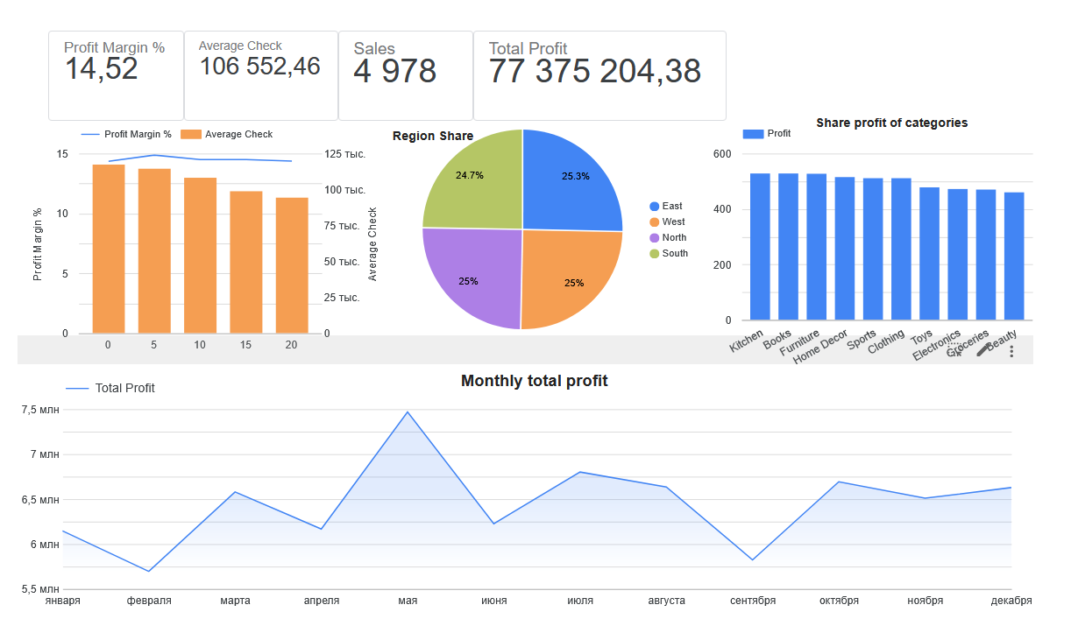
Looker Studio dashboard — summary view

11. Conclusions and Recommendations
The business demonstrates strong stability over the full two-year period: consistent margins, a healthy AOV, and no significant structural weaknesses across categories, regions, or payment channels.
The main finding worth flagging, however, is that stability has not been accompanied by growth: revenue and profit hold steady but do not trend upward across the two years. Whether this reflects a deliberate choice (a mature market, a conscious focus on margin over expansion) or an unaddressed growth ceiling cannot be determined from this dataset alone, but it is the single most actionable observation in this analysis.
Recommendations
– Investigate the root cause of the growth plateau before treating current stability as sufficient on its own.
– Compare the weaker end of the category range (Beauty) against the stronger end (Furniture, Home Decor, Electronics) to identify transferable factors.
– Given the consistently high AOV across categories and regions, prioritize cross-sell and bundling experiments over pure customer-acquisition spend.
– Treat the discount- and payment-method-level patterns as starting hypotheses rather than conclusions — a larger, multi-year dataset with additional dimensions (e.g. marketing spend, category-level discount rules) would be needed to confirm them with confidence.
Overall, this analysis is based on a single 5,000-row transaction table covering 2023–2025; broader conclusions about the business would require additional data (marketing activity, cost breakdowns, customer acquisition channels) that falls outside the scope of what was available here.

