LAB Authentication – Firebase Google Sign-In & Email OTP

1. Overview
This lab belongs to Module 10 – Authentication, Session Management & Notifications (Authentication part). It shows how to secure user accounts in a Flutter app with two methods: Google sign-in through Firebase Authentication and OTP verification sent by email during registration.
Students clone a ready-made Flutter project (branch main), then configure and run the app step by step. The lab has 2 exercises, each verified by running the app:
- Exercise 1 – Integrate Firebase Authentication (Google Sign-In)
- Exercise 2 – Integrate email OTP into registration
Exercise 2 reuses the Firebase setup from Exercise 1, so students must work in order.

App flow
Registration (Exercise 2):
- The user enters name, email and password.
- The app checks whether the email already exists in Firebase (Firestore: registered_emails). If it does, it shows an error and asks the user to sign in.
- If not, the app generates a 6-digit OTP and sends it by email over SMTP.
- The user enters the OTP. A wrong or expired code shows an error and allows resending.
- A correct OTP creates the Firebase Auth account, saves users/{uid} and returns to the Login screen (email + password).
Login:
- Email + password (Firebase Auth)
- Google: google_sign_in → Firebase Auth → save users/{uid} (Exercise 1)

2. Learning Outcomes
After completing this lab, students can:
- Create and configure a Firebase project: Authentication, Firestore and Security Rules
- Register an Android app with Firebase, add the SHA-1/SHA-256 fingerprints and generate the config file with the FlutterFire CLI
- Integrate Google Sign-In (OAuth 2.0) with Firebase Authentication and store the user profile in Firestore
- Send an OTP by email (SMTP) and verify it: expiry, attempt limit, single use
- Explain why keeping OTP logic and SMTP credentials inside the app is only suitable for a demo, and what a real system should do instead

3. Prerequisites & Tools
Tool | How to check | Notes
Flutter SDK (Dart ≥ 3.3) | flutter --version
JDK 17 | java -version | Used by Gradle and keytool
Node.js + npm | node -v | To install the Firebase CLI
Git | git --version | To clone the project
Android Studio / Android device | flutter devices | Choose an emulator image with Google Play (needed for Google sign-in)

- A Google account to sign in to the Firebase Console
- A Gmail account with 2-Step Verification enabled, to create the App Password used to send the OTP (Exercise 2)
- An Internet connection (needed for Firebase and for sending email)
The Firebase packages are already in pubspec.yaml (firebase_core, firebase_auth, cloud_firestore, google_sign_in); no extra flutter pub add is needed.

4. Required Packages & References
- Firebase Authentication
https://firebase.google.com/docs/auth
- Cloud Firestore
https://firebase.google.com/docs/firestore
- FlutterFire
https://firebase.flutter.dev
- google_sign_in
https://pub.dev/packages/google_sign_in
- mailer (SMTP email)
https://pub.dev/packages/mailer
- Firebase Console
https://console.firebase.google.com
- Google App Passwords
https://myaccount.google.com/apppasswords
Other packages used: firebase_core, firebase_auth, cloud_firestore. OTP hashing uses crypto.

5. Submission Rules

5.1 Required submissions
Students must submit all of the following:
- The Lab_Authentication project with both exercises completed and running
- Screenshots as evidence for each exercise (see the Expected Output of each exercise)

5.2 Naming rules
- Project: Lab_Authentication
- Archive: Lab_Authentication.zip
- Evidence screenshots: Ex1_<content>.png, Ex2_<content>.png

5.3 Submission format
- Compress the project into a .zip file (delete the build/ and .dart_tool/ folders first)
- Do not submit your real App Password: restore smtpUser and smtpAppPassword in lib/config/app_config.dart to the sample values before zipping
- Include a short README describing:
  - How to run the app
  - Test accounts (if any)
- Mask personal information in screenshots (email, SHA, App Password, etc.)

6. LAB TASKS

Preparation – Clone the practice project

Goal
Get the sample project onto your machine, install the required tools and install the dependencies.

Description
The project is shared on Git with 2 branches: main is the starter version (Firebase and SMTP not yet configured) used for practice, and completed is the finished version used for reference.

Steps
- Clone the project and create your own working branch
- Install dependencies with flutter pub get
- Install the Firebase CLI and the FlutterFire CLI (once per machine)

Detailed instructions

Step 1. Clone the project and create a working branch
git clone <REPO_URL>
cd <REPO_NAME>
git switch -c my-practice

Replace <REPO_URL> and <REPO_NAME> with the repository address given by the instructor. Work on the my-practice branch so that main stays untouched.

Step 2. Install dependencies
flutter pub get

The android/ and ios/ folders already exist. Only if they are missing, run the command below (it does not overwrite pubspec.yaml or lib/):
flutter create . --project-name flutter_otp_demo --platforms=android,ios

Note: if flutter create generates the default test/widget_test.dart (the counter test), delete this file.

Step 3. Install the Firebase CLI and the FlutterFire CLI
npm install -g firebase-tools
firebase login
dart pub global activate flutterfire_cli

firebase login opens a browser to sign in with the Google account that owns the project. Check: firebase projects:list must list your project and flutterfire --version must run.
Windows: if the flutterfire command is not found, add %LOCALAPPDATA%\Pub\Cache\bin to the PATH environment variable and reopen the terminal.

Project structure
File / folder | Role
lib/main.dart | Initializes Firebase, AuthGate (switches Login ↔ Home)
lib/firebase_options.dart | Firebase configuration (generated by flutterfire configure or written by hand – Exercise 1, Step 7)
lib/config/app_config.dart | SMTP settings and OTP rules
lib/services/auth_service.dart | Firebase Auth + Firestore + Google Sign-In
lib/services/otp_service.dart | Generates, hashes and verifies the OTP (expiry, attempt limit)
lib/services/email_service.dart | Sends the OTP through Gmail SMTP
lib/screens/ | login_screen, register_screen, otp_screen, home_screen
lib/utils/validators.dart | Validates form input
test/otp_service_test.dart | Unit tests for the OTP logic
firestore.rules | Firestore Security Rules

Compare with the finished version (optional)
git fetch
git diff my-practice origin/completed --stat

Note: the completed branch uses a sample firebase_options.dart, so you still have to run flutterfire configure with your own Firebase project. Every machine has a different SHA, so each student must add the SHA of their own machine.

Exercise 1 – Integrate Firebase Authentication (Google Sign-In)

Goal
Configure Firebase for the app and sign in successfully with a Google account; the user profile is stored in Firestore.

Description
Students create a Firebase project, enable the sign-in methods, create Firestore and its Security Rules, register the Android app with its SHA, generate the config file with the FlutterFire CLI, then run the app and sign in with Google. On every sign-in the app saves the profile to users/{uid}.

Steps
- Create a Firebase project
- Enable Authentication: Email/Password and Google
- Create the Firestore Database
- Publish the Firestore Security Rules
- Get the SHA-1 / SHA-256 of the build machine
- Register the Android app and add the SHA
- Connect the app to Firebase (flutterfire configure)
- Check the Google Services plugin in Gradle
- Run the app and sign in with Google

Detailed instructions

Step 1. Create a Firebase project
- Open https://firebase.google.com and click Go to console (choose Sign in with a Google account if you are not logged in) (Figure 1, Figure 2).
- Click Create a new Firebase project (Figure 3).
- Enter a project name (e.g. test) and click Continue (Figure 4).
- Keep the defaults in the following steps: Gemini in Firebase (Figure 5) and Google Analytics (can be turned off, Figure 6). If Analytics is on, choose a country, accept the terms and click Create project (Figure 7).
- When the project is created, open it from the list (Figure 8).
Note: the project ID is generated by Firebase, so it will differ from the one in the screenshots.
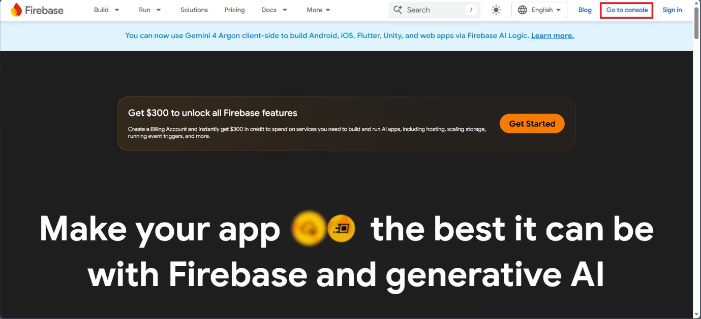
Figure 1. Firebase home page: click Go to console (choose Sign in if you are not logged in)
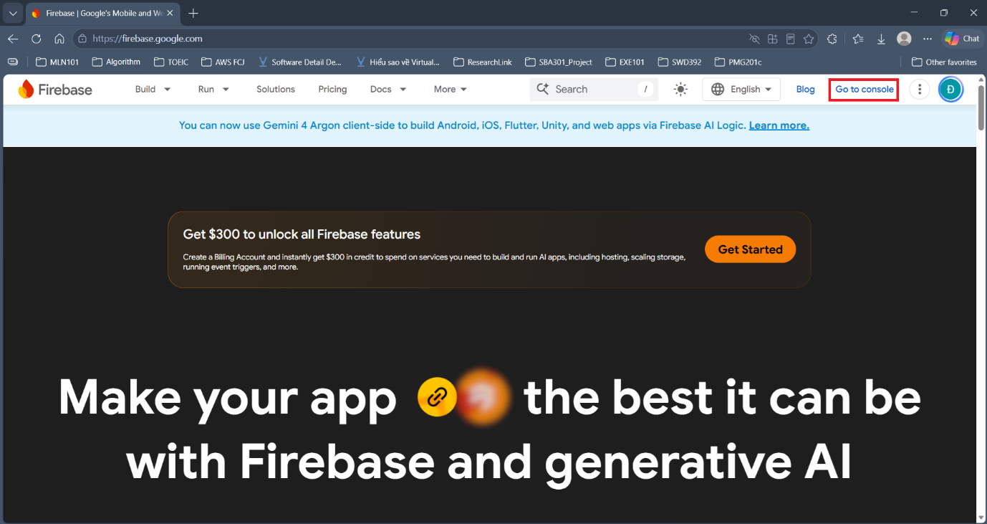
Figure 2. Logged in (avatar at top right): click Go to console
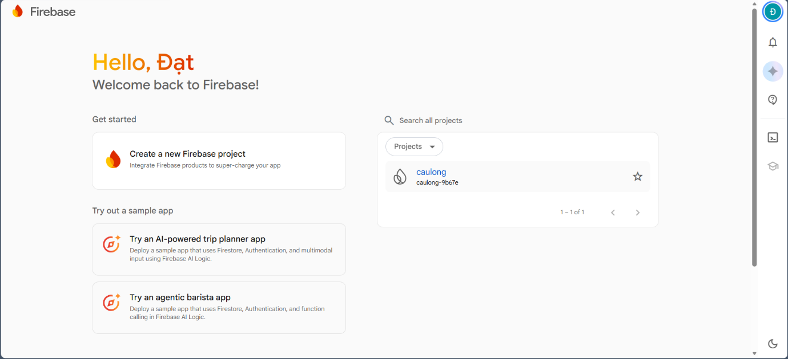
Figure 3. In the Firebase Console, click Create a new Firebase project
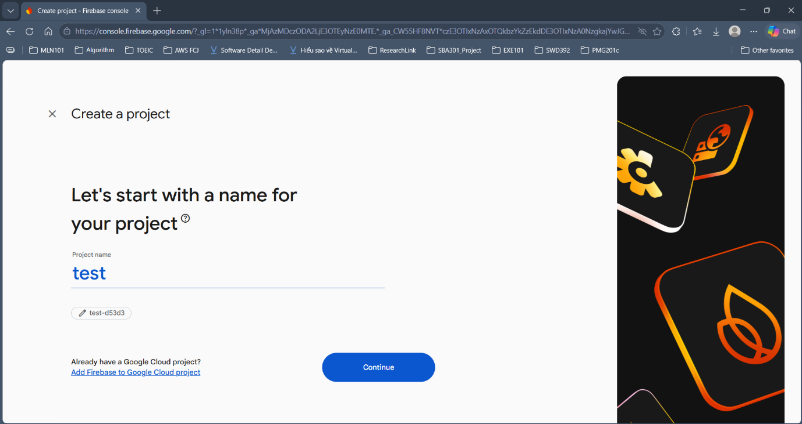
Figure 4. Enter a project name (e.g. test), then click Continue
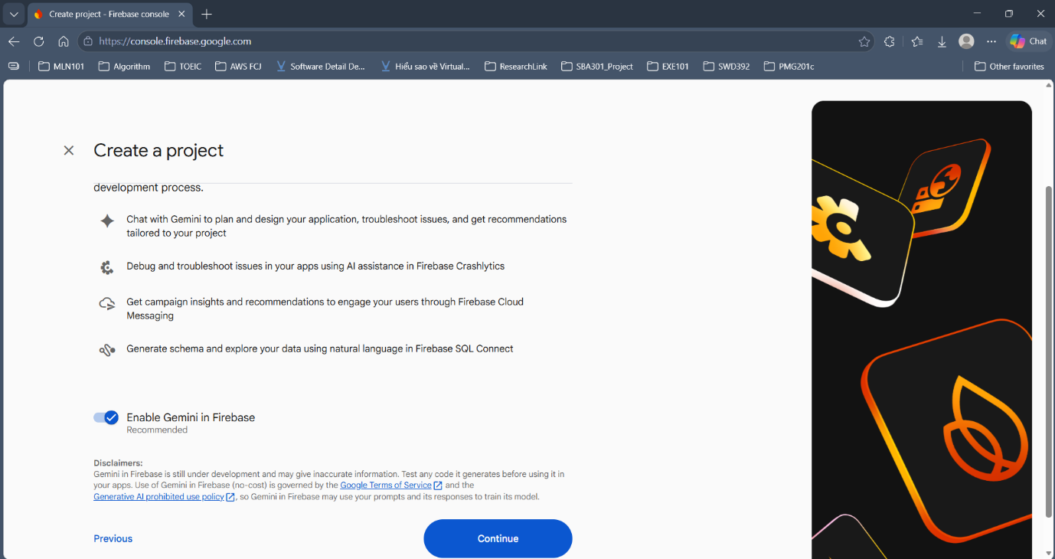
Figure 5. Gemini in Firebase step: keep the default and click Continue
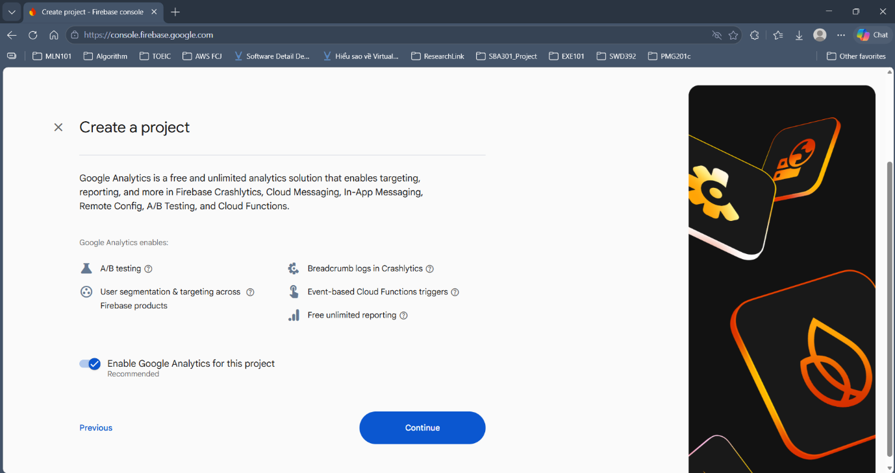
Figure 6. Google Analytics step (can be turned off): click Continue
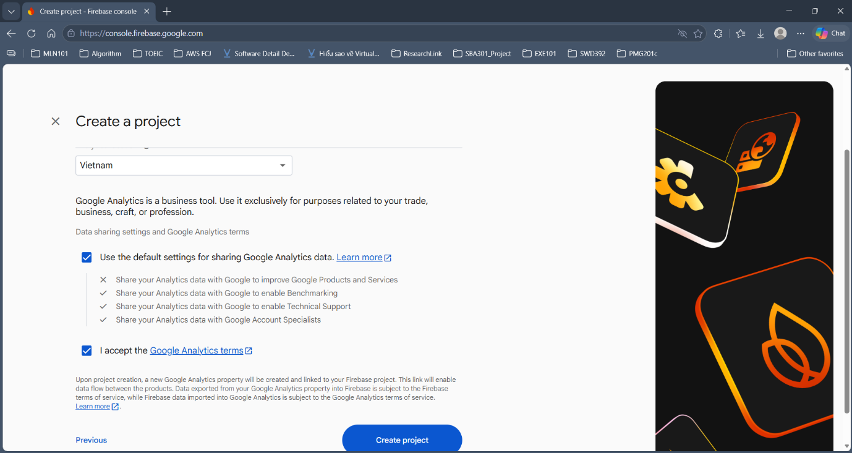
Figure 7. Choose a country, accept the terms, then click Create project
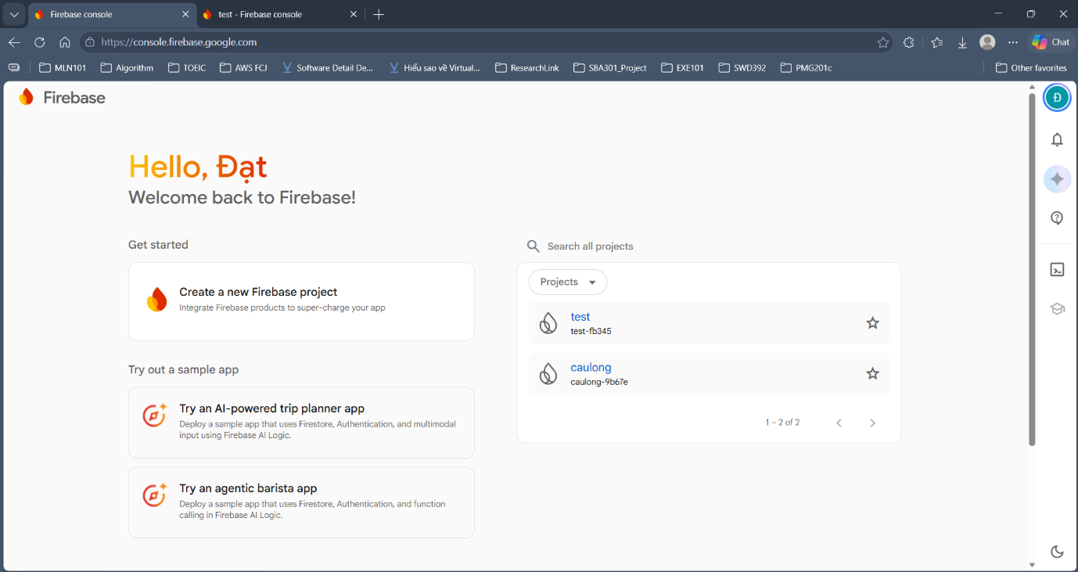
Figure 8. The new project appears in the project list

Step 2. Enable Authentication: Email/Password and Google
- In Project Overview, open Security → Authentication (Figure 9), then click Get started (Figure 10).
- On the Sign-in method tab, choose Email/Password (Figure 11) and turn on the first switch. You do not need *Email link*. Click Save.
- Choose Google (Figure 12), turn on Enable, choose the *Project support email* and click Save (Figure 13).
Note: Email/Password is for Exercise 2 and Google is for Exercise 1. If you forget the *support email*, Google sign-in fails with ApiException: 12500.
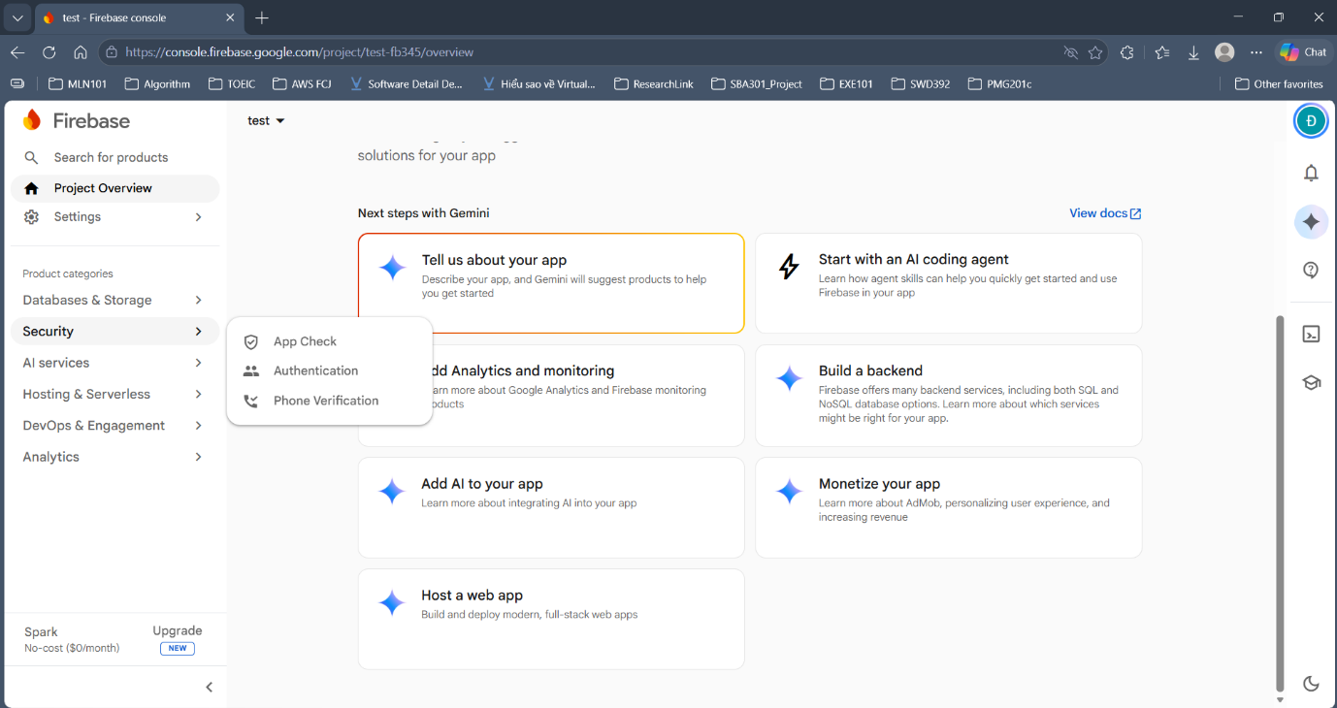
Figure 9. Open Authentication from the Security menu
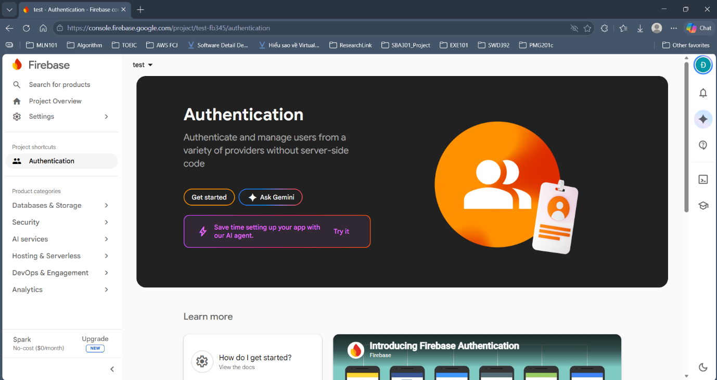
Figure 10. Authentication page: click Get started
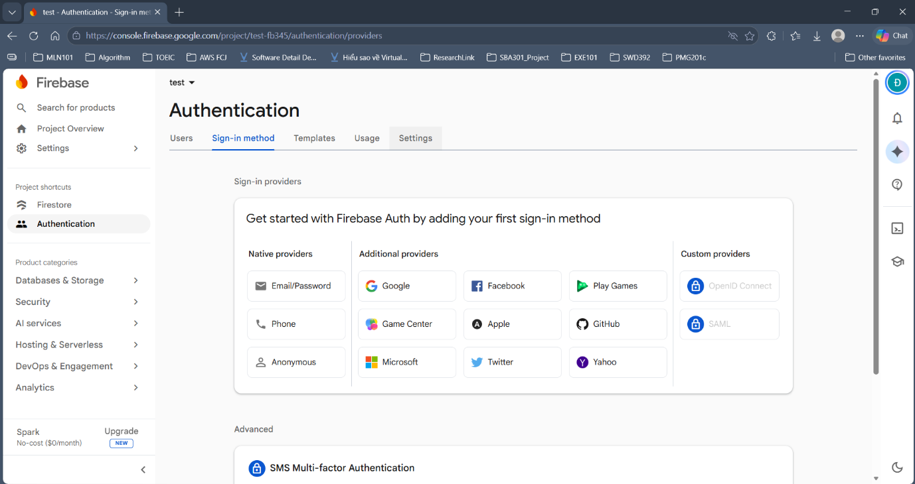
Figure 11. Sign-in method tab: choose Email/Password to enable it
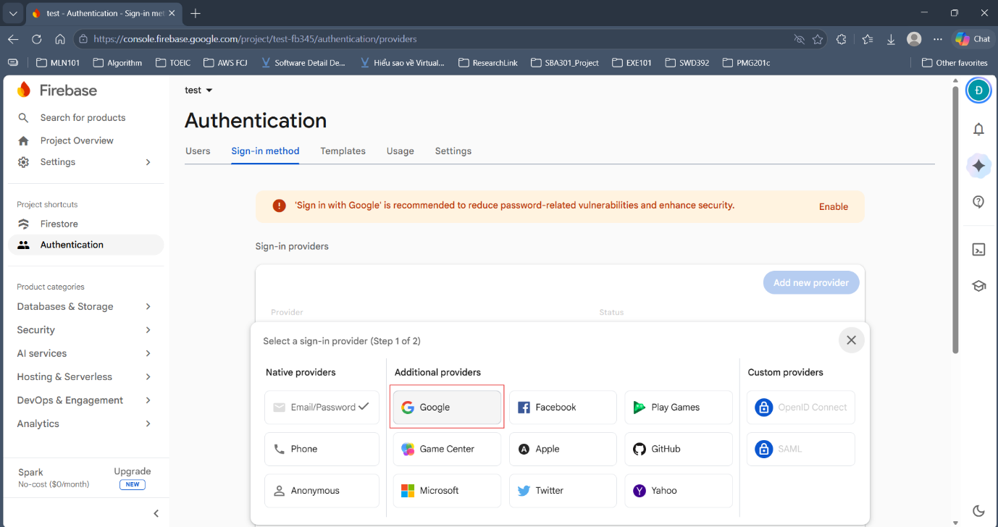
Figure 12. Choose Google in the provider list (Email/Password already has a tick)
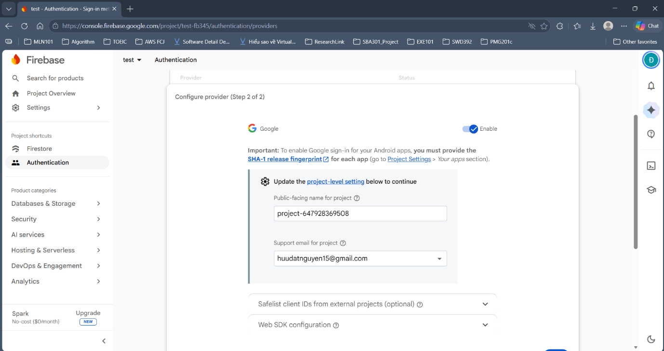
Figure 13. Turn on Enable, choose a Support email, then click Save

Step 3. Create the Firestore Database
- Open Databases & Storage → Firestore and click Create database (Figure 14).
- Choose Standard edition and click Next (Figure 15).
- Keep the Database ID as (default). Choose a location close to Vietnam, e.g. asia-southeast1 (Singapore), then click Next (Figure 16).
- Choose Start in production mode and click Next (Figure 17).
- The *Scheduled backups (optional)* screen can be skipped; click Create (Figure 18).
- When the database is ready, switch to the Rules tab (Figure 19).
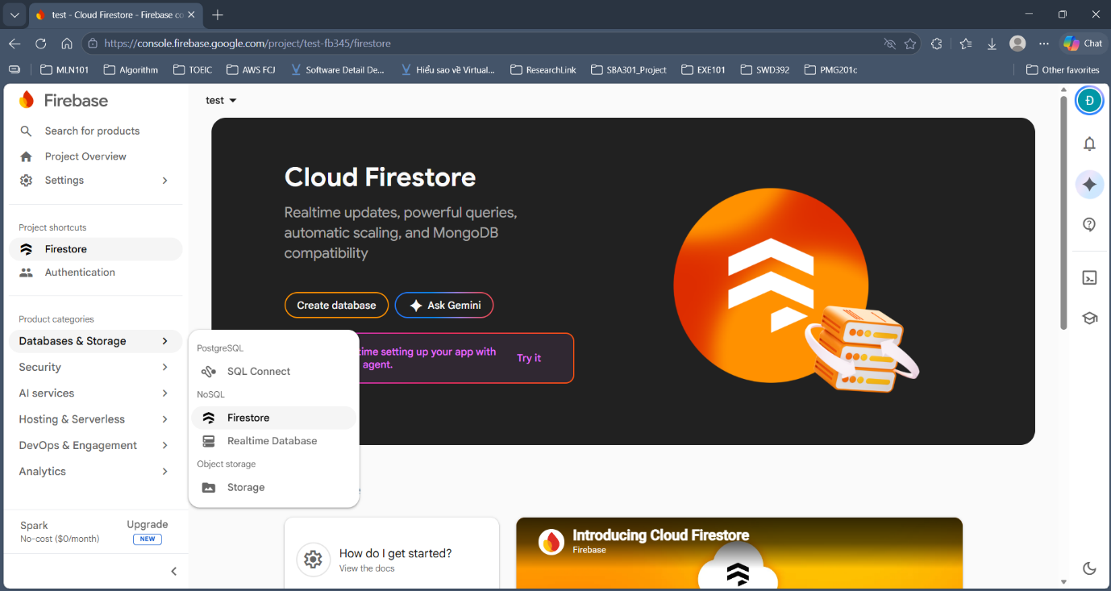
Figure 14. Open Firestore from the Databases & Storage menu, then click Create database
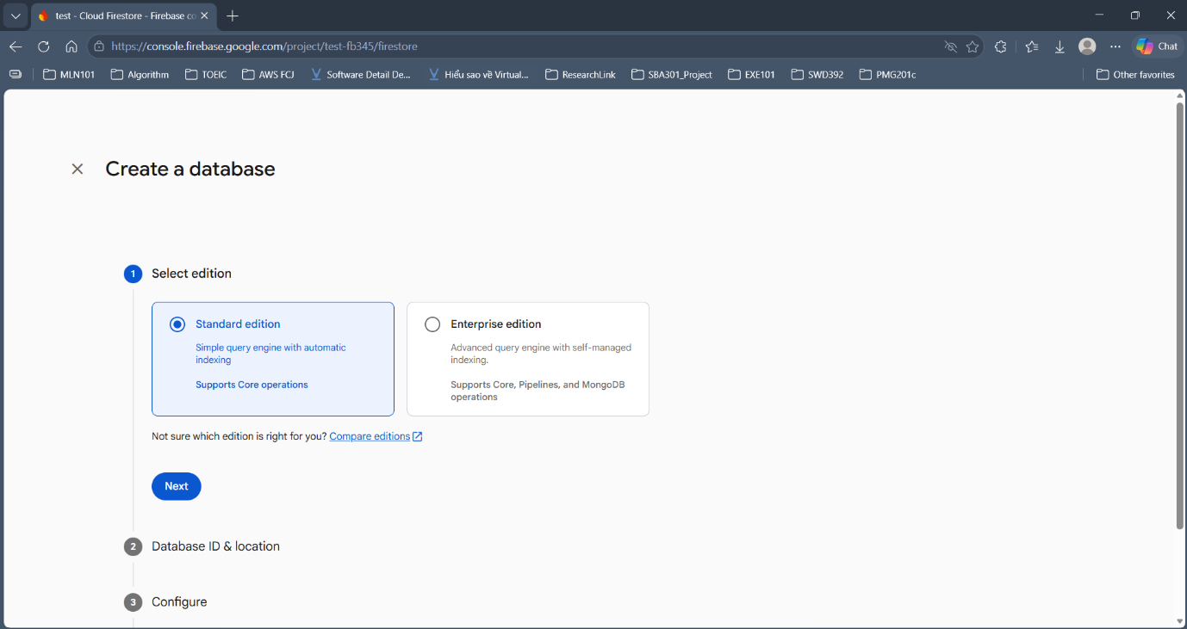
Figure 15. Choose Standard edition, then click Next
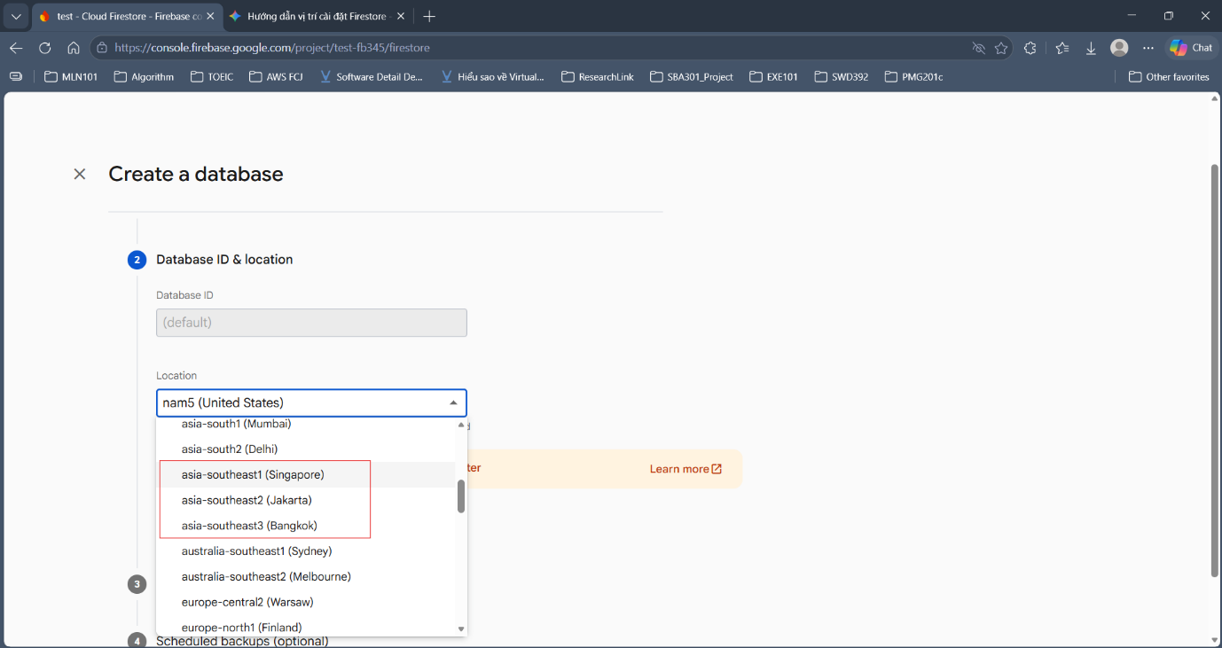
Figure 16. Keep Database ID as (default), choose location asia-southeast (Singapore, Jakarta or Bangkok)
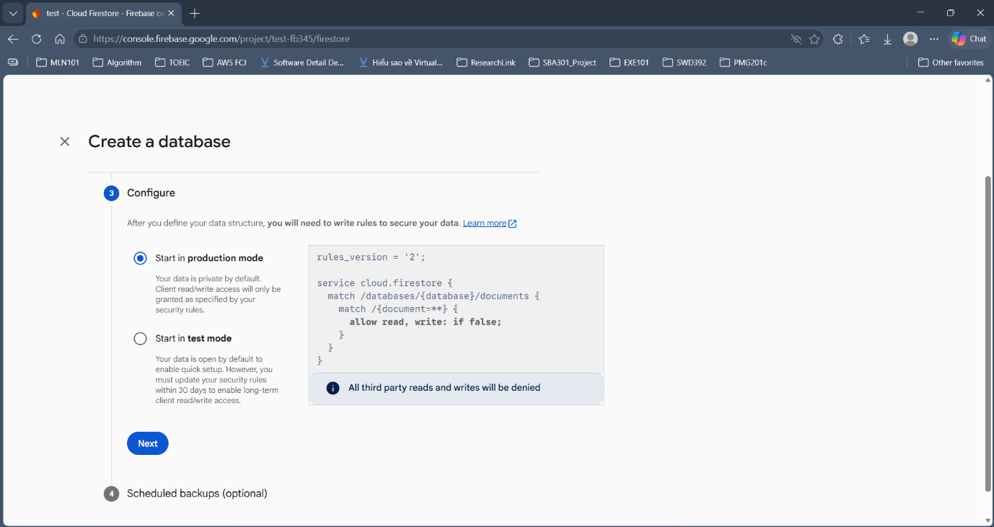
Figure 17. Choose Start in production mode, then click Next
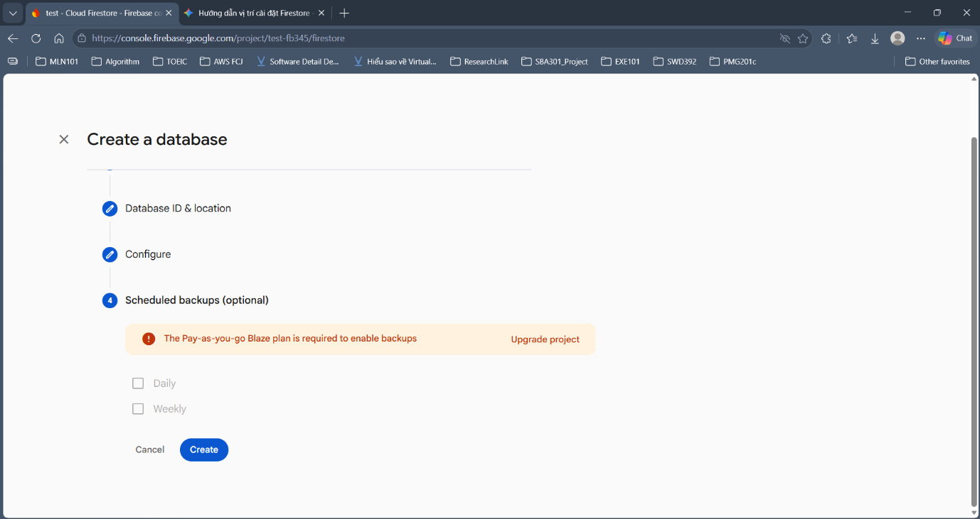
Figure 18. Skip Scheduled backups (optional), click Create
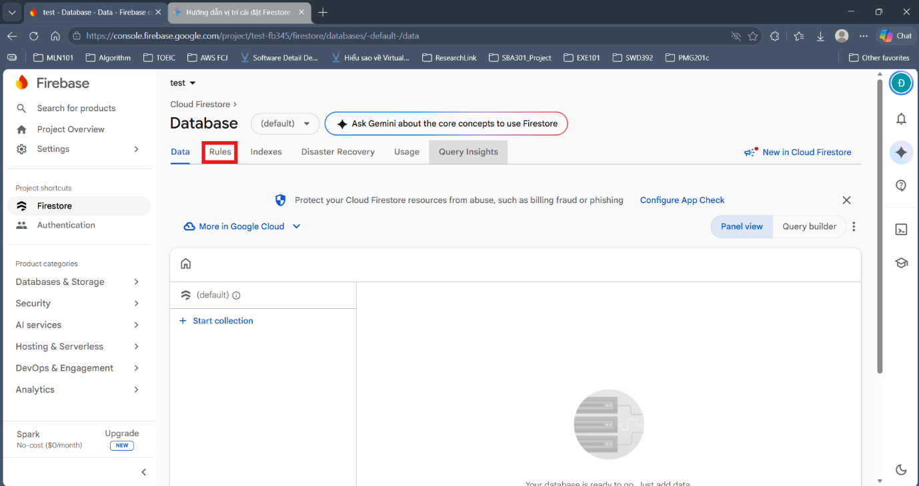
Figure 19. Database created: open the Rules tab

Step 4. Publish the Firestore Security Rules
- The Rules tab contains the default content, which denies all access (Figure 20).
- Delete the default content, paste the whole firestore.rules file of the project (below) and click Publish (Figure 21).
- Check that the rules were published (Figure 22).
rules_version = '2';

service cloud.firestore {
match /databases/{database}/documents {

// User profile: only the owner can read/write.
match /users/{uid} {
allow read, write: if request.auth != null && request.auth.uid == uid;
}

// Marks an email as registered (duplicate check BEFORE sending the OTP).
// - get: allowed when signed out (the user is registering)
// - list: denied, to avoid listing all emails
// - create: only when signed in (i.e. after the account is created)
match /registered_emails/{key} {
allow get: if true;
allow list: if false;
allow create: if request.auth != null;
allow update, delete: if false;
}
}
}

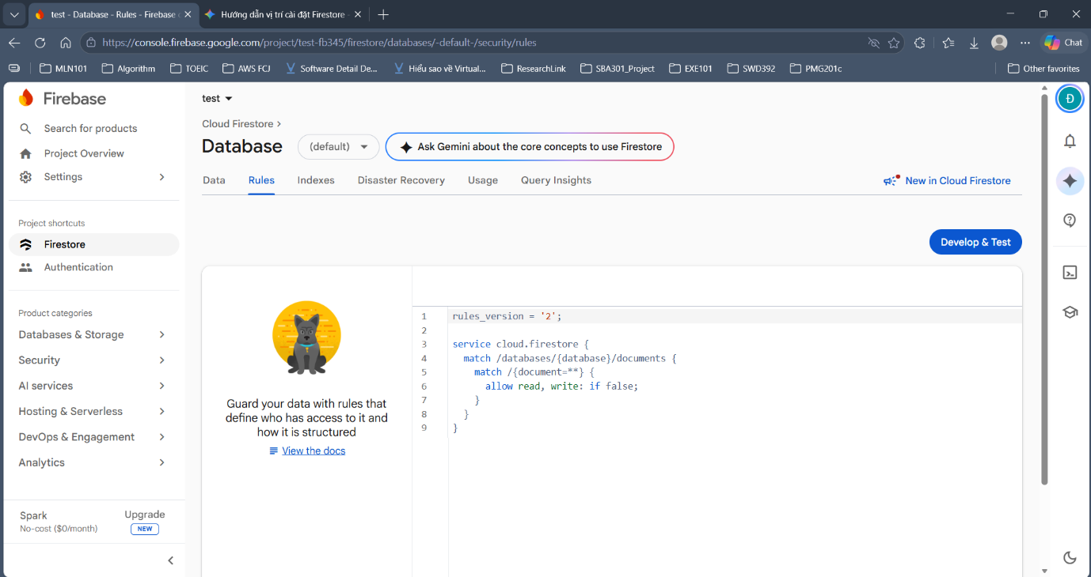
Figure 20. Default rules deny all access
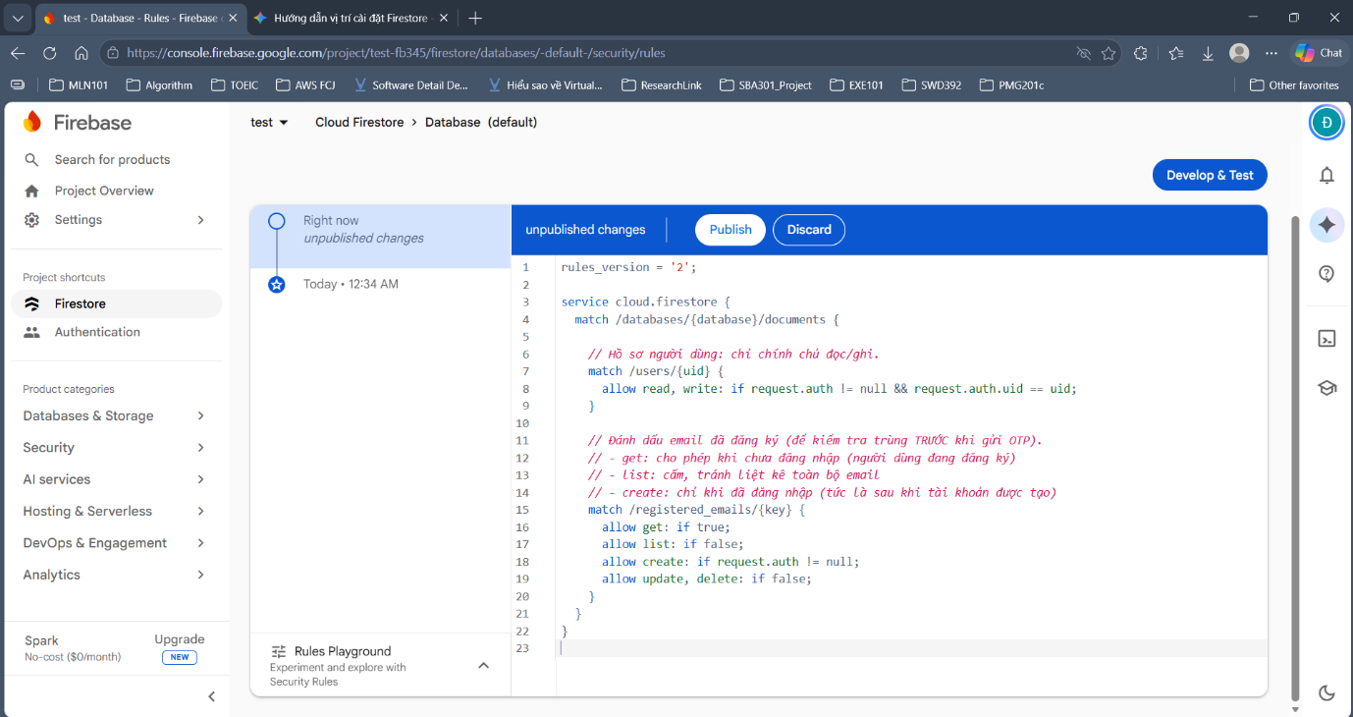
Figure 21. Paste the project rules, then click Publish
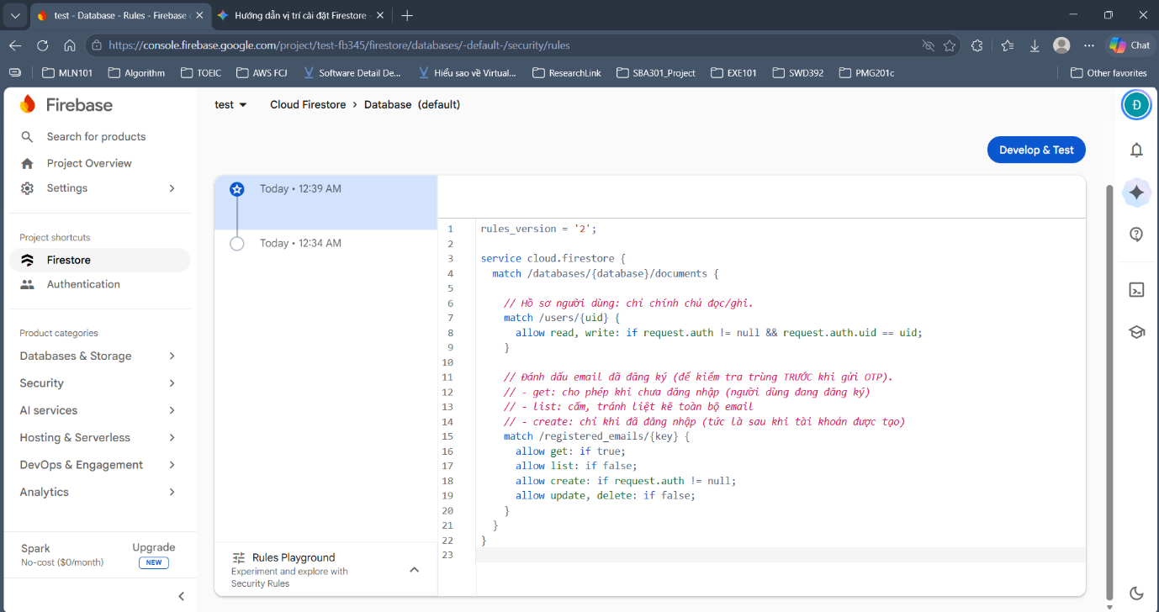
Figure 22. Rules published (a new version appears in the history)

Step 5. Get the SHA-1 / SHA-256 of the build machine
The SHA is required for Google Sign-In to work on Android. There are 2 ways to get it:
Option 1 – using Gradle:
cd android
./gradlew signingReport # Windows CMD/PowerShell: .\gradlew signingReport

Find the Variant: debug block and copy the SHA1 and SHA-256 lines.
Option 2 – read the debug keystore directly:
keytool -list -v -alias androiddebugkey -storepass android -keypass android \
-keystore ~/.android/debug.keystore
# Windows: -keystore %USERPROFILE%\.android\debug.keystore

Note: every computer has a different debug keystore, so each team member must add the SHA of their own machine.

Step 6. Register the Android app and add the SHA
- In Project Overview, choose the Android icon (Figure 23).
- Android package name: com.example.flutter_otp_demo (must match applicationId in android/app/build.gradle.kts). Click Register app (Figure 24).
- After clicking Register app you can close (X) the instruction dialog: downloading the config file and adding the SDK are done in Step 7 and Step 8. The app now appears in Project Overview (Figure 25).
- Click the gear icon next to the app name to open Project settings (Figure 26).
- In Your apps (Android), click Add fingerprint (Figure 27), paste the SHA-1 and Save. Repeat for the SHA-256 (Figure 28).
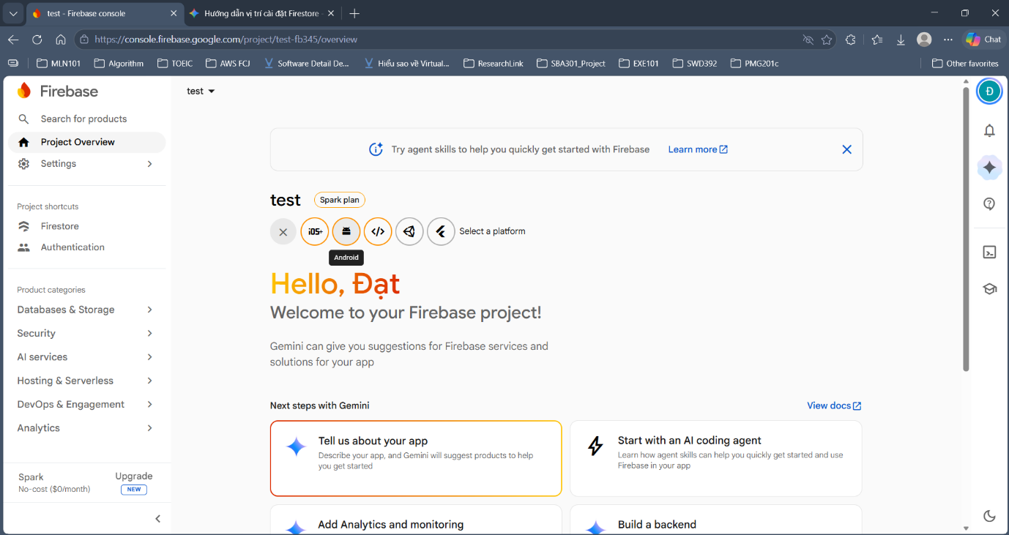
Figure 23. Project Overview: click the Android icon to add an app
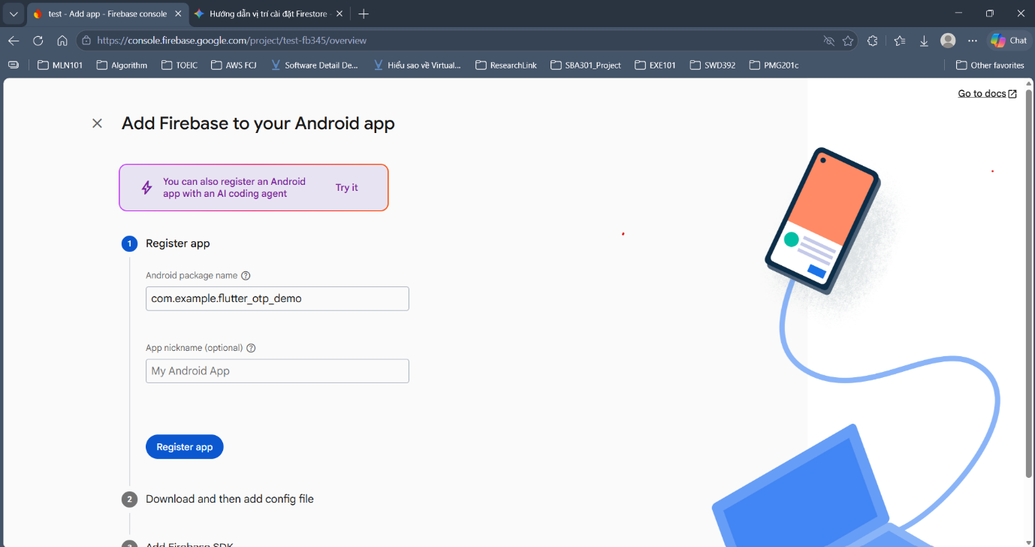
Figure 24. Enter the Android package name, then click Register app
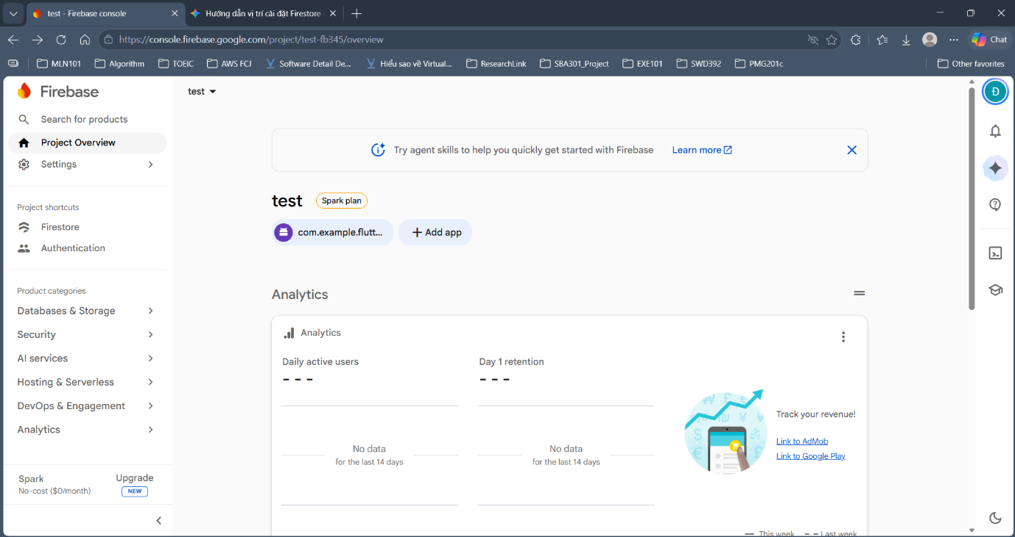
Figure 25. The Android app now appears in Project Overview
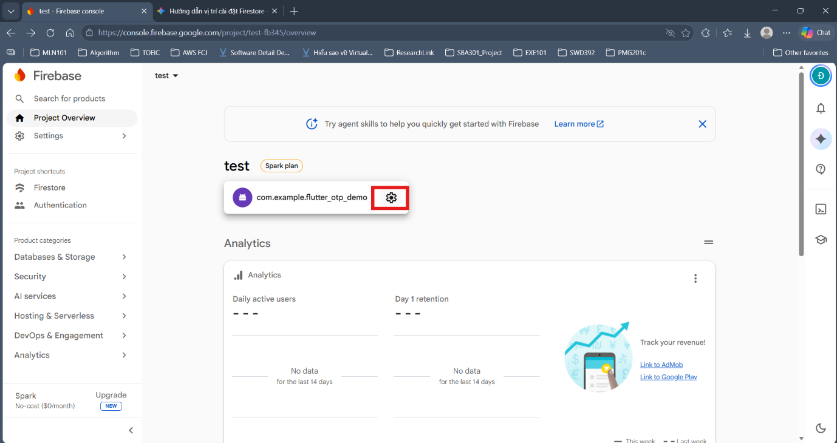
Figure 26. Click the gear icon next to the app name to open Project settings
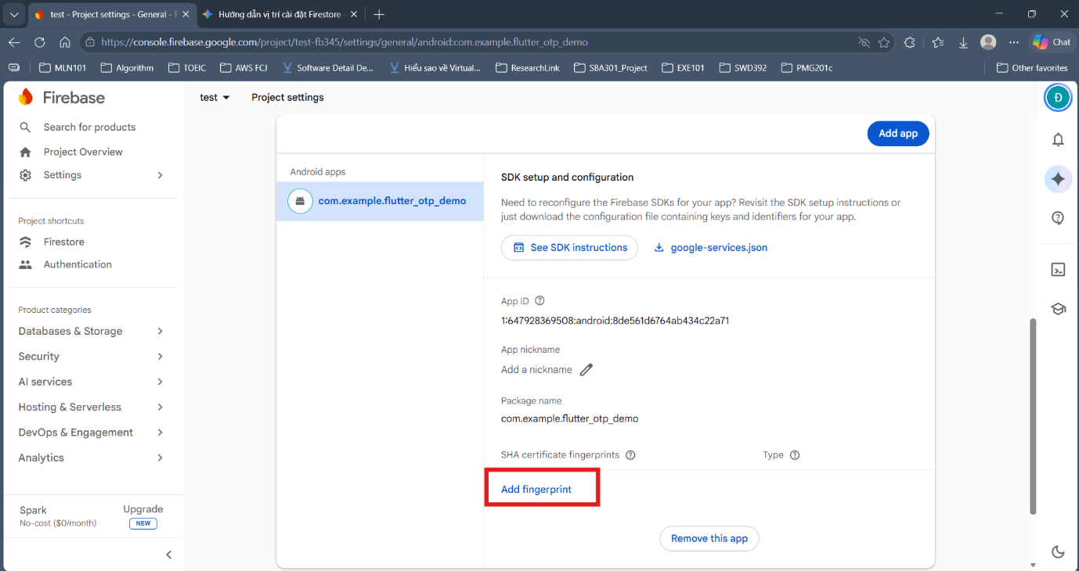
Figure 27. Your apps (Android) section: click Add fingerprint
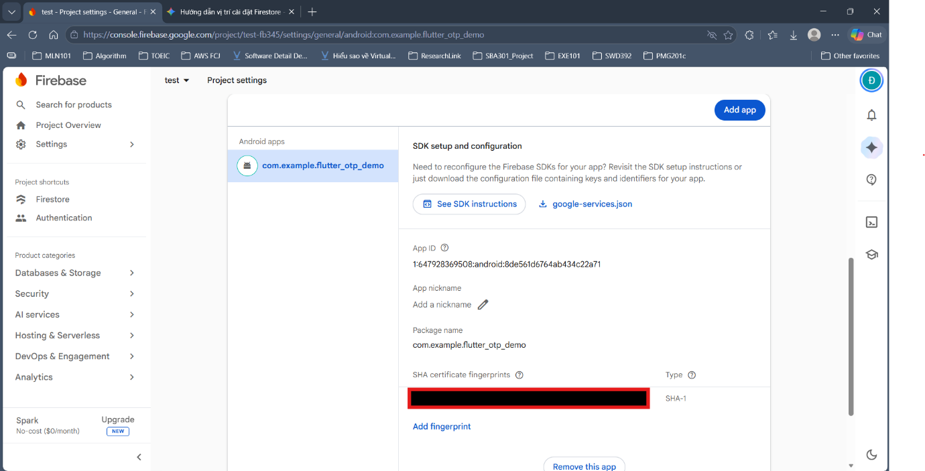
Figure 28. SHA-1 added (the value is masked in the screenshot)

Step 7. Connect the app to Firebase (generate the config file)
Do this AFTER Step 6 so that the config file contains the OAuth client for Google Sign-In.
flutterfire configure

- Choose the project you just created and tick the android platform (and ios if needed).
- When asked whether to update the Gradle configuration (Google Services plugin), choose yes.
Expected result:
File | Role
lib/firebase_options.dart | Replaces the placeholder file; contains apiKey, appId, projectId, etc.
android/app/google-services.json | Android configuration, contains the OAuth client for Google Sign-In
ios/Runner/GoogleService-Info.plist | Only present if iOS was selected
firebase.json | File that records the FlutterFire configuration

Manual way (no Firebase CLI / FlutterFire CLI needed) – Android only
- Firebase Console → *Project settings → Your apps (Android)* → Download google-services.json and place it at android/app/google-services.json.
- Overwrite lib/firebase_options.dart with the code below, replacing the values taken from google-services.json according to the mapping table.
Field in FirebaseOptions | Taken from google-services.json
apiKey | client[0].api_key[0].current_key
appId | client[0].client_info.mobilesdk_app_id
messagingSenderId | project_info.project_number
projectId | project_info.project_id
storageBucket | project_info.storage_bucket

import 'package:firebase_core/firebase_core.dart' show FirebaseOptions;
import 'package:flutter/foundation.dart'
show defaultTargetPlatform, kIsWeb, TargetPlatform;

class DefaultFirebaseOptions {
DefaultFirebaseOptions._();

static FirebaseOptions get currentPlatform {
if (kIsWeb) {
throw UnsupportedError('Firebase is not configured for Web.');
}
switch (defaultTargetPlatform) {
case TargetPlatform.android:
return android;
default:
throw UnsupportedError(
'Firebase is not configured for $defaultTargetPlatform. '
'Run "flutterfire configure" and select this platform.',
);
}
}

static const FirebaseOptions android = FirebaseOptions(
apiKey: 'AIza...', // current_key
appId: '1:123456789:android:abcdef...', // mobilesdk_app_id
messagingSenderId: '123456789', // project_number
projectId: 'project-name', // project_id
storageBucket: 'project-name.firebasestorage.app',
);
}

The manual way only configures Android. To run iOS you still need flutterfire configure (or add a static const FirebaseOptions ios from GoogleService-Info.plist). After adding a new SHA in Step 6, remember to download `google-services.json` again.

Step 8. Check the Google Services plugin in Gradle
GoogleSignIn() in auth_service.dart does not pass serverClientId, so on Android the com.google.gms.google-services plugin is required to read google-services.json. Open the two files below; if flutterfire configure has not added it, add the lines marked with the comment add.
Firebase shows the same changes in its *Add Firebase SDK* step (Figure 29). This project uses Kotlin DSL files (.kts), so write them in the form below.
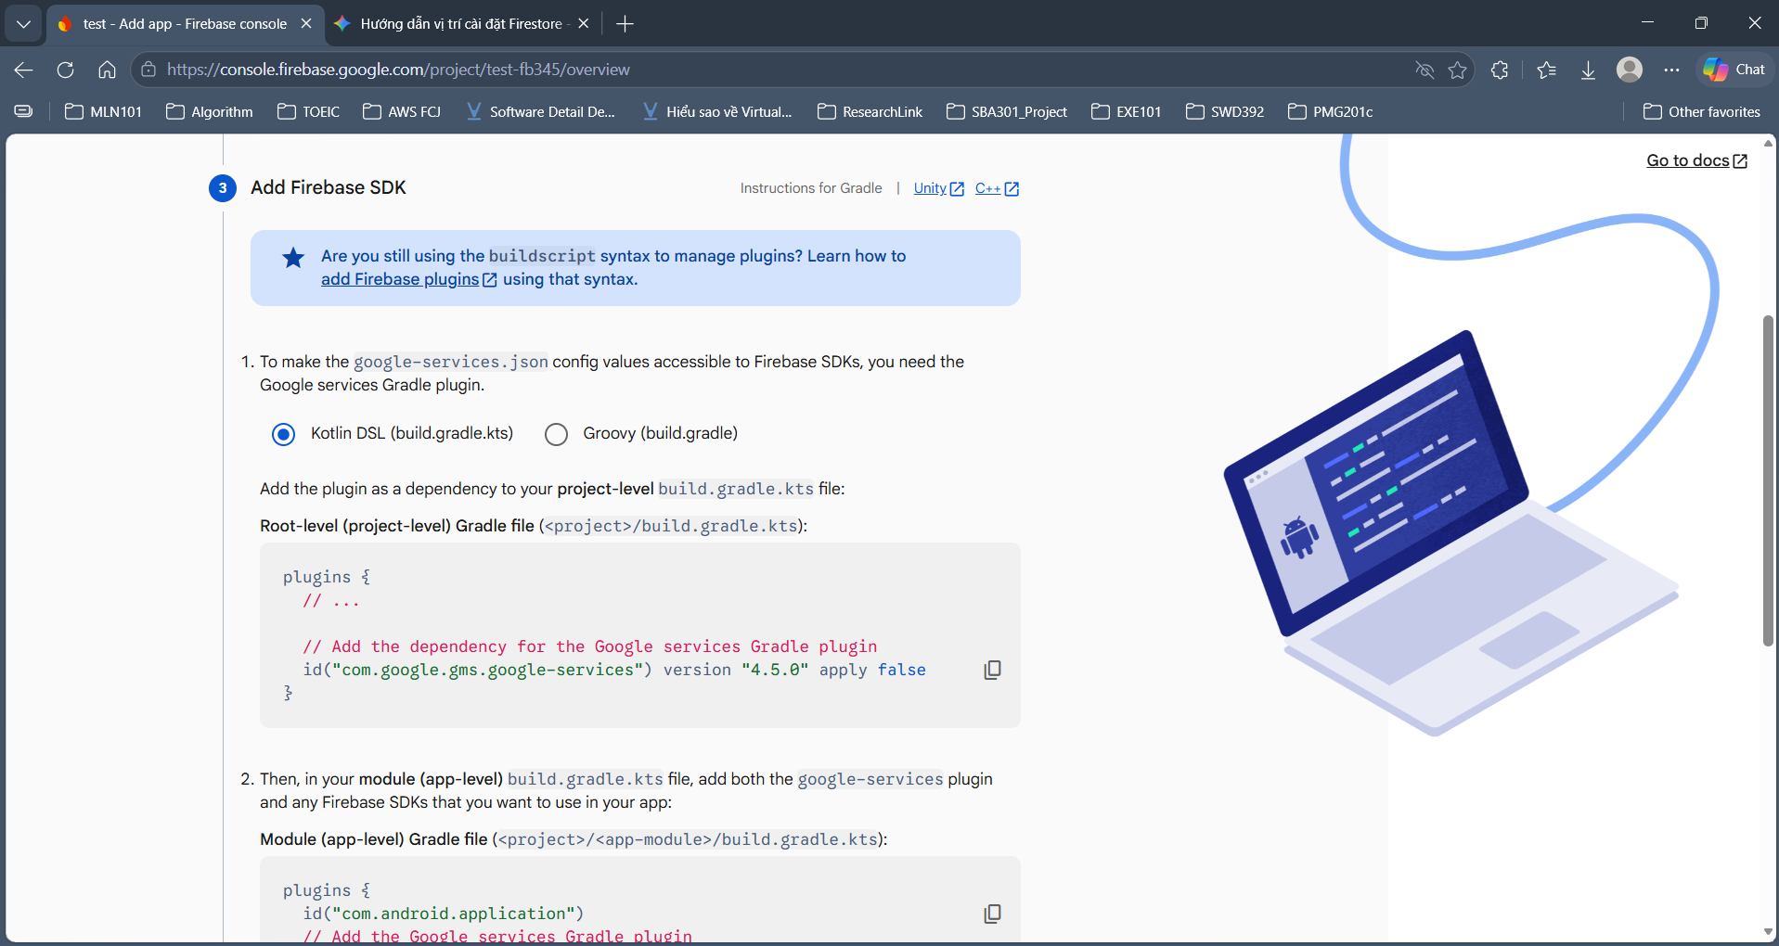
Figure 29. Firebase suggests adding the Google services plugin to the two Gradle files (done automatically if flutterfire configure was answered yes)
android/settings.gradle.kts:
plugins {
id("dev.flutter.flutter-plugin-loader") version "1.0.0"
id("com.android.application") version "..." apply false
id("org.jetbrains.kotlin.android") version "..." apply false
id("com.google.gms.google-services") version "4.4.2" apply false // add
}

android/app/build.gradle.kts:
plugins {
id("com.android.application")
id("com.google.gms.google-services") // add
id("dev.flutter.flutter-gradle-plugin")
}

If the build reports a minSdk error, set minSdk = 23 in android/app/build.gradle.kts. If you run iOS, see the URL scheme (REVERSED_CLIENT_ID) section in the project README.md.

Step 9. Run the app and sign in with Google
Start an Android emulator (or plug in a phone with *USB debugging* enabled):
flutter emulators # list available emulators
flutter emulators --launch <emulator_id> # e.g. Pixel_7
flutter devices # an android device must appear

The emulator must use a system image with Google Play (Play Store icon in Device Manager), otherwise Google sign-in fails with ApiException: 12500. The first time on an emulator you need to sign in to a Google account in *Settings*.
flutter clean
flutter pub get
flutter run # choose the android device if asked (not Chrome/Edge)

The first Android build is slow (5–10 minutes) because Gradle downloads dependencies. Later builds are much faster. Flutter Web is not supported.
Verify:
- On the Login screen, tap Sign in with Google and choose an account. The app opens the Home screen showing name, email and the Google label.
- Firebase Console → Authentication → Users: a new user with the Google provider.
- Firebase Console → Firestore → users: a document users/{uid} whose providers contains google.com.
- Tap Sign out: the app returns to the Login screen.

Expected Output
- Google sign-in succeeds and the Home screen shows the account information
- A new user appears in Authentication → Users
- A document users/{uid} exists in Firestore
- Signing out returns to the Login screen

Evidence to submit
- Screenshot of the Home screen after Google sign-in
- Screenshots of Authentication → Users and Firestore → users

Exercise 2 – Integrate email OTP into registration

Goal
Finish the email-sending configuration and verify the OTP in the registration flow.

Description
The app generates a 6-digit OTP and sends it to the registering email through Gmail SMTP. The Firebase account is created only when the correct OTP is entered. Students configure SMTP, run the test scenarios and study the OTP security rules. This exercise needs the Firebase setup from Exercise 1.

Steps
- Create a Gmail App Password
- Fill the SMTP settings into app_config.dart
- Run the app and register with a real email
- Run the OTP test scenarios
- Study the OTP security rules in the source code
- Run the OTP unit tests

Detailed instructions

Step 1. Create a Gmail App Password
- On the Gmail account used to send the OTP, turn on 2-Step Verification.
- Open https://myaccount.google.com/apppasswords and create an App password (16 characters).

Step 2. Fill the SMTP settings into app_config.dart
Edit lib/config/app_config.dart:
static const String smtpUser = 'your_name@gmail.com';
static const String smtpAppPassword = 'abcd efgh ijkl mnop';

- The App Password has 16 letters; with or without spaces (as Google displays it) are both accepted.
- Do not use your normal Gmail sign-in password: Gmail rejects it (535 Username and Password not accepted).
Security: the App Password sits in the source code. Do not push app_config.dart with the real password to a public GitHub repository. If it leaks, go to https://myaccount.google.com/apppasswords, delete that password and create a new one.
SMTP not configured? The app still runs in *dev mode*: the email is not sent, the OTP is printed to the Debug Console / logcat, and the OTP screen shows a matching message.

Step 3. Run the app and register with a real email
flutter run

- On the Login screen, tap Register and enter a name, an email you can access and a password (at least 8 characters, letters and digits).
- The OTP email arrives within a few seconds (also check the Spam folder).
- If sending fails, an error message appears on screen and in the Debug Console.

Step 4. Run the OTP test scenarios
# | Action | Expected result
1 | Register a new email | Receive an email with a 6-digit OTP
2 | Enter a wrong OTP | Error shown with the remaining attempts
3 | Enter a wrong OTP 5 times | The code is cancelled and must be resent
4 | Wait more than 5 minutes, then enter it | Expired message
5 | Enter the correct OTP | Account created, back to the Login screen (email pre-filled)
6 | Register the same email again | Email-already-exists message, no OTP sent
7 | Sign in with email + password | Home screen with the profile from Firestore
8 | Sign out, then sign in with Google | Home screen, Google profile saved in Firestore (Exercise 1)

Check the data in the Firebase Console: Authentication → Users and Firestore → users / registered_emails.

Step 5. Study the OTP security rules in the source code
Read lib/config/app_config.dart and lib/services/otp_service.dart and compare with the table below:
Rule | Value | Location in source
Code length | 6 digits | AppConfig.otpLength
Validity period | 5 minutes | AppConfig.otpTtl
Maximum wrong attempts | 5 attempts | AppConfig.maxOtpAttempts
Resend cooldown | 60 seconds | AppConfig.resendCooldown
Secure random generation | Random.secure | OtpService.generate
Only the hash is stored | SHA-256 + salt | OtpService
Single use | A correct entry cancels the code | OtpService.verify

Differences between this demo and a real system:
- The OTP is generated and checked inside the app, so a technical user can tamper with it. A real system must generate and verify the OTP on a server (Cloud Functions, own backend) and create the account only when the server confirms.
- The SMTP credentials are inside the app and can be extracted from the APK. In practice, send mail from a server or use a service such as SendGrid / the Firebase *Trigger Email* extension.
- The registered_emails collection allows only get (not list) to limit email enumeration; emails can still be probed one by one. This is a trade-off that makes the duplicate check possible before sending the OTP.
- The mailer package uses sockets, so it works on Android/iOS but not on Flutter Web.

Step 6. Run the OTP unit tests
flutter test

If flutter test reports a Counter increments smoke test error, delete the default test/widget_test.dart generated by flutter create.

Expected Output
- A 6-digit OTP email is delivered to the inbox
- A wrong, expired or more-than-5-times-wrong OTP is rejected with a suitable message
- A correct OTP creates the account and returns to the Login screen
- Registering the same email again is blocked and no OTP is sent
- Signing in with the newly registered email and password works
- flutter test passes

Evidence to submit
- Screenshot of the OTP email (mask the email address if needed) and of the OTP screen showing a wrong-code error
- Screenshots of Authentication → Users with the email/password user and of Firestore → registered_emails
- Screenshot of the flutter test result

7. Final Checklist
- lib/firebase_options.dart no longer contains the line FILE TẠM (placeholder)
- The file android/app/google-services.json exists and its package_name is com.example.flutter_otp_demo
- google-services.json has an oauth_client entry with client_type: 3 (if empty, the SHA was not added; redo Steps 5–7 of Exercise 1)
- The com.google.gms.google-services plugin was added to both Gradle files
- Authentication has Email/Password and Google enabled
- Firestore database created and the rules published
- Exercise 1: Google sign-in and sign-out work
- Exercise 2: real smtpUser and smtpAppPassword were filled in for testing (and restored to the sample values before submitting)
- Exercise 2: all 8 test scenarios give the expected result
- The default test/widget_test.dart was deleted and flutter test passes
- Naming and submission format follow the rules

8. Score Distribution (percentage)
- Exercise 1 – Firebase Google Sign-In integration: 60%
- Exercise 2 – Email OTP integration: 40%
Total: 100%

Appendix – Common Errors
Symptom | Cause / fix
The app shows a "Firebase not configured" screen | flutterfire configure was not run, so firebase_options.dart is still the placeholder
File google-services.json is missing during build | Put the file in android/app/ (not android/)
Google sign-in: PlatformException(sign_in_failed, ... ApiException: 10) | SHA-1 missing or wrong, or google-services.json was not downloaded again after adding the SHA
Google sign-in: ApiException: 12500 | *Support email* not chosen when enabling the Google provider, or the emulator has no Google Play
Nothing happens after tapping Google / default_web_client_id not found | The com.google.gms.google-services plugin is missing (Step 8)
[firebase_auth/operation-not-allowed] | Email/Password or Google was not enabled in Sign-in method
[cloud_firestore/permission-denied] | firestore.rules was not published
[cloud_firestore/not-found] / database (default) does not exist | The Firestore database was not created
OTP sending fails with 535 Username and Password not accepted | Wrong password (must be the App Password), or 2-Step Verification is not enabled
OTP email not received | Check the Spam folder; make sure smtpUser is the Gmail address that created the App Password
OTP only printed to the console, no email sent | smtpUser / smtpAppPassword are still the sample values
flutter test error Counter increments smoke test | Delete the default test/widget_test.dart
flutter run only shows Chrome / Edge | No Android emulator started or no phone connected
firebase: command not found after npm install -g | Reopen the terminal; check that the folder from npm prefix -g is in PATH
flutterfire: command not found | Add %LOCALAPPDATA%\Pub\Cache\bin (Windows) or ~/.pub-cache/bin to PATH
Failed to fetch your Firebase projects | Not logged in with firebase login, or logged in with the wrong account

