Create a Linux EC2 Instance

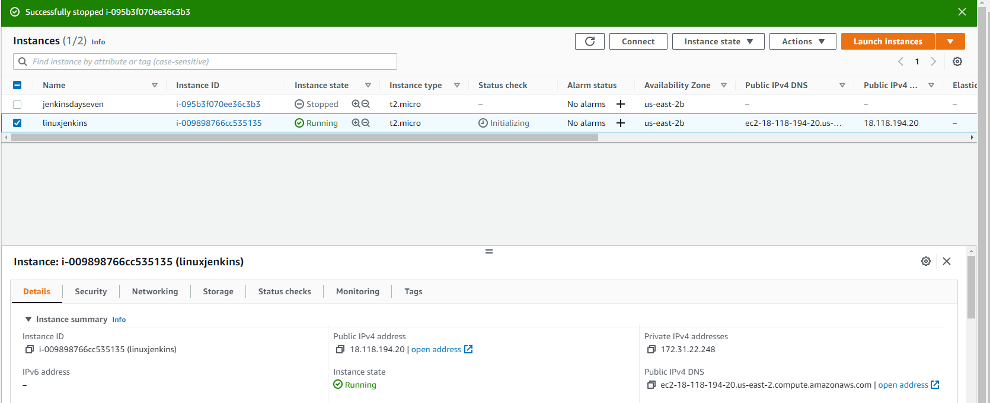

Download MobaXterm

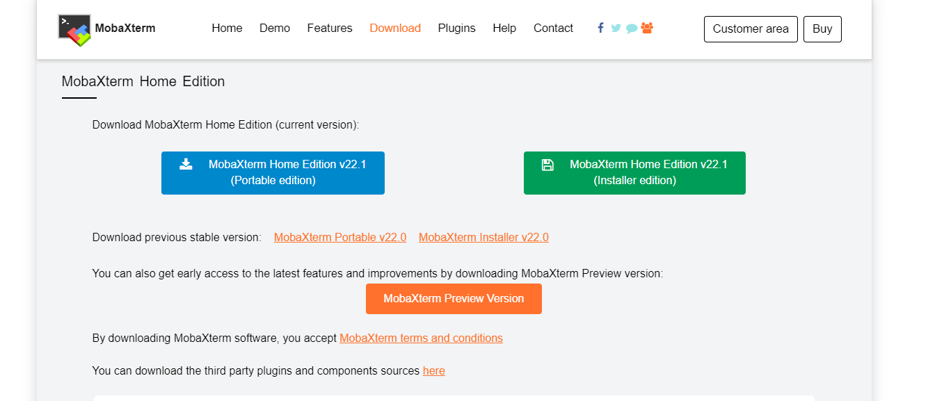

Connect to the instance

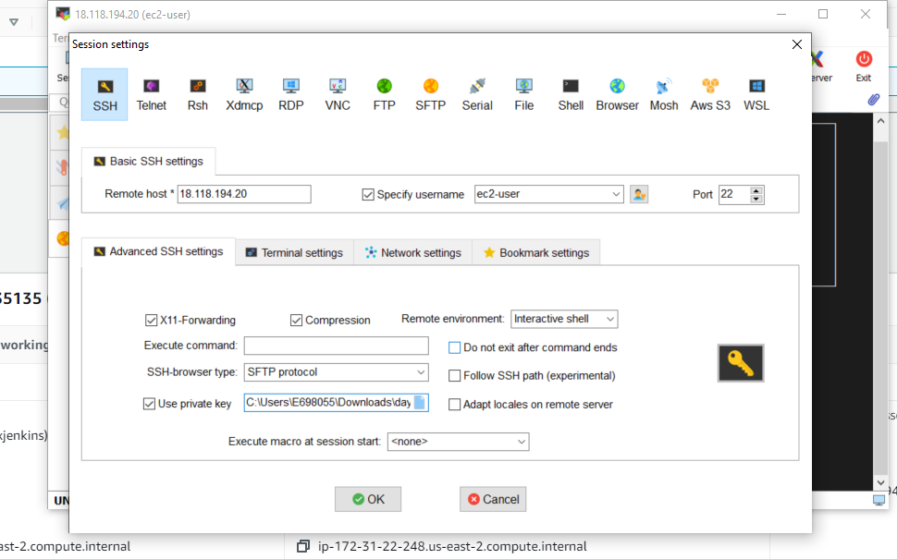

Connected to the instance

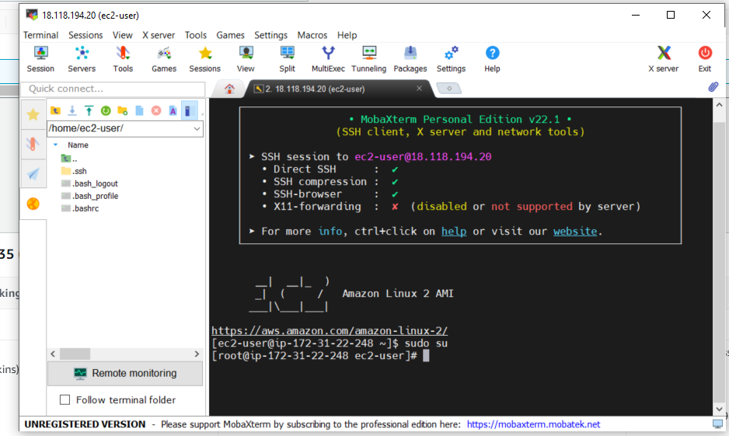

Add Jenkins to Repo

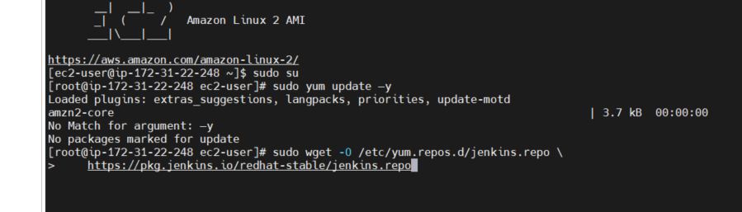

Import and upgrade Jenkins

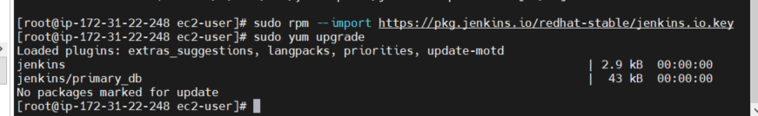

Install Java

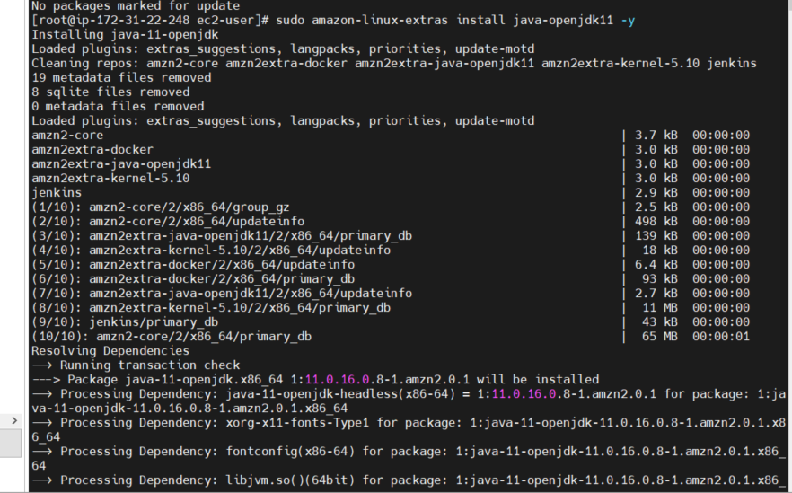

Install Jenkins

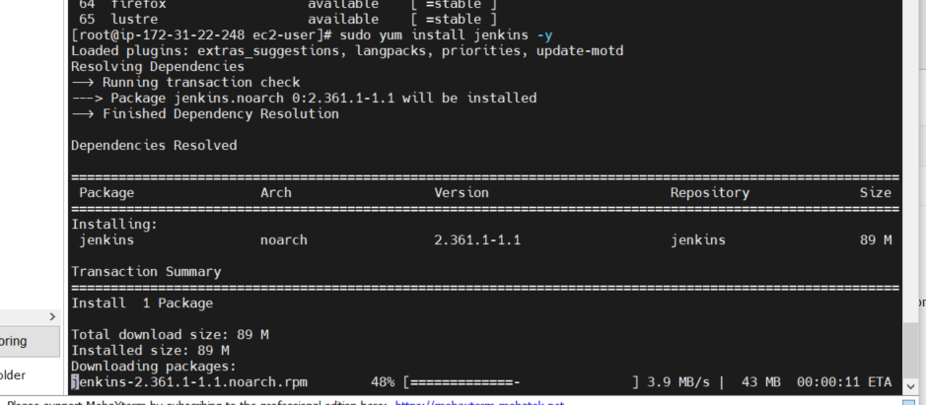

Create Jenkins Declarative Pipeline

Open Jenkins

Create Get Password and Create account.

Go to Manage Jenkins and Add Git and Maven

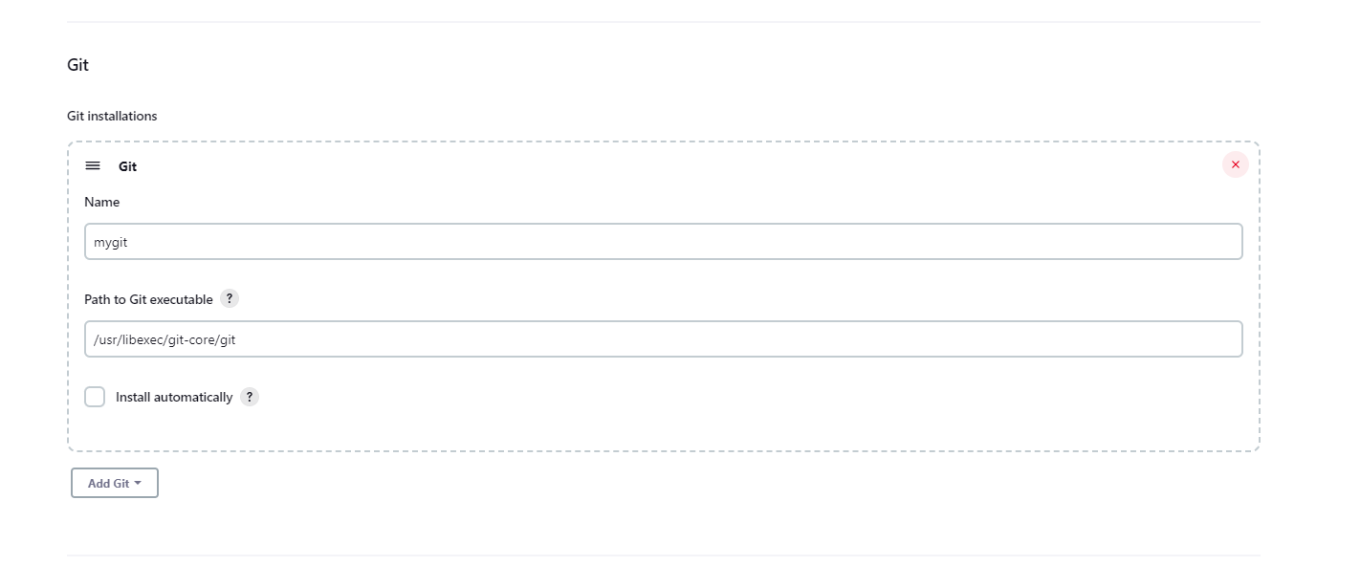

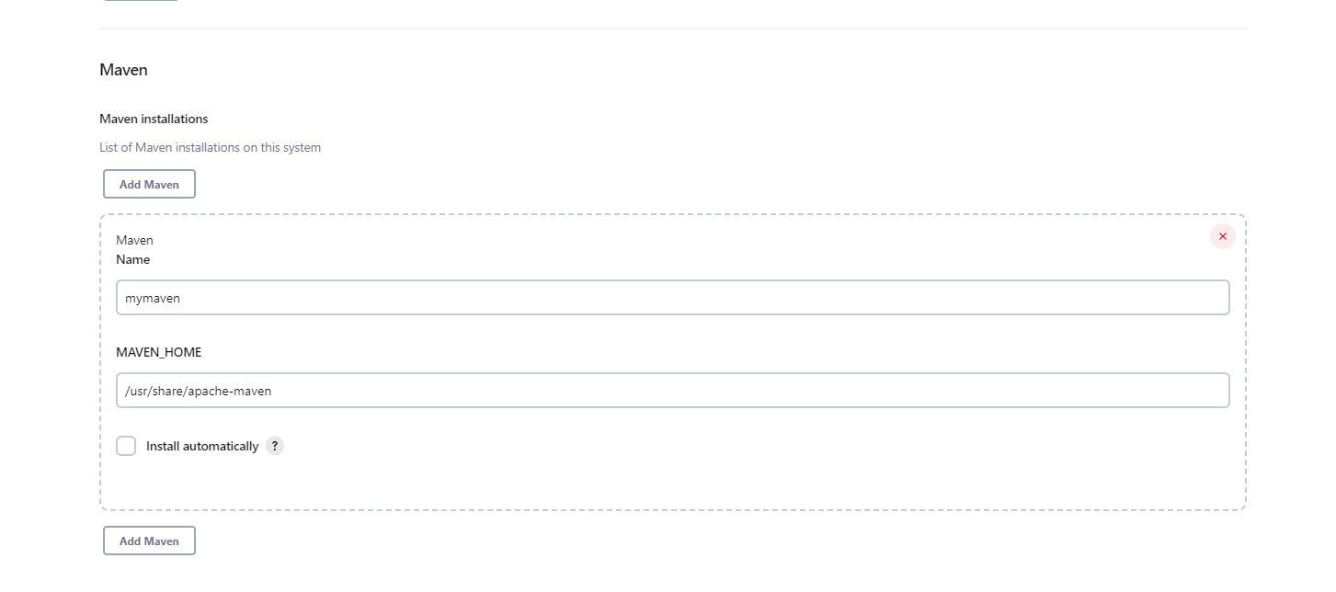

Create code-compile, code-test, code-quality and package items.

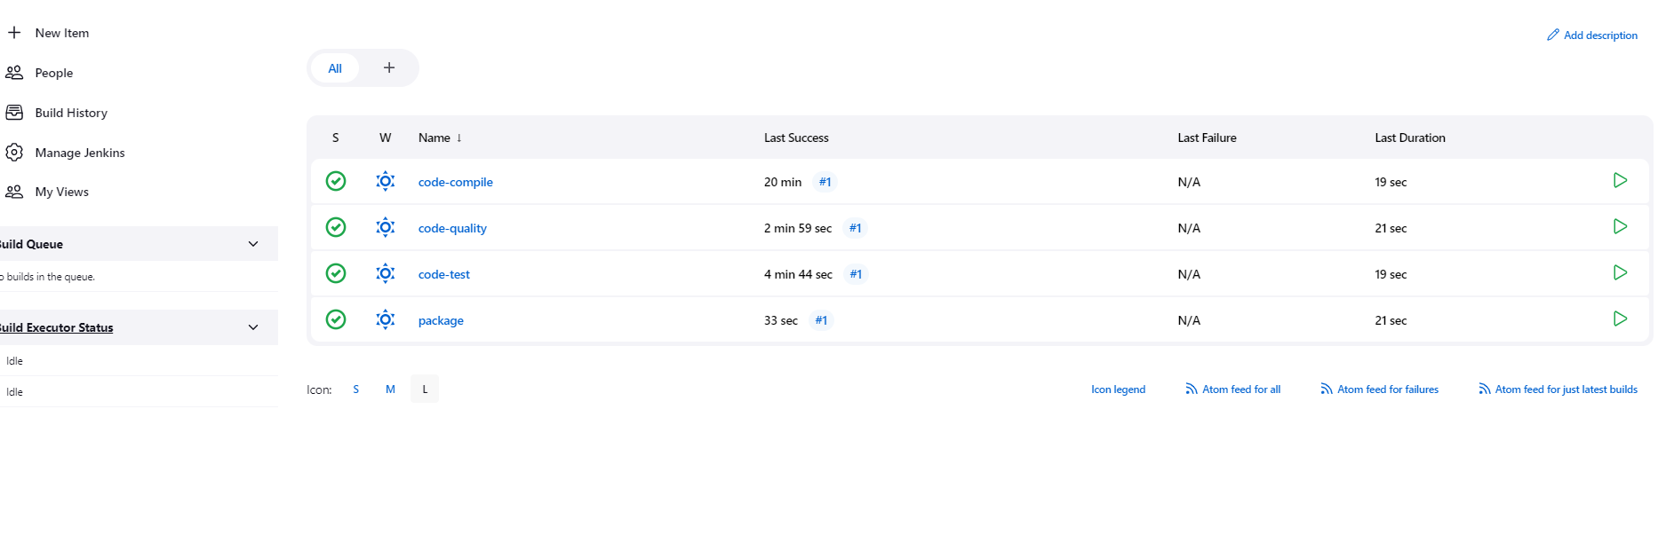

Install Build Pipeline Plugin

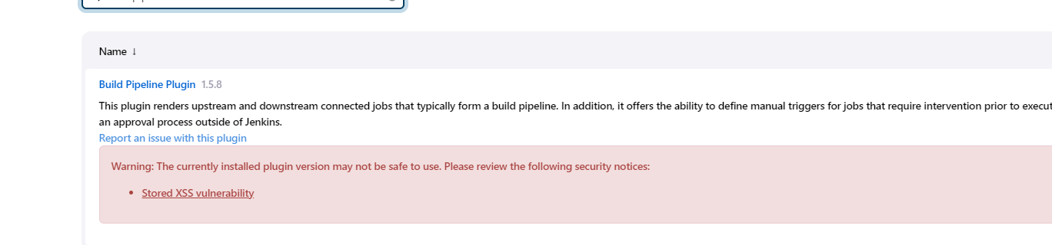

Build pipeline

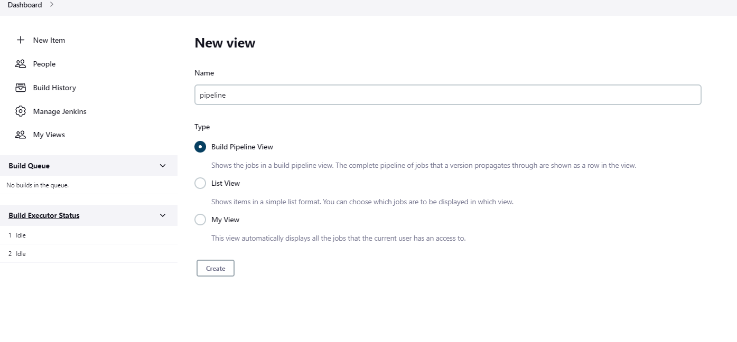

CI/CD Declarative Pipeline (Not sure why they’re not all green)

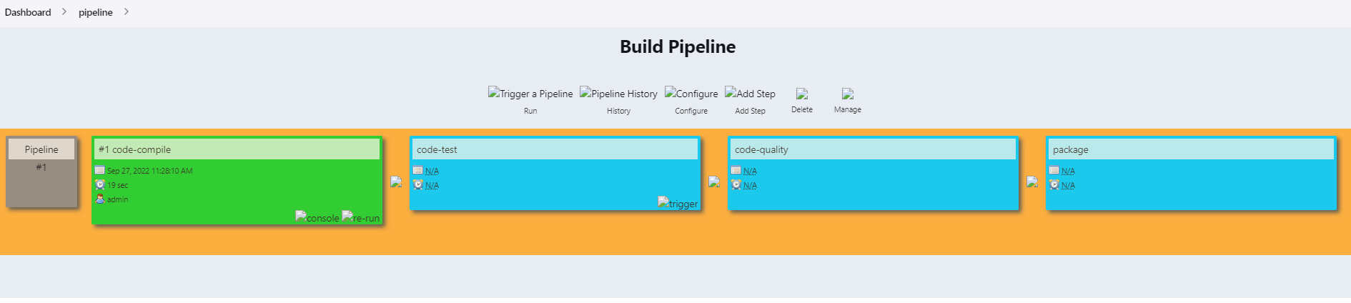

Create Jenkins Scripted Pipeline

Create scripted pipeline item

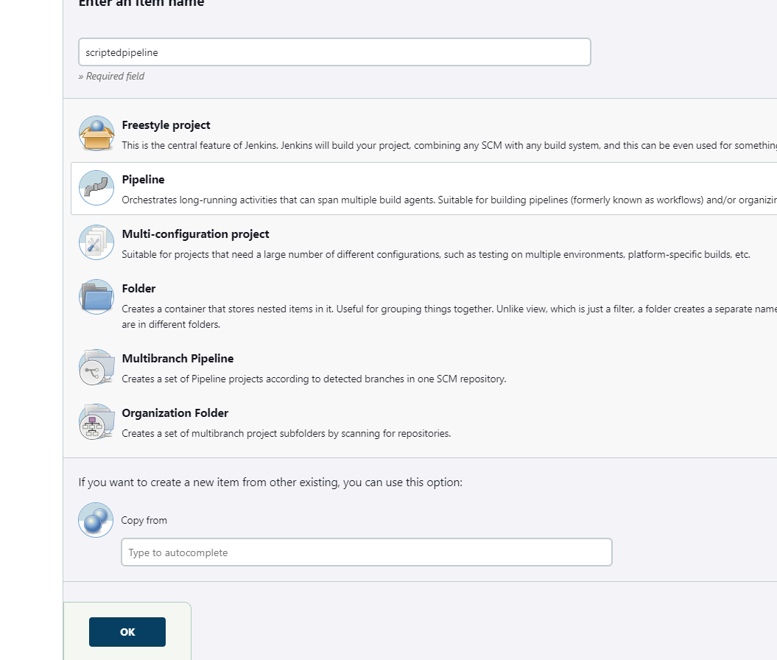

Add code for creating the pipeline

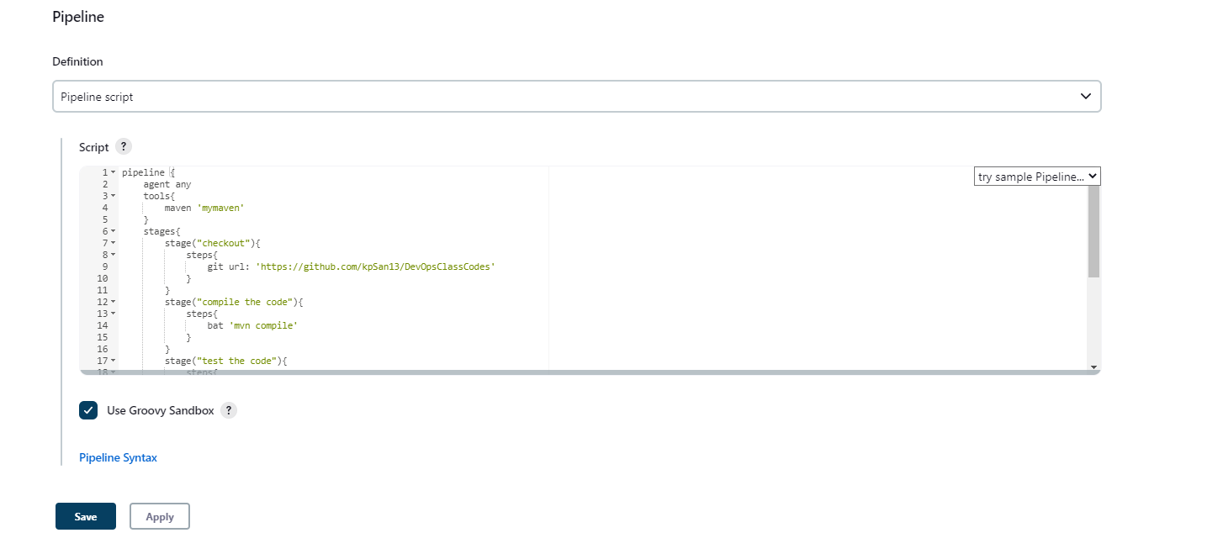

Scripted Pipeline

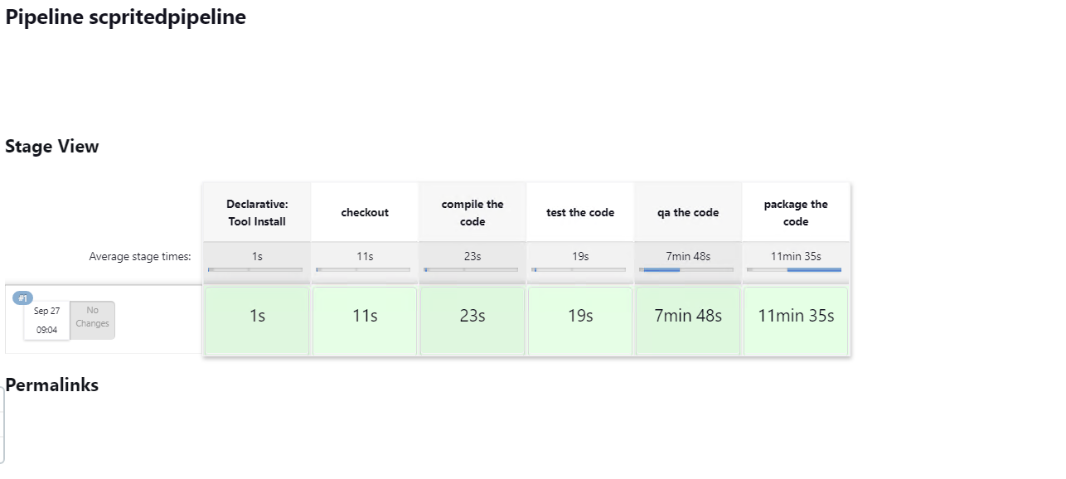

Console Output

