Docker Day 2 assignment

Question 2

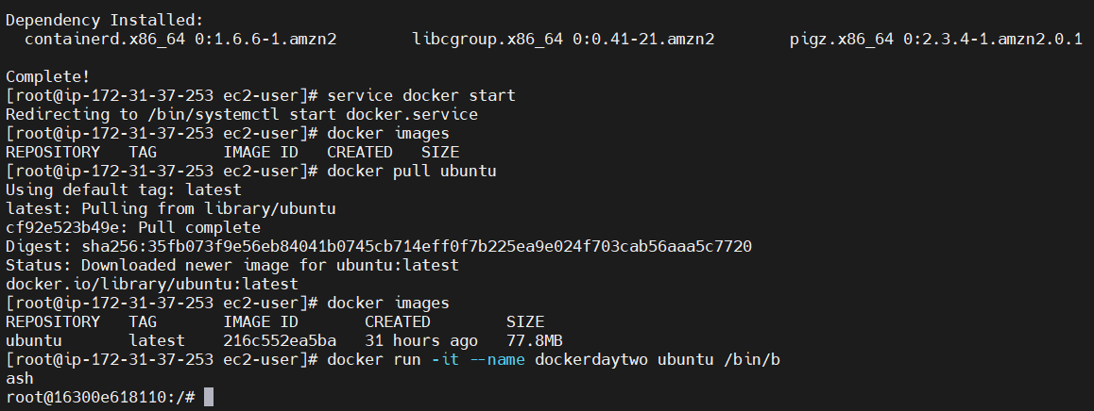

Install Docker and Start it

Pulled Ubuntu image

Created container called “dockerdaytwo”

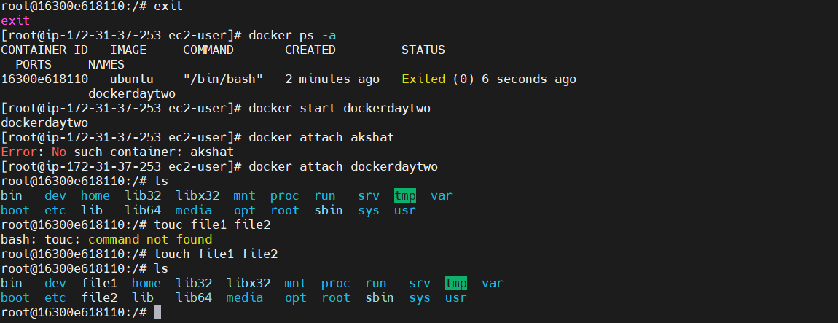

Exit container

Check your containers using “docker ps -a”

Start your container and attach it

Added file1 & file2

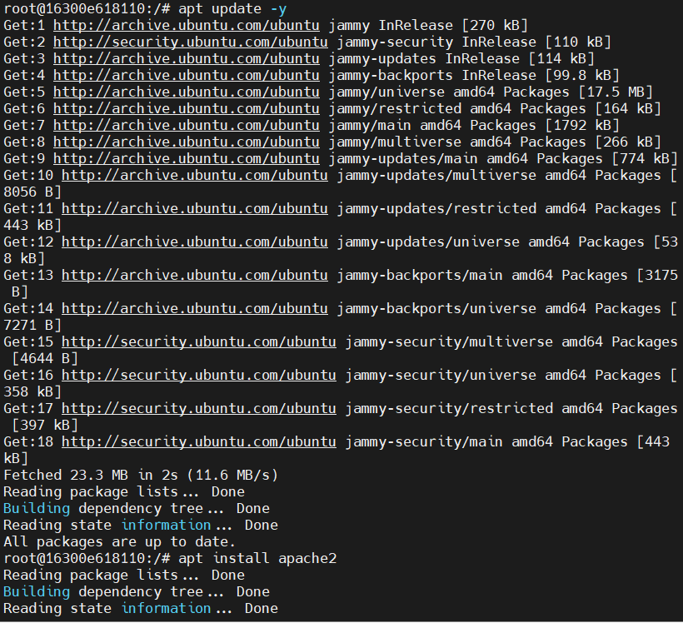

Update and install Apache

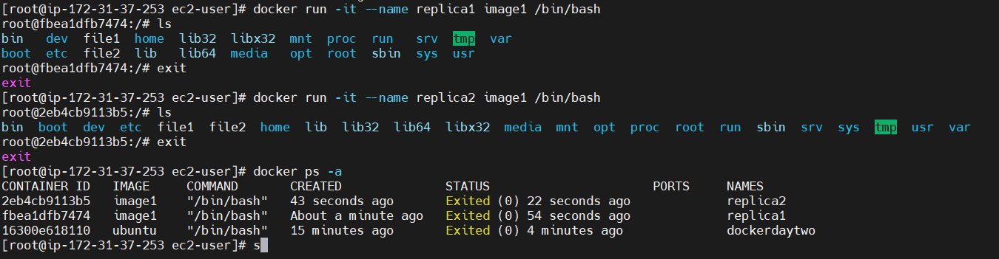

Create the replicas of dockerdaytwo.

You can see that replica1 and replica2 has file1 and file2 in them.

Question 3

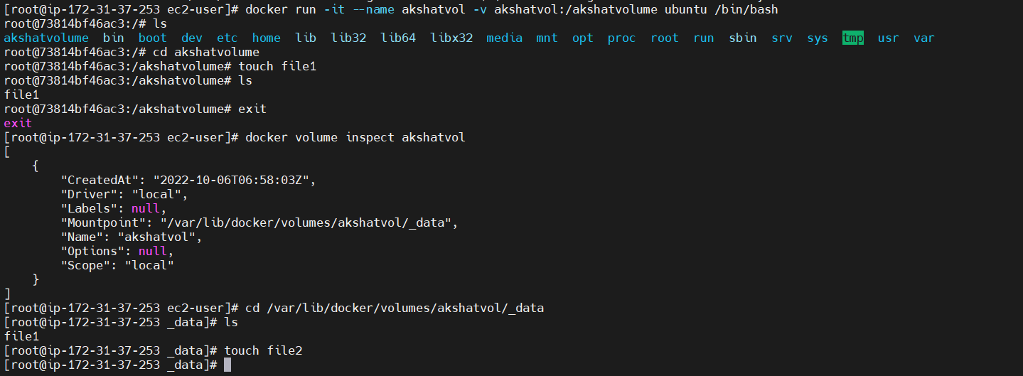

Create “akshatvolume”

And add some files to it

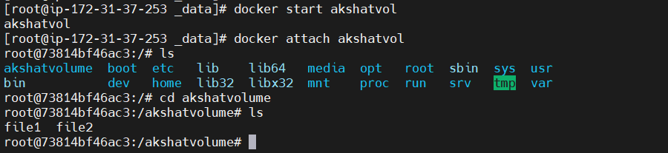

Start and attach the volume

Check the files , and go into akshatvolume to see file1 and file2

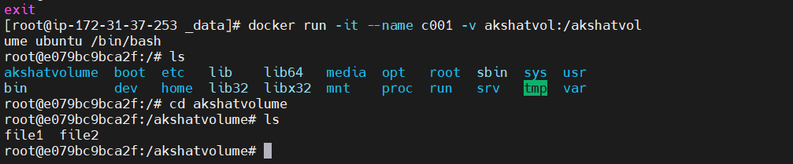

Created container c001 and shared akshatvolume to it

Check if volume and files are there.

Repeat 4 more times

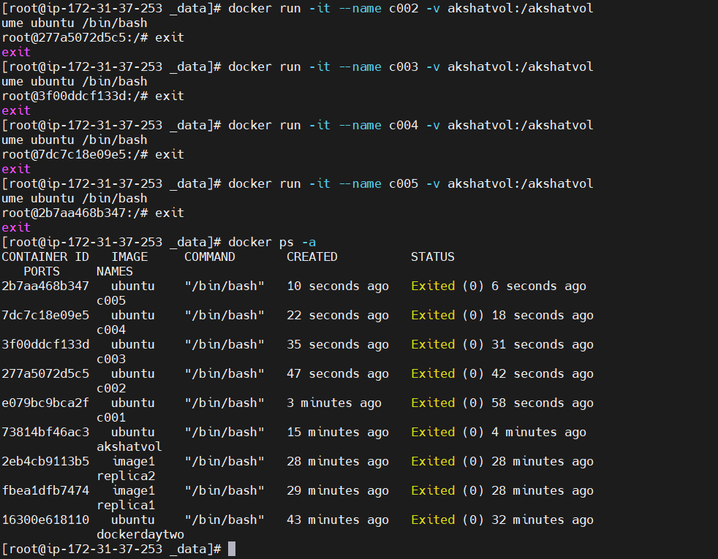

Question 4

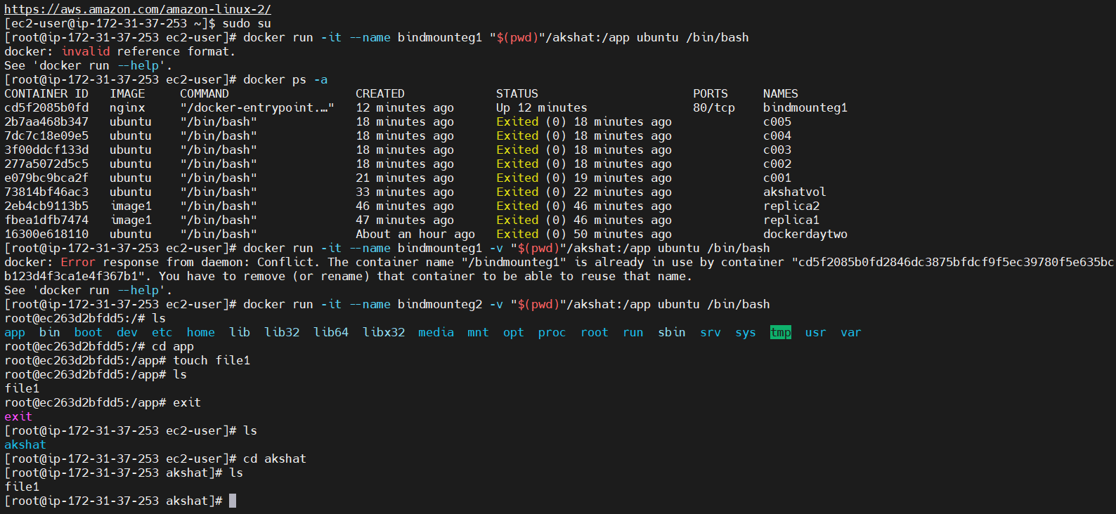

Bind Mount

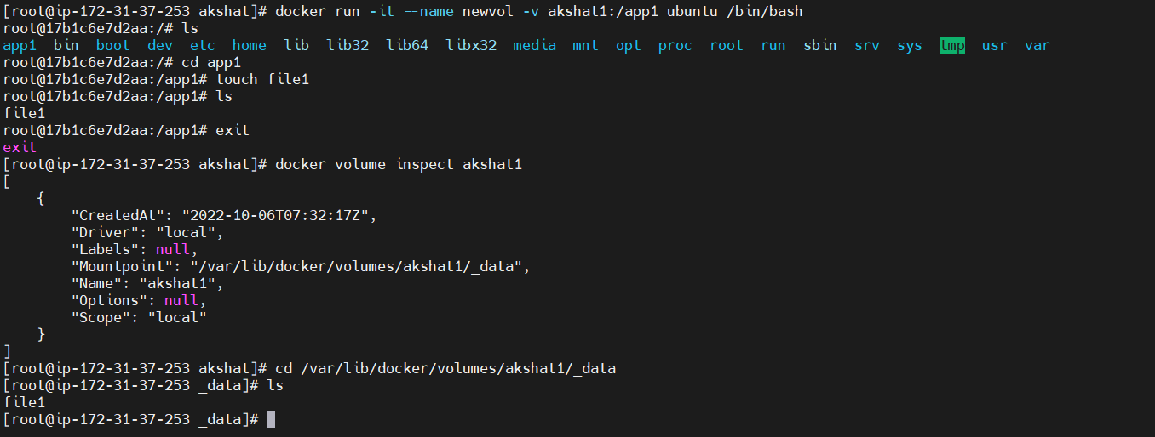

Volume

Question 5

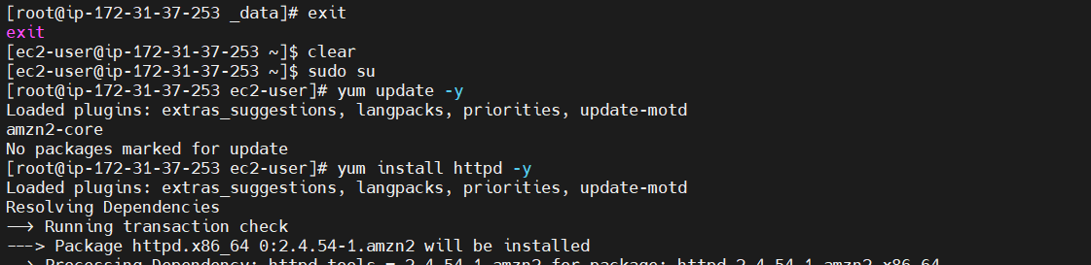

Update machine and install httpd

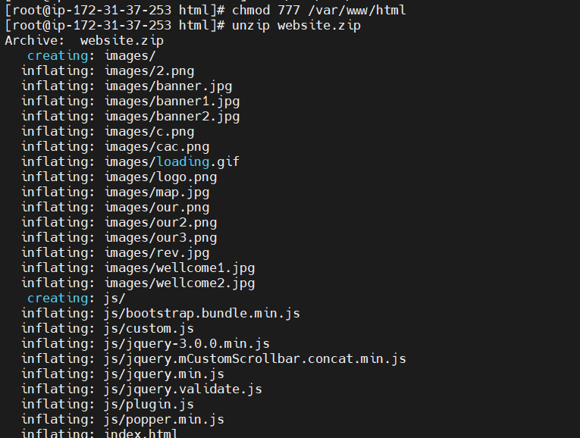

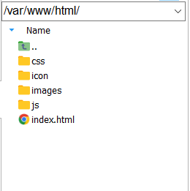

Go into /var/www/html file.

Upload website and unzip the file

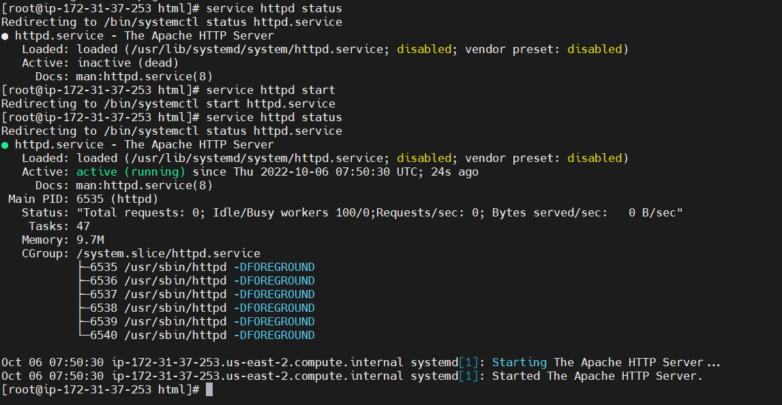

Start httpd service and check the status to see if its running



Paste the public IP of your instance in your browser to view the website