**UDP Class**

Methods documented for [WiFiUDP Class](https://www.arduino.cc/en/Reference/WiFiUDPConstructor) in [Arduino](https://github.com/arduino/Arduino)

1. [begin()](https://www.arduino.cc/en/Reference/WiFiUDPBegin)
2. [available()](https://www.arduino.cc/en/Reference/WiFiUDPAvailable)
3. [beginPacket()](https://www.arduino.cc/en/Reference/WiFiUDPBeginPacket)
4. [endPacket()](https://www.arduino.cc/en/Reference/WiFiUDPEndPacket)
5. [write()](https://www.arduino.cc/en/Reference/WiFiUDPWrite)
6. [parsePacket()](https://www.arduino.cc/en/Reference/WiFiUDPParsePacket)
7. [peek()](https://www.arduino.cc/en/Reference/WiFiUDPPeek)
8. [read()](https://www.arduino.cc/en/Reference/WiFiUDPRead)
9. [flush()](https://www.arduino.cc/en/Reference/WiFiUDPFlush)
10. [stop()](https://www.arduino.cc/en/Reference/WiFIUDPStop)
11. [remoteIP()](https://www.arduino.cc/en/Reference/WiFiUDPRemoteIP)
12. [remotePort()](https://www.arduino.cc/en/Reference/WiFiUDPRemotePort)

Methods and properties described further down are specific to ESP8266. They are not covered in [Arduino WiFi library](https://www.arduino.cc/en/Reference/WiFi)documentation. Before they are fully documented please refer to information below.

**Multicast UDP**

uint8_t beginMulticast (IPAddress interfaceAddr, IPAddress multicast, uint16_t port)

virtual int beginPacketMulticast (IPAddress multicastAddress, uint16_t port, IPAddress interfaceAddress, int ttl**=**1)

IPAddress destinationIP ()

uint16_t localPort ()

The WiFiUDP class supports sending and receiving multicast packets on STA interface. When sending a multicast packet, replace udp.beginPacket(addr, port) with udp.beginPacketMulticast(addr, port, WiFi.localIP()). When listening to multicast packets, replace udp.begin(port) with udp.beginMulticast(WiFi.localIP(), multicast_ip_addr, port). You can use udp.destinationIP() to tell whether the packet received was sent to the multicast or unicast address.

For code samples please refer to separate section with [examples](http://arduino-esp8266.readthedocs.io/en/2.4.0/esp8266wifi/udp-examples.html) dedicated specifically to the UDP Class.

**EXAMPLES**

# UDP

The purpose of example application below is to demonstrate UDP communication between ESP8266 and an external client. The application (performing the role of a server) is checking inside the loop() for an UDP packet to arrive. When a valid packet is received, an acknowledge packet is sent back to the client to the same port it has been sent out.

# Table of Contents

* [Declarations](http://arduino-esp8266.readthedocs.io/en/2.4.0/esp8266wifi/udp-examples.html#declarations)
* [Wi-Fi Connection](http://arduino-esp8266.readthedocs.io/en/2.4.0/esp8266wifi/udp-examples.html#wi-fi-connection)
* [UDP Setup](http://arduino-esp8266.readthedocs.io/en/2.4.0/esp8266wifi/udp-examples.html#udp-setup)
* [An UDP Packet Arrived!](http://arduino-esp8266.readthedocs.io/en/2.4.0/esp8266wifi/udp-examples.html#an-udp-packet-arrived)
* [An Acknowledge Send Out](http://arduino-esp8266.readthedocs.io/en/2.4.0/esp8266wifi/udp-examples.html#an-acknowledge-send-out)
* [Complete Sketch](http://arduino-esp8266.readthedocs.io/en/2.4.0/esp8266wifi/udp-examples.html#complete-sketch)
* [How to Check It?](http://arduino-esp8266.readthedocs.io/en/2.4.0/esp8266wifi/udp-examples.html#how-to-check-it)
* [Conclusion](http://arduino-esp8266.readthedocs.io/en/2.4.0/esp8266wifi/udp-examples.html#conclusion)

## Declarations

At the beginning of sketch we need to include two libraries:

*#include <ESP8266WiFi.h>*

*#include <WiFiUdp.h>*

The first library ESP8266WiFi.h is required by default if we are using ESP8266’s Wi-Fi. The second one WiFiUdp.h is needed specifically for programming of UDP routines.

Once we have libraries in place we need to create a WiFiUDPobject. Then we should specify a port to listen to incoming packets. There are conventions on usage of port numbers, for information please refer to the [List of TCP and UDP port numbers](https://en.wikipedia.org/wiki/List_of_TCP_and_UDP_port_numbers). Finally we need to set up a buffer for incoming packets and define a reply message.

WiFiUDP Udp;

unsigned int localUdpPort **=** 4210;

char incomingPacket[255];

char replyPacekt[] **=** "Hi there! Got the message :-)";

## Wi-Fi Connection

At the beginning of setup() let’s implement typical code to connect to an access point. This has been discussed in [Quick Start](http://arduino-esp8266.readthedocs.io/en/2.4.0/esp8266wifi/readme.md#quick-start). Please refer to it if required.

## UDP Setup

Once connection is established, you can start listening to incoming packets.

Udp**.**begin(localUdpPort);

That is all required preparation. We can move to the loop()that will be handling actual UDP communication.

## An UDP Packet Arrived!

Waiting for incoming UDP packed is done by the following code:

int packetSize **=** Udp**.**parsePacket();

**if** (packetSize)

{

Serial**.**printf("Received %d bytes from %s, port %d\n", packetSize, Udp**.**remoteIP()**.**toString()**.**c_str(), Udp**.**remotePort());

int len **=** Udp**.**read(incomingPacket, 255);

**if** (len **>** 0)

{

incomingPacket[len] **=** 0;

}

Serial**.**printf("UDP packet contents: %s\n", incomingPacket);

(**...**)

}

Once a packet is received, the code will printing out the IP address and port of the sender as well as the length of received packet. If the packet is not empty, its contents will be printed out as well.

## An Acknowledge Send Out

For each received packet we are sending back an acknowledge packet:

Udp**.**beginPacket(Udp**.**remoteIP(), Udp**.**remotePort());

Udp**.**write(replyPacekt);

Udp**.**endPacket();

Please note we are sending reply to the IP and port of the sender by using Udp.remoteIP() and Udp.remotePort().

## Complete Sketch

The sketch performing all described functionality is presented below:

*#include <ESP8266WiFi.h>*

*#include <WiFiUdp.h>*

const char**\*** ssid **=** "********";

const char**\*** password **=** "********";

WiFiUDP Udp;

unsigned int localUdpPort **=** 4210; **//** local port to listen on

char incomingPacket[255]; **//** buffer **for** incoming packets

char replyPacekt[] **=** "Hi there! Got the message :-)"; **//** a reply string to send back

void setup()

{

Serial**.**begin(115200);

Serial**.**println();

Serial**.**printf("Connecting to %s ", ssid);

WiFi**.**begin(ssid, password);

**while** (WiFi**.**status() **!=** WL_CONNECTED)

{

delay(500);

Serial**.**print(".");

}

Serial**.**println(" connected");

Udp**.**begin(localUdpPort);

Serial**.**printf("Now listening at IP %s, UDP port %d\n", WiFi**.**localIP()**.**toString()**.**c_str(), localUdpPort);

}

void loop()

{

int packetSize **=** Udp**.**parsePacket();

**if** (packetSize)

{

**//** receive incoming UDP packets

Serial**.**printf("Received %d bytes from %s, port %d\n", packetSize, Udp**.**remoteIP()**.**toString()**.**c_str(), Udp**.**remotePort());

int len **=** Udp**.**read(incomingPacket, 255);

**if** (len **>** 0)

{

incomingPacket[len] **=** 0;

}

Serial**.**printf("UDP packet contents: %s\n", incomingPacket);

**//** send back a reply, to the IP address **and** port we got the packet **from**

Udp.beginPacket(Udp**.**remoteIP(), Udp**.**remotePort());

Udp**.**write(replyPacekt);

Udp**.**endPacket();

}

}

## How to Check It?

Upload sketch to module and open serial monitor. You should see confirmation that ESP has connected to Wi-Fi and started listening to UDP packets:

Connecting to twc**-**net**-**3 **........** connected

Now listening at IP 192.168**.**1.104, UDP port 4210

Now we need another application to send some packets to IP and port shown by ESP above.

Instead of programming another ESP, let’s make it easier and use a purpose build application. I have selected the [Packet Sender](https://packetsender.com/download). It is available for popular operating systems. Download, install and execute it.

Once Packet Sender’s window show up enter the following information: * Name of the packet * ASCII text of the message to be send inside the packet * IP Address shown by our ESP * Port shown by the ESP * Select UDP

What I have entered is shown below:

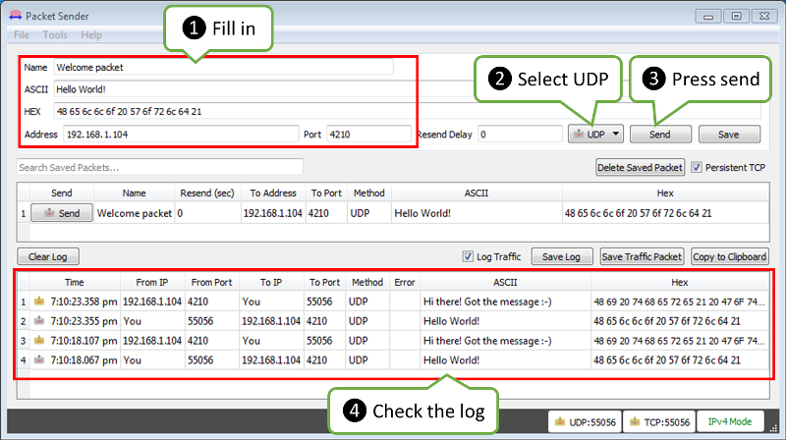

*alt text*

Now click Send.

Immediately after that you should see the following on ESP’s serial monitor:

Received 12 bytes from 192.168.1.106, port 55056

UDP packet contents: Hello World!

The text 192.168.1.106, port 55056 identifies a PC where the packet is send from. You will likely see different values.

As ESP sends an acknowledge packet back, you should see it in the log in the bottom part of the Packet Sender’s window.

## Conclusion

This simple example shows how to send and receive UDP packets between ESP and an external application. Once tested in this minimal set up, you should be able to program ESP to talk to any other UDP device. In case of issues to establish communication with a new device, use the [Packet Sender](https://packetsender.com/) or other similar program for troubleshooting

For review of functions provided to send and receive UDP packets, please refer to the [UDP Class](http://arduino-esp8266.readthedocs.io/en/2.4.0/esp8266wifi/udp-class.html) documentation.