CE/CS/SE 3354 · Software Engineering · Fall 2026
Project Milestone P2

Analysis and High-Level Design
[Project title]
Team | Team [NN], section [.003 / .005 / .010]
Document version | 1.0 (baseline for P2; grows from your P1 version 0.x)
Date
Repository URL | https://github.com/[owner]/[repository]
Git tag for this milestone | p2 (points at the commit that contains this exact PDF)
Submitted on Canvas by | [one member only]

Team member | NetID | GitHub username
Chayeol Jung | Cxj240000 | Jcy1205

0 Revision History, Contribution Record and Changes Since P1
All three tables below are graded. The contribution record carries the individual 20% of this milestone and must agree with your repository history.
Version | Date | Author | Summary of change
0.x |  |  | P1 baseline (copy your last P1 row)
1.0 |  |  | P2 baseline: analysis and high-level design added

0.1 Individual contribution record (P2)
Team member | Sections and artifacts this person produced for P2 | Evidence in the repository (commit hashes, PR numbers) | Reviews given (PR numbers)

GUIDANCE: DELETE THIS BOX BEFORE SUBMITTING
Evidence means something a reader can open and that existed before the deadline: a commit hash, a pull request, a file in the repository. Issues you own count as indirect evidence; link the commits that close them for full credit.
Commit your own work from your own GitHub account. If one person uploads everyone's text from a shared document, the history shows one author and the other members have no verifiable evidence. A shared drafting document is fine; the final text of each section is committed by its owner.
Cite only what exists. Every commit, pull request, branch and file named in this table is checked. Citing evidence that is not in the repository is an academic-honesty matter, not a formatting slip.
Every member appears with a distinguishable contribution. Two rows with identical wording are marked as vague claims. If a member did not contribute, write that plainly in their row rather than leaving it blank or covering for them.

0.2 Changes since the P1 baseline
Change ID | What changed (IDs affected) | Why (P1 feedback, new finding, spike result) | Knock-on effect | Agreed on
CH-01
CH-02
CH-03
1 Introduction
1.1 Purpose of this document and of the system

The purpose of this document is to online the requirements, goals, and the functions of the Game Review Aggregator system. It is intended for the development team, the stakeholders, and anyone to review or evaluate the system. This document will serve as a reference throughout the development process to ensure it meets the intended requirements.
The Game Review Aggregator is a website that is designed to help gamers research, discover, and compare video games by bringing reviews from several different sources into one place. Currently, games must visit several other websites to compare ratings and opinions, which is time-consuming and confusing as often times reviews conflict with each other. This system aims to solve this problem by allowing users to search for games, filter results based on their preferences, and view ratings and detailed reviews from available sources on one location.

1.2 Scope

In scope — we will build this | Out of scope — we will not, and why
A website where users can search for video games and view their information | A game purchasing or payment system, since the website is intended for research rather than selling games.
Display available game reviews, ratings, and their original sources | Integration with every review platform, because API restrictions and development time limitations
Allow users to filter games by selected characteristics, such as genre and platform, when the data is available | Advanced personalized recommendation algorithms, because they require additional development and testing
Allow users to compare games and available ratings from different sources | Automatic detection of fake or biased reviews, because accurately identifying them would require more complex methods
Display review details, including written explanations and publication dates when available | Steam account login and friend-based review prioritization, because their necessity and technical feasibility have not been confirmed

These features were excluded to make the project manageable within the course timeline and allow the development team to focus on the core functionality of the website. More advanced features could be considered in future versions once the basic system is out.

1.3 Definitions, acronyms and abbreviations

Term or abbreviation | Meaning as used in this project
Game Review Aggregator | A website that collects and displays video game reviews and ratings from multiple sources in one location
API (Application Programming Interface) | A way for the website to retrieve game information and reviews from external platforms such as Steam
Aggregate Rating | A combined rating calculated using reviews or scores from multiple sources
Stakeholder | A person or organization that uses, develops, or is affected by the system, such as gamers, developers, or Steam
Review Source | The original platform or website where a game review or rating was published
Filtering | Narrowing game search results based on characteristics such as genre or platform
Steam | A digital gaming platform that may provide game reviews and information through its supported API
UI (User interface) | The visual parts of the website that users interact with, including search bars, filters, and review pages

1.4 References

[R1] Valve Corporation, Steamworks Web API Overview. Steamworks Web API Documentation
[R2] Valve Corporation, Steam User Reviews API. Steam User Reviews API Documentation
[R3] Interview transcript in repository. docs\interviews\Interview_1_Gamer.pdf
[R3] Interview notes in repository. docs\interviews\Interview_2_Gamer.pdf

2 Overall Description
2.1 Product perspective and context

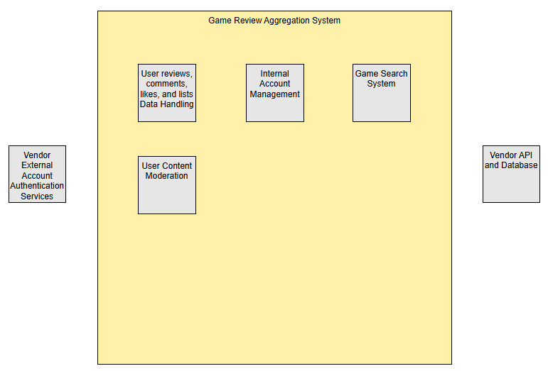
The Game Review Aggregation system is only responsible for the handling of internal data, mainly the data tied to individual user accounts such as reviews, likes, and lists, as well as the account information. If users want to link external accounts from vendors like Steam or Roblox, that functionality wouldn’t fall under our system responsibility since that would require external authentication services. Furthermore, game metadata supplied by databases and APIs from vendors such as Steam would allow us to provide the information we need for our game search system. However, this ultimately means that we are dependent and not responsible for the data we are supplied with. Lastly, account management and user content moderation are within the bounds of our system responsibility since these systems operate strictly on our data and would rely on no third-party providers.

2.2 Stakeholders and how you reached them

Stakeholder | Role in relation to the system | What they need from it | How you learned this
Gamers researching games (represented by interview participants) | Primary users who use the website to research games before deciding what to play or purchase. | Reliable reviews, useful ratings, information about game difficulty and quality, and help deciding whether a game suits their preferences. | Interviews with two gamers (R1 and R2). Their gaming experiences and preferences informed the initial requirements.
Casual and dedicated game reviewers | Users who contribute written reviews and ratings. | An easy way to submit reviews and ratings that other gamers can read. | Initially assumed based on the proposed user-review functionality; needs confirmation through additional elicitation.
Website moderators | Responsible for reviewing reported or inappropriate content, if moderation is included. | Tools to identify and remove reviews that violate the website's rules. | Initially assumed based on the possibility of user-submitted reviews; moderator needs have not yet been directly elicited.
External game and review platforms (e.g., Steam) | Potential providers of game information or existing reviews if external data is incorporated. | Appropriate use of their information and compliance with applicable access restrictions and terms. | Identified during project planning. Specific platform requirements must be researched if external data is used.
Website administrators and development team | Responsible for maintaining the website and its data. | A manageable system that can be maintained, updated, and operated within the team's available resources. | Assumed based on the team's responsibility for developing and maintaining the project.

2.3 User characteristics

Gamers researching games: These users visit the website to learn about games before deciding whether to play or purchase them. They may have different levels of gaming experience and may not be familiar with every game's mechanics, difficulty, or genre. They need clear game information, understandable ratings, and reviews that help them make informed decisions.
Game reviewers: These users submit written reviews and ratings based on their experiences with games. They may have different levels of writing experience and familiarity with review websites. The system should provide a straightforward review submission process with clear instructions and understandable rating options.
Website moderators (if included in the project scope): These users are responsible for managing user-submitted content and ensuring reviews follow the website's rules. They may have varying levels of technical experience, so moderation functions should be clearly labeled and easy to use.

2.4 Constraints

We must comply with the deliverable requirements, submission format, and deadlines specified for SE 3354. We must maintain the project's source code and development history in the team's designated version-control repository. We must comply with the applicable terms of service and technical requirements of any external platform from which we retrieve data. If we use the Steam Web API (R1), we must comply with its applicable access requirements and restrictions. We must not depend on access to private or restricted third-party data unless we have the necessary authorization. We must comply with applicable data usage and attribution requirements for external platforms. We must protect user privacy and comply with applicable privacy requirements if we collect personal information. We must use review sources that provide an accessible and permitted method of obtaining their data. We must use hosting and database services available within our team's budget and resources.

2.5 Assumptions and dependencies

# | Assumption or dependency | What breaks if it does not hold
A1 | Availability of game metadata from official vendors (Dependency) | Wouldn’t be able to use official vendor APIs if they don’t provide public metadata. Would have to use third party databases
A2 | Vendors supporting account linking (Dependency) | Wouldn’t be able to support external account linking if not supported
A3 | Social actions for users, such as creating lists and liking lists from other users (Assumption) | If list features aren’t used for social or game discoverability purposes, then they’d be added for no reason. While interviews haven’t explicitly shown a need for these features, popular review websites such as Letterboxd or MyAnimeList include these features, so we are assuming they’d be useful for our system as well.

2.6 Feasibility summary

Feasibility gate | Verdict | Evidence behind the verdict
Technical | Feasible | Steam documents multiple endpoints such as “IUserReviewsService.GetAppReviews” that would allow us to collect reviews using official steam API. Furthermore, multiple independent third-party database sources (SteamDB, itchDB, and Rolimon’s) that would allow us to gather game metadata for search functionality. Lastly, comparable systems such as Letterboxd are already in production, which shows that our system is technically feasible
Operational | Feasible | Our system would require little to no operation or maintenance after deployment, due to the website and user workflow being small, straightforward, and simple. Furthermore, interviews (R1 and R2) show that there’s a need for this type of system, which suggests that it will be used after deployment
Schedule | A narrow initial version is feasible | Given a little less than two months, it would be more feasible if the team prioritized one supported data source, core search/display functionality, and a simple review/rating system.
Economic / resource | Feasible | The cost of hosting a website is around $2-15/month which is within budget. Database services such as Supabase and MongoDB have free tiers which would satisfy the needs for our simple website.

3 Specific Requirements

3.1 Functional requirements

ID | Requirement — one “shall” sentence | Priority | Source | Acceptance criterion
FR-01 | The system shall allow users to search for games by title. | MUST | Gamer interviews | A tester searches for an existing game and sees matching results.
FR-02 | The system shall display an individual game's information, including its title and available review information. | MUST | Gamer interviews | A tester selects a game and sees its title and available review information.
FR-03 | The system shall display game reviews submitted by users. | MUST | Gamer interviews | A tester opens a game page and can read its submitted reviews.
FR-04 | The system shall allow registered users to submit a review for a game. | MUST | Gamer interviews | A registered tester submits a review, and it appears on the appropriate game page.
FR-05 | The system shall allow users to assign a rating to a game when submitting a review. | MUST | Gamer interviews | A tester submits a review with a rating, and the rating is displayed correctly.
FR-06 | The system shall display an aggregate rating calculated from available game ratings. | SHOULD | Project goal; confirm with team | A tester verifies that the displayed aggregate matches the ratings used in the calculation.
FR-07 | The system shall allow users to sort available reviews by a supported criterion. | COULD | Proposed feature; confirm with team | A tester selects a sorting option and sees reviews in the selected order.
FR-08 | The system shall allow designated moderators to remove reviews that violate the review rules. | SHOULD | Proposed moderator stakeholder; confirm with team | A moderator removes a review, and it no longer appears among published reviews.
FR-09 | The system shall allow users to report and flag content | SHOULD | Proposed moderator stakeholder | A tester verifies that there are options to report user content such as reviews, comments, and lists. After reporting, flagged content should be visible for moderators

3.2 Quality requirements
ID | Requirement — threshold, condition, and measurement | Priority | Source | How it will be verified
QR-01 | Under normal test conditions with up to 20 simultaneous users, at least 95% of game searches shall return results within 3 seconds, measured through 100 test searches. | SHOULD | Proposed performance target | Run 100 searches and record their response times.
QR-02 | The system shall display its main pages correctly at viewport widths of 360 pixels and 1366 pixels, verified by testing each page at both widths. | MUST | Proposed usability requirement | Open each main page at both viewport widths and check for clipped or overlapping content.
QR-03 | The system shall prevent users who are not authorized moderators from accessing moderator-only actions in 100% of the tested unauthorized-access attempts. | MUST | Proposed security requirement | Attempt moderator actions using an ordinary user account and an unauthenticated session.
QR-04 | For a test set of 20 valid reviews, the system shall display all 20 reviews correctly after they are submitted and the relevant page is reloaded. | MUST | Proposed reliability requirement | Submit 20 reviews, reload the relevant page, and confirm that all reviews remain available.

3.3 Constraint requirements
ID | Constraint — one sentence | Source | Why it cannot be negotiated
CON-01 | The system shall comply with the applicable terms and access restrictions of any external platform from which it retrieves game or review data. | Official documentation and terms of each platform used, such as Steamworks documentation [R1] | The team cannot disregard the restrictions imposed by external data providers.
CON-02 | The system shall not access private or restricted third-party game or review data without the authorization required by the data provider. | Official documentation and access policies of each platform used [R1] | The team cannot assume permission to access restricted data.

3.4 Initial use cases
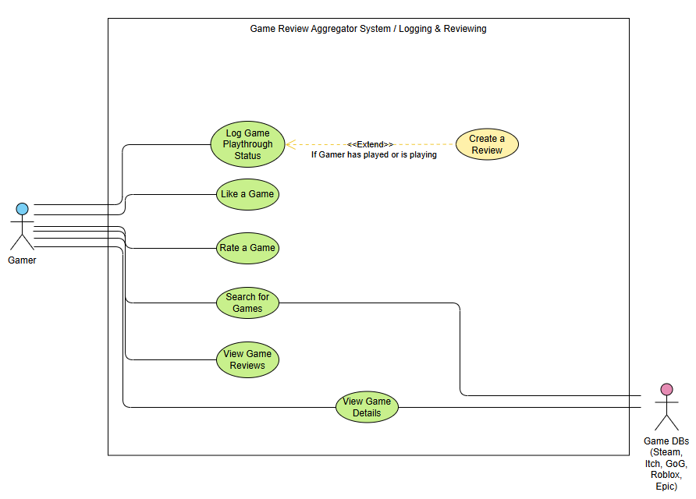
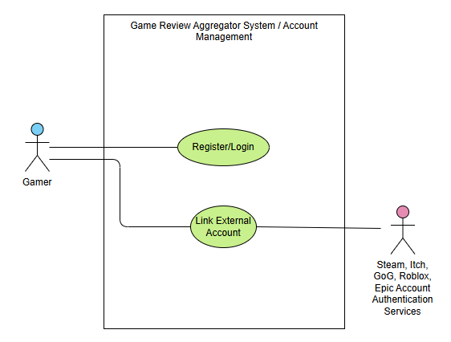
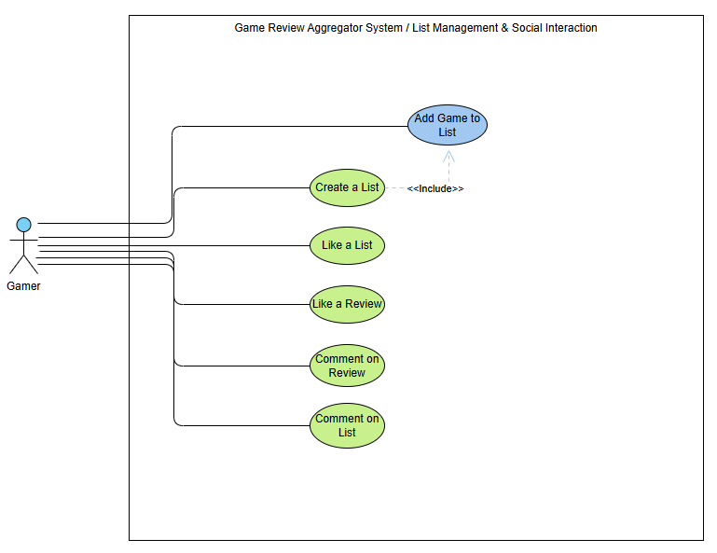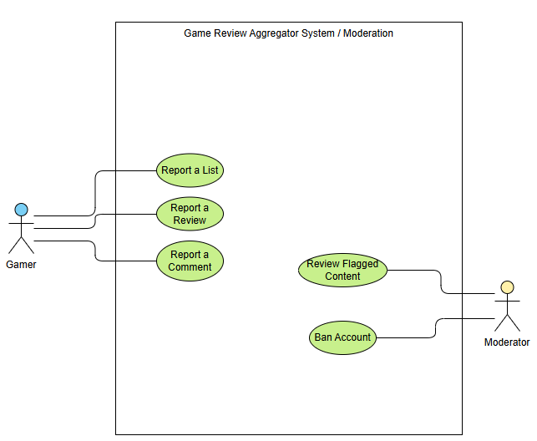

Expanded use case
Field | Content
Identifier and name | UC-05 Search for Games
Primary actor | Gamer
Supporting actors | Game DBs from Vendors
Preconditions — what must be true before it starts | The Website is available and search source is accessible
Trigger — what starts it | Gamer enters a title or term in the search box
Main success scenario — numbered steps | 1. Gamer enters a title or search term  2. Game Review Aggregator System searches for the game records  3. System displays matching results  4. Gamer selects a game
Alternative and exception flows | 1. Gamer enters a title or search term  2. System displays no matching results
Postconditions — what is true when it succeeds | The Gamer can see game page information based on what they search for
Requirements realized | FR-01
Expanded use case
Field | Content
Identifier and name | UC-02 Create a Review
Primary actor | Gamer
Supporting actors | Game DBs from Vendors
Preconditions — what must be true before it starts | The Gamer must log the game playthrough status as either playing or played.
Trigger — what starts it | Gamer writes text into the “Add a review” box and then presses save/continue
Main success scenario — numbered steps | 1. Gamer pressed the “Log” button  2. Searches for the game they want to review  3. Selects the game they want to review  4. Sets playthrough status as “Played” or “Playing”  5. Writes something into the “Add a review” box  6. Presses the “save” button
Alternative and exception flows | 1. Gamer is on a game’s page  2. Gamer presses the “Log/Review” button  3. Sets playthrough status as “Played” or “Playing”  4. Writes something into the “Add a review” box  5. Presses the “save” button
Postconditions — what is true when it succeeds | Gamer has a review posted that they and other Gamers can view
Requirements realized | FR-04

3.5 Requirements to use case traceability

Requirement ID | Use case(s) that realise it | If blank — why, and what you will do
FR-01 | UC-05 Search for Games
FR-02 | UC-06 View Game Reviews  UC-07 View Game Details
FR-03 | UC-06 View Game Reviews
FR-04 | UC-02 Create a Review
FR-05 | UC-04 Rate a Game
FR-06 | UC-06 View Game Reviews  UC-07 View Game Details
FR-07 | UC-06 View Game Reviews
FR-08 | UC-19 Review Flagged Content
FR-09 | UC-16 Report a List  UC-17 Report a Review  UC-18 Report a Comment

The matrix revealed that our core requirements have use cases attached to them, meaning that our use cases all trace back to requirements that we collected through elicitation. This means that our use case features were specifically asked for by stakeholders. However, there are use cases that we proposed that don’t trace back to any requirements, which is a sign of scope creep. We will do further elicitation to determine whether these use cases are

4 Use-Case Analysis
Chapter 7, first half. Here you take the use cases from section 3.4 and write the most important of them out turn by turn, still with the technology switched off.

4.1 Use cases selected for analysis
Use case | Name | Why it was selected | Non-trivial steps
UC-05 | Search | Currently, users must visit several different websites to compare ratings and opinions, which is time-consuming and confusing due to conflicting reviews. This use case directly addresses and fulfills the core purpose and in-scope requirements of the system. | Multi-Criteria Search & Filtering: The system processes user queries by applying specific selected characteristics (such as genre and platform) across available aggregated game data.
UC-07 | View Game Details | Core functional journey connecting discovery to evaluation; carries high architectural risk because it must combine catalog metadata across multiple supported platforms with external review aggregations while satisfying performance and data consistency constraints. | Step 2: Retrieval, mapping, and consolidation of multi-platform attributes, genres, and external ratings for the selected title.  Step 4: Synthesis and presentation of platform-specific review breakdowns and aggregate scores.
UC-06 | Compare Game  Review | The primary purpose of the Game Review Aggregator is to help gamers research, discover, and compare video games by consolidating reviews and ratings from multiple external sources in one place. | Multi-Source Review Aggregation: The system fetches and aggregates available

4.2 Expanded use cases
Copy the block below once for each use case in 4.1.

UC-05 [Display Review Details]
Primary actor | Gamer / End User
Supporting actors and external systems
TUCBW (this use case begins when) | User selects a specific game or clicks on an individual review/outlet from the aggregated game summary page.
TUCEW (this use case ends when) | System formats the review cards, displaying available dates in localized chronological order and rendering the written review content.
Preconditions | The user has searched or browsed for a game and selected it to view its reviews.  The aggregator database or external API has aggregated review data available for the selected title.
Postconditions | Complete review details (written commentary/excerpt, score, publication date, source publication name, and link to original source) are rendered on the screen.
Traces to requirements | FR- , QR- , CON-

Actor input / action | System response
 | (0)
(1) User selects a specific game or clicks on an individual review/outlet from the aggregated game summary page. | (2) System receives the request and fetches all recorded review records for that game.
(3) | (4) System checks each review record for available metadata: original publication/source, numeric/letter rating, written explanation/excerpt, publication date, and external URL.
(5) | (6) System formats the review cards, displaying available dates in localized chronological order and rendering the written review content.
(7) User reads the written explanation and inspects publication dates to evaluate the recency of the review. | (8) System displays an outbound attribution link to the original review article on the external publisher's website.
(Optional) User clicks the external source link. | System opens the original review source page in a new browser tab/window.

Alternate flow | At step | Condition | What happens | Ends or rejoins at
A1 | 2a | Missing Publication Date | If the original source did not provide a publication date or it could not be parsed, the system omits the date field or displays "Date not available" without breaking the layout.
A2 | 2b | Missing Written Explanation (Score-Only Review) | If the source only provides a numeric rating with no written text, the system displays the score and an indicator stating "Rating only (no written explanation provided)" alongside the source link.
A3 | 2c | Review Text Exceeds Preview Length | If the written review is extensive, the system truncates the text with an inline Show More / Read More expander or directs the user to the original publisher link to read the full article.
A4 | 5a | External Source URL Unavailable or Broken | If the link to the original review is missing or deprecated, the system displays the source publication name as static text rather than a broken hyperlink.

UC-06 [Navigate to Original Review Source]
Primary actor | Gamer / End User
Supporting actors and external systems
TUCBW (this use case begins when) | User selects a specific game or clicks on an individual review/outlet from the aggregated game summary page.
TUCEW (this use case ends when) | System formats the review cards, displaying available dates in localized chronological order and rendering the written review content.
Preconditions | The user is viewing a game’s review details or comparison screen where individual review cards/outlets are displayed.  The aggregator contains a recorded external URL link for the target review outlet.
Postconditions | The user is navigated to the external publisher's review page in a separate browsing context without terminating their active session on the aggregator.
Traces to requirements | FR- , QR- , CON-

Actor input / action | System response
 | (0)
While inspecting an individual review or outlet card, the user clicks the external source link or outlet attribution badge. | System intercepts the click event to validate the destination URL format and parameters.
 | System confirms the target URL is valid and properly formed.
 | System appends necessary outbound referral headers and opens the target destination in a new browser tab/window (target="_blank" rel="noopener noreferrer").
 | The aggregator maintains the user’s original state (filters, scroll position, and search context) in the primary tab.
The user reads the complete review on the external publisher's website.

Alternate flow | At step | Condition | What happens | Ends or rejoins at
A1 | 2a | Target Source Link is Deprecated or Malformed | If the recorded external URL fails validation or has an invalid structure:  • System suppresses external navigation.  • System displays a non-intrusive notification: "Link to original source is currently unavailable."  • The review snippet and publication name remain visible on the card.
A2 | 3a | Outbound Navigation Blocked by User's Browser (Pop-up Blocker) | If browser security settings prevent opening a new tab:  - System displays an inline prompt offering direct navigation or copying the link to clipboard.  - User manually copies the URL or allows pop-ups for the site.
A3 | 5a | External Review Page Returns an HTTP Error (404 / Paywall / Removed) | If the destination page has been altered or removed by the third-party publisher:  - The external site handles the error.  - The user can switch back to the aggregator tab without loss of their current comparison or search state.

UC-07 [View Game Details]
Primary actor | Gamer
Supporting actors and external systems | Game DBs from Vendors (e.g., Steam Web API)
TUCBW (this use case begins when) | The gamer requests to view the details for a specific game from a search results or browsing list.
TUCEW (this use case ends when) | The gamer sees the complete game profile displaying title metadata, supported platforms, genres, aggregate rating, and review breakdown.
Preconditions | The website is operational and the target game record exists within the system or vendor game database.
Postconditions | The comprehensive game information, characteristics, and aggregated score breakdown are presented to the gamer.
Traces to requirements | FR-02, FR-06, QR-02, CON-01

Actor input / action | System response
 | The system displays a list of games from a search or catalog view, each showing a title, summary badge, and aggregate score.
(1) The gamer selects a specific game to view its full details. | (2) The system retrieves the game's metadata (release date, publisher/developer, genres, supported platforms) and associated review summaries from the game records.
(3) The gamer requests the breakdown of reviews across available platforms and sources. | (4) The system compiles and displays the game profile containing the descriptive details, available platform attributes, aggregate rating, and source attributions.

Alternate flow | At step | Condition | What happens | Ends or rejoins at
A1 | (2) | Game metadata is incomplete or partially unavailable from vendor source | The system displays the available fields (e.g., title, aggregate score) and displays "Not available" or omits missing attributes (such as release date or publisher) without disrupting the layout. | Rejoins at (4)
A2 | (2) | External vendor API fails to respond or game record is unreachable | The system displays a message indicating that full game details cannot currently be retrieved and provides an option to return to the search list. | Ends
A3 | (4) | No reviews or ratings exist for the selected game title | The system displays all available game descriptive information alongside an indicator stating "No reviews or ratings recorded yet". | Ends

4.3 Self-review log
Use case | Check from the Lesson 13 review checklist | Defect found | How it was fixed

GUIDANCE: DELETE THIS BOX BEFORE SUBMITTING
Run the review checklist from Lesson 13 on each expanded use case before anyone draws a diagram, and record what each check found, including any defects you fixed. Report honestly; a clean result is acceptable when it is true. Budget: a quarter of a page.

5 Analysis Models
Chapter 7, second half. What has to exist inside the system for the use cases in section 4 to happen, and how those parts talk to each other.

5.1 Domain model
+-------------------+ +-------------------+
| SearchQuery | 1 * | SearchResult |
|-------------------|-------------------|-------------------|
| text | generates > | rank |
| genreFilter | | matchScore |
| platformFilter | +-------------------+
+-------------------+ | 1
|
| references
|
v 1
+-------------------+ 1 * +-------------------+
| Genre |---------------------| Game |
|-------------------| categorizes |--------------------|
| name | | title |
+-------------------+ | description |
| releaseDate |
+-------------------+ 1..* * | aggregateScore |
| Platform |-------------------|---------------------|
|---------------------| supports |
| name | |
+-------------------+ | 1
|
| has
|
v 0..*
+-------------------+ 1 * +-------------------+
| ReviewSource |------------------| Review |
|-----------------------| publishes |----------------------|
| name | | score |
| url | | summaryText |
+-------------------+ | publicationDate |
+-------------------+

Figure 5.1 Domain model (conceptual classes, attributes, associations with multiplicities)
Class | What it represents (one line) | Key attributes | Associations (with multiplicity)
SearchQuery | The search criteria and filter terms submitted by the gamer. | text, genreFilter, platformFilter | 1 SearchQuery ── 0..* SearchResult (generates)
SearchResult | An individual ranked match entry generated from executing a search. | rank, matchScore | * SearchResult ── 1 SearchQuery (produced by)  1 SearchResult ── 1 Game (references)
Game | A video game record cataloged within the aggregator. | title, description, releaseDate, aggregateScore | 1 Game ── 1 SearchResult (referenced by)  * Game ── 1..* Platform (supports)  * Game ── 1..* Genre (categorized by)  1 Game ── 0..* Review (has)
Game | A video game record cataloged within the aggregator. | title, description, releaseDate, aggregateScore | Game ── 1 SearchResult (referenced by)  * Game ── 1..* Platform (supports)  * Game ── 1..* Genre (categorized by)  1 Game ── 0..* Review (has)
Genre | A categorical genre classification for video games. | name | 1..* Genre ── * Game (categorizes)
Platform | A gaming system, console, or operating environment. | name | 1..* Platform ── * Game (supported by)
Review | An aggregated critique or evaluation of a game from a source. | An aggregated critique or evaluation of a game from a source. | 0..* Review ── 1 Game (belongs to)  * Review ── 1 ReviewSource (published by)
ReviewSource | An external outlet, publication, or vendor providing reviews. | name, url | 1 ReviewSource ── 0..* Review (publishes)

5.2 Object interaction models
Copy the block below for at least two of the use cases in 4.1; preferably including your riskiest.

UC-05 [Search for Games]
(a) Non-trivial steps. List the steps from 4.2 that need objects inside the system, and say in one line why each of the others is trivial.
- Step 2 (Non-trivial): Requires system objects to parse search criteria, apply active genre and platform filters, query the catalog domain records, and rank matching candidates.
- Step 3 (Non-trivial): Requires the system to construct the structured search result set, calculate relative match scores, and format game summary entries for display.
- (Step 0 is the passive pre-state; Step 1 is the physical entry of search criteria by the actor; Step 4 is the actor selecting a title from the returned list).

(b) Scenario table.
Step | Subject (who acts) | Subject action (what it does) | Other data / objects (what is used) | Object acted upon (who receives)
2.1 | Gamer | submits search keywords and filter criteria | SearchQuery parameters | SearchController
2.2 | SearchController | creates query evaluation instance | text, genreFilter, platformFilter | SearchQuery
2.3 | SearchController | queries catalog records matching title criteria | SearchQuery.text | Game
2.4 | SearchController | filters matching titles by selected platform | SearchQuery.platformFilter | Platform
2.5 | SearchController | filters matching titles by selected genre | SearchQuery.genreFilter | Genre
3.1 | SearchController | creates ranked search result list | matching Game instances | SearchResult
3.2 | SearchResult | retrieves summary details and aggregate score | title, aggregateScore | Game
3.3 | SearchController | presents ranked matching game list | collection of SearchResult items | Gamer

(c) Analysis sequence diagram.

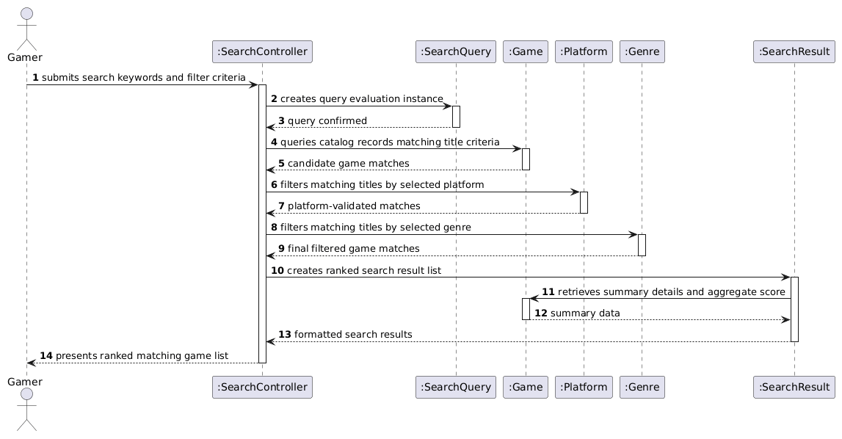
Figure 5.2.x Analysis sequence diagram for UC-xx; message numbers match the scenario table

UC-06 [View Game Reviews]

(a) Non-Trivial Steps
- Step 2 (Non-trivial): Requires the system controller to query the catalog for a specific game's review collection, sort the reviews by a selected criterion (e.g., date or score), and retrieve the associated scores, written summaries, and publisher identities.
- Step 4 (Non-trivial): Requires the system to process individual ratings to verify/display the aggregate rating alongside the formatted review items.
- (Step 0 is the actor's initial view of the game profile; Step 1 is the actor selecting a review sorting criterion; Step 3 is the actor selecting an individual review for inspection).

(b) Scenario Table
Step | Subject (who acts) | Subject action (what it does) | Other data / objects (what is used) | Object acted upon (who receives)
2.1 | Gamer | requests reviews with sort option | sortCriterion (e.g., date, rating) | ReviewViewController
2.2 | ReviewViewController | requests review collection for title | Game.title | Game
2.3 | Game | queries associated reviews | Game identity | Review
2.4 | ReviewViewController | requests publisher details | Review record | ReviewSource
2.5 | ReviewViewController | orders review entries | Review.publicationDate, Review.score | Review
4.1 | ReviewViewController | requests current overall rating | Game identity | Game
4.2 | Game | provides calculated rating | Game.aggregateScore | ReviewViewController
4.3 | ReviewViewController | presents sorted reviews with aggregate score and source attributions | formatted review cards, aggregateScore | Gamer

(c) Analysis Sequence Diagram

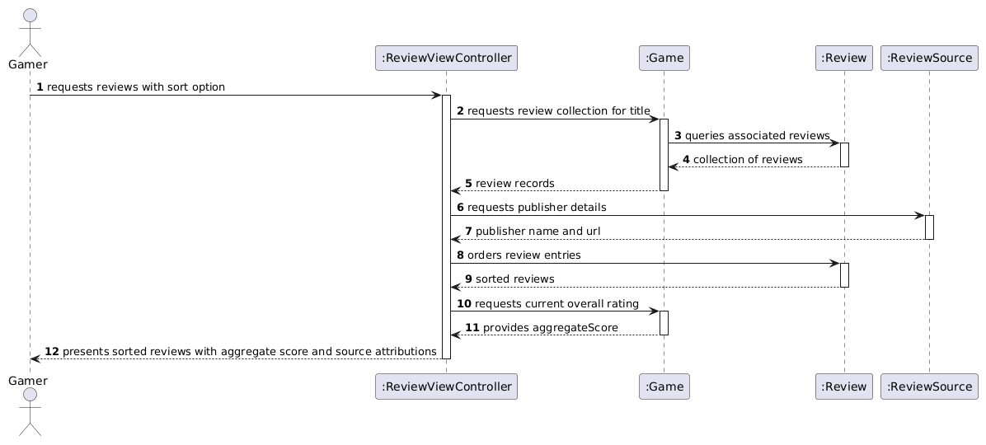

5.3 Consistency cross-check
Check | Result (pass, or what failed) | Fixed in
K1: Every attribute passed across interactions (text, genreFilter, platformFilter, rank, title, aggregateScore) matches attributes defined in the 5.1 Domain Model.
K2: Objects on the diagram are exclusively domain entities (SearchQuery, SearchResult, Game, Platform, Genre) or the declared interaction controller (SearchController).
K3: Every scenario table row corresponds 1:1 with a message on the sequence diagram.
K4: All non-trivial steps identified in part (a) (Steps 2 and 3) are represented across rows 2.1–3.3.
K6: The final response message (step 3.3) presents the matching results to the actor, satisfying the postcondition of UC-05.
K6 The last messages of each diagram make the use case postcondition true

6 High-Level Design (Architecture)
Chapter 8. The rule now reverses: a high-level design that does not say where things run, what they are built from and what that choice cost has not been done.

6.1 Architectural drivers: quality-attribute scenarios
QAS | Quality attribute | Stimulus | Artifact | Response | Response measure | From
QAS-01 | Performance | Up to 20 concurrent users execute search queries simultaneously during normal peak hours. | Web Application & Search Engine | Processes queries, filters against catalog, and renders results. | At least 95% of test searches return results in $≤$ 3.0 seconds across 100 test runs. | QR-01
QAS-02 | Usability | A user accesses search, game details, and review comparison pages on mobile and desktop viewports. | Presentation Layer / UI Components | Renders adaptive, unclipped layouts without overlapping elements. | Verified 100% pass rate at viewport widths of 360 px and 1366 px. | QR-02
QAS-03 | Security | An unauthenticated visitor or regular gamer attempts to access moderation/removal endpoints. | Access Control & Auth Middleware | Blocks unauthorized requests and logs the attempt. | 100% of tested unauthorized attempts are blocked and redirected to login/error page. | QR-03
QAS-04 | Reliability | Users submit 20 valid reviews with ratings under normal operation. | Review Ingestion & Storage Service | Validates, persists, and associates reviews with target games. | 100% (20/20) of reviews persist and display accurately upon page reload. | QR-04

6.2 Architectural style and alternatives
Style considered | Drivers it serves | What it costs | Verdict
Layered (3-Tier) Client-Server with RESTful Services | QAS-01 (caching at API/data tiers), QAS-02 (decoupled responsive UI), QAS-03 (centralized middleware security), CON-01 (API rate-limiting abstraction). | Additional network latency between tiers; requires explicit DTO transformations. | Chosen
Microservices Architecture | High scalability for independent review scraping and search workloads. | Significant operational overhead, complex distributed tracing, high hosting cost for a 5-person semester scope. | Rejected
Monolithic MVC (Server-Side Rendered) | Simple initial setup and zero API boundary overhead. | Tight coupling between presentation and domain logic; hinders independent responsive mobile client optimization (QAS-02). | Rejected

6.3 Component view

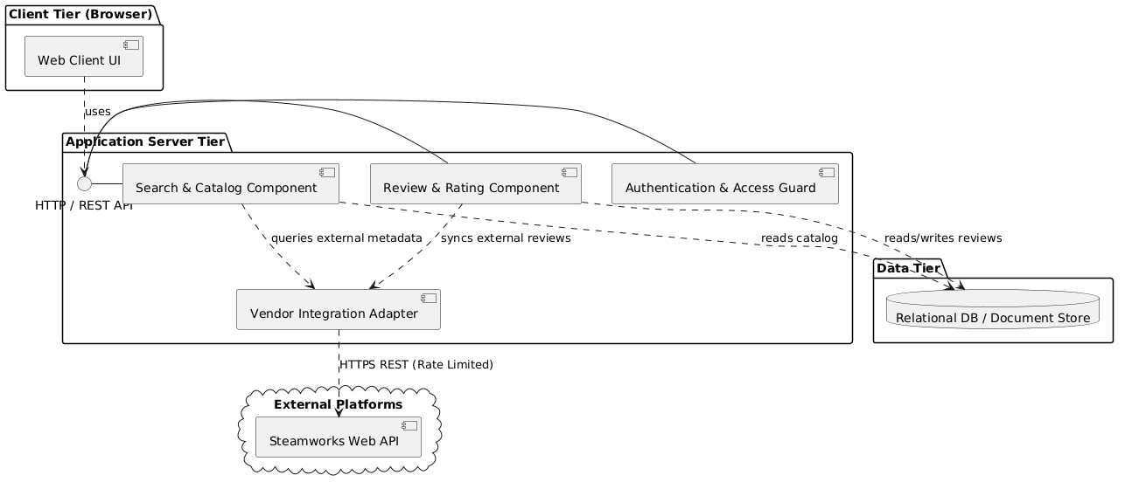

Figure 6.3 Component diagram: components, provided and required interfaces, external systems
Component | Responsibility (one sentence) | Provides | Requires | Answers to (UC / QAS / ADR)
Web Client UI | Renders adaptive search, detail, and review views for users on mobile and desktop viewports. | User Interaction Flow | HTTP / REST API | UC-05, UC-06, UC-07, QAS-02
Auth & Access Guard | Validates session tokens and enforces role-based access control for protected user and moderation operations. | AuthService | User credential store | QAS-03, FR-08, FR-09
Search & Catalog Component | Coordinates search query parsing, platform/genre filtering, and game metadata formatting. | GameSearchService, CatalogQuery | DB, Vendor Integration Adapter | UC-05, UC-07, QAS-01
Review & Rating Component | Manages user review submissions, computes aggregate scores, and serves sorted review feeds. | ReviewService, RatingAggregator | DB, Vendor Integration Adapter | UC-02, UC-06, QAS-04, FR-06
Vendor Integration Adapter | Interfaces with external platforms (Steam API), enforcing API rate limiting and response mapping. | ExternalGameDataService | Steamworks Web API | CON-01, CON-02, R1, R2
Database Storage | Persists users, internal reviews, game catalog cache, and flagged content records. | SQL / Document Persistence | Underlying filesystem/cloud volume | QAS-04, QR-04

6.4 Deployment view
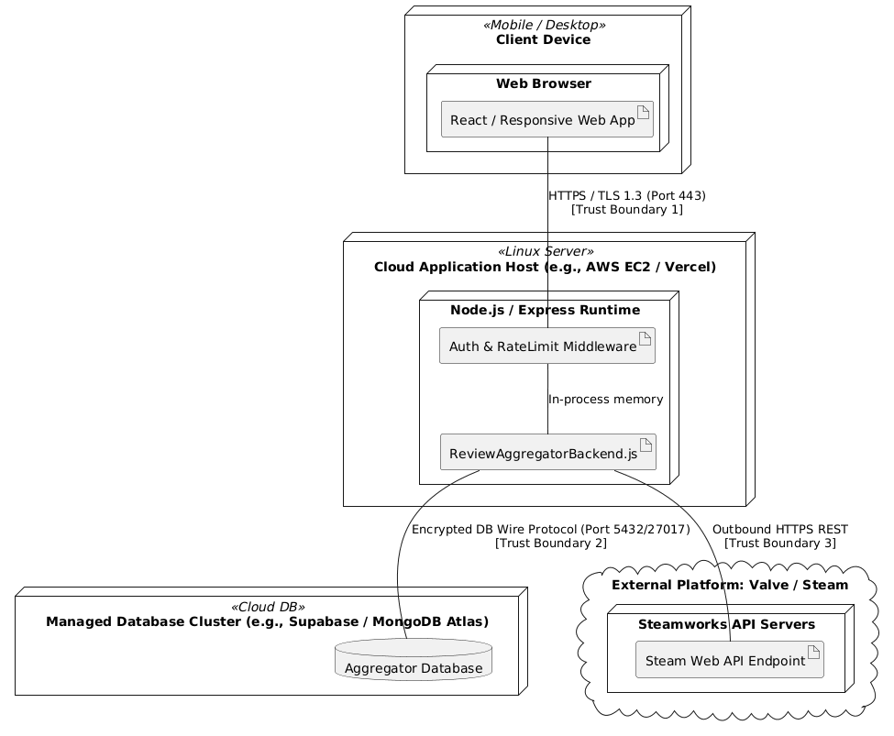

Figure 6.4 UML deployment diagram: nodes, execution environments, deployed artifacts, communication paths with protocols, trust boundaries
Node | What runs on it (artifacts, components) | Communicates with (protocol) | Trust zone
Client Device (Gamer Browser) | Web Client UI (Single Page HTML/JS/CSS bundle) | Application Host via HTTPS (Port 443) | Untrusted Zone (Public Internet)
Application Server Node | Express/Node.js runtime, API routing, Search & Review controllers, RateLimiter | Client via HTTPS; DB via TLS TCP; External API via HTTPS | DMZ / Application Trust Zone
Managed DB Cluster | PostgreSQL/MongoDB engine, tables/collections for Reviews, Games, Users | Application Server via encrypted database connection | Secure Internal Data Zone
External Vendor Host (Steam) | Steamworks API service | Application Server via outbound HTTPS API requests | External Third-Party Zone

Trust Boundaries & Shared Responsibility:
- Boundary 1 (Client $↔$ Server): Public Internet. All inputs are sanitized; JWT tokens verified on every state-changing request.
- Boundary 2 (Server $↔$ DB): VPC or SSL-secured DB link. Team manages schemas and access keys; provider handles hardware patching.
- Boundary 3 (Server $↔$ Third Party): Only outbound HTTPS requests; API secrets stored as environment variables on the server and never exposed to the client

6.5 From analysis to architecture
Analysis object (from 5.1 and 5.2) | Component that owns it (6.3) | Note (split, merged, external)
SearchQuery | Web Client UI & Search Component | Captured as state on the client; passed as query DTO to backend search.
SearchResult | Search Component | Transient DTO compiled by backend and returned to client.
Game | Search & Catalog Component | Core persistent entity; attributes cached in DB and enriched via Vendor Adapter.
Platform | Search & Catalog Component | Merged into game metadata relations/attributes.
Genre | Search & Catalog Component | Merged into catalog indexing structures for filtering.
Review | Review & Rating Component | Persistent entity stored in DB; aggregates both user reviews and external snippets.
ReviewSource | Vendor Integration Adapter | External entity modeling publisher endpoints and platforms.
SearchController | Search & Catalog Component | Mapped to backend route controller (/api/search).
ReviewViewController | Review & Rating Component | Mapped to backend route controller (/api/games/:id/reviews).
GameCatalogController | Search & Catalog Component | Mapped to backend route controller (/api/games/:id).

6.6 Design principles applied
Principle | Where it shows in your design | Evidence (component, interface, ADR)
Separation of concerns | UI rendering is decoupled from review aggregation algorithms and database persistence. | Three-tier separation: Web Client UI $↔$ Review & Rating Component $↔$ Database.
Information hiding | External Steam API specifics (rate limits, raw JSON schema) are hidden behind internal interfaces. | Vendor Integration Adapter exposing standard ExternalGameDataService.
Low coupling | Frontend interacts exclusively through generic REST endpoints rather than knowing storage or vendor layout. | HTTP / REST API interface layer.
High cohesion | All score calculating, averaging, and review sorting responsibilities are centralized together. | Review & Rating Component (RatingAggregator class).
Design for change | Adding another review source (e.g., Metacritic or itch.io) requires changing only one adapter without touching frontend UI. | Vendor Integration Adapter modular plug-in architecture.
Keep it simple (KISS) | Rejection of distributed microservices in favor of a cohesive modular backend service. | Section 6.2 Architectural Style selection.

7 Design Rationale

7.1 Architecture decision records
At least three. ADR-01 records the style decision from 6.2. Use the format you practiced in the Lesson 16 workshop, written about your own project. Copy the block for each decision.

ADR-xx [Decision title]
Status | Accepted / Superseded by ADR-
Date and owner
Context (drivers) | Which QAS, use cases and constraints force a decision here
Options considered | At least two, each in one line
Decision
Consequences | Name the quality it favors, the move, and the cost you accept
Evidence | Spike result (section 8), measurement, documentation, or "none yet" with an open question
Related | ADR-, QAS-, R- (risk), CH- (change)

7.2 Trade-off summary
Quality favored | Architectural move | Cost accepted | Recorded in
 |  |  | ADR-
 |  |  | ADR-
 |  |  | ADR-

GUIDANCE: DELETE THIS BOX BEFORE SUBMITTING
One row per real trade-off. This is the table a reviewer reads first. Budget: a quarter of a page.

8 Prototype Evidence: Architecture Spike
Spike ID and title | S-01
Risk or decision it addresses | R- / ADR- / QAS-
Question (answerable yes or no)
Set-up | Stack, data, what was simulated; folder in the repository
How it was measured
Result (numbers)
What it changed or confirmed | Which ADR, QAS or requirement
Where to see it | Commit hash, /spikes/S-01/, screenshot or log file

GUIDANCE: DELETE THIS BOX BEFORE SUBMITTING
Build the smallest thing that answers your riskiest architectural question, run it, and measure it. Time-box it to a few hours. It may be thrown away afterwards; it is not the product.
Good spikes answer questions such as: can we read the external data source, and is it fresh to within 60 seconds? Does the chosen hosting meet QAS-01 under a simulated peak? Does the authentication provider fit our trust boundary?
Never commit passwords, API keys or other credentials; keep them in local configuration excluded from the repository.
The code, the measurement and a short README are committed to /spikes before the deadline. A spike described but not in the repository is not evidence.
Budget: half a page.

9 Traceability

9.1 Extended traceability matrix
Requirement | Use case | Analysis classes | Component(s) | QAS / ADR | Evidence
FR-01
FR-02
QR-01
CON-01

GUIDANCE: DELETE THIS BOX BEFORE SUBMITTING
Extend the P1 matrix one column at a time: from each requirement to the use case, to the analysis classes that realize it, to the component that will own it, to the decision or scenario that shaped it, and to whatever evidence exists (spike, measurement).
Requirements realized by the use cases you analyzed need the full chain. Every other MUST requirement needs at least its component. Withdrawn requirements stay in the matrix, marked as such.
Budget: one page.

9.2 Gap analysis
Gap | Items | What you did about it
Requirements with no component
Components with no requirement, QAS or ADR
Use cases not analyzed (and why that is acceptable)

GUIDANCE: DELETE THIS BOX BEFORE SUBMITTING
An empty gap table is believable only if the matrix above is complete. Say what each gap means and what you did. Budget: a quarter of a page.

10 Project Plan
4.1 Team roles and working agreement
Team member | Role for P1 to P2 | How the team makes a decision when it disagrees
Terrell Johnson | Revise use cases, perform further elicitation | Gather everyone’s opinion, find a common ground and compromise
Mary Demas | Structure of repository | Agree on organization, issue, and pushes in the repository before major restructuring
Umar Shaikh | Handling APIs/Back-end capabilities | Communicate with the relevant owners with research and information to determine the best course of action
Rohith Rajan | Improve requirements/Revise traceability | Contact and communicate with the associated owner and decide on a solution
Ethan Nguyen | Handling open questions | Asking internal questions and communicating with the team to come to a consensus
Chayeol Jung | Working on front-end capabilities/Revising risks | Communicate with the relevant owners with research and information to determine the best course of action

10.2 Plan to P2
Date | What will be finished | Owner
10/30 | Research on the game APIs and rate limiting | Umar Shaikh
10/30 | Handling and solving existing open questions | Ethan Nguyen
10/30 | Revise requirements and confirm traceability | Rohith Rajan
10/30 | Go over use cases, perform XP spike for technical feasibility | Terrell Johnson
10/30 | Cleaning and revising the repository | Mary Demas

10.3 Risks
# | Risk | Likelihood | Impact | Mitigation — action and owner
R1 | Review Bombing & Spam | Low | Coordinated malicious reviews or bot spam will distort game ratings, destroying trust for gamers researching titles. | Implement rate limiting, captcha for review submissions, and automated keyword flagging to quarantine suspicious reviews before publication.
R2 | Traffic Spikes on Release Days | Low | Massive influxes of users checking reviews for highly anticipated AAA game releases could overload servers, causing system timeouts and violating performance quality requirements. | Design the architecture for horizontal scaling and cache static game information/average ratings to reduce database load during peak times.
R3 | Moderator Bottlenecks | Low | A high volume of user submissions could overwhelm the moderation team, leading to a backlog of unpublished reviews or missed rule violations. | Build efficient bulk-moderation tools, prioritize flagged content, and implement a tiered trust system where veteran reviewers bypass manual approval.
R4 | Reviewer Abandonment | Low | If the review submission process is too complex or lacks clear instructions, reviewers will abandon drafts, resulting in a lack of fresh content. | Conduct usability testing on the submission form early in development to ensure rating options and text fields are straightforward for non-technical writers.
R5 | Moderation Scope Creep | Medium | Over-engineering the moderator dashboard with complex features could delay the core functionality needed for P1 delivery. | Strictly limit the initial moderation tools to basic approve, reject, and flag functions, explicitly defining what is excluded from the current scope.

10.4 Repository and tooling
Repository URL: https://github.com/AgentRachel/game-review-aggregator
Issues are used to log individual work. Team members shall assign themselves an issue and close it upon completion. All team members have access to the GitHub repository.

10.5 Declaration of AI tool use

Tool | What it was used for | Who used it | How the output was checked
ChatGPT | Converting findings into formal requirements of documentation and formatting content to match the P1 template. | Mary Demas | Reviewed against the resources listed in 1.4

11 Open Questions

# | The question | Who can answer it | Needed by | What you assumed in the meantime
Q1 | How would a new gaming vendor enter the system | Rohith Rajan | Gamer and vendors | No new major vendors would try to join the system because existing ones are extremely dominant in the market
Q2 | How would a vendor leave the system | Rohith Rajan | Vendors | A vendor just wouldn't want to leave the system
Q3 | How to differentiate and handle bad actors leaving contradictory reviews | Rohith Rajan | Gamers | Gamers leaving reviews would generally be accurate and would not need to be managed
12 Baseline Declaration

We confirm that the requirements in section 3 represent our agreed baseline as of the submission date, and that every team member has read this document in full.
Team member | Signature or typed name | Date
Terrell Johnson | Terrell Johnson | 10/18/2026
Mary Demas | Mary Demas | 10/18/2026
Umar Shaikh | Umar Shaikh | 10/17/2026
Rohith Rajan | Rohith Rajan | 10/18/2026
Ethan Nguyen | Ethan Nguyen | 10/17/2026
Chayeol Jung | Chayeol Jung | 10/18/2026

How P2 Is Marked
Delete this page and the next before submitting. 60 points: 48 for the shared team artifact (80%) and 12 for individual contribution evidence (20%).
Criterion | Points | What full marks look like
Baseline, change control, plan and repository (sections 0.2, 1 to 3, 10 to 12) | 6 | Every point of the P1 feedback is answered in 0.2. Requirement IDs are preserved and withdrawn items marked. The plan to P3, risks, AI-use declaration, open questions and signed v1.0 baseline are up to date. The repository is accessible and, before the deadline, holds this PDF, the diagram sources and the spike, with the tag p2 on that commit.
Use-case analysis (section 4) | 8 | At least three use cases expanded turn by turn with step (0), one turn per row, an acknowledgment at the end, real alternate flows, and no technology. Preconditions are true assumptions, not hidden alternate flows. The self-review log records what each check found, including any defects fixed.
Domain model and object interaction (section 5) | 10 | A conceptual domain model with attributes and multiplicities that contains every item the actor columns mention. At least two use cases carried through non-trivial steps, a five-column scenario table and an analysis sequence diagram whose messages match the table row for row. The six cross-checks are run honestly.
High-level design (section 6) | 10 | At least three quality-attribute scenarios with response measures. A named style chosen over at least two alternatives for reasons tied to those scenarios. A component view in which every component answers to a use case, scenario or decision; a UML deployment view with protocols and trust boundaries; every analysis object mapped to a component; design principles pointed out in the design itself.
Design rationale (section 7) | 6 | At least three decision records, each with real alternatives, a decision and a stated cost. The trade-off summary agrees with them.
Prototype evidence (section 8) | 4 | One spike that answers a real architectural question with a measured result, committed with its README before the deadline, and linked to the decision it changed or confirmed.
Traceability (section 9) | 4 | Every requirement realized by the analyzed use cases is traced through analysis classes to a component, and to the scenario or decision that shaped it where one exists. Every other MUST requirement reaches at least a component. Gaps are named, explained and acted on.
Document quality | up to −3 | Deducted from the team points, not awarded: guidance, example or warning boxes left in, placeholders, sections out of order or renumbered, unreadable diagrams, or a document far beyond its length budget.
Individual contribution evidence (section 0.1) | 12 each | 12: owns specific sections or artifacts, with own commits or pull requests before the deadline and at least one review of a teammate's pull request. 9: specific ownership and own commits, but thin or no review evidence. 6: specific claim with indirect evidence only (issues owned, or work uploaded explicitly on the member's behalf). 4: specific claim with no repository evidence. 2: vague or duplicated claim. 0: no credited work. A member with no credited work at all (absent from the contribution record and with no commits) may also lose the team portion, because the syllabus does not allow credit for work completed by others. This applies to individual non-participation only, never to a whole team.

WHERE P1 MARKS WERE LOST (DELETE THIS BOX BEFORE SUBMITTING)
Repositories that were empty, unreachable, or held a single upload from one account at the deadline. Repository and contribution credit could not be given, however good the document was.
Contribution records that cited commits, pull requests or files that were not in the repository. Everything cited is checked.
Guidance boxes, placeholders and unconfirmed draft text left in the submitted document.
Several members uploading different versions to Canvas. One member submits. If more than one file is uploaded, the latest upload is the one graded.
Quality requirements with no number in them, and requirements whose source was still "pending".
Work committed after the deadline. It is not counted, even a few minutes after.

5 Open Questions

# | The question | Who can answer it | Needed by | What you assumed in the meantime
Q1 | How would a new gaming vendor enter the system | Rohith Rajan | Gamer and vendors | No new major vendors would try to join the system because existing ones are extremely dominant in the market
Q2 | How would a vendor leave the system | Rohith Rajan | Vendors | A vendor just wouldn't want to leave the system
Q3 | How to differentiate and handle bad actors leaving contradictory reviews | Rohith Rajan | Gamers | Gamers leaving reviews would generally be accurate and would not need to be managed

6 Baseline Declaration

We confirm that the requirements in section 3 represent our agreed baseline as of the submission date, and that every team member has read this document in full.
Team member | Signature or typed name | Date
Terrell Johnson | Terrell Johnson | 10/18/2026
Mary Demas | Mary Demas | 10/18/2026
Umar Shaikh | Umar Shaikh | 10/17/2026
Rohith Rajan | Rohith Rajan | 10/18/2026
Ethan Nguyen | Ethan Nguyen | 10/17/2026
Chayeol Jung | Chayeol Jung | 10/18/2026

