

Name: Chintapenta Sai Rahul Bharadwaj Regn number: 21BCE7848

School: SCOPE Semester: Fall Sem 2021-22 Subject: Problem Solving using Python Subject Code: CSE1012

**ANSWERS OF ASSIGNMENT-1**

**Python IDE used: Spyder Python 3.7.9 Submission Date: 28-Oct-2021**

**Marks (Weightage): 100 Submission Due Date: 1-Nov-2021**

ALL THE CODE AND .PY Files are available at

<https://github.com/AgentRatz/VITAP-FRESHERS-CSE1002-AS1>

1. Program to find ASCII value of any input character
2. 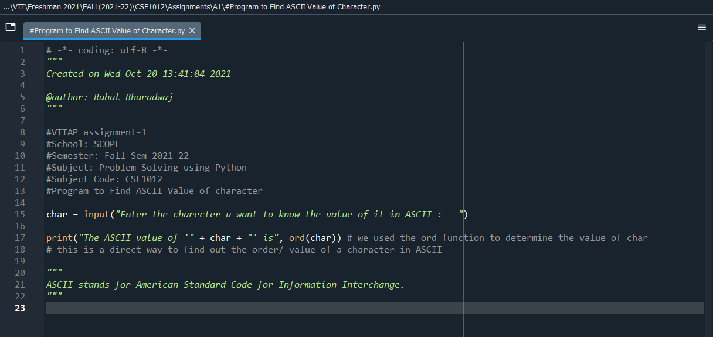Code
3. 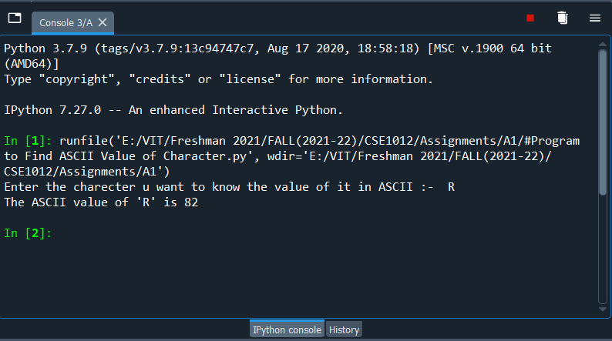Output Screenshot

2. Reverse a Given Number Using While Loop

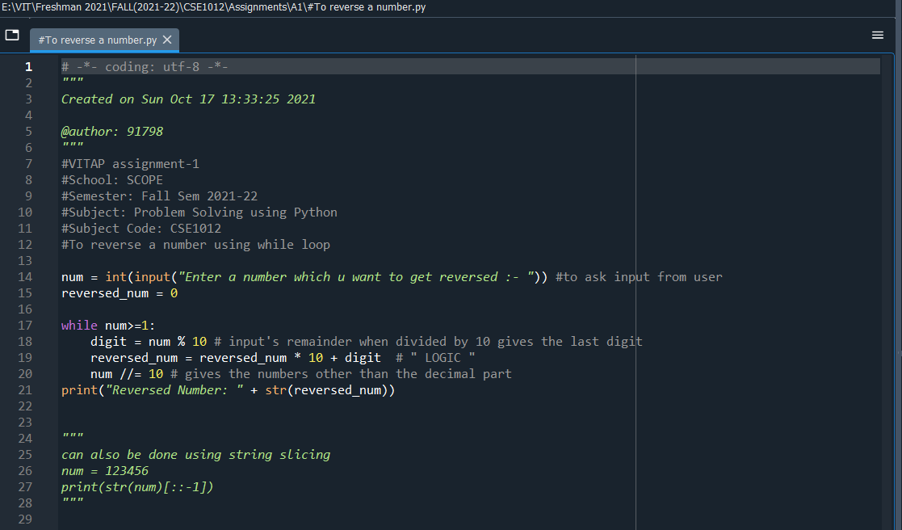(a) Code

(b) Output Screenshot

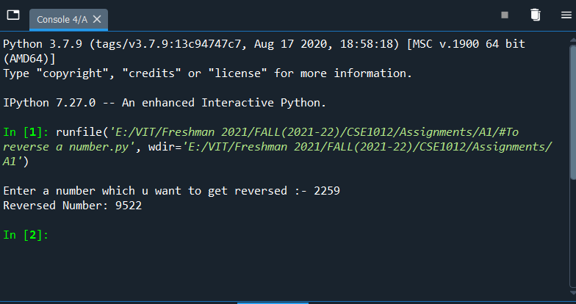

3. Find the Number Is Armstrong or Not Using While Loop

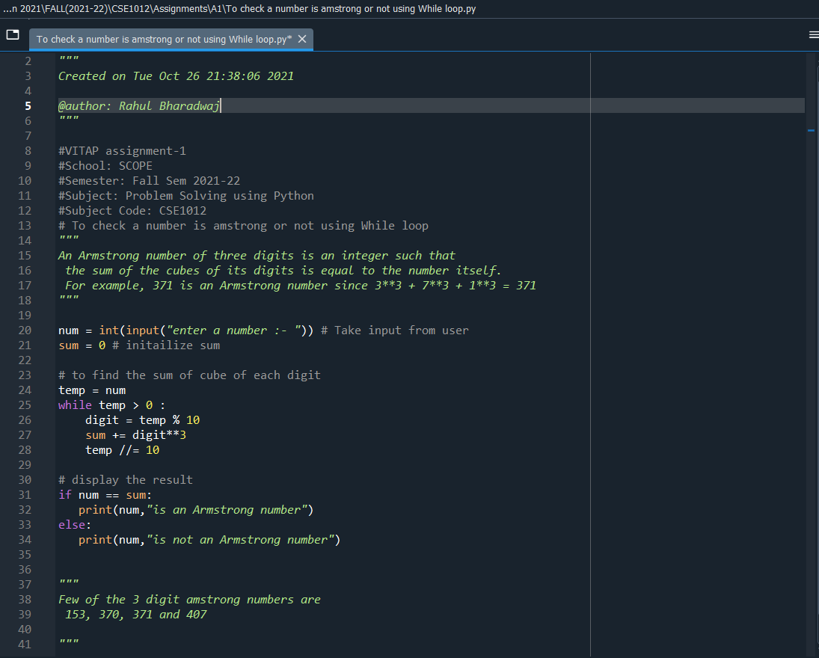(a) Code

(b) Output Screenshot

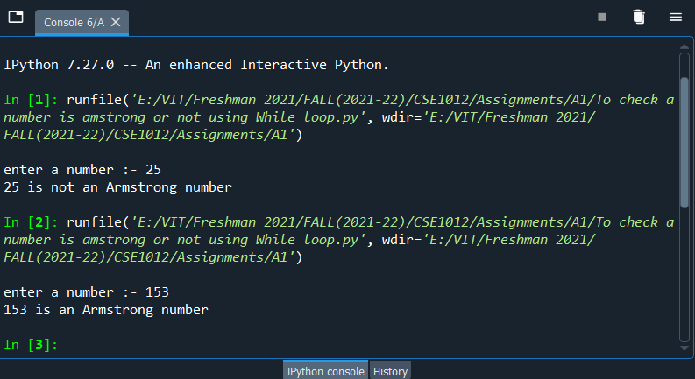

4. Calculate the Sum of Natural Numbers Using While Loop

(a) Code

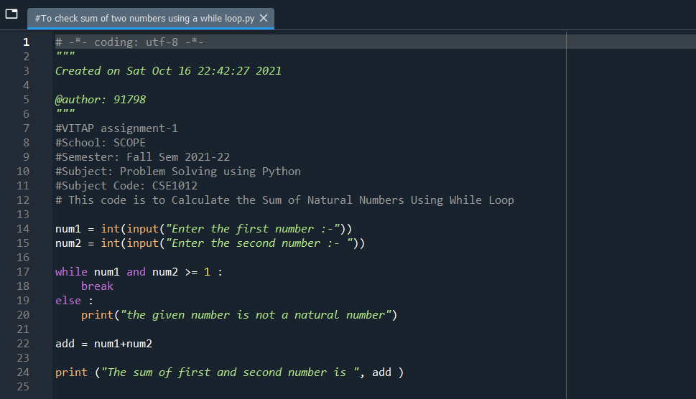

(b) Output Screenshot

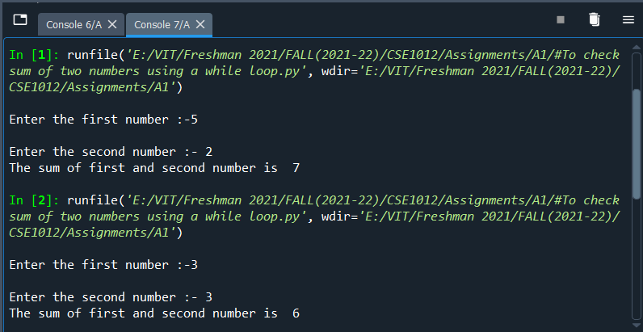

5. Checking a Number Is Prime or Not

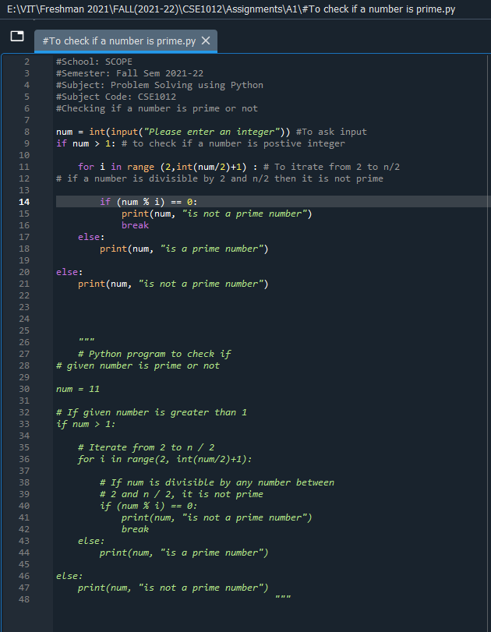(a) Code

(b) Output Screenshot

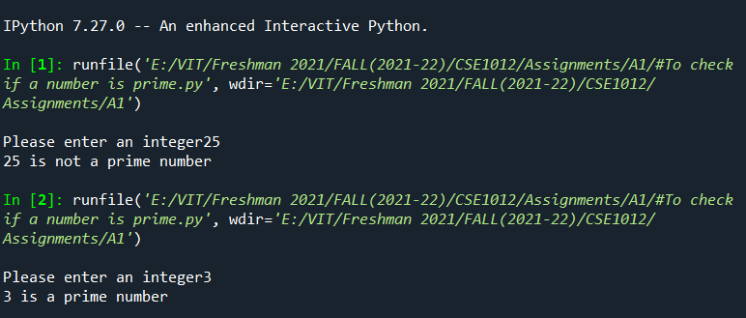

6. Print Multiplication Table Using for Loop

(a) Code

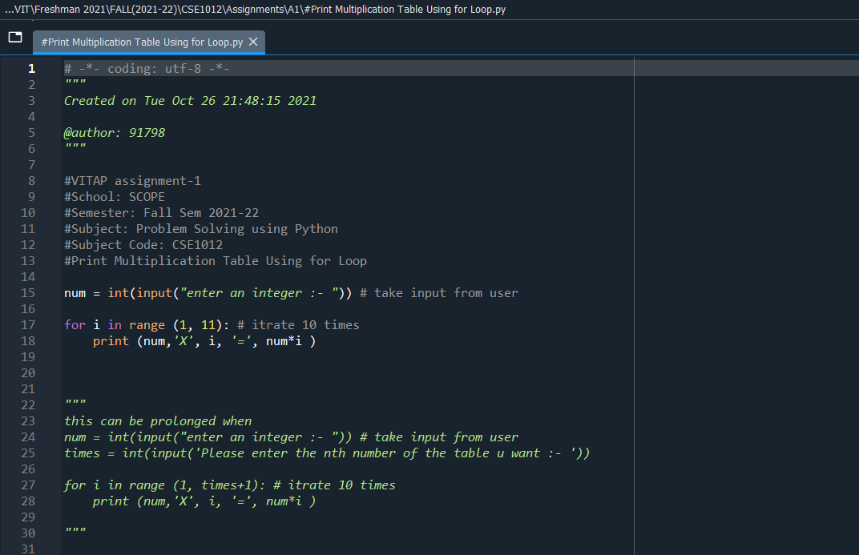

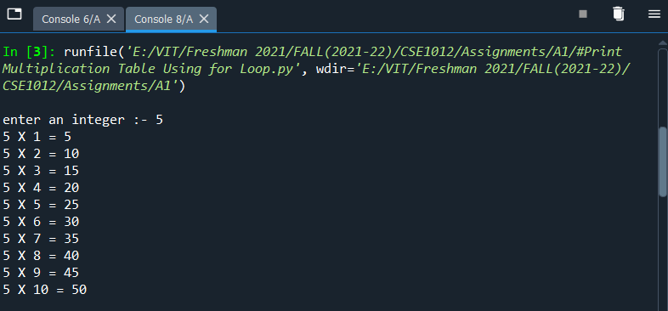(b) Output Screenshot

7. Display Fibonacci Series Using While Loop

(a) Code

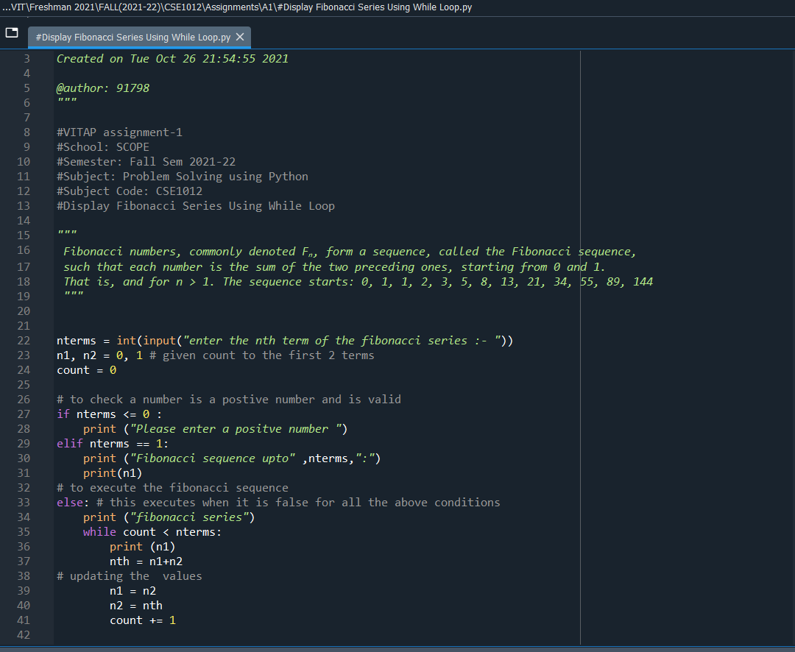

(b) Output Screenshot

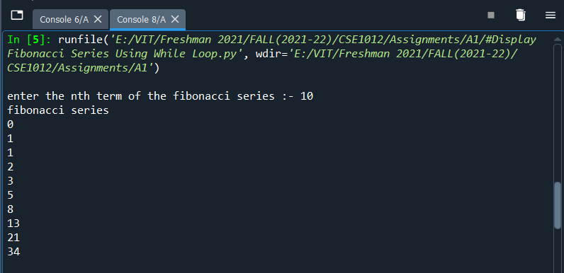

8. Find GCD of Two Numbers Using for Loop

(a) Code

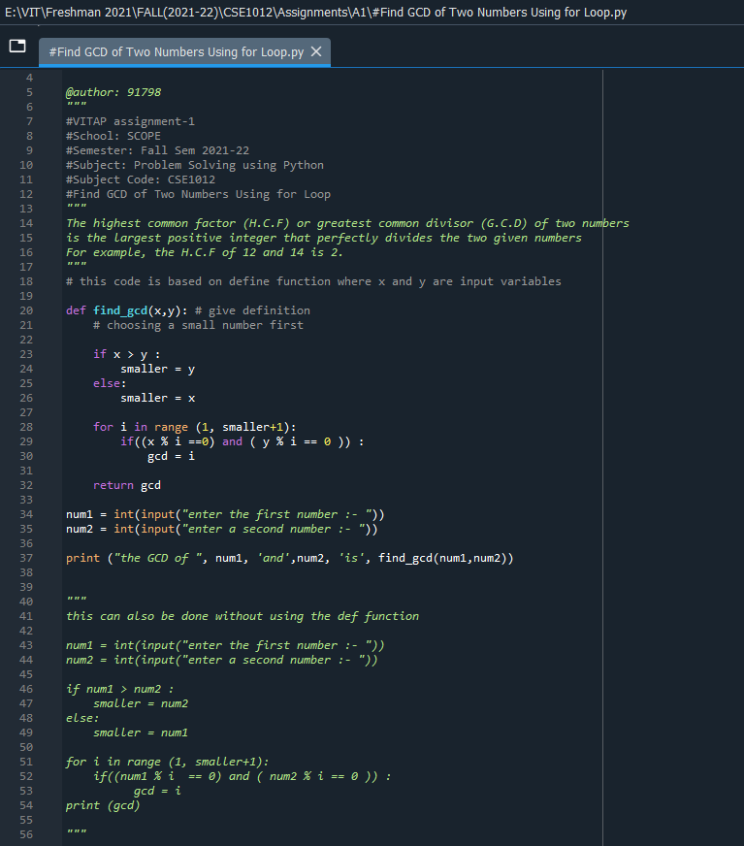

(b) Output Screenshot

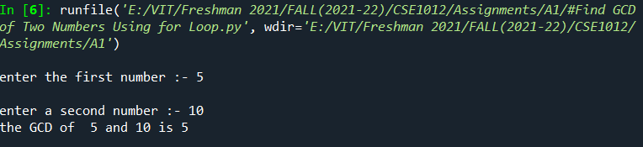

9. Find LCM of Two Numbers Using While Loop

(a) Code

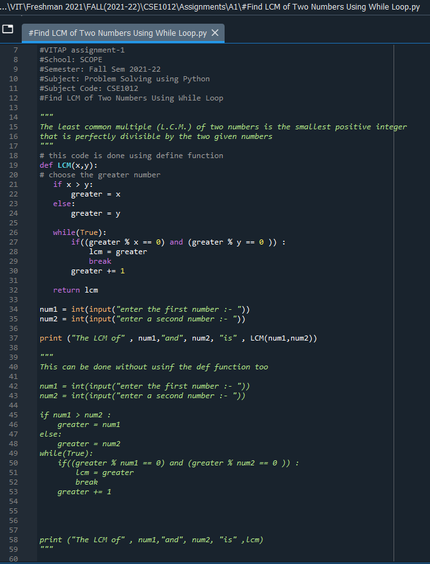

(b) Output Screenshot

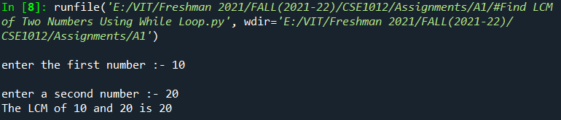

10. Reverse a Number Using While Loop

(a) Code

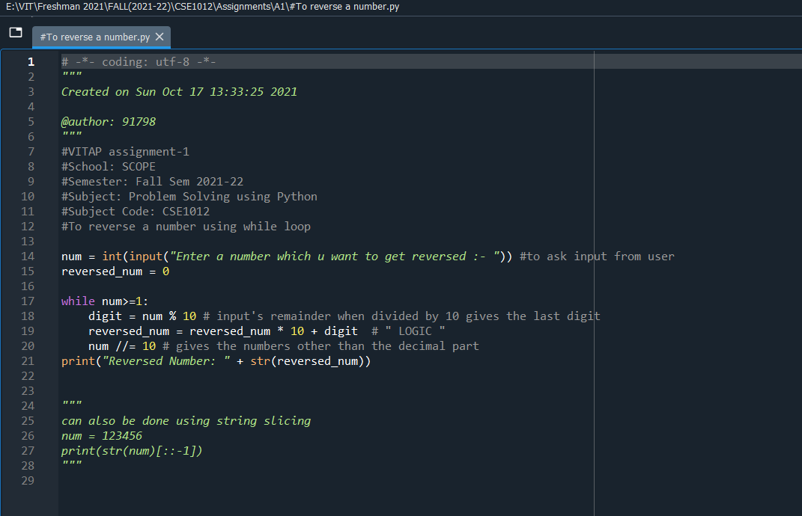

(b) Output Screenshot

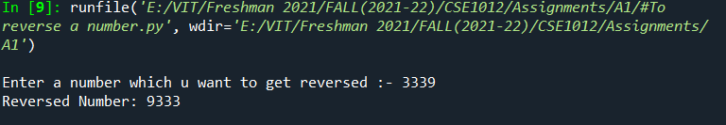

11. Number Is a Palindrome or Not Using While Loop

(a) Code

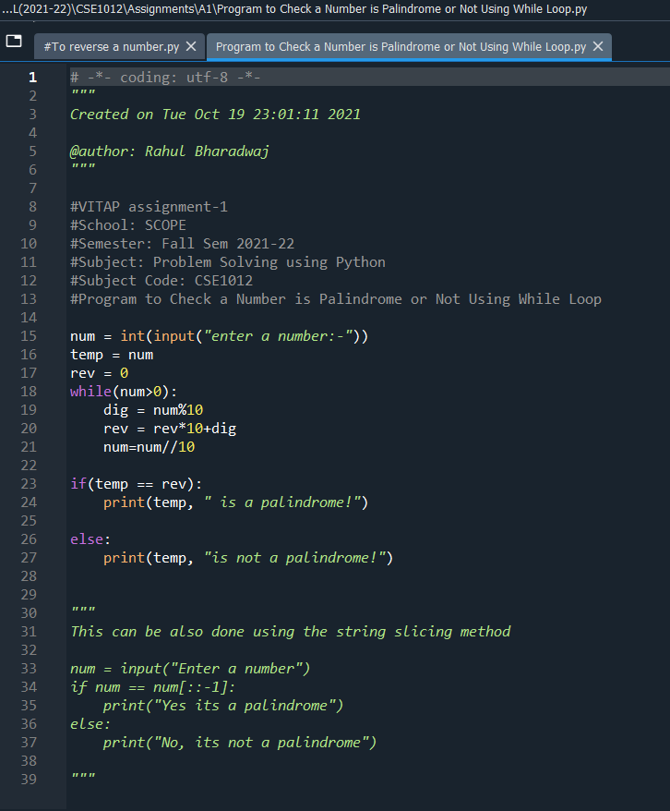

(b) Output Screenshot

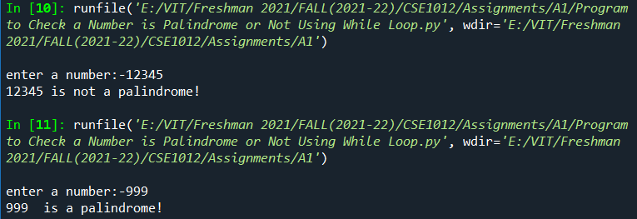

12. Count Number of Digits of an Integer Using While Loop

(a) Code

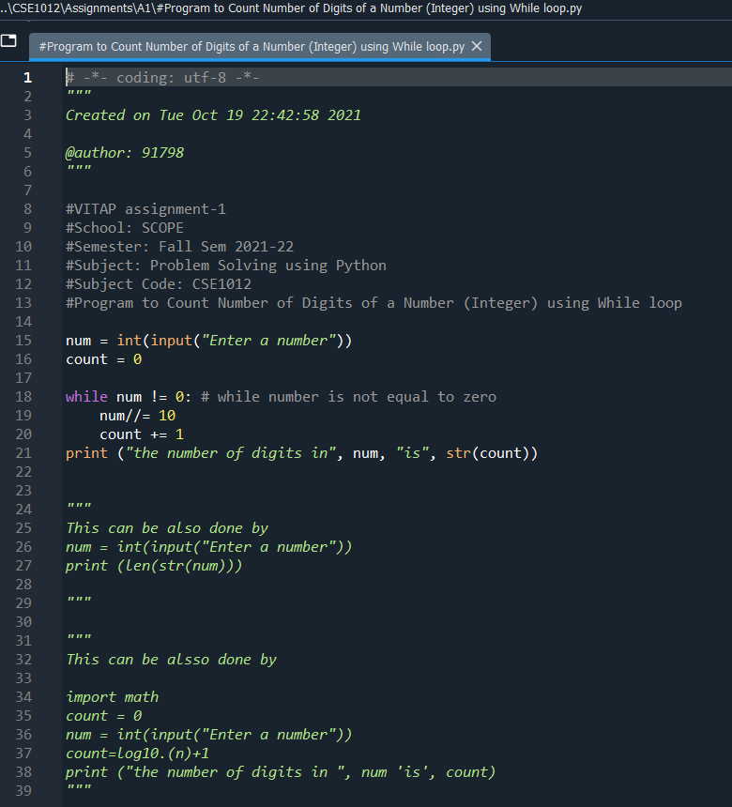

(b) Output Screenshot

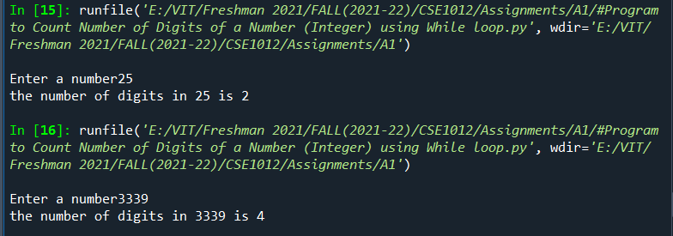

13. Find a Generic Root of a Number Using While Loop

(a) Code

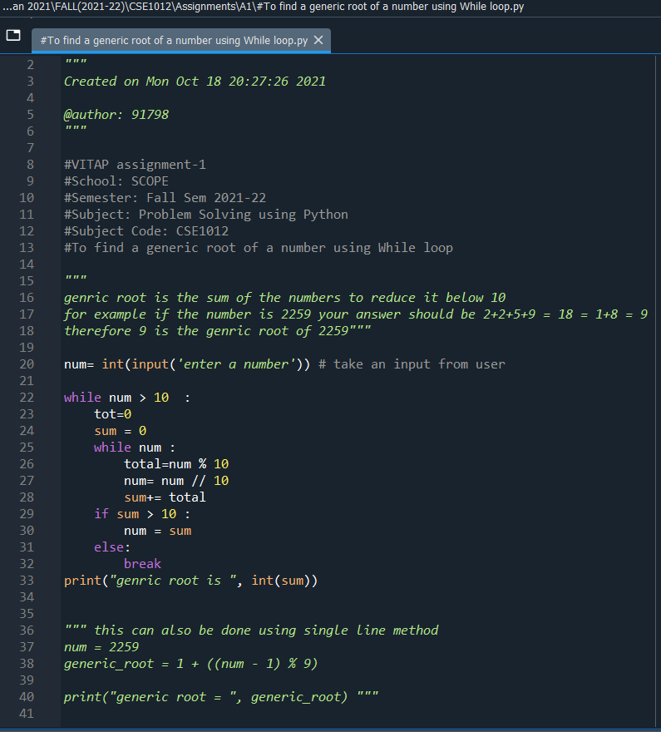

(b) Output Screenshot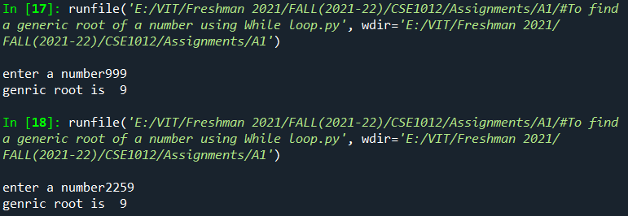

14. Print a Calendar Taking Input from User Using a Loop

(a) Code

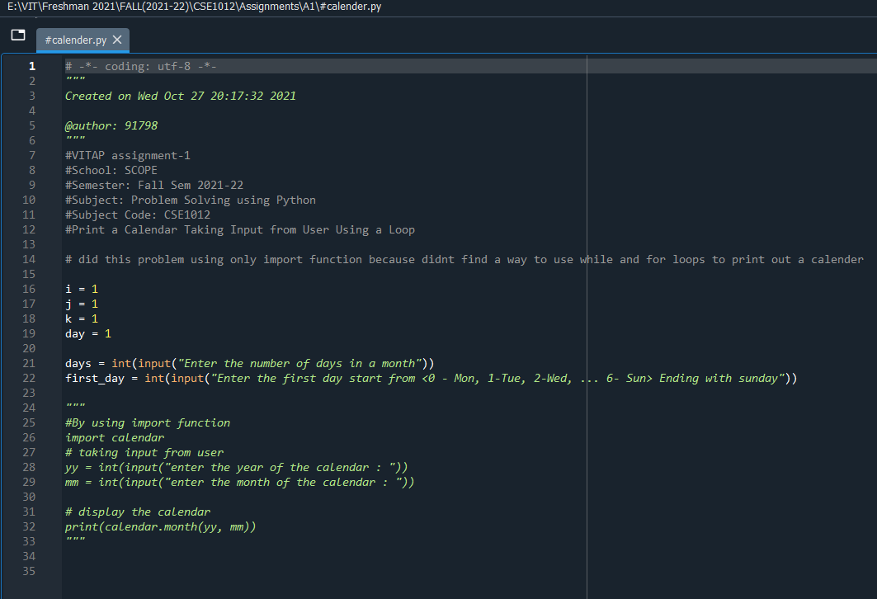

(b) Output Screenshot

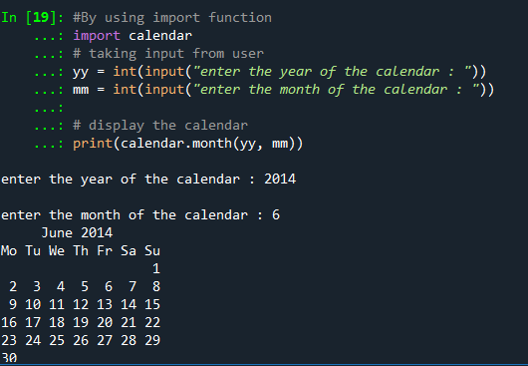

15. Print Factors of a Number

(a) Code

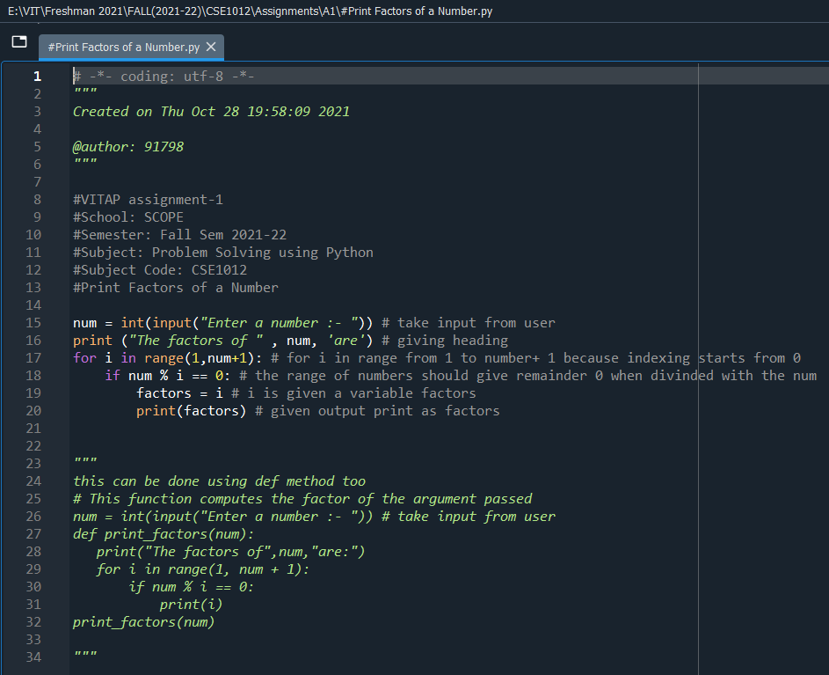

(b) Output Screenshot

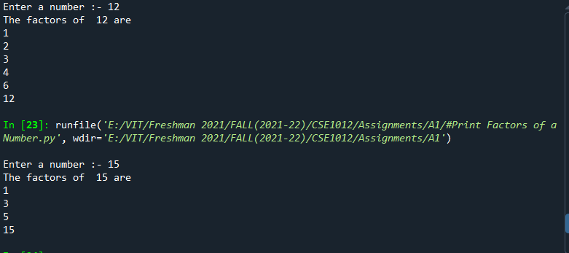

16. Print the following Pattern

*

* *

* * *

* * * *

* * * * *

(a) Code

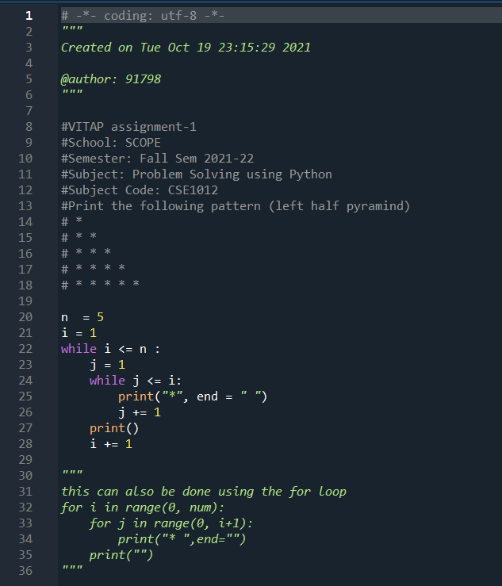

(b) Output Screenshot

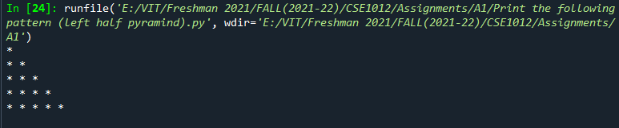

17. Print the following Pattern

1

1 2

1 2 3

1 2 3 4

1 2 3 4 5

(a) Code

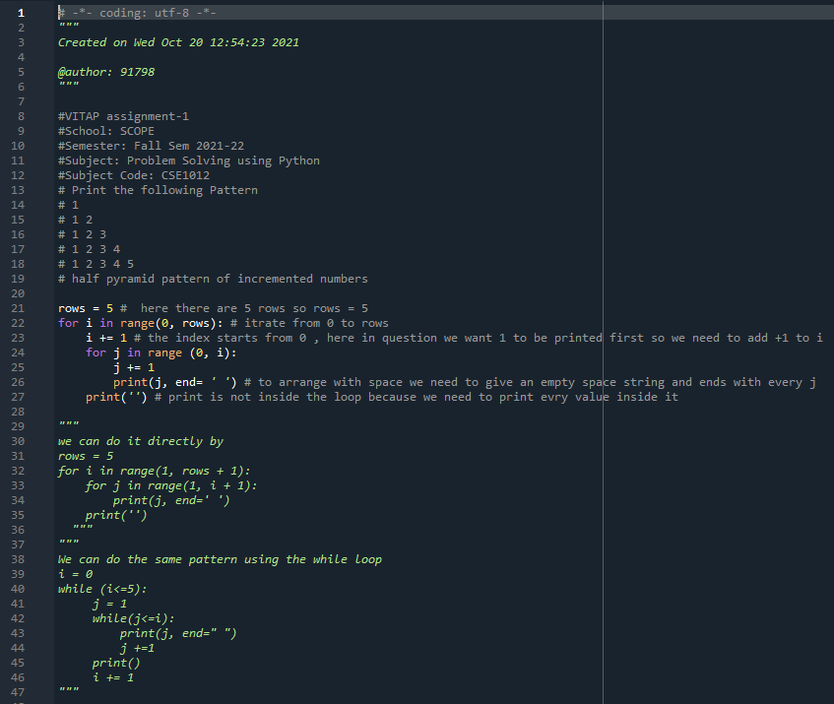

(b) Output Screenshot

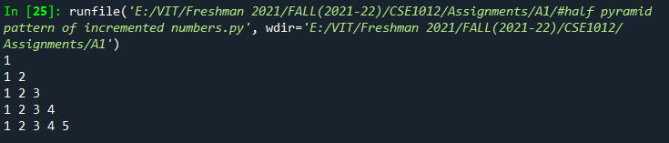4

18. Print the following Pattern

A

B B

C C C

D D D D

E E E E E

(a) Code

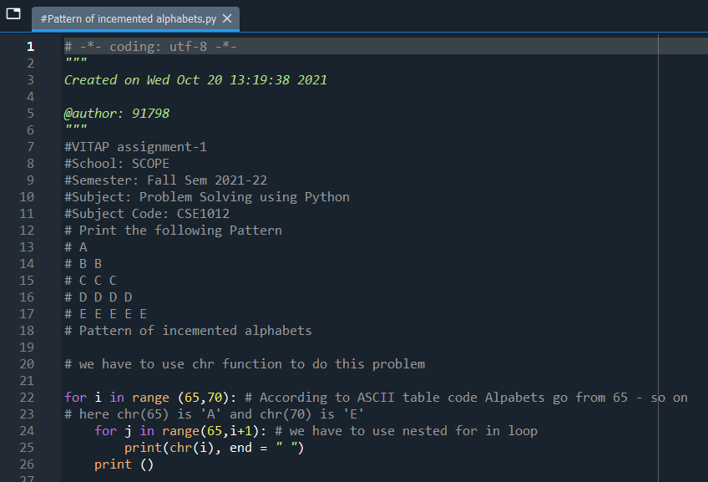

(b) Output Screenshot

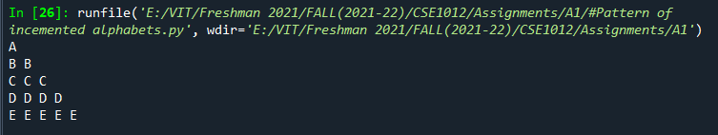

19. Print the following Pattern

* * * * *

* * * *

* * *

* *

*

(a) Code

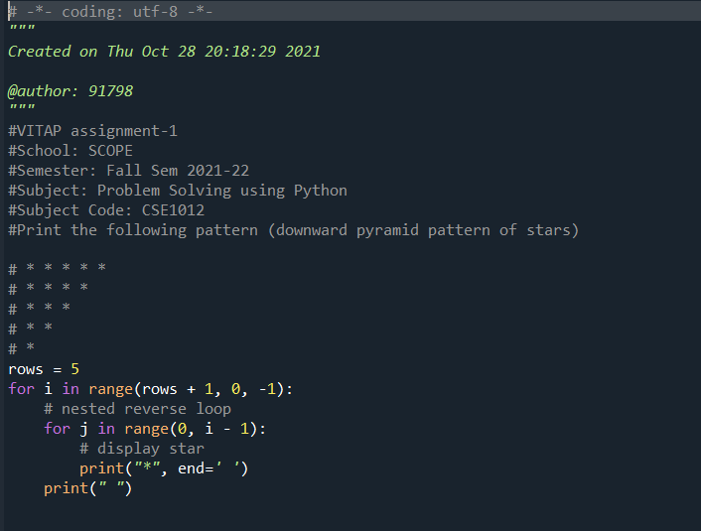

(b) Output Screenshot

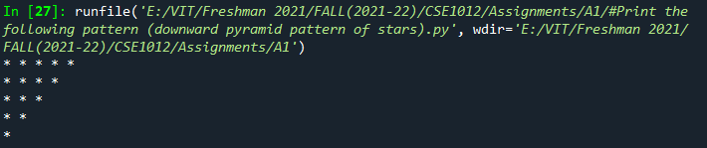

20. Print the following Pattern

1 2 3 4 5

1 2 3 4

1 2 3

1 2

1

(a) Code

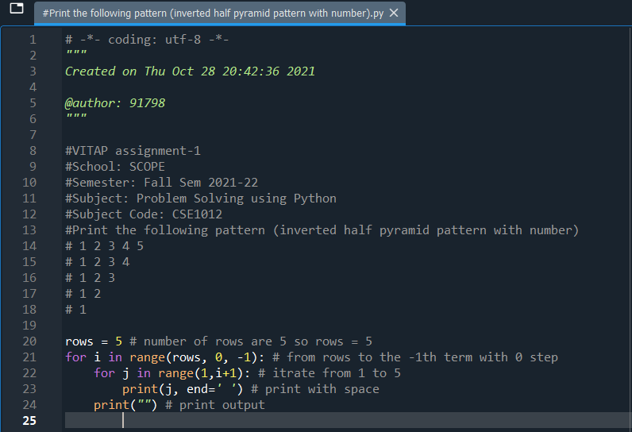

(b) Output Screenshot

