Executive Summary
This report presents a comprehensive analysis of three Human Resources Information Systems (HRIS) - Workday, BambooHR, and Rippling - to provide a recommendation to Hali Hali Halibut Ltd. The purpose of my evaluation is to identify an HRIS that will enable our company to digitize its human resources operations, thereby enhancing efficiency in managing staff information, including payslips, training records, and benefits administration.

All three platforms evaluated can handle the company’s workforce and seasonal hiring surges, but each has distinct strengths. Based on Hali Hali Halibut Ltd.'s specific requirements as a fish processing company undergoing digital transformation, Rippling is recommended as the optimal HRIS solution.

Its balanced approach to security and usability, comprehensive integration capabilities, and unified platform aligns most effectively with HaliHalibut Ltd.'s current needs and future digital ecosystem plans. Rippling's ability to maintain compliance and security while enabling productivity makes it particularly suitable for supporting HaliHalibut Ltd. 's growth objectives.

Context
At HaliHali Halibut, we use paper forms and basic Microsoft Office tools to handle our business operations. We're introducing a Human Resource Information System (HRIS) as part of our efforts to modernize and grow. Think of an HRIS as a digital filing cabinet where everything about our team is organized and easy to access.
The new system will simplify tasks like paying employees, tracking training, managing benefits, and handling vacation time. Instead of using paper forms and spreadsheets, everything will be stored online in one place, making HR work faster and more accurate. It will not only help us improve day-to-day operations but also give us more time to focus on growing the business and taking care of our employees.
To find the best HRIS for HaliHali Halibut, we'll be looking for three important things:
- Ease of Use: Assess how intuitive and user-friendly each system is for both HR staff and employees. This includes interface design, mobile accessibility, and the learning curve.
- Security: Evaluate each platform's ability to protect sensitive HR data, including compliance with standards like GDPR and SOC 2, data encryption, access controls, and audit practices.
- Integration: Examines how well each system connects with HaliHali's core business tools. For example, the HRIS should sync employee data with the e-commerce platform, integrate with the CRM for client management, link to accounting software for payroll and financial records, and connect to the ATS for hiring surges.
In this report, we'll compare three HRIS options - Workday, Bamboo HR and Rippling - based on the factors mentioned above, using research and expert opinions to guide our decision. The following sections present the detailed analyses.

Details

Workday

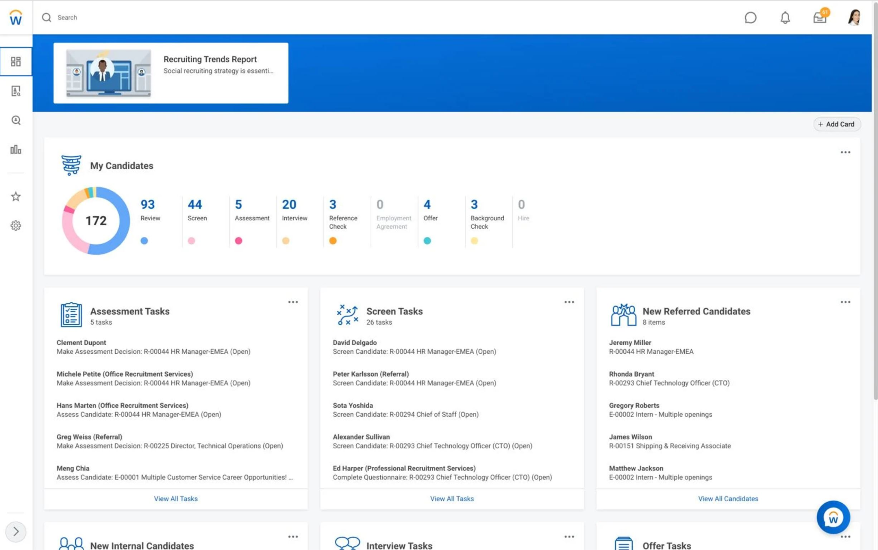
Figure 1: Workday HRIS interface, sourced from [1]

Ease of Use: As seen in Figure 1, Workday has a comprehensive, enterprise-level HRIS.
Workday's interface is not immediately simple. Users might face a steeper learning curve before mastering the system​. Advanced HR functions (talent management, analytics, etc.) are accessible through a unified dashboard, which allows experienced users to perform complex tasks but can feel overwhelming to those accustomed to simpler HR tools​ [3].
Workday leverages machine learning to personalize the user experience for each employee. The welcome screen, accessible on both desktop and mobile, displays pending tasks, company announcements and easy links to common operations. Employees can also access Workday through apps like Slack and Microsoft Teams and use Workday everywhere [2].

Security: All sensitive data in Workday is protected with strong encryption (Workday uses AES-256 encryption for data at rest and TLS for data in transit)​. These encryptions ensure that information like personal identifiers and payroll details are safeguarded against unauthorized access [4].

The system also employs robust role-based access controls and multi-factor authentication so that users only access data appropriate to their job roles​. Workday's security framework is reinforced by continuous monitoring and regular third-party audits since the platform undergoes annual SOC 1 and SOC 2 Type II audits [4].

Integration: Workday is built as a unified HR system and excels in integration capabilities. But how? Workday offers over 600 pre-built integrations, all secured under a unified security model [5].

It offers an open API architecture and an integration platform that allows data exchange with numerous external systems​. For HaliHali Halibut, this means Workday can integrate with the company website, for instance, to provision accounts or share employee data for customer service roles. It can also sync with CRMs, accounting and ATS software [3].

BambooHR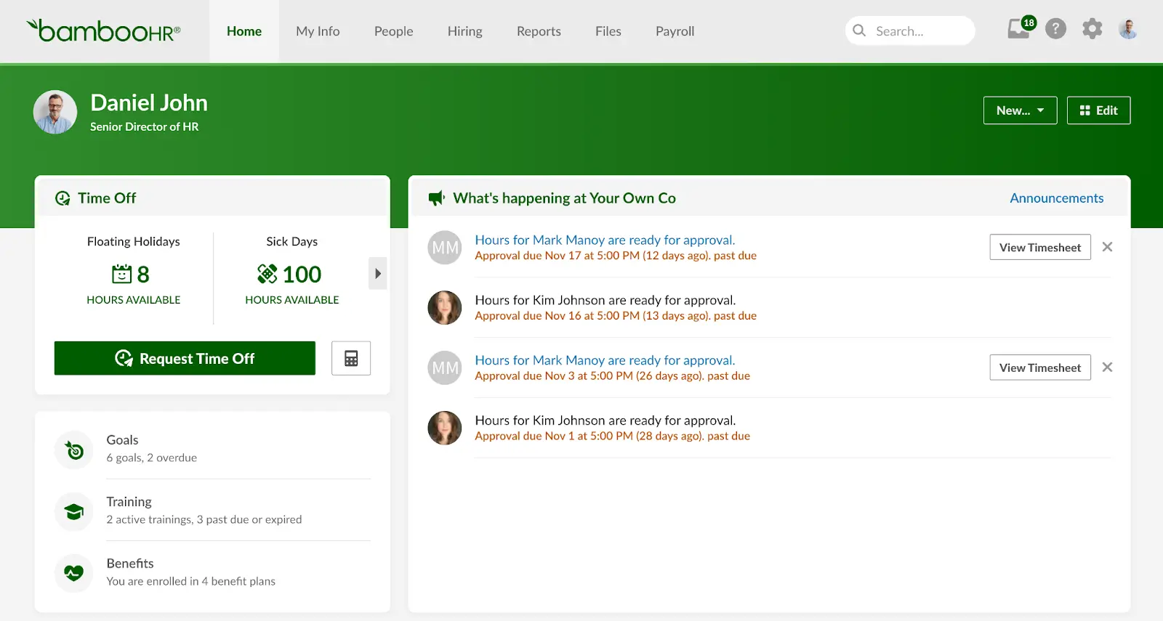
Figure 2: BambooHR interface, sourced from [6]

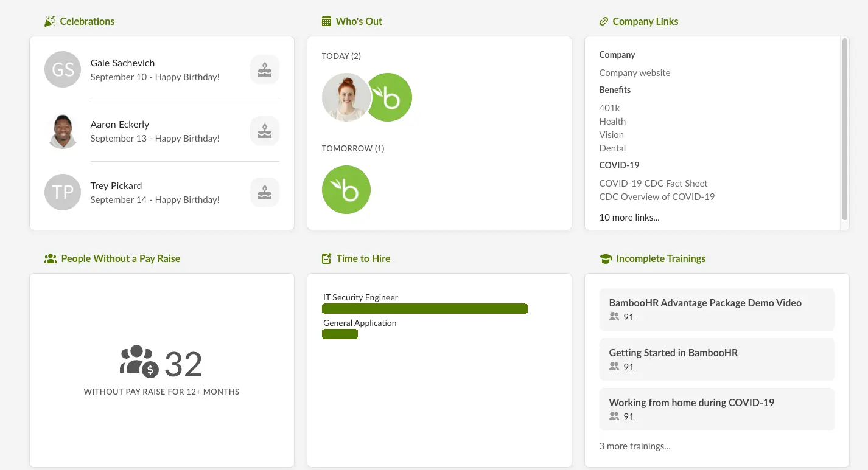
Figure 3: BambooHR interface, sourced from [6]
Ease of Use: BambooHR is recognized for its user-friendly interface and intuitive design, as evident from Figures 2 & 3. The platform offers straightforward employee self-service features that allow workers to access their personal information and manage basic HR functions independently [3]. For a fish processing company like Hali Hali Halibut Ltd., where staff may have varying levels of technical proficiency, BambooHR's accessibility could facilitate faster adoption and reduce training requirements.

BambooHR also offers a mobile app, ensuring that on-the-go access (for example, an employee clocking in remotely or a manager approving time off) is convenient and accessible. To help users get the most out of the platform, BambooHR offers online videos that explain each tool and function in detail [7].

One consideration is that BambooHR's simplicity has some functional limits (fewer advanced features than Workday). However, for ease of use, it ranks extremely high.

Security: All data stored in BambooHR is encrypted in transit and at rest. This prevents eavesdropping or breaches​. The system also supports multi-factor authentication​ [9]. BambooHR also allows detailed user permission settings, so HaliHali's administrators can enforce that employees and managers only see information relevant to their role​ [8].

The company also maintains an active bug bounty program. BambooHR conducts frequent vulnerability scans and undergoes annual third-party (SOC I & II security) audits and a third-party penetration test, ensuring adherence to security best practices [9].

Integration: BambooHR focuses on core HR needs and extends its functionality through a marketplace of integrations. It offers over 125 pre-built integrations with various HR and business applications​ [9]. These one-click or easy configurations cover payroll, benefits administration, time tracking, and applicant tracking [9].

Rippling
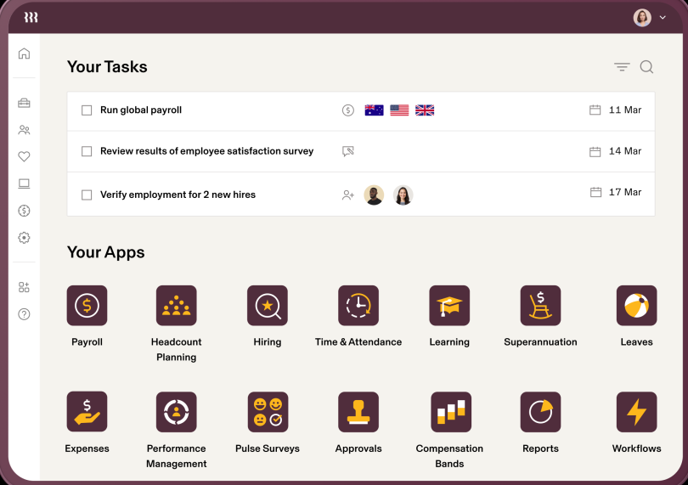
Figure 4: Rippling interface, sourced from [11]

Ease of Use: Rippling features an intuitive interface designed to simplify HR processes, as evident from Figure 11. Its customizable dashboard enables users to automate administrative tasks across all HR modules, including learning management and headcount planning. This platform also offers pre-built workflow templates and the ability to trigger actions in third-party applications. These actions reduce manual efforts. Rippling also provides a mobile app for iOS and Android devices for on-the-go access [12][13].

One of Rippling’s signature ease-of-use features is its automated onboarding: with a single workflow, an HR manager can set up a new employee’s payroll, benefits, computer accounts, and app access in “90 seconds”​ [14]. This level of automation directly benefits HaliHali during seasonal hiring surges - dozens of seasonal workers can be on boarded or offboarded quickly with minimal manual work.

Security: All sensitive data in Rippling is protected with AES-256 encryption [15]. This ensures that data is unreadable if intercepted​. The platform supports two-factor authentication for all user logins. Access within the system is governed by granular role-based access controls, meaning HaliHali can precisely define which roles (HR, managers, IT admins, etc.) can view or edit specific information​ [16].

Rippling maintains strong compliance credentials: it undergoes SOC 2 Type II audits annually​ and publicly provides a SOC 3 report for transparency [15]. When employees depart, Rippling instantly disables their devices, apps, and access during offboarding [16].

Integration: Integration is arguably Rippling’s greatest strength and a key differentiator. It offers 600+ pre-built integrations with third-party applications​. These integrations span many categories, from HR-focused apps (payroll, ATS) to general business tools (Slack, Google Workspace)​ [14]. For HaliHali Halibut, this means Rippling can seamlessly connect employees to the systems used across the company.

Conclusion

Ease of Use: BambooHR and Rippling score higher in user-friendliness than Workday since it requires more user training [2] [3] [6] [7] [12] [13].

Security: All three systems meet high-security standards, but Workday and Rippling have an edge in enterprise credentials, i.e. GDPR, SOC 2, ISO 27001, AES-256 encryption, role-based access, and regular SOC 2 audits [4] [8] [9] [15] [16]​.

Integration: Workday and Rippling distinguish themselves with broad integration capabilities, though they are achieved differently. Workday requires more development/configuration effort. Rippling, however, offers hundreds of pre-built integrations ready to deploy [3] [5] [9] [14].
Below is a summary comparison of the three HRIS solutions across the key criterias:
Criteria | Workday | BambooHR | Rippling
Ease of Use | Powerful but complex UI. Requires training for full utilization​ | Highly intuitive and easy to navigate; minimal training needed​. Mobile friendly. | Modern, easy-to-use interface with automation; very quick onboarding​.  Mobile friendly
Security | AES-256 encryption, robust access controls, SOC 1/2, ISO 27001, GDPR & FedRAMP compliant. Continuous monitoring.​ | Encryption in transit/at rest, MFA, SOC 2 Type II audits, GDPR compliant​. Monitoring and annual pen-tests | Multi-layer security (encryption, MFA, RBAC)​, SOC 2 Type II, GDPR/CCPA compliant​. Regular vulnerability assessments.
Integration | Open APIs & integration framework; pre-built connectors for many apps. Suited for complex, custom integrations​ | 125+ integrations for HR-related tools (payroll, ATS, etc.)​. API available for custom links. | 600+ integrations across HR, IT, finance (Slack, Salesforce, QuickBooks, etc.)​.

Given HaliHali’s needs, Rippling stands out as the best all-around fit. The final section provides the explicit recommendation and justification.

Recommendation
After a thorough evaluation, I recommend Rippling as the HRIS for HaliHali Halibut Ltd.

First, Rippling offers exceptional integration capabilities, effortlessly connecting with the e-commerce, CRM, accounting, ATS, and expense systems that HaliHali Halibut Ltd. needs. Rippling’s ease of use is a significant benefit for a workforce that includes seasonal employees who need to be onboard quickly. Lastly, Rippling meets HaliHali’s security requirements with enterprise-level safeguards (including encryption, SOC 2 compliance, and GDPR adherence)​, ensuring the company’s sensitive HR data remains protected.

While Workday is equally secure and more established, it is considerably more complex to implement and navigate, which could hinder user adoption. BambooHR is very user-friendly but lacks the breadth of integration that HaliHali’s multi-system environment demands. Considering these factors, Rippling provides the best balance of capabilities.

With no strict budget constraints, HaliHali can leverage Rippling’s full feature set to streamline HR operations, support its seasonal workforce effectively, and scale for future growth.

References

- B. Ungashick, "The most user-friendly HRIS systems in 2022 with screenshots," OutSail HRIS Advisor, Sep. 25, 2024. [Online]. Available: https://www.outsail.co/post/the-most-user-friendly-hris-systems-in-2022-with-screenshots. [Accessed: Mar. 18, 2025]

- D. O'Reilly, "Workday Review," Forbes, Dec. 3, 2024. [Online]. Available: https://www.forbes.com/advisor/business/software/workday-review/. [Accessed: Feb. 26, 2025].

- B. Ungashick, "Workday vs. BambooHR: Which HRIS solution is right for your business?", OutSail HRIS Advisor, Oct. 3, 2024. [Online]. Available: https://www.outsail.co/post/workday-vs-bamboohr-which-hris-solution-is-right-for-your-business. [Accessed: Mar. 18, 2025].

- Workday, "Security And Privacy," Workday, [Online]. Available: https://www.workday.com/en-ca/why-workday/trust/security.html. [Accessed: Feb. 26, 2025]

- Workday, "Platform & Product Extensions: Integrations," Workday, [Online]. Available: https://www.workday.com/en-ca/products/platform-product-extensions/integrations.html. [Accessed: Feb. 26, 2025]

- R. Cuevas, "BambooHR insights dashboard & homepage redesign," BambooHR Blog, Dec. 12, 2022. [Online]. Available: https://www.bamboohr.com/blog/bamboohr-insights-dashboard-homepage-redesign. [Accessed: Mar. 18, 2025].

- R. Watts, "BambooHR Review," Forbes, [Online]. Available: https://www.forbes.com/advisor/business/software/bamboohr-review/. [Accessed: Feb. 26, 2025].

- BambooHR, "Access Levels in BambooHR," BambooHR Blog, [Online]. Available: https://www.bamboohr.com/blog/access-levels-bamboohr. [Accessed: Feb. 26, 2025].

- BambooHR, "Security," BambooHR, [Online]. Available: https://www.bamboohr.com/legal/security. [Accessed: Feb. 26, 2025].

- BambooHR, "Ease Integrations," BambooHR, [Online]. Available: https://www.bamboohr.com/integrations/listings/ease. [Accessed: Feb. 26, 2025].

- C. Shu, "Rippling opens Asia-Pacific HQ as its international expansion gears up," TechCrunch, Feb. 12, 2024. [Online]. Available: https://techcrunch.com/2024/02/12/rippling-2/. [Accessed: Mar. 20, 2025]

- D. O'Reilly, "Rippling review: A comprehensive look at the HR and IT software platform," Forbes, 2025. [Online]. Available: https://www.forbes.com/advisor/business/software/rippling-review/. [Accessed: Feb. 26, 2025].

- S. Schooley, "Rippling review: A comprehensive guide to the HR software platform," Business.com, Jun. 27, 2024. [Online]. Available: https://www.business.com/hr-software/rippling/review/. [Accessed: Feb. 26, 2025].

- Rippling, "Rippling Integration," Dialpad App Marketplace, 2024. [Online]. Available: https://www.dialpad.com/app-marketplace/rippling/#overview. [Accessed: Mar. 18, 2025].

- Rippling, "Security," Rippling, [Online]. Available: https://www.rippling.com/en-CA/security. [Accessed: Feb. 26, 2025].

- Rippling, "Security Program," Rippling, Oct. 1, 2020. [Online]. Available: https://go.rippling.com/rs/345-FHM-674/images/PM_WP_Security-Program_100120.pdf. [Accessed: Feb. 26, 2025].

