OmGithub

System Design: Game Publishing and Delivery

STATUS  Draft  [Draft / Proposed / Approved] |  | OWNER  Not specified  [Team Name] |  | LAST UPDATED  September 11, 2026  [Month, DD, YYYY]

Authors | Not specified
Reviewers | Not specified
Related docs | README.md; wiki/omgithub.md; wiki/oh-my-github-app.md; wiki/supabase.md
Scope | Public game publishing, builds, catalog, and delivery.

1. Abstract
OmGithub is a Vue and Node service. A visitor submits a reviewed public GitHub game path. The service validates the source, coordinates a GitHub Actions build, receives a verified archive, records catalog data, and serves the resulting browser build on a project subdomain.
The system supports direct repository tree paths and selected HTML files. It relies on GitHub for source, authentication, and build execution; Supabase for production catalog and social records; and persistent DATA_DIR for game files and caches. Standalone OpenCode execution is out of scope and belongs to OhMyGithub.

2. Goals and Non-Goals
Goals | Non-goals
Publish a validated direct game path. | Do not publish roots, catalog pages, lists, or unreviewed sources.
Bind a deployment to a source commit and path. | Do not operate standalone OpenCode execution.
Reuse cached project and GitHub metadata. | Do not expose source provenance publicly.
Recover failed builds only in a temporary checkout. | Do not commit, push, or upload unrelated content.

3. Background and Problem Statement
Publishing repository roots or catalog pages can create unsafe or misleading store entries. OmGithub accepts only reviewed direct tree or blob game sources. It requires index.html in a validated archive before publication and uses GitHub Actions for source checkout and builds.
The browser is outside the trust boundary. The Express service validates requests, manages sessions, dispatches builds, validates uploads, and serves public delivery. The key invariant is that every deployment maps to a validated source commit and selected path, and contains a valid index.html.

4. Proposed Architecture

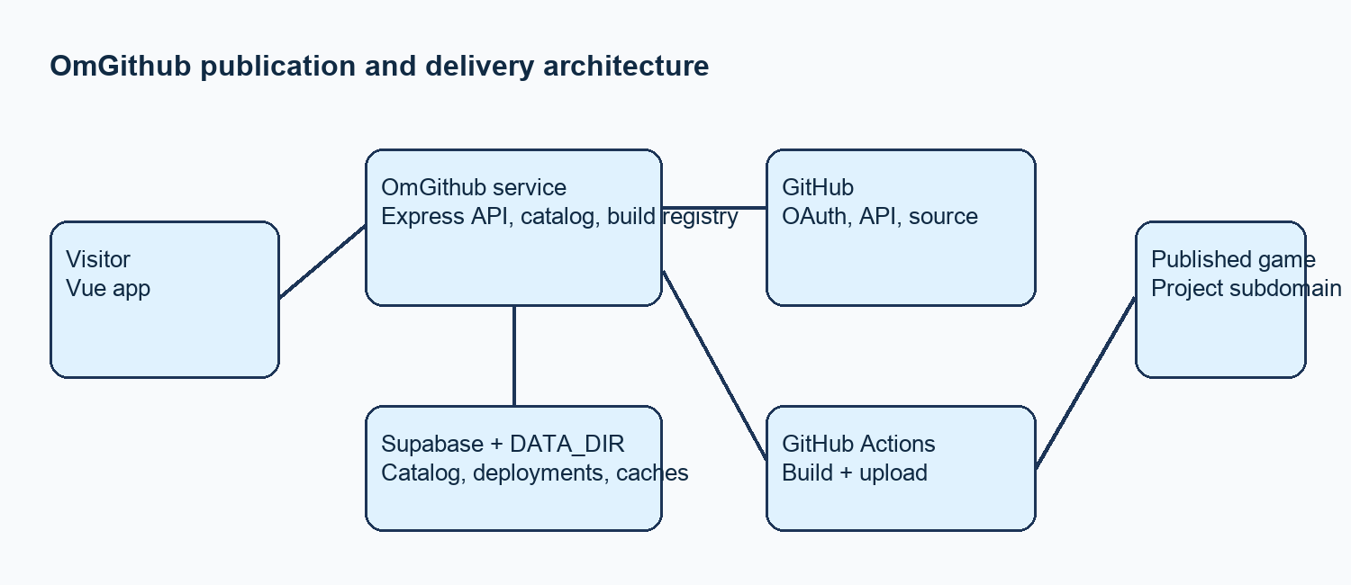
Figure 1. OmGithub publication and delivery architecture.

Core components

Component | Responsibility | Primary storage | Failure behavior
Vue frontend | Submission, progress, catalog UI. | Browser state | Show failure.
Express service | Validate, dispatch, upload, serve. | DATA_DIR; Supabase | Reject invalid archive.
GitHub API and OAuth | Source metadata and sign-in. | GitHub | Use stale successful cache.
GitHub Actions | Build and upload deployable ZIP. | Temporary checkout | Keep existing deployment.
Supabase and DATA_DIR | Catalog, deployments, caches. | PostgreSQL; volume | Require persistent storage.

5. Request Lifecycle
- A visitor opens a direct OmGithub repository, tree, or blob route, or submits a source URL to POST /api/publish. Input includes source_url and optional title, description, tags, prompt, provenance, and up to eight HTTPS screenshot URLs.
- The service requires the OmGithub origin for publication and validates the direct game source. Public submission does not require GitHub sign-in. GitHub OAuth supports documented signed-in functions and site issue submission.
- The service loads cached GitHub repository and commit metadata where available. It uses Supabase for production catalog and social records, and DATA_DIR for deployment files and caches.
- For a new validated source, the service dispatches GitHub Actions. The workflow builds the selected path, selects deployable output, and can capture a screenshot. Repeat visits reuse the cached published project.
- The workflow uploads a deployable ZIP to /api/builds with a short-lived signed upload token and matching source headers. The service validates source commit, selected path, archive limits, and index.html before it replaces a deployment.
- Concurrent requests for the same named path and source commit share in-memory work in one server process. OpenCode recovery is limited to the temporary checkout after normal build failure.
- After successful validation, the service stores deployment files, updates catalog state, and serves the project subdomain. It exposes build progress and reuses stale successful GitHub metadata during rate limits or temporary server errors.

6. API and Data Contracts

Primary data contract

Field | Type | Required | Description
source_url | string | Yes | Direct GitHub tree or blob source.
metadata | object | No | Optional public metadata.
build_runner | string | No | ubuntu-latest default; macos-latest supported.
refresh | boolean | No | Request recapture.
source commit | string | Yes | Resolved publication commit.
selected path | string | Yes | Game directory or HTML file.
archive | ZIP | Yes | Must contain index.html.

Contract guarantees

- Validate the direct source route and retain selected source commit and path before accepting an archive. Require index.html and apply archive entry and size limits before publication.
- Use named repository path and resolved source commit to identify a publication. Coalesce concurrent work only within the current server process.
- Capture source URL, resolved commit, selected path, metadata, build runner, and upload context. Preserve prompt source information when a prompt is stored.
- Supabase is the production source of truth for catalog and social records. DATA_DIR holds deployment files and operational caches. The in-memory build registry is not durable across restart.
The versioned schema or interface definition is published at
Repository contract reference: README.md and wiki/omgithub.md.

7. Consistency, Idempotency, and Replay

A repeated named-path visit reuses the cached project. Concurrent work for the same named path and source commit is shared in memory. Partial build failures must not replace an existing deployment until replacement metadata and archive validation pass.
Scenario | Expected behavior | Reasoning
Repeated path visit | Reuse cached published project. | Avoid repeat path resolution.
Archive validation fails | Reject upload; retain existing deployment. | Prevent invalid publication.
GitHub temporary error | Reuse stale successful metadata. | Resist transient dependency failure.
Config changes during build | Use selected run context. | Avoid mixed request state.

8. Security and Privacy Considerations

- Validate direct public GitHub tree or blob inputs before build dispatch. Use GitHub OAuth only for documented signed-in functions. Verify GitHub App installation webhook signatures.
- Do not return or display source provenance through public project APIs. Do not request visitor credentials for public repositories. Do not share token-bearing session URLs.
- Keep GitHub tokens, OAuth credentials, App private key, webhook secret, session secret, OpenCode credentials, and Supabase DB URL in the deployment environment.
- Keep workflow changes reviewable. Use the App only to install listeners. Run issue preparation and OpenCode in GitHub Actions. Limit recovery to the temporary checkout and selected game.
- Keep DATA_DIR on persistent storage for game files and caches. The project guides do not specify deletion, residency, or retention periods.

9. Operational Readiness
Signal | SLO or alert | Owner | Launch gate
Publication success | Define target and page threshold. | Not specified | Required
Build completion time | Define percentile target. | Not specified | Required
Upload validation failures | Alert on sustained rejection. | Not specified | Required
Deployment drift | Detect unsafe workflow divergence. | Not specified | Recommended
Recovery checks | Test restore and integrity. | Not specified | Required
Rollout constraint: Start with reviewed direct game paths. Retain the old deployment until replacement validation completes.

10. Alternatives Considered

Alternative | Why it was considered | Why it was not selected
Publish repository roots | Simple input. | Project policy excludes unreviewed roots.
Build in web service | Less coordination. | Documented design uses GitHub Actions.
Bulk import lists | Faster catalog growth. | Each source requires review.
Commit route primary | Direct source state. | Named paths are preferred stable links.

11. Open Questions
- Who owns production operations and alert response?
- What are the current archive size and entry limits, and how do visitors see rejected submissions?
- What availability and recovery objectives apply to the single-process build registry, database, and deployment volume?
- Which lifecycle events need an operator audit trail beyond current catalog data?

12. Decision and Next Steps
Adopt the validated source-to-archive flow. First test the publish and upload contracts with a direct game and dry run. Then validate deployment replacement and subdomain delivery. Broaden use only after validation, rollback, and operational ownership are confirmed.
Milestone | Deliverable | Exit criteria
M1 | Validate source and upload contract. | Test game reaches validated upload.
M2 | Exercise replacement and recovery. | Existing deployment survives failed replacement.
M3 | Limited reviewed-path release. | Build and delivery remain stable.
M4 | Broader availability. | Owners and operational gates are defined.

Use footnotes for definitions, assumptions, or terms that need precision without interrupting the main narrative.

