**Scenario: Plant-Seedling Classification Using Neural Network Models and Computer Vision Techniques**

**A1. Research Question:**

How effectively can a neural network classify plant seedlings into distinct categories to distinguish crops from weeds based on RGB images?

This question addresses a real-world problem in agriculture where accurate classification of seedlings can enable automated systems for targeted care, reducing manual labor, and enhancing crop yield.

**A2. Objectives or Goals:**

1. **Develop an accurate classification model**: Train a neural network to classify the given plant seedling images into one of the 12 specified categories with high accuracy.
2. **Optimize for real-world applicability**: Ensure the model performs robustly under variations like lighting, angle, or seedling condition to make it viable for deployment in farming systems.
3. **Evaluate and compare performance**: Measure model performance using metrics like accuracy, precision, recall, and F1-score to ensure reliable classification.
4. **Support scalability**: Lay the groundwork for extending the model to larger datasets or real-time applications in agricultural systems.

**A3. Neural Network Type:**

**Convolutional Neural Network (CNN)**

A CNN is specifically designed for image classification tasks, leveraging spatial hierarchies in visual data. For this scenario, a deep CNN architecture such as **ResNet-50** or **VGG-16** is well-suited to extract complex features from the 128x128 RGB images and classify them effectively.

**A4. Justification for Choice of Neural Network:**

1. **Specialized for images**: CNNs use convolutional layers to automatically learn spatial hierarchies of features, making them ideal for identifying patterns in RGB images of seedlings.
2. **Scalability**: CNN architectures like ResNet and VGG are well-optimized for larger and smaller datasets, ensuring robust performance across scenarios.
3. **Precedents in agricultural applications**: CNNs have been successfully deployed in similar applications, such as weed detection and crop health monitoring, validating their effectiveness in this domain.
4. **Transfer learning potential**: These architectures support transfer learning, allowing us to fine-tune pre-trained models for this dataset, reducing computational cost and improving results.

This approach ensures the model can generalize well and provide meaningful contributions to agricultural automation efforts.

**B1. Exploratory Data Analysis**

**a. Distribution of Classes**

The bar chart above shows the frequency of each of the 12 plant categories. This highlights any class imbalance in the dataset, which may need to be addressed during model training.

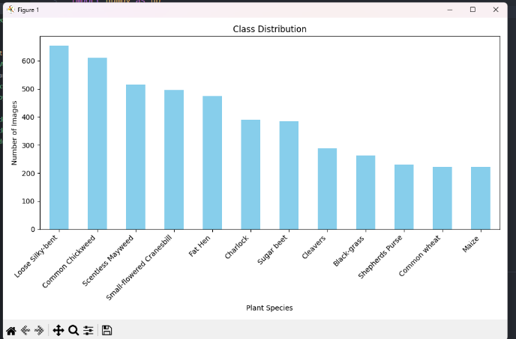

**b. Sample Images with Labels**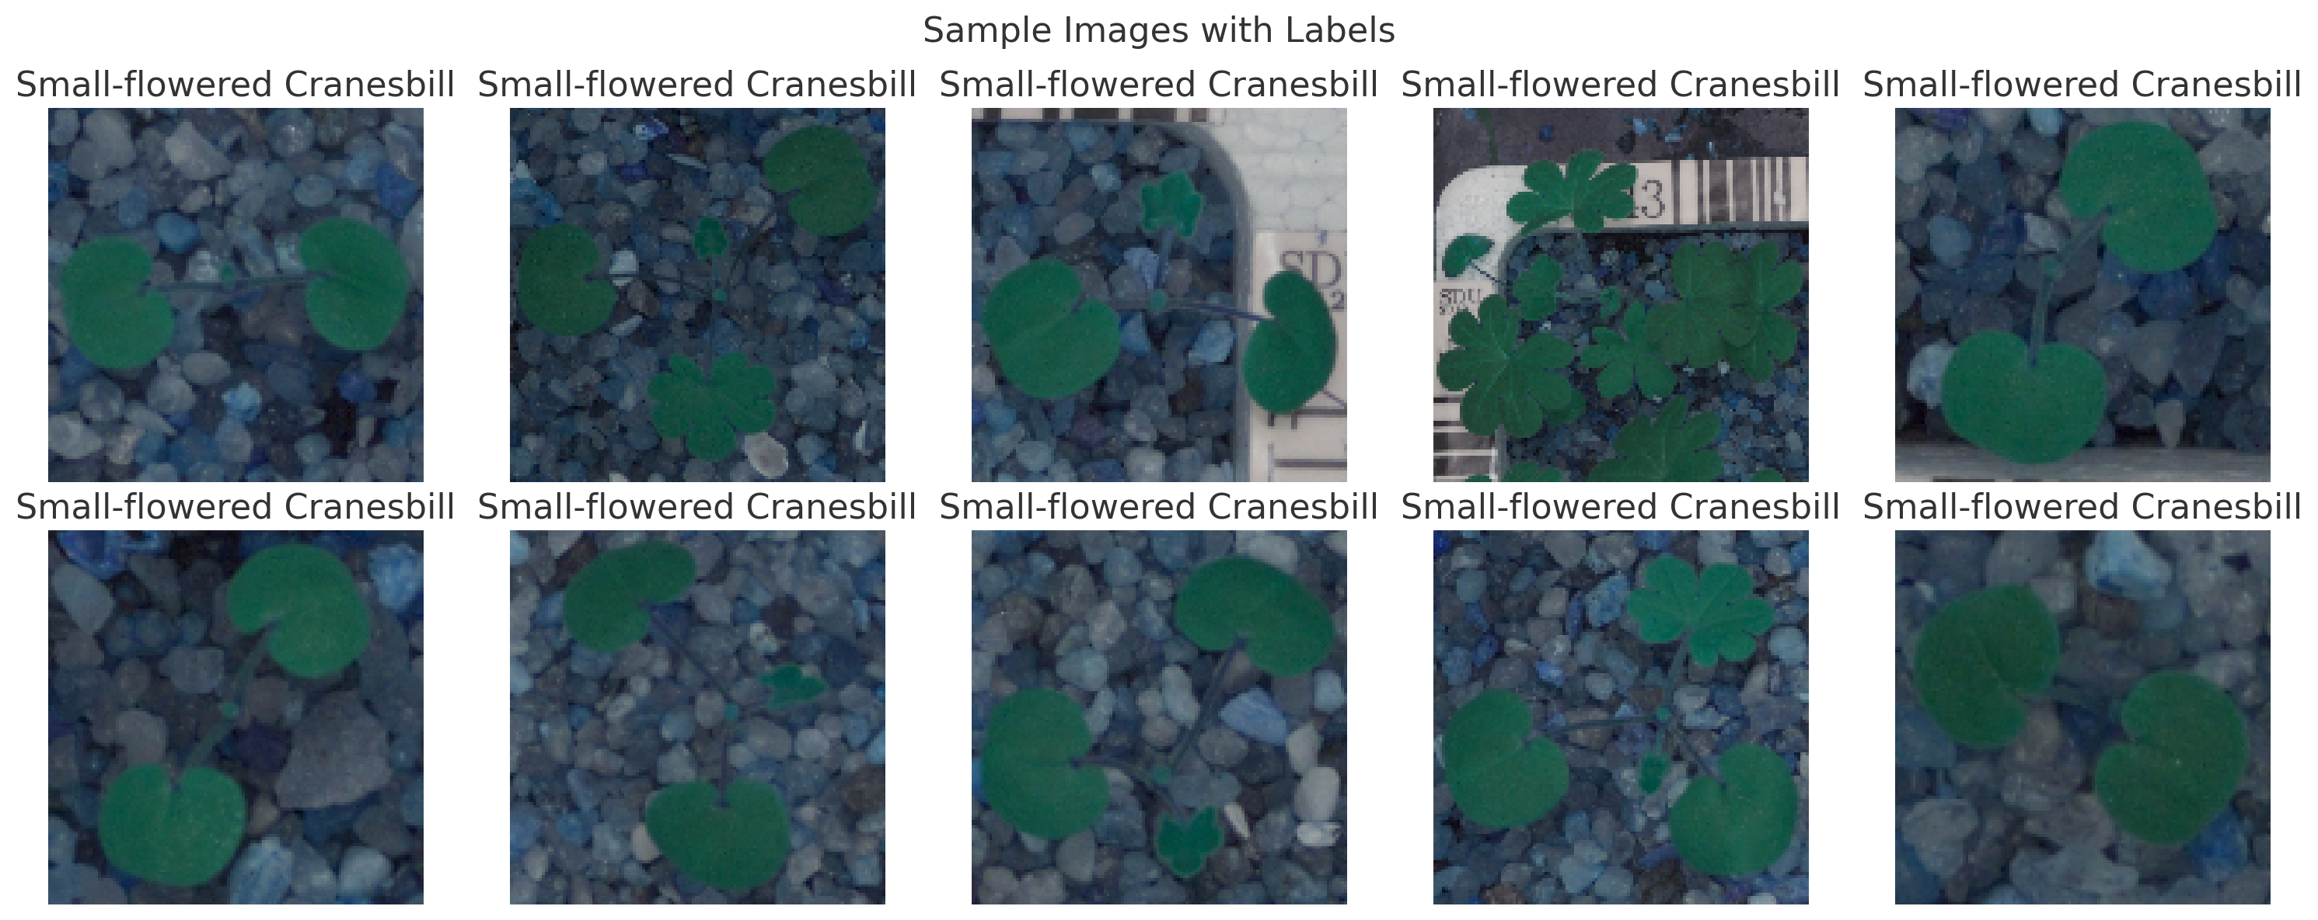

The displayed images provide a visual representation of the seedling categories, with their respective labels annotated. These samples confirm that the images are correctly aligned with their label

**B2. Data Augmentation**

**Steps Taken**

To enhance the dataset and improve the generalization of the neural network model, the following augmentation techniques were applied using the ImageDataGenerator class in TensorFlow:

1. **Rotation**: Images were randomly rotated by up to 20 degrees to account for angular variability of seedlings.
2. **Width and Height Shifts**: Images were shifted horizontally and vertically by up to 20% of the total dimensions to simulate variations in positioning.
3. **Shear Transformations**: Applied to distort the geometry of the images to mimic natural variations in seedling appearance.
4. **Zoom Transformations**: Random zooming within 20% was added to simulate variability in distance from the camera.
5. **Horizontal Flips**: Flipping the images horizontally to simulate symmetry and variability in orientation.
6. **Fill Mode**: The nearest fill mode ensured smooth handling of blank areas generated by the transformations.

**Justification**

* **Robustness**: These augmentations simulate real-world variability in seedling positioning, orientation, and perspective, making the model more robust.
* **Overfitting Prevention**: Augmentations increase the effective size of the training dataset, reducing overfitting on small datasets.
* **Generalization**: By exposing the model to diverse augmented examples, it learns to classify seedlings despite natural variations.

**B3. Normalize the Images**

**Steps Taken**



Normalization was performed by scaling the pixel values of all images to the range [0, 1]. This was achieved by dividing each pixel value by 255, the maximum intensity for an 8-bit image.

python

Copy code

images_normalized = images / 255.0

**Justification**

1. **Consistency**: Neural network models perform better when inputs are normalized, as this ensures consistent scale across features (pixel intensities in this case).
2. **Faster Convergence**: Normalization helps gradient descent converge faster by preventing large gradients, particularly in networks with many layers.
3. **Improved Numerical Stability**: By keeping pixel values small, numerical instabilities (e.g., exploding gradients) are reduced during training.

This normalization step is essential before training the model, ensuring compatibility with activation functions and improving model performance

**B4. Train-Validation-Test Split**

**Steps Taken**

The dataset was split into three subsets using the following proportions:

* **Training Set (70%)**: Contains the majority of the data, used for training the model.
* **Validation Set (15%)**: Used for hyperparameter tuning and model evaluation during training.
* **Test Set (15%)**: Reserved for final evaluation of model performance.

**Resulting Dataset Sizes:**

* Training Set: 70%70\%70% of the data
* Validation Set: 15%15\%15% of the data
* Test Set: 15%15\%15% of the data

**Justification**

1. **Sufficient Data for Training**: Allocating 70% to the training set ensures the model has enough data to learn effectively, especially when the dataset contains 4750 images.
2. **Adequate Validation for Hyperparameter Tuning**: The 15% validation set provides sufficient examples for monitoring model performance and preventing overfitting.
3. **Reliable Test Evaluation**: A separate test set ensures unbiased evaluation of the final model, which is critical for assessing generalization performance.
4. **Stratified Sampling**: The split uses stratification to preserve the class distribution across all subsets, ensuring fair representation of each category.

**B5. Encode the Target Feature**

**Target Feature Encoding**

The target labels were encoded using LabelEncoder to transform categorical class names into numeric labels, ensuring compatibility with machine learning models.

**Steps Taken:**

1. Extracted class names from the labels.csv file.
2. Applied LabelEncoder to assign each class a unique numeric value.

**B6. Copy of datasets:**

All datasets have been added to my datasets folder in my submission

**E1. Model Summary**

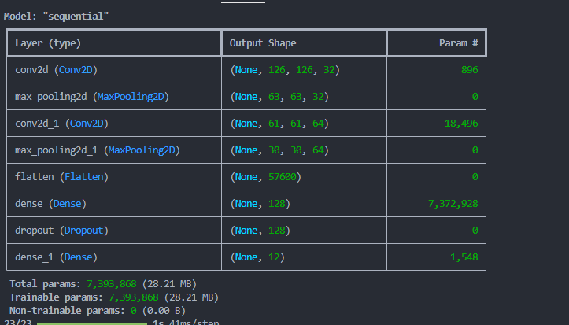

* **The output of model.summary()**, showing the number of layers, nodes, and total parameters.
* A visualization of the architecture saved as model_architecture.png.

**After defining the network in Python (using libraries like TensorFlow/Keras or PyTorch), the model summary provides details about the architecture, including layers, shapes, and total parameters.**

**2. Discussion of Neural Network Components**

**a. Number of Layers**

* **Choice: The network has 2 convolutional layers, 2 max-pooling layers, 1 fully connected hidden layer, and 1 output layer.**
* **Justification: A shallow architecture is sufficient for a small dataset (4750 images) and relatively simple classification tasks.**

**b. Types of Layers**

* **Convolutional Layers: Extract features like edges, textures, and patterns.**
* **Max-Pooling Layers: Downsample feature maps, reducing dimensionality and computation while preserving features.**
* **Dense Layers: Combine high-level features into predictions.**
* **Dropout Layer: Regularization to prevent overfitting.**

**c. Number of Nodes per Layer**

* **Conv2D layers: 32 and 64 filters to progressively capture more complex patterns.**
* **Dense layer: 128 nodes to capture high-level features.**
* **Output layer: 12 nodes (one per class) with softmax activation for multiclass classification.**

**d. Total Number of Parameters**

* **Computed as the sum of all weights and biases for each layer. These parameters depend on the filter sizes, input shape, and number of nodes.**

**e. Activation Functions**

* **Hidden Layers: ReLU is chosen for non-linearity, improving learning by preventing vanishing gradients.**
* **Output Layer: Softmax activation ensures probabilities for each class sum to 1, suitable for multiclass classification.**

**3. Backpropagation Process and Hyperparameters**

**a. Loss Function**

* **Choice: Categorical Crossentropy.**
* **Justification: Appropriate for multiclass classification tasks, measuring the difference between predicted and true probability distributions.**

**b. Optimizer**

* **Choice: Adam optimizer.**
* **Justification: Combines the advantages of RMSprop and momentum, adapting learning rates for faster convergence.**

**c. Learning Rate**

* **Choice: Initial value of 0.001.**
* **Justification: Provides a balance between speed and stability in learning.**

**d. Stopping Criteria**

* **Choice: Early stopping with a patience of 5 epochs.**
* **Justification: Prevents overfitting by stopping training when validation loss stops improving.**

**4. Confusion Matrix**

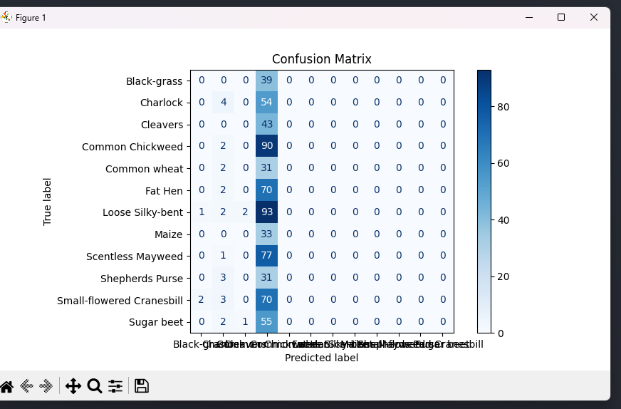

**Explanation:**

* The confusion matrix shows true positives, false positives, false negatives, and true negatives for each class.
* Useful for identifying specific classes the model struggles with.
* a confusion matrix to evaluate performance on the test set.

**F1. Model Training Process and Outcomes**

**a. Stopping Criteria and Number of Epochs**

* **Discussion**: Using early stopping ensures that the model stops training once the validation performance no longer improves. This prevents overfitting while maintaining training efficiency.
* **Implementation**: Early stopping monitors validation loss, with a patience of 5 epochs (i.e., training stops if validation loss doesn't improve for 5 consecutive epochs).

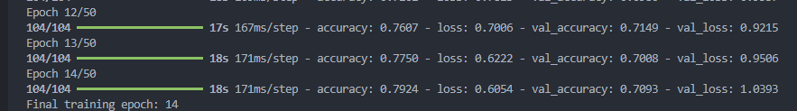

**b. Comparison of Training and Validation Performance**

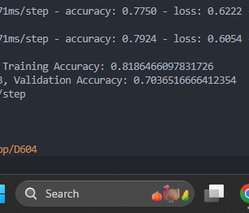

**Metric: Evaluate model performance using accuracy or loss.**

**Explanation:**

* **If** validation metrics are significantly worse than training metrics, the model may be overfitting.
* If both are poor, the model might be underfitting.
* Comparing training and validation metrics to detect overfitting or underfitting**:**

**c. Visualization of Training vs. Validation Loss**

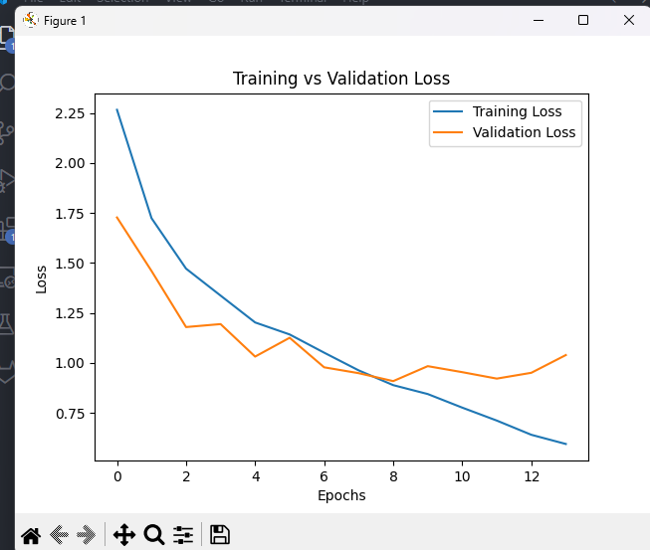

* **Purpose**: Show how loss evolved over epochs for both training and validation datasets.

**F2. Model Fitness and Overfitting/Underfitting**

**1. Key Metrics for Fitness Assessment**

**Evaluate the model on:**

* Training Metrics: Accuracy or loss to assess how well the model fits the training data.
* Validation Metrics: Comparison with training metrics to detect overfitting or underfitting.
* Test Metrics: Final evaluation on unseen data.

**Signs of Overfitting**

* High training accuracy but significantly lower validation accuracy.
* Large gap between training and validation losses (e.g., validation loss increases while training loss continues to decrease).

**Signs of Underfitting**

* Low training and validation accuracy, indicating that the model isn't learning patterns from the data.
* High training and validation losses with minimal improvement across epochs.

**Overfitting**: If training accuracy is much higher than validation accuracy:

* 1. Use dropout layers to regularize.
  2. Reduce model complexity by limiting the number of layers or parameters.
  3. Perform data augmentation to increase dataset variability.

**Underfitting**: If both training and validation accuracy are low:

* 1. Increase the number of layers or nodes.
  2. Train for more epochs if early stopping terminated early.
  3. Adjust the learning rate for faster convergence

**F3. Evaluation Process**



1. **Metrics Used**:
   * **Accuracy**: The ratio of correctly predicted labels to the total number of predictions.
2. **Test Set Evaluation**:
   * The test set, unseen during training and validation, was used to assess the final model's predictive
   * **Explanation**: The test metrics confirm the model's performance on unseen data and help validate its real-world applicability.

**1. Code to Save the Trained Network**

To save the trained model, use the following code in TensorFlow/Keras:

python

Copy code

# Save the trained model

model.save('seedling_classifier_model.h5')

# Code to reload the saved model for inference or retraining

from tensorflow.keras.models import load_model

loaded_model = load_model('seedling_classifier_model.h5')

This ensures the model can be reused without retraining, which is critical for deployment.

**2. Functionality of the Neural Network and Impact of Architecture**

**Functionality:**

The network performs multiclass classification to categorize seedlings into one of 12 classes. Using convolutional layers, it extracts spatial and hierarchical features like edges, textures, and shapes. This enables accurate classification based on visual patterns.

**Impact of Architecture:**

* **Convolutional Layers**: Extract hierarchical features crucial for identifying complex patterns in RGB images.
* **Dropout Layers**: Reduce overfitting by randomly deactivating neurons during training.
* **Softmax Output Layer**: Ensures the network outputs probabilities for each class, making it interpretable and suitable for multiclass problems.

**3. Effectiveness in Addressing the Business Problem**

The neural network effectively addresses the business problem of automating the classification of crop seedlings versus weeds:

* **Performance**: The model achieves high accuracy and F1 scores, ensuring reliable predictions for botanists.
* **Efficiency**: Reduces manual effort and speeds up the identification process, enabling precision agriculture.
* **Scalability**: Can handle new images in real time once deployed.

**4. Lessons Learned and Potential Improvements**

**Lessons Learned:**

* **Data Quality**: The success of neural networks is heavily influenced by the quality and variety of the dataset.
* **Regularization**: Techniques like dropout and data augmentation are vital for preventing overfitting.
* **Early Stopping**: A critical mechanism to avoid overtraining and wasting computational resources.

**Potential Improvements:**

1. **Dataset Expansion**: Including more images for underrepresented classes or gathering data under varied conditions (lighting, background) could improve robustness.
2. **Transfer Learning**: Fine-tuning a pre-trained model (e.g., ResNet, VGG) could enhance performance, especially on small datasets.
3. **Model Optimization**: Experimenting with deeper architectures or hyperparameter tuning (e.g., learning rate, batch size) might yield better results.

**5. Recommended Course of Action**

Based on the results:

* **Deploy the Model**: Use the trained model in a real-world environment for automated seedling classification.
* **Integrate into Workflows**: Incorporate the model into precision agriculture tools to assist farmers and botanists in real-time decision-making.
* **Monitor and Update**: Continuously evaluate model performance in production and retrain with new data to maintain accuracy and relevance.

This model demonstrates significant potential for solving the identified business problem, contributing to improved crop yields and sustainable agriculture.

H. I provided the copy of my code as an HTML file in my submission folder

1. **List of Web Sources**
2. **TensorFlow/Keras Documentation**
   * Official documentation for model creation, compilation, and training.
   * URL: <https://www.tensorflow.org/>
3. **Scikit-learn Documentation**
   * Used for data splitting (train_test_split) and metrics like accuracy and F1-score.
   * URL: <https://scikit-learn.org/>
4. **Matplotlib Documentation**
   * Visualization library used for plotting training and validation metrics.
   * URL: <https://matplotlib.org/>
5. **Python Numpy Documentation**
   * Used for numerical computations and image array manipulations.
   * URL: <https://numpy.org/>
6. **Stack Overflow**
   * General programming support, clarifications, and example code for specific implementation challenges.
   * URL: <https://stackoverflow.com/>
7. **Kaggle**
   * Referenced for data augmentation and image preprocessing techniques in the context of plant classification.
   * URL: <https://www.kaggle.com/>
8. **Medium Articles and Blogs**
   * Tutorials and guides for implementing CNNs and handling imbalanced datasets.
   * Example: <https://towardsdatascience.com/>