# Albert George

#Module: HW1

def NumTwo(): #Number 2

m=eval(input("M = "))

n=eval(input("N = "))

sum = 0

for i in range(m,n+1):

sum+=i

print(sum)

def NumThree(): #Number 3

m=eval(input("M = "))

n=eval(input("N = "))

return m,n

def PrintNumThree():

a,b=NumThree()

sum=0

for i in range(a,b+1):

sum+=i

print(sum)

def NumFour(): #Number 4

L=[]

num=int(input("Enter a positive integer or 0 to stop= "))

sum=0

while num >0:

L.append(num)

sum+=num

num=int(input("Enter another number= "))

print(sum)

def NumFive(): #Number 5

L=[]

num = int(input("Enter a positive integer or 0 to stop= "))

while num>0:

L.append(num)

num=int(input("Enter another number= "))

print(max(L))

#Shell#

>>> from HW1 import *

>>> NumTwo()

M = 17

N = 31

360

>>> PrintNumThree()

M = 7

N = 13

70

>>> NumFour()

Enter a positive integer or 0 to stop= 5

Enter another number= 7

Enter another number= 12

Enter another number= 20

Enter another number= 0

44

>>> NumFive()

Enter a positive integer or 0 to stop= 5

Enter another number= 7

Enter another number= 12

Enter another number= 20

Enter another number= 0

20

#Number 6

>>> def main():

win=GraphWin("Draw a Triangle")

win.setCoords(0.0, 0.0, 10.0, 10.0)

message=Text(Point(5, 0.5), "Click on three points")

message.draw(win)

p1 = win.getMouse()

p1.draw(win)

p2 = win.getMouse()

p2.draw(win)

p3 = win.getMouse()

p3.draw(win)

triangle=Polygon(p1,p2,p3)

triangle.setFill("peachpuff")

triangle.setFill("cyan")

triangle.draw(win)

message.setText("Click anywhere to quit")

win.GetMouse()

main()

>>> from graphics import *

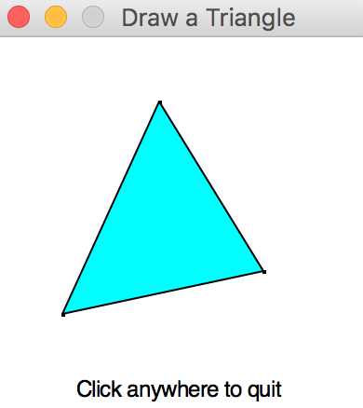>>> main()