Project – External Documentation | 
COSC6103001
Mobile Technology Solution
Odd Semester Year 2026/2027

- Project Title
KarFlex - Vehicle Rental Mobile Application
- Introduction
KarFlex is a company that provides vehicle rentals, both cars and motorcycles. To reach more customers, KarFlex needs an Android application where customers can register, see the list of vehicles, rent a vehicle, manage their active rentals, and find the KarFlex store location.
The application is built with Kotlin in Android Studio, using XML layouts and SQLite as the local database. There are three tables in the database based on the given ERD: Users, Vehicle, and Rentals. Vehicle data is fetched from a JSON web service using the Volley library, then saved into the Vehicle table, so the list in the app always comes from the database. Login uses an OTP code (4 random digits) that is sent to the user's phone number with SmsManager, and the store location is shown with Google Maps SDK for Android.
How to use the application:
1. Open the app, then press "Register here!" to create an account with username, password, and phone number.
2. Log in with the registered account. Allow the SMS permission so the app can send the OTP code.
3. Enter the 4 digit OTP code from the SMS, then press Verify to enter the Home page.
4. In the Browse section, choose a vehicle to see the detail, fill the duration (days), and press Rent Now.
5. Open My Rental to see active rentals. Press Update to change the duration or Cancel to delete the rental.
6. Open Profile to see account info, open Rental History, see the Store Location, or log out.
- Report / Documentation
- Login Page
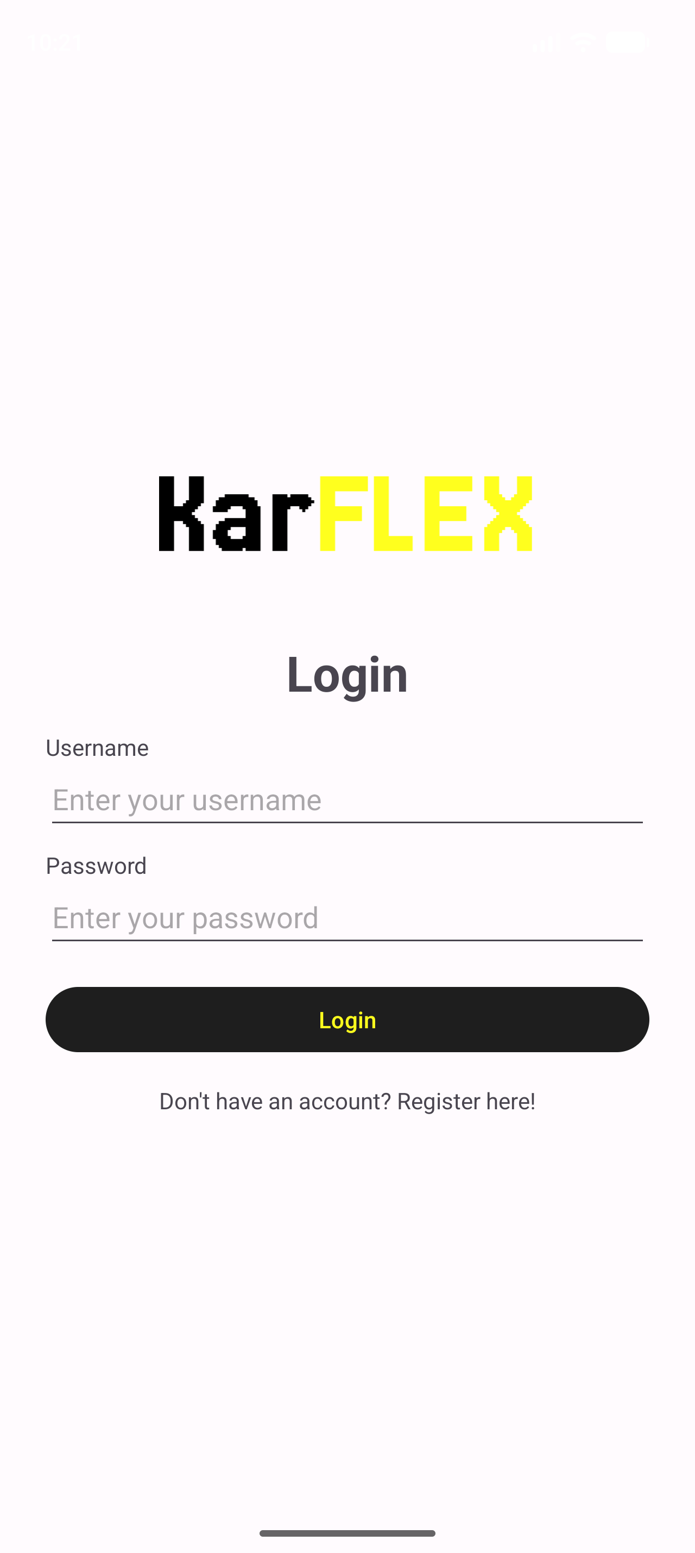
The first page that appears when the app is opened. The user fills in username and password and presses the Login button.
Validation: username must be filled, password must be filled, and the username and password must be registered in the database. If one of them fails, the error is shown with a Toast. If the login is valid, the app generates a random 4 digit OTP code, sends it by SMS to the user's phone number, and moves to the OTP page.
The text "Don't have an account? Register here!" opens the Register page.
- Register Page
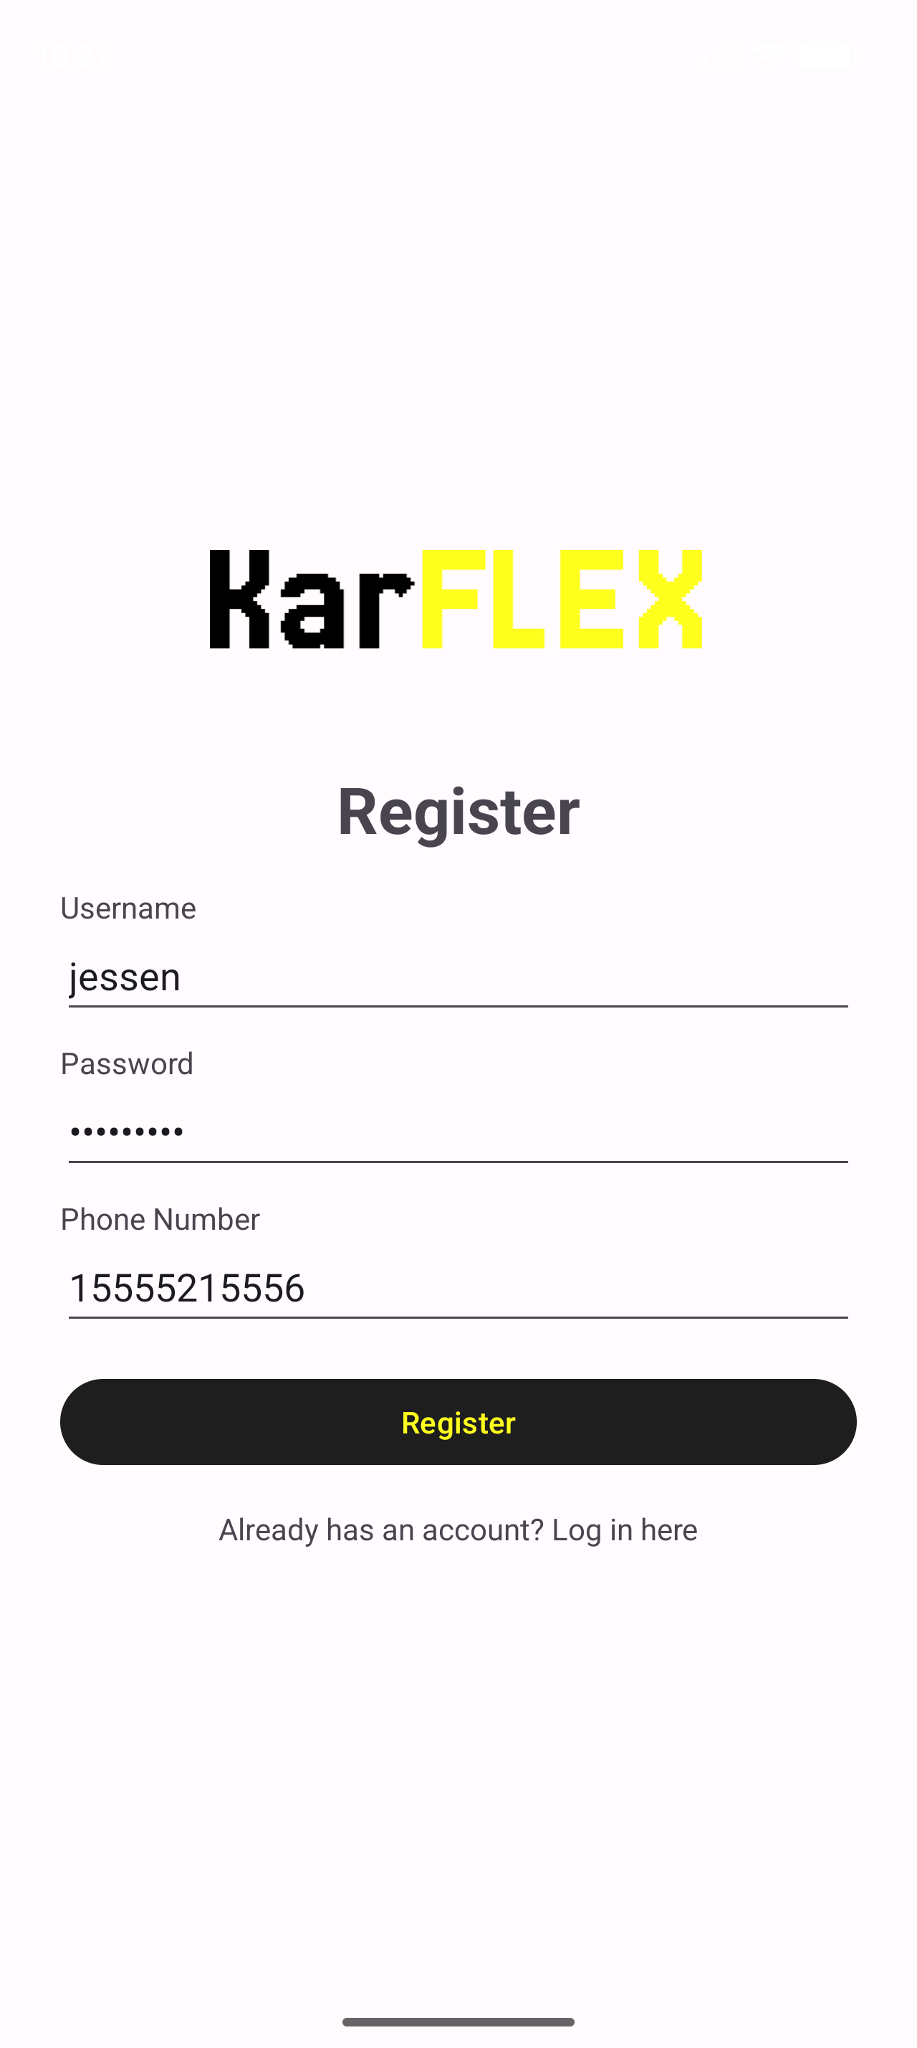
Used to create a new account. The form has username, password (textPassword input type) and phone number (phone input type).
Validation: all fields must be filled, username must be unique, password at least 6 characters, and phone number at least 10 digits. If everything is valid, the data is inserted into the Users table (UserID is AUTOINCREMENT) and the user is sent back to the Login page.
- OTP Page
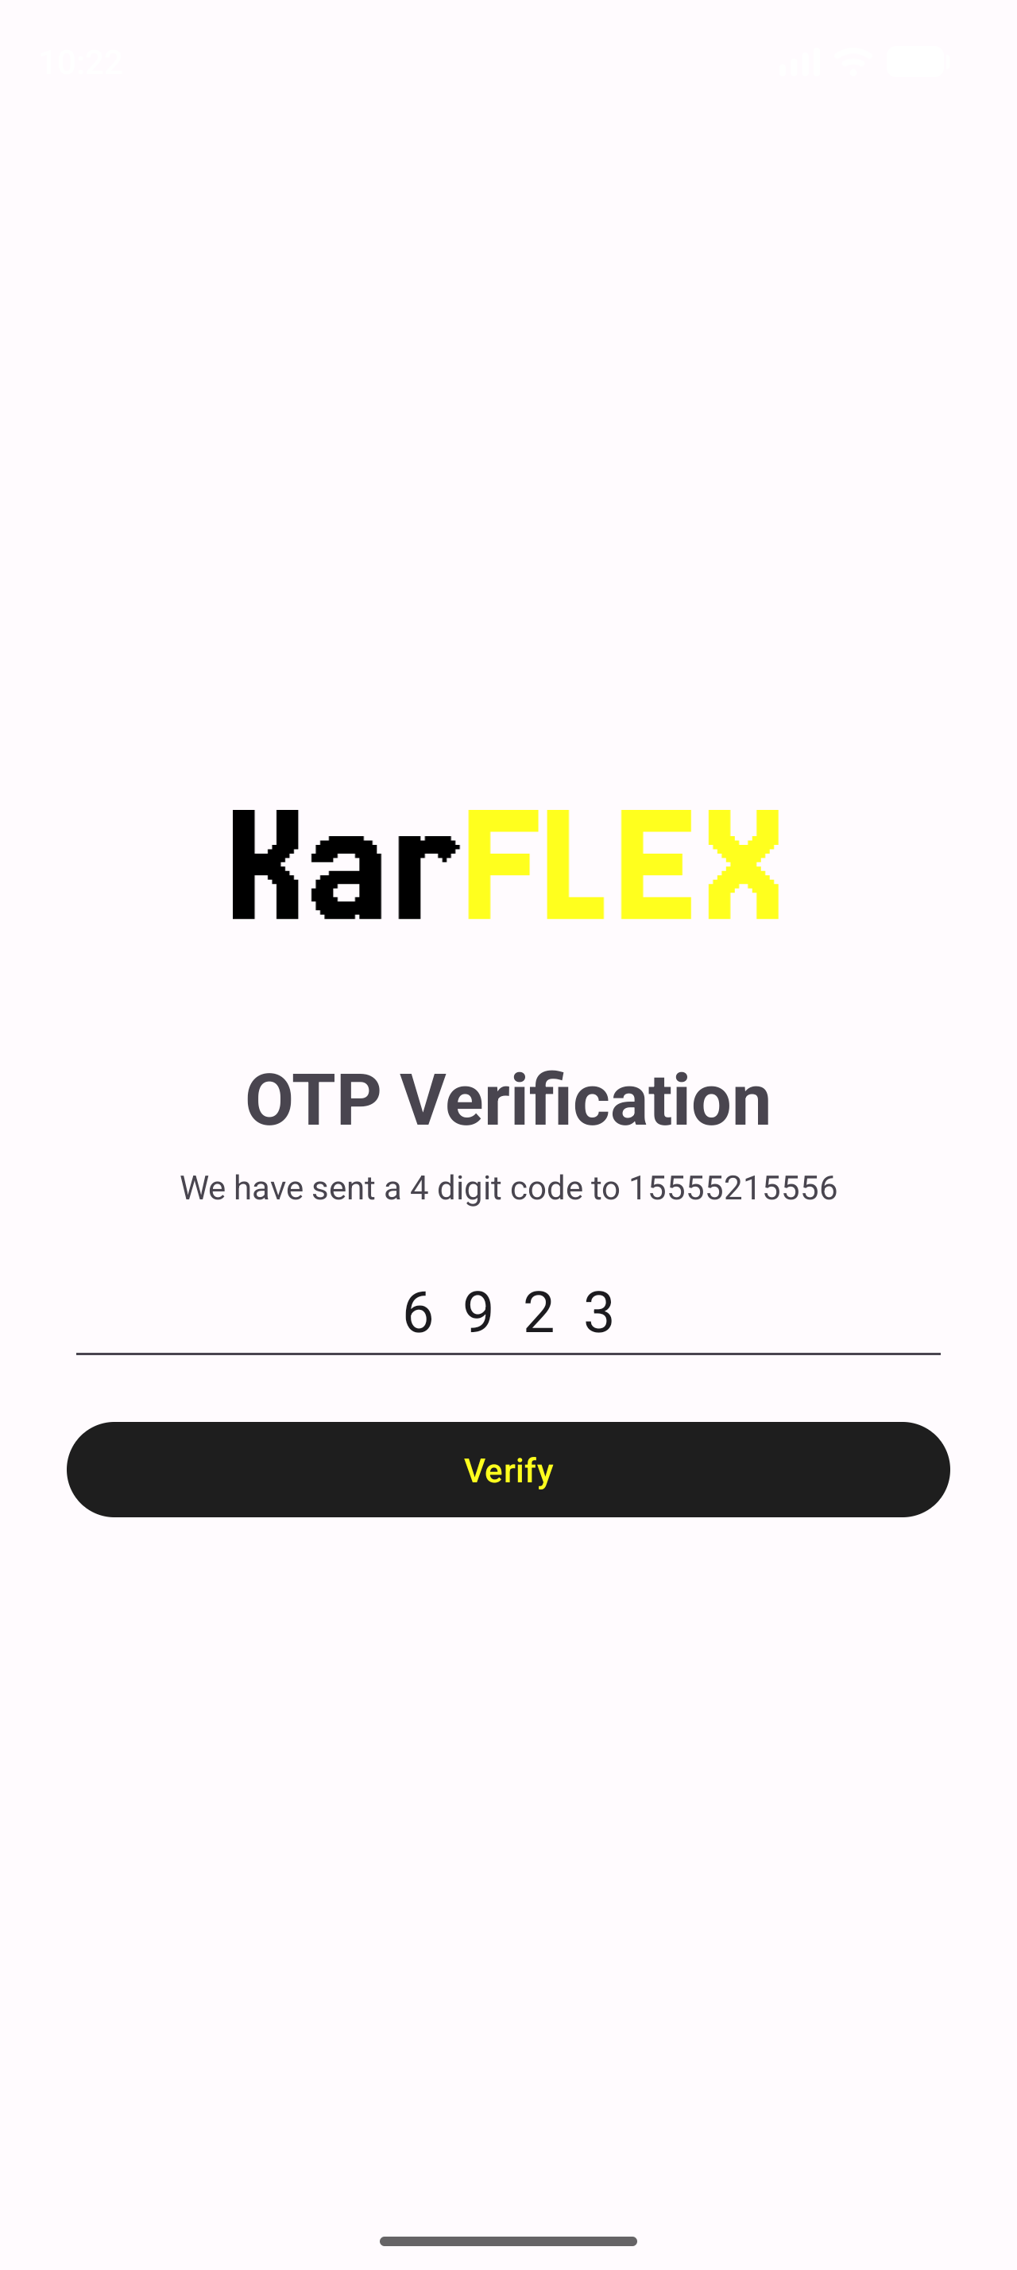
Shows the phone number that receives the OTP code. The user types the 4 digit code from the SMS and presses Verify.
Validation: the OTP field must be filled and the code must be the same as the one sent by SMS, otherwise a Toast is shown. If the code is correct, the login session is saved and the user is redirected to the Home page.
- Home Page - Browse Section
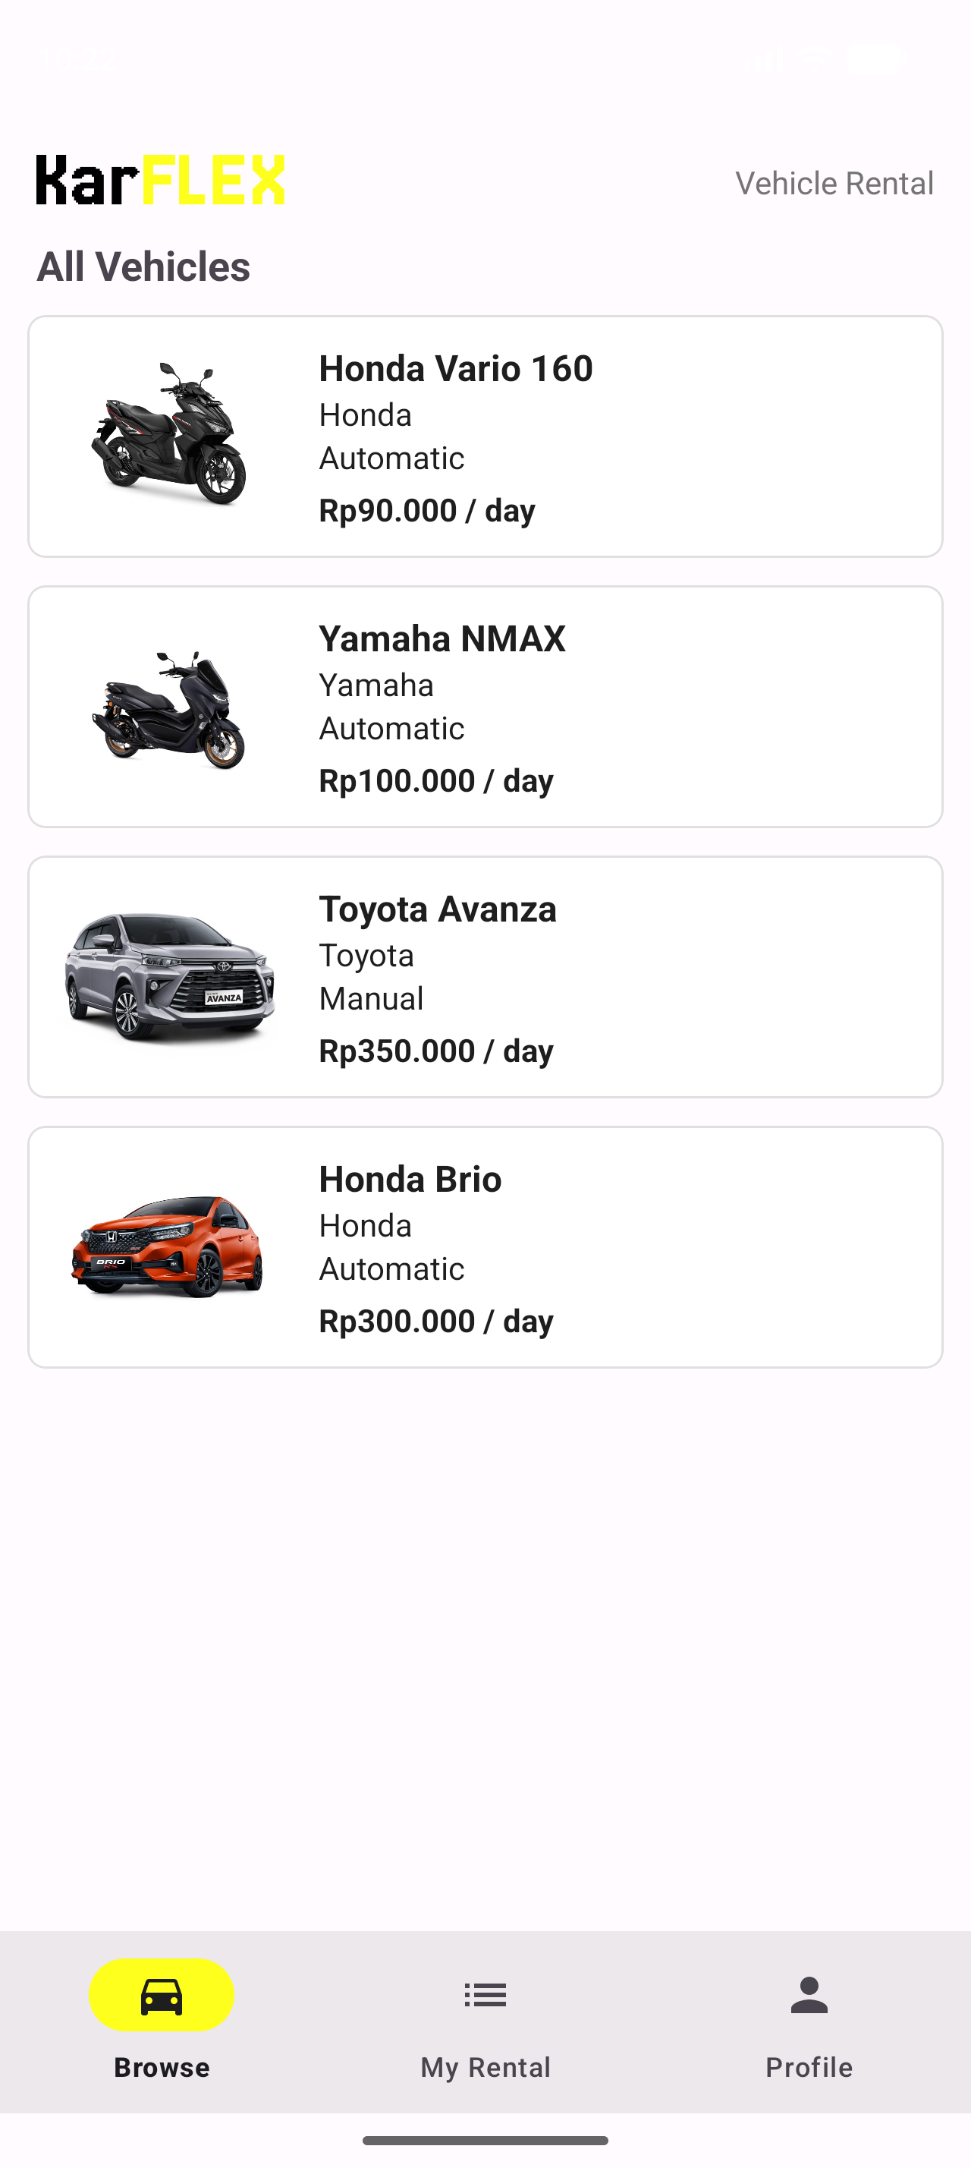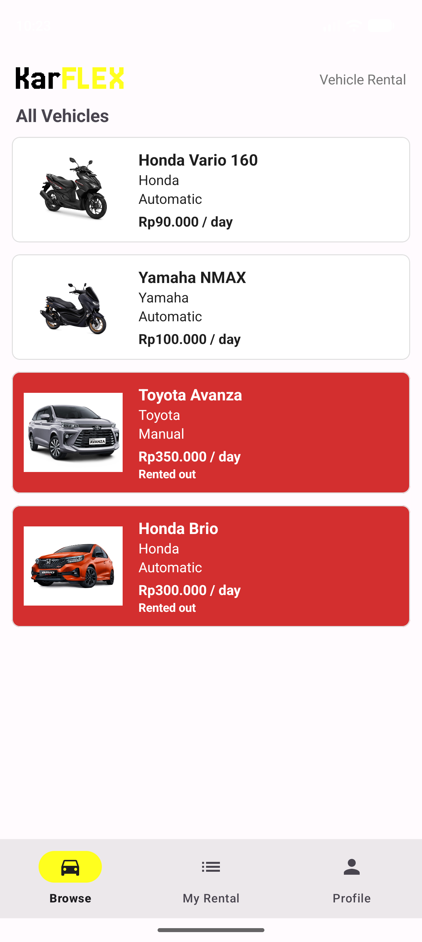
The Home page uses a Bottom Navigation with three menus: Browse, My Rental, and Profile. The Browse section shows the KarFlex logo and title, and the list of all vehicles in a RecyclerView (image, model name, brand, transmission, and price in IDR).
The data is fetched from the JSON URL using Volley (JsonArrayRequest), parsed, and stored into the Vehicle table first, then the list is loaded from the database. If the vehicle is being rented (there is an Active rental for it), the card background turns red (right picture). Clicking a vehicle opens the Vehicle Detail page.
- Vehicle Detail Page
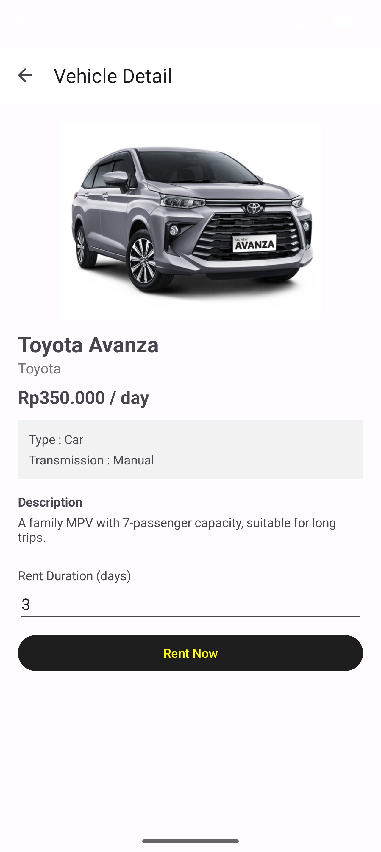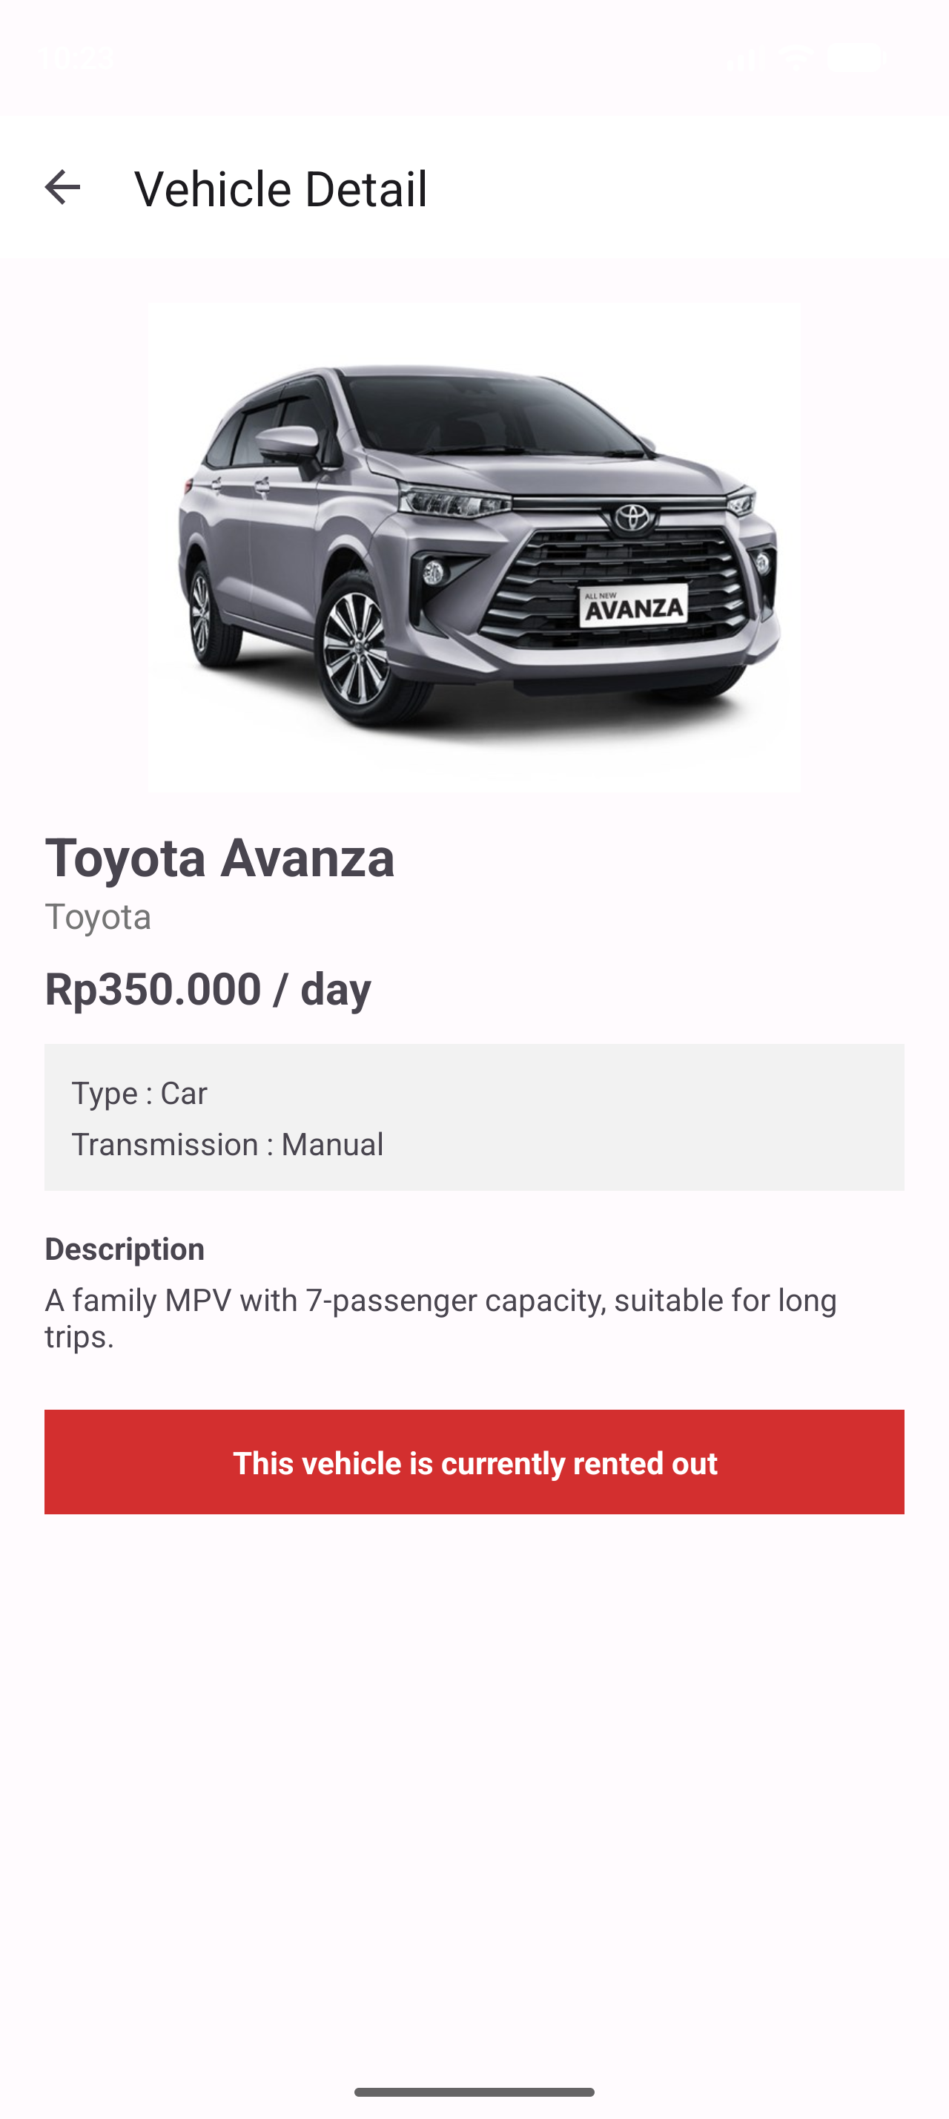
Shows the image, model name, brand, price, type, transmission, and description of the selected vehicle from the database. The user enters the rent duration in days and presses Rent Now.
Validation: duration must be filled, must be a number and more than 0. If valid, a new row is inserted into the Rentals table with the vehicle, user, duration, current date as start date, and status Active. If the vehicle is already rented out, the input and button are hidden and a rented out notice is shown instead (right picture).
- Home Page - My Rental Section
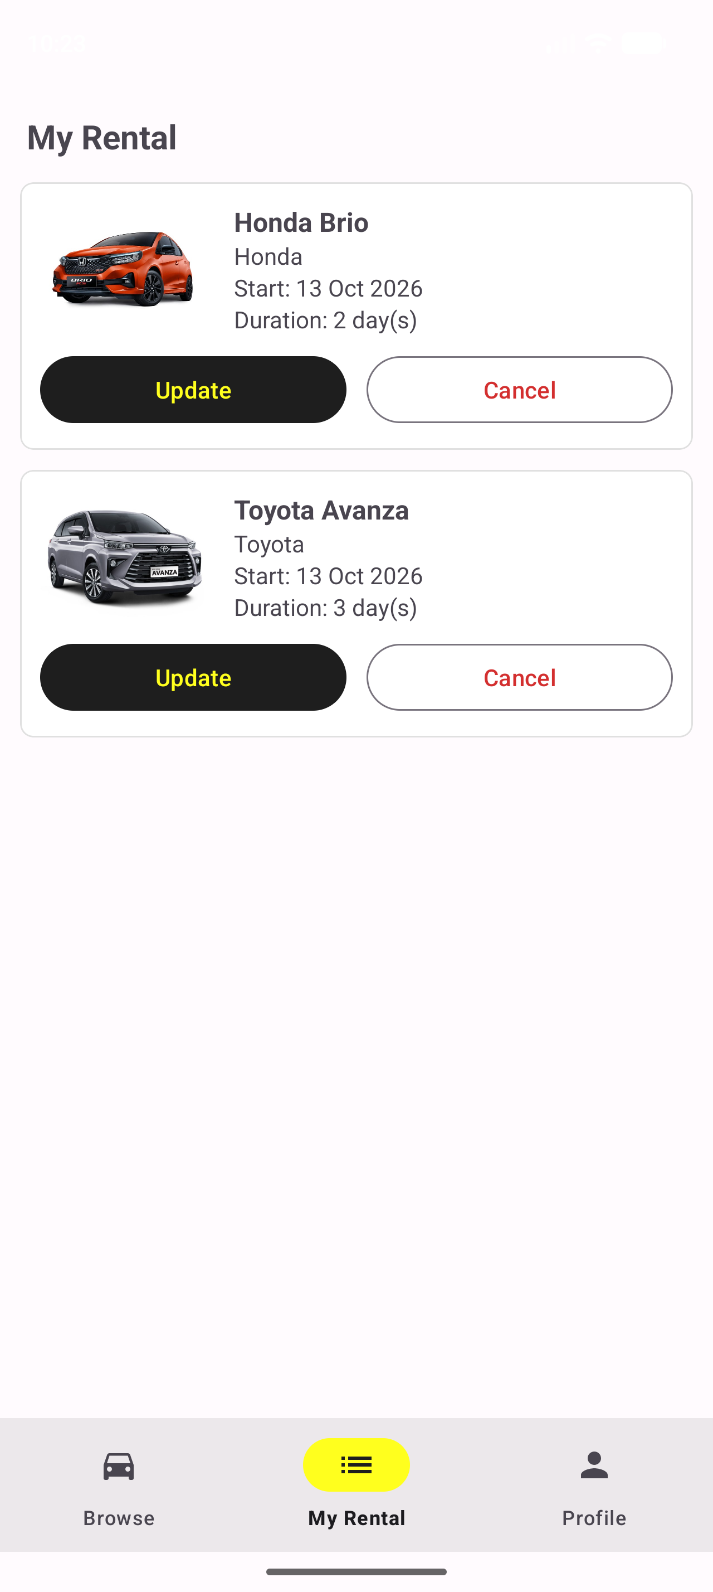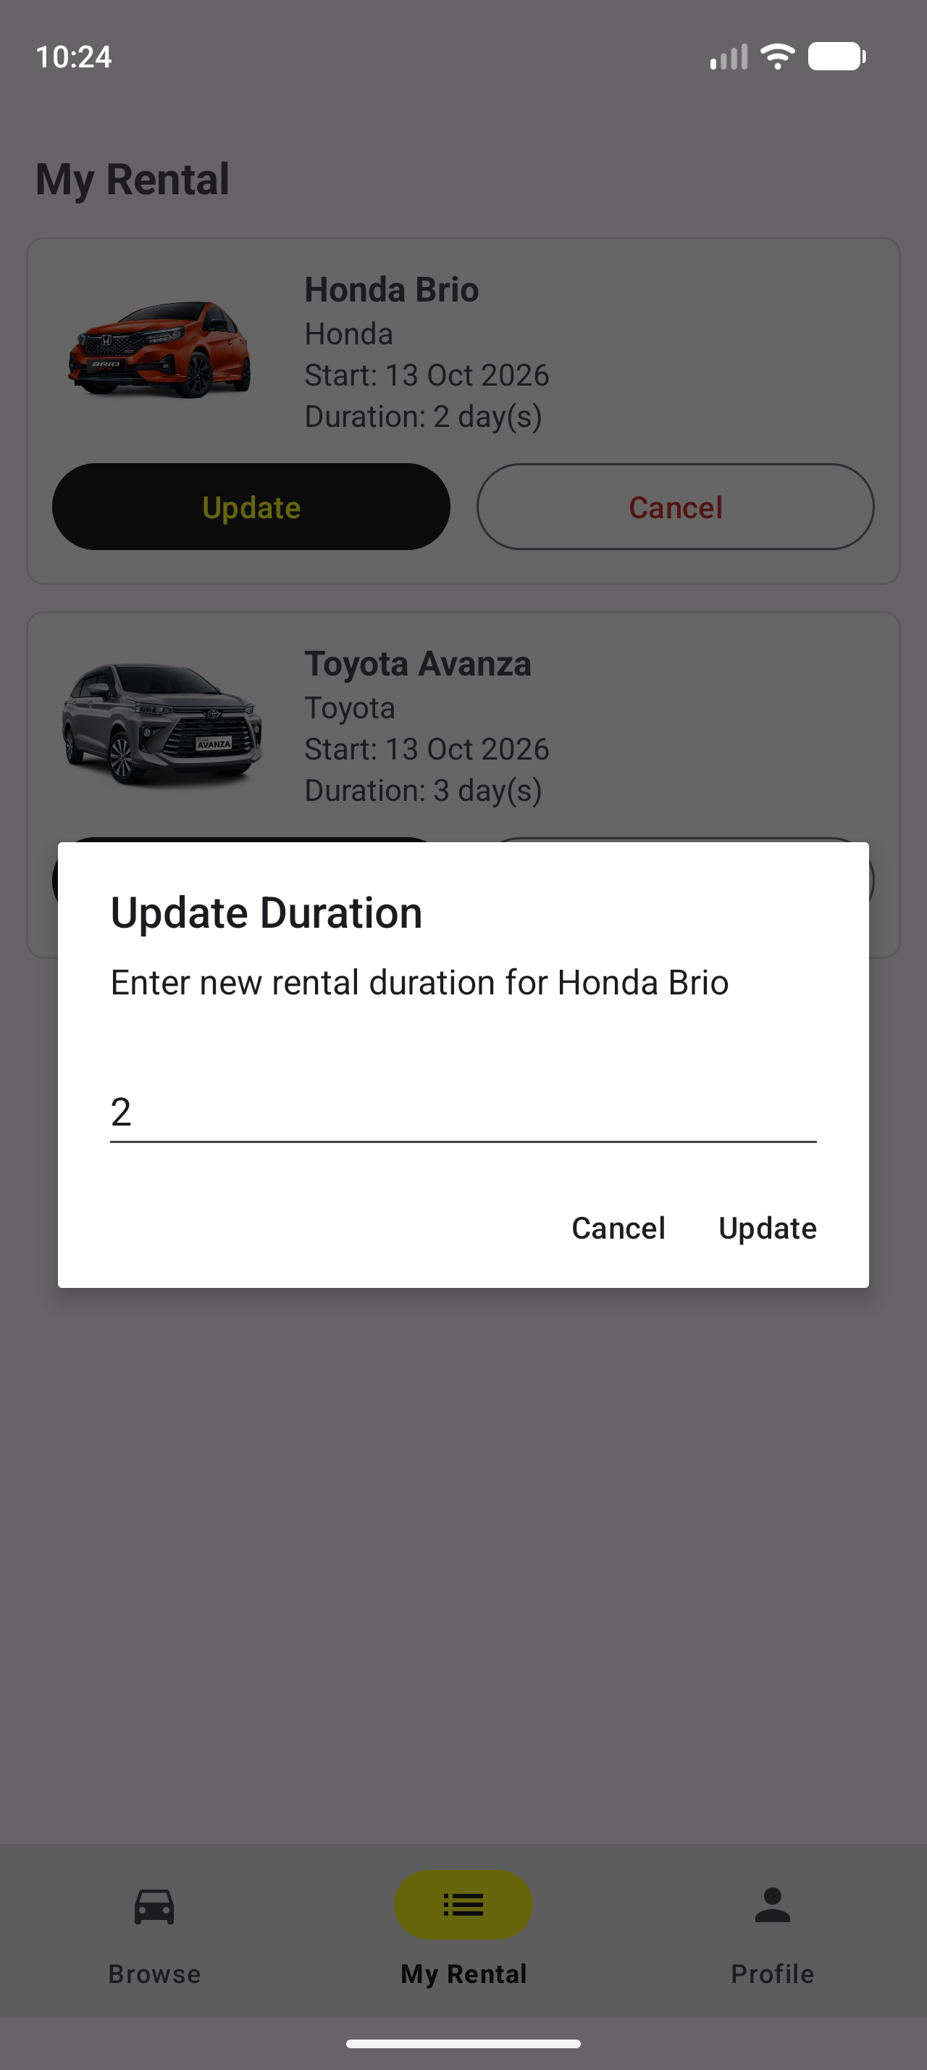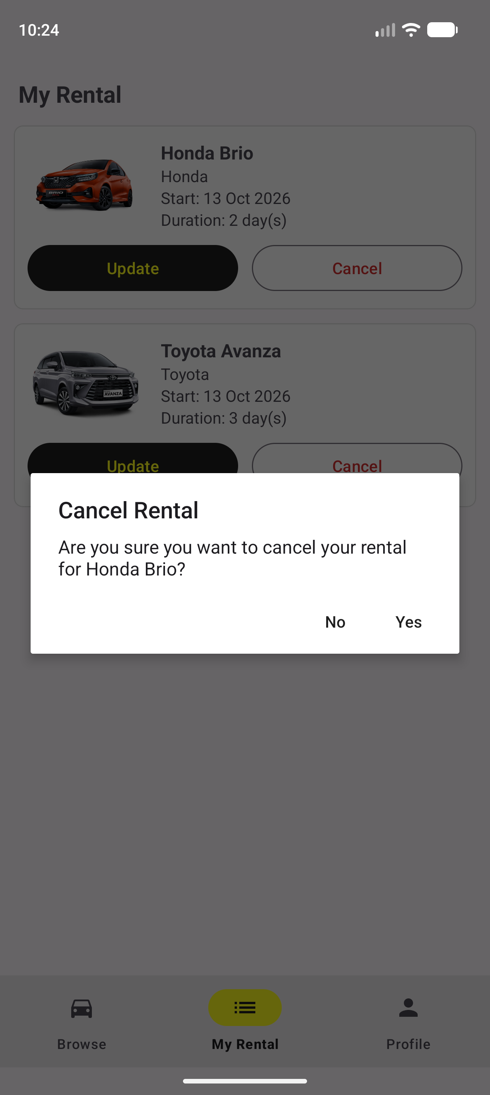
Shows the active rentals of the logged in user in a RecyclerView (image, name, brand, start date, and duration). Every time the list is loaded, rentals whose start date plus duration has passed are changed from Active to Completed automatically.
The Update button shows a dialog with an input for the new duration (must be a number and more than 0), then updates the rental in the database. The Cancel button shows a confirmation dialog first, and if the user presses Yes the rental is deleted from the database.
- Home Page - Profile Section
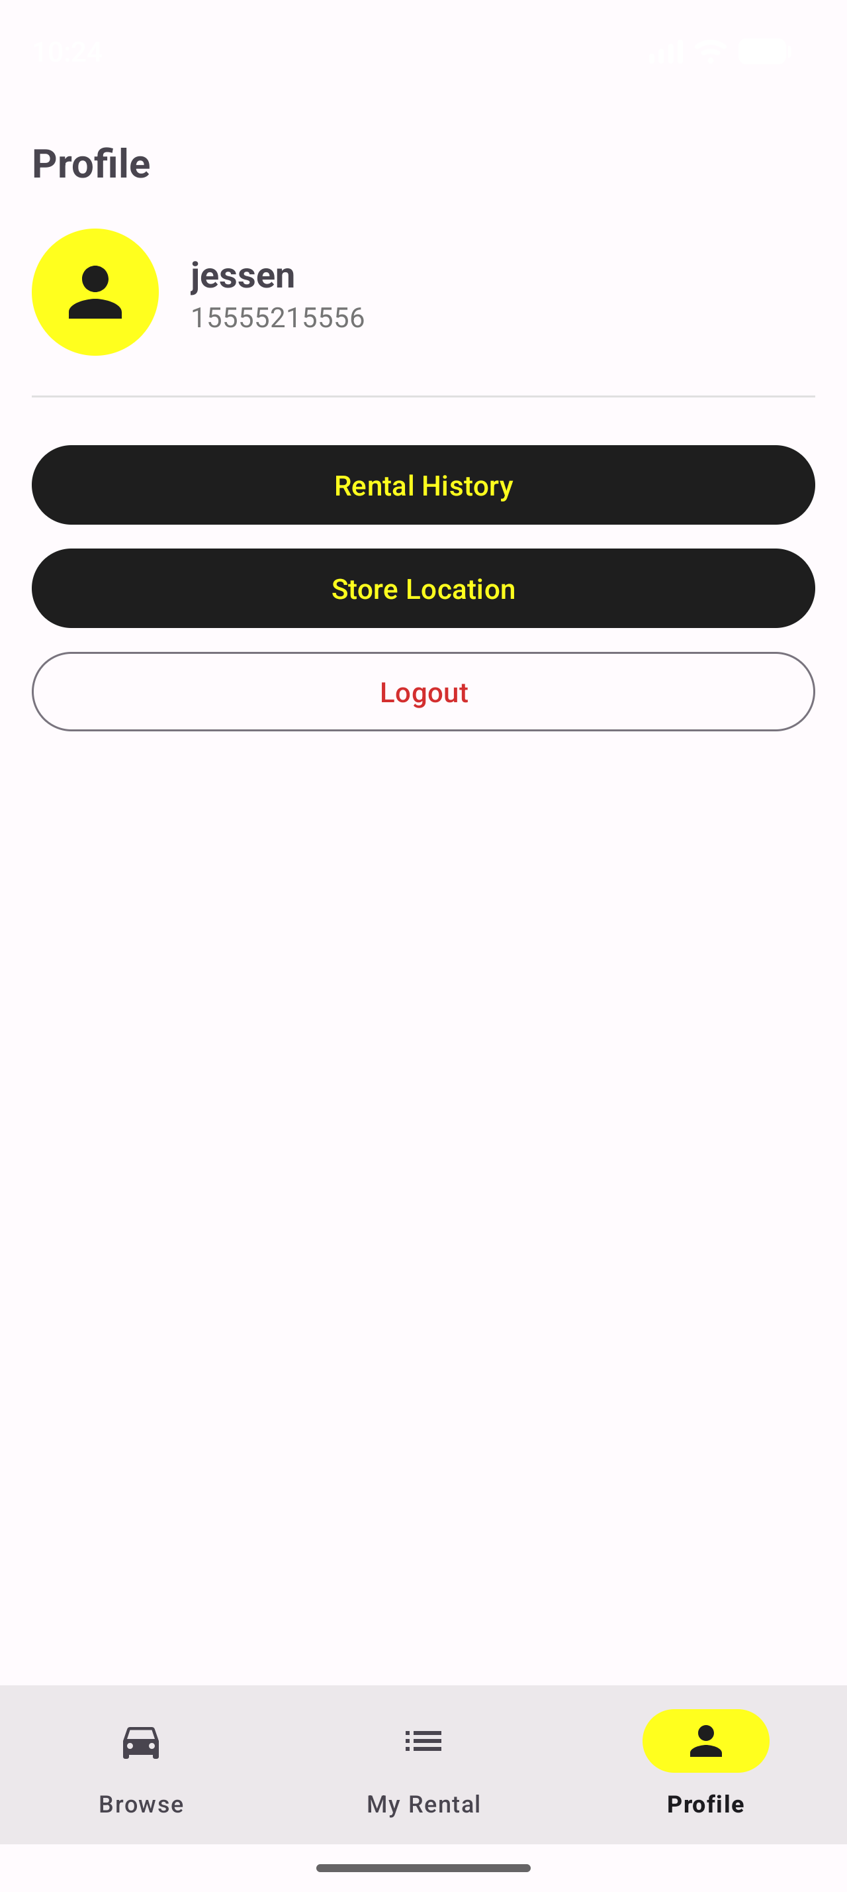
Shows the username and phone number of the logged in user. There are buttons to open the Rental History page and the Store Location page, and a Logout button that clears the session and redirects the user to the Login page.
- Rental History Page
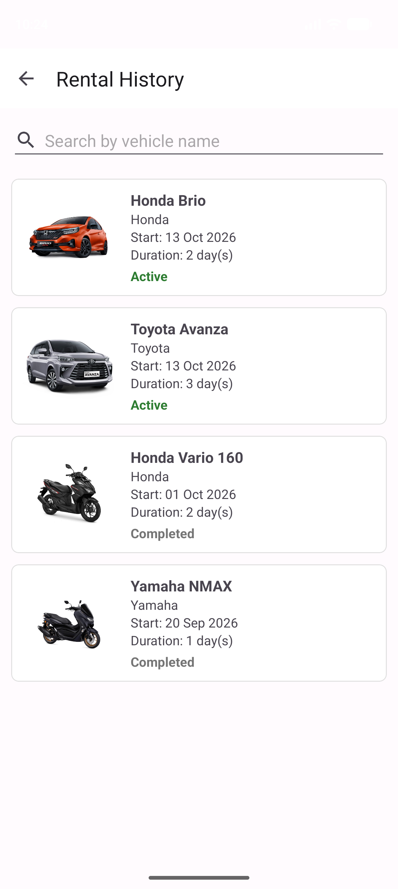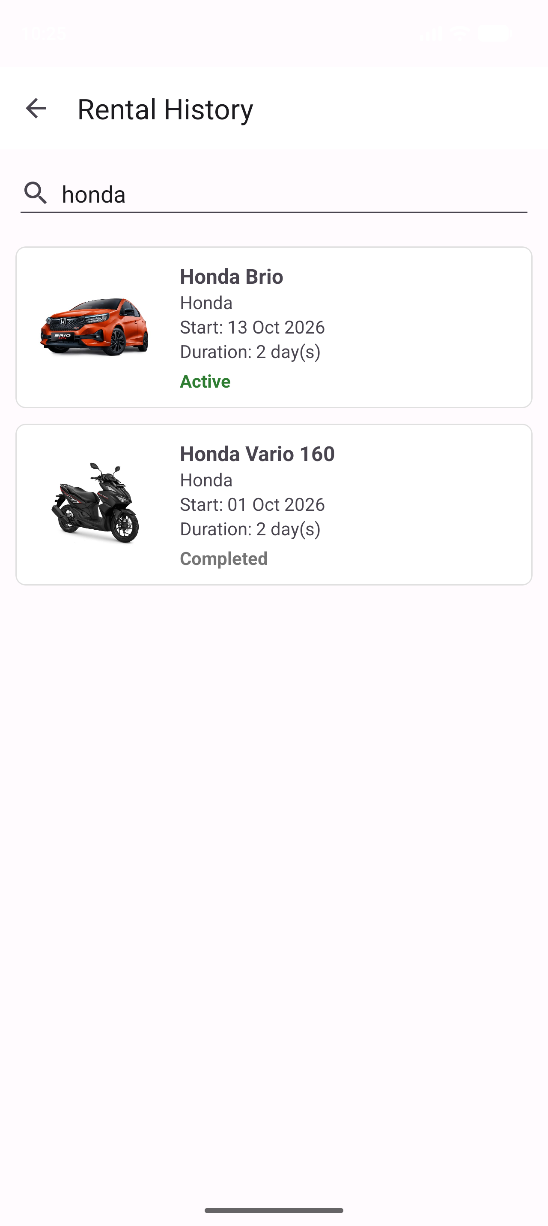
Shows all rentals of the user (active and completed) ordered from the newest to the oldest. Each item shows image, name, brand, start date, duration, and status. Active status is written in green and Completed status in gray.
The search EditText at the top filters the list by vehicle name while the user is typing (right picture).
- Location Page
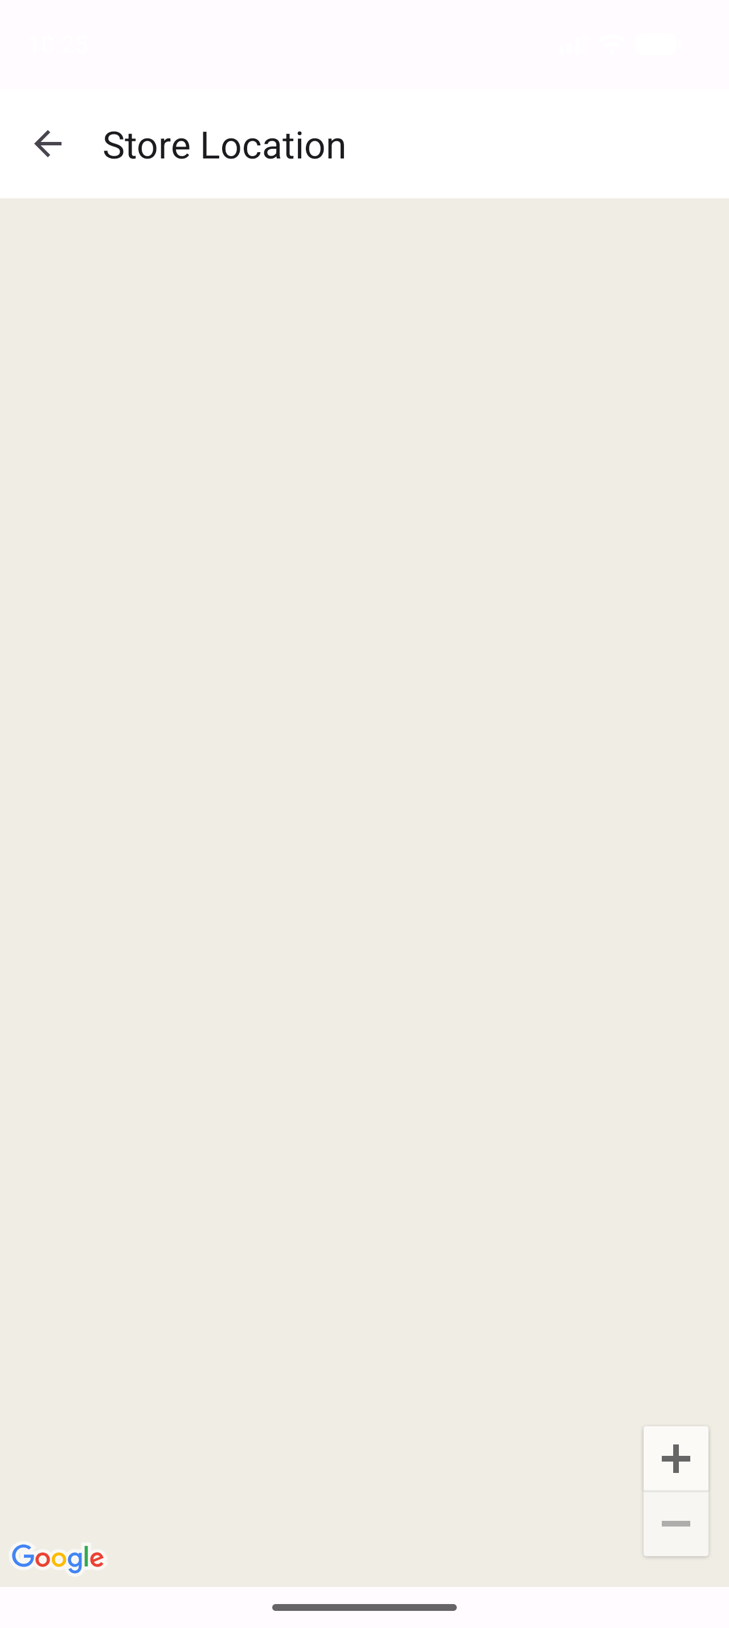
Shows the KarFlex store location using Google Maps SDK for Android. The page has a Toolbar with a back button. A marker named "KarFlex" is placed at latitude -6.201733 and longitude 106.781592.
- Reference
- Vehicle JSON data: https://gist.githubusercontent.com/axelkrnwn/01c506ac60735f553af951e550634b59/raw/08489b2ff76e1356a6df38d09948716628024195/karflex.json
- Honda Vario 160 image: https://honda-motor.id/wp-content/uploads/2024/02/New-Honda-Vario-160-CBS-Active-Matte-Black.png
- Yamaha NMAX image: https://yamahacianjur.com/wp-content/uploads/2023/10/NMAX-STD.jpg
- Toyota Avanza image: https://d1g6w7sntckt92.cloudfront.net/public/images/car_gallery_images/vUYy6ktf3RYqwaQJtfpyXox5h2FhAsvfgeu01QEy.jpg
- Honda Brio image: https://dealermobilhondabanjarmasin.com/wp-content/uploads/2018/09/All-New-brio-Banjarmasin.png
- Icons (directions car, list, person, search): https://fonts.google.com/icons
- Volley: https://google.github.io/volley/
- SQLite in Android: https://developer.android.com/training/data-storage/sqlite
- RecyclerView: https://developer.android.com/develop/ui/views/layout/recyclerview
- SmsManager: https://developer.android.com/reference/android/telephony/SmsManager
- Maps SDK for Android: https://developers.google.com/maps/documentation/android-sdk/overview
- Group Member
- <NIM> – <1st STUDENT NAME>
- <NIM> – <2nd STUDENT NAME>
- <NIM> – <3rd STUDENT NAME>
- <NIM> – <4th STUDENT NAME>

