Project Case | 
COSC6103001
Mobile Technology Solution
Computer Science | O272-COSC6103-KF01-00
Valid on Odd Semester Year 2026/2027 | Revision 00

- Kelompok tidak diperkenankan untuk:
Members of the group are prohibited from:
    - Melihat sebagian atau seluruh jawaban kelompok lain,
Seeing a part or the whole answer from other groups,
    - Menyadur sebagian atau seluruh jawaban dari buku, catatan, video, dan jenis referensi lainnya,
Retell a part or the whole answer from books, notes, videos, and other references,
    - Menyadur sebagian atau seluruh jawaban dari internet,
Retell a part or the whole answer from the internet,
    - Mengumpulkan jawaban yang tidak sesuai dengan tema soal,
Submitting an answer with a different theme from the given case,
    - Melakukan tindakan yang menyebabkan jawaban dicontek oleh orang lain atau kelompok lain, baik disengaja maupun tidak disengaja,
Doing action that could result the answer being copied by someone or other groups, intentionally or unintentionally,
    - Melakukan tindakan kecurangan lainnya.
Committing other dishonest actions.

- Jika kelompok terbukti melakukan tindakan seperti yang dicantumkan pada butir ke-1, maka nilai mahasiswa dan/atau kelompok yang melakukan kecurangan, baik menyontek atau dicontek, akan dinolkan sesuai dengan peraturan yang berlaku.
If it has been proven that a group has committed dishonest actions outlined in point 1 above, the whole groups related to the incident, regardless of which one copies or has their answer copied, will be issued a score of zero according to the regulation.

- Jawaban yang dapat diterima dan dinilai adalah jawaban yang dikumpulkan sebelum batas waktu yang telah ditentukan.
The answer must be submitted before the designated deadline to be accepted and graded,

- Jawaban akan dinilai berdasarkan teknik atau metode yang diajarkan pada kelas praktikum dengan menggunakan software yang sudah ditentukan.
The scoring will be based on the materials taught during the practicum classes using the designated software. Using different software than requested may result in your answer not being graded.

- Jika Anda tidak membaca peraturan ini, maka Anda dianggap sudah membaca dan menyetujuinya.
By taking this exam, you agree to these regulations, regardless of whether you have read it or not.

- Persentase penilaian untuk matakuliah ini adalah sebagai berikut:
The score will be distributed as follows:
Tugas Mandiri  Assignment | Proyek  Project | UAP  Final Exam
- | 100% | -

- Perangkat lunak yang digunakan pada matakuliah ini adalah sebagai berikut:
This course uses the following software:
Software
Software
Android SDK API 37
Android Studio Quail 1 2026.1.1

- Ekstensi file yang harus dikumpulkan untuk matakuliah ini adalah sebagai berikut:
Your answers must be in the following file extensions:
Tugas Mandiri  Assignment | Proyek  Project | UAP  Final Exam
- | Android Folder Project Kotlin (CLASS, XML, Asset Files) | -

- File yang harus dikumpulkan adalah keseluruhan jawaban beserta dengan aset yang digunakan (gambar, audio, video, dll) dan dokumentasi proyek yang berisikan link referensi aset dan penjelasan mengenai aplikasi yang dibuat (terlampir bersama dengan soal).
Include other files that can support your project, such as: all files in your project, other files (image, audio, video, etc.) used in your project, *.doc file (documentation of your project) that contains all pages in your project, reference links of additional files (image, audio, video, etc.) used in your project, the description about how to use your application, etc.

Soal
Case

KarFlex
KarFlex is one of the premier companies providing high-quality vehicle rentals. Currently, KarFlex is trying to reach even more customers by creating a mobile application based on the Android operating system that may be downloaded by customers, thus increasing KarFlex's popularity. The application provides user authentication features, viewing all vehicles, renting vehicles, managing active rentals, and checking for the KarFlex store's location via Google Maps.
For the database engine, you are required to use SQLite. Below is the Entity-Relationship Diagram (ERD) used in this application.
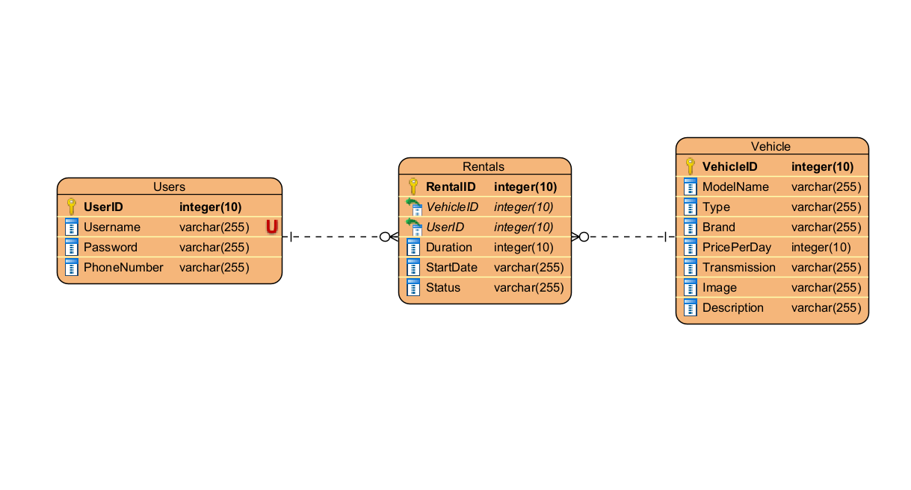
Figure 1. ERD of the Application’s Database

As stated above, this application will then need several pages to fulfill its purpose. The breakdown of those pages is described below:
- Login Page
This page contains a login form that will authenticate users to the application. The authentication process requires the user to input the registered username and password. The page has several components and validations, which are:
- Use EditText for the username and password input field. Adjust the component’s type to suit the proper purpose.
- Use the Button for the user to log in. This Button will validate and authenticate the user. The login processes are:
  - Validate that username must be filled.
  - Validate that password must be filled.
  - Validate that username and password are registered in the application’s database.
- If the validation fails, the application will show an error message according to the failure using Toast.
- If the validations are fulfilled, generate the OTP Code by random four numbers and send it using SMS to authenticate the user’s phone number.
- Redirect the logged-in user to the OTP page.
- Use TextView that contains “Don’t have an account? Register here!”. This component will direct users to the Register Page whenever clicked by the user.
- Register Page
This page contains a registration form that will be used to register a new user, which will then be stored in the application’s database. The registration process requires a username, password, and phone number. The requirements for this form are:
- Use EditText for the username, password, and phone number input field. The component’s type must be adjusted to suit the proper purpose.
- Use Button for the user to register. This Button will validate and register the user. The registration processes are:
  - Validate that all fields must be filled.
  - Validate that username must be unique and not registered by other users.
  - Validate that password’s length of at least six characters.
  - Validate that the phone number must be at least ten digits long.
  - User ID will be an integer that always increments.
  - If any validation fails, the application will show an error message according to the failure using Toast.
  - Otherwise, register the given information and store it in the application’s database. The user will then be directed to the Login Form.
- Use TextView for Login. This component contains “Already has an account? Log in here” which will redirect the user to the Login Page when clicked.
- OTP Page
This page contains an OTP form that will be used to re-authenticate the user by OTP Code sent through SMS. The requirements for this form are:
- Validate that OTP Edit Text must be filled.
- Validate that the code typed by the user must be the same as the OTP Code in the SMS. If the OTP Code is not valid, show an error message using Toast.
- Otherwise, redirect the user to Home Page.
- Home Page
This home page contains three sections: the Browse section, My Rental section, and Profile section. You must use bottom navigation for these sections. The details for the sections will be explained below:
- Browse Section
  - Show your application’s logo and title.
  - Show a list of all available vehicle data from the application’s database. But you must retrieve the data from JSON, then store it in the application’s database. Use the Volley library to fetch information from the JSON data. The JSON data is available at https://gist.githubusercontent.com/axelkrnwn/01c506ac60735f553af951e550634b59/raw/08489b2ff76e1356a6df38d09948716628024195/karflex.json.
  - You must use Recycler View to show the data. Show the vehicle’s image, model name, brand, transmission, and price (in IDR).
  - If the vehicle is currently rented out, the card background must change to a red color.
  - When the specific vehicle is clicked, redirect the user to the corresponding vehicle detail page.
- My Rental Section
  - Get the active rental list with a specific logged-in user from the application’s database.
  - Automatically change status from Active to Completed if the current date has surpassed the start date plus the duration.
  - You must use Recycler View to show the data. Show vehicle's image, name, brand, start date, and rental duration in every rental item.
  - Provides update and delete/cancel button in every rental item.
  - If the user clicks the update button, show the input field for the duration. Then validate the duration with the validation details below:
    - Validate duration must be a number and more than 0.
    - If any validation fails, the application will show an error message according to the failure using Toast.
    - Otherwise, update the duration of the selected rental data in the application’s database.
  - If the user clicks the cancel button, show a confirmation dialog before deleting the rental to avoid human error.
    - If the user has confirmed, physically delete the selected rental in the application’s database.
- Profile Section
  - Show username and phone number from the user logged in.
  - Provide a button to navigate to the Rental History Page.
  - Provide a button to navigate to the Store Location Page.
  - Provides logout Button to log out the user from the application.
  - Redirect the user to Login Page after the user successfully logged out.
- Vehicle Detail Page
This page will show detailed vehicle information for a specific vehicle from the application’s database. Show vehicle's image, model name, brand, transmission, type, price, and description. This page also provides a form for users to rent the vehicle. The requirements for this form are:
- If the vehicle is already rented out, hide the input and rent button, and show a rented out notice instead.
- Use EditText to enter the duration (days) that the user wants to rent. The components’ type must be adjusted to suit the proper purpose.
- Use Button for the user to rent the vehicle. This Button will validate and insert the transaction data into the application’s database. The transaction process details will be explained below:
  - Validate duration must be filled.
  - Validate duration must be a number and more than 0.
  - If any validation fails, the application will show an error message according to the failure using Toast.
  - Otherwise, insert the transaction of the selected vehicle, duration, and current start date in the application’s database.
- Rental History Page
This page will show the user their past and present rental transactions. The requirements for this page are specified below:
- Provide an EditText that acts as a search filter to filter the list by vehicle name.
- Use RecyclerView to display the rental history from the application's database, ordered newest to oldest.
- Display the vehicle's image, name, brand, duration, start date, and status.
- Format "Active" status text in green and "Completed" status text in gray.
- Location Page
This page will show the user of KarFlex’s location with a marker. The requirements for this page are specified below:
- Provide a Toolbar that serves as a header with a back button.
- Use Google Play Services for Android Maps SDK.
- Put the marker on the specified location (latitude & longitude) and name the marker. The details will be specified below:
Google Map Details
Longitude | 106.781592
Latitude | -6.201733
Marker’s Name | KarFlex

