Statistics: The Science of Decisions Project Instructions

# Questions For Investigation

**Q1**: What is our independent variable? What is our dependent variable?

**Ans**:

The given experiment is a study for evaluation of Stroop effect, which essentially measures the effect that interference has on efficiency for completing a task.

The independent variable will be the test conditions which increase or decrease interference. In this particular experiment, independent variable is whether the color of the ink is the same or different from the word.

The dependent variable will be something by which we can measure the effect of the interference. Thus, dependent variable is the time taken by the participants to read the list of words.

**Q2**. What is an appropriate set of hypotheses for this task? What kind of statistical test do you expect to perform? Justify your choices.

**Ans**:

This test measures the effect of interference for completing a task. It measures the effect by measuring the time it takes people to identify the color of ink of words in two lists – congruent and incongruent.

In this task, we are evaluating a small sample of population, to make predictions for the entire population. Only our point estimate for difference in mean response times for congruent and incongruent conditions will be same for the sample and the entire population. Our actual decision for the population will have to be made after proper statistical evaluation.

Thus, the appropriate null hypotheses will be that there is no significant difference in the average time it takes for completing a task under congruent and incongruent conditions, task being to state the color of the words in a list.

The appropriate alternate hypotheses will be that there is significant difference in the average time it takes for completing a task under congruent and incongruent conditions.

To express mathematically, we can write:

null Hypotheses -> H0 : µCongruent - µIncongruent = 0

Alternate Hypotheses -> HA : µCongruent - µIncongruent ≠ 0

Where

µCongruent is the population average time for completing the task (reading out a list of words) under congruent conditions.

µIncongruent is the population average time for completing the task (reading out a list of words) under incongruent conditions.

For selecting an appropriate statistical test, we have the following information about the data:

* We have a small sample out of the population data.
* The experiment is a repeated measures design where the same people are taking the test twice.
* We have normally distributed data for our samples (as seen from the histograms attached below in Ans 4)
* We do not have the means or standard deviations for the population (this rules out a z-test)
* Our null hypotheses does not predict a direction for the results.

Considering all these factors, we will perform a two-tailed Dependent t-test for paired samples because we can not perform a z-test or a one-tailed t-test.

**Q3**. Report some descriptive statistics regarding this dataset. Include at least one measure of central tendency and at least one measure of variability.

**Ans**:

Number of samples, n = 24

Mean of congruent list, Congruent = 14.05 seconds

Median of congruent list, MCongruent = 14.36 seconds

Inter-quartile range for congruent list (Q3-Q1), IRQCongruent = 4.69

Mean of incongruent list, Incongruent = 22.02 seconds

Median of incongruent list, MIncongruent = 21.02 seconds

Inter-quartile range for incongruent list (Q3-Q1), IRQIncongruent = 5.52

Difference of means, D = Congruent - Incongruent

= -7.96

SD of differences, S = 4.86

**Q4**. Provide one or two visualizations that show the distribution of the sample data. Write one or two sentences noting what you observe about the plot or plots.

**Ans**:

Histograms for the congruent list and the incongruent list are as below:

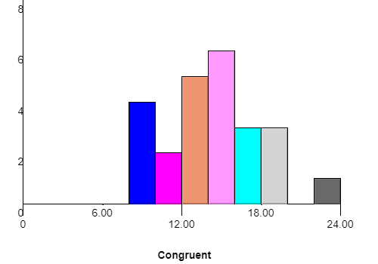

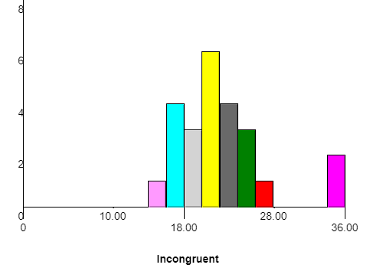

In both the histograms shown above, the bin size has been selected as 2.

Both the histograms appear to be normal distributions with very thick tails and there appear to be some outliers to the data as well. This indicates that we have not collected enough samples.

**Q5**. Now, perform the statistical test and report your results. What is your confidence level and your critical statistic value? Do you reject the null hypothesis or fail to reject it? Come to a conclusion in terms of the experiment task. Did the results match up with your expectations?

**Ans**:

Number of samples, n = 24

Degrees of freedom, df = 23

Difference of means, D = -7.96

Standard Deviation of differences, S = 4.86

Let us use a confidence level of 95%. i.e. α = 0.05

The point estimate for difference, µCongruent - µIncongruent = -7.96

t-statistic = $\frac{µCongruent - µIncongruent }{S/{\sqrt{n}}}$

= $\frac{-7.964}{{4.864}/{\sqrt{24}}}$

= - 8.02

For α = 0.05, tCritical = ±2.07

Since t-statistic is less than negative value of tCritical, i.e. t-statistic lies in the critical region, we reject the null hypotheses. For this value, p < 0.05 and hence, our results are statistically significant.

Effect size measure, Cohen’s d = $\frac{{Mean}_{D}}{SD}$

= $\frac{-7.964}{4.864}$

= -1.63

Critical Interval, CI = MeanD ± tCritical()

= (-10.02, -5.91)

Coefficient of determination, r2 =

= .74

To summarize the results of our statistical test:

Mean of differences, M = -7.96

Standard Deviation of differences, SD = 4.86

t(23) = -8.02, p < 0.05, two-tailed

Confidence interval on mean differences; 95% CI = (-10.02, -5.91)

d = -1.63

r2 = .74

**Q6**. Optional: What do you think is responsible for the effects observed? Can you think of an alternative or similar task that would result in a similar effect? Some research about the problem will be helpful for thinking about these two questions!

**Ans**: The most plausible explanation is that while identifying colors in the incongruent list, the actual text starts interfering with the person’s ability to identify color. In my opinion, if the text had been something else, like names of animals or plants, identifying the color in the incongruent list would have been much faster.

A task with similar effect will be to read out numbers with different sizes of the digits. The reader will be able to read the numbers much faster if they are of the same size and slower if the size of the digits is different.

**References**:

1. <https://statistics.laerd.com/statistical-guides/dependent-t-test-statistical-guide.php>

**Tools used**:

1. <http://www.wolframalpha.com>
2. <http://www.shodor.org/interactivate/activities/Histogram/>