Apache Hive on S3A
Raghav Aggarwal

Context 1
Possible Solution 3
Accessing Multiple Buckets in a session 4

Context
There are 3 problem statement with HIVE on S3A:
- How to allow users to access S3A bucket at session level.
- User accessing multiple buckets at session level.
- Fine grain access for a user on a specific path in a bucket.

This doc is specifically for Problem Statement [1] and address the limitation for [2]
Presently if user needs to access S3A storage then respective configuration must be set in Ambari HDFS core-site.xml
- fs.s3a.endpoint
- fs.s3a.access.key
- fs.s3a.secret.key

But there are drawbacks to this approach:
- Only 1 bucket will be accessible to the whole cluster and every user will be able to access the S3A data.
- Change in configuration requires restart of services which is not ideal for production clusters.

If a user tries to set the credentials at session level then the DDL operation will fail as the HiveMetaStore (HMS) won’t have the credentials set. Here is a crude diagram representing the same.

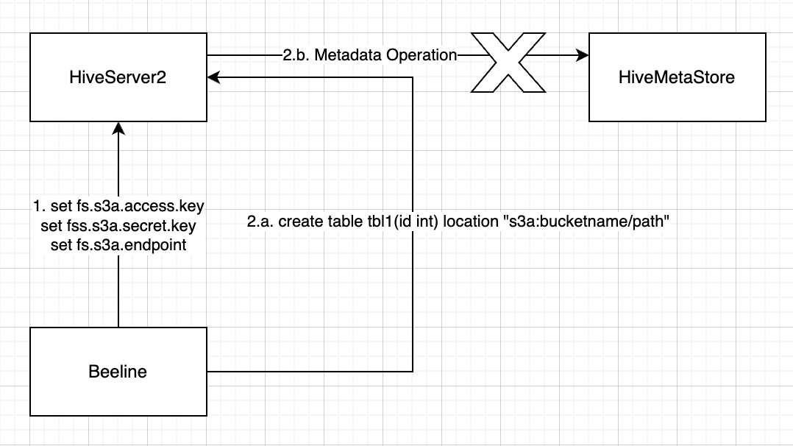
In order to solve this problem, HIVE-16913 and HIVE-28272 were introduced.

With the current solution proposed in the HIVE-28272 (configs are exposed in metaconf), we can set the S3A credentials in beeline, then the user will be able to run DDL operation, as shown in the figure

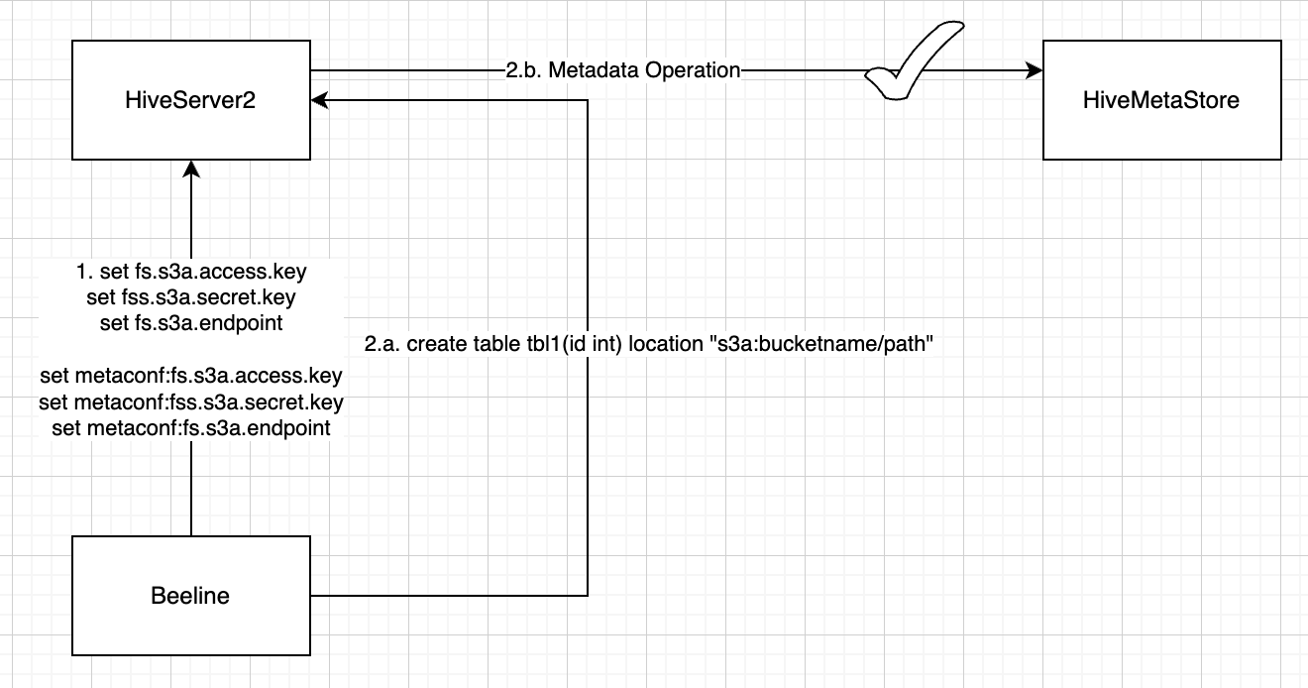

but during insert the query will fail as TEZ container won’t be able to create staging directory in S3A table location as the credentials are not passed from HS2 to TEZ, because the S3A secret key and access key are part of hidden list and in DAGUtils it will set empty values for those configuration and pass to jobconf. Here is a crude diagram explaining the same.

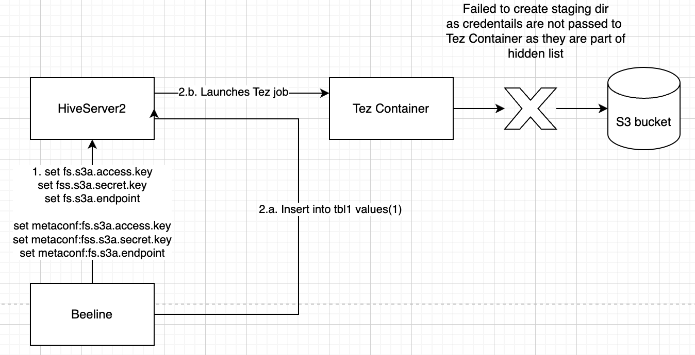

One Workaround for this will be to remove the S3A configs from the hidden list, then both DDL and DML operations will work. This approach has a major security violation as the credentials will be exposed in plain text form in TEZ View and in TEZ DAGS and in Hive protologging data as well.

Possible Solution
After reading the hadoop-awd module doc, the best possible way to securely pass the credentials to TEZ job is by creating a credentials file by running the 2 following commands.

- hadoop credential create fs.s3a.access.key -value <access key> -provider \ jceks://hdfs@<Active NameNode>:<>port/user/backup/s3.jceks

- hadoop credential create fs.s3a.secret.key -value <secret key> -provider \ jceks://hdfs@<Active NameNode>:<>port/user/backup/s3.jceks

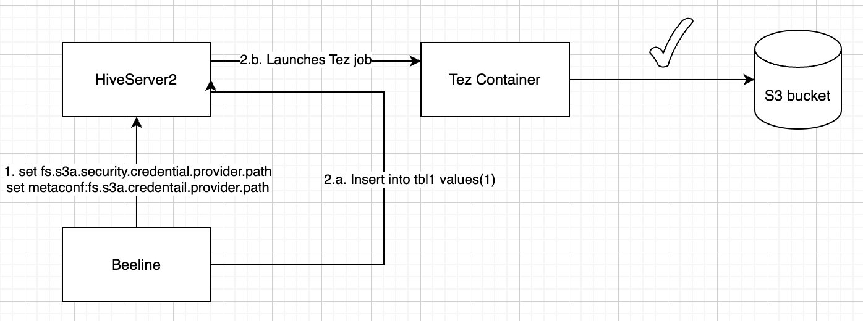

NOTE: A credential file can be created on any Hadoop filesystem; when creating one on HDFS or a Unix file system the permissions are automatically set to keep the file private to the reader —though as directory permissions are not touched, users should verify that the directory containing the file is readable only by the current user.

This will allow to securely pass the credentials to the services by running the following two set commands on beeline:

set fs.s3a.security.credential.provider.path=jceks://hdfs@<ActiveNameNode>:<port>/user/backup/s3.jceks;
set metaconf:fs.s3a.security.credential.provider.path=jceks://hdfs@<ActiveNameNode>:<port>/user/backup/s3.jceks;

NOTE: The property hadoop.security.credential.provider.path is global to all filesystems and secrets. There is another property, fs.s3a.security.credential.provider.path which only lists credential providers for S3A filesystems. The two properties are combined into one, with the list of providers in the fs.s3a. property taking precedence over that of the hadoop.security list (i.e. they are prepended to the common list).

Accessing Multiple Buckets in a session
In order to access multiple buckets, hadoop-aws jar provides capability to provide per bucket configuration. Here is an example:

set fs.s3a.bucket.bucket1.security.credential.provider.path=/path/to/s3.jceks;
set metaconf:fs.s3a.bucket.bucket1.security.credential.provider.path=/path/to/s3.jceks;

set fs.s3a.bucket.bucket2.security.credential.provider.path=/path/to/another-s3.jceks;
set metaconf:fs.s3a.bucket.bucket2.security.credential.provider.path=/path/to/another-s3.jceks;
But the problem is that we cannot set a new metaconf key at runtime. Only configuration present in metaConfVars in MetastoreConf.java can be set/modified at runtime. The configuration key has to be exposed on the HMS side unlike HS2. The below screenshot shows the problem.

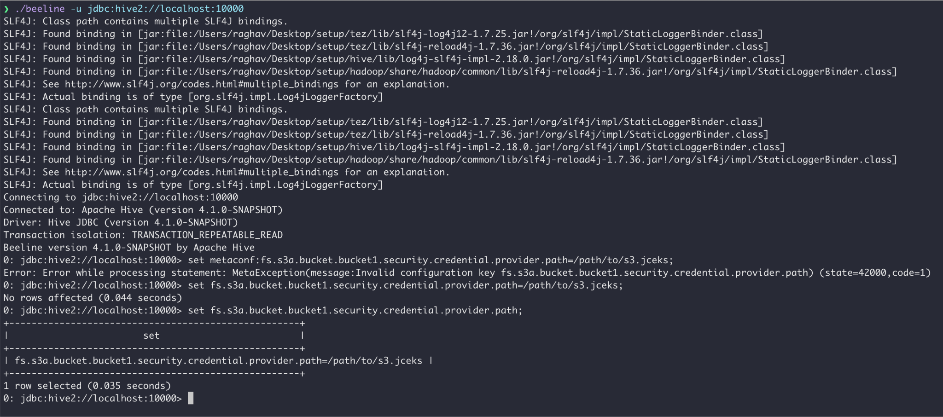

To make this work, we need to allow metaconf to create the configuration that starts with prefix fs.s3a.bucket at runtime. Otherwise the user cannot access multiple buckets simultaneously in a session.

For the Problem Statement[3], fine grain access for a user on a specific path in a bucket, requires something like Ranger Authorization Service (RAZ), as mentioned in this doc.

