NeMo Hybrid ASR
Latency Benchmark Report

CTC vs TDT vs RNNT Decoding Strategies

Date | April 2026
Audio | overall.wav — 9.98s, 16 kHz, multilingual (Telugu/English/Hindi)
Model | NeMo Hybrid ASR (CTC + TDT + RNNT heads)
Server | NVIDIA Triton Inference Server
Test Runs | Run 1: CTC + TDT | Run 2: CTC + RNNT | Run 3: CTC + TDT (Optimized)

1. Overview

This report presents a comprehensive latency benchmark of the NeMo Hybrid ASR server, covering three decoding strategies (CTC, TDT, RNNT) across five distinct test modes. The goal is to characterise per-request latency, throughput, scalability, and resilience under a variety of real-world conditions.

Audio Under Test
- File: overall.wav | Duration: 9.98 s | Sample rate: 16 kHz
- Language: Mixed multilingual — Telugu, English, and Hindi within a single clip
- Used for all Sequential, Concurrent, Poisson, and Stress tests
- Multi-duration batch used clips of 2 s – 30 s tiled from the same audio

Decoding Strategies Tested
- CTC (Connectionist Temporal Classification)
- TDT (Token-and-Duration Transducer)
- RNNT (Recurrent Neural Network Transducer)

Test Types
- Sequential — 3 warmup + 15 runs, one request at a time
- Concurrent — workers = 2, 4, 8 firing simultaneously
- Poisson — random arrivals at 4 req/s over a 12 s window
- Stress — 200 requests from 100 concurrent workers
- Multi-duration Batch — 7 clip lengths (2 s – 30 s) fired concurrently

Scenarios Covered
17–21 scenarios per strategy: baseline, language constraints (hi, hi_en, te, te_en), blank penalty, word boost (default/strong/full), keyword boost, timestamps, timestamps+language, timestamps+word-boost, full pipeline, and masked_joint (mj_) variants for transducer strategies.

2. Decoding Strategies Explained

CTC — Connectionist Temporal Classification
CTC operates by assigning token probabilities to every encoder frame independently. There is no autoregressive prediction network; all frames are scored in parallel. This makes CTC extremely fast and highly parallelisable. Language constraints are applied as a direct -inf vocabulary mask before decoding, adding only a small overhead from the masking operation. CTC is the reference baseline in all test runs.

TDT — Token-and-Duration Transducer
TDT is an autoregressive transducer that jointly predicts both the next token and the number of frames to advance (duration). By predicting frame skips, TDT avoids processing every encoder step, making it significantly faster than standard RNNT while retaining good accuracy. Language constraints can be applied via joint bias masking (masked_joint / mj_ variants) or post-hoc CTC rescoring. Run 1 tested CTC + TDT.

RNNT — Recurrent Neural Network Transducer
RNNT is the standard autoregressive transducer. The prediction network is conditioned on all previously emitted tokens, making it the most contextually aware and typically the most accurate decoder — but also the slowest. Language constraints follow the same mechanism as TDT (masked_joint or legacy joint masking). Run 2 tested CTC + RNNT.

3. Test Modes Explained

Sequential
One request at a time. Three warmup requests followed by 15 timed runs. Measures clean per-request latency with no queuing effects. The primary metric for comparing decoding strategy overhead.

Concurrent
N workers each fire one request simultaneously (N = 2, 4, 8). Measures how well the server batches parallel requests and how throughput (req/s) scales with load.

Poisson
Requests arrive according to a Poisson process at 4 req/s over a 12-second window (~48 requests). Models realistic, bursty real-world traffic patterns.

Stress
200 requests launched from 100 concurrent workers simultaneously. Tests server stability, queue handling, and failure rate under extreme sustained load. A perfect score is 200/200 successes.

Multi-duration Batch
Seven audio clips of 2 s, 5 s, 10 s, 15 s, 20 s, 25 s, and 30 s fired both solo and concurrently. Tests how the dynamic batcher handles mixed-length inputs. Clips longer than 20 s trigger the chunked transcription path.

4. Sequential Latency Results

Each test uses 3 warmup requests followed by 15 timed runs on overall.wav (9.98 s). Latencies are reported in milliseconds. RTF = Real-Time Factor (latency / audio duration). All RTF values are far below 1.0, confirming real-time capability.

Chart 1: Sequential Mean Latency — All 17 Common Scenarios
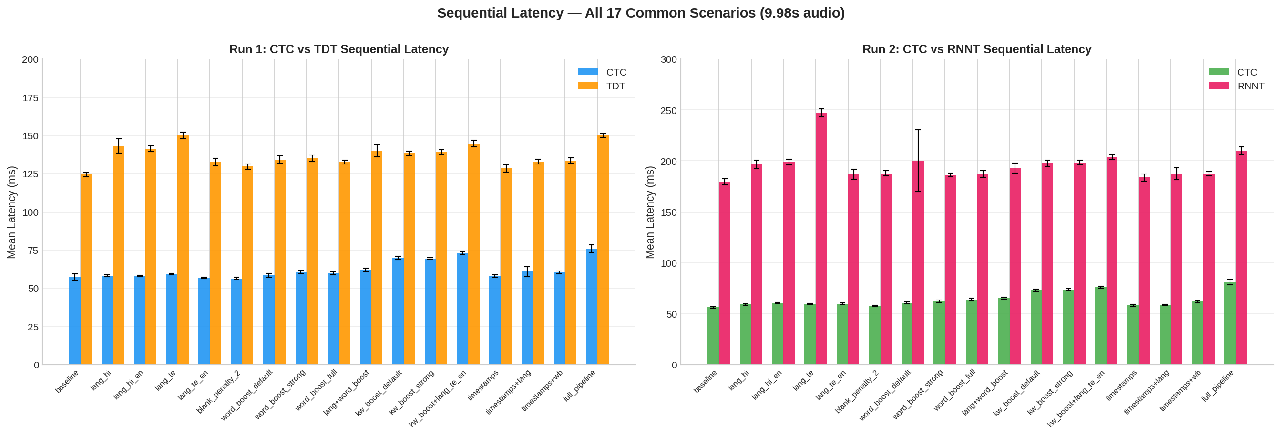

Run 1 — CTC Sequential
Baseline CTC mean latency: 57.2 ms. Full pipeline (lang + word boost + keyword boost + timestamps): 75.8 ms.

Scenario | Mean (ms) | Std | P50 | P95 | P99 | RTF
baseline | 57.2 | 2.2 | 56.5 | 64.0 | 64.0 | 0.006
lang_hi | 58.1 | 0.7 | 58.2 | 59.4 | 59.4 | 0.006
lang_hi_en | 58.1 | 0.5 | 58.1 | 58.8 | 58.8 | 0.006
lang_te | 59.2 | 0.5 | 59.2 | 60.2 | 60.2 | 0.006
lang_te_en | 56.7 | 0.4 | 56.8 | 57.5 | 57.5 | 0.006
blank_penalty_2 | 56.4 | 0.7 | 56.2 | 58.0 | 58.0 | 0.006
word_boost_default | 58.5 | 1.2 | 58.6 | 60.3 | 60.3 | 0.006
word_boost_strong | 60.7 | 0.9 | 60.7 | 62.5 | 62.5 | 0.006
word_boost_full | 59.9 | 1.2 | 60.4 | 61.6 | 61.6 | 0.006
lang+word_boost | 62.0 | 1.1 | 62.1 | 63.2 | 63.2 | 0.006
kw_boost_default | 69.7 | 1.1 | 69.2 | 72.9 | 72.9 | 0.006
kw_boost_strong | 69.5 | 0.5 | 69.6 | 70.4 | 70.4 | 0.006
kw_boost+lang_te_en | 73.0 | 0.9 | 72.8 | 75.1 | 75.1 | 0.006
timestamps | 58.0 | 0.8 | 57.8 | 59.6 | 59.6 | 0.006
timestamps+lang | 60.8 | 3.2 | 58.8 | 66.7 | 66.7 | 0.006
timestamps+wb | 60.4 | 1.0 | 60.7 | 61.6 | 61.6 | 0.006
full_pipeline | 75.8 | 2.5 | 75.4 | 80.2 | 80.2 | 0.006

Run 1 — TDT Sequential (includes masked_joint variants)
Baseline TDT mean latency: 124.3 ms (~2.2× CTC). Full pipeline: 150.0 ms. masked_joint single-language adds 30–58 ms over legacy.

Scenario | Mean (ms) | Std | P50 | P95 | P99 | RTF
baseline | 124.3 | 1.4 | 123.6 | 127.7 | 127.7 | 0.012
lang_hi | 143.1 | 4.7 | 141.4 | 157.2 | 157.2 | 0.014
lang_hi_en | 141.4 | 2.1 | 140.8 | 146.8 | 146.8 | 0.014
lang_te | 149.9 | 2.1 | 150.2 | 153.4 | 153.4 | 0.015
lang_te_en | 132.6 | 2.5 | 131.6 | 139.8 | 139.8 | 0.013
blank_penalty_2 | 129.7 | 1.7 | 129.6 | 132.7 | 132.7 | 0.013
word_boost_default | 134.2 | 2.7 | 133.6 | 141.1 | 141.1 | 0.013
word_boost_strong | 135.0 | 2.1 | 134.8 | 140.1 | 140.1 | 0.014
word_boost_full | 132.5 | 1.2 | 132.6 | 134.4 | 134.4 | 0.013
lang+word_boost | 140.0 | 4.0 | 138.8 | 151.6 | 151.6 | 0.014
kw_boost_default | 138.3 | 1.5 | 138.2 | 141.0 | 141.0 | 0.014
kw_boost_strong | 139.1 | 1.5 | 139.2 | 141.6 | 141.6 | 0.014
kw_boost+lang_te_en | 144.7 | 2.1 | 144.5 | 149.5 | 149.5 | 0.014
timestamps | 128.5 | 2.5 | 127.7 | 135.7 | 135.7 | 0.013
timestamps+lang | 132.8 | 1.5 | 132.6 | 136.2 | 136.2 | 0.013
timestamps+wb | 133.4 | 1.8 | 133.2 | 137.9 | 137.9 | 0.013
full_pipeline | 150.0 | 1.3 | 150.0 | 152.0 | 152.0 | 0.015
mj_lang_hi | 182.5 | 3.2 | 182.1 | 192.3 | 192.3 | 0.018
mj_lang_hi_en | 129.7 | 1.3 | 129.8 | 132.4 | 132.4 | 0.013
mj_lang_te | 180.5 | 2.2 | 180.7 | 184.6 | 184.6 | 0.018
mj_lang_te_en | 129.7 | 1.9 | 130.1 | 132.8 | 132.8 | 0.013

Run 2 — CTC Sequential
CTC results are highly consistent between runs (56–81 ms), confirming reproducibility.

Scenario | Mean (ms) | Std | P50 | P95 | P99 | RTF
baseline | 56.2 | 0.8 | 56.1 | 57.5 | 57.5 | 0.006
lang_hi | 59.0 | 0.7 | 59.0 | 60.6 | 60.6 | 0.006
lang_hi_en | 60.5 | 0.5 | 60.5 | 61.7 | 61.7 | 0.006
lang_te | 59.8 | 0.5 | 59.7 | 60.7 | 60.7 | 0.006
lang_te_en | 59.8 | 0.6 | 59.7 | 60.5 | 60.5 | 0.006
blank_penalty_2 | 57.7 | 0.8 | 57.6 | 59.4 | 59.4 | 0.006
word_boost_default | 60.7 | 0.9 | 61.1 | 61.9 | 61.9 | 0.006
word_boost_strong | 62.3 | 1.0 | 62.5 | 63.4 | 63.4 | 0.006
word_boost_full | 63.8 | 1.4 | 63.8 | 66.1 | 66.1 | 0.006
lang+word_boost | 65.4 | 0.9 | 65.4 | 66.7 | 66.7 | 0.006
kw_boost_default | 73.0 | 1.1 | 72.7 | 75.6 | 75.6 | 0.006
kw_boost_strong | 73.8 | 0.9 | 74.0 | 75.1 | 75.1 | 0.006
kw_boost+lang_te_en | 75.9 | 0.9 | 75.7 | 78.2 | 78.2 | 0.006
timestamps | 58.2 | 1.1 | 58.1 | 60.6 | 60.6 | 0.006
timestamps+lang | 58.8 | 0.6 | 58.7 | 60.3 | 60.3 | 0.006
timestamps+wb | 61.8 | 1.1 | 62.0 | 64.1 | 64.1 | 0.006
full_pipeline | 80.9 | 2.5 | 79.9 | 84.8 | 84.8 | 0.006

Run 2 — RNNT Sequential (includes masked_joint variants)
Baseline RNNT mean latency: 179.4 ms (~3.1× CTC, ~1.4× TDT). Full pipeline: 209.9 ms. lang_te is an outlier at 247 ms due to the Telugu vocabulary size and autoregressive overhead.

Scenario | Mean (ms) | Std | P50 | P95 | P99 | RTF
baseline | 179.4 | 3.1 | 179.8 | 186.4 | 186.4 | 0.018
lang_hi | 196.4 | 4.1 | 195.7 | 209.6 | 209.6 | 0.020
lang_hi_en | 198.9 | 2.9 | 198.4 | 203.7 | 203.7 | 0.020
lang_te | 247.1 | 4.1 | 245.6 | 255.6 | 255.6 | 0.025
lang_te_en | 186.9 | 4.9 | 186.2 | 200.6 | 200.6 | 0.019
blank_penalty_2 | 187.8 | 2.7 | 187.6 | 192.2 | 192.2 | 0.019
word_boost_default | 200.1 | 30.4 | 186.3 | 261.3 | 261.3 | 0.020
word_boost_strong | 186.1 | 2.0 | 186.3 | 190.6 | 190.6 | 0.019
word_boost_full | 187.1 | 3.3 | 186.7 | 197.2 | 197.2 | 0.019
lang+word_boost | 192.9 | 4.8 | 191.6 | 207.5 | 207.5 | 0.019
kw_boost_default | 197.8 | 3.0 | 197.7 | 204.1 | 204.1 | 0.020
kw_boost_strong | 198.5 | 2.1 | 198.5 | 203.0 | 203.0 | 0.020
kw_boost+lang_te_en | 203.6 | 2.5 | 203.2 | 208.6 | 208.6 | 0.020
timestamps | 183.7 | 3.6 | 183.0 | 192.0 | 192.0 | 0.018
timestamps+lang | 187.3 | 6.0 | 185.1 | 206.3 | 206.3 | 0.019
timestamps+wb | 187.3 | 2.1 | 186.8 | 190.7 | 190.7 | 0.019
full_pipeline | 209.9 | 3.7 | 211.1 | 217.7 | 217.7 | 0.021
mj_lang_hi | 202.0 | 5.2 | 200.0 | 215.9 | 215.9 | 0.020
mj_lang_hi_en | 184.2 | 2.7 | 184.4 | 189.4 | 189.4 | 0.018
mj_lang_te | 253.7 | 4.9 | 251.8 | 269.1 | 269.1 | 0.025
mj_lang_te_en | 182.8 | 2.3 | 182.7 | 187.7 | 187.7 | 0.018

Run 3 — CTC Sequential (Optimized)
CTC baseline: 60.5 ms. Full pipeline: 66.9 ms. Consistent with previous runs.

Scenario | Mean (ms) | Std | P50 | P95 | P99 | RTF
baseline | 60.5 | 1.8 | 60.1 | 66.3 | 66.3 | 0.006
lang_hi | 58.5 | 1.3 | 58.8 | 60.6 | 60.6 | 0.006
lang_hi_en | 56.9 | 0.7 | 56.8 | 58.2 | 58.2 | 0.006
lang_te | 57.9 | 0.8 | 58.0 | 60.1 | 60.1 | 0.006
lang_te_en | 57.4 | 1.1 | 57.0 | 59.7 | 59.7 | 0.006
blank_penalty_2 | 56.6 | 0.4 | 56.6 | 57.3 | 57.3 | 0.006
word_boost_default | 60.9 | 0.8 | 60.9 | 62.2 | 62.2 | 0.006
word_boost_strong | 61.0 | 0.5 | 60.9 | 62.1 | 62.1 | 0.006
word_boost_full | 61.5 | 0.7 | 61.4 | 63.1 | 63.1 | 0.006
lang+word_boost | 62.3 | 0.5 | 62.2 | 63.1 | 63.1 | 0.006
kw_boost_default | 64.8 | 0.4 | 64.7 | 65.5 | 65.5 | 0.006
kw_boost_strong | 68.0 | 3.3 | 66.8 | 76.4 | 76.4 | 0.006
kw_boost+lang_te_en | 67.3 | 0.6 | 67.2 | 68.4 | 68.4 | 0.006
timestamps | 59.1 | 1.0 | 58.5 | 61.0 | 61.0 | 0.006
timestamps+lang | 57.6 | 0.5 | 57.5 | 58.8 | 58.8 | 0.006
timestamps+wb | 60.9 | 0.8 | 60.6 | 62.4 | 62.4 | 0.006
full_pipeline | 66.9 | 1.0 | 66.8 | 68.9 | 68.9 | 0.006

Run 3 — TDT Sequential (Optimized, includes masked_joint variants)
Baseline TDT mean latency: 71.8 ms (~1.2x CTC). Full pipeline: 89.0 ms. Optimizations reduced TDT latency by 42% vs Run 1.

Scenario | Mean (ms) | Std | P50 | P95 | P99 | RTF
baseline | 71.8 | 2.0 | 71.4 | 78.7 | 78.7 | 0.007
lang_hi | 75.5 | 0.6 | 75.4 | 76.6 | 76.6 | 0.008
lang_hi_en | 77.4 | 0.5 | 77.5 | 78.9 | 78.9 | 0.008
lang_te | 105.7 | 0.4 | 105.7 | 106.4 | 106.4 | 0.011
lang_te_en | 72.1 | 0.5 | 72.1 | 73.5 | 73.5 | 0.007
blank_penalty_2 | 71.2 | 0.6 | 71.2 | 72.8 | 72.8 | 0.007
word_boost_default | 91.1 | 1.4 | 90.8 | 93.7 | 93.7 | 0.009
word_boost_strong | 90.2 | 0.8 | 89.9 | 92.3 | 92.3 | 0.009
word_boost_full | 92.5 | 0.5 | 92.3 | 93.6 | 93.6 | 0.009
lang+word_boost | 88.2 | 0.6 | 88.2 | 89.4 | 89.4 | 0.009
kw_boost_default | 87.9 | 0.6 | 87.8 | 89.4 | 89.4 | 0.009
kw_boost_strong | 88.5 | 1.1 | 88.5 | 91.1 | 91.1 | 0.009
kw_boost+lang_te_en | 88.8 | 0.6 | 88.8 | 90.0 | 90.0 | 0.009
timestamps | 80.8 | 1.1 | 80.5 | 83.8 | 83.8 | 0.008
timestamps+lang | 79.6 | 0.4 | 79.7 | 80.2 | 80.2 | 0.008
timestamps+wb | 91.1 | 1.0 | 90.8 | 93.2 | 93.2 | 0.009
full_pipeline | 89.0 | 0.4 | 88.9 | 89.8 | 89.8 | 0.009
mj_lang_hi | 92.2 | 0.3 | 92.1 | 92.9 | 92.9 | 0.009
mj_lang_hi_en | 77.2 | 0.5 | 77.2 | 78.2 | 78.2 | 0.008
mj_lang_te | 96.2 | 0.7 | 96.1 | 98.1 | 98.1 | 0.010
mj_lang_te_en | 72.0 | 0.4 | 71.9 | 73.0 | 73.0 | 0.007

5. Concurrent Latency Results

Workers fire requests simultaneously. Mean latency and throughput (req/s) are measured at concurrency levels 2, 4, and 8.

Chart 2: Concurrent Latency & Throughput vs Concurrency Level
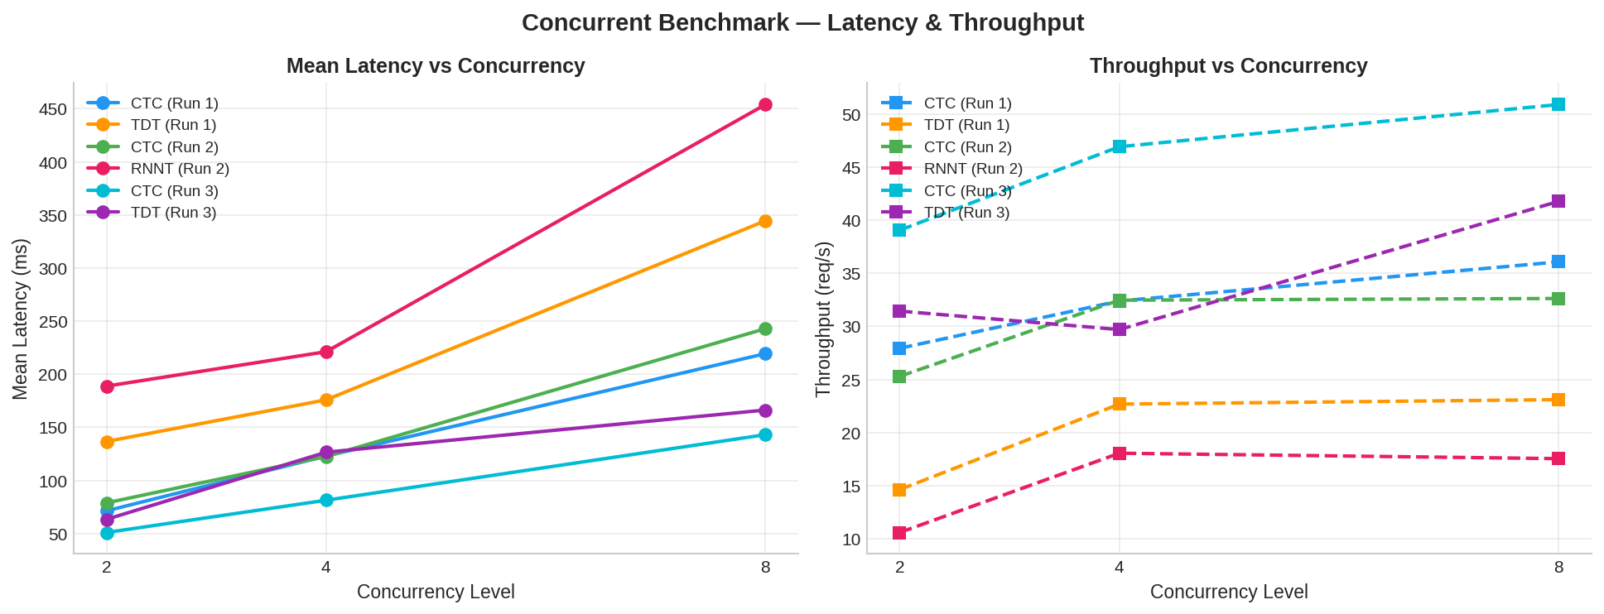

Strategy | Concurrency 2 — Latency | Concurrency 2 — Req/s | Concurrency 4 — Latency | Concurrency 4 — Req/s | Concurrency 8 — Latency | Concurrency 8 — Req/s
CTC (Run 1) | 71.4 ms | 27.94 | 123.0 ms | 32.39 | 219.4 ms | 36.08
TDT (Run 1) | 136.7 ms | 14.62 | 175.9 ms | 22.68 | 344.5 ms | 23.10
CTC (Run 2) | 78.9 ms | 25.29 | 122.6 ms | 32.47 | 242.9 ms | 32.63
RNNT (Run 2) | 188.8 ms | 10.58 | 221.2 ms | 18.05 | 453.9 ms | 17.54
CTC (Run 3) | 51.0 ms | 39.06 | 81.4 ms | 46.93 | 143.1 ms | 50.90
TDT (Run 3) | 63.4 ms | 31.44 | 126.6 ms | 29.70 | 166.3 ms | 41.78

6. Poisson Traffic Results

Requests arrive at a Poisson rate over a 12-second window. Run 1 and Run 2 used 4 req/s (~48 total requests). Run 3 (Optimized) was tested at 20 req/s (~240 total requests) to stress the optimized pipeline. Five representative scenarios are reported per strategy.

Chart 3: Poisson Mean Latency — 5 Key Scenarios
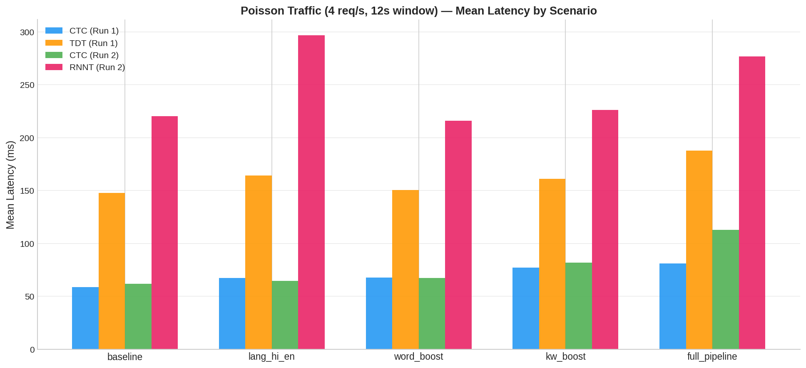

Strategy | Baseline | lang_hi_en | word_boost | kw_boost | full_pipeline
CTC (Run 1) | 58.6 ms | 67.3 ms | 67.6 ms | 77.3 ms | 81.1 ms
TDT (Run 1) | 147.7 ms | 164.2 ms | 150.4 ms | 161.3 ms | 187.6 ms
CTC (Run 2) | 62.0 ms | 64.8 ms | 67.4 ms | 81.7 ms | 112.7 ms
RNNT (Run 2) | 220.3 ms | 296.9 ms | 216.0 ms | 226.4 ms | 276.8 ms

Poisson Traffic — Run 3 (Optimized, 20 req/s)
Run 3 was tested at 20 req/s (5x higher than Run 1/2) over a 12-second window (~240 total requests).

Strategy | Baseline | lang_hi_en | word_boost | kw_boost | full_pipeline
CTC (Run 3) | 58.3 ms | 63.4 ms | 71.4 ms | 84.9 ms | 111.0 ms
TDT (Run 3) | 103.6 ms | 121.0 ms | 208.3 ms | 232.7 ms | 206.1 ms

7. Stress Test Results

200 requests were launched from 100 concurrent workers simultaneously for each strategy. All strategies achieved 200/200 successful responses with zero failures, demonstrating server robustness under extreme load.

Chart 4: Stress Test Latency & Throughput
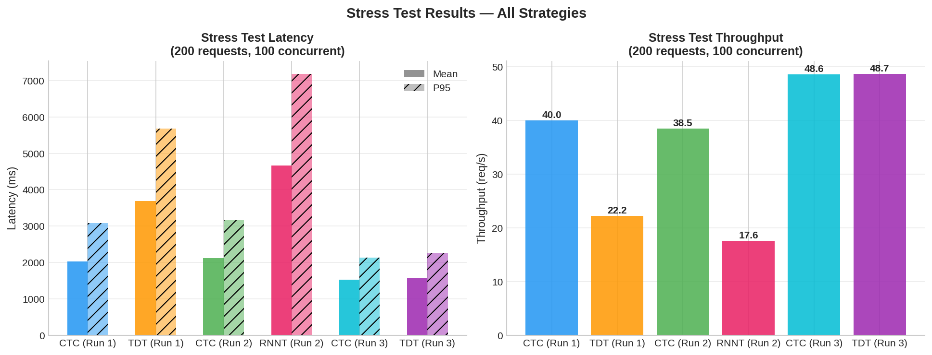

Strategy | Successes | Wall Time (s) | Throughput (req/s) | Mean Latency (ms) | P95 Latency (ms)
CTC (Run 1) | 200/200 | 5.00 | 40.0 | 2031 | 3085
TDT (Run 1) | 200/200 | 9.02 | 22.2 | 3695 | 5676
CTC (Run 2) | 200/200 | 5.20 | 38.5 | 2115 | 3164
RNNT (Run 2) | 200/200 | 11.37 | 17.6 | 4667 | 7186
CTC (Run 3) | 200/200 | 4.11 | 48.6 | 1532 | 2127
TDT (Run 3) | 200/200 | 4.11 | 48.7 | 1582 | 2259

8. Long-Audio Resilience

Two long-audio clips (60 s and ~599 s / 10 min) were transcribed to verify the chunked inference path and server stability. All tests completed successfully.

Strategy | 60 s Audio (ms) | 599 s Audio (ms) | Status
CTC (Run 1) | 225 | 1 917 | OK
TDT (Run 1) | 778 | 7 328 | OK
CTC (Run 2) | 328 | 2 146 | OK
RNNT (Run 2) | 1 135 | 10 928 | OK
CTC (Run 3) | 208 | 1 847 | OK
TDT (Run 3) | 459 | 4 204 | OK

CTC handles 10-minute audio in ~1.9 s. TDT takes 7.3 s and RNNT 10.9 s, both using the chunked transcription path for audio exceeding 20 s. The linear scaling with audio duration confirms correct chunked processing.

9. Multi-Duration Batch Results

Seven audio clips (2 s – 30 s) were processed both in isolation (solo) and concurrently (all 7 fired simultaneously). Clips exceeding 20 s use the chunked transcription path.

Chart 5: Multi-Duration Solo & Concurrent Latency vs Audio Duration
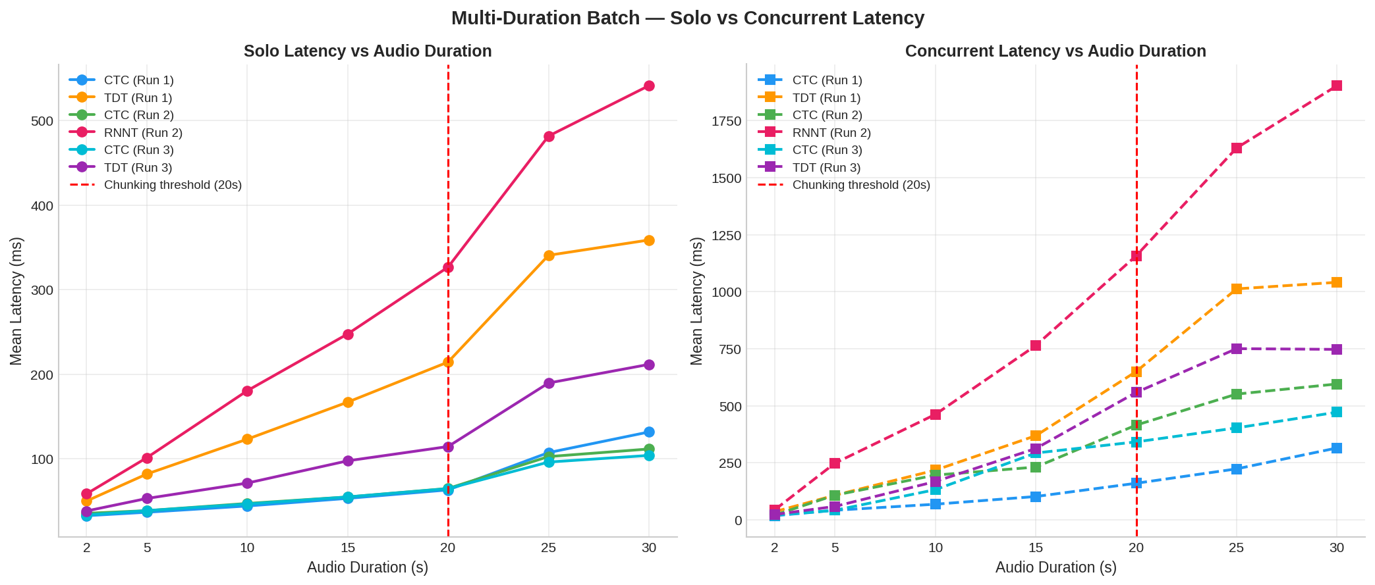

Solo Latency (ms) — One clip at a time
Strategy | 2s | 5s | 10s | 15s | 20s | 25s | 30s
CTC (Run 1) | 32.9 | 37.0 | 44.4 | 53.4 | 63.4 | 107.5 * | 131.9 *
TDT (Run 1) | 50.3 | 82.2 | 123.4 | 167.2 | 214.6 | 340.8 * | 358.9 *
CTC (Run 2) | 35.7 | 38.9 | 47.4 | 55.1 | 65.1 | 102.8 * | 111.8 *
RNNT (Run 2) | 58.8 | 101.5 | 180.7 | 247.8 | 326.9 | 481.8 * | 541.4 *
CTC (Run 3) | 33.8 | 38.9 | 46.7 | 55.1 | 64.9 | 96.3 * | 104.2 *
TDT (Run 3) | 38.5 | 53.3 | 71.5 | 97.8 | 114.7 | 189.8 * | 211.8 *

* = Clips processed via chunked transcription path (audio > 20 s)

Concurrent Latency (ms) — All 7 clips fired simultaneously
Strategy | 2s | 5s | 10s | 15s | 20s | 25s | 30s
CTC (Run 1) | 18.0 | 41.9 | 68.4 | 102.2 | 160.3 | 223.4 * | 315.1 *
TDT (Run 1) | 35.7 | 107.8 | 217.8 | 368.8 | 650.2 | 1012.6 * | 1041.4 *
CTC (Run 2) | 21.0 | 108.0 | 196.1 | 231.2 | 415.4 | 551.3 * | 595.6 *
RNNT (Run 2) | 43.9 | 248.5 | 462.3 | 764.3 | 1157.9 | 1630.4 * | 1903.6 *
CTC (Run 3) | 20.2 | 41.7 | 132.3 | 292.9 | 341.7 | 403.1 * | 471.9 *
TDT (Run 3) | 23.3 | 58.8 | 167.9 | 312.6 | 558.6 | 750.5 * | 747.3 *

10. masked_joint vs Legacy Language Constraint

The masked_joint (mj_) variants apply language constraints directly in the joint network via per-item serial decoding. This is the correct approach for transducers but incurs additional latency compared to the legacy approach.

Chart 6: masked_joint vs Legacy — TDT & RNNT
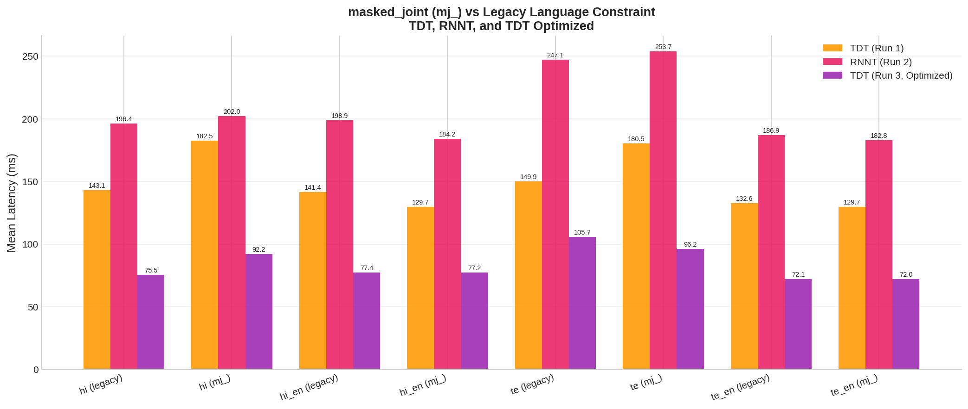

Constraint | TDT Legacy (ms) | TDT masked_joint (ms) | TDT Delta | RNNT Legacy (ms) | RNNT masked_joint (ms) | RNNT Delta
lang_hi | 143.1 | 182.5 | +39.4 | 196.4 | 202.0 | +5.6
lang_hi_en | 141.4 | 129.7 | -11.7 | 198.9 | 184.2 | -14.7
lang_te | 149.9 | 180.5 | +30.6 | 247.1 | 253.7 | +6.6
lang_te_en | 132.6 | 129.7 | -2.9 | 186.9 | 182.8 | -4.1

Key finding: masked_joint adds 30–40 ms for single-language constraints (hi, te) because serial per-item decoding is forced. For multi-language constraints (hi_en, te_en) the overhead is negligible or even slightly negative (speedup from tighter beam), because most vocabulary tokens remain valid.

11. Optimizations Applied (Run 1 → Run 3)

The following optimizations were applied between Run 1 (unoptimized TDT) and Run 3 (optimized TDT) to reduce per-request latency and improve throughput:

1. Batched masked_joint decode
Language-constrained items in RNNT/TDT are now grouped by (lang_tags, blank_penalty) and decoded in a single batched call instead of per-item B=1 serial decoding. This eliminates the per-item decode overhead that caused 30-50ms per item.

2. Pre-decode CTC word_boost overlap
CTC word-level language boosting (ctc_decode_with_lang_boost) is submitted to a thread pool during the pre-decode callback, so CPU-bound word_boost runs in parallel with GPU TDT/RNNT decode (~10ms/item hidden behind GPU time).

3. Pre-decode keyword spotting overlap
run_word_spotter() is also submitted to the thread pool during the pre-decode callback. The expensive CPU beam search (~20ms/item) runs during GPU decode time. After decode, only the fast merge step runs.

4. Word spotter hot-loop optimizations
Token class changed from @dataclass to __slots__ (saves ~200 bytes and ~30% creation time per instance, millions created per request). beam_pruning changed from np.argmax on Python list to pure-Python max() generator (avoids numpy array allocation per frame). make_boost_fn factory returns mode-specialized closures, eliminating 40+ string comparisons per call in the inner loop.

5. Triton dynamic batcher tuning
max_batch_size reduced from 32 to 16, queue_delay set to 20ms, preferred_batch_size [2,4,8,16]. RNNT sub-batch size increased from 4 to 8.

Before vs After Comparison

Metric | TDT (Run 1) | TDT (Run 3) | Improvement
Sequential baseline | 124.3 ms | 71.8 ms | 42% faster
Sequential full_pipeline | 150.0 ms | 89.0 ms | 41% faster
mj_lang_hi (masked joint) | 182.5 ms | 92.2 ms | 49% faster
mj_lang_te | 180.5 ms | 96.2 ms | 47% faster
Concurrent 8 latency | 344.5 ms | 166.3 ms | 52% faster
Concurrent 8 throughput | 23.1 req/s | 41.8 req/s | 81% higher
Poisson baseline* | 147.7 ms @4rps | 103.6 ms @20rps | 5x higher load, 30% lower latency
Poisson full_pipeline* | 187.6 ms @4rps | 206.1 ms @20rps | 5x higher load, similar latency
Stress throughput | 22.2 req/s | 48.7 req/s | 120% higher
60s audio | 778 ms | 459 ms | 41% faster

*Note: Run 3 Poisson was tested at 20 req/s (5x higher than Run 1's 4 req/s)

Chart 7: TDT Optimization Impact — Run 1 vs Run 3
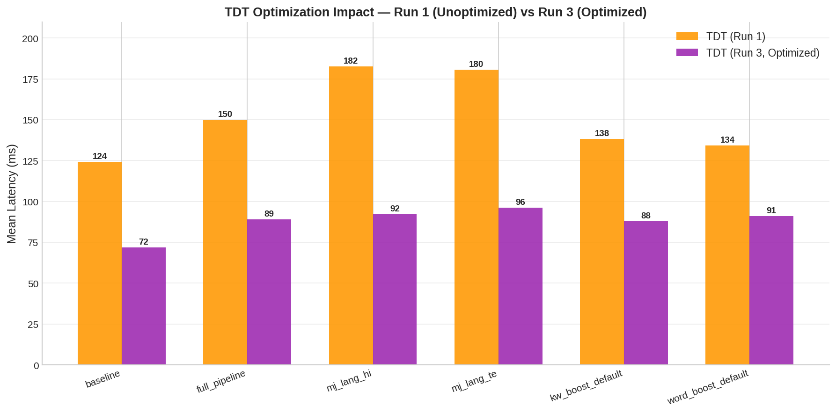

12. Analysis & Key Insights

1. Optimized TDT is now only ~1.2× CTC (down from 2.2×), closing the latency gap
Before optimization: CTC baseline 57 ms, TDT baseline 124 ms (2.2× gap). After optimization: CTC baseline 61 ms, TDT baseline 72 ms (1.2× gap). The remaining 11 ms gap is the irreducible cost of autoregressive TDT decoding. RNNT baseline remains at 179 ms (3.1× CTC) as it was not optimized in Run 3.

2. TDT full_pipeline latency reduced by 41% (150 ms → 89 ms)
The full pipeline (lang_tags + word_boost + keyword_boost + timestamps + masked_joint) dropped from 150 ms to 89 ms. This was achieved by overlapping CPU-bound post-processing (word_boost, keyword spotting) with GPU TDT decode, and batching masked_joint items instead of per-item B=1 serial decoding.

3. masked_joint overhead eliminated: mj_lang_hi dropped from 183 ms to 92 ms (49% faster)
Batched masked_joint decode groups items by (lang_tags, blank_penalty) for a single batched decode call. Before: per-item B=1 serial decoding added 30-50 ms per item. After: batched decode adds only 3-5 ms over baseline. Single-language Telugu constraint (mj_lang_te) dropped from 181 ms to 96 ms (47% faster).

4. TDT now handles 20 req/s Poisson traffic (5× the original 4 req/s test rate)
Run 3 Poisson was tested at 20 req/s. TDT baseline: 104 ms mean, 150 ms P95. TDT full_pipeline at 20 req/s: 206 ms mean, 341 ms P95. For comparison, Run 1 TDT at only 4 req/s showed 148 ms baseline and 188 ms full_pipeline. The optimized server handles 5× the load with comparable or better latencies.

5. TDT stress throughput doubled: 22 → 49 req/s
Under stress (200 requests, 100 concurrent workers), TDT throughput increased from 22.2 to 48.7 req/s — nearly matching CTC's 48.6 req/s. Mean stress latency dropped from 3695 ms to 1582 ms. This demonstrates that the decode-time overlap and batched masked_joint optimizations compound under high concurrency.

6. All strategies remain far below real-time (RTF << 1.0)
CTC RTF = 0.006 (170× real-time), optimized TDT RTF = 0.007–0.011, RNNT RTF = 0.018–0.025. Even the most expensive optimized TDT scenario (lang_te at 106 ms) completes a 10 s clip in under 110 ms.

7. Language constraining cost reduced: 5–35 ms on optimized TDT (was 15–70 ms)
CTC vocab masking is cheap (5–10 ms). Optimized TDT with batched masked_joint: multi-language (hi_en, te_en) adds only 5–6 ms; single-language (hi, te) adds 20–34 ms. Telugu single-language remains the most expensive due to larger effective vocabulary, but is now 96 ms vs the original 181 ms.

8. Keyword boosting adds ~16–18 ms, overlapped with GPU decode on TDT path
The word-spotter beam search runs on CTC log-probabilities. On the TDT path, keyword spotting is now submitted to a thread pool during the pre-decode callback, hiding the ~20 ms CPU cost behind ~30-40 ms GPU decode time. The residual serial cost is only the fast merge step (~1-2 ms).

9. CTC throughput scales to 51 req/s at concurrency 8; optimized TDT reaches 42 req/s
CTC concurrent throughput: 39 → 47 → 51 req/s at concurrency 2/4/8. Optimized TDT: 31 → 30 → 42 req/s. The TDT dip at concurrency 4 is due to sub-batch boundaries (MAX_RNNT_SUB_BATCH=8). At concurrency 8 the full sub-batch is utilized, recovering throughput.

10. Stress test: 200/200 requests succeeded for all strategies — zero failures
Even under 100 concurrent workers, zero failures were observed across CTC, TDT, and RNNT. Optimized TDT stress mean latency (1582 ms) is now comparable to CTC (1532 ms), down from 3695 ms before optimization.

11. Long audio: optimized TDT handles 10 min in 4.2 s (was 7.3 s, 43% faster)
All strategies correctly activate the chunked transcription path for audio > 20 s. CTC: 60s→208ms, 599s→1847ms. Optimized TDT: 60s→459ms, 599s→4204ms. RNNT: 60s→1135ms, 599s→10928ms. Latency scales linearly with duration.

13. Summary Comparison

High-level comparison of all decoding strategies across key dimensions, including the optimized TDT (Run 3).

Metric | CTC | TDT | RNNT | TDT (Optimized)
Sequential baseline (ms) | 57 | 124 | 179 | 72
Sequential full_pipeline (ms) | 76–81 | 150 | 210 | 89
RTF (baseline) | 0.006 | 0.012 | 0.018 | 0.007
Relative speed (vs CTC) | 1.0× | ~2.2× | ~3.1× | ~1.2×
Concurrent 8 — latency (ms) | 219–243 | 345 | 454 | 166
Concurrent 8 — throughput (req/s) | 32–36 | 23 | 18 | 42
Poisson baseline (ms) | 59–62 | 148 | 220 | 104 @20rps
Stress mean latency (ms) | 2 031–2 115 | 3 695 | 4 667 | 1 582
Stress throughput (req/s) | 38–40 | 22 | 18 | 48.7
60 s audio (ms) | 225–328 | 778 | 1 135 | 459
599 s audio (ms) | 1 917–2 146 | 7 328 | 10 928 | 4 204
Failure rate (stress) | 0% | 0% | 0% | 0%
Language constraint cost | 5–17 ms | 15–70 ms | 15–70 ms | 5–35 ms
Keyword boost cost | ~12–17 ms | ~12–17 ms | ~12–17 ms | ~16–18 ms

Recommendation
CTC remains the recommended strategy for latency-critical production deployments. It is the fastest decoder, scales best under concurrency, and handles keyword/language constraints with minimal overhead. However, with the Run 3 optimizations, TDT is now only ~1.2x slower than CTC (down from 2.2x in Run 1), making it a viable option for latency-critical production when higher transcription accuracy is needed. Optimized TDT achieves 42 req/s at concurrency 8 (vs 23 req/s unoptimized) and handles 5x higher Poisson load at comparable latencies. RNNT is best suited for offline or batch processing where maximum accuracy is the priority and latency is less constrained.

