CEE 5410/6410
HW 4 – More Complicated Linear Programs

Choose to solve either the Reservoir Operation or the Network Shipping problem. Solve only 1 problem!!

Reservoir Operation Problem

A reservoir is designed to provide hydropower and water for irrigation. The turbine releases may also be used for irrigation as shown in Figure 1. At least one unit of water must be kept in the river each month at point A. The hydropower turbines have a capacity of 4 units of water per month (flows are constant during any single month), and any other releases must bypass the turbines. The size of farmed area is very large relative to the amount of irrigation water available, so there is no upper limit on usable irrigation water. The reservoir has a capacity of 9 units, and initial storage is 5 units of water. The ending storage must be equal to or greater than the beginning storage. The benefits per unit of water, and the estimated average inflows to the reservoir are given in Table 1.

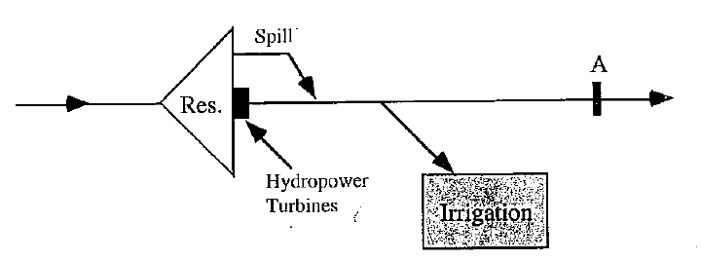

Figure 1: Schematic of a Hydropower and Irrigation Supply Problem

Table 1: Hydropower and Irrigation Problem Data
Month | Inflow Units | Hydropower Benefits ($/unit) | Irrigation Benefits ($/unit)
1 | 2 | 1.6 | 1.0
2 | 2 | 1.7 | 1.2
3 | 3 | 1.8 | 1.9
4 | 4 | 1.9 | 2.0
5 | 3 | 2.0 | 2.2
6 | 2 | 2.0 | 2.2

- Develop and solve an LP model for maximizing the economic benefits of reservoir operation.

- How will net benefits change if the:

  - Reservoir capacity is expanded one unit?

  - In-stream flow requirement is increased?

  - Farms are irrigated with one more unit of water in months 1, 2, and 3?

- What increase in the in-stream flow requirement is allowed before the solution basis changes?

- What concerns would a water manager likely raise as the number of months in this model increases?

HINTS:

- In GAMS, define a set for time (months) so that input data, variables, and equations can be written in a general form once for each time step.

- Define a model constraint that specifies reservoir storage (mass) balance in each time step. As part of the reservoir mass balance, define a decision variable that represents the reservoir storage volume in each time step.

Network Shipping Problem
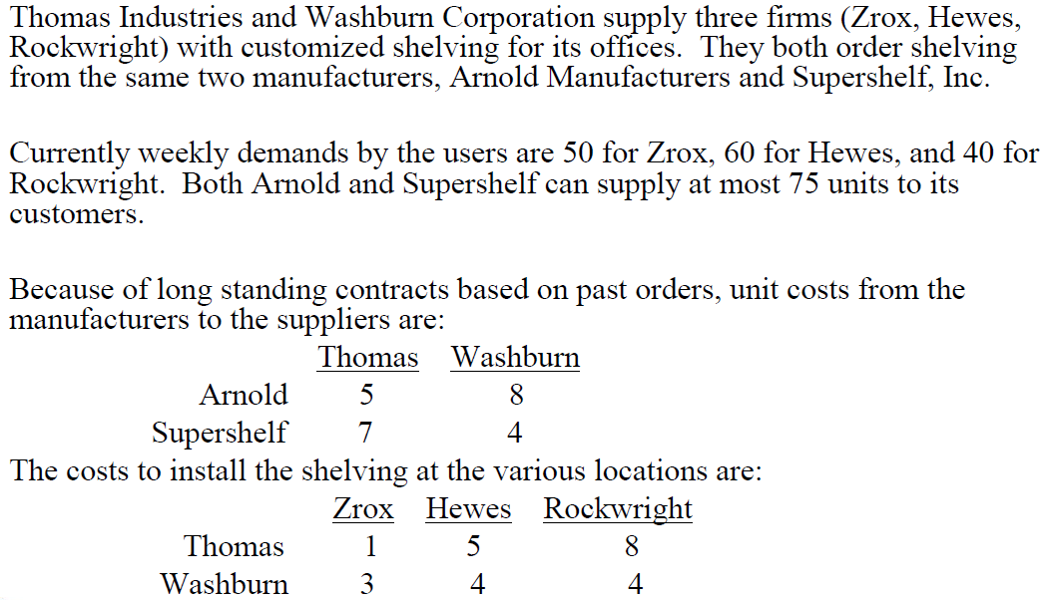

Network schematic
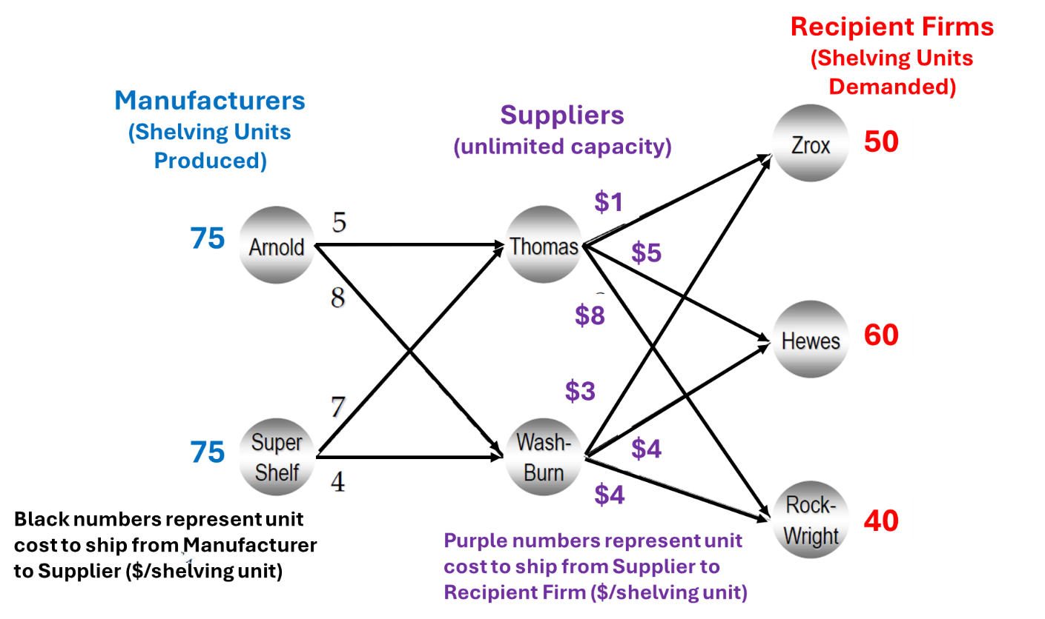

- Develop and solve an LP model to minimize the cost of delivering shelving units to the recipient firms.

- How will costs change if the:

  - Arnold’s production increases by 1 shelving unit (to 76 units)?

  - Hewes demand increases by 1 shelving unit (to 61 units).?

  - Thomas delivery costs to Zrox increase by 1 unit (to $2/unit)?

- What increase in Arnold’s production can happen before the solution basis changes?

What concerns would a transportation manager likely raise as the number of suppliers increases?

HINTS:

- In GAMS, define separate sets for the manufactures (e.g., Man), suppliers (e.g, Sup), and recipient firms (i.e., Recip).

- Define a TABLE that describes costs from manufacturers (rows) to Suppliers (columns). This will look something like

  - TABLE ManufactureShipmentCosts(Man, Sup) Cost to ship from Manufacturer Man to Supplier Sup.

- Define a TABLE that describes costs from Suppliers (rows) to Recipient Firms (columns).

- Similarly define DECISION VARIABLES with the same structures as the TABLES.

- Define one set of constraints that limit shipments from Arnold to Wash-Burn and Arnold to Thomas to be less than Arnold’s production (75 units).

- Define a second set of constraints that limit shipments from SuperShelf to Thomas and SuperShelf to Wash-Burn to be less than SuperShelf’s production (75 units).

- Define a third set of constraints that limit Thomas’s deliveries to Zrox, Hewes, and Rock-Wright to be less than shipments Thomas receives from Arnold and SuperShelf.

- Do the same for Wash-Burn.

- Finally, define a set of constraints that require shipments from Thomas to Zrox and Wash-Burn to Zrox to equal or exceed Zrox’s demand.

Category  (Max. Score) | No Evidence | Doesn’t Meet Standard | Nearly Meets Standard | Meets Standard | Exceeds Standard | Self- Score | Instructor Score
Title  (1) | Absent  0 | Evidence of two or less  0 | Evidence of three  0 | Evidence of four  1 | Title – can assess main point from title alone; Name, Instructors’ Names, Course, Date, Neatly finished 1
Introduction  (3) | Absent, no evidence  0 | There is no clear introduction or main topic.  1 | Introduction states the main topic but either:  - Does not give a full overview, Or:  - Too detailed, leading to annoying repetition later. 2 | The introduction states the main topic and previews the structure of the report.  2 | The introduction states the main topic and previews the structure of the report. Good overview of the problem and solution approach. Gives enough detail to motivate the reader to continue reading.  3
Organization and structural development of the idea: procedure, results, conclusions  (10) | No content provided.  0 | Paragraphs fail to develop the main idea. No section headers or guide to help the reader understand how material is organized.  1 – 5 | Organization of ideas not fully developed. Paragraphs lack supporting detail sentences. No transitions and/or ineffective section headers.  6 - 7 | Paragraph development present but not perfected. Each paragraph has sufficient supporting detail sentences. Few transitions.  8 | Writer demonstrates logic and sequencing of ideas through well-developed section headers, paragraphs, and transitions. The first sentence of each paragraph is the summary sentence.  9 - 10
Technical Correctness  (70) | Questions not addressed.  3 – 42% | The writer has no clue what they are talking about.  45 – 58% | Sketchy: left out required design points. Did not work on this as much as you should have, and it shows. Many important answers are incorrect.  61 – 79% | Discussion lacks adequate detail, but all the necessary points are covered and nearly all answers are correct.  82 – 88% | Provides what was explicitly asked for. The function of each piece is demonstrated to the reader in adequate, but not overwhelming, detail. Answers are correct and reasonable.  91 – 100%
Technical Correctness  (70) | - Problem formulation (15) and solution (10)
Technical Correctness  (70) | - Sensitivity of net benefits (25)
Technical Correctness  (70) | - Allowable increase of in-stream flow requirement (5)
Technical Correctness  (70) | - Manager concerns as model time period increases (5)
Technical Correctness  (70) | - New insights gained from modeling work (10)
Technical Correctness  (70) | - Provide a link to your GAMS code on Github (0)

Category  (Max. Score) | No Evidence | Doesn’t Meet Standard | Nearly Meets Standard | Meets Standard | Exceeds Standard | Self- Score | Instructor Score
Word Usage and Format  (7) | Not applicable | Numerous and distracting errors in punctuation, capitalization, spelling, sentence structure, word usage, significant figures, tables, and figures. Data vomited onto page(s). Unacceptable / unprofessional at the graduate level. 1 – 5 | Misspelled words, poor English grammar and word choice. Main body of report is either longer or significantly less than one page. Figures are too small and/or under-labeled, although they are usually of acceptable quality and focus. Tables incoherent or not cohesive. Bad font sizes. Too much or too little data in appendices. Could be improved by being more meticulous.  5 | Almost no errors in punctuation, capitalization, spelling, sentence structure, word usage, significant figures, and presentation of figures, tables, and appendices. Main body of report is one page or less  6 | Punctuation, capitalization, spelling, sentence structure, word usage, and significant figures all correct. Main body of report is one page or less. Clear, consistent fonts. Good word processing skills. Figures have adequate contrast. Informative figure and table titles and legends. Figures have appropriate axis tick spacing, labels, units, and legends. Table columns cohesive, labeled, and specify units. Document is stapled. Appendices, if provided, are separated by topic, and each have a title, discussion, and proper formatting and display of information 7
Conclusion  (4) | Absent  0 | Incomplete and/or not focused. 1 | The conclusion does not adequately restate the main results. 2 | The conclusion restates the main results. 3 | The conclusion restates the main results, and is an effective summary. 4
Use of AI  (3) | Absent  (Return without grade) |  |  | See Policy on Use in Syllabus  If used, list the AI tool], provide a short description of use, how use is within the course policy, and link to the transcript of student-AI interactions.  If not used, write “No AI was used in the analysis or write-up of this report.” 3
References  (2) | Absent  0 | Numerous errors, off-the-wall sources used. 0 | Some errors in citing format; more sources should be cited. 1 | Prior work cited with few errors.  2 | All prior work and data sources are cited in the correct format with no errors. 2
TOTAL (100)

