# Custom Content

This guide is meant to help you understand the process of creating skinned meshes. It’s not going to go into the details of every program, but it will give you a starting point.

## Skeletons

A skinned mesh requires to parts. The mesh or skin itself and a skeleton that drives the skin’s animations. The skeleton typically comes from an application like Maya, 3DS Max, or even Unity. In fact, Unity has a ‘Humanoid’ rig that other skeletons can map to.

## Skinned Meshes

Skinned Meshes are just like other meshes, but each vertex is tied to one or more bones in a skeleton.

In the same way that our skin deforms as the bones under it moves, the skinned mesh will deform its bones are moved.

## Skin & Bones

In the image below, Unity’s Humanoid Rig (or skeleton) is mapped to the human mesh. Each vertex in the mesh is “weighted” to one or more ones. When the skeleton is animated, the skin follows the bones and is animated.

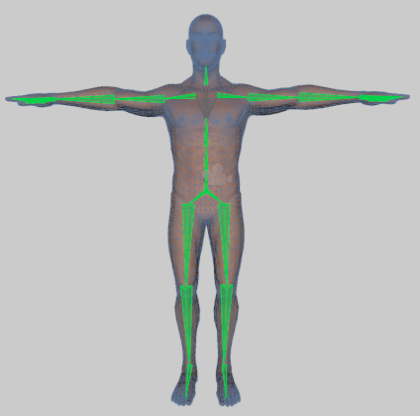

## Creating Skeletons

Creating the initial skeleton and even the human model is beyond the scope of this document. You can do this in a 3D package like Maya, 3DS Max, or Blender. However, you can also buy models on the asset store that are already skinned and ready for use. In addition, tools exist that will allow you to create the base human skin as well as the skeleton to your specifications.

Pre-Built Models:

<https://www.assetstore.unity3d.com/en/#!/content/547>

<https://www.assetstore.unity3d.com/en/#!/content/20553>

<https://www.assetstore.unity3d.com/en/#!/content/667>

Creation Tools:

<https://www.assetstore.unity3d.com/en/#!/content/13930>

<https://www.mixamo.com/fuse/>

<http://www.makehuman.org/>

# Getting Started

## Character Base

In my case, I chose to use Maximo’s Fuse. It’s a great took, easy to learn, and has awesome results.

One of the nice things about starting with a base character is that you can copy the skin bone weights from the base character to your skinned mesh instead of having to create them yourself. You’ll see later how easy it is.

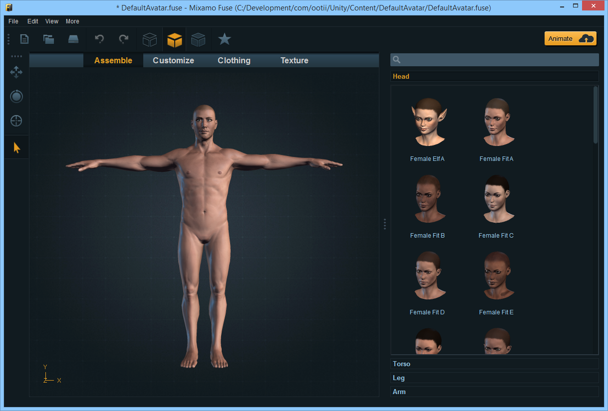

I’m not going to go into creating the character. Suffice it to say, Mixamo has plenty of tutorials for that.

The key is to create a character that has both the skeleton and a base skin that already “weighted” to the bones.

# Creating Content

Now that we have a base character to build off of, we can create clothes. These skinned meshes are really just like any other mesh. So you can use a 3D software package like Maya to create them, buy the meshes off the Unity Asset Store, or use another tool to create them.

Again, we’re just starting off with a mesh that has vertices. Later we’ll tie these vertices to bones.

For what I’m doing, I chose to go with Marvelous Designer.

## Marvelous Designer

[Marvelous Designer](http://www.marvelousdesigner.com/marvelousdesigner/overview/) is a software package used for building clothes. The magic is in its ability to create a mesh from a standard sewing pattern. It does this by allowing you to create a pattern and then it drapes the “cloth” over your avatar.

As you can imagine, our avatar is the base character we created above.

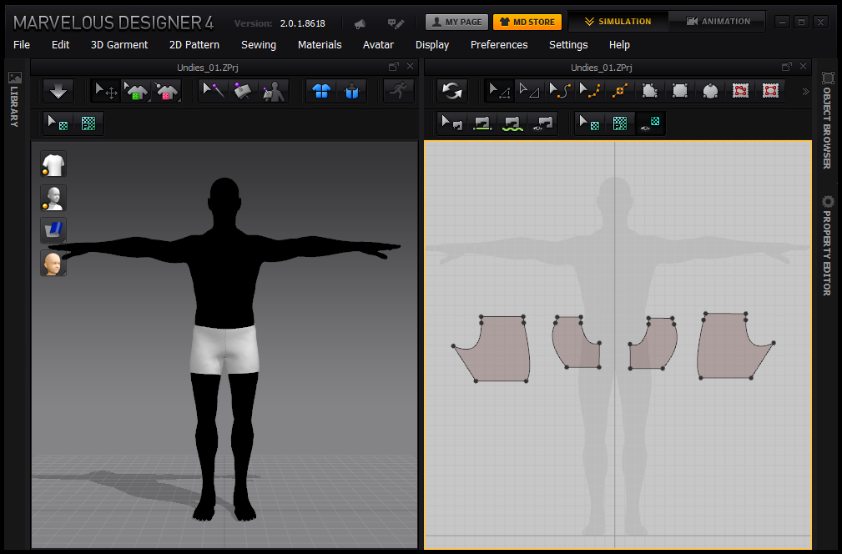

In the image above, I imported the base character I got from Mixamo (left) and I created a pattern for a pair of shorts (right). Then, Marvelous Designer wrapped the pattern around the character to create the actual garment.

With the garment shaped to the character, we can export it as a mesh.

## Autodesk Maya

With the mesh created, we now have to skin it to the bones. To do this, you can use Maya, 3DS Max, Blender, etc. I’m using Maya.

There’s really nothing tricky here. You’ll import the base character and then import the garment. Just remember to make sure you import the same character you used in Marvelous Designer or the mesh won’t actually fit.

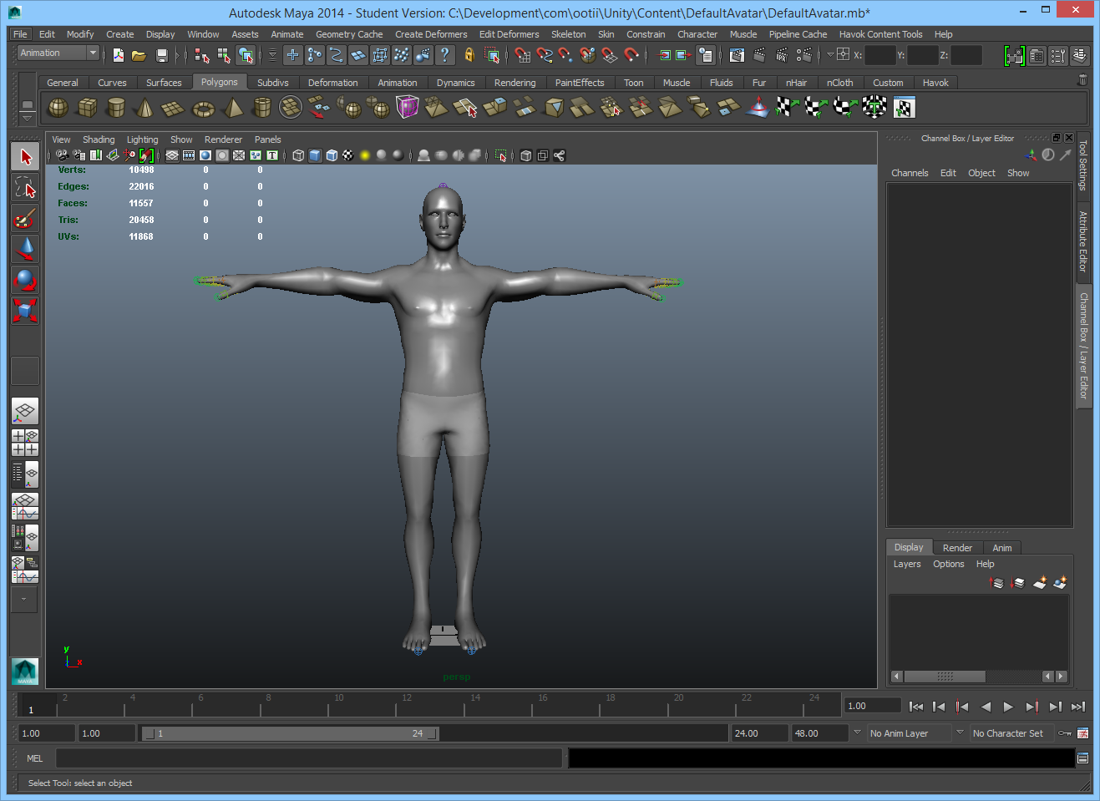

### Skinning the Mesh

With the two objects imported, it’s time to tell the mesh (shorts) about the bones that will control it.

First, tell the mesh what bones it will care about. You do this by selecting the bones that will control the mesh, selecting the mesh, and then press the ‘Skin | Bind Skin | Smooth Bind’ menu option.

The picture below may be a little hard to see, but I selected the Hips, LeftUpperLeg, and RightUpperLeg. Then, I selected the shorts.

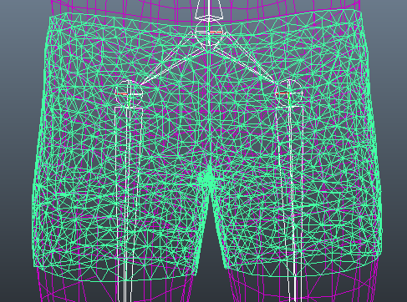

The next thing you’ll have to do is “weight” the skin. What this means is that for each vertex, you’ll have to say how much control each bone has on its position.

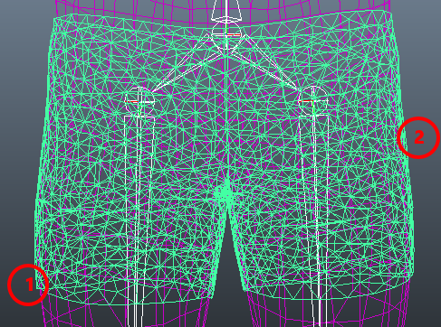For example, in the image to the left, the vertex at point “1” would only be controlled by the RightUpplerLeg bone. However, the vertex at point “2” could be controlled by the LeftUpperLeg bone and the Hip bone.

You could paint these weight by hand using whatever tool you have. However, that’s a pretty tedious process.

What I’ve found is that you can leverage your base character.

To do this in Maya, simply select the base character’s mesh and then select the mesh you’re skinning (the shorts). Then, press ‘Skin | Edit Skin | Copy Skin Weights’. With one menu button press, the weights are copied over from the base character onto our pair of shorts.

When exporting the garment, you don’t want to export the skeleton. That will come from your base character. Instead, just export the skinned mesh as an FBX.

# Loading Content

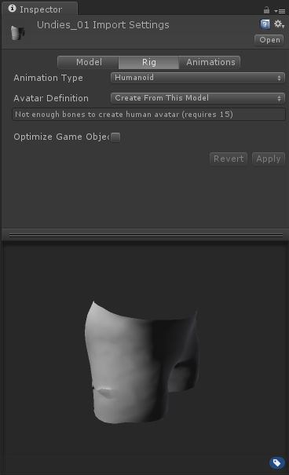With the garment created, we just need to load it into Unity. To do this, we load it like any other FBX.

We’ll assign a ‘Humanoid’ rig to it and it’s ready to go.

Don’t worry that it says there aren’t enough bones. When using Mount Points, we’ll copy the bone information from the base character and apply it.

# Using Content

With that, we’re ready to use it with our base character. Import the base character into Unity and then put him into your scene. Then, you just need to call the ‘InstanciateSkinnedMesh’ function from the MountPoints asset.

MountPoints.InstanciateSkinnedMesh(GameObject.Find("DefaultAvatar"), "Prefabs/Armor/Pants/Pants_01");

The first argument is the base character that’s in the scene and the second argument is the path to the skinned mesh we imported.

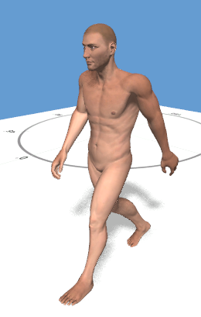 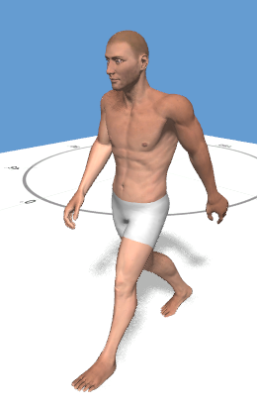

# Wrap Up

That’s it. While I’m no artist, I’ve gotten pretty good results using tools like Fuse and Marvelous Designer. Obviously you’ll want to texture the things you create, but getting them skinned and in the game is easy.