**First Phase of App**

* **Open Android Studio**
* **Create New Project**
* **See MainActivity.java file**

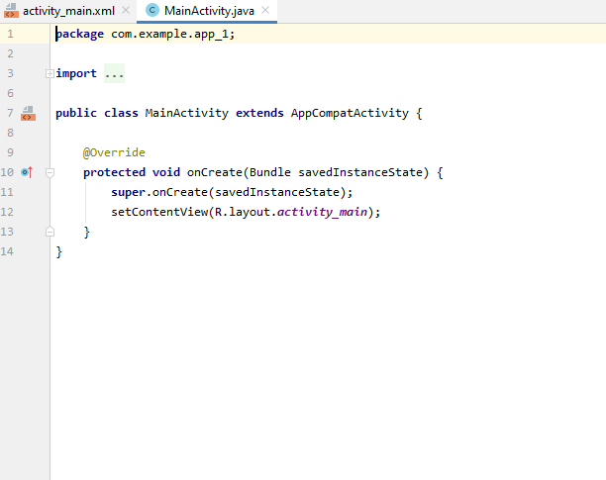

* **See activity_main.xml file**

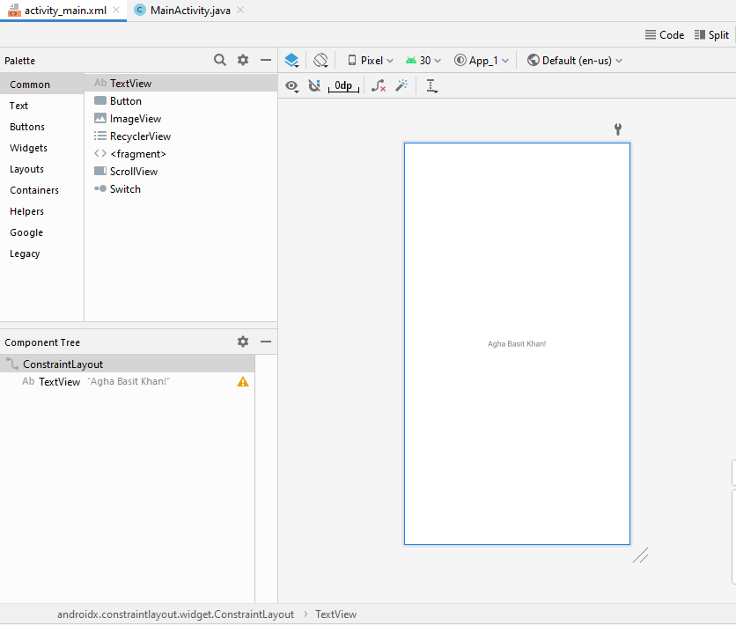

* **Design And Blueprint of activity_main.xml file.**

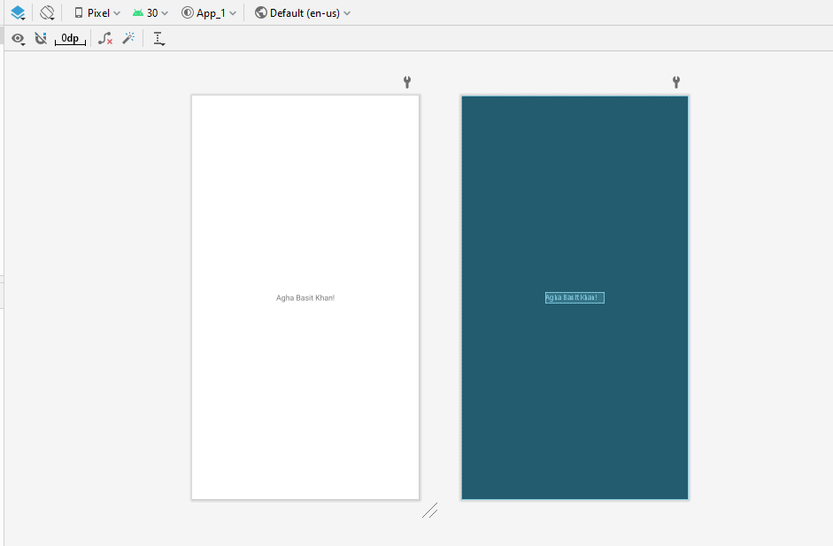

* **Attributes at right side**

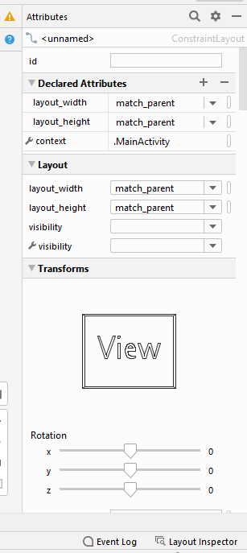

* **Click on text field**
* **Remove bottom spring**
* **Change the text also.**

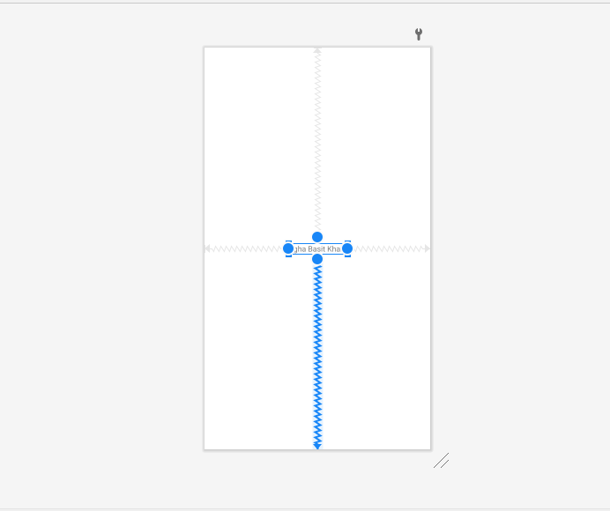

* **After removing the field move upward.**

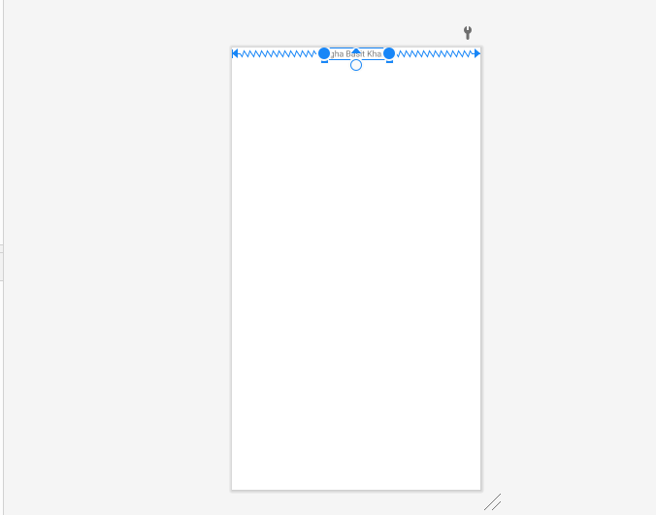

* **Apply some padding**

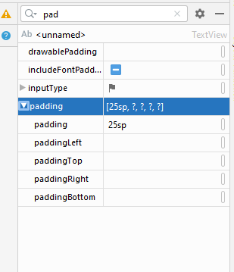

* **After Padding apply**

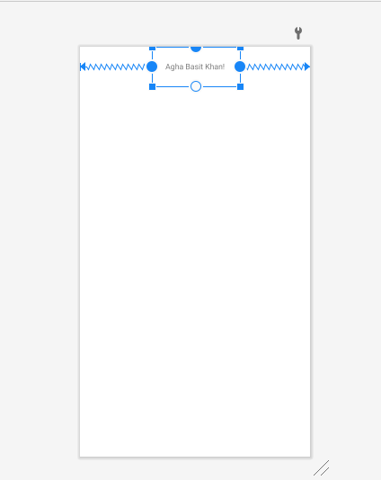

* **In the attribute section change the text to “Student Login App”.**

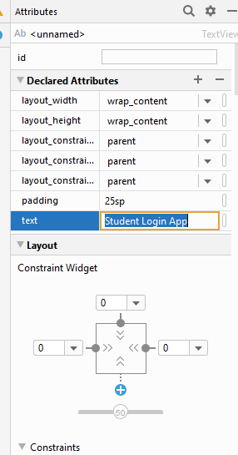

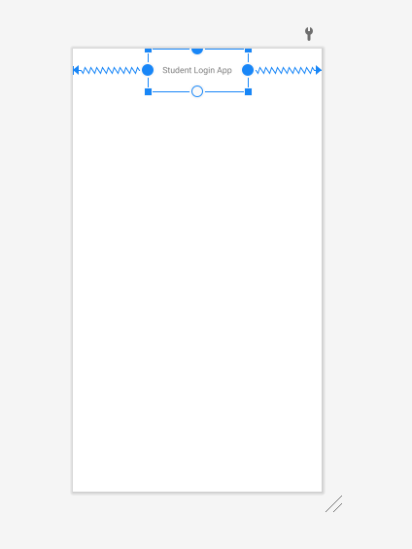

* **Add plain text from the text.**

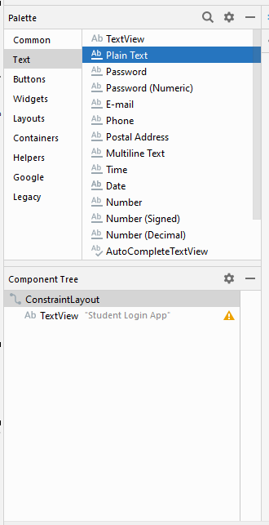

* **Adding plain text from Text**

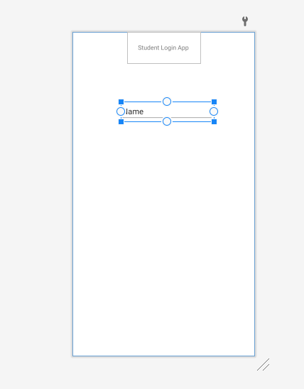

* **Attach left and right side of plain text field with the walls of parent.**

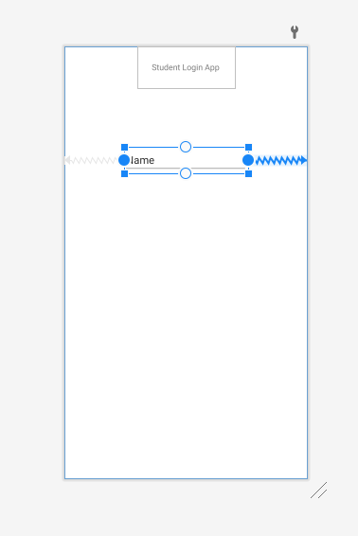

* **At right side in attribute , change the text of text field to “Enter Student Name”.**

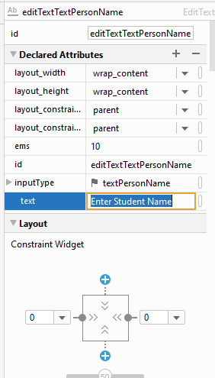

* **After Applying , text field add with “Enter Student Name”.**

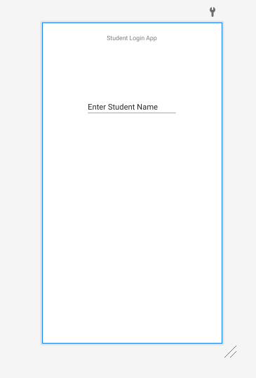

* **Add Another Plain Text From the Text Palette at the bottom of first one**

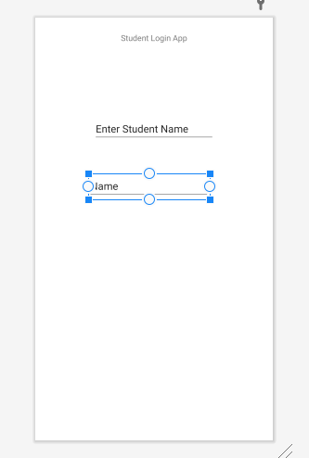

* **Change the Text of Second text field to “Enter Rollno”.**

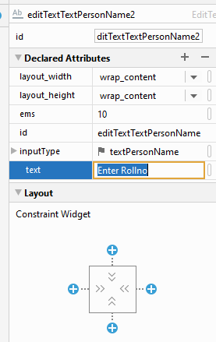

* **Add Another text field from the text palette**

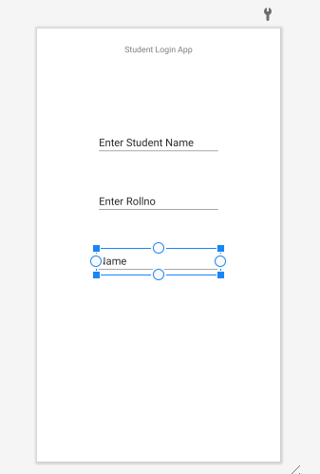

* **Select password field from the text palette**

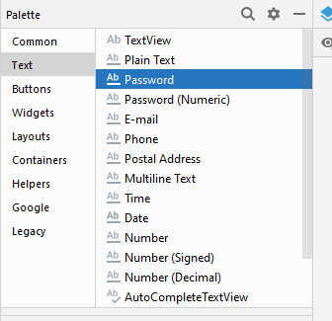

* **Add password field at the bottom of Student Rollno.**

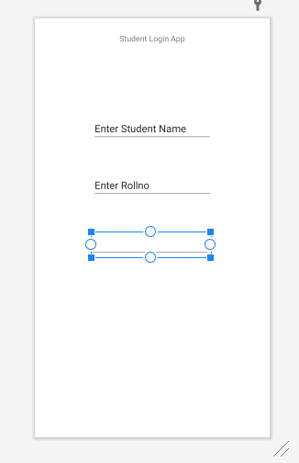

* **Add hint in password field from the attribute of password at right side**

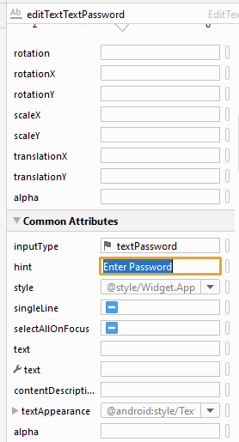

* **Hint added , “Enter Password”.**

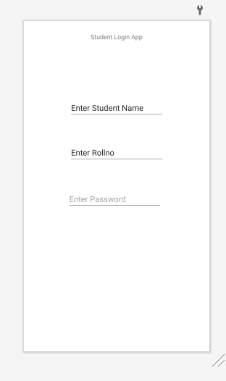

* **Select Button from the button palette.**

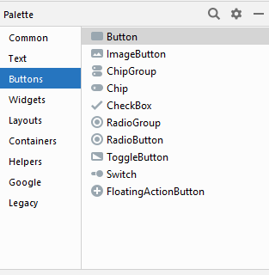

* **Add button at the bottom of password.**

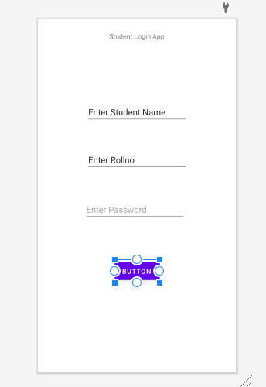

* **Change the text of button in the button’s attribute to “LOGIN”.**

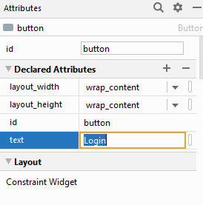

* **After Changing Text , button become “LOGIN” button.**

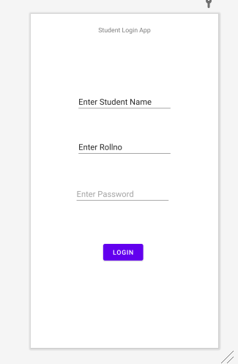

* **In constraints layout , some errors occurs that “There are no vertical constraints after run they will jump at the top”.**

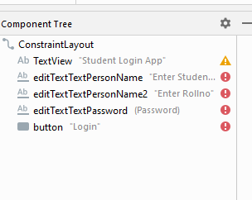

* **After Applying vertical constraint, to remove errors.**

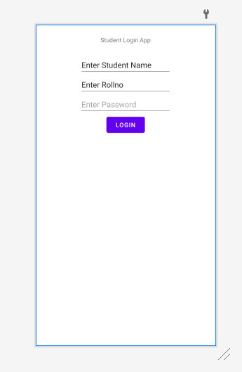

* **Apply some margins to make spaces between all fields**

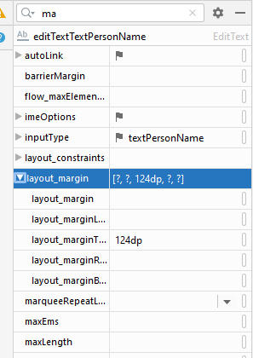

* **After Applying Margins**

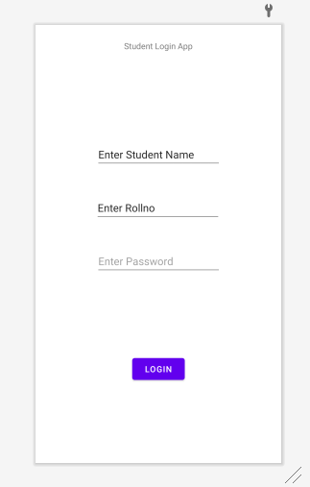

* **Increase the size of text by applying text size to 36sp in the attribute section.**

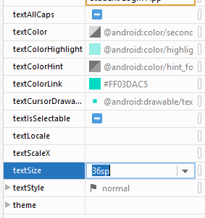

* **After Applying text size 36sp to the “Student Login App”.**

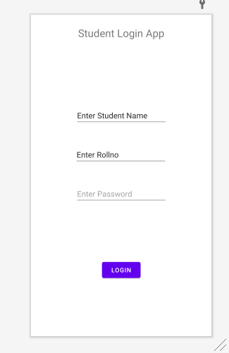

* **Create Virtual device with “helo” name. Now run app with the play button.**

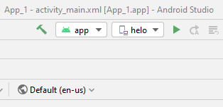

* **App installing process in running , Gradle building.**

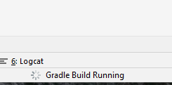

* **After gradle building , App is in launching process.**

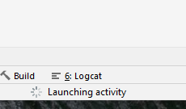

* **After launching and installing , App run on virtual device “helo”.**

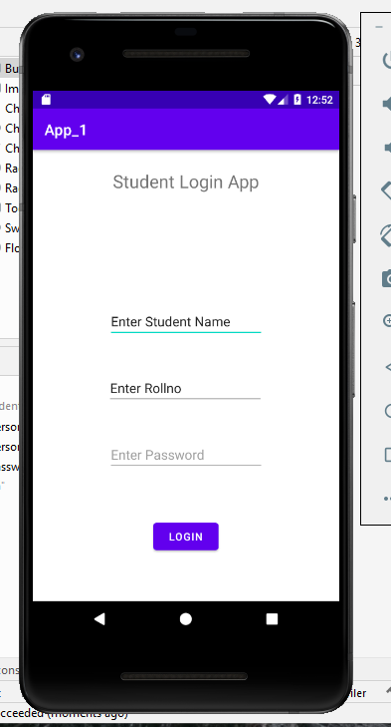

* **Check the app by putting values in the fields.**

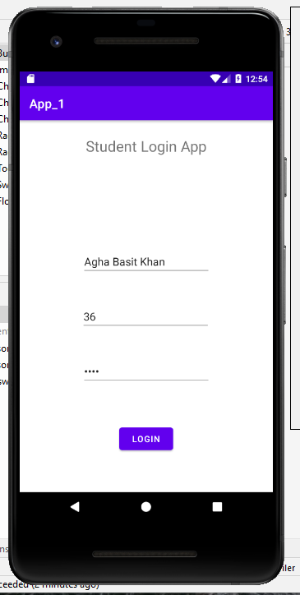

* **This is the text view of activity_main.xml file.**

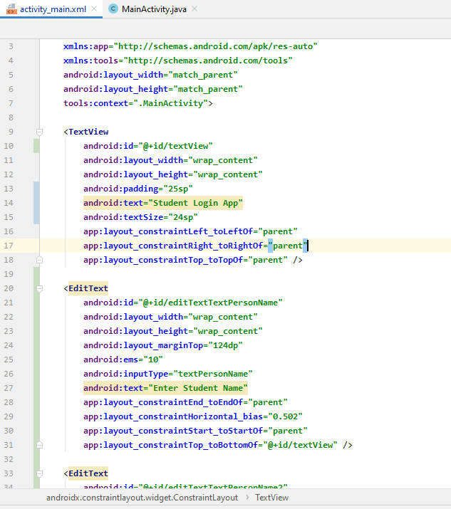

* **Now adding app into GitHub repository. Open the git cmd and move to that drive and then folder where repository is cloned.**

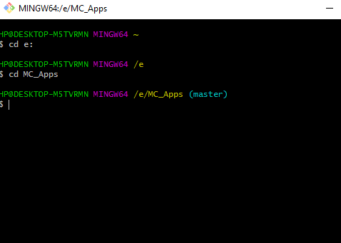

* **Add changes to repository , give complete path after git add command.**

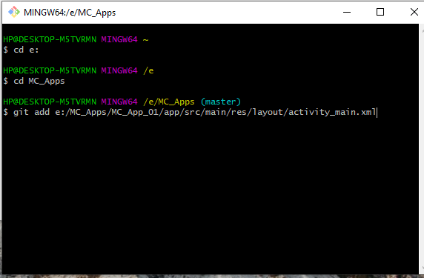

1. **After adding , commit the changes to “First Phase of App” using git commit –m command.**

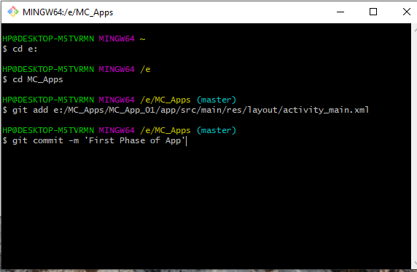

* **After Committing , push the changes to repository using git push command.**

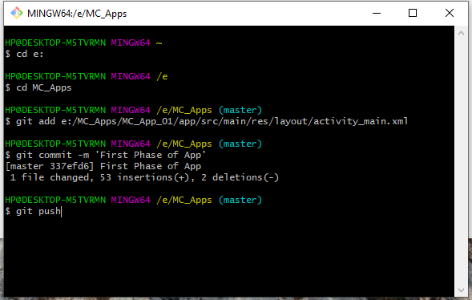

* **Successful run all commands.**

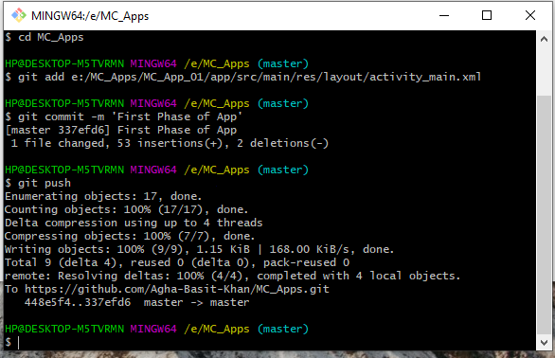

* **Now move to online GitHub account and open specific “MC_Apps” repository to see changes in the repository.**
* **Changes updated to “First Phase of App”.**

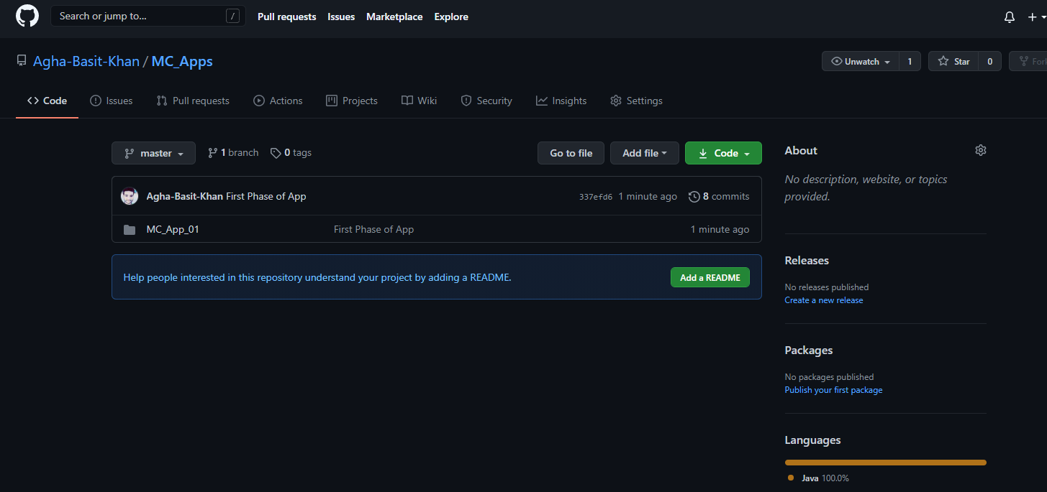

* **Click on “First Phase of App” , see the changes you made in the file.**

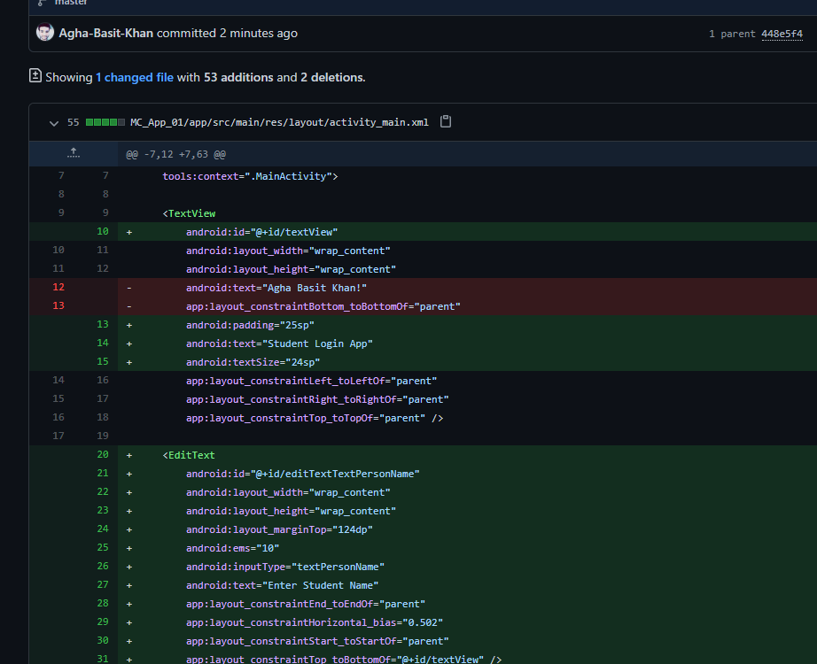

**Second Phase of App**

* **“Second Phase of App” started. In this Phase Some Styling Apply to all the fields.**
* **Clear text from all the text fields and apply hint.**

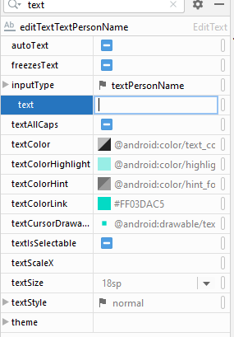

* **Apply hint for “Enter Student Name”.**

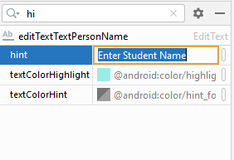

* **Apply hint for “Enter Rollno”.**

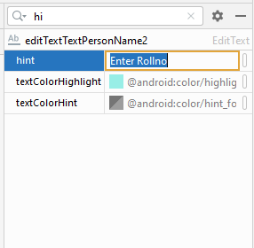

* **After Applying hints instead of text.**

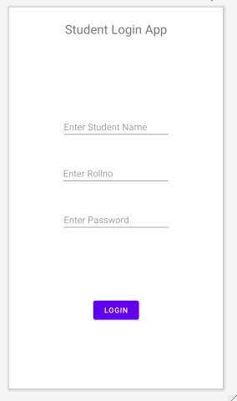

* **Apply Background Color using “background” int the attribute section.**

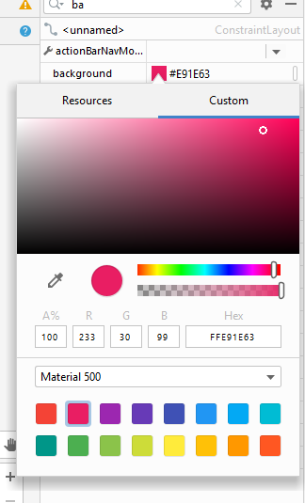

* **After Applying Color.**

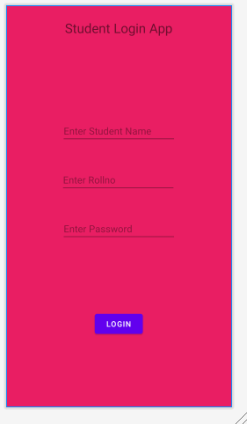

* **Now apply background color for text fields also.**
* **Click on text field**
* **Then select “background” in the attribute section and apply color for text fields.**

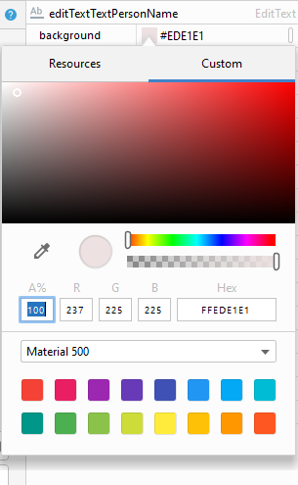

* **After Applying background color for “Enter Student Name” field.**

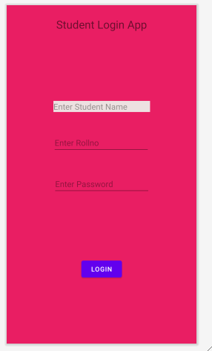

* **After Applying background for remaining text fields.**

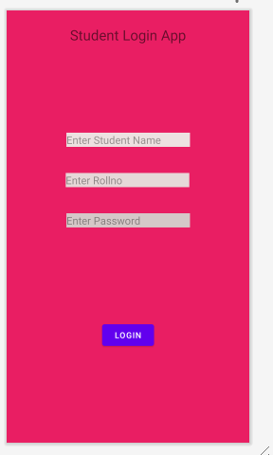

* **Increase the height of text field.**
* **Select layout_height in the attribute section**
* **Set height to 50dp.**

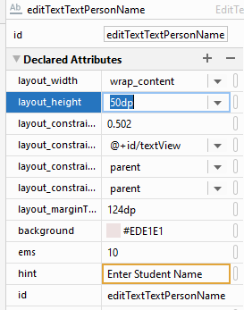

* **After increase the height of “Enter Student Name” field.**

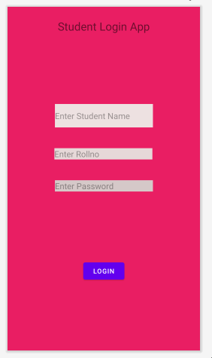

* **After Applying layout_height attribute to all text fields.**

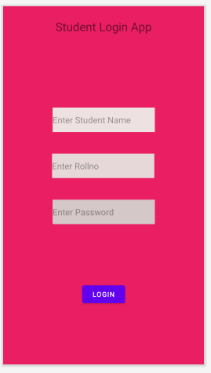

* **Select the textColorHint attribute for apply color to the hint text.**

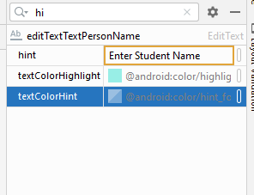

* **Select color for the hint text.**

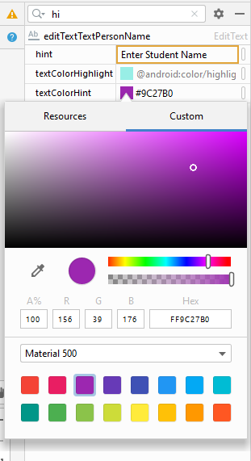

* **After Applying Text Hint color .**

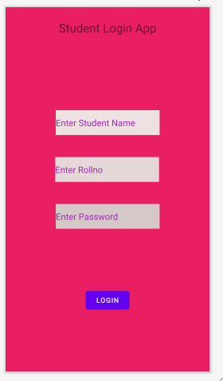

* **Now Style the Button**
* **Select Button**
* **In the Attribute Section of button Select layout_height**
* **Set height to 100dp**

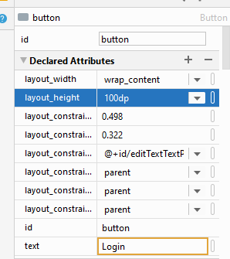

* **For Button**
* **Select the layout_width**
* **Set width to wrap_content**

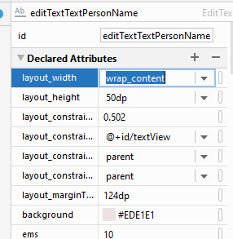

* **Now Change the Width of text fields**
* **Select the Enter Student Name field**
* **In the Attribute , select the layout_width**
* **Set width to 0dp**

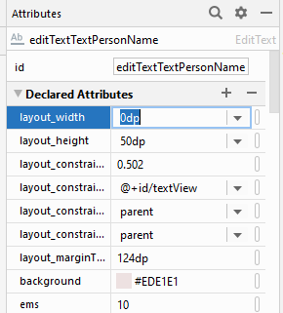

* **After Styling Button and changing width of first text field.**

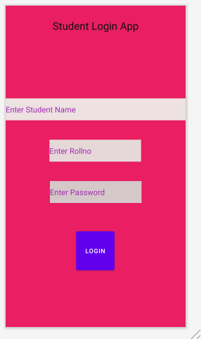

* **After Applying the width to all text fields.**

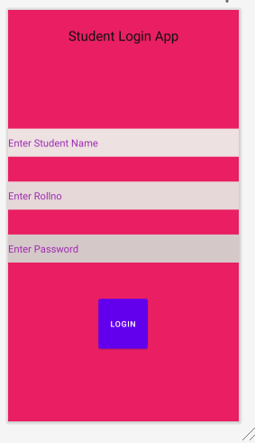

* **Run this App using virtual device “helo”.**
* **Click on play button**

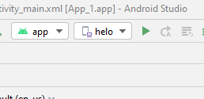

* **App is launching and instaling.**

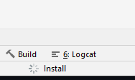

* **After installation complete on virtual device.**
* **This message shows.**

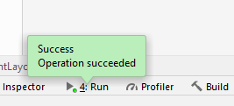

* **See App on virtual device.**

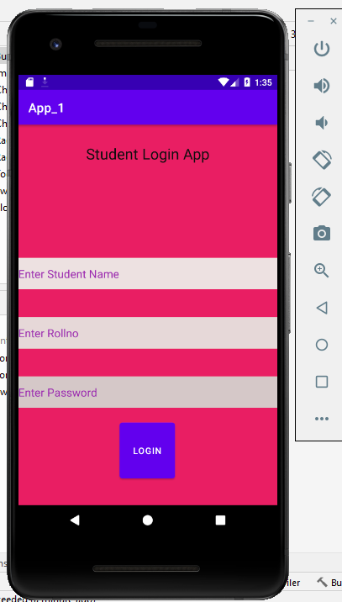

* **Putting Data for checking purpose.**

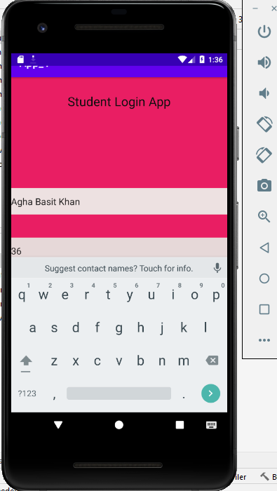

* **After put all the data fields.**

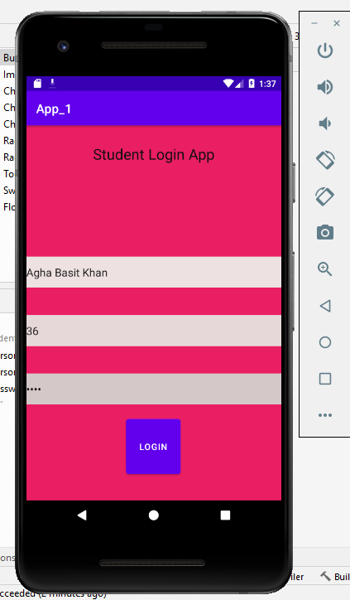

* **Second Phase of App updated in the repository**
* **Add the changing file using git add command.**

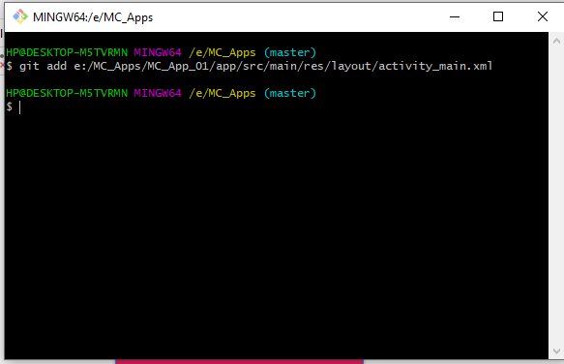

* **After add commit the changes to “Second Phase of App” using git commit –m command.**

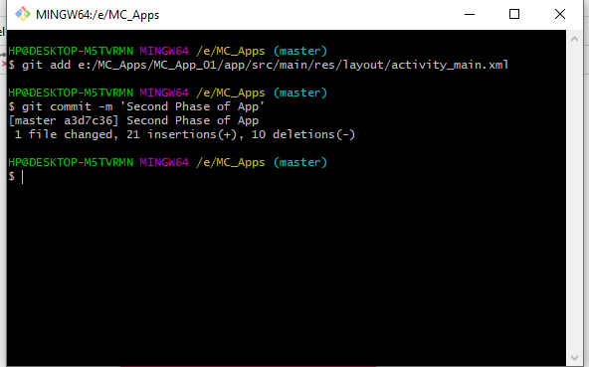

* **At the End push the changes using git push command.**

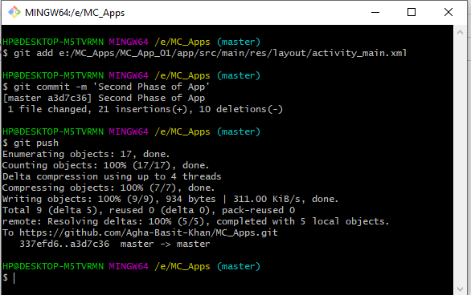

* **Open the GitHub account .**
* **Open the repository MC_Apps.**
* **See the changes “Second Phase of App”.**

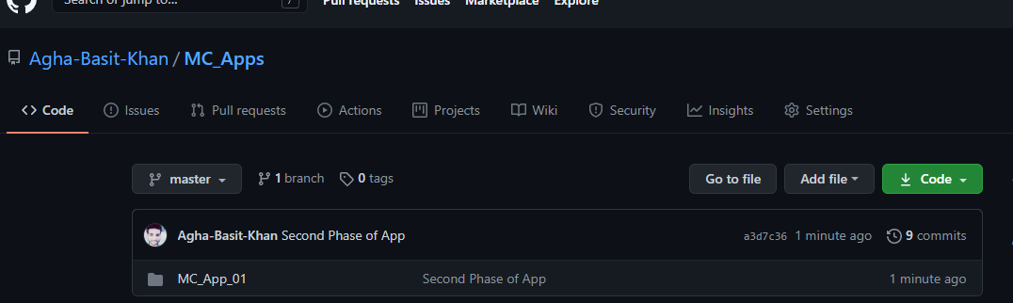

* **After clicking on “Second Phase of App” see the changes made in the file.**

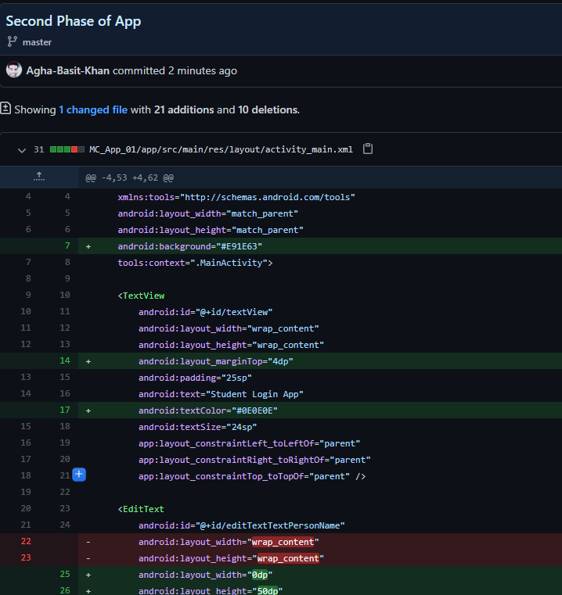

**Third Phase of App**

* **In Third Phase of App , make app more attractive by applying styles also using drawables and themes and image.**
* **Apply the padding to app 20dp.**

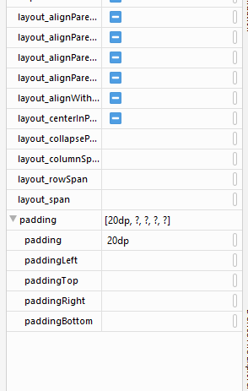

* **After Applying the padding.**

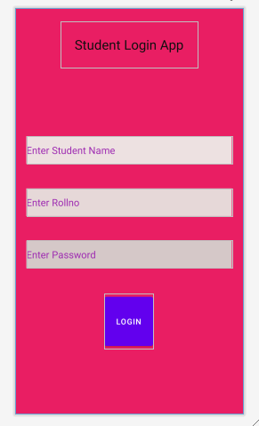

* **Download a image from google.**
* **Rename it to bg2.jpg.**



* **At the left most side**
* **Open the res folder**
* **Then open drawable**
* **Copy bg2.jpg image from desktop**

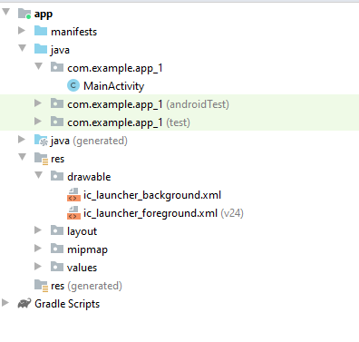

* **Paste image to drawable folder**
* **Then select the folder**
* **And press ok.**

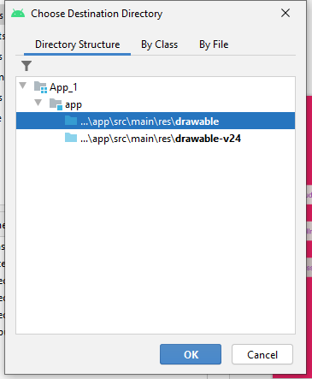

* **Image is successfully paste in the drawable folder.**

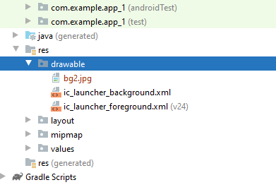

* **In the Attribute Section**
* **Search the background**



* **After click on background option**

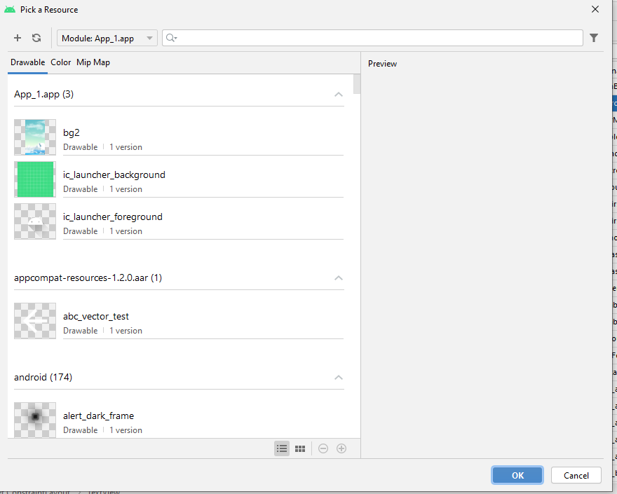

* **Select the bg2.jpg image**
* **Press ok.**

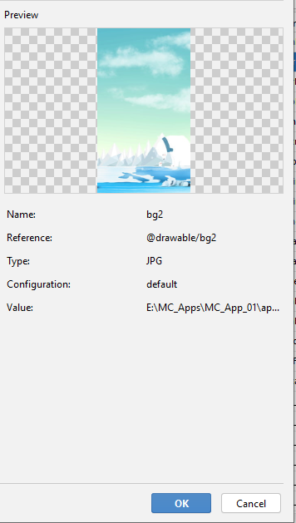

* **After Applying background image.**

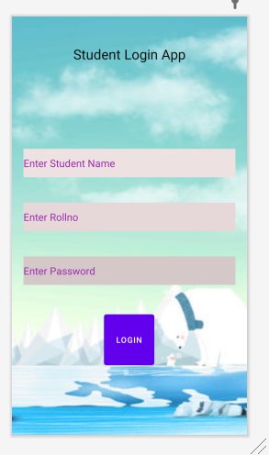

* **Select the button**
* **In the attribute section select layout_height**
* **Set height to 50dp**

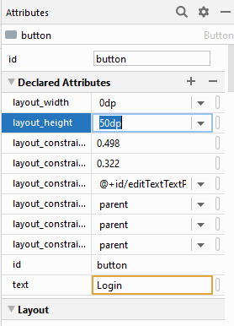

* **Select the background**
* **Set background color.**

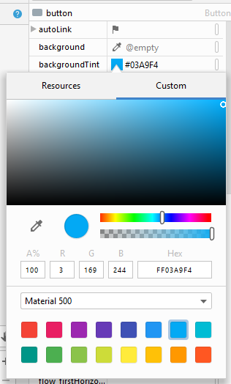

* **After Applying Styling to button.**

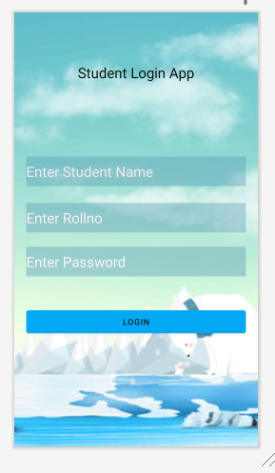

* **Click on Text field**
* **In the attribute section , search fontFamily**

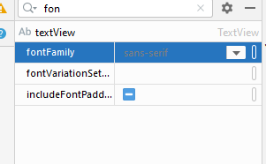

* **Click on fontFamily attribute**
* **Select any style**
* **Then press ok.**

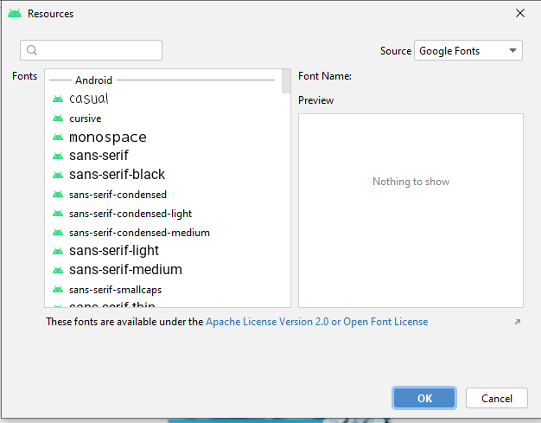

* **After Applying fontFamily Style to “Student Logon App”.**

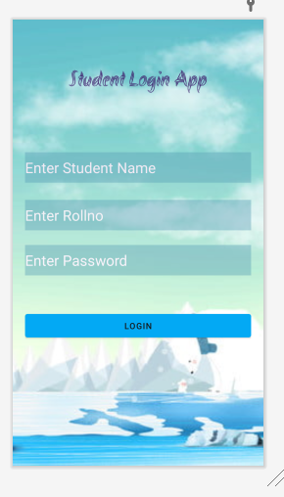

* **Repeat above steps and apply fonrFamily for other text fields.**

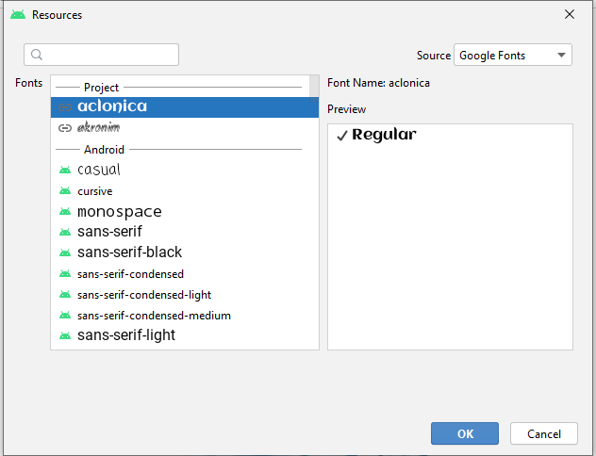

* **After using fontFamily attribute for other text fields.**

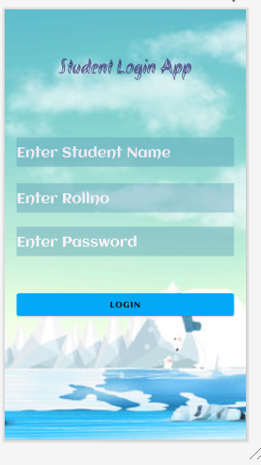

* **Run the App using virtual device**
* **Click on play button**

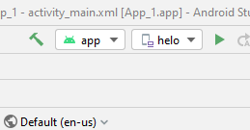

* **App is installing**

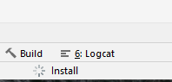

* **After Installing on virtual device**

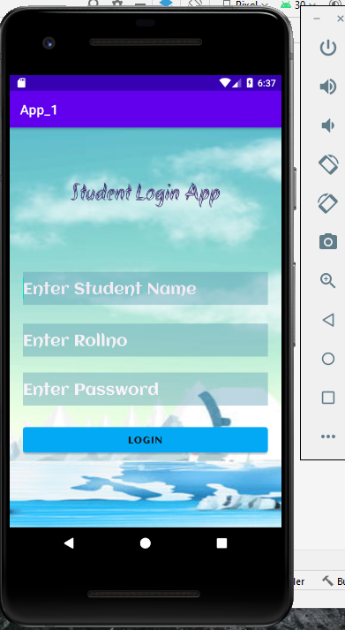

* **Add Data into the fields for checking the app.**

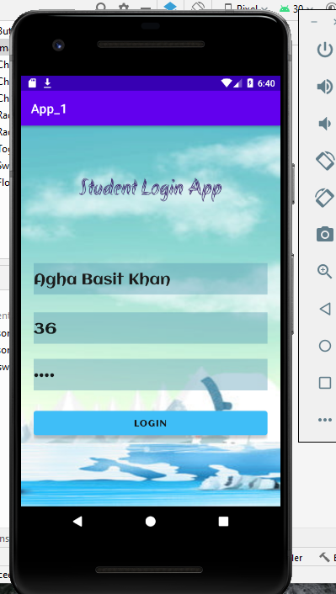

* **Remove the Action Bar in the app**
* **Select the themes.xml in the values folder**
* **Open it.**

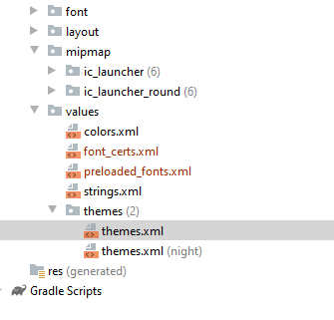

* **Change the darkActionBar to NoActionBar for removal of action bar in the app.**

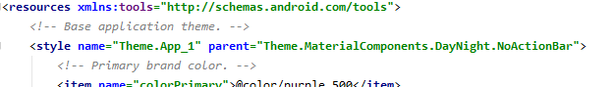

* **Again run the app on virtual device.**
* **Now action bar is not present in the app.**

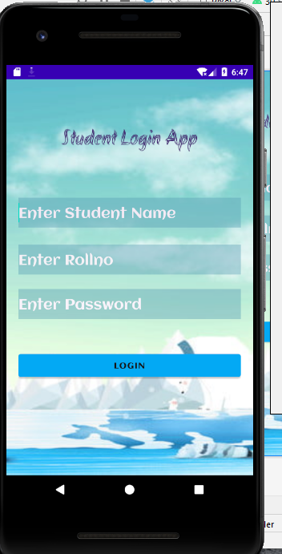

* **For Checking , add some data.**

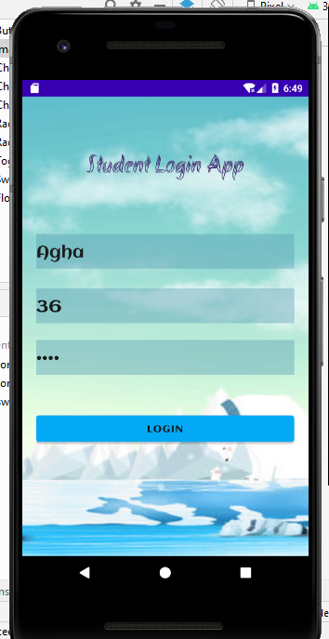

* **Add Third Phase of App in the repository.**
* **Open the git cmd**
* **Add changes using git add**
* **Commit changes using git commit –m commands.**

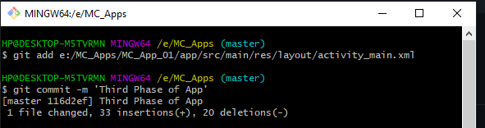

* **Push Third Phase changes using git push command.**

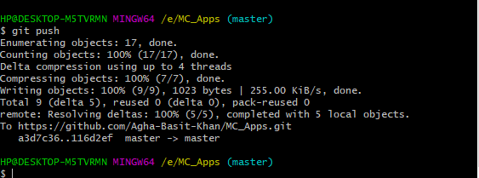

* **Open the github account**
* **See the repository**
* **Changes updated as “Third Phase of App”**

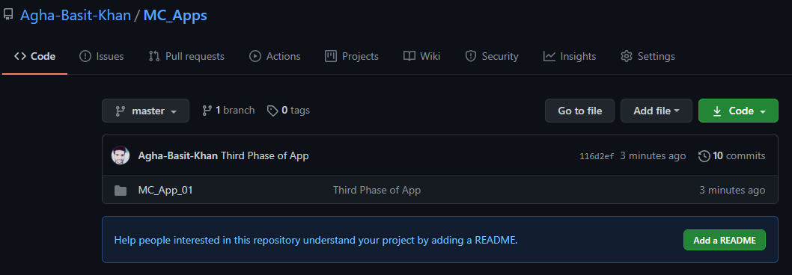

* **Upload image also in the repository**
* **First add then commit and push it**

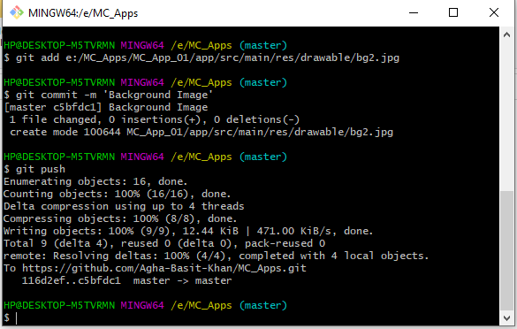

* **In the repository, changes updated as Background Image.**

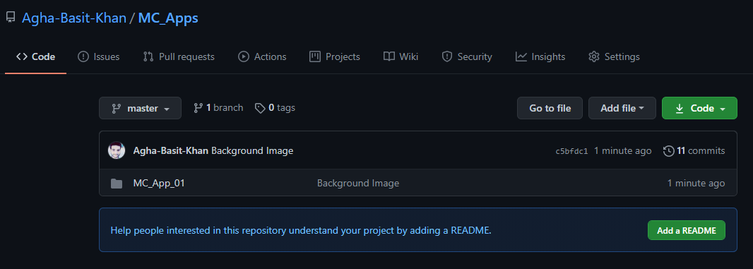

* **Also update the theme.xml in the repository**
* **In the same way, first add then commit and push it to repository**

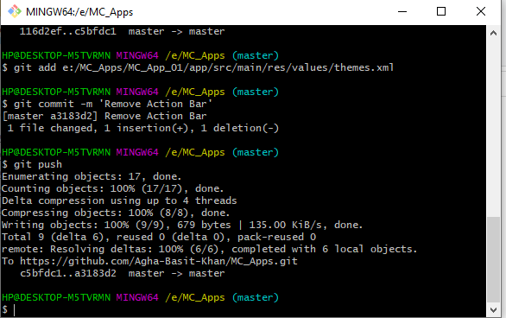

* **In the repository, changes updated as Remove Action Bar.**

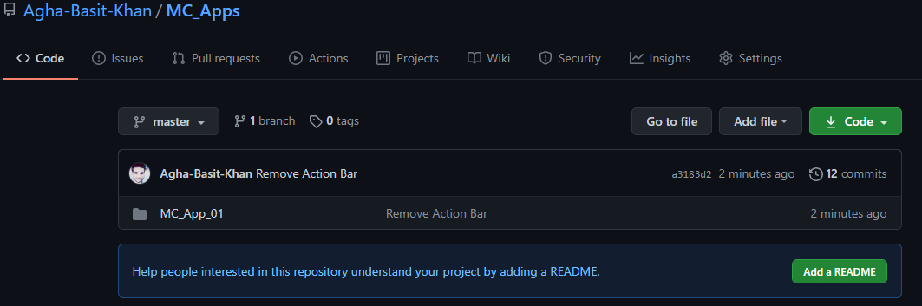

* **Also update the fonts in the repository**
* **In the same way, first add then commit and push it to repository**

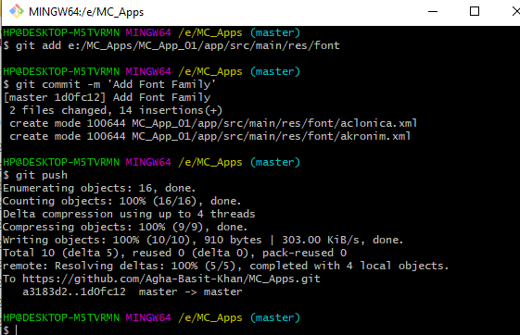

* **In the repository, changes updated as Add Font Family.**

