Secure Coding Review
CodeAlpha Cyber Security Internship — Task 3

1. Scope
Language / application: Python 3, Flask web application (sample_app.py).
Method: manual line-by-line code review, supplemented by pattern checks consistent with static-analysis rules (e.g. flagged use of shell=True, string-built SQL, unescaped output).
Objective: identify security vulnerabilities in the source code, rate their severity, and provide concrete remediation.

2. Summary of Findings
1 | SQL Injection | Critical | The login route builds a SQL query with Python string formatting (% substitution) directly from the username/password fields, so an attacker can inject SQL (e.g. ' OR '1'='1) to bypass authentication or extract data.
2 | Command Injection | Critical | The /ping route passes a user-supplied host value into subprocess.run() with shell=True, so shell metacharacters (; | &&) let an attacker run arbitrary OS commands.
3 | Path Traversal | High | The /download route joins a user-supplied filename onto a base directory without normalizing or validating it, so a value like ../../etc/passwd can read files outside the intended folder.
4 | Reflected XSS | High | The /search route inserts the raw query string into an HTML response with an f-string, so a script tag in the URL executes in the victim's browser.
5 | Hardcoded secrets | High | The Flask secret_key and a database password are hardcoded string literals in source, so anyone with repo access can forge session data or reuse the credential.
6 | Insecure session cookie | Medium | The session cookie is set without HttpOnly, Secure, or SameSite flags, making it readable by client-side scripts and sendable over plain HTTP.
7 | Debug mode in production | Medium | app.run() is called with debug=True and binds to 0.0.0.0, exposing the interactive Werkzeug debugger (which allows remote code execution) on all network interfaces.
8 | Verbose / unauthenticated debug endpoint | Low | A /debug route exists with no authentication check and no clear purpose, expanding the attack surface unnecessarily.

3. Detailed Findings & Remediation

3.1 SQL Injection (Critical)
Location: login(), query built with '%s' % (username, password).
Risk: an attacker can log in as any user or dump the database without valid credentials.
- Fix: use parameterized queries — cur.execute("SELECT * FROM users WHERE username=? AND password=?", (username, password)).
- Fix: store password hashes (e.g. bcrypt/argon2) and compare hashes, never plaintext passwords.

3.2 Command Injection (Critical)
Location: ping(), subprocess.run(f"ping -c 1 {host}", shell=True).
- Fix: call subprocess with a list of arguments and shell=False — subprocess.run(['ping','-c','1', host], shell=False).
- Fix: validate host against a strict allow-list pattern (e.g. IPv4/hostname regex) before use.

3.3 Path Traversal (High)
Location: download(), os.path.join('/var/app/files', filename) with no sanitization.
- Fix: resolve the final path and confirm it stays inside the intended directory (os.path.realpath + startswith check), or use werkzeug.utils.secure_filename.
- Fix: maintain an allow-list of downloadable file IDs instead of accepting raw filenames.

3.4 Reflected XSS (High)
Location: search(), f"<h1>Results for: {term}</h1>".
- Fix: render through a templating engine with autoescaping (Flask's render_template with Jinja2) instead of building HTML with f-strings.
- Fix: set a Content-Security-Policy header as defense in depth.

3.5 Hardcoded Secrets (High)
Location: app.secret_key and DB_PASSWORD literals at module level.
- Fix: load secrets from environment variables or a secrets manager (e.g. os.environ['SECRET_KEY']), never commit them to source control.
- Fix: rotate any credential that has already been committed to a repository.

3.6 Insecure Session Cookie (Medium)
Location: login(), resp.set_cookie('session_user', username).
- Fix: set httponly=True, secure=True, samesite='Lax' (or 'Strict') on the cookie, and use Flask's signed session (flask.session) instead of a plain cookie.

3.7 Debug Mode in Production (Medium)
Location: app.run(host='0.0.0.0', port=5000, debug=True).
- Fix: disable debug mode in production (debug=False) and run behind a production WSGI server (gunicorn/uWSGI) rather than the Flask dev server.

3.8 Unauthenticated Debug Endpoint (Low)
Location: /debug route.
- Fix: remove the route before deployment, or gate it behind authentication and an environment check.

4. General Secure Coding Recommendations
- Validate and sanitize all external input at the boundary (query params, form fields, headers, file uploads).
- Use parameterized queries / ORM methods for all database access — never string-concatenate SQL.
- Avoid shell=True; prefer argument lists for subprocess calls.
- Keep secrets out of source code; use environment variables, .env files excluded via .gitignore, or a secrets manager.
- Enable autoescaping templates for all HTML output; never hand-build HTML from user input.
- Set secure cookie flags (HttpOnly, Secure, SameSite) on any session or auth cookie.
- Turn off framework debug modes before deployment and run behind a hardened WSGI/HTTP server.
- Run a static analyzer (e.g. Bandit for Python) in CI to catch these patterns automatically on every commit.

Bandit Output:
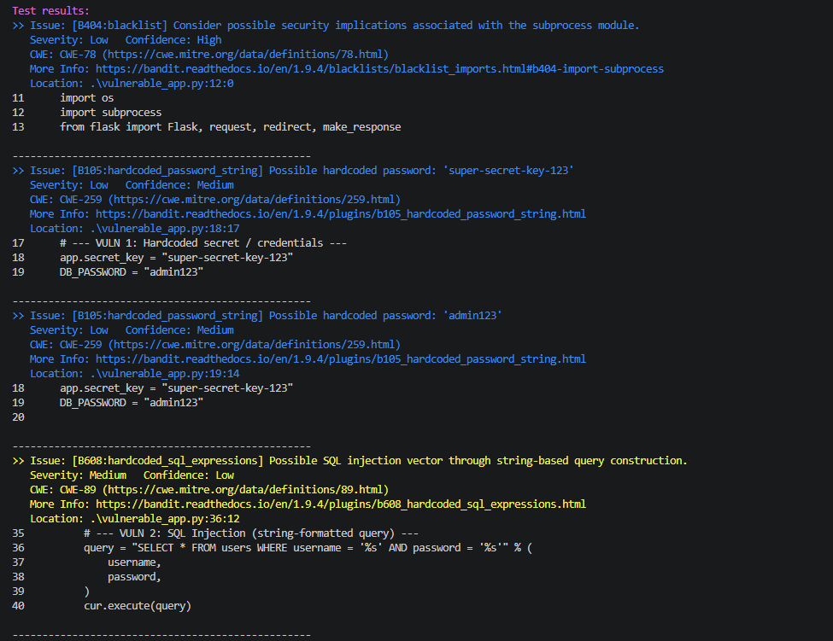

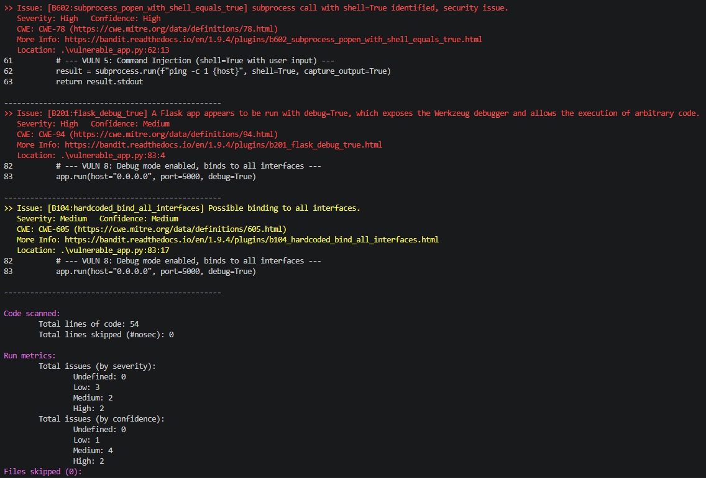

5. Conclusion
The reviewed application contains 8 findings across 4 severity levels, including two critical issues (SQL injection and command injection) that would allow full compromise of the application and, potentially, the host. All findings include specific, actionable remediation. Addressing the critical and high findings should be prioritized before any deployment.

