

**CSCI-549 PROJECT REPORT**

**(PARSING AN INPUT STRING USING CKY)**

**AGHALYA DHARSHNI MANMATHARAJ-50202743**

**Under guidance of**

**Dr. Sang C. Suh (Ph.D.)**

**(Department of Computer Science and Information System,**

**Texas A & M University –Commerce)**

**ACKNOWLEDGEMENT**

I take this opportunity to express my profound gratitude and deep regards to our professor Dr. Sang C. Suh for his exemplary guidance, monitoring and constant encouragement throughout the course, without which this project would not have been successful.

I am grateful to him for teaching me this course and providing me with all the concepts necessary in the field and for helping throughout the semester by answering all my doubts.

I would also like to extend our thanks to staff and members of Dept. of Computer Science and Information Systems - Texas A & M University-Commerce.

**PROJECT DESCRIPTION**

This project is aimed at understanding the concepts of grammar and parsing.

Generate a Context Free Grammar (CFG) and convert CFG into Chomsky Normal Form Grammar (CNFG), we follow the following steps:

Step 1: Killing Null Productions

Step 2: Killing Unit Productions

Step 3:

Non-Terminal String of Non-Terminals

Non-Terminal One Terminal

Step 4:

Non-Terminal Non-Terminal Non-Terminal

Non-Terminal One Terminal

Parse an input string using the CKY parsing algorithm to and check whether it is derivable by the grammar or not.

**CONTEXT FREE GRAMMAR**

Context Free grammar is collection of 3 things:

1. An alphabet of letters called terminals from which we are going to make strings that will be words of language.

2. A set of symbols Called Non-Terminals, one of which is the symbol S.

3. A finite set of productions of the form,

One Non-Terminal →finite strings of terminals and /or Non-Terminals.

|  |  |
| --- | --- |
| **Context Free Grammars** | **Lexicon** |
| S → NP VP | DET → this | the |a |
| NP → DET V | V → is | do | using| assist | has | closed | buy | want | have | find| open |
| VP → DET ADJ V N | ADJ→ discount| like| welcome |
| NP → V NP | N → bookstore | book | price| office | author | kind | students | automata | thanks |
| VP → V ADJ N | NP → you | I | what | who | our |
| NP→ ADV AUX | ADV→ how | sundays | any | where | weekends |
| VP → NP V NP | AUX→ can| is| would | are |
| NP→ NP AUX | P → of |on |to |for| at |
| VP → DET N P DET N | INJ→ hi |
| NP→ DET N |  |
| VP → V DET ADJ |  |
| VP → ADJ P V DET N |  |
| VP → AUX ADV P N |  |
| NP → NP N |  |
| VP → P N V NP V |  |
| NP→ V NP |  |
| VP→V AUX V P NP N |  |
| VP→DET ADJ N ADJ |  |
| VP→ NP V DET N |  |
| NP→ INJ ADJ |  |
| VP→ P NP N |  |
| VP→NP V N |  |
| NP→AUX NP |  |
| VP→N ADJ CONJ DET N |  |
| VP→ ADJ N ADJ P NP N |  |
| VP→ V P ADV |  |
| NP→ N P |  |
| VP→ ADJ P NP N |  |
| VP → V AUX ADV P N |  |
| VP → V DET N ADJ P NP N |  |

**CFG INTO CHOMSKY NORMAL FORM GRAMMAR (CNFG)**

|  |  |
| --- | --- |
| **Context Free Grammars** | **Chomsky Normal Form** |
| S → NP VP | S → NP VP |
| NP → DET V | NP → DET V |
| VP → DET ADJ V N | VP → DET X1 |
|  | X1 → ADJ X2 |
|  | X2 → V N |
| NP → V NP | NP → V NP |
| VP → V ADJ N | VP → V X1 |
|  | X1 → ADJ N |
| NP→ ADV AUX | NP→ ADV AUX |
| VP → NP V NP | VP → NP X1 |
|  | X1 → V NP |
| NP→ NP AUX | NP→ NP AUX |
| VP → DET N P DET N | VP → DET X1 |
|  | X1 → N X2 |
|  | X2 → P X3 |
|  | X3 → DET N |
| NP→ DET N | NP→ DET N |
| VP → V DET ADJ | VP → V X1 |
|  | X1 → DET ADJ |
| NP → NP N | NP → NP N |
| NP→ V NP | NP→ V NP |
| NP→ INJ ADJ | NP→ INJ ADJ |
| NP→AUX NP | NP→AUX NP |
| NP→ N P | NP→ N P |
| VP → ADJ P V DET N | VP → ADJ X1 |
|  | X1 → P X2 |
|  | X2 → V X3 |
| VP → AUX ADV P N | VP → AUX X1 |
|  | X1 → ADV X2 |
|  | X2 → P N |
| VP→ V P ADV | X1→ P ADV |
| VP→ P NP N | X1→ NP N |
| VP→NP V N | X1→V N |
| VP→ NP V DET N | X1→ V X2 |
|  | X2→ DET N |
| VP→DET ADJ N ADJ | X2→ N ADJ |
| VP→N ADJ CONJ DET N | VP→ N X1 |
|  | X2→ CONJ X3 |
| VP→ ADJ N ADJ P NP N | X2→ ADJ X3 |
|  | X4→ NP N |
| VP → P N V NP V | VP → P X1 |
|  | X3 → NP V |
| VP→V AUX V P NP N | X1→ AUX X2 |
|  | X3→ P X4 |
| VP → V DET N ADJ P NP N | X1-> DET X2 |
|  | X2-> N X3 |
|  | X3-> ADJ X4 |
|  | X4-> P X5 |
|  | X5-> NP N |
| VP→ ADJ P NP N | X2-> NP N |
| VP → V AUX ADV P N | X3-> P N |

**INPUT STRING TO BE PARSED**

**Accepted Strings:**

1. hi welcome to our bookstore
2. how can i assist you
3. i would like to buy a book
4. what kind of book do you want
5. where can i find the book automata
6. what is the price of this book
7. who is the author of this book
8. do you have any discount for students
9. this book has a discount
10. the office is closed on sundays
11. are you open on weekends
12. thanks for using our bookstore

**Not Accepted Strings:**

1. the office is closed on Sunday
2. how can we assist you
3. where can i find automata book

**CKY TABLES**

Applying CKY algorithm on one each of the sentences:

1. **hi welcome to our bookstore**

|  |  |  |
| --- | --- | --- |
| **Derivation** | | |
| [0, 1] |  | INJ |
| [0, 2] | [0, 1], [1, 2] | NP |
| [0, 3] | [0, 1], [1, 3] + [0, 2], [2, 2] |  |
| [0, 4] | [0, 1], [1, 4] + [0, 2], [2, 4] + [0, 3], [3, 4] |  |
| [0, 5] | [0, 1], [1, 5] + [0, 2], [2, 5] + [0, 3], [3, 5] + [0, 4], [4, 5] | S, VP |
| [1, 2] |  | ADJ |
| [1, 3] | [1, 2], [2, 3] |  |
| [1, 4] | [1, 2], [2, 4] + [1, 3], [3, 4] |  |
| [1, 5] | [1, 2], [2, 5] + [1, 3], [3, 5] + [1, 4], [4, 5] | VP, X2, X3 |
| [2, 3] |  | P |
| [2, 4] | [2, 3], [3, 4] |  |
| [2, 5] | [2, 3], [3, 5] + [2, 4], [4, 5] | VP, X1, X3, X4 |
| [3, 4] |  | NP |
| [3, 5] | [3, 4], [4, 5] | NP, X1, X2, X4, X5 |
| [4, 5] |  | N |

|  |  |  |  |  |
| --- | --- | --- | --- | --- |
| **hi** | **welcome** | **to** | **our** | **bookstore** |
| INJ (0,1) | NP  (0,2) | (0,3) | (0,4) | S,VP  (0,5) |
| ADJ  (1,2) | (1,3) | (1,4) | X2,X3,VP  (1,5) |
| P  (2,3) | (2,4) | X3,VP,X4,X1  (2,5) |
| NP  (3,4) | NP,X4,X1,X5,X2  (3,5) |
| N  (4,5) |

1. **how can i assist you**

|  |  |  |
| --- | --- | --- |
| **Derivation** | | |
| [0, 1] |  | ADV |
| [0, 2] | [0, 1], [1, 2] | NP |
| [0, 3] | [0, 1], [1, 3] + [0, 2], [2, 2] |  |
| [0, 4] | [0, 1], [1, 4] + [0, 2], [2, 4] + [0, 3], [3, 4] |  |
| [0, 5] | [0, 1], [1, 5] + [0, 2], [2, 5] + [0, 3], [3, 5] + [0, 4], [4, 5] | S |
| [1, 2] |  | AUX |
| [1, 3] | [1, 2], [2, 3] | NP |
| [1, 4] | [1, 2], [2, 4] + [1, 3], [3, 4] | X3 |
| [1, 5] | [1, 2], [2, 5] + [1, 3], [3, 5] + [1, 4], [4, 5] | VP |
| [2, 3] |  | NP |
| [2, 4] | [2, 3], [3, 4] | X3 |
| [2, 5] | [2, 3], [3, 5] + [2, 4], [4, 5] | VP |
| [3, 4] |  | V |
| [3, 5] | [3, 4], [4, 5] | NP, X1 |
| [4, 5] |  | N |

|  |  |  |  |  |
| --- | --- | --- | --- | --- |
| **how** | **can** | **i** | **assist** | **you** |
| ADV (0,1) | NP  (0,2) | (0,3) | (0,4) | S  (0,5) |
| AUX  (1,2) | NP  (1,3) | X3  (1,4) | VP  (1,5) |
| NP  (2,3) | X3  (2,4) | VP  (2,5) |
| V  (3,4) | NP,X1  (3,5) |
| NP  (4,5) |

1. **i would like to buy a book**

|  |  |  |
| --- | --- | --- |
| **Derivation** | | |
| [0, 1] |  | NP |
| [0, 2] | [0, 1], [1, 2] | NP |
| [0, 3] | [0, 1], [1, 3] + [0, 2], [2, 2] |  |
| [0, 4] | [0, 1], [1, 4] + [0, 2], [2, 4] + [0, 3], [3, 4] |  |
| [0, 5] | [0, 1], [1, 5] + [0, 2], [2, 5] + [0, 3], [3, 5] + [0, 4], [4, 5] |  |
| [0, 6] | [0, 1], [1, 6] + [0, 2], [2, 6] + [0, 3], [3, 6] + [0, 4], [4, 6] + [0, 5], [5, 6] |  |
| [0, 7] | [0, 1], [1, 7] + [0, 2], [2, 7] + [0, 3], [3, 7] + [0, 4], [4, 7] + [0, 5], [5, 7] + [0, 6], [6, 7] | S |
| [1, 2] |  | AUX |
| [1, 3] | [1, 2], [2, 3] |  |
| [1, 4] | [1, 2], [2, 4] + [1, 3], [3, 4] |  |
| [1, 5] | [1, 2], [2, 5] + [1, 3], [3, 5] + [1, 4], [4, 5] |  |
| [1, 6] | [1, 2], [2, 6] + [1, 3], [3, 6] + [1, 4], [4, 6] + [1, 5], [5, 6] |  |
| [1, 7] | [1, 2], [2, 7] + [1, 3], [3, 7] + [1, 4], [4, 7] + [1, 5], [5, 7] + [1, 6], [6, 7] |  |
| [2, 3] |  | ADJ |
| [2, 4] | [2, 3], [3, 4] |  |
| [2, 5] | [2, 3], [3, 5] + [2, 4], [4, 5] |  |
| [2, 6] | [2, 3], [3, 6] + [2, 4], [4, 6] + [2, 5], [5, 6] |  |
| [2, 7] | [2, 3], [3, 7] + [2, 4], [4, 7] + [2, 5], [5, 7] + [2, 6], [6, 7] | VP |
| [3, 4] |  | P |
| [3, 5] | [3, 4], [4, 5] |  |
| [3, 6] | [3, 4], [4, 6] + [3, 5], [5, 6] |  |
| [3, 7] | [3, 4], [4, 7] + [3, 5], [5, 7] + [3, 6], [6, 7] | VP, X1 |
| [4, 5] |  | V |
| [4, 6] | [4, 5], [5, 6] |  |
| [4, 7] | [4, 5], [5, 7] + [4, 6], [6, 7] | NP, X1, X2 |
| [5, 6] |  | DET |
| [5, 7] | [5, 6], [6, 7] | NP, X2, X3 |
| [6, 7] |  | N |

|  |  |  |  |  |  |  |  |  |
| --- | --- | --- | --- | --- | --- | --- | --- | --- |
| **i** | **Would** | **like** | **to** | **buy** | **a** | | **book** | |
| NP (0,1) | NP  (0,2) | (0,3) | (0,4) | (0,5) | (0,6) | | S  (0,7) | |
| AUX (1,2) | (1,3) | (1,4) | (1,5) | (1,6) | | (1,7) | |
| ADJ  (2,3) | (2,4) | (2,5) | (2,6) | | VP  (2,7) | |
| P  (3,4) | (3,5) | (3,6) | | X1,VP  (3,7) | |
| V  (4,5) | (4,6) | | X2,X1,NP  (4,7) | |
| DET  (5,6) | | NP,X2,X3  (5,7) |
|  | | N  (6,7) |

1. **what kind of book do you want**

|  |  |  |
| --- | --- | --- |
| **Derivation** | | |
| [0, 1] |  | NP |
| [0, 2] | [0, 1], [1, 2] | NP, X4, X1, X2, X5 |
| [0, 3] | [0, 1], [1, 3] + [0, 2], [2, 2] |  |
| [0, 4] | [0, 1], [1, 4] + [0, 2], [2, 4] + [0, 3], [3, 4] | VP |
| [0, 5] | [0, 1], [1, 5] + [0, 2], [2, 5] + [0, 3], [3, 5] + [0, 4], [4, 5] |  |
| [0, 6] | [0, 1], [1, 6] + [0, 2], [2, 6] + [0, 3], [3, 6] + [0, 4], [4, 6] + [0, 5], [5, 6] | S |
| [0, 7] | [0, 1], [1, 7] + [0, 2], [2, 7] + [0, 3], [3, 7] + [0, 4], [4, 7] + [0, 5], [5, 7] + [0, 6], [6, 7] | S, VP |
| [1, 2] |  | N |
| [1, 3] | [1, 2], [2, 3] | NP |
| [1, 4] | [1, 2], [2, 4] + [1, 3], [3, 4] | NP, X1, X2, X4, X5 |
| [1, 5] | [1, 2], [2, 5] + [1, 3], [3, 5] + [1, 4], [4, 5] | X3 |
| [1, 6] | [1, 2], [2, 6] + [1, 3], [3, 6] + [1, 4], [4, 6] + [1, 5], [5, 6] | VP, S |
| [1, 7] | [1, 2], [2, 7] + [1, 3], [3, 7] + [1, 4], [4, 7] + [1, 5], [5, 7] + [1, 6], [6, 7] | VP |
| [2, 3] |  | P |
| [2, 4] | [2, 3], [3, 4] | X2, X3 |
| [2, 5] | [2, 3], [3, 5] + [2, 4], [4, 5] |  |
| [2, 6] | [2, 3], [3, 6] + [2, 4], [4, 6] + [2, 5], [5, 6] |  |
| [2, 7] | [2, 3], [3, 7] + [2, 4], [4, 7] + [2, 5], [5, 7] + [2, 6], [6, 7] | VP, X1 |
| [3, 4] |  | N |
| [3, 5] | [3, 4], [4, 5] |  |
| [3, 6] | [3, 4], [4, 6] + [3, 5], [5, 6] | VP |
| [3, 7] | [3, 4], [4, 7] + [3, 5], [5, 7] + [3, 6], [6, 7] | X2, X1 |
| [4, 5] |  | V |
| [4, 6] | [4, 5], [5, 6] | NP, X1 |
| [4, 7] | [4, 5], [5, 7] + [4, 6], [6, 7] | X3, X2 |
| [5, 6] |  | NP |
| [5, 7] | [5, 6], [6, 7] | X3 |
| [6, 7] |  | V |

|  |  |  |  |  |  |  |  |  |
| --- | --- | --- | --- | --- | --- | --- | --- | --- |
| **what** | **kind** | **of** | **book** | **do** | **you** | | **want** | |
| NP (0,1) | NP,X4,X1,X5,X2  (0,2) | (0,3) | VP  (0,4) | (0,5) | S  (0,6) | | VP,S  (0,7) | |
| N (1,2) | NP  (1,3) | NP,X4,X1,X5,X2  (1,4) | X3  (1,5) | VP,S  (1,6) | | VP  (1,7) | |
| P  (2,3) | X2,X3  (2,4) | (2,5) | (2,6) | | X1,VP  (2,7) | |
| N  (3,4) | (3,5) | VP  (3,6) | | X2,X1  (3,7) | |
| V  (4,5) | NP,X1  (4,6) | | X3,X2  (4,7) | |
| NP  (5,6) | X3  (5,7) | |
| V  (6,7) |

1. **where can i find the book automata**

|  |  |  |
| --- | --- | --- |
| **Derivation** | | |
| [0, 1] |  | ADV |
| [0, 2] | [0, 1], [1, 2] | NP |
| [0, 3] | [0, 1], [1, 3] + [0, 2], [2, 2] |  |
| [0, 4] | [0, 1], [1, 4] + [0, 2], [2, 4] + [0, 3], [3, 4] |  |
| [0, 5] | [0, 1], [1, 5] + [0, 2], [2, 5] + [0, 3], [3, 5] + [0, 4], [4, 5] |  |
| [0, 6] | [0, 1], [1, 6] + [0, 2], [2, 6] + [0, 3], [3, 6] + [0, 4], [4, 6] + [0, 5], [5, 6] | S |
| [0, 7] | [0, 1], [1, 7] + [0, 2], [2, 7] + [0, 3], [3, 7] + [0, 4], [4, 7] + [0, 5], [5, 7] + [0, 6], [6, 7] | S |
| [1, 2] |  | AUX |
| [1, 3] | [1, 2], [2, 3] | NP |
| [1, 4] | [1, 2], [2, 4] + [1, 3], [3, 4] | X3 |
| [1, 5] | [1, 2], [2, 5] + [1, 3], [3, 5] + [1, 4], [4, 5] |  |
| [1, 6] | [1, 2], [2, 6] + [1, 3], [3, 6] + [1, 4], [4, 6] + [1, 5], [5, 6] | VP |
| [1, 7] | [1, 2], [2, 7] + [1, 3], [3, 7] + [1, 4], [4, 7] + [1, 5], [5, 7] + [1, 6], [6, 7] | VP,S |
| [2, 3] |  | NP |
| [2, 4] | [2, 3], [3, 4] | X3 |
| [2, 5] | [2, 3], [3, 5] + [2, 4], [4, 5] |  |
| [2, 6] | [2, 3], [3, 6] + [2, 4], [4, 6] + [2, 5], [5, 6] | VP |
| [2, 7] | [2, 3], [3, 7] + [2, 4], [4, 7] + [2, 5], [5, 7] + [2, 6], [6, 7] | VP, S |
| [3, 4] |  | V |
| [3, 5] | [3, 4], [4, 5] |  |
| [3, 6] | [3, 4], [4, 6] + [3, 5], [5, 6] | NP, X1, X2 |
| [3, 7] | [3, 4], [4, 7] + [3, 5], [5, 7] + [3, 6], [6, 7] | NP, X2, X1, X4, X5, VP |
| [4, 5] |  | DET |
| [4, 6] | [4, 5], [5, 6] | NP, X2, X3 |
| [4, 7] | [4, 5], [5, 7] + [4, 6], [6, 7] | NP, X2, X1, X4, X5 |
| [5, 6] |  | N |
| [5, 7] | [5, 6], [6, 7] |  |
| [6, 7] |  | N |

|  |  |  |  |  |  |  |
| --- | --- | --- | --- | --- | --- | --- |
| **Where** | **can** | **i** | **find** | **the** | **book** | **automata** |
| ADV (0,1) | NP  (0,2) | (0,3) | (0,4) | (0,5) | S  (0,6) | S  (0,7) |
| AUX  (1,2) | NP  (1,3) | X3  (1,4) | (1,5) | VP  (1,6) | VP,S  (1,7) |
| NP  (2,3) | X3  (2,4) | (2,5) | VP  (2,6) | VP,S  (2,7) |
| V  (3,4) | (3,5) | X2,NP,X1  (3,6) | X2,X1,NP,VP,X4,X5  (3,7) |
| DET  (4,5) | X3,NP,X2  (4,6) | NP,X4,X1,X5,X2  (4,7) |
|  | N  (5,6) | (5,7) |
|  |  | N  (6,7) |

|  |  |
| --- | --- |
| **No** | **Substring** |
| 1 | Where can i find the book |

1. **what is the price of this book**

|  |  |  |
| --- | --- | --- |
| **Derivation** | | |
| [0, 1] |  | NP |
| [0, 2] | [0, 1], [1, 2] | NP, X3 |
| [0, 3] | [0, 1], [1, 3] + [0, 2], [2, 2] |  |
| [0, 4] | [0, 1], [1, 4] + [0, 2], [2, 4] + [0, 3], [3, 4] | VP |
| [0, 5] | [0, 1], [1, 5] + [0, 2], [2, 5] + [0, 3], [3, 5] + [0, 4], [4, 5] |  |
| [0, 6] | [0, 1], [1, 6] + [0, 2], [2, 6] + [0, 3], [3, 6] + [0, 4], [4, 6] + [0, 5], [5, 6] |  |
| [0, 7] | [0, 1], [1, 7] + [0, 2], [2, 7] + [0, 3], [3, 7] + [0, 4], [4, 7] + [0, 5], [5, 7] + [0, 6], [6, 7] | S |
| [1, 2] |  | AUX,V |
| [1, 3] | [1, 2], [2, 3] |  |
| [1, 4] | [1, 2], [2, 4] + [1, 3], [3, 4] | X1, X2, NP |
| [1, 5] | [1, 2], [2, 5] + [1, 3], [3, 5] + [1, 4], [4, 5] |  |
| [1, 6] | [1, 2], [2, 6] + [1, 3], [3, 6] + [1, 4], [4, 6] + [1, 5], [5, 6] |  |
| [1, 7] | [1, 2], [2, 7] + [1, 3], [3, 7] + [1, 4], [4, 7] + [1, 5], [5, 7] + [1, 6], [6, 7] | VP |
| [2, 3] |  | DET |
| [2, 4] | [2, 3], [3, 4] | X3,NP,X2 |
| [2, 5] | [2, 3], [3, 5] + [2, 4], [4, 5] |  |
| [2, 6] | [2, 3], [3, 6] + [2, 4], [4, 6] + [2, 5], [5, 6] |  |
| [2, 7] | [2, 3], [3, 7] + [2, 4], [4, 7] + [2, 5], [5, 7] + [2, 6], [6, 7] | VP |
| [3, 4] |  | N |
| [3, 5] | [3, 4], [4, 5] | NP |
| [3, 6] | [3, 4], [4, 6] + [3, 5], [5, 6] |  |
| [3, 7] | [3, 4], [4, 7] + [3, 5], [5, 7] + [3, 6], [6, 7] | X1, VP |
| [4, 5] |  | P |
| [4, 6] | [4, 5], [5, 6] |  |
| [4, 7] | [4, 5], [5, 7] + [4, 6], [6, 7] | X1, X2 |
| [5, 6] |  | DET |
| [5, 7] | [5, 6], [6, 7] | X3, NP, X2 |
| [6, 7] |  | N |

|  |  |  |  |  |  |  |  |  |
| --- | --- | --- | --- | --- | --- | --- | --- | --- |
| **what** | **is** | **the** | **price** | **of** | **this** | | **book** | |
| NP (0,1) | X3,NP  (0,2) | (0,3) | VP  (0,4) | (0,5) | (0,6) | | S  (0,7) | |
| V,AUX (1,2) | (1,3) | X2,NP,X1  (1,4) | (1,5) | (1,6) | | VP  (1,7) | |
| DET  (2,3) | X3,NP,X2  (2,4) | (2,5) | (2,6) | | VP  (2,7) | |
| N  (3,4) | NP  (3,5) | (3,6) | | X1,VP  (3,7) | |
| P  (4,5) | (4,6) | | X2,X1  (4,7) | |
| DET  (5,6) | X3,NP,X2  (5,7) | |
| N  (6,7) |

1. **who is the author of this book**

|  |  |  |
| --- | --- | --- |
| **Derivation** | | |
| [0, 1] |  | NP |
| [0, 2] | [0, 1], [1, 2] | NP, X3 |
| [0, 3] | [0, 1], [1, 3] + [0, 2], [2, 2] |  |
| [0, 4] | [0, 1], [1, 4] + [0, 2], [2, 4] + [0, 3], [3, 4] | VP |
| [0, 5] | [0, 1], [1, 5] + [0, 2], [2, 5] + [0, 3], [3, 5] + [0, 4], [4, 5] |  |
| [0, 6] | [0, 1], [1, 6] + [0, 2], [2, 6] + [0, 3], [3, 6] + [0, 4], [4, 6] + [0, 5], [5, 6] |  |
| [0, 7] | [0, 1], [1, 7] + [0, 2], [2, 7] + [0, 3], [3, 7] + [0, 4], [4, 7] + [0, 5], [5, 7] + [0, 6], [6, 7] | S |
| [1, 2] |  | AUX,V |
| [1, 3] | [1, 2], [2, 3] |  |
| [1, 4] | [1, 2], [2, 4] + [1, 3], [3, 4] | X1, X2, NP |
| [1, 5] | [1, 2], [2, 5] + [1, 3], [3, 5] + [1, 4], [4, 5] |  |
| [1, 6] | [1, 2], [2, 6] + [1, 3], [3, 6] + [1, 4], [4, 6] + [1, 5], [5, 6] |  |
| [1, 7] | [1, 2], [2, 7] + [1, 3], [3, 7] + [1, 4], [4, 7] + [1, 5], [5, 7] + [1, 6], [6, 7] | VP |
| [2, 3] |  | DET |
| [2, 4] | [2, 3], [3, 4] | X3,NP,X2 |
| [2, 5] | [2, 3], [3, 5] + [2, 4], [4, 5] |  |
| [2, 6] | [2, 3], [3, 6] + [2, 4], [4, 6] + [2, 5], [5, 6] |  |
| [2, 7] | [2, 3], [3, 7] + [2, 4], [4, 7] + [2, 5], [5, 7] + [2, 6], [6, 7] | VP |
| [3, 4] |  | N |
| [3, 5] | [3, 4], [4, 5] | NP |
| [3, 6] | [3, 4], [4, 6] + [3, 5], [5, 6] |  |
| [3, 7] | [3, 4], [4, 7] + [3, 5], [5, 7] + [3, 6], [6, 7] | X1, VP |
| [4, 5] |  | P |
| [4, 6] | [4, 5], [5, 6] |  |
| [4, 7] | [4, 5], [5, 7] + [4, 6], [6, 7] | X1, X2 |
| [5, 6] |  | DET |
| [5, 7] | [5, 6], [6, 7] | X3, NP, X2 |
| [6, 7] |  | N |

|  |  |  |  |  |  |  |  |  |
| --- | --- | --- | --- | --- | --- | --- | --- | --- |
| **who** | **is** | **the** | **author** | **of** | **this** | | **book** | |
| NP (0,1) | X3,NP  (0,2) | (0,3) | VP  (0,4) | (0,5) | (0,6) | | S  (0,7) | |
| V,AUX (1,2) | (1,3) | X2,NP,X1  (1,4) | (1,5) | (1,6) | | VP  (1,7) | |
| DET  (2,3) | X3,NP,X2  (2,4) | (2,5) | (2,6) | | VP  (2,7) | |
| N  (3,4) | NP  (3,5) | (3,6) | | X1,VP  (3,7) | |
| P  (4,5) | (4,6) | | X2,X1  (4,7) | |
| DET  (5,6) | X3,NP,X2  (5,7) | |
| N  (6,7) |

1. **do you have any discount for students**

|  |  |  |
| --- | --- | --- |
| **Derivation** | | |
| [0, 1] |  | V |
| [0, 2] | [0, 1], [1, 2] | NP, X1 |
| [0, 3] | [0, 1], [1, 3] + [0, 2], [2, 2] | X3, X2 |
| [0, 4] | [0, 1], [1, 4] + [0, 2], [2, 4] + [0, 3], [3, 4] |  |
| [0, 5] | [0, 1], [1, 5] + [0, 2], [2, 5] + [0, 3], [3, 5] + [0, 4], [4, 5] |  |
| [0, 6] | [0, 1], [1, 6] + [0, 2], [2, 6] + [0, 3], [3, 6] + [0, 4], [4, 6] + [0, 5], [5, 6] |  |
| [0, 7] | [0, 1], [1, 7] + [0, 2], [2, 7] + [0, 3], [3, 7] + [0, 4], [4, 7] + [0, 5], [5, 7] + [0, 6], [6, 7] | S |
| [1, 2] |  | NP |
| [1, 3] | [1, 2], [2, 3] | X3 |
| [1, 4] | [1, 2], [2, 4] + [1, 3], [3, 4] |  |
| [1, 5] | [1, 2], [2, 5] + [1, 3], [3, 5] + [1, 4], [4, 5] |  |
| [1, 6] | [1, 2], [2, 6] + [1, 3], [3, 6] + [1, 4], [4, 6] + [1, 5], [5, 6] |  |
| [1, 7] | [1, 2], [2, 7] + [1, 3], [3, 7] + [1, 4], [4, 7] + [1, 5], [5, 7] + [1, 6], [6, 7] | S |
| [2, 3] |  | V |
| [2, 4] | [2, 3], [3, 4] |  |
| [2, 5] | [2, 3], [3, 5] + [2, 4], [4, 5] |  |
| [2, 6] | [2, 3], [3, 6] + [2, 4], [4, 6] + [2, 5], [5, 6] |  |
| [2, 7] | [2, 3], [3, 7] + [2, 4], [4, 7] + [2, 5], [5, 7] + [2, 6], [6, 7] | VP |
| [3, 4] |  | ADV |
| [3, 5] | [3, 4], [4, 5] |  |
| [3, 6] | [3, 4], [4, 6] + [3, 5], [5, 6] |  |
| [3, 7] | [3, 4], [4, 7] + [3, 5], [5, 7] + [3, 6], [6, 7] | X1 |
| [4, 5] |  | ADJ |
| [4, 6] | [4, 5], [5, 6] |  |
| [4, 7] | [4, 5], [5, 7] + [4, 6], [6, 7] | X1, X2 |
| [5, 6] |  | P |
| [5, 7] | [5, 6], [6, 7] | X3, X2 |
| [6, 7] |  | N |

|  |  |  |  |  |  |  |  |  |
| --- | --- | --- | --- | --- | --- | --- | --- | --- |
| **do** | **you** | **have** | **any** | **discount** | **for** | | **students** | |
| V (0,1) | NP,X1  (0,2) | X3,X2  (0,3) | (0,4) | (0,5) | (0,6) | | S  (0,7) | |
| NP (1,2) | X3  (1,3) | (1,4) | (1,5) | (1,6) | | S  (1,7) | |
| V  (2,3) | (2,4) | (2,5) | (2,6) | | VP  (2,7) | |
| ADV  (3,4) | (3,5) | (3,6) | | X1  (3,7) | |
| ADJ  (4,5) | (4,6) | | X1,X2  (4,7) | |
| P  (5,6) | X2,X3  (5,7) | |
| N  (6,7) |

1. **this book has a discount**

|  |  |  |
| --- | --- | --- |
| **Derivation** | | |
| [0, 1] |  | DET |
| [0, 2] | [0, 1], [1, 2] | NP, X2, X3 |
| [0, 3] | [0, 1], [1, 3] + [0, 2], [2, 2] | X3 |
| [0, 4] | [0, 1], [1, 4] + [0, 2], [2, 4] + [0, 3], [3, 4] |  |
| [0, 5] | [0, 1], [1, 5] + [0, 2], [2, 5] + [0, 3], [3, 5] + [0, 4], [4, 5] | S |
| [1, 2] |  | N |
| [1, 3] | [1, 2], [2, 3] |  |
| [1, 4] | [1, 2], [2, 4] + [1, 3], [3, 4] |  |
| [1, 5] | [1, 2], [2, 5] + [1, 3], [3, 5] + [1, 4], [4, 5] |  |
| [2, 3] |  | V |
| [2, 4] | [2, 3], [3, 4] |  |
| [2, 5] | [2, 3], [3, 5] + [2, 4], [4, 5] | VP |
| [3, 4] |  | DET |
| [3, 5] | [3, 4], [4, 5] | X1 |
| [4, 5] |  | ADJ |

|  |  |  |  |  |
| --- | --- | --- | --- | --- |
| **this** | **book** | **has** | **a** | **discount** |
| DET (0,1) | X3,NP,X2  (0,2) | X3  (0,3) | (0,4) | S  (0,5) |
| N  (1,2) | (1,3) | (1,4) | (1,5) |
| V  (2,3) | (2,4) | VP  (2,5) |
| DET  (3,4) | X1  (3,5) |
|  | ADJ  (4,5) |

1. **the office is closed on sundays**

|  |  |  |
| --- | --- | --- |
| **Derivation** | | |
| [0, 1] |  | DET |
| [0, 2] | [0, 1], [1, 2] | NP, X2, X3 |
| [0, 3] | [0, 1], [1, 3] + [0, 2], [2, 2] | X3, NP |
| [0, 4] | [0, 1], [1, 4] + [0, 2], [2, 4] + [0, 3], [3, 4] | X3 |
| [0, 5] | [0, 1], [1, 5] + [0, 2], [2, 5] + [0, 3], [3, 5] + [0, 4], [4, 5] |  |
| [0, 6] | [0, 1], [1, 6] + [0, 2], [2, 6] + [0, 3], [3, 6] + [0, 4], [4, 6] + [0, 5], [5, 6] | S |
| [1, 2] |  | N |
| [1, 3] | [1, 2], [2, 3] |  |
| [1, 4] | [1, 2], [2, 4] + [1, 3], [3, 4] |  |
| [1, 5] | [1, 2], [2, 5] + [1, 3], [3, 5] + [1, 4], [4, 5] |  |
| [1, 6] | [1, 2], [2, 6] + [1, 3], [3, 6] + [1, 4], [4, 6] + [1, 5], [5, 6] |  |
| [2, 3] |  | V, AUX |
| [2, 4] | [2, 3], [3, 4] |  |
| [2, 5] | [2, 3], [3, 5] + [2, 4], [4, 5] |  |
| [2, 6] | [2, 3], [3, 6] + [2, 4], [4, 6] + [2, 5], [5, 6] |  |
| [3, 4] |  | V |
| [3, 5] | [3, 4], [4, 5] |  |
| [3, 6] | [3, 4], [4, 6] + [3, 5], [5, 6] | VP |
| [4, 5] |  | P |
| [4, 6] | [4, 5], [5, 6] | X1 |
| [5, 6] |  | ADV |

|  |  |  |  |  |  |
| --- | --- | --- | --- | --- | --- |
| **the** | **office** | **is** | **closed** | **on** | **sundays** |
| DET (0,1) | X3,NP,X2  (0,2) | X3,NP  (0,3) | X3  (0,4) | (0,5) | S  (0,6) |
| N  (1,2) | (1,3) | (1,4) | (1,5) | (1,6) |
| V,AUX  (2,3) | (2,4) | (2,5) | (2,6) |
| V  (3,4) | (3,5) | VP  (3,6) |
| P  (4,5) | X1  (4,6) |
| ADV  (5,6) |

1. **are you open on weekends**

|  |  |  |
| --- | --- | --- |
| **Derivation** | | |
| [0, 1] |  | AUX |
| [0, 2] | [0, 1], [1, 2] | NP |
| [0, 3] | [0, 1], [1, 3] + [0, 2], [2, 2] | X3 |
| [0, 4] | [0, 1], [1, 4] + [0, 2], [2, 4] + [0, 3], [3, 4] |  |
| [0, 5] | [0, 1], [1, 5] + [0, 2], [2, 5] + [0, 3], [3, 5] + [0, 4], [4, 5] | S |
| [1, 2] |  | NP |
| [1, 3] | [1, 2], [2, 3] | X3 |
| [1, 4] | [1, 2], [2, 4] + [1, 3], [3, 4] |  |
| [1, 5] | [1, 2], [2, 5] + [1, 3], [3, 5] + [1, 4], [4, 5] | S |
| [2, 3] |  | V |
| [2, 4] | [2, 3], [3, 4] |  |
| [2, 5] | [2, 3], [3, 5] + [2, 4], [4, 5] | VP |
| [3, 4] |  | P |
| [3, 5] | [3, 4], [4, 5] | X1 |
| [4, 5] |  | ADV |

|  |  |  |  |  |
| --- | --- | --- | --- | --- |
| **are** | **you** | **open** | **on** | **weekends** |
| AUX (0,1) | NP  (0,2) | X3  (0,3) | (0,4) | S  (0,5) |
| NP  (1,2) | X3  (1,3) | (1,4) | S  (1,5) |
| V  (2,3) | (2,4) | VP  (2,5) |
| P  (3,4) | X1  (3,5) |
| ADV  (4,5) |

1. **thanks for using our bookstore**

|  |  |  |
| --- | --- | --- |
| **Derivation** | | |
| [0, 1] |  | N |
| [0, 2] | [0, 1], [1, 2] | NP |
| [0, 3] | [0, 1], [1, 3] + [0, 2], [2, 2] | X3 |
| [0, 4] | [0, 1], [1, 4] + [0, 2], [2, 4] + [0, 3], [3, 4] | VP |
| [0, 5] | [0, 1], [1, 5] + [0, 2], [2, 5] + [0, 3], [3, 5] + [0, 4], [4, 5] | S, VP. X2 |
| [1, 2] |  | P |
| [1, 3] | [1, 2], [2, 3] |  |
| [1, 4] | [1, 2], [2, 4] + [1, 3], [3, 4] | VP |
| [1, 5] | [1, 2], [2, 5] + [1, 3], [3, 5] + [1, 4], [4, 5] | VP, X1, X3, X4 |
| [2, 3] |  | V |
| [2, 4] | [2, 3], [3, 4] | NP, X1 |
| [2, 5] | [2, 3], [3, 5] + [2, 4], [4, 5] | VP, NP, X1, X2, X4, X5 |
| [3, 4] |  | NP |
| [3, 5] | [3, 4], [4, 5] | NP, X1, X2, X4, X5 |
| [4, 5] |  | N |

|  |  |  |  |  |
| --- | --- | --- | --- | --- |
| **thanks** | **for** | **using** | **our** | **bookstore** |
| N (0,1) | NP  (0,2) | X3  (0,3) | VP  (0,4) | VP,S,X2  (0,5) |
| P  (1,2) | (1,3) | VP  (1,4) | X3,VP,X4,X1  (1,5) |
| V  (2,3) | NP,X1  (2,4) | NP,X4,X1,X5,X2,VP  (2,5) |
| NP  (3,4) | NP,X4,X1,X5,X2  (3,5) |
| N  (4,5) |

**Non Derivable Sentences:**

1. **the office is closed on Sunday**

|  |  |  |
| --- | --- | --- |
| **Derivation** | | |
| [0, 1] |  | DET |
| [0, 2] | [0, 1], [1, 2] | NP, X2, X3 |
| [0, 3] | [0, 1], [1, 3] + [0, 2], [2, 2] | X3, NP |
| [0, 4] | [0, 1], [1, 4] + [0, 2], [2, 4] + [0, 3], [3, 4] | X3 |
| [0, 5] | [0, 1], [1, 5] + [0, 2], [2, 5] + [0, 3], [3, 5] + [0, 4], [4, 5] |  |
| [0, 6] | [0, 1], [1, 6] + [0, 2], [2, 6] + [0, 3], [3, 6] + [0, 4], [4, 6] + [0, 5], [5, 6] |  |
| [1, 2] |  | N |
| [1, 3] | [1, 2], [2, 3] |  |
| [1, 4] | [1, 2], [2, 4] + [1, 3], [3, 4] |  |
| [1, 5] | [1, 2], [2, 5] + [1, 3], [3, 5] + [1, 4], [4, 5] |  |
| [1, 6] | [1, 2], [2, 6] + [1, 3], [3, 6] + [1, 4], [4, 6] + [1, 5], [5, 6] |  |
| [2, 3] |  | V, AUX |
| [2, 4] | [2, 3], [3, 4] |  |
| [2, 5] | [2, 3], [3, 5] + [2, 4], [4, 5] |  |
| [2, 6] | [2, 3], [3, 6] + [2, 4], [4, 6] + [2, 5], [5, 6] |  |
| [3, 4] |  | V |
| [3, 5] | [3, 4], [4, 5] |  |
| [3, 6] | [3, 4], [4, 6] + [3, 5], [5, 6] |  |
| [4, 5] |  | P |
| [4, 6] | [4, 5], [5, 6] |  |
| [5, 6] |  |  |

|  |  |  |  |  |  |
| --- | --- | --- | --- | --- | --- |
| **the** | **office** | **is** | **closed** | **on** | **sunday** |
| DET (0,1) | X3,NP,X2  (0,2) | X3,NP  (0,3) | X3  (0,4) | (0,5) | (0,6) |
| N  (1,2) | (1,3) | (1,4) | (1,5) | (1,6) |
| V,AUX  (2,3) | (2,4) | (2,5) | (2,6) |
| V  (3,4) | (3,5) | (3,6) |
| P  (4,5) | (4,6) |
| (5,6) |

1. **how can we assist you**

|  |  |  |
| --- | --- | --- |
| **Derivation** | | |
| [0, 1] |  | ADV |
| [0, 2] | [0, 1], [1, 2] | NP |
| [0, 3] | [0, 1], [1, 3] + [0, 2], [2, 2] |  |
| [0, 4] | [0, 1], [1, 4] + [0, 2], [2, 4] + [0, 3], [3, 4] |  |
| [0, 5] | [0, 1], [1, 5] + [0, 2], [2, 5] + [0, 3], [3, 5] + [0, 4], [4, 5] |  |
| [1, 2] |  | AUX |
| [1, 3] | [1, 2], [2, 3] |  |
| [1, 4] | [1, 2], [2, 4] + [1, 3], [3, 4] |  |
| [1, 5] | [1, 2], [2, 5] + [1, 3], [3, 5] + [1, 4], [4, 5] |  |
| [2, 3] |  |  |
| [2, 4] | [2, 3], [3, 4] |  |
| [2, 5] | [2, 3], [3, 5] + [2, 4], [4, 5] |  |
| [3, 4] |  | V |
| [3, 5] | [3, 4], [4, 5] | NP, X1 |
| [4, 5] |  | NP |

|  |  |  |  |  |
| --- | --- | --- | --- | --- |
| **how** | **can** | **we** | **assist** | **you** |
| ADV (0,1) | NP  (0,2) | (0,3) | (0,4) | (0,5) |
| AUX  (1,2) | (1,3) | (1,4) | (1,5) |
| (2,3) | (2,4) | (2,5) |
| V  (3,4) | NP,X1  (3,5) |
| NP  (4,5) |

1. **where can i find automata book**

|  |  |  |
| --- | --- | --- |
| **Derivation** | | |
| [0, 1] |  | ADV |
| [0, 2] | [0, 1], [1, 2] | NP |
| [0, 3] | [0, 1], [1, 3] + [0, 2], [2, 2] |  |
| [0, 4] | [0, 1], [1, 4] + [0, 2], [2, 4] + [0, 3], [3, 4] |  |
| [0, 5] | [0, 1], [1, 5] + [0, 2], [2, 5] + [0, 3], [3, 5] + [0, 4], [4, 5] | S |
| [0, 6] | [0, 1], [1, 6] + [0, 2], [2, 6] + [0, 3], [3, 6] + [0, 4], [4, 6] + [0, 5], [5, 6] |  |
| [1, 2] |  | AUX |
| [1, 3] | [1, 2], [2, 3] | NP |
| [1, 4] | [1, 2], [2, 4] + [1, 3], [3, 4] | X3 |
| [1, 5] | [1, 2], [2, 5] + [1, 3], [3, 5] + [1, 4], [4, 5] | VP |
| [1, 6] | [1, 2], [2, 6] + [1, 3], [3, 6] + [1, 4], [4, 6] + [1, 5], [5, 6] |  |
| [2, 3] |  | NP |
| [2, 4] | [2, 3], [3, 4] | X3 |
| [2, 5] | [2, 3], [3, 5] + [2, 4], [4, 5] | VP |
| [2, 6] | [2, 3], [3, 6] + [2, 4], [4, 6] + [2, 5], [5, 6] |  |
| [3, 4] |  | V |
| [3, 5] | [3, 4], [4, 5] | X2, X1 |
| [3, 6] | [3, 4], [4, 6] + [3, 5], [5, 6] |  |
| [4, 5] |  | N |
| [4, 6] | [4, 5], [5, 6] |  |
| [5, 6] |  | N |

|  |  |  |  |  |  |
| --- | --- | --- | --- | --- | --- |
| **where** | **can** | **i** | **find** | **automata** | **book** |
| ADV  (0,1) | NP  (0,2) | (0,3) | (0,4) | S  (0,5) | (0,6) |
| AUX  (1,2) | NP  (1,3) | X3  (1,4) | VP  (1,5) | (1,6) |
| NP  (2,3) | X3  (2,4) | VP  (2,5) | (2,6) |
| V  (3,4) | X2,X1  (3,5) | (3,6) |
| N  (4,5) | (4,6) |
| N  (5,6) |

|  |  |
| --- | --- |
| **No** | **Substring** |
| 1 | Where can i find the automata |

**CODE EXECUTION**

<!DOCTYPE html>

<html lang="en">

<head>

<meta charset="utf-8">

<meta name="viewport" content="width=device-width, initial-scale=1, shrink-to-fit=no">

<meta name="description" content="">

<meta name="author" content="">

<title>Aghal's Project - CKY Parsing</title>

<!-- Bootstrap core CSS -->

<link href="vendor/bootstrap/css/bootstrap.min.css" rel="stylesheet">

<!-- Custom fonts for this template -->

<link href="https://fonts.googleapis.com/css?family=Source+Sans+Pro:200,200i,300,300i,400,400i,600,600i,700,700i,900,900i" rel="stylesheet">

<link href="https://fonts.googleapis.com/css?family=Merriweather:300,300i,400,400i,700,700i,900,900i" rel="stylesheet">

<link href="vendor/font-awesome/css/font-awesome.min.css" rel="stylesheet">

<!-- Custom styles for this template -->

<link href="css/coming-soon.min.css" rel="stylesheet">

<script type="text/javascript">

function check_grammar(grammar) {

this._terminal_rules = new Array();

this._non_terminal_rules = new Array();

var re_rule = /^(\w+)\s*->\s*(\w+)(?:\s+(\w+))?\s*\.?$/;

grammar = grammar.split(/\r?\n/);

for ( var i = 0; i < grammar.length; ++i) {

var r = grammar[i];

if (r.length == 0)

continue;

var a = re_rule.exec(r);

if (a == null)

throw "Invalid Sentence: " + r;

if (a[3]) {

var new_rule = new Array(a[1], a[2], a[3]);

this._non_terminal_rules.push(new_rule);

if (this._s == null)

this._s = new String(a[1]);

} else {

var new_rule = new Array(a[1], a[2]);

this._terminal_rules.push(new_rule);

}

}

this.start_symbol = function() {

return this._s;

}

this.left_hand_sides = function(s) {

var res = new Array();

for ( var i = 0; i < this._terminal_rules.length; ++i) {

var r = this._terminal_rules[i];

if (r[1] == s)

res.push(r[0]);

}

return res;

}

this.left_hand_sides2 = function(s, t) {

var res = new Array();

for ( var i = 0; i < this._non_terminal_rules.length; ++i) {

var r = this._non_terminal_rules[i];

if (r[1] == s && r[2] == t)

res.push(r[0]);

}

return res;

}

return this;

}

function tokenize_sentence(sentence) {

//split sentance that matches one or more space characters including line breaks

var s = sentence.split(/\s+/);

return s;

}

function allocate_chart(N) {

var c = new Array(N + 1);

c[0] = new Array(N);

for ( var i = 1; i <= N; ++i) {

c[i] = new Array(N - (i - 1));

}

return c;

}

function cky_offline(grammar, sentence, eh) {

var G = new check_grammar(grammar);

var S = tokenize_sentence(sentence);

var N = S.length;

var C = allocate_chart(N);

eh.start(S);

for ( var j = 0; j < N; ++j) {

eh.active_cell_changed(j, N-(j+1));

C[0][j] = G.left_hand_sides(S[j]);

eh.cell_updated(j, N-(j+1), C[0][j]);

}

for ( var i = 1; i < N; ++i) {

for ( var j = 0; j < N - i; ++j) {

var nt = C[i][j];

eh.active_cell_changed(i+j, N-j-1);

for ( var k = i - 1; k >= 0; --k) {

var nts1 = C[k][j];

var nts2 = C[i - k - 1][j + k + 1];

eh.attempt_match(k, j, i - k - 1, j + k + 1);

if (nts1 != null && nts2 != null) {

for ( var ii = 0; ii < nts1.length; ++ii) {

var nt1 = nts1[ii];

for ( var jj = 0; jj < nts2.length; ++jj) {

var nt2 = nts2[jj];

var rhss = G.left_hand_sides2(nt1,nt2);

if (rhss == 0 || rhss.length == 0)

continue;

if (nt == null) {

nt = new Array();

C[i][j] = nt;

}

foundString = 1;

merge_arrays(nt, rhss);

eh.found_match(k, j, i - k - 1, j + k +1);

eh.cell_updated(i+j, N-j-1, nt);

}}}}}}

var accepted = array_index(C[N - 1][0], G.start_symbol()) != -1;

eh.end(accepted);

return accepted;

}

function array_index(a, e) {

if (a != null) {

for ( var i = 0; i < a.length; ++i) {

if (a[i] == e)

return i;

}

}

return -1;

}

function merge_arrays(a, b) {

for ( var i = 0; i < b.length; ++i) {

if (array_index(a, b[i]) == -1) {

a.push(b[i]);

}

}

}

</script>

<script>

var NORMAL_CELL_COLOR = "white";

var ACTIVE_CELL_COLOR = "green";

var TEST_CELL_COLOR = "gray";

var COLOR_MATCH_CELL = "blue";

var COLOR_UPDATE_CELL = "pink";

var UPDATE_INTERVAL = 1;

var update_actions = new Array();

var _update_action_idx = 0;

var _active_cell = [ -1, -1 ];

var _context_cells = [ -1, -1, -1, -1 ];

var _update_timer_id = -1;

var _is_animation_running = false;

function paint_cell(i, j, color) {

var cell = entry2cell(i, j);

cell.bgColor = color;

}

function dump_object(o) {

var s = "";

for ( var p in o) {

s += p + ":" + o[p] + "; ";

}

alert('Error :' + s);

}

function update_ui(idx) {

var action = update_actions[idx];

eval(action);

}

function set_entry_content(i, j, content) {

var cell = entry2cell(j, i);

cell.innerHTML = content;

}

function entry2cell(i, j) {

return chart.rows.item(chart.rows.length - 1 - i).cells.item(j);

}

function gotoInput() {

window.history().back();

}

function parse() {

var cky_event_handler = new Object();

cky_event_handler.start = function(s) {

build_table(s);

set_sentence(s);

cky_input.style.display = "none";

output.style.display = "block";

output.focus();

}

cky_event_handler.end = function(accepted) {

var s = "paint_cell(" + _context_cells[0] + "," + _context_cells[1] + ",NORMAL_CELL_COLOR);";

s += "paint_cell(" + _context_cells[2] + "," + _context_cells[3]

+ ",NORMAL_CELL_COLOR);";

s += "paint_cell(" + _active_cell[0] + "," + _active_cell[1]

+ ",NORMAL_CELL_COLOR);";

update_actions.push(s);

_update_action_idx = 0;

while (_update_action_idx < update_actions.length) {

update_ui(_update_action_idx);

_update_action_idx++;

}

}

cky_event_handler.cell_updated = function(i, j, content) {

update_actions.push("paint_cell(" + i + "," + j + ",ACTIVE_CELL_COLOR);" +

"set_entry_content(" + i + "," + j + ",\"" + content + "\");");

}

cky_event_handler.active_cell_changed = function(i, j)

{

var s = "";

if (_context_cells[0] != -1) {

s += "paint_cell(" + _context_cells[0] + "," + _context_cells[1] +

",NORMAL_CELL_COLOR);";

s += "paint_cell(" + _context_cells[2] + "," + _context_cells[3] +

",NORMAL_CELL_COLOR);";

}

if (_active_cell[0] != -1) {

s += "paint_cell(" + _active_cell[0] + "," + _active_cell[1] + ",NORMAL_CELL_COLOR);";

}

s += "paint_cell(" + i + "," + j + ",ACTIVE_CELL_COLOR);";

_active_cell[0] = i;

_active_cell[1] = j;

update_actions.push(s);

}

cky_event_handler.attempt_match = function(i, j, k, l)

{

var s = "";

if (_context_cells[0] != -1) {

s += "paint_cell(" + _context_cells[0] + "," + _context_cells[1] +

",NORMAL_CELL_COLOR);";

s += "paint_cell(" + _context_cells[2] + "," + _context_cells[3] +

",NORMAL_CELL_COLOR);";

}

s += "paint_cell(" + i + "," + j + ",TEST_CELL_COLOR);";

s += "paint_cell(" + k + "," + l + ",TEST_CELL_COLOR);";

update_actions.push(s);

_context_cells[0] = i;

_context_cells[1] = j;

_context_cells[2] = k;

_context_cells[3] = l;

}

cky_event_handler.found_match = function(i, j, k, l) {

var s = "";

s += "paint_cell(" + i + "," + j + ",COLOR_MATCH_CELL);";

s += "paint_cell(" + k + "," + l + ",COLOR_MATCH_CELL);";

s += "paint_cell(" + _active_cell[0] + "," + _active_cell[1] + ",COLOR_MATCH_CELL);";

update_actions.push(s);

}

try {

var result = cky_offline(idgram.value, idsen.value, cky_event_handler)

if (result == true) {

alert('The grammar accepts this sentence');

} else {

alert('The grammar does not accept this sentence');

}

} catch (e) {

alert('Error :' + e);

return;

}

}

function build_table(s) {

var n = s.length;

var tb = chart.firstChild;

if (tb == null || typeof (tb) == 'undefined') {

tb = document.createElement("TBODY");

chart.appendChild(tb);

}

for ( var i = n; i >= 1; --i) {

var row = document.createElement("TR");

tb.appendChild(row);

for ( var j = n; j >= 1; j--) {

if(j>i)

{

var cell = document.createElement("TD");

row.appendChild(cell);

cell.setAttribute("width", (1 / n) * 50.00 + "%");

cell.setAttribute("align", "center");

cell.setAttribute("style", "background-color: white;");

cell.innerHTML = "&nbsp;";

}

else

{

var cell = document.createElement("TD");

row.appendChild(cell);

cell.setAttribute("width", (1 / n) * 50.00 + "%");

cell.setAttribute("align", "center");

cell.setAttribute("style", "background-color: yellow;");

cell.innerHTML = "&nbsp;";

}

}

}

}

function set_sentence(s) {

var n = s.length;

var tb = sentence.firstChild;

if (tb == null || typeof (tb) == 'undefined') {

tb = document.createElement("TBODY");

sentence.appendChild(tb);

}

var row = document.createElement("TR");

tb.appendChild(row);

for ( var i = 0; i < n; ++i) {

var cell = document.createElement("TD");

row.appendChild(cell);

cell.setAttribute("width", (1 / n) * 50.00 + "%");

cell.setAttribute("align", "center");

cell.setAttribute("bgColor", "#D8D8D8");

cell.innerHTML = s[i];

}

}

</script>

<style>

body {

background-image: url(/pix/samples/bg1.gif);

background-repeat: no-repeat;

background-size: 100% 100%;

}

</style>

</head>

<body>

<div id="cky_input">

<div class="overlay"></div>

<div class="masthead">

<div class="masthead-bg"></div>

<div class="container h-100">

<div class="row h-100">

<div class="col-12 my-auto">

<div class="masthead-content text-white py-5 py-md-0">

<br/><span class="label"><font size="5" color="white"><b><center>Chomsky Normal Form</center></b></font></span>

<p align="middle"><textarea id="idgram" cols="60" rows="20" style="background: transparent" style="border: none">

S -> NP VP

NP -> DET V

VP -> DET X1

X1 -> ADJ X2

X2 -> V N

NP -> V NP

VP -> V X1

X1 -> ADJ N

NP-> ADV AUX

VP-> NP X1

X1->V NP

NP-> NP AUX

X1-> N X2

X2-> P X3

X3-> DET N

NP-> DET N

X1-> DET ADJ

X1-> P ADV

VP-> ADJ X1

X1-> P X2

X2-> V X3

VP->AUX X1

X1-> ADV X2

X2-> P N

NP-> NP N

VP-> P X1

X3-> NP V

X2-> ADJ X3

X3-> P N

X1-> AUX X2

X3-> P X4

X4-> NP N

X2-> N ADJ

X1-> V X2

X2-> DET N

NP-> INJ ADJ

X1-> NP N

X1-> V N

NP-> AUX NP

VP-> N X1

X2-> CONJ X3

X1-> DET X2

X2-> N X3

X3-> ADJ X4

X4-> P X5

X5-> NP N

NP-> N P

X2-> NP N

DET -> this

V -> is

DET -> the

N -> bookstore

N -> book

V -> do

NP -> you

V -> using

ADV-> how

AUX-> can

NP-> i

V-> assist

NP-> what

AUX-> is

N-> price

P-> of

NP-> who

N-> author

V-> has

DET-> a

ADJ-> discount

N-> office

V-> closed

P-> on

ADV-> sundays

AUX-> would

ADJ-> like

P-> to

V-> buy

P-> for

N-> kind

V-> want

V->have

ADV->any

N-> students

AUX-> are

INJ-> hi

ADJ-> welcome

NP-> our

ADV-> where

V-> find

N-> automata

P-> at

V-> open

ADV-> weekends

N-> thanks

</textarea>

</div>

</div>

</div>

</div>

</div>

<div class="social-icons">

<ul class="list-unstyled text-center mb-0">

<p>

<td style="background-color: #770077; width: 200px;">

<p>

<span class="label"><font size="4" color="Black"><b><center>Input String to Parse</center></b></font></span>

<p align="middle"><input type="text" id="idsen" value="" size="100"><br>

</p>

<p>

<p align="middle"><input type="button" style="font-size: larger; color: white; background-color: blue;" value="PARSE"

onclick="parse();">

</p>

</p

</ul>

</div>

</div>

<br/>

<br/>

<br/>

<br/><p align="middle" style="font-size: larger; color: white; background-color: blue;">CKY Table</p>

<br/>

<br/>

<body>

<div id="output" tabindex="1" style="display: none; width: 80%; margin: 0 auto;">

<table id="sentence" width="100%" border="1"></table>

<table id="chart" width="100%" height="80%" ></table>

</div>

<br/>

<br/>

<p align="middle"><input type="button" style="font-size: larger; color: white; background-color: blue;" value="Try another Grammar" onclick="location.reload();" ></p>

<!-- Bootstrap core JavaScript -->

<script src="vendor/jquery/jquery.min.js"></script>

<script

src="vendor/bootstrap/js/bootstrap.bundle.min.js"></script>

<!-- Plugin JavaScript -->

<script src="vendor/vide/jquery.vide.min.js"></script>

<!-- Custom scripts for this template -->

<script src="js/coming-soon.min.js"></script>

</body>

</html>

**OUTPUT**

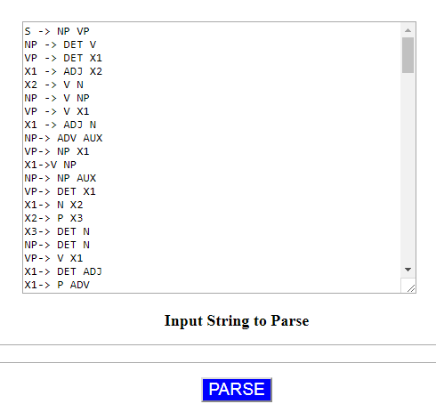

Figure : Index Page with CKY Grammar

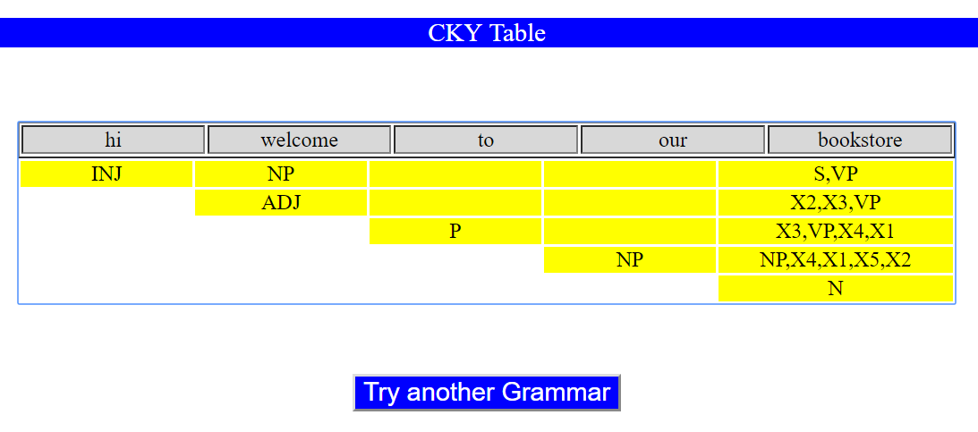

String : hi welcome to our bookstore

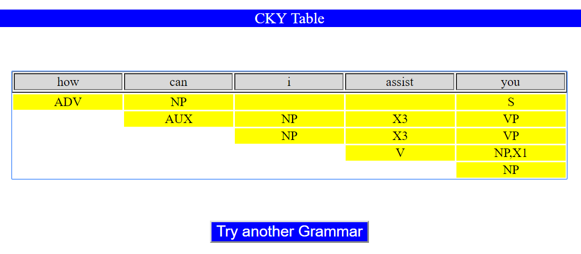

String : how can i assist you

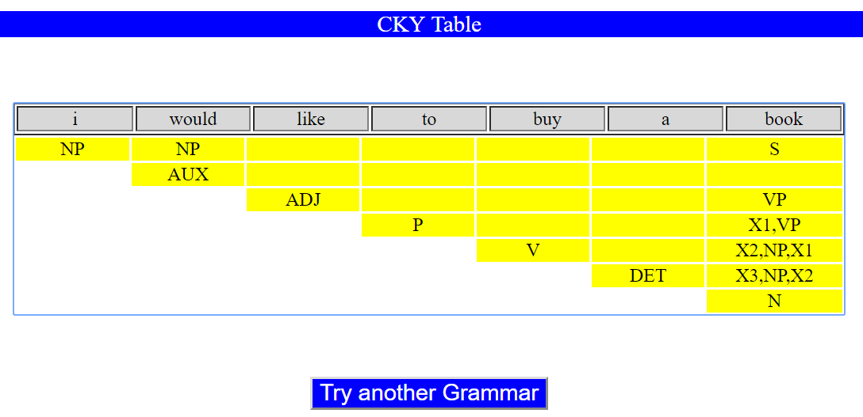

String : i would like to buy a book

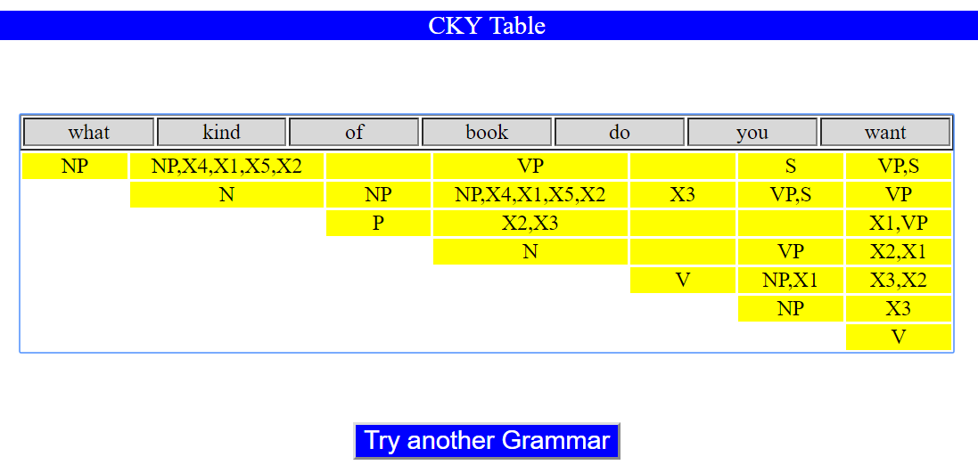

String : what kind of book do you want

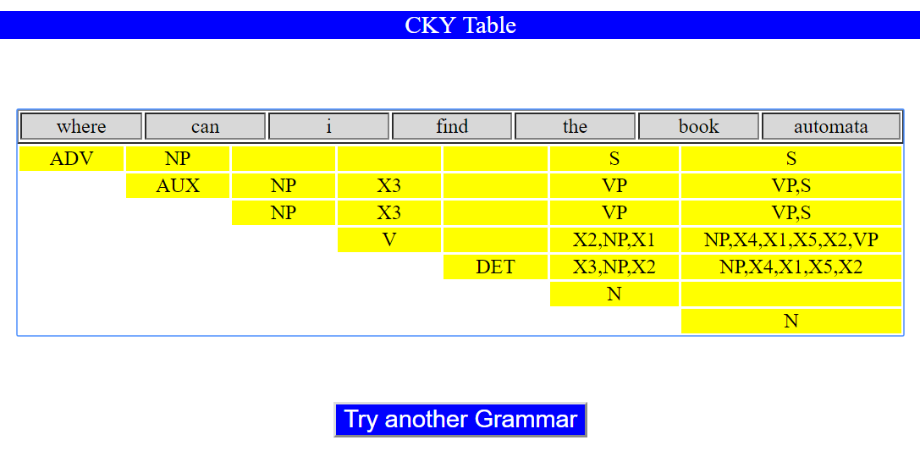

String : where can i find the book automata

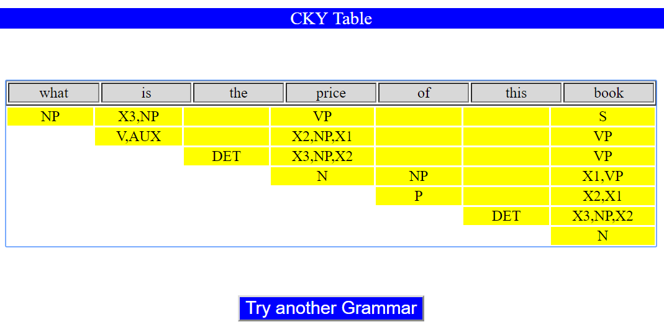

String : what is the price of this book

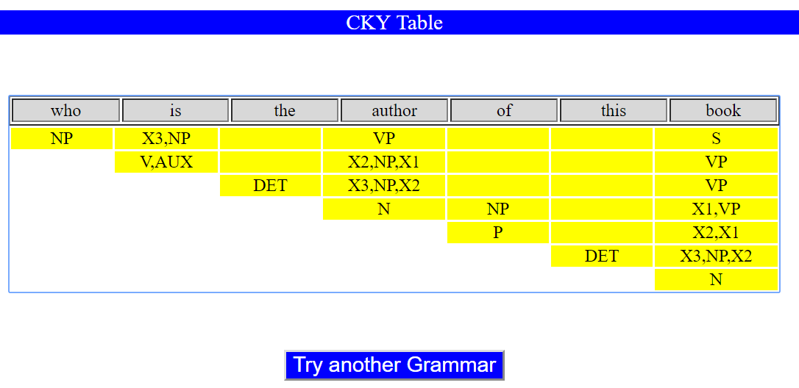

String : who is the author of this book

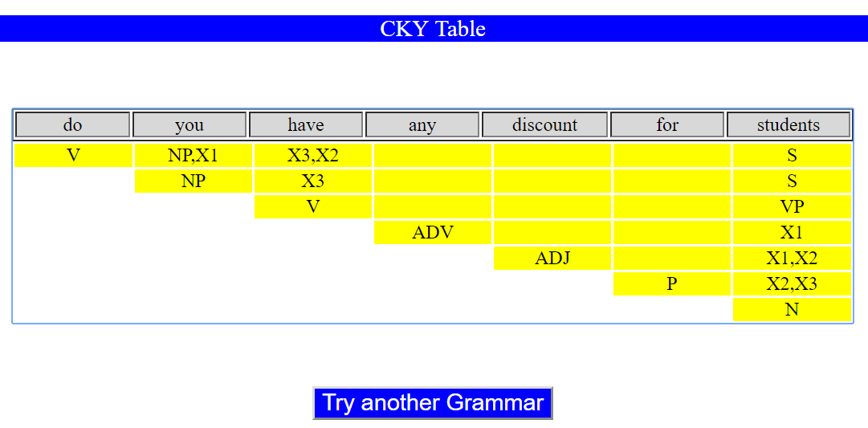

String : do you have any discount for students

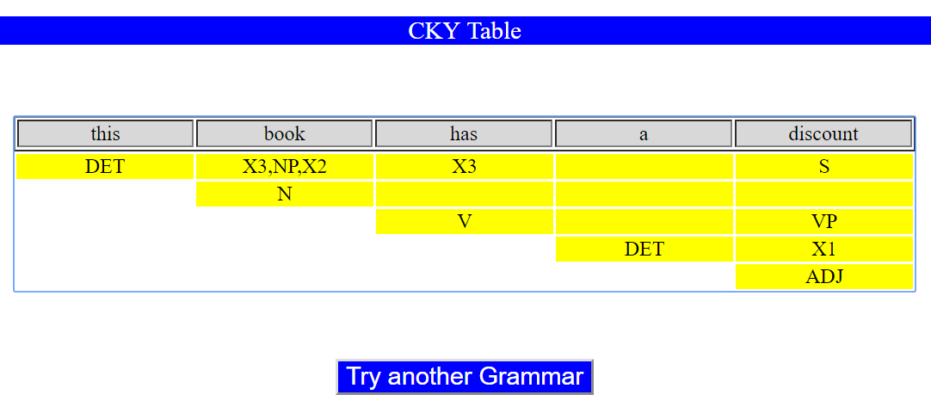

String : this book has a discount

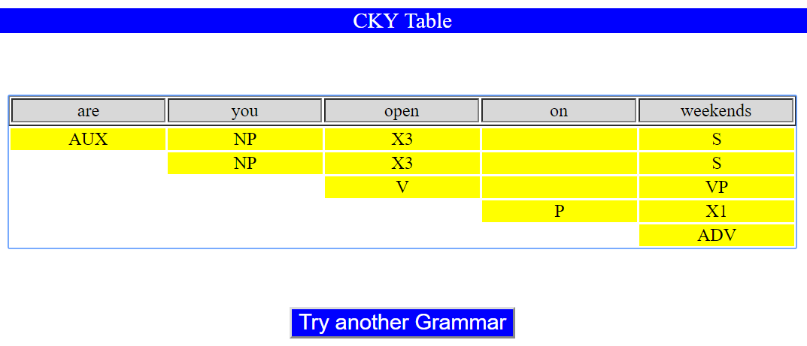

String 10: are you open on weekends

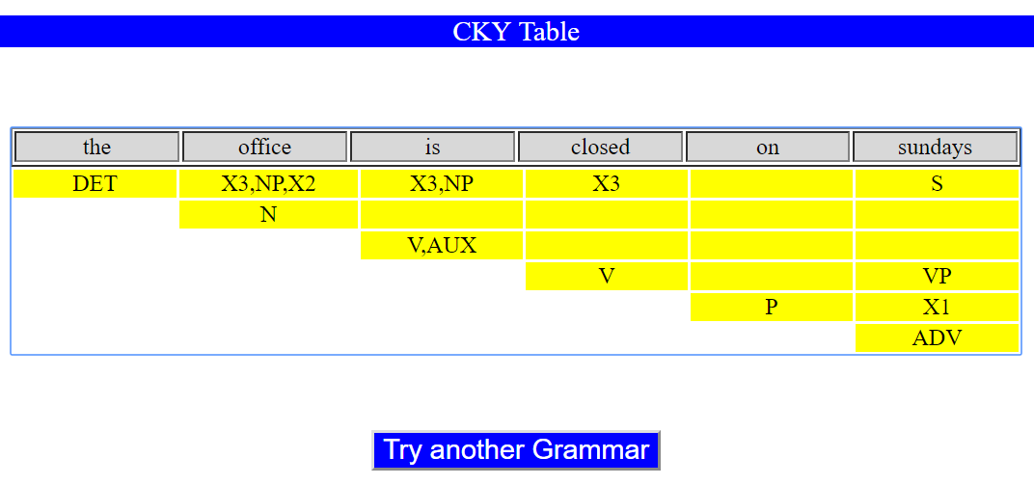

String 11: the office is closed on sundays

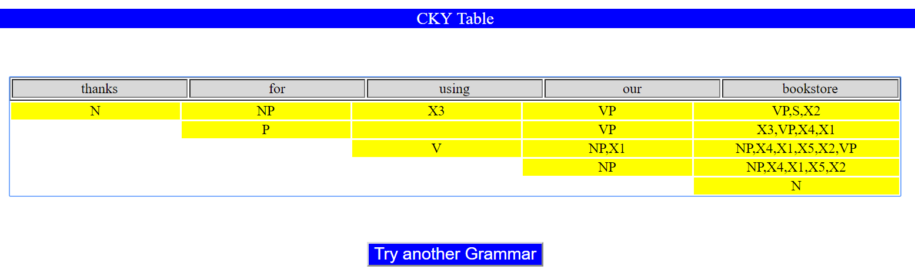

String : thanks for using our bookstore

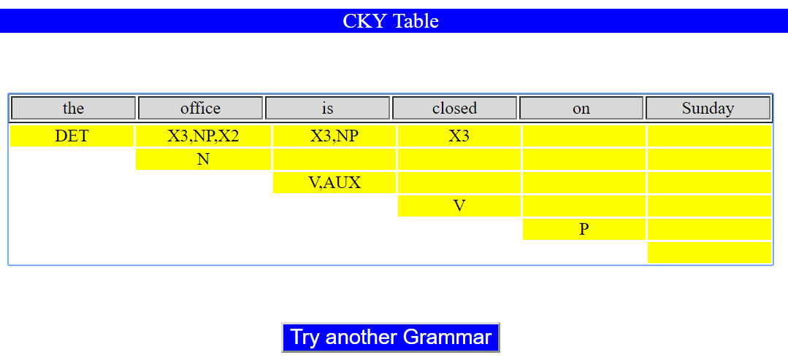

String : the office is closed on Sunday

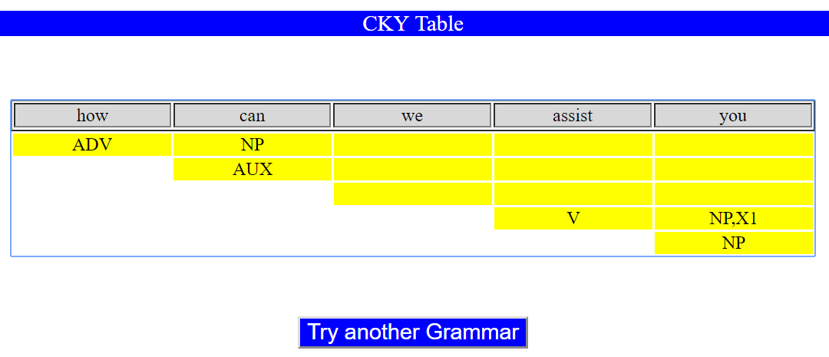

String : how can we assist you

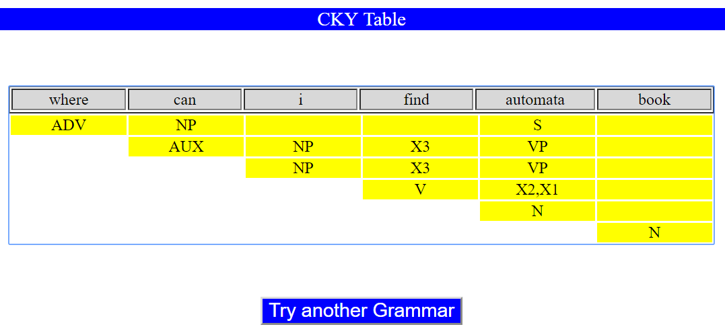

String : where can i find automata book

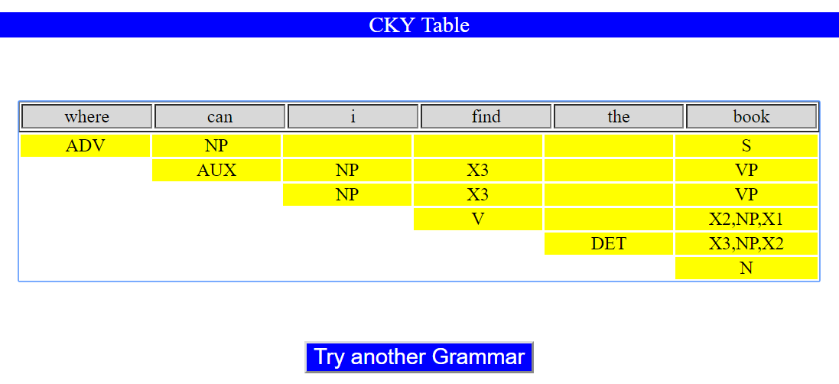

String : where can i find the book

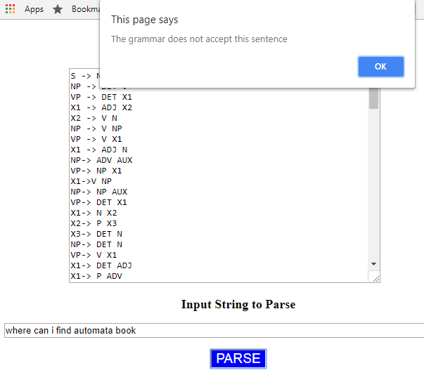

Figure : Wrong String Error Message

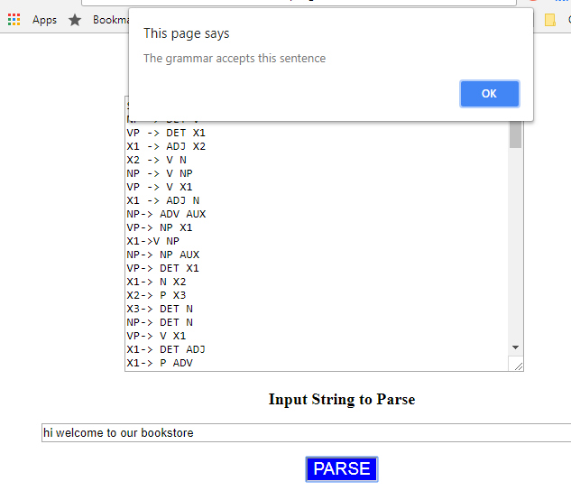

Figure : Correct String Acceptance Message