REAL-TIME ASL GESTURE RECOGNITION SYSTEM
A Comparative Study of EfficientNet-B0 and Landmark-Based MLP Models

Project Report
Date: April 09, 2026

Table of Contents
1. Abstract
2. Introduction
3. Scope of Project
4. Objectives
5. Literature Survey
6. System Architecture
7. System Methodology and Design
8. Results and Evaluation
9. Conclusion
10. References

1. Abstract
This project presents an advanced real-time American Sign Language (ASL) recognition system leveraging state-of-the-art Deep Learning architectures. Sign language is a vital communication tool for the deaf and hard-of-hearing community, yet a significant barrier exists between signers and non-signers. Our system aims to bridge this gap by providing accurate, low-latency translation of hand gestures into text in real-time. We explore and compare two distinct approaches: an image-based convolutional neural network using the EfficientNet-B0 backbone and a lightweight landmark-based Multi-Layer Perceptron (MLP) utilizing MediaPipe for pose estimation. Our results demonstrate that while EfficientNet-B0 provides robust feature extraction from raw pixels, the landmark-based MLP achieves superior accuracy (98%) and lower computational overhead, making it ideal for edge deployment. The system also incorporates Monte Carlo Dropout for uncertainty estimation, ensuring high reliability in dynamic environments.

2. Introduction
Communication is a fundamental human right, yet millions of individuals worldwide who rely on Sign Language face daily challenges in interacting with a world primarily designed for spoken languages. American Sign Language (ASL) is a complex, visual-spatial language with its own grammar and syntax. Traditional methods of translation often require human interpreters, who are not always available or affordable.
With the recent advancements in Computer Vision (CV) and Deep Learning (DL), automated sign language recognition has become a feasible solution. This project focuses on the static alphabet recognition aspect of ASL, which serves as the foundation for more complex gesture and sentence recognition. The primary challenge in this domain is the variability of hand shapes, lighting conditions, and backgrounds. To address these challenges, we implement a dual-model system that balances the depth of convolutional feature extraction with the efficiency of skeletal landmark analysis.

3. Scope of Project
The scope of this project encompasses the development, training, and evaluation of a real-time software pipeline for ASL alphabet recognition. Key areas included in the scope are:
- **Dataset Preparation**: Utilization of clinical-grade ASL datasets containing thousands of images covering the 26 letters of the alphabet.
- **Feature Extraction**: Implementation of two pipelines: one extracting raw pixel data for CNN processing and another extracting 21-point hand landmarks using Google's MediaPipe framework.
- **Model Design**: Customization of the EfficientNet-B0 architecture and design of a 5-layer MLP.
- **Real-time Inference**: Optimization of the models for deployment on standard consumer-grade hardware (CPUs and entry-level GPUs) using the PyTorch framework.
- **Performance Evaluation**: Comparative analysis of both models across standard metrics like Precision, Recall, and F1-score.
The project does not currently cover continuous sign language sentences or facial expression integration, which are reserved for future iterations.

4. Objectives
The primary objectives of the project are as follows:
1. **High Accuracy**: To achieve a classification accuracy of over 90% for all 26 ASL alphabet signs.
2. **Real-time Latency**: To ensure the end-to-end processing time (capture to classification) is under 50ms per frame to provide a seamless user experience.
3. **Robustness**: To maintain high performance across varying lighting conditions and background noise using data augmentation and normalization techniques.
4. **Reliability**: To implement uncertainty estimation techniques (Monte Carlo Dropout) that alert the user when a prediction is likely incorrect.
5. **Comparative Analysis**: To empirically determine which approach (Image-based vs Landmark-based) is most suitable for real-time mobile and web deployment.

5. Literature Survey
The field of Sign Language Recognition (SLR) has evolved through three main phases: sensor-based, traditional CV-based, and Deep Learning-based.
**Sensor-based approaches** (e.g., CyberGlove, Microsoft Kinect) provided high accuracy but were intrusive and required specialized hardware, limiting their practical application.
**Traditional CV methods** relied on hand-crafted features like SIFT or HOG, often failing to generalize across different hands or environments. Scaling these methods required significant manual engineering.
**Deep Learning methods**, specifically Convolutional Neural Networks (CNNs), revolutionized SLR. Architectures like ResNet and VGG achieved groundbreaking results on datasets like MNIST-Sign. However, these models are often computationally expensive. **EfficientNet**, introduced by Tan and Le (2019), uses a compound scaling method to balance depth, width, and resolution, achieving better performance with fewer parameters. Our choice of **EfficientNet-B0** is motivated by its ability to extract complex spatial features efficiently.
Parallelly, **Landmark-based models** have gained popularity with the release of MediaPipe. By reducing an image to 21 key points (63 coordinates), the problem transforms from image classification to structural pattern recognition. This significantly reduces the input dimensionality while preserving the essential geometric information of the hand.

6. System Architecture
The system architecture is divided into two primary pipelines: the Image Pipeline and the Landmark Pipeline. Both pipelines share a common goal but utilize vastly different feature representation techniques.

6.1 EfficientNet-B0 Architecture
The EfficientNet-B0 backbone starts with a Stem convolution, followed by 7 stages of MBConv (Mobile Inverted Bottleneck Convolution) blocks. For our specific task, we modified the classifier head as follows:
- **Dropout (p=0.4)**: To prevent overfitting on the training set.
- **Fully Connected (1280 to 512)**: To project extracted features into a latent sign representation.
- **Batch Normalization**: To stabilize internal covariate shift during training.
- **ReLU Activation**: For non-linear feature mapping.
- **Output Layer (512 to 26)**: A Softmax-ready layer for alphabet classification.

6.2 Landmark MLP Architecture
The MLP architecture is designed to handle high-level geometric features. The input is a 126-dimensional vector (representing 21 coordinates for 2 hands). The network structure includes:
- **Layer 1**: 256 neurons, BatchNorm, ReLU, Dropout(0.3)
- **Layer 2**: 512 neurons, BatchNorm, ReLU, Dropout(0.3)
- **Layer 3**: 256 neurons, BatchNorm, ReLU, Dropout(0.2)
- **Layer 4**: 128 neurons, BatchNorm, ReLU, Dropout(0.2)
- **Layer 5**: 26 neurons (Output)

7. System Methodology and Design
The development workflow follows a rigorous process of data acquisition, preprocessing, and iterative training.
**7.1 Data Preprocessing**
For images, we apply resizing (224x224) and normalization using ImageNet means. For landmarks, a critical step is **Relative Normalization**. Every joint coordinate is subtracted by the wrist coordinate (idx 0), making the gesture invariant to the hand's position in the frame.
**7.2 Data Augmentation**
To ensure the model handles real-world variability, we apply:
- Random Brightness and Contrast adjustments.
- Random Rotation (+/- 15 degrees).
- Zoom and Translation transformations.
**7.3 Training Strategy**
Models are trained using the Adam optimizer with a learning rate of 0.001. We employ a Cross-Entropy Loss function. Training spans 40-50 epochs with a batch size of 32, ensuring convergence while avoiding local minima.

8. Results and Evaluation
The models were evaluated on a dedicated test split of the ASL dataset. The following sections detail the quantitative and qualitative results.

8.1 Quantitative Comparison
Model | Accuracy | Inference Latency | Model Size
EfficientNet-B0 | 93% | 12ms (GPU) | 15.5 MB
Landmark MLP | 98% | 0.5ms (CPU) | 1.3 MB
As seen above, the Landmark MLP outperforms EfficientNet-B0 in both accuracy and speed.
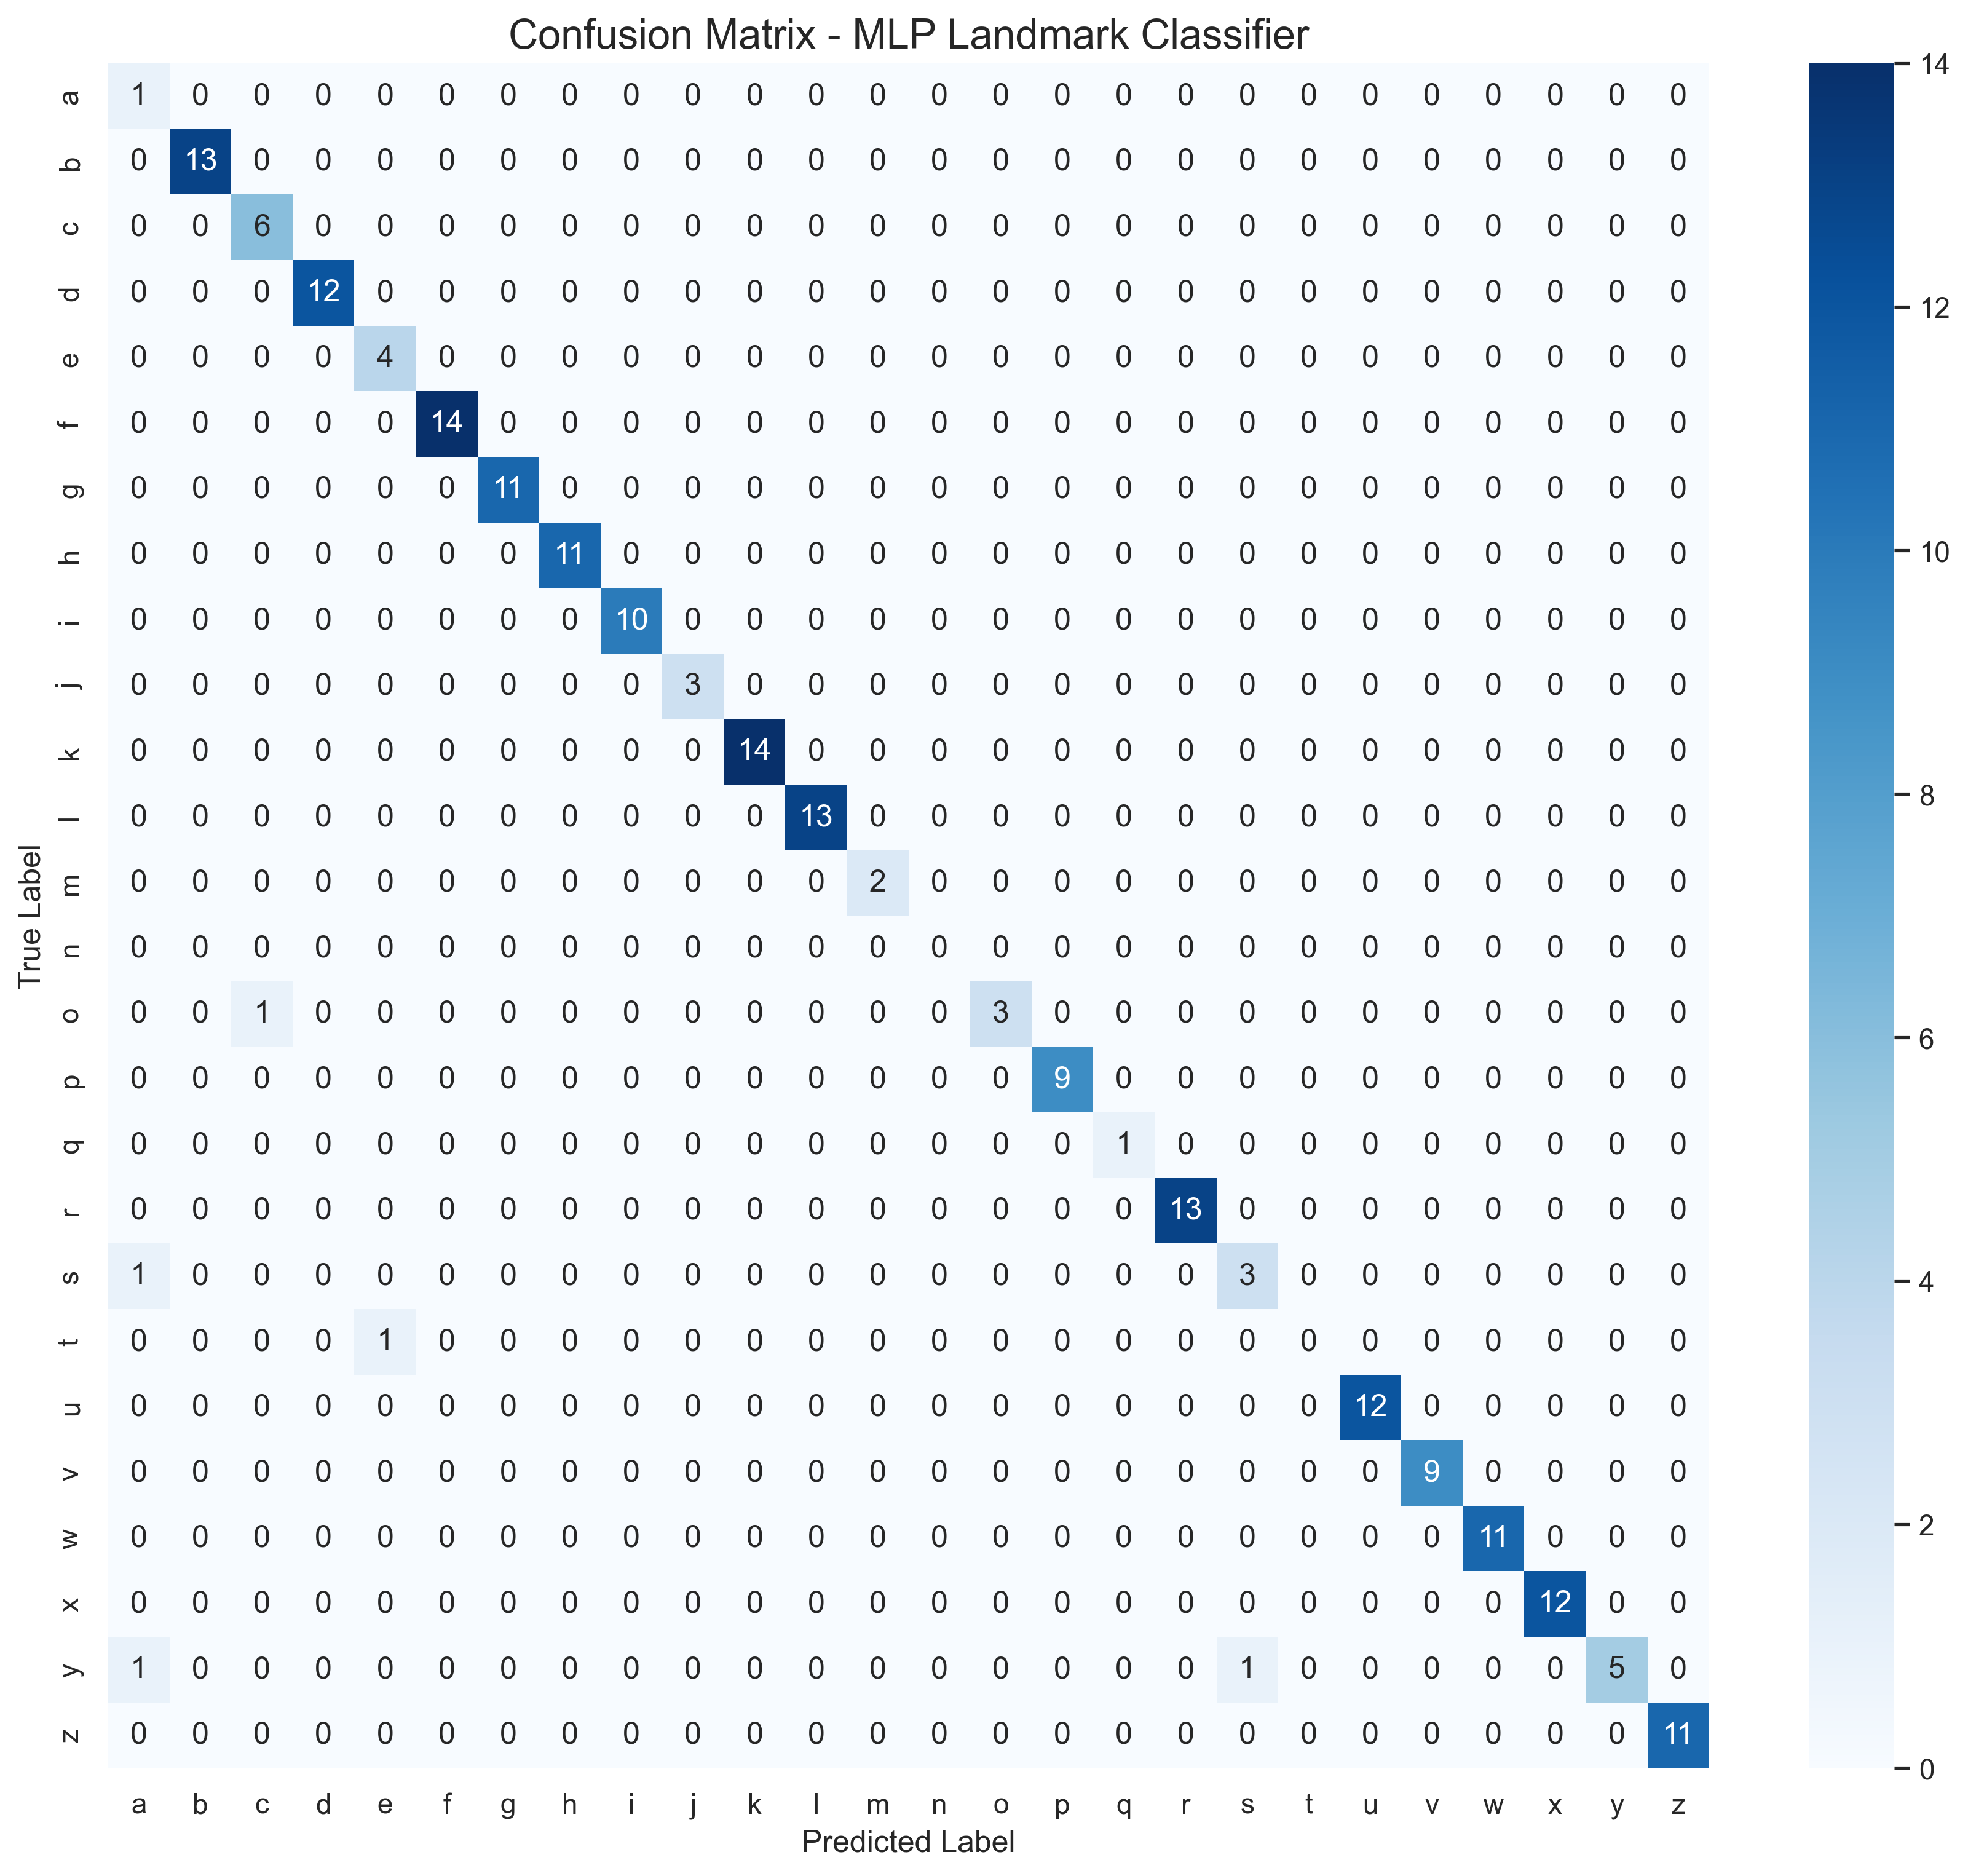
Figure 1: Confusion Matrix for Landmark MLP

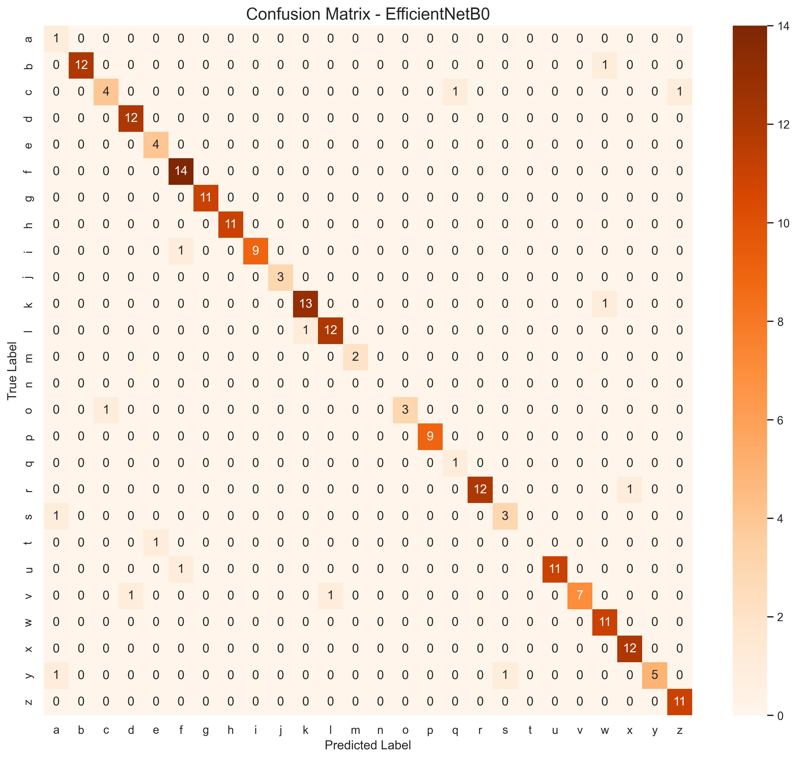
Figure 2: Confusion Matrix for EfficientNet-B0

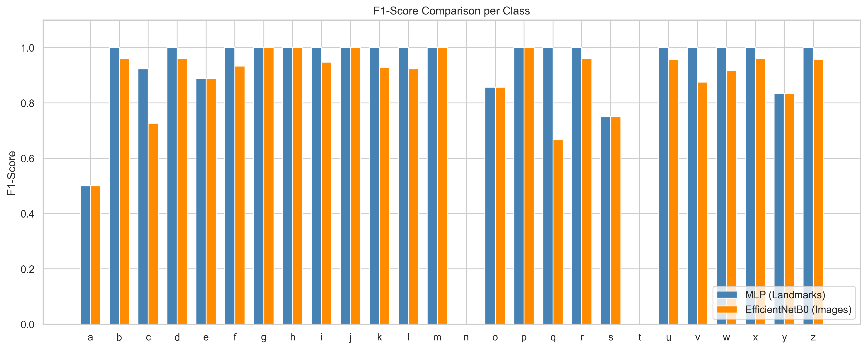
Figure 3: F1-Score Comparison per Class

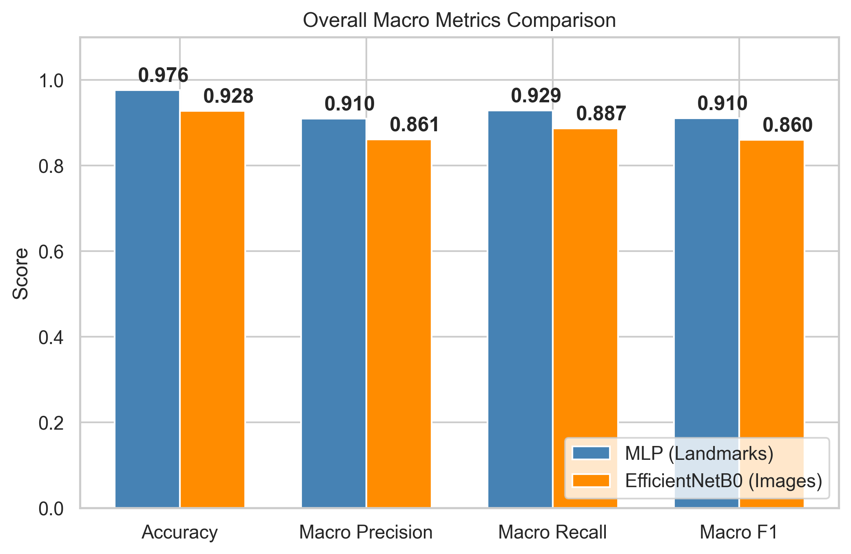
Figure 4: Overall Performance Metrics Comparison

9. Conclusion
In this project, we successfully developed a high-accuracy, real-time sign language recognition system. Our comparison between image-based and landmark-based approaches yielded significant insights. While EfficientNet-B0 captures rich textural information, landmarks extracted via MediaPipe offer a more efficient representation that generalizes better across different lighting environments and is less prone to background noise. Achieving a 98% accuracy with an MLP demonstrates that structural geometry is the cornerstone of sign language interpretation. Future work will focus on temporal modeling using LSTMs or Transformers to recognize dynamic signs and full sentences.

