Day 1 – 10/09/2024

Q] Program to print n natural numbers

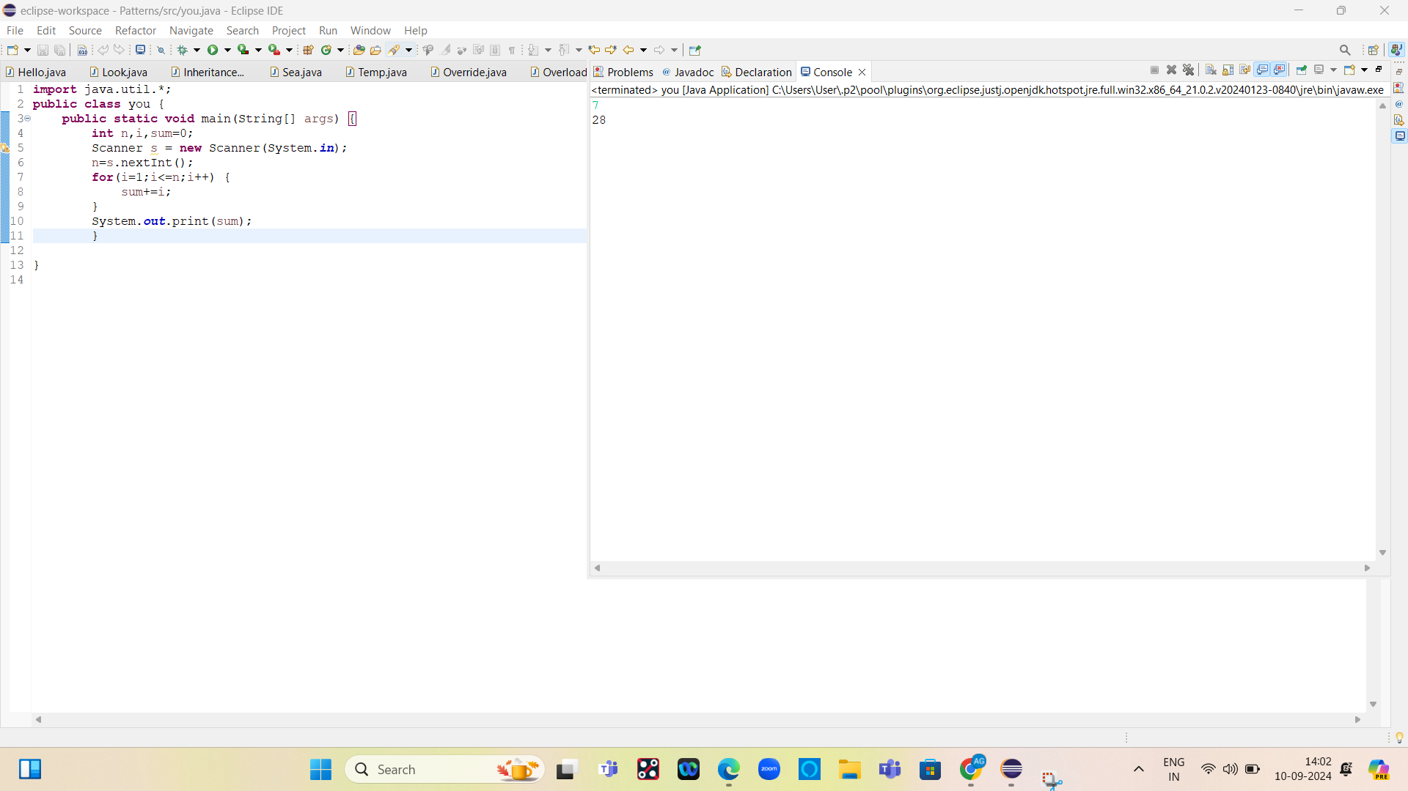

Code:

**import** java.util.*;

**public** **class** you {

**public** **static** **void** main(String[] args) {

**int** n,i,sum=0;

Scanner s = **new** Scanner(System.***in***);

n=s.nextInt();

**for**(i=1;i<=n;i++) {

sum+=i;

}

System.***out***.print(sum);

}

}