**Sensor Basics:**

**Types of Sensors and Their Functions:**

1. **Proximity Sensor**: Detects the presence or absence of an object without physical contact. Used in applications like detecting the position of a machine part or a person entering a room.

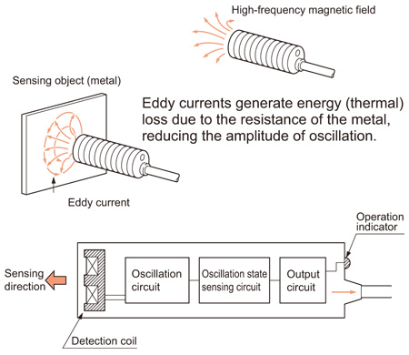 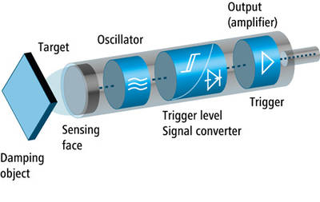

2. **Temperature Sensor**: Measures temperature. Common types include thermocouples, RTDs, and thermistors.

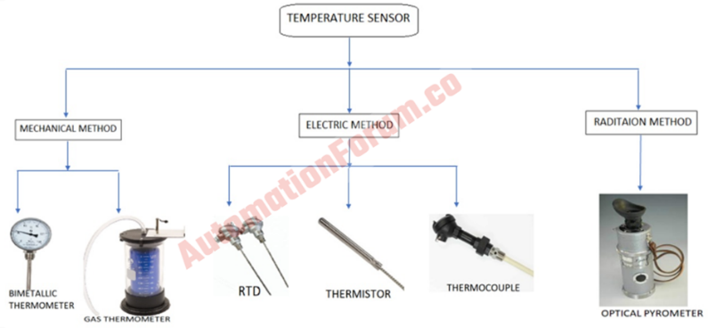

3. **Phototransistor**: Converts light intensity into an electrical signal. Used in light sensing applications like automatic lighting and optical encoders.

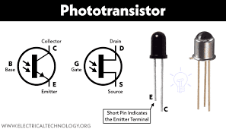

4. **Inductive Proximity Sensor:** Operates on the principle of magnetic induction, detecting metallic objects by inducing eddy currents in the object.

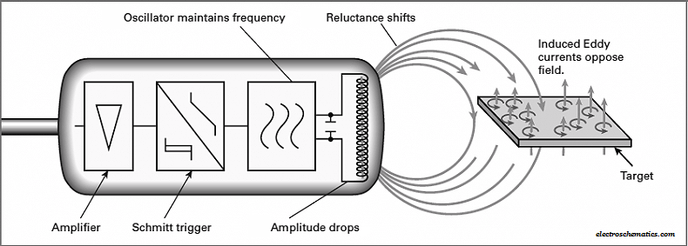

5. **Capacitive Proximity Sensor**: Measures changes in capacitance to detect objects, including non-metallic materials such as liquids or plastics.

**Sensor Integration with PLCs:**

**PLC Modules for Sensor Integration:**

**1**. **Analog Input Module**: Interfaces with sensors that provide analog signals (e.g., 4-20 mA, 0-10 V). It converts the analog signal to a digital form that the PLC can process. An analog input module in a PLC system converts analog signals from sensors (like temperature or pressure sensors) into digital signals the PLC can process. It handles signal conversion, scaling, and noise filtering. Sensors such as thermocouples or RTDs connect to it to measure physical quantities. The module configuration must match the sensor's output range. In the PLC program, instructions like SCP scale the raw data to meaningful units for control and monitoring

**2.** **Digital Input Module**: Examples include limit switches and proximity sensors. A digital input module in a PLC system reads binary signals (ON/OFF) from sensors and switches. It detects the presence or absence of voltage to determine the state of connected devices, such as limit switches or proximity sensors. The module translates these signals into a format the PLC can process for control logic. Wiring and configuration must ensure proper signal detection. Digital inputs are typically used for simple, discrete events in automation systems.

**3. Signal Conditioning:** Essential for converting sensor signals into a form suitable for PLC inputs, such as amplifying, filtering, or converting signals. Signal conditioning involves processing raw sensor signals to make them suitable for input into a PLC. This may include:

1. Amplification: Increasing the signal strength to match the input range of the PLC module.
2. Filtering: Removing noise and unwanted frequencies to ensure a clean signal.
3. Isolation: Protecting the PLC from high voltage spikes and grounding issues by electrically isolating the signal.
4. Linearization: Converting nonlinear sensor outputs to a linear form for accurate measurement.
5. Conversion: Changing the signal type, such as converting current to voltage or vice versa, to match the PLC input requirements.

These steps ensure accurate, reliable, and safe sensor data for processing by the PLC.

**Sensor Types and Applications:**

**Applications of Different Sensors:**

**1. Encoders:** Measure the rotational position of a shaft, providing precise control in automation systems. Encoders are sensors used to detect the rotational position, speed, or direction of a shaft or motor. They generate digital signals corresponding to the shaft's angular displacement. Types include:

1. **Incremental Encoders**: Output pulses proportional to shaft rotation, used for speed and position control.
2. **Absolute Encoders**: Provide unique digital codes for each shaft position, enabling precise position feedback.
3. **Rotary Encoders**: Detect rotation in a circular motion.
4. **Linear Encoders**: Measure linear displacement along a straight path.

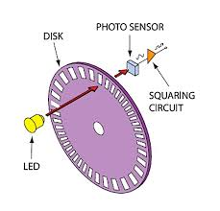

**2.** **Ultrasonic Sensor**: Measures distance by emitting ultrasonic waves and measuring the time it takes for the waves to return. Used in level measurement in tanks. Ultrasonic sensors utilize sound waves with frequencies above the human audible range to measure distance or detect objects. They emit ultrasonic pulses and measure the time it takes for the pulses to bounce back after hitting an object, calculating distance based on the speed of sound. Common types include:

1. **Ultrasonic Distance Sensors**: Measure distance by sending and receiving ultrasonic waves.

2. **Ultrasonic Proximity Sensors**: Detect the presence of objects within a certain range without physical contact.

3. **Ultrasonic Level Sensors**: Monitor liquid levels in tanks by measuring the distance to the liquid surface.

4. **Ultrasonic Motion Sensors**: Detect movement by analyzing changes in reflected sound waves.

These sensors are widely used in robotics, industrial automation, parking assistance systems, and home security applications for accurate and non-contact detection.

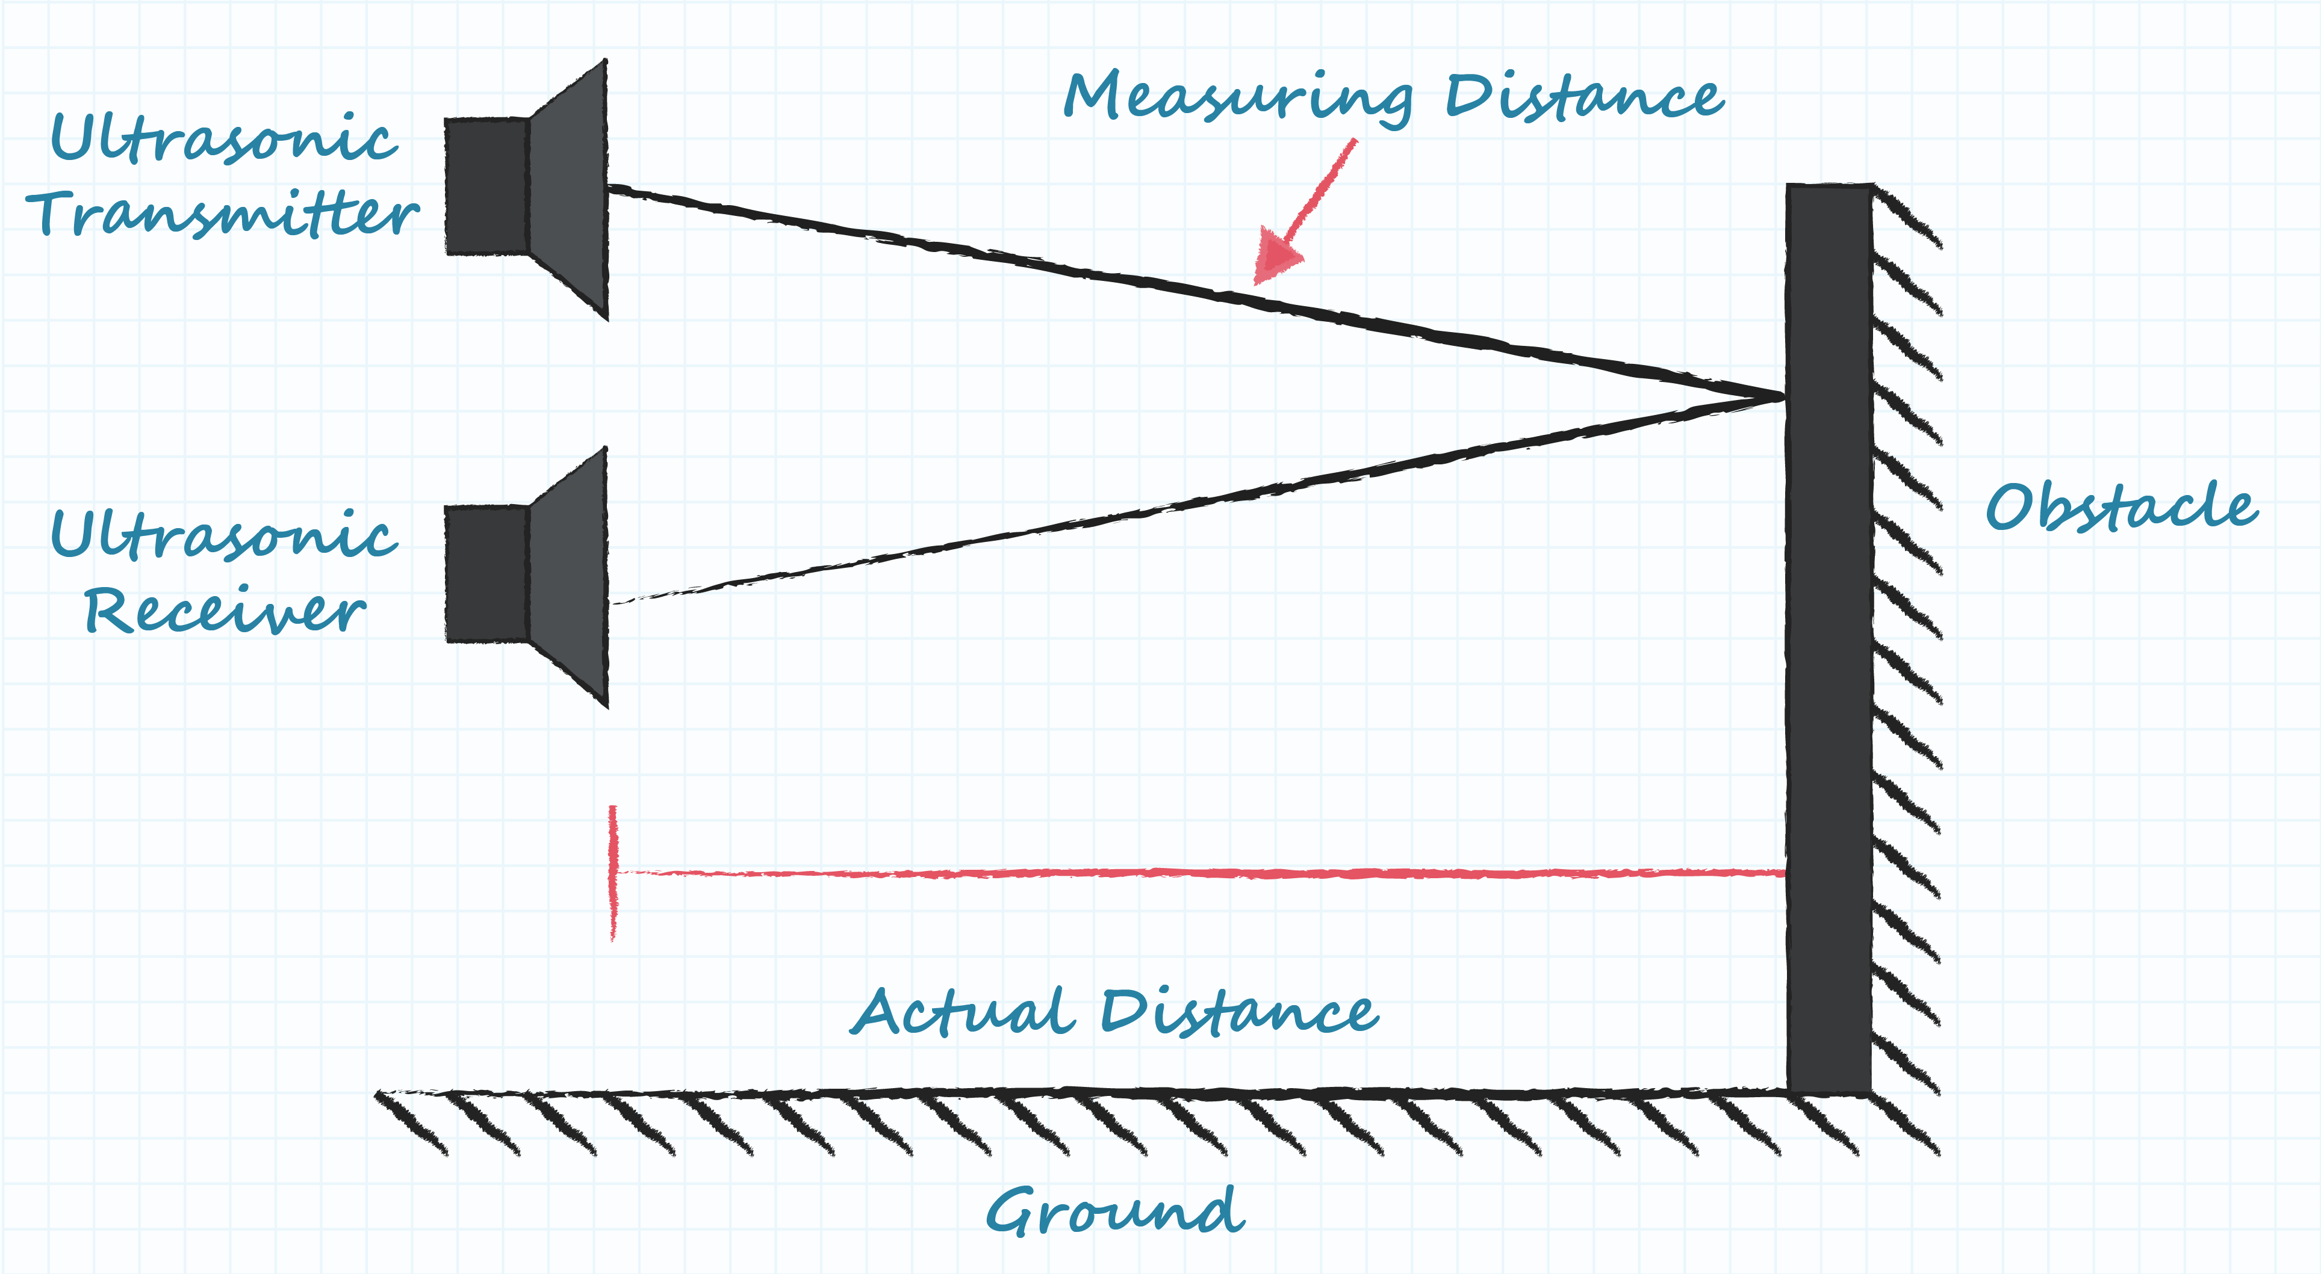

**3.** **Strain Gauge**: Measures force or load by detecting changes in electrical resistance caused by deformation. A strain gauge is a sensor used to measure the strain or deformation of an object. It consists of a thin conductive wire or foil arranged in a grid pattern on a flexible backing material. When the object to which the strain gauge is attached undergoes mechanical stress or strain, the wire stretches or compresses, causing changes in its electrical resistance. By measuring these changes, the strain on the object can be accurately determined.

Strain gauges are commonly used in structural engineering, materials testing, and load monitoring applications to measure forces, stresses, and deformations. They play a crucial role in ensuring the structural integrity and safety of various mechanical systems, including bridges, buildings, aircraft, and industrial machinery.

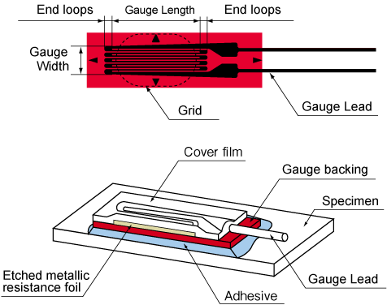

**4.** **Radar Sensor**: Uses the Doppler effect to measure velocity, commonly used in speed detection applications. A radar sensor uses radio waves to detect objects, measuring their distance, speed, and direction by analyzing reflected signals. It operates by emitting radio pulses and analyzing the echoes bounced back from objects. Radar sensors are adept at detecting objects in various conditions, including adverse weather. They're commonly used in automotive safety systems, traffic monitoring, industrial automation, and weather forecasting. Their reliability in diverse environments makes them indispensable for many applications.

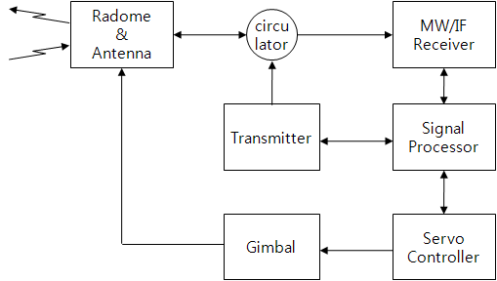

**5.** **Anemometer**: Used in HVAC systems to detect air flow by measuring wind speed. An anemometer is a sensor used to measure wind speed and direction. It typically consists of cups that rotate in the wind, a vane that points into the wind, or ultrasonic sensors that measure the time taken for sound waves to travel between transducers in different directions. By analyzing these movements or signals, the anemometer determines wind speed and direction. Anemometers are crucial for weather monitoring, aviation, maritime navigation, and various industrial applications where wind conditions impact safety and efficiency.

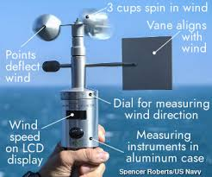

**Advanced Sensor Concepts**

**Key Concepts:**

1. **Debouncing**: A technique used to prevent false triggering of sensors due to mechanical noise. Important for ensuring accurate digital inputs in PLC programming. Debouncing is a technique used to filter out electrical noise or mechanical vibration in digital signals, particularly from switches or sensors. It ensures that a clean, stable signal is received by the system, preventing false or erratic triggering of events. Debouncing typically involves adding a delay or filtering mechanism to the signal processing circuitry to ignore rapid changes in the signal state that occur due to noise or mechanical bounce. This ensures that only valid and intentional signal transitions are recognized, improving the reliability and accuracy of digital input readings in electronic systems.

2. **Load Cell**: Measures weight by converting mechanical force into an electrical signal through strain gauges. A load cell is a transducer that converts mechanical force or weight into an electrical signal. It typically consists of a metal structure with strain gauges bonded to it. When force is applied to the load cell, it deforms slightly, causing changes in the electrical resistance of the strain gauges. This change in resistance is proportional to the applied force and is measured as an electrical signal, usually in the form of voltage or current. Load cells are used in various applications, including industrial weighing scales, force measurement systems, material testing machines, and load monitoring devices in industries such as aerospace, automotive, and manufacturing.

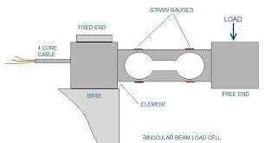

3. **PID Control**: Stands for Proportional-Integral-Derivative control, adjusting output based on the difference between a setpoint and the measured variable. PID control is a feedback control technique used to maintain a desired setpoint. It adjusts a control output based on the error, integrating past errors, and predicting future trends. Proportional control responds to the current error, integral control eliminates steady-state error over time, and derivative control anticipates changes in the error rate. Combining these actions provides precise and stable control in diverse systems, from temperature regulation in ovens to speed control in motors.

**Sensor Calibration and Testing**

**Importance of Calibration:**

1. **Calibration**: Adjusting a sensor's output to match a known standard, ensuring accurate and reliable readings.

2. **Signal Generator**: A device used to simulate sensor signals during PLC testing, verifying the PLC's response to different sensor inputs.

3. **Span Adjustment**: Setting the range of the sensor output to match the measured variable, crucial for ensuring that sensor readings are accurate over the expected range of values.

**Sensor Programming in PLCs**

**PLC Programming Instructions:**

1. **Digital Inputs in Ladder Logic**: Represented as contacts, which are used to read the state (ON/OFF) of a sensor.

2. **Analog Inputs**: Often require scaling (e.g., using the SCP instruction) to map the raw sensor signal to a meaningful engineering unit.

3. **Comparison Instructions**: Instructions like GRT (Greater Than) are used to activate outputs based on sensor readings exceeding certain values.

**Sensor-Related Safety and Maintenance**

**Safety and Maintenance:**

1. **Redundancy**: Important in safety applications to provide backup in case of sensor failure, ensuring continuous operation.

2. **Shielded Cables**: Used to ensure signal integrity in noisy industrial environments by protecting sensor signals from electromagnetic interference.

3. **Regular Recalibration**: Crucial for maintaining the long-term reliability and accuracy of sensors.

**Sensor Data Analysis and Processing**

**Data Processing Techniques:**

1. **Filtering**: Necessary for noisy analog sensor data to provide stable and accurate readings.

2. **Hysteresis**: A range where no output change occurs despite input changes, used to prevent rapid switching of sensor outputs.

3. **Averaging**: Functions like AVG are used to smooth out sensor readings over time, providing more stable data for decision-making.

**Sensor-Based Control Strategies**

**Control Strategies:**

1. **PID Control**: Adjusts outputs based on proportional, integral, and derivative terms to maintain the desired setpoint.

2. **Multi-Sensor Fusion**: Uses data from multiple sensors to improve system accuracy and reliability, particularly in complex environments.

**Sensor Innovations and Future Trends**

**Emerging Technologies:**

1. **Artificial Intelligence (AI)**: Integrated with sensors for enhanced data analysis, predictive maintenance, and smarter decision-making in industrial automation.

2. **Wireless Sensors**: Offer easier installation and maintenance, especially in environments where wiring is challenging or costly.

3. **Internet of Things (IoT)**: Enables remote monitoring and control of sensors, significantly enhancing the capabilities and flexibility of PLC systems in industrial applications.