INTERNET & WORLD WIDE WEB

Terminology and how it works

INTERNET (Wikipedia)  
The global computer network accessible to the public.

It is a network of networks without a nerve center, made up of millions of networks, both public and private.

As the internet has been popularized by the appearance of the World Wide Web (WWW), both are sometimes confused by the unsuspecting public. The World Wide Web is only one of the applications of the Internet.

WORLD WIDE WEB (Wikipedia)  
The "web (spider) world", commonly called the Web, and sometimes the Web, is a public hypertext system running on the Internet.

Retrieved 6 August 1991.

The Web is just one of the distinct Internet applications of other applications such as email, instant messaging, and peer-to-peer file sharing. The Web was invented by Tim Berners-Lee in 1989, several years after the Internet, but it was he who made the public aware of the Internet.

The word "Canvas" is often used in non-technical texts without clearly designating the Web or the Internet.

IP ADDRESS (Wikipedia)

An IP address (with IP for Internet Protocol) is an identification number that is permanently or temporarily assigned to each device connected to a computer network using the Internet Protocol. The IP address is the basis of the routing system (routing) messages on the Internet.

MAC ADDRESS (Wikipedia)

A Media Access Control (MAC) address, sometimes called a physical address, is a physical identifier stored in a network adapter or similar network interface. Unless it has been modified by the user, it is unique in the world. The MAC (acronym for Media Access Control) has nothing to do with the Apple Mac (diminutive Macintosh). All network cards have a MAC address, even those contained in PCs and other connected devices (touch pad, smartphone, game consoles ...).

DOMAINE NAME (Wikipedia)

A domain name is, in the domain name system, an internet domain identifier. A domain name is a "mask" on an IP address.

The purpose of a domain name is to easily remember and communicate the address of a set of servers (website, email, FTP). For example, wikipedia.org is easier to remember than 208.80.154.224 or 91.198.174.192.

The organization that manages the reservation of domain names is called a "registrar". The registrar is in direct contact with the end customer. He has registered with the various domain name registries according to the extensions he wants to market (he pays for this an annual fee).

In Switzerland the best known registrar for .ch domain names is Switch. But there are many other accredited registrars (https://www.nic.ch/en/registrars) and today there is very beneficial competition for the end user.

WEB HOSTING (Wikipedia)

A web host (or web host) is an entity whose purpose is to provide Internet users with websites designed and managed by third parties.

It gives access to all Internet content deposited in their accounts by webmasters often via FTP software or a file manager. For this, it keeps computers switched on and connected 24 hours a day to the Internet (web servers for example) by a very high speed connection (several hundred Mb / s), on which software is installed: HTTP server (often Apache), mail server, database ...

The main activity of the web host is to install its servers, to secure (by a corrugated power supply, rescued by a generator, an air-conditioned room equipped with fire-fighting devices), to keep them up to date by installing the bets security to avoid malicious attacks, to repair them in case of a failure, to install the software technologies desired by customers or that he wishes to offer them (such as the PHP programming language and its modules).

DNS (Wikipedia)

The Domain Name System is a service for translating a domain name into information of several types associated with it, including the IP addresses of the machine with that name.

Computers connected to an IP network, such as the Internet, have an IP address. These addresses are numeric in order to be more easily processed by a machine. To facilitate access to systems that have these addresses, a mechanism has been put in place to associate with an IP address a name, easier to remember, called "domain name". Solving a domain name means finding the IP address associated with it.

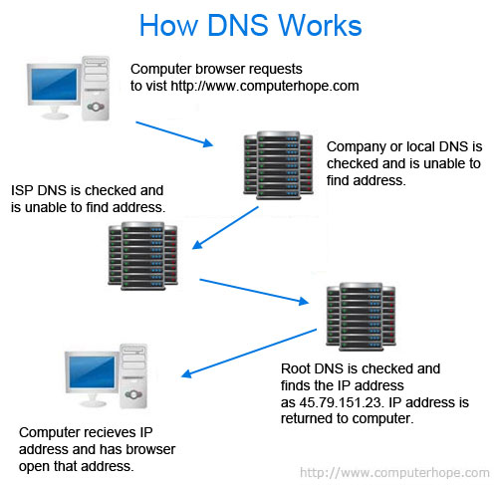

INTERNET COMMUNICATION PROTOCOLS (Wikipedia)

LOW LEVEL

* TCP: Transmission Control Protocol
* UDP: User Datagram Protocol

HIGH LEVEL

* HTTP: HyperText Transfer Protocol
* FTP: File Transfer Protocol
* SMTP: Simple Mail Transfer Protocol
* IMAP: Internet Message Access Protocol

HTTP  
The Hypertext Transfer Protocol, better known by the abbreviation HTTP is a client-server communication protocol developed for the World Wide Web.

HTTPS (with S for secured, or "secure") is the variant of secure HTTP through the use of SSL or TLS protocols.

HTTP REQUEST / RESPONSE EXAMPLE

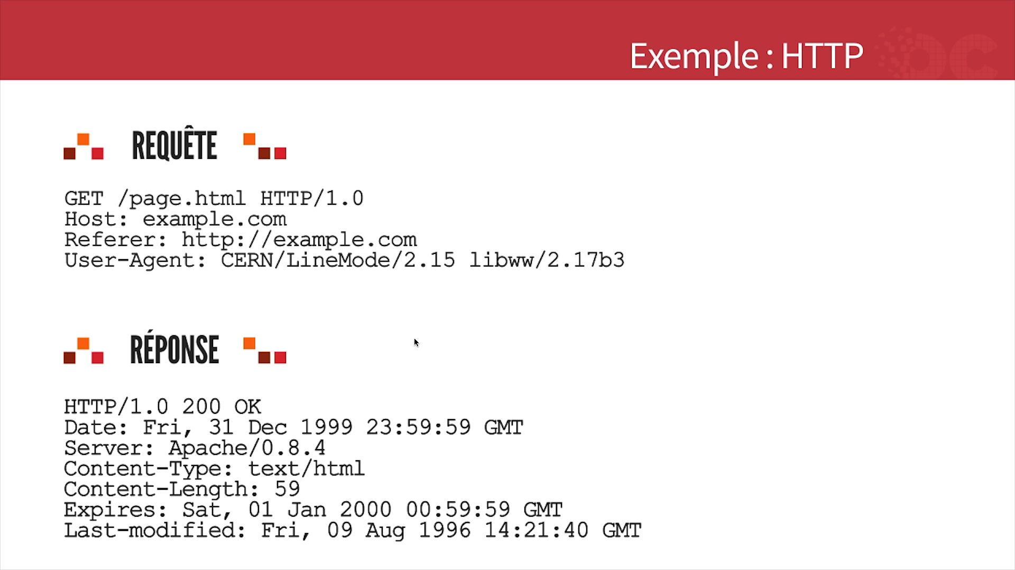

FTP  
File Transfer Protocol or FTP, is a communication protocol for sharing files over a TCP / IP network. It allows you to copy files from a computer to another computer on the network, or to delete or edit files on that computer.

SMTP

Simple Mail Transfer Protocol or SMTP, is a communication protocol used to transfer electronic mail (e-mail) to e-mail servers.

IMAP

Internet Message Access Protocol or IMAP, is a protocol that allows you to access your emails directly on the mail servers.

This protocol allows you to leave the emails on the server for the purpose of being able to consult them from different email clients or Webmail.

URL (Wikipedia)

The abbreviation URL comes from Uniform Resource Locator, which is informally substituted for the expression web address, refers to a string of characters used to address the Internet resources: HTML document, image, sound, Usenet forum, electronic mailbox, among others.

BROWSER (Wikipedia)

A browser ("browser") is a software designed to view and display the World Wide Web. Market shares in January 2018:

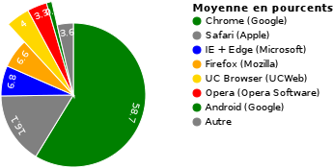

COMPUTER SERVER (Wikipedia)

A computer server is a hardware or software computer device that provides services to different customers.

A server runs continuously, automatically answering requests from other computing devices (clients), according to the so-called client-server principle.

According to Netcraft, there are more than 412 million web servers in the world in March 2014, and their number has been steadily increasing since the invention of the World Wide Web in 1995.

Below, a "Data Center", a room with stacked servers. Ambient temperature between 10-20 ° C

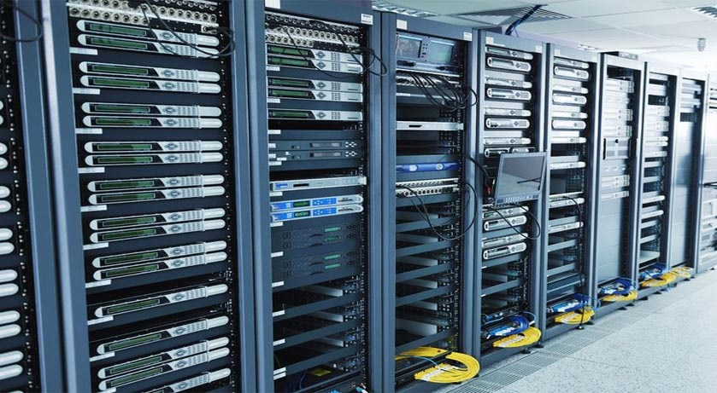

STATIC SITE (Wikipedia)

These sites have the simplest functioning mechanism: the URLs correspond to a file returned by the web server. The content of the pages of a static site does not depend on variables such as date or databases. To change the content of a page, it is necessary to change the contents of the file.

In addition, visitors can only view the content of the site but not participate. To achieve them, only the so-called "client-side" languages (Frontend) are necessary, ie HTML, CSS and JavaScript (in theory, it is however possible to use only the HTML).

DYNAMIC SITE (Wikipedia)

These sites offer content that can evolve over time. Programs run on the server side, in the background (Backend) to generate the pages of the site. These programs can use databases or other data sources to compose the pages that will be displayed in the browser.

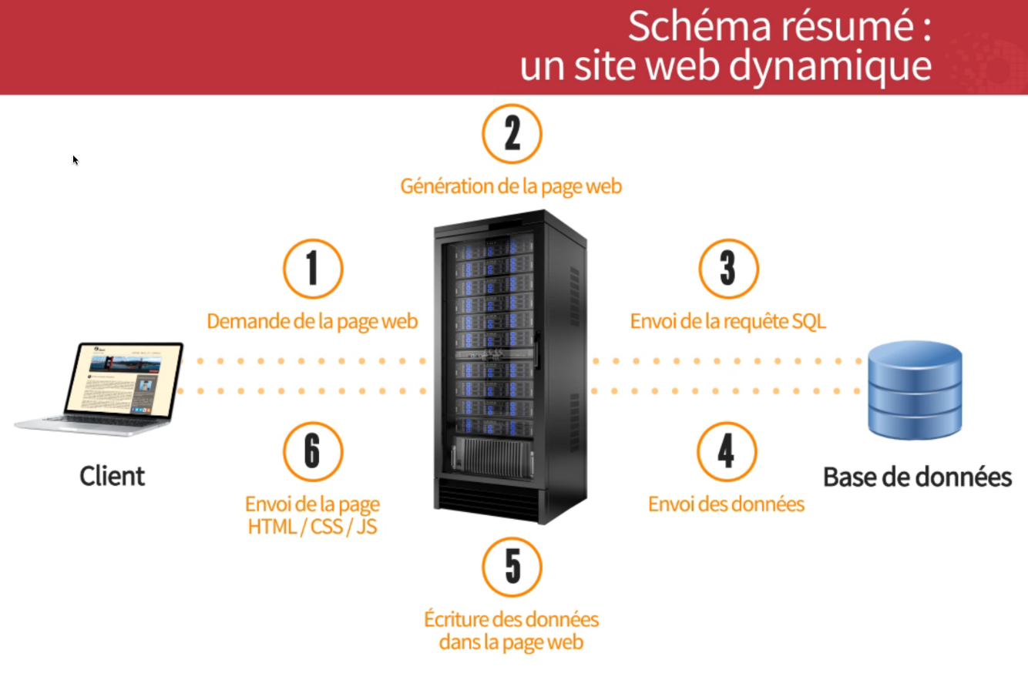

*(image de openclassrooms.com)*

CLIENT SIDE LANGUAGES - Interpreted by your browser:

The "clients" are: Chrome, Firefox, Internet Explorer, Safari, Opera, etc.

* HTML
* CSS
* JavaScript

Client languages and responsabilities:

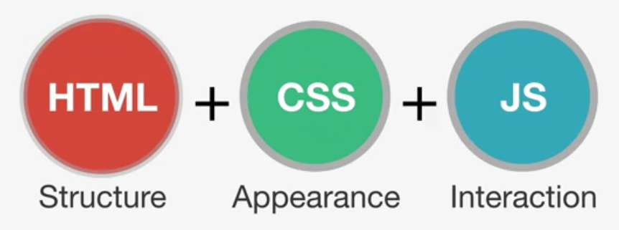

HTML

HyperText Markup Language, usually abbreviated HTML, is the data format designed to represent web pages. It is a markup language for writing hypertext, hence its name.

HTML also allows to structure semantically and logically and to format the content of the pages

CSS

Cascading Style Sheets, commonly referred to as Cascading Style Sheets, form a computer language that describes the presentation of HTML documents.

JavaScript

JavaScript is a scripting language mainly used in interactive web pages.

SERVER SIDE LANGUAGE - Interpreted by a server:

* PHP
* ASP et ASP.NET
* Java
* Python
* Ruby
* ...

One of the roles of these "server-side" languages is to generate HTML.

PHP is the most used server-side language in the world.

Distribution of server-side programming languages, websites in 2016 :

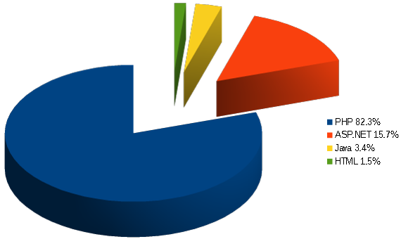

*(image from wikipedia.org)*

CMS (Wikipedia)

Content Management System or CMS is a family of software for the design and dynamic update of websites or multimedia applications. They share the following features:

* they allow several individuals to work on the same document
* they provide a publication chain (workflow) that offers, for example, the possibility of uploading the content of documents
* they separate management operations from form and content
* they allow to structure the content (use of FAQs, documents, blogs, discussion forums, etc.)
* they allow users to be prioritized and assigned roles and permissions (anonymous user, administrator, contributor, etc.)

WordPress is the most used CMS in the world (2017)

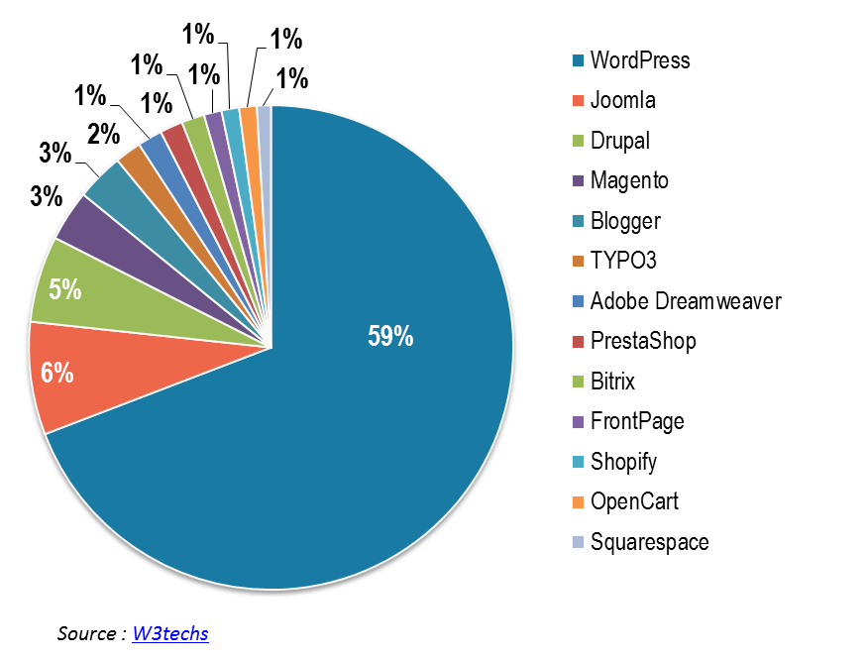

DATABASES (Wikipedia)

A database is a tool for storing and retrieving all raw data or information related to a theme or activity.

The best known are:

* MySQL - often associated with PHP
* MariaDB
* Microsoft SQL Server - often associated with ASP, ASP.NET
* Oracle
* PostgreSQL
* SQLite

They share a query language called SQL (Structured Query Language). Below, a MySQL database viewed with Navicat software. On the left the databases, on the right the tables. Above, an open table, the resemblance to Excel is striking.

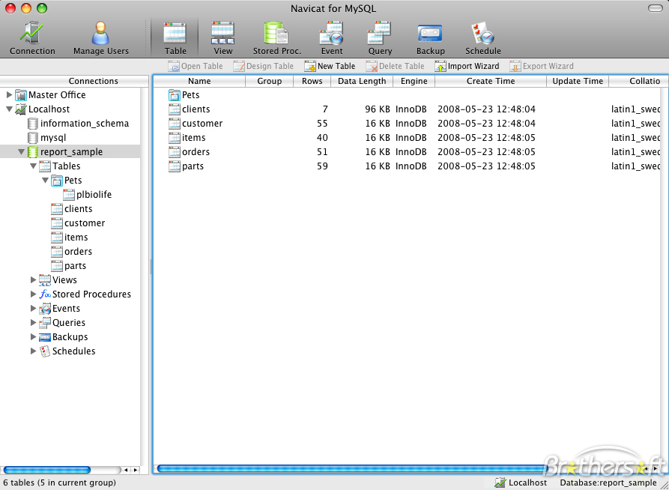

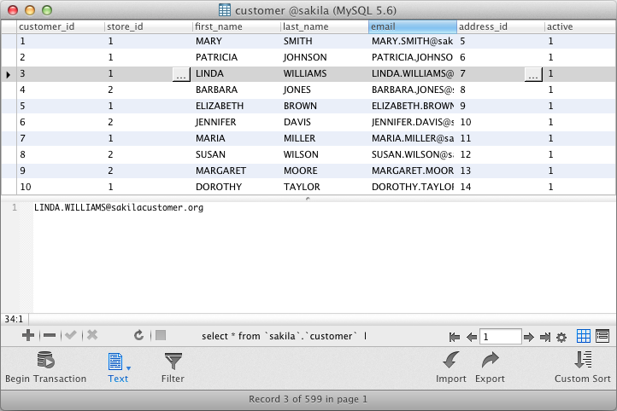RESPONSIVE WEB DESIGN (Wikipedia)

A responsive web design (RWD) is a website whose design aims, through different principles and techniques, to offer a comfortable consultation even for different media.

The user can thus consult the same website through a wide range of devices (computer monitors, smartphones, tablets, TV, etc.) with the same visual comfort and without having to scroll horizontally or zoom in / back on touch devices including manipulations that can sometimes degrade the user experience, both reading and navigation.

The notion of adaptive web rethinks the way to design browsing paths on the Internet, since it is no longer about designing as many routes as there are families of terminals, but to design a single, self-adaptable interface.

An adaptive website is an example of interface plasticity.

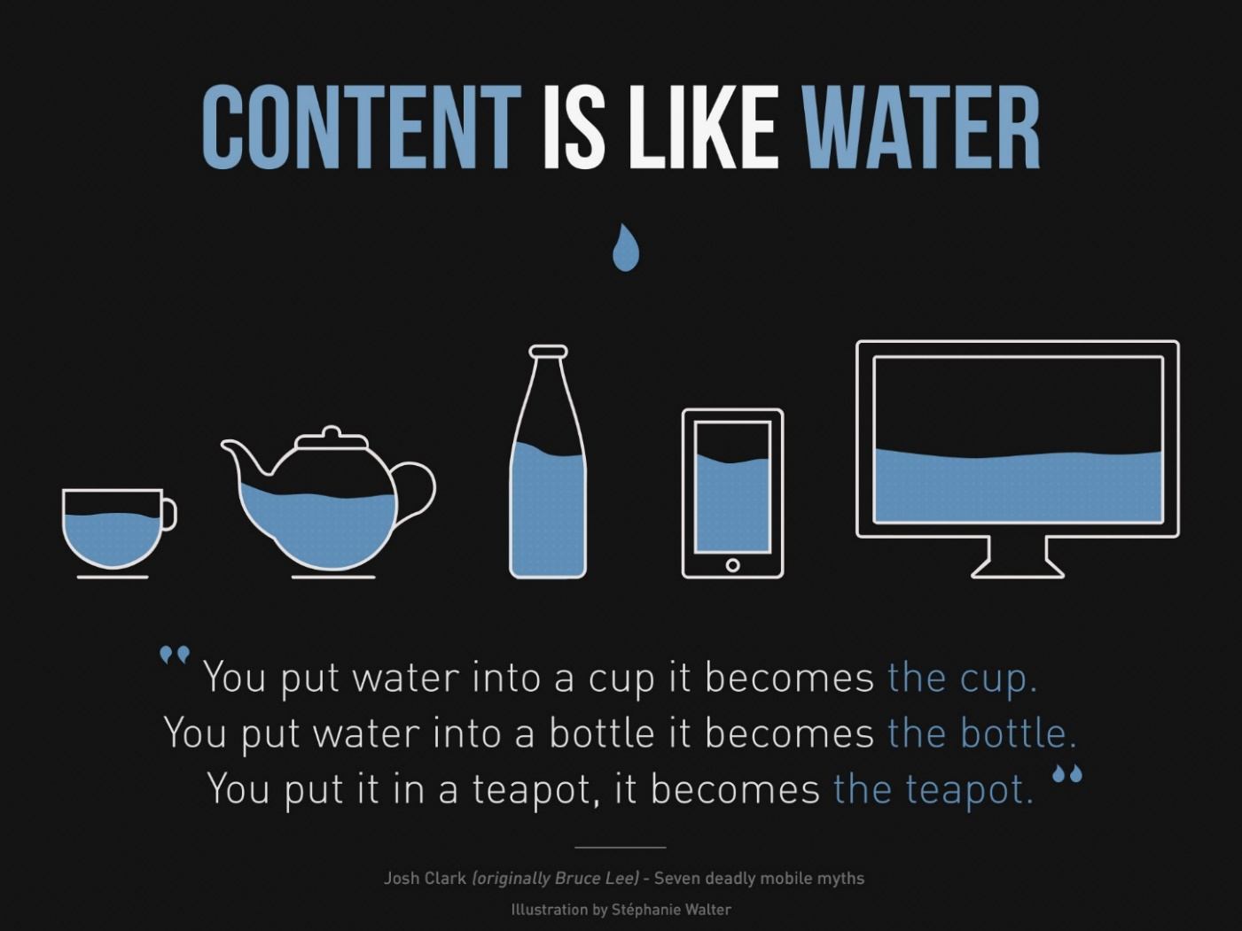

*(image from wikipedia.org)*