LEAVE MANAGEMENT SYSTEM

Leave management System (LMS) basically works almost the same as electronic paper leave application form.

The Leave Application has the following modules:

MODULES
Employees
Cadre
Leave Types
Public Holidays
Initial Leave Balances
Supervisors
Leave Balances
Leave Application History
Approved leave request
Rejected leave requests
Change password module

INTRODUCTION

The Leave Management System (LMS) is an application that can be accessed by all the employees of the organization.This system can be used to automate the workflow of leave applications , their approvals , application history and balances.

Existing Scenario
Each time employee wants to go on leave, he will have to provide the details on paper, get it approved from the superior and submit it to the HR person for updating in records. At the
end of the year the leave balance is updated. However this electronic paper based process is very time consuming and also causes discrepancies in the records.

Proposed Solution
Due to the inconvenience in managing the data using electronic paper, it is required to have a computer based system where an employee can login and apply for the leave. He can even see the records of the previous leaves taken as well check the balance leaves.

SYSTEM FUNCTIONALITY
There will be registered people in the system. Some will be approvers. An approver can also be a requestor. The approvers will be
HR Managers
Director
Deputy Director-Clinical
Deputy Director SI
Deputy Director - SSD
Coordinators
SCLARO

1. A person should be able to login to the system through the first page of the application

I. change the password after logging into the system
ii. see his/her eligibility details (like how many days of leave he/she is eligible
for etc.)
iii. query the leave balance
iv. See his/her leave history since the time he/she joined the company
v. Apply for leave, specifying the from and to dates, reason for taking leave.
vi. Send email notification to the supervisor
vii. Send back email notification when the leave is approved or rejected
vii. Periodic report generation
ix. A calendar outlining the public holidays

Login Panel:-
Enter correct username and password then login and perform specific tasks the application automatic check who is login Admin / HR/ User

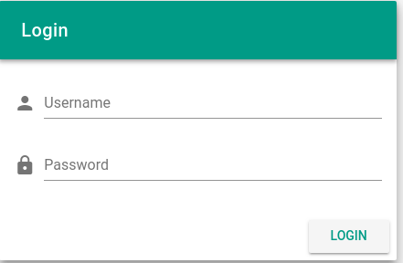

Main Window:-

