**Curneu MedTech Innovations Private Limited**

**AGILAN K S**

**agilanksds@gmail.com**

**Problem statement 2:**

Explore whether the no. of cases, deaths, CFR … of malaria increases every year. From scratch.

**SOLUTION:**

The given data sets are holding the estimated and reported number of malaria cases and deaths over the years and different countries.

When we undertake these data into exploratory data analysis we obtain certain results.

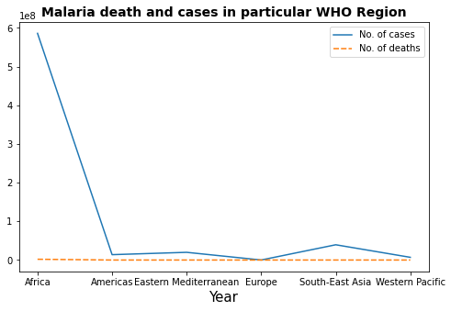

We can clearly see that the number of cases with Africa , Mediterranean and South Asia are in a negative direction and others are moving in a positive direction.

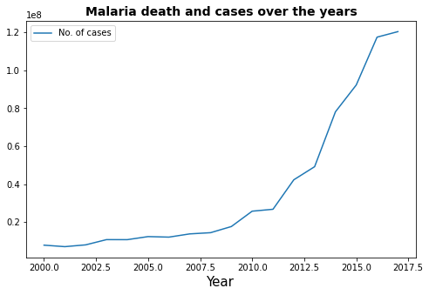

Whereas on the whole we can observe that the number of cases in keep on increasing every year.