AGILE T3.2 IoT Data Management User Interface

**Table of Contents**

**I. Revision History** **1**

**II. Overview** **2**

**III. UI control API** **2**

**Open Questions:** **2**

**IV. IoT Data Management UI** **3**

**Frequency of Data Updates** **3**

**Defined dependencies:** **3**

**Open Questions:** **3**

**What Data is Stored Initially** **3**

**Baseline Release:** **3**

**Future Release:** **3**

**Defined Dependencies:** **3**

**Open Questions:** **3**

**View the Data** **3**

**Base Release:** **3**

**Future Release:** **3**

**Defined Dependencies:** **3**

**Open Questions:** **4**

**Export the Data** **4**

**Open Questions** **4**

# I. Revision History

|  |  |  |  |
| --- | --- | --- | --- |
| **Version** | **Date** | **Author** | **Comments** |
| 1.0 | 01.03.2017 | Annalisa Wilde | Initial Release for Review by Csaba, Craig, Juan |
| 2.0 | 10.03.2017 | Annalisa, Craig, Csaba | General Release for Review by WP3 team |

# II. Overview

Within the AGILE Gateway there is a centralized GUI provided via an OS.js instance accessed via the local network. This user interface allows for management of both the AGILE gateway configuration and the connected devices. The overview of the specifications can be found in the document AGILE_D3.1.v1.0.pdf.

Here is an overview of the various UIs described in that document:

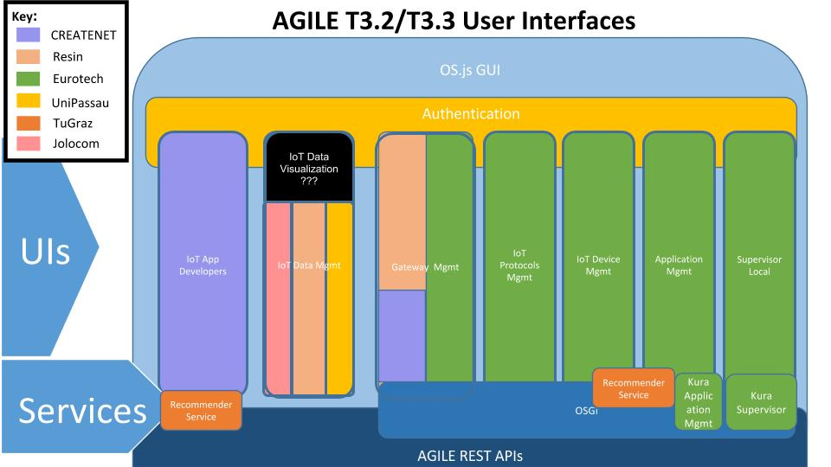

This document will address only the “IoT Data Mgmt” user interface and the “IoT Data Visualization” user interface which is considered an component of the larger user interface. The user needs to be able to access this “IoT Data Mgmt” user interface via the “Iot Device Mgmt” (Documentation forthcoming).

# III. UI control API

There has been confirmation that you can open a new ‘Application’ from an existing frame via the OSjs.API.launch(ApplicationName) method here: <https://os.js.org/doc/client/OSjs.API.html#.launch>. This API will be accessible to the UIs to update OS.js.

### Open Questions:

1 What partner will develop this API?

# IV. IoT Data Management UI

The user will select a device from the Device UI screen and from there launch this UI. This UI will allow the user to configure the frequency of data updates and what data will be stored, view the incoming device data, and export the data locally or to a cloud hosted provider.

## Frequency of Data Updates

The user can configure how frequently to retrieve data from the device.

### **Defined dependencies:**

1 Device API protocol information - metadata will determine options available to user

### **Open Questions:**

1. Exactly what metadata will be exposed? What protocols can we identify as a pilot
2. Who is responsible for this item?

## What Data is Stored Initially

The user can configure what data from the sensor will be stored locally and may add additional data like timestamp.

### **Baseline Release:**

1 Select one or multiple data elements if device has more than one

2 Timestamp added automatically

### **Future Release:**

1 Location - if can get accurate enough information to make this worthwhile

### **Defined Dependencies:**

1 Device API device profile information - kind of data available and units

### **Open Questions:**

1. Who is allowed to view this locally stored data? Where are those configurations?
2. What data exactly will be available in the device profile?
3. Who is responsible for this item?

## View the Data

The user can view the data in a graphical form and modify the timespan and other aspects of the graph dynamically

### **Base Release:**

1 Line-graphs

2 Graph Manipulations:

1. Multiple measurements over-layed
2. Modifications of the time span viewed

### **Future Release:**

1 Others graph types as available

2 Other graph manipulations as available

3 Image export as available

### **Defined Dependencies:**

1 The graphing library selected will determine what additional kinds of graphs and graph manipulations are available

### **Open Questions:**

1 [Can we integrate our security system with grafana?](http://docs.grafana.org/installation/configuration/#auth-proxy)

2 How real-time is the data that is displayed? Do we need to have a Storage Service to access old data?

3 Who is responsible for this item?

## Export the Data

The user can export the data for a given time interval in common data formats either locally or to external sources.

Base Release:

1 Local export: Need to determine use cases so we can determine the best formats locally

2 External export: Will have the Xively and Dropbox integrations

### **Open Questions**

1. For local export, what data format makes the most sense?
   1. JSON
   2. CSV
   3. influxdb (.txt) [here](https://docs.influxdata.com/influxdb/v0.9/tools/shell/#import-data-from-a-file-with-import)
2. For external export:
   1. How do we expose the work that is done in NODE-RED for Xively and Dropbox so that this UI can access it?
3. Who is responsible for this item?