**References:**

* scaledagileframework.com
* SAFe in 7 minutes - https://www.youtube.com/watch?v=RXzurBazN-I

**Scaled Agile Framework (SAFe):**

Dean Leffingwell - Agile Software Requirements: Lean Requirements for Teams Programs and the Enterprise (2011) and Scaling Software Agility: Best Practices for Large Enterprieses (2007)

Implementing agile practices at enterprise scale

Synchronizes alignment, collaboration and delivery for large numbers teams

**Core values:**

* Code quality - can't scale crappy code
* Program execution
* Alignment
* Transparency

**House of Lean:**

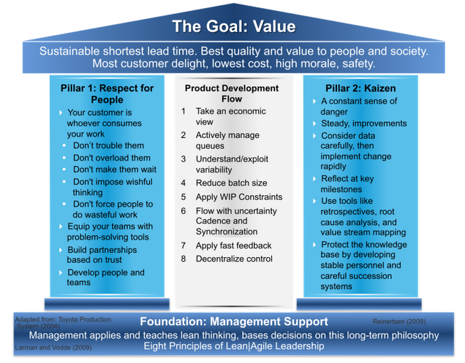

"We need to figure out a way to deliver software so fast that our customers don't have time to change their minds" - Mary Poppendieck

Team -> Program -> Portfolio

**Team**

* Cross functional
* Scrum
* Release cadence
* HIP

**Program**

* Built on Scrum, except scaled up
* self-organizing, self-managing team-of-agile-teams
* release trains
* working off a single backlog of features, driven by vision and roadmap
* product and release management, release planning
* program psi objectives
* common sprint lengths - system continuous integration
* architectural runway

**Portfolio**

* business epics
* architectural epics
* kanban epic system – limit WIP
* program portfolio management, enterprise architect
* value streams
* investment themes - provide operating budgets for release trains

**SAFe v3.0 - late July 2014**

* develop on cadence, deliver on demand
* strategic themes