Github Link: <https://github.com/AgileAssessment/Work>

Website Link: <https://agileassessment.github.io/Work/New%20folder%20(3)/index.html>

Assignment by: Liam, Arun and Josh

Stakeholder list:

|  |  |  |  |  |  |  |
| --- | --- | --- | --- | --- | --- | --- |
| Stakeholder documentation | | | | | | |
| Name | Position | Internal/External | Department | Expectation | Alma Mater | Location |
| H. Giovanni | CEO | Internal | Management | Manage the entire team/company and make higher level decisions. | Uni of Milan - General Management | 12 Richmond Street |
| T. Jameson | Project Director | Internal | Management | Cooperate with the CEO, lead the development team in-depth, ensure efficient workflow and quality results of the project. | Victoria Uni - Project Management | 71 Miller Drive |
| M. Rosmov | Lead Programmer | Internal | Development | Manage all of the programmers and assist/oversee their workings. | Kyiv Uni - Programming | 95 Hillpark Street |
| N. Alan | Lead Designer | Internal | Development | Administer all designers and related design decisions of the project. | Melbourne College of Art  - Design | 24 Limbston Lane |
| L. Man | Lead Marketing | Internal | Marketing | Steer marketing efforts both digital and physical, will also advise decisions associated with our business; due to the focus of our services being marketing. | Canterbury Uni - Marketing | 9 St. Michael Street |
| Q. Jones | QA lead | Internal | QA | Ensure the overall quality of our product, and diagnose any flaws associated with the product. | Unitec - Quality Management | 43 Havel Drive |
| D. Laster | Majority Shareholder | External | N/A | Hold majority shares of the company and make decisions on behalf of the shareholders. | N/A | 102 Timbrook Street |
| Josh | Developer | Internal | Development | Grunt developer, specialized in Javascript and HTML. | N/A | N/A |
| Liam | Developer | Internal | Development | Specialized in all types of coding and design. | N/A | N/A |
| Arun | Developer | Internal | Development | Specialized in all coding and design tools. | N/A | N/A |

Description of Product:

General Description:

“HashingAdvertisements.com” is going to be a website that shall present the advertising services of Hashing Advertisements inc. These services can be ordered and configured on the website. Customers can view the specific details, customize and then order the advertising services. The design of our website should reflect our style and format of our advertisements, so the quality of  The website’s design shall be a mix of minimalism and corporate imagery, appealing to the larger firms that require advertising services.

This product is being made to both promote and ease the acquisition of our company’s services. It will also expand our horizons on potential clientele, and both should flourish financially from deals with them through contact with our sales team.

Main Features:

The frontend pages of the website are the Home, Our Services, Service Listings, About and Login. The backend of the website shall contain CSS, Javascript and a secure database of  login details.

* Every page: Navigation bar, background and top banner (no banner on our services page).

* Home: Central banner of main service, gloss over description.
* Our services page: Give description of services with contact details of sales staff, button leading to service listings page.
  + Service listings(pricing) page: Lists every service, it’s price and details.
* About: Description of company’s history, goals, staff and products/services.
* Login: Login screen for staff and returning customers.

Comparison to similar products

Basically every big tech company has an advertising product or service, incorporating AI and personalized content. Our services are more based on the procurement and placement of advertisements physically and/or digitally on different platforms, rather than the automatic placements on big tech owned services. Other than that, the agencies that are focused on advertisement are either distributing or creating the adverts, our firm does both or one of the services whether or not the client chooses them or not. Although big tech is the Goliath to our David, there are much more mid to small scale competitors with similar websites that we must stand out from. In this case we should make our website’s design striking yet unique and most of all, simple and navigable for maximum ease of use and visually distinctness for any future clients.

Reflection analysis

After the release of our product, hashingadvertisements.com shall give us a source of acquisitions of our services, increasing our client pool and in turn net revenue. Another benefit we gain from this is the experience our staff gain from the development process, this experience can be applied to the post-release monitoring and updates or future projects. In the future our team might create a successor to our recently made website or another project entirely, and can reflect on both the steps and milestones, successes and issues overcome within the course of this project’s timeline. Our company might create a dedicated team to maintain the website’s integrity in either/both the front end and back end. The team of designers that create original advertisements shall gain experience designing the website’s layout and images too, increasing the quality of future advertisements and other marketing endeavours.

WBS Work Breakdown Structure

|  |  |  |  |  |  |  |  |
| --- | --- | --- | --- | --- | --- | --- | --- |
| ID | Main Task | Sub Task | PERT Duration | Start | Finish | Predecessor | Resource Name |
| 1 | Planning into early prototype | Personal list, Wireframe concepts and documentation planning | 3 days 12 hours | 1/06/21 | 4/06/21 |  | Josh, Arran, Liam |
| 2 | Implementation planning into prototype | Wireframes, documentation draft | 5 days | 4/06/21 | 9/06/21 | 1 | Josh, Arran, Liam |
| 3 | Early development of front end | Starting documentation and website plan | 6 days | 9/06/21 | 15/06/21 | 2 | Josh, Arran, Liam |
| 4 | Early development of back end | Finish documentation finish website design | 5 days | 15/06/21 | 20/06/21 | 3 | Arran, Liam |
| 5 | Development of database | Database listing and creation | 5 days | 20/06/21 | 25/06/21 | 4 | Josh, Liam |
| 6 | Development of Javascript | Creation and implementation of code | 6 days | 25/06/21 | 1/07/21 | 5 | Josh |
| 7 | Development of CSS | Creation and implementation of code | 3 days | 1/07/21 | 3/07/21 | 6 | Arran |
| 8 | Website Testing Evaluation/ and Analysis | Early testing of website functions and abilities | 8 days | 3/07/21 | 11/07/21 | 7 | Arran, Liam |
| 9 | Evaluation and Analysis Report | Find and document issues found | 2 days | 11/07/21 | 13/07/21 | 8 | Josh, Arran |
| 10 | Website Issue Fix | Update website with issue fix | 4 days | 13/07/21 | 17/07/21 | 9 | Josh, Arran, Liam |
| 11 | Test that bug fix worked | Test that website issue is now fixed | 2 days | 17/07/21 | 19/07/21 | 10 | Josh, Liam |
| 12 | Website public release | Release public version of the website | 1 day | 19/07/21 | 20/07/21 | 11 | Josh, Arran, Liam |
| 13 | Post Release Monitoring | Company administration monitors the website | 2 month | 20/07/21 | 20/09/21 | 12 | Arran, Liam |
| 14 | Post update | Release updates for post issues | 5 days | 20/09/21 | 25/09/21 | 13 | Josh, Arran, Liam |

Project Roadmap and Resource Needs

Roadmap:

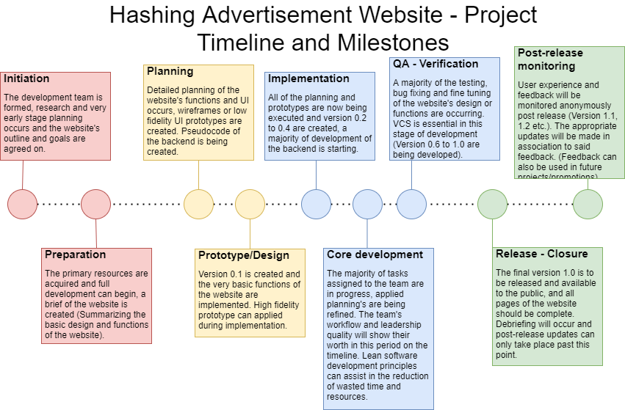

Initial resources:

At the start of the project development, resources for almost the entire project are gathered. The basic needs of this project are the funding, development space/area, PCs and development tools, total value of funding at this level of the project is estimated to be around $15,000 to $32,500. The office space of Hashing Advertisements already provided by the company shall  be used, desktop PCs, laptops and tablets are supplied by the company also. Paid software tools used to develop the website throughout the timeline shall be: Adobe Photoshop ($33.44 per month) and Microsoft Office 365 Business Standard (NZ$18.90). For reference the free software in use is Microsoft Visual Studio or Notepad++ for coding and editing the website, Filezilla for FTP and (web based) Github as VCS. Management may need an ERP solution for management of said resources both human and material, so software such as Microsoft Dynamics 365 or Jeeves might be of major importance to management staff.

Planning resources:

At this stage, up until the wireframe and prototypes are finished and implemented into the execution, funding would probably be minimal and used mostly on the team’s upkeep. Tools to create wireframes, GUI prototypes and general image manipulation shall be essential in this stage. So software such as: Balsamiq, Adobe xd and Photoshop, Webflow or Framer are good choices for the various tasks during the visual prototyping phase.

Execution resources:

This phase of the project’s timeline, the resources required are more than the planning phase. Both the programming of the website’s front end structure and functions, and it’s code heavy backend can cause many problems and reactive solutions. Another injection of funding is possibly needed to smoothly progress in the project, but may not be entirely necessary. Tools that manage both code fidelity between versions (VCS such as GitHub or Azure DevOps) may be used regularly.

Closure resources:

During the closure of this project, less resources are required than the execution period but . Post release there shall be some sort of upkeep cost on the website, that is a combination of the domain cost and the wages of maintainers. Software that manages user feedback may be useful and the acquisition of software such as Retently (Essential package at $110 yearly, professional at $333 yearly) could be a worthwhile investment.

Resource Constraints:

 Our team shall be kept small (Maximum of 12 staff) due to management keeping hiring constraints for our project, but the team also needs to be kept adaptive and have clear communications between each other (Which becomes more difficult the larger the team becomes). Funding constraints are strict with a maximum possible funding being capped at $60,000, this funding shall strictly be used as business expenses. Although there is a degree of high autonomy within the development team, the website’s design is ultimately decided by the company’s upper management, so each iteration should be assessed and approved by them before it is implemented with finality.

Resource Needs Table:

|  |  |  |  |  |
| --- | --- | --- | --- | --- |
| WBS Code | Description | Resource | Amount | Cost |
|
| 1 | Early prototype initial hiring | 2x Web Developers  2x Web Designers | 4 | Average salary 5k monthly x 4 = $20,000 monthly |
| 1 or 1-12 | Early stage funds | Funding for entire project | Can be one payment or over each stage | $32,250 |
| 1-12 | Microsoft Office | Microsoft office 365 for entire team | 12 | $226.80 Monthly |
| 2, 3 | Adobe Creative Cloud and xd subscription | Image manipulation tools for designer staff | 4x for 2 designers  1 Head designer  1 Lead marketer | $442.6 Monthly |
| 5 |  |  |  |  |
| 12 | Website domain | Domain for HashingAdvertisements.com | 1 | $442.6 |

Risk Register

|  |  |  |  |  |  |  |
| --- | --- | --- | --- | --- | --- | --- |
| Project Risk Plan for: Hashing Advertisements website | | | | | | |
| Assessment team members: (Responsibility refers to the stakeholder ) | | | | | | |
| Risk Desc | Impact Desc | Impact Level (1 - 10) | Probability Level (1 - 10) | Priority Level (1 - 25) | Mitigation precautions | Responsibility |
| Liam absence | One of the individuals on the development team is absent often, and his tasks can be communicated to him. | 7 | 4 | 18 | 1. Establish contact via Zoom, Skype or Microsoft teams 2. Give tasks to him through these programs | T. Jameson |
| Josh work leave | Josh takes a work leave to Columbia on occasion, often coming back within 2 weeks to a month. | 5 | 2 | 16 | -  Get him a mobile work solution (Laptop w/ international mobile data plan)  - Make him contact from zoom or skype with said laptop | Josh, T. Jameson |
| Error message of “Script javascpt 72 fatal error” when buttons are pressed | Doesn’t seem to impact the button but is annoying | 1 | 8 | 4 | * Fix referred line in javascript backend * Delete function | M. Rosmov |
| Navigation bar causing crashing | Website freezes and crashes when the navigation bar is dropped down | 9 | 3 | 22 | * Analyse, locate and fix bugs or messy code in the navigation bar section of code * Analyse and fix code linking/relating to navigation bar | M. Rosmov |
| Banner resolution | The banner’s resolution is extremely low | 2 | 10 | 6 | * If export mistake: save banner as png and a higher resolution * If image is actually that resolution: Upscale via photoshop or AI * Can always create another image | N. Alan |
| Link switching | Navigation bar links can randomly take user to other undesired pages | 4 | 1 | 10 | * Fix links within the navigation bar | M. Rosmov |
| Log in overflow | After a total of 35 user accounts have been registered, there is a chance that no other entries can be created in the database. | 7 | 1 | 19 | * Analyse backend code that is linking the login information to database * Analyse database itself and its link to website backend * Fix issues when found | M. Rosmov |
| About page doesn’t load | The about page doesn’t load properly when accessed from the service page | 5 | 5 | 14 | * Fix code relating to the link between service and about | M. Rosmov |

Testing Document

|  |  |  |  |  |  |
| --- | --- | --- | --- | --- | --- |
| Process | Function being tested | Steps | Status | Expected Result | Result |
| Opening website on home page from browser | Index page | 1 | Passed | Entered home page within 0.5 - 1.5 seconds | Home page appeared after 1 second when link is opened |
| Navigation bar collapsing from top right | Navigation bar - all pages | 1 | Not Working | Navigation bar collapses with animation, sliding in from the right | Navigation bar ethier doesn’t appear at all, appears without animation or possibly crashes the website entirely |
| Forgot password | Login process | 4 | Passed | User verification and password reset | Confirmation email was sent to user to allow there password to be reset |
| Order Process | Ordering Ability | 6 | In progress | Order option is supposed to show | Order option isn't showing up |
| More details button | More details button within the “Our Services” page | 2 | Not working | Clicking the button “More details” should send the user to the service listings page | Link could be broken or the button function isn’t working properly, possibly the boxes that hold them could break the button. |
| Service boxes | Boxes within the the “Our services” page | 1 | Passed | Upon entering the our services page, there will be three boxes in the bottom three quarters of the page the hold the brief information and contact details of the service | Boxes appear as desired, holding all contents adequately. |

Wireframes:

